FISCAL UPDATE February 4, 2002
Legislative Fiscal Bureau (515)-281-5279 FAX 281-8451
http://staffweb.legis.state.ia.us/lfb/
House PAsses HF 2075 - Endowment Reimbursement Bill
HF 2075 The House passed HF 2075 (Endowment Reimbursement Bill) that establishes a mechanism to reimburse the Endowment for Healthy Iowans $40.0 million beginning in FY 2003.

FY 2002 Action The General Assembly appropriated $40.0 million from the Endowment to fund the Teacher Quality Act in FY 2002. Senate File 531 (FY 2002 Administration and Regulation Appropriations Act) contained language that provided for the repayment of the $40.0 million from excess revenues in the Economic Emergency Fund at the end of FY 2001 and FY 2002. However, due to budget shortfalls, the funds will not be repaid by the end of FY 2002.
Bill Provisions Beginning in FY 2003, HF 2075 requires any funds that are in excess of the amount required to maximize the balance of the Economic Emergency Fund be transferred annually to the Endowment for Healthy Iowans until the total amount transferred reaches $40.0 million.
STAFF CONTACT: David Reynolds (Ext. 16934)
Court Information On-line
On-line Access The Judicial Branch announced the availability of on-line access to statewide court information starting January 30. The address of the on-line service is: www.iowacourtsonline.org.

Information Available The service will provide the public with free access via the Internet to basic court information such as child support payment histories, criminal and traffic records, and case dispositions from all 99 counties and the appellate courts. The site will also include a search tool that allows users to search for information by case number, case title, litigant names, and attorney names.
Future Services The Judicial Branch is planning to add an E-pay service in the near future. The service will enable users to pay traffic fines online. The Judicial Branch also plans to provide more detailed access to court information for a $25 monthly subscription fee. Subscribers will be able to check trial and hearing dates, judgment liens, and other court information not available on the free portion of the web site. The Judicial Branch web site address is: www.judicial.state.ia.us.
IN THIS ISSUE: | HF 2075-Endowment Reimbursement, pg. 1 | Ag/Land Stewardship Division Administrator, pg. 7
 | Court Information On-Line, pg. 1 | Summary of LIL FY 2001 Approps. Acts, pg. 7
 | New Director, Supreme Court Comm., pg. 2 | Dept. Nat. Resources FY 2001 LIL, pg. 8
 | IA Workforce Dev., Surcharge Rpt., pg. 2 | Dept. of Human Services FY 2001 LIL, pg. 9
 | Medicaid Reimbursement Reduction, pg. 3 | Dept. of Corrections FY 2001 LIL, pg. 11
 | Medical Assistance Expenditures Update, pg. 3 | Board of Parole FY 2001 LIL, pg. 13
 | Alternative Teacher Licensure Rules, pg. 4 | Dept. of Justice FY 2001 LIL, pg. 13
 | Federal Funding for Bioterrorism, pg. 5 | Public Defense-Military Division FY 2001 LIL, pg. 14
 | DGS Quarterly Maintenance Report, pg. 6 | What’s New on the LFB Web Site, pg. 15
STAFF CONTACT: Jennifer Dean (Ext. 17846)
New Director of Supreme Court Commissions Named
New Director Paul Wieck has been appointed Director of Supreme Court Commissions. Mr. Wieck will replace John Courtney, who is retiring after 22 years of service. Mr. Wieck had been the Commissioner of Public Safety from 1990 to 1999.
Responsibilities As the Director of Commissions, Mr. Wieck will administer the Client Security and Attorney Discipline Commission, which conducts investigations and performs audits of attorneys; the Continuing Legal Education Commission, which accredits continuing education programs for attorneys; and the Lawyer Trust Account Commission, which makes grants to agencies and programs that provide civil legal services to the poor.

STAFF CONTACT: Jennifer Dean (Ext. 17846)
Iowa Workforce Development Annual Surcharge Office Report
Report Presented On January 31, Jane Barto, Deputy Director of Iowa Workforce Development, presented the Department’s Report on Workforce Development offices supported by the Administrative Contribution Surcharge to the House Economic Development Committee. Section 96.7(12), Code of Iowa, as amended by HF 696 (Administrative Contribution Surcharge Act), passed during the first extraordinary session of 2001, requires the Department to conduct an annual review and report to the General Assembly on the local surcharge office system.

REPORT

Results are Preliminary The Report covers five months of data, and the Department considers the results to be preliminary. The Report addresses performance measures, collocation efforts, services to employers with less than 50 employees, and fee-based pilot projects.
Services During the five months for which data were collected, the surcharge-supported offices served 80,000 individual and 12,000 business customers. The general public customers received multiple services, distributed as follows: job match applicants (35,000); job referrals (86,000); career development activities or general information (47,000); unemployment insurance claims and questions (58,000); partner services and referrals (7,000); and resource room sessions (12,000). Business customers also received multiple services, distributed as follows: job order listings and referrals (73,000); general information (1,000); unemployment assistance (1,000); and consultation and other business


services (1,300). The local offices placed 7,000 new employees at an average wage of $8.02.
STAFF CONTACT: Dwayne Ferguson (Ext. 16561)
Legislative Administrative Rules Committee Medicaid Reimbursement Rate Reduction Delays
Rules Delayed At its January 24 meeting, the Administrative Rules Review Committee voted to delay the effective date of cutbacks relating to Medicaid reimbursement rates. The amendments to various Medicaid rules would have implemented a 13.2% across-the-board reduction for FY 2002 to most Medicaid providers, effective February 1, 2002, saving approximately $18.6 million General Fund dollars. This Session delay by the Administrative Rules Review Committee allows the General Assembly to deal with the issue legislatively. Absent legislative action, the amendments will go into effect upon adjournment of the 2002 legislative session.

Administrative
Rules
More Information More information is available from the Legislative Fiscal Bureau.
STAFF CONTACT: Sue Lerdal (Ext. 17794) Sam Leto (Ext. 16764)
FY 2002 MEDICAL ASSISTANCE EXPENDITURES UPDATE
Medical Assistance For the week ending January 28, 2002, the FY 2002 General Fund expenditures for the Medical Assistance Program in the Department of Human Services were $6.6 million. This is $2.3 million above the weekly budget of $4.3 million established by the Department. Year-to-date General Fund expenditures are $252.7 million (11.02%), over the $227.6 million budgeted by the Department for the fiscal year.

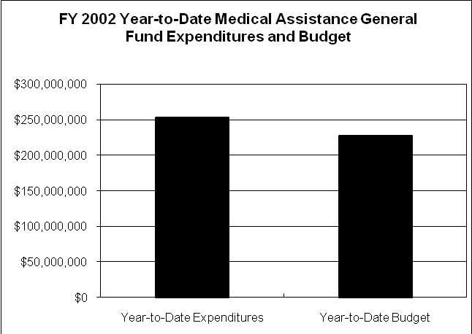
More Information More information is available from the Legislative Fiscal Bureau.
STAFF CONTACT: Sam Leto (Ext. 16764)
Alternative Teacher Licensure Rules Approved by Board of Educational Examiners
Board Approves Rules At its meeting on January 18, the Board of Educational Examiners approved for public notice, administrative rules establishing a teacher intern license, restricted to grades 9-12. The rules also outline requirements for teacher interns to progress to an initial license and, finally, a standard license.
Intern License Requirements To obtain a teacher intern license under the proposed rules, applicants must:

- Hold a baccalaureate degree with a minimum cumulative grade point average of 2.5 on a 4.0 scale.
- Meet the requirements of at least one secondary endorsement area.
- Possess a minimum of three years of post-baccalaureate work experience.
- Complete an introductory teacher intern program approved by the State Board of Education, including:
- Learning environment/classroom management
- Instructional planning and strategies
- Student learning and diverse learners
- Collaboration, ethics, and relationships
- Assessment
- Field experience
Qualification Rules To subsequently qualify for an initial license, the teacher intern must complete a one-year internship with a school district, a four-semester-hour intern seminar during that year, and a concluding teacher intern program the following summer. The one-year internship will count toward the two years of teaching required to move from the initial license to the standard license.
Alternative Teacher Prg. The Board has received indications that five higher education institutions in the State would be interested in developing and offering alternative teacher education programs. The State Board of Education intends to adopt administrative rules regarding program approval in March 2002.
STAFF CONTACT: Robin Madison (Ext. 15270)
FEDERAL FUNDING FOR BIOTERRORISM

Federal Funding Health and Human Services Secretary Tommy Thompson announced January 31 the state-by-state allocations for bioterrorism preparedness funds. Approximately $1.1 billion dollars will be appropriated to states to help strengthen their ability to respond to bioterrorism and other public health emergencies resulting from terrorism. Funding to states will be in two phases.

First Phase of Funding The first phase of funding will come from the Centers for Disease Control and Prevention (CDC) and will be targeted toward bioterrorism, infectious diseases, and public health emergency preparedness. Each state will receive base funding in the amount of $5.0 million and will then receive additional funds based on its share of the total United States population. The second phase of funding will come from the Health Resources and Services Administration (HRSA). States are to use this funding to create regional hospital plans to respond in the event of a bioterrorism attack. This funding will be allocated based on a formula similar to the one used by the CDC. In order to avoid delay in starting preparedness measures, states will be allowed to immediately begin spending up to 20% of their allocations.

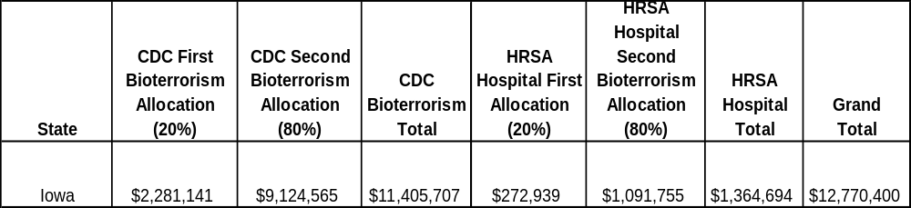
Second Phase States will receive the remaining 80% of their allocations after their state plans are received and approved by the federal Department of Health and Human Services. State plans are due no later than April 15, 2002, and should demonstrate how the state will respond to bioterrorism and other outbreaks of infectious disease, as well as how the state will strengthen its core public health functions in all relevant areas. Each plan is to be reviewed and endorsed by the Governor before it is submitted. Iowa is currently awaiting its 20% initial allocation and final instructions for the request for proposal from HRSA and the CDC. The State is estimated to receive the following funding:

Des Moines Designated cities will also receive funding in the way of Metropolitan Medical Response System (MMRS) contracts from the Health and Human Service’s Office of Emergency Preparedness. This funding will be aimed at helping local jurisdictions improve response to events involving mass casualties. The City of Des Moines is estimated to receive $200,000 for FFY 2002.

STAFF CONTACT: Russ Trimble (Ext. 14613)
Department of General Service - Routine Maintenance Quarterly Report
Report Received The Department of General Services submitted the quarterly report on routine maintenance to the Legislative Fiscal Bureau on November 16 for the quarter ending September 30, 2001. The Report details the allocation and expenditure of funds appropriated for routine maintenance in FY 2001 and FY 2002. The General Assembly appropriated $2.0 million for FY 2001 and $2.0 million for FY 2002 to the Department for routine maintenance needs of State facilities that are under the purview of the Department. The Governor’s Vertical Infrastructure Advisory Committee established the policy to distribute the funds to State agencies on a square-foot basis.
Maintenance Funding The following table summarizes the quarterly report and shows the total allocations for each State agency and the amount expended through December 31, 2001.

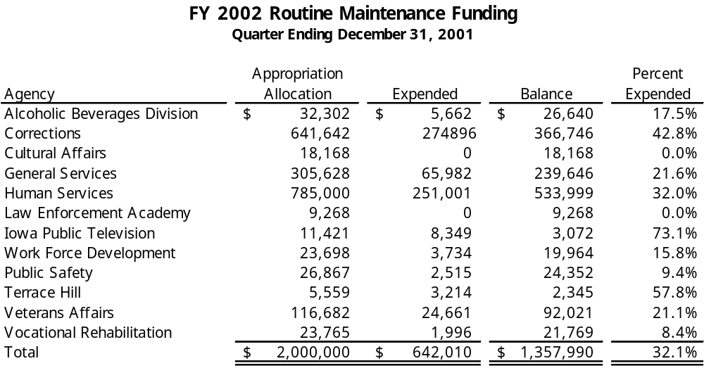
Expenses Exceed Allocations In some instances, the amount expended by an agency has exceeded its allocation. The Report states the amounts expended that exceed the allocation will be funded by the agency’s operating budgets.
Funds Available/Four Years The routine maintenance appropriations remain available for expenditure for four years from the date the funds were appropriated.
Copies Available Copies of the Report are available from the Legislative Fiscal Bureau.
STAFF CONTACT: David Reynolds (Ext. 16934)
Department of Agriculture and Land Stewardship Appoints Division Administrator

New Division Admin. Patty Judge, Secretary of Agriculture, announced on January 29, that Bill Ehm has been selected as the Director of the Soil Conservation Division in the Department of Agriculture and Land Stewardship. Ehm has been working in the Department of Natural Resources as the Total Maximum Daily Load (TMDL) Program Coordinator for the past two years and has served on the Environmental Protection Commission for over 10 years.
Ehm will replace former director Jim Gulliford, who is working as a Regional Administrator for the federal Environmental Protection Agency. Ehm will assume his new duties on February 15, 2002.
STAFF CONTACT: Deb Kozel (Ext. 16767)
Summary of Department Action on Legislative Intent Language in all FY 2001 Appropriations Acts
FY 2001 Legislative Intent Legislative Fiscal Bureau staff report that there were 450 sections of legislative intent language included in the FY 2001 Appropriations Acts. By the end of FY 2001, the status of departmental action related to each section show the following:
Legislative Intent
- COMPLIANCE – departments had complied with 426 sections of intent language.
- NONCOMPLIANCE – departments had not complied with nine sections of intent language.
- IN PROGRESS – departments were still in the process of complying with four sections of intent language.
- OTHER – the remaining 11 sections were classified as other, meaning that circumstances had changed and compliance would either have been inappropriate or impossible.
Summary by Department A summary report for each department not fully complying with the legislative intent language in the Acts is being provided separately, with the explanation the departments provided for the status.
STAFF CONTACT: Douglas Wulf (Ext. 13250)
Department of Natural Resources FY 2001 Legislative Intent Language
Natural Resources The LFB identified 23 sections of intent language in SF 2430 (Agriculture and Natural Resources Appropriations Act), passed by the General Assembly in 2000, for the Department of Natural Resources. The Department complied with 19 sections and is in noncompliance with four sections.
Legislative Intent
Noncompliance NONCOMPLIANCE
Dues Upper Mississippi River Commission Dues
SF 2430, Section 3.1(b): Allocates $12,000 for membership dues to the Upper Mississippi River Basin Commission.

Status: Total dues paid by the Department of Natural Resources on September 14, 2000, were $25,500. The Department of Transportation reimbursed the Department for $4,500 reducing the total cost to $21,000.
FTE Limits FTE Position Limits
SF 2430, Section 3.1 through Section 3.8: Maximum FTE positions in the Department of Natural Resources include: Administrative Services Division - 118.25; Parks and Preserves Division - 195.73; Forests and Prairies - 53.71; Energy and Geology - 59.00; Environmental Protection Division - 246.50; Fish and Wildlife Division - 354.18; and Waste Management Division - 17.75.
Status: The Department reorganized the FTEs within the Divisions by moving the 36.00 FTE positions in the Land Quality Bureau from the Environmental Protection Division to the Waste Management Division. The Environmental Protection Division added 5.00 FTE positions to the Water Supply Program, as provided by Section 3.6(b). The reorganization changed the FTE limit in the Administrative Services Division to 118.25, the Energy and Geology Division to 59.00, the Environmental Protection Division to 215.50, and the Waste Management Division to 53.75.
The current FTE positions include: Administrative Services Division - 121.37; Parks and Preserves Division - 188.28; Forests and Prairies - 54.94; Energy and Geology - 54.36; Environmental Protection Division - 205.95; Fish and Wildlife Division - 346.94 and Waste Management Division - 53.98. The following chart depicts the FTE status in each Division:

Eurasian Milfoil Eurasian Milfoil
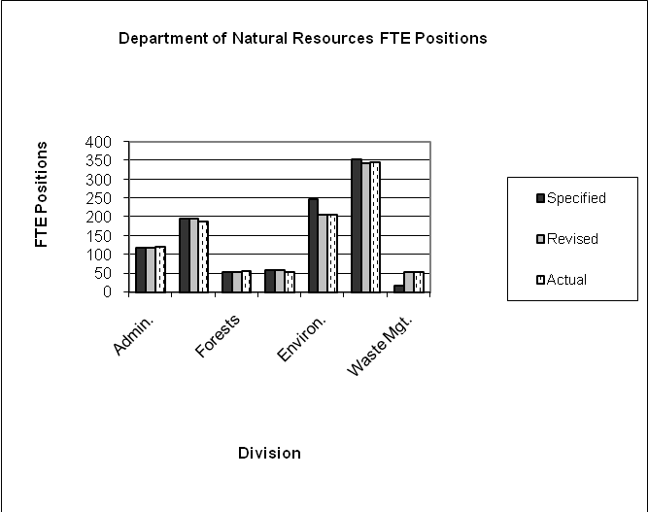
SF 2430, Section 6.1: Allocates $100,000 and 1.00 FTE position for the control and eradication of Eurasian Milfoil.
Status: The Department allocated $110,000 and 1.39 FTE positions.
Lagoon Study Municipal Lagoon Study
SF 2430, Section 20: Extends the completion date for a study of groundwater and surface water contamination from municipal lagoons to January 13, 2003, and specifies the Department is to submit interim reports on January 8, 2001, and January 14, 2002. States unobligated funds remaining on June 30, 2001, revert to the Water Quality Protection Fund.

Status: The study was not started or completed and the Department will not be submitting any interim reports.
STAFF CONTACT: Deb Kozel (Ext. 16767)
Department of Human Services FY 2001 Legislative Intent Language
Human Services Intent The Legislative Fiscal Bureau has identified 100 sections of intent language in SF 2435 (FY 2001 Human Services Appropriations Act) passed by the 2000 General Assembly, five sections in HF 2555 (FY 2001 Tobacco Fund Appropriations Act), 32 sections in SF 2193 (Senior Living Programs Act) for the Department of Human Services (DHS), and eight sections in HF 2533 (FY 2001 Block Grant/Federal Funds Appropriations Act) for the DHS, for a total of 145 sections of intent language for FY 2001. The DHS complied with 133, is in the process of complying with three, two are included in the “Other” category, and seven are in noncompliance.
Legislative Intent
In Progress IN PROGRESS: SF 2435 (FY 2001 Human Services Appropriations Bill):
Pilot Projects Section 4.4(d)(3) permitted a maximum of $250,000 be used to develop or continue pilot projects to assist parents in meeting child support obligations, to prevent family separations, and maximize the use of existing community service resources and encourage local contributions. The DHS expended $130,000 on these initiatives, and $120,000 was unexpended due to funding concerns in other DHS areas funded with Temporary Assistance for Needy Families (TANF) funding.
Well-being Incentive Section 4.4(d)(5) permitted the DHS to expend a maximum of $100,000 for incentive payments to agencies successfully completing well-being visits with families terminated from the Family Investment Program (FIP). None of the $100,000 was expended, as well-being incentive payments were paid through funds appropriated for the Promise Jobs Program instead of the FIP.
Case Management Study Section 9 provided $414,000 to be expended to implement a disease specific-pharmaceutical case management study to measure the effects of case management for Medical Assistance recipients identified by the DHS as high risk for medication related problems. The DHS is required to reimburse physician-pharmacist teams who participate in the study. The DHS is required to submit a preliminary report to the General Assembly by December 15, 2001, and a final report by December 15, 2002. The University of Iowa College of Public Health is preparing the preliminary report.
OTHER (SF 2435):
Electronic Benefits Prog. Section 4.1(e) relates to the Electronic Benefits Transfer Program. The DHS is required by Iowa Code (1998 Iowa Acts, Chapter 1218, Section 5(1)(d) and 1999 Iowa Acts, Chapter 203, Section 5(1)(d)) to implement a statewide program by October 1, 2002. The DHS issued a Request for Proposal in November 2000, with one response received. Costs within the response exceeded federal allowable spending and State resources. The DHS has been working with the United States Department of Agriculture (USDA) on an implementation plan and a waiver to the October 1, 2002, requirement and is currently waiting for USDA approval of the implementation plan. The scope of the Program has changed to food stamps issuance only through the Electronic Benefits Transfer Program. The DHS anticipates issuance of a revised Request for Proposal by December 5, 2001.
Client Participation Section 16.2 (c)(3) required the DHS to change the process for client participation of those within a psychiatric medical institution for children (PMIC). The DHS conducted the study and indicated that the federal Center for Medicare and Medicaid (CMS) required the DHS to include the client participation amount within the payment calculation.
Noncompliance NONCOMPLIANCE (SF 2435):
School Liaisons Section 16 provided an additional $650,000 in FY 2001 compared to FY 2000 for 25 additional school liaisons. The DHS reports that only $512,921 of the additional funds was expended for that purpose.
Day Treatment Section 16.17 required the DHS to expend $687,876 for day treatment and aftercare services for juvenile females. The DHS reports that only $360,529 was expended for that specific purpose.
Salary Appropriation Section 20.2 included a salary appropriation for the Mental Health Institute at Clarinda, in addition to the salary funds provided in HF 2545 (FY 2001 Administration Appropriations Act). Calculations indicate that $49,461 was not expended for salaries as provided.
Mt. Pleasant - Equipment Section 20.4 included a reduction of equipment funding for the Mental Health Institute at Mount Pleasant of $76,789 for FY 2001 compared to FY 2000. Data shows that expenditures for equipment increased when comparing the two fiscal years.

Glenwood - Equipment Section 21.1 included a reduction of equipment funding for the State Resource Center at Glenwood of $90,000 for FY 2001 compared to FY 2000. Data shows that expenditures for equipment increased when comparing the two fiscal years.
Bonus Payments Section 28 reduced the FY 2001 appropriation for Field Operations by $17,114 to eliminate bonus pay funding. The DHS expended $16,555 for FY 2001 bonus payments to 11 staff positions within this budget unit.

Section 29 provided $14.9 million for the General Administration budget unit. The Legislature decreased the appropriation by $3,351 to eliminate the bonus pay funding from the budget. The DHS expended $24,000, total funds, to 10 staff from this budget unit for bonus-related purposes.
More Information Additional information is available upon request.
STAFF CONTACT: Sue Lerdal (Ext. 17794) Sam Leto (Ext. 16764)
Department of Corrections - FY 2001 Legislative Intent Language
Dept. of Corrections The LFB identified 29 sections of intent language in HF 2552 (Justice System Appropriations Act), passed by the General Assembly in 2000 for the Department of Corrections (DOC). The DOC complied with all sections. Highlights include:
Legislative Intent

Compliance COMPLIANCE
Hard Labor Inmate Hard Labor
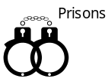
HF 2552, Section 5.6: Requires the DOC to provide a report concerning inmate hard labor, as defined in Section 904.701, Code of Iowa.

Status: The DOC provided the report that shows there were 204 inmates employed in private sector jobs in June 2001. This is a decrease of 25 positions (10.9%) compared to June 2000. The decrease is primarily due to having fewer employers involved.
During FY 2001, there was an average of 480 inmates employed in Iowa Prison Industries’ shops and private sector work. This is a decrease of 60 inmates (11.1%) compared to one year ago.
Prison Industries Iowa Prison Industries
HF 2552, Section 5.7: Specifies that the DOC shall continue farm operations at the same or greater level as existed on January 1, 2000. The DOC is prohibited from renting farmland that is not currently rented without Legislative approval. The DOC is to provide meaningful job opportunities for inmates employed on the prison farms.
Status: Iowa Prison Industries opened the Newton Farm in FY 2001. Options to increase farm operations’ solvency and inmate employment are being researched. This includes gardens, livestock management, building repairs, and grounds work. There were 76 inmates employed in farm operations during FY 2001. This is an increase of 50 inmates (192.3%) compared to FY 2000. Iowa Prison Industries intends to double farm production by FY 2003, thereby employing more inmates.
HF 2552, Section 8: Requires the Prison Industries Advisory Board and the DOC to continue to implement a plan for enhancement of vocational training opportunities within the institutions.
Status: The DOC offers various types of vocational training to inmates. Vocational training includes:
- “On the job training” overseen by staff. Examples include: community service work crews, and work performed within the institution, such as dietary, building repair, and laundry.
- Education programs provided by contracts with community college instructors. Examples include: computer/keyboarding skills, computer repair/support, graphics, data entry, office skills, and mechanics.
- Iowa Prison Industries provides private sector and production employment. Examples include: auto body repair, metal stamping and fabrication, graphic arts, telemarketing, welding, and printing.
HF 2552, Section 9: Encourages State agencies to purchase Iowa Prison Industries’ products whenever possible.
Status: Total sales were $9.7 million to State agencies during FY 2001. This is a decrease of $1.7 million (14.9%) compared to FY 2000. The decrease is primarily due to fewer discretionary purchases made by State agencies because of tight budget constraints.
Noncompliance NONCOMPLIANCE
HF 2552, Section 9.3: Requires State agencies to report FY 2000 purchases from Iowa Prison Industries to the LFB by January 15, 2001.
Status: Few agencies report their purchases to the LFB. However, Iowa Prison Industries monitors purchases from each agency.
STAFF CONTACT: Beth Lenstra (Ext. 16301)
Board of Parole – FY 2001 Legislative Intent Language
Board of Parole The LFB identified two sections of intent language in HF 2552 (Justice System Appropriations Act), passed by the General Assembly in 2000 for the Board of Parole. The Board complied with requirements to maintain an automated docket and automated risk assessment model and the requirement for a pilot program for probation violations. The Board is not in compliance with one section.
Legislative Intent
Noncompliance NONCOMPLIANCE
Statistical Research Statistical Research Analysts:
HF 2552, Section 13: Requires the Board to employ two statistical research analysts to assist with the application of the risk assessment model in the parole decision-making process.
Status: During FY 2001, one of these positions was filled while the other position was converted to a Clerk Specialist. Senate File 530 (Justice System Appropriations Subcommittee Act) does not contain this requirement for FY 2002.
STAFF CONTACT: Beth Lenstra (Ext. 16301)
Department of Justice - FY 2001 Legislative Intent Language
Dept. of Justice The LFB identified eight sections of intent language in HF 2552 (Justice System Appropriations Act), passed by the General Assembly in 2000 for the Department of Justice. The Department complied with all sections. Highlights include:
Legislative Intent

Compliance COMPLIANCE
Contingent Funds Contingent Funds
HF 2552, Section 1.3: Provides a contingent appropriation of $200,000 for enforcement of the Iowa Competition Law. The appropriation is contingent upon receipt of damages due to anti-trust lawsuits.

Status: The year-end balance of funds carry forward to the next fiscal year. The Department brought forward $224,000 from FY 2000 to FY 2001. During FY 2001, the Department received $62,200, while it spent $66,700 as a reimbursement to the Office of the Attorney General. The FY 2001 year-end balance of $219,000 carried forward to FY 2002.
HF 2552, Section 1.4: Provides a contingent appropriation of $225,000 for consumer education to combat consumer fraud. The appropriation is contingent upon the receipt of damages due to consumer fraud lawsuits.
Status: The year-end balance of funds carry forward to the next fiscal year. The Department brought forward $1.3 million from FY 2000 to FY 2001. During FY 2001, the Department received $120,000 and earned $77,400 in interest. The Department spent $225,000 as a reimbursement to the Office of the Attorney General. The FY 2001 year-end balance of $1.2 million carried forward to FY 2002.
Victim Assistance Victim Assistance Programs
HF 2552, Section 1.5(a): Requires grants to be awarded to care providers for domestic abuse, rape, and sexual assault victims.
Status: 65 contracts have been granted to care providers of these victims.
HF 2552, Section 1.7: Permits 20.0 FTE positions to be funded from the Victim Compensation Fund.
Status: 20.0 FTE positions were budgeted from the Victim Compensation Fund for FY 2001, while 19.5 FTE positions were utilized.
STAFF CONTACT: Beth Lenstra (Ext. 16301)
Department of Public Defense - Military Division FY 2001 Legislative Intent Language
Dept. of Public Defense The Legislative Fiscal Bureau has identified one section of intent language in HF 2552 (Justice Systems Appropriation Act), passed by the General Assembly in 2000 for the Department of Public Defense. The Department is in the process of complying with the intent language.
Legislative Intent

In Progress IN PROGRESS
HF 2552, Section 20.2: Allows the Military Division to incur a negative cash balance in its R31 appropriation of up to $500,000, as long as the Division has receipt invoices to cover the negative balance. The Military Division experienced its first negative balance on March 8, 2001. The Division was out of the negative until June 6, 2001.

Status: The Military Division is working with the Department of Revenue and Finance in complying with the Federal l Cash Management Improvement Act. By December 31, 2002, this process will be in place and the Military Division will be drawing federal funds in advance rather than as a reimbursement.
STAFF CONTACT: Jennifer Dean (Ext. 17846)
What’s New on the LFB Web Site?

Most LFB files are in pdf (Adobe Acrobat Reader).
FY 2003 Detail Analysis The LFB analysis of Governor’s budget recommendations for FY 2003 for each appropriation subcommittee is now available at: http://staffweb.legis.state.ia.us/lfb/docs/BudgAnalysis/BudgAnalysis.htm
Fiscal Update The January 28, 2002, version of the Fiscal Update, a weekly newsletter about state government finances, is available at: http://staffweb.legis.state.ia.us/lfb/fupdate/fupdate.htm
Revenue Memo The LFB Monthly Revenue Memo for January 2002 is complete; the document is available at: http://staffweb.legis.state.ia.us/lfb/mrmemo/mrmemo.html
Daily Receipts Use the LFB web site and call up the daily General Fund receipts. http://staffweb.legis.state.ia.us/lfb/receipts/daily.html
STAFF CONTACT: Nicole Navara (Ext. 16766)

This document can be found on the LFB web site:
http://staffweb.legis.state.ia.us/lfb/fupdate/fupdate.htm

