FISCAL UPDATE February 02, 1999
Legislative Fiscal Bureau (515) 281-5279 FAX 281-8451
***Governor’s Budget - Special Edition****

Governor’s General Fund Budget Recommendations
IN THIS ISSUE: | Governor’s General Fund Budget, pg. 1 | Justice System Subcommittee, pg. 19
 | Administration & Regulation Subcom., pg. 6 | Oversight & Communication Subcom., pg. 23
 | Agriculture & Natural Resources Sub., pg. 8 | Transportation, Infrastructure & Capitals
 | Economic Development Subcom., pg. 9 | Dept. of Transportation, pg. 24
 | Education Subcommittee, pg. 11 | Infrastructure, Recreation, Environ., pg. 25
 | Health & Human Rights Subcom., pg. 14 | Rebuild Iowa Distribution Account, pg. 29
 | Human Services Subcommittee, pg. 16 | Summary of Education Initiatives, pg. 31
FY 2000 Gov. Rec. The Governor's FY 2000 General Fund budget recommendation is $4.636 billion, an increase of $113.0 million (2.5%) compared to estimated FY 1999.

FY 2000

FY 1999
- The Governor is recommending $3.0 million in FY 1999 General Fund supplemental appropriations. This results in a FY 1999 projected ending General Fund balance of $330.6 million.
- The Cash Reserve Fund and the Economic Emergency Fund are at the maximum balance of 5.0% of the General Fund revenue estimate, or $221.9 million in each Fund. An excess of $410.5 million will be transferred from the Economic Emergency Fund to the General Fund in FY 1999.
FY 2000
- The Governor’s FY 2000 General Fund budget recommendation reduces receipts by a total of $59.5 million and increases spending by $113.0 million (2.5%), but the actual growth in expenditures is estimated to be in a range between 4.3% to 5.4%.
- The Governor is recommending creating the Rebuild Iowa Distribution Account (RIDA). Currently, gambling revenues in excess of $60.0 million are required by the Code of Iowa to be transferred to the Rebuild Iowa Infrastructure Fund (RIIF). The Governor’s proposal would transfer all gambling receipts to the RIDA. This would result in $60.0 million less in General Fund receipts.
- The Governor is recommending shifting $73.4 million of FY 1999 General Fund appropriations to the RIDA. The Governor’s recommended FY 2000 RIDA funding for these appropriations is $79.9 million. The appropriations to be transferred from the General Fund to the RIDA include:

 |  | FY 1999  General Fund Approp. |  | FY 2000  RIDA  Approp.
Education Local K-12 Technology |  | $30.0 million |  | $30.0 million
Regent Tuition Replacement |  | 27.9 million |  | 27.9 million
Natural Resources REAP |  | 9.0 million |  | 15.0 million
Agr. Soil Conservation Cost Share |  | 6.5 million |  | 7.0 million
Total |  | $73.4 million |  | $79.9 million

- If the recommended RIDA funded appropriations remained General Fund appropriations, the FY 2000 General Fund appropriation increase would be 4.3% over Estimated FY 1999.
- The Governor’s FY 2000 General Fund budget recommendation does not include funding for salary increases or annualization. Collective Bargaining negotiations are currently under way. The Department of Management estimates that each 1.0% increase in salaries for all FY 2000 State employees costs the General Fund $10.0 million. If the cost of salary increases is the same as FY 1999 costs, there will be an additional 1.1% growth in appropriations for a total expenditure growth estimate of 5.4%.
- The Governor’s projected ending balance for FY 2000 is $268.0 million compared to $330.6 for FY 1999, a decrease of $62.4 million. The Governor’s recommendation projects that the Cash Reserve Fund and the Economic Emergency Fund be at the maximum balance of 5.0% of the General Fund revenue estimate, or $228.9 million in each Fund. The recommendation projects that an excess of $316.7 million will be transferred from the Economic Emergency Fund to the General Fund in FY 2000, a decrease of $93.8 million compared to the FY 1999 transfer.

Major Increases/Decreases Table 1 lists the General Fund increases and decreases of $2.0 million or more recommended by the Governor for FY 2000.

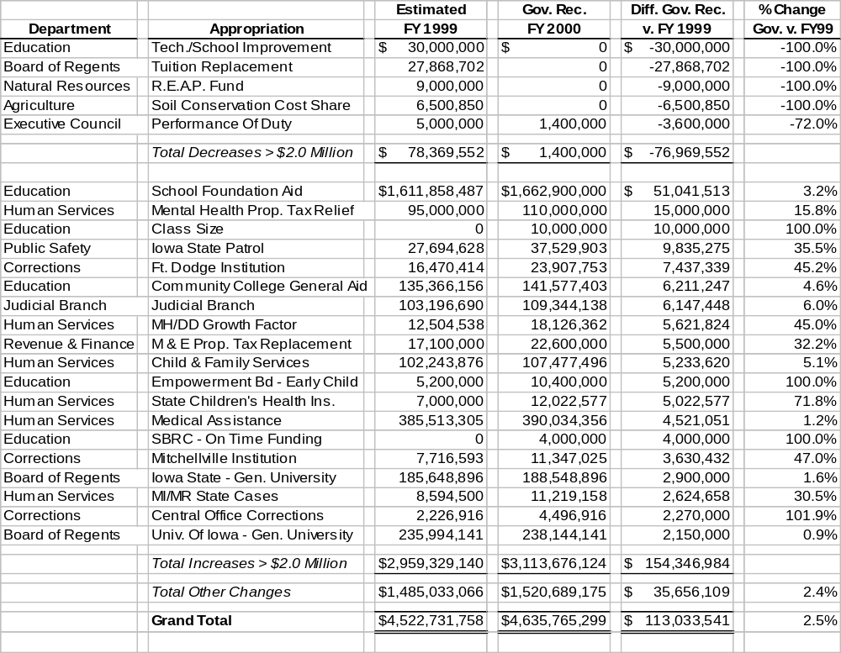Table 1
Governor’s Major General Fund Decreases/Increases Recommendations

Approp. by Subcommittee The Governor’s FY 2000 General Fund recommendations are listed in Table 2 by Appropriations Subcommittee. Details of the recommendations are included in the FY 2000 Budgets and Subcommittee Issues Section of this document and a tracking document of all the Governor’s appropriations recommendations is in Appendix A.


Table 2
Governor’s FY 2000 General Fund Recommendations
(Dollars in Millions)
Subcommittee |  | Est.  FY 1999 |  | Gov.  Rec.  FY 2000 |  | FY 2000  vs.  FY 1999 |  | %  Change
Administration & Regulation |  | $ 89.2 |  | $ 89.9 |  | $ 0.7 |  | 0.8%
Agriculture & Natural Resources |  | 51.0 |  | 37.5 |  | -13.5 |  | -26.5%
Economic Development |  | 41.6 |  | 42.8 |  | 1.2 |  | 2.7%
Education |  | 896.7 |  | 910.0 |  | 13.3 |  | 1.5%
Health & Human Rights |  | 90.3 |  | 94.4 |  | 4.1 |  | 4.6%
Human Services |  | 743.4 |  | 767.2 |  | 23.8 |  | 3.2%
Justice System |  | 428.1 |  | 470.5 |  | 42.4 |  | 9.9%
Trans., Infrastructure, &  Capitals |  | 4.0 |  | 4.3 |  | 0.3 |  | 7.6%
Oversight & Communications |  | 23.6 |  | 23.6 |  | 0.0 |  | 0.0%
Unassigned Standings |  | 2,154.8 |  | 2,195.4 |  | 40.6 |  | 1.9%
TOTAL |  | $ 4,522.7 |  | $ 4,635.8 |  | $ 113.0 |  | 2.5%

Note: The dollar amounts may not add due to rounding.
FY 1999 Supplemental Rec. The Governor’s FY 1999 General Fund supplemental recommendations are listed in Table 3.
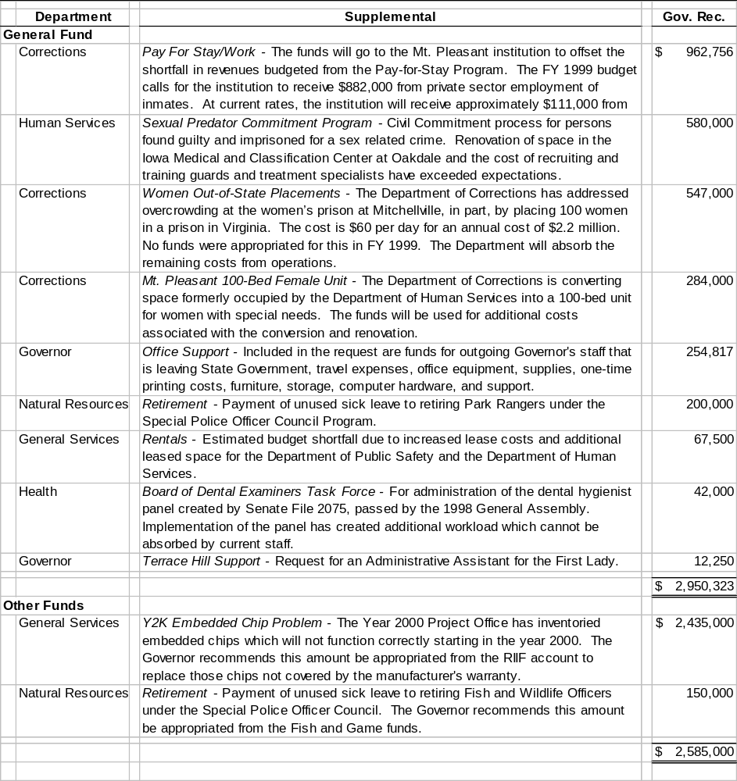

Table 3
STAFF CONTACT: Dennis Prouty (Ext. 13509)
Governor’s FY 2000 Recommendations - Administration and Regulation Appropriations Subcommittee
Admin./Regulation Sub. The Governor is recommending $89.8 million from the General Fund and 1,928.5 FTE positions, an increase of $1.7 million (1.9%) and an increase of 32.3 (1.7%) FTE positions compared to estimated FY 1999. This does not include $1.0 million that remains unallocated from the FY 1999 Salary Adjustment Fund. Unless otherwise indicated, all increases or decreases are compared to estimated FY 1999.
Significant Changes Significant General Fund Changes Recommended:
Auditor of State Office of the Auditor of State
- An increase of $75,000 for audit costs at the two new prisons.
- An increase of $20,000 for increased costs of supplies and materials.
Dept. of Commerce Department of Commerce
- A decrease of $71,000 and 1.0 FTE position to transfer an Administrative Law Judge position to the Department of Inspections and Appeals to implement the Administrative Procedures Act.

- A decrease of $31,000 for funding of the Real Estate Audit Program. The Governor is recommending that the Program be funded by the Local Housing Assistance Fund through the Iowa Department of Economic Development.
Ethics/Campaign Disc. Ethics and Campaign Disclosure - A decrease of $2,000 due to a one-time funding in FY 1999 for a computer.
General Services Department of General Services
- An increase of $193,000 for rental costs due to added rental space and increased lease costs.
- An increase of $51,000 for maintenance costs and support of a volunteer coordinator to promote Terrace Hill as an historic site and to manage volunteers.
- An increase of $49,000 and 1.0 FTE position for an Administrative Assistant for the First Lady.
- An increase of $38,000 and 1.0 FTE position for an Accounting Technician position to process the increasing number of claims and provide routine reports required for decision making.
- An increase of $29,000 and 1.0 FTE position for a Maintenance Worker position for Terrace Hill.
- A decrease of $120,000 to shift two design and construction FTE positions from the General Fund to the Rebuild Iowa Infrastructure Fund (RIIF).
- A decrease of $47,000 to cease cleaning of Capitol Complex Cafeterias.
- A decrease of $32,000 to cease off hours carpet cleaning.
Governor Office of the Governor - An increase of $91,000 to add funds for support costs for the Governor’s Office.
Inspections & Appeals Department of Inspections and Appeals
- 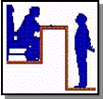An increase of $143,000 and 2.0 FTE positions to transfer two Administrative Law Judge positions from the Department of Revenue and Finance to the Appeals and Fair Hearings Division of the Department of Inspections and Appeals to implement the Administrative Procedures Act. The Department of Revenue and Finance is requesting a decrease of $138,000 due to the transfer of the 2.0 FTE positions.
- An increase of $100,000 and 1.0 FTE position to survey non-Joint Commission on Accreditation of Health Care Organizations and the American Osteopathic Association accredited hospitals more than the current once every seven to 10 years.
- An increase of $85,000 and 1.0 FTE position for staff and support to regulate the new excursion gambling boat licensed to operate in Osceola.
- An increase of $71,000 and 1.0 FTE position to transfer an Administrative Law Judge position from the Insurance Commission to the Appeals and Fair Hearings Division of the Department of Inspections and Appeals to implement the Administrative Procedures Act.
- An increase of $59,000 to allow the continuance of health care industry construction inspection activities funded by Lottery money in FY 1999.
Management Department of Management - An increase of $250,000 to fund the State Strategic Plan.
Personnel Department of Personnel
- An increase of $644,000 for increased medical costs and increased claims paid from the Workers’ Compensation and Insurance Fund.

Retirement

- An increase of $125,000 to support the Deferred Compensation Program funded by Lottery money in FY 1999.
- An increase of 18.8 FTE positions for the Iowa Public Retirement System (IPERS) funded by IPERS money to handle the increased demand associated with members’ services and for the examination, design, and reprogramming of the technology application system.
Revenue & Finance Department of Revenue and Finance - A decrease of $138,000 and 2.0 FTE positions to transfer two Administrative Law Judge positions to the Department of Inspections and Appeals to implement the Administrative Procedures Act. The Department of Inspections and Appeals is requesting an increase of $143,000 to fund the 2.0 FTE positions.
Secretary of State Office of the Secretary of State
- An increase of $40,000 for costs associated with the biennial printing of the Iowa Official Register.
- An increase of $23,000 for a Voter Education Program for all Iowa counties.
Treasurer Treasurer of State - An increase of $57,000 for new carpet and drapes for the Treasurer’s office.
STAFF CONTACT: Shawn Snyder (Ext. 16765) Ron Robinson (Ext. 16256)
Governor’s FY 2000 Budget Recommendations - Agriculture and Natural Resources Appropriations Subcommittee
Agriculture & Land Steward. The Governor is recommending $19.4 million from the General Fund and 446.28 FTE positions for FY 2000 for the Department of Agriculture and Land Stewardship. This is a total decrease of $5.9 million (23.3%) and an increase of 10.2 (2.3%) FTE positions compared to estimated FY 1999. The Governor is recommending changing the source of the Soil Conservation Cost Share funding from the General Fund to the Recreation, Environment, and Cultural Fund. This results in a $6.5 million decrease from the General Fund compared to FY 1999. Other changes include:
- An increase of $372,000 and 8.1 FTE positions for the Administrative Division.
- An increase of $124,000 and 1.5 FTE positions for the Regulatory Division.
- A decrease of $22,000 and 2.1 FTE positions for the Laboratory Division.
- An increase of $110,000 and 1.7 FTE positions for the Soil Conservation Division, including:
- An increase of $125,000 and 2.0 FTE positions to establish the Iowa Watershed Protection Program to accelerate watershed protection efforts to provide flood control, water quality protection, and reduce soil erosion. The Department has requested $1,515,000 for this package and the Governor is recommending the balance to be funded through the Recreation, Environment, and Cultural Fund.
- An increase of $500,000 for the Soil Conservation Cost Share Program from the Recreation, Environment, and Cultural Fund.
Natural Resources The Governor is recommending $18.2 million from the General Fund and 1,018.12 FTE positions for FY 2000 for the Department of Natural Resources. This is a decrease of $7.6 million (29.4%) and an increase of 2.00 (0.2%) FTE positions compared to estimated FY 1999. Some of the changes include:
- A decrease of $104,000 and no change in FTE positions in the Administrative Services Division. This is for a reduction in the base budget.
- An increase of $200,000 for payment of unused sick leave to retiring Park Rangers under the Special Police Council Program.
- A decrease of $177,000 in the Parks and Preserves Division as a reduction in the base budget.
- A decrease of $69,000 in the Forestry Division as a reduction in the base budget,
- An increase of $50,000 and 1.0 FTE position in the Forestry Division for the restoration of a Service Forestry Division in southwest Iowa.
- A decrease of $19,000 and an increase of 1.00 FTE position in the Forestry Division.
- An increase of $1.4 million and 1.00 FTE position in the Environmental Protection Division, including:
- An increase of $1.0 million for the Federal Air Quality Grant Program. This Program had been previously funded with Air Emission Fees and funds from the Hazardous Waste Remedial Fund.
- An increase of $422,000 for increased regulation of animal feeding operations. This includes a review of manure management plans, permit issuance, compliance inspectors, and licensing of manure applicators.
- A decrease of $9.0 million for the Resource Enhancement and Protection Fund (REAP). Funding for REAP will be transferred to the Recreation, Environment, and Cultural Fund and increased to $15.0 million.
STAFF CONTACT: Sherry Weikum (Ext. 17846) Deb Kozel (Ext. 16787)
Governor’s FY 2000 Recommendations - Economic Development Appropriations Subcommittee
Economic Development The Governor is recommending $42.8 million from the General Fund and 1,328.4 FTE positions for the three departments of the Economic Development Appropriations Subcommittee. This is an increase of $1.1 million (2.8%) and 22.3 (1.7%) FTE positions compared to estimated FY 1999. Included in the figures are $7.6 million and 74.3 FTE positions for seven Board of Regents programs traditionally funded through the Economic Development Appropriations Subcommittee.
Significant Changes Significant General Fund Changes Recommended:
Dept. of Econ. Develop. Department of Economic Development (DED) - An increase of $780,000 (3.1%) and 2.7 FTE positions (1.5%) compared to estimated FY 1999. The recommended change includes:
- An increase of $50,000 to provide support funding for an Agricultural Biotechnology liaison position to work with world class companies to stay abreast of trends and developments in biotechnology. The recommendation does not include an FTE position.
- An increase of $100,000 for expansion of the Human Resource Recruitment Initiative and to develop cooperative programs with local air service providers.

- An increase of $95,000 and 1.0 FTE position to promote domestic value-added and organic food production.
- An increase of $80,000 and 2.0 FTE positions to maintain DED’s electronic commerce and procurement efforts at current levels.
- An increase of $100,000 to sustain and expand the IowAccess Business License Information Center.
- An increase of $60,000 to administer the Housing Enterprise Zone legislation enacted by the 1998 General Assembly.
- An increase of $250,000 to provide funding for a new grant program for communities to develop plans and mechanisms to guide growth.
- An increase of $35,000 to cover increased City Development Board staff travel and support expenditures.
- An increase of $350,000 to provide increased funding for the Iowa Manufacturing Technology Center.
- An increase of $160,000 to offset declining loan repayments to the Iowa Community Development Loan and Rural Community 2000 Funds.
- An increase of $500,000 to provide funding for a new School-to-Career Work Program enacted by the 1998 General Assembly.
- A decrease of $1.0 million for the Community Economic Betterment Account component of the Strategic Investment Fund.
Workforce Development Department of Workforce Development - An increase of $365,000 (4.5%) and 19.8 (1.9%) FTE positions compared to estimated FY 1999. The recommended change includes:
- An increase of $235,000 and 4.0 FTE positions for the elevator and boiler safety programs.
- An increase of $130,000 and 5.0 FTE positions for additional Iowa Occupational Safety and Health enforcement. The General Fund dollars would be matched by federal funds.
- An increase of 8.0 FTE positions to service local regions as account executives assisting employers with numerous activities. These positions would be funded through the Unemployment Administration Contribution Surtax appropriation.
Other Funds Significant Other Fund Changes Recommended
DED – Other Funds In addition to the General Fund, the Governor’s recommendations for the Department of Economic Development include funding from several other State funds. Significant recommendations include:
- $8.8 million from the DED’s Workforce Development Fund, an increase of $2.0 million compared to estimated FY 1999. The increase would be used to expand program activity.
- $5.0 million for the Physical Infrastructure Program from the Rebuild Iowa Infrastructure Fund, which is no change from the estimated FY 1999 level.

- $1.0 million from the Rebuild Iowa Infrastructure Fund for housing programs.
- $10.0 million from the Rebuild Iowa Infrastructure Fund to be used to fund a new Community Attractions Grant Program.
Workforce Dev./Other Funds In addition to the General Fund, the Governor’s recommendations for the Department of Workforce Development include funding from several other State funds. Significant recommendations include:
- $100,000 from the Rebuild Iowa Infrastructure Fund to design a filing system to allow employers to file Unemployment Compensation claims electronically.

- $500,000 from the Rebuild Iowa Infrastructure Fund and 2.5 FTE positions to expand the computer system that provides direct access to information about community resources.
- $7.5 million from the Unemployment Administration Contribution Surcharge Fund, an increase of $400,000 (5.6%) compared to estimated FY 1999. The funds would be used to expand service to local regions.
STAFF CONTACT: Jeff Robinson (Ext. 14614)
Governor’s FY 2000 Recommendations - Education Appropriations Subcommittee
Education Subcom. The Governor is recommending $910.0 million for operations from the General Fund and 17,357.4 FTE positions for the four departments of the Education Appropriations Subcommittee. This is an increase of $13.4 million (1.5%) and 47.8 FTE positions (0.3%) compared to estimated FY 1999. This figure does not include the Unassigned Standings, the Infrastructure Fund, the Technology Fund, or salary allocation.
Significant Changes Significant General Fund Changes Requested:
College Student Aid College Student Aid Commission
- An increase of $166,000 for the National Guard Tuition Aid Program to increase the number of recipients from 975 to 1,169.
- An increase of $3.2 million for the Tuition Grant Program to increase the maximum grant from $3,650 to $4,000 and the average grant from $3,032 to $3,285 for approximately 14,585 recipients.
- An increase of $238,000 for the Vocational-Technical Tuition Grant Program to increase the maximum grant from $600 to $650, increase the average grant from $395 to $428, and increase the number of recipients receiving the average grant from 5,681 to 5,800.

- An increase of $250,000 to establish a new forgivable loan program for teacher preparation students who agree to teach in Iowa in subjects defined as shortage areas. This recommendation also incorporates the $90,000 that was appropriated in FY 1999 for an Industrial Technology Forgivable Loan Program. As a result, net new funding for FY 2000 is $160,000.
- An increase of $1.7 million to establish a new Worker Retaining Forgivable Loan Program.
- A decrease of $90,000 to eliminate separate funding for the Industrial Technology Forgivable Loan Program. Funds for this Program have been incorporated in the forgivable loan program for teacher shortage areas discussed above.
Cultural Affairs Department of Cultural Affairs
- Iowa Arts Council - An increase of $100,000, including:
- An increase of $50,000 for the Access to the Arts Grant Program.

- An increase of $50,000 for the Operational Support Grant Program.
- State Historical Society - An increase of $25,000 to annualize funding for an archivist that was added in FY 1999 to process State records, including papers from the Branstad administration.
Dept. of Education Department of Education
- Board of Educational Examiners - An increase of $600,000 for a two-year study to assess performance of teacher education graduates.
- State Library - An increase of $210,000, including:
- An increase of $100,000 for one-time funding to develop and customize census materials and promote the importance of Census 2000.

- An increase of $50,000 to cover the higher costs of library materials.
- An increase of $60,000 for the Open Access Program, which reimburses local libraries on a transaction basis for allowing patrons from other libraries to use their facilities. This would increase funding to 84.0% of the projected need for FY 2000 as estimated by the State Library.
- Regional Libraries - An increase of $100,000 to increase regional library staff salaries. Regional library staff are not State employees. They do not participate in collective bargaining and are not included in salary adjustment legislation.
- Local Libraries - $1.0 million for the Enrich Iowa Libraries initiative to provide funding for direct grants to local libraries to help libraries enhance current technology and provide higher levels of service.
- Iowa Public Television - An increase of $375,000, including:

- An increase of $180,000 to maintain the current level of service of children’s and educational programming.
- An increase of $195,000 to begin the transition to digital television broadcasting.
- New Initiatives – An increase of $15.0 million for new programs, including:
- $10.0 million to reduce class size from kindergarten through third grade for elementary schools.
- $4.0 million to the School Budget Review Committee (SBRC) to assist school districts on an individual basis with on-time funding due to increased enrollments.
- $750,000 for work keys assessments to be given to high school freshmen for testing in the areas of reading for information, applied math, listening, and writing. Students would be retested as seniors to determine progress.
- $100,000 to expand the Starbase Leadership Conference for adolescent students. The Department of Education would allocate the money to the National Guard for students to participate in leadership camps during the summer.
- $125,000 to improve teacher standards through participation in a State collaborative assessment and in the Interstate New Teacher Assessment and Support Consortium.
- Administration – An increase of $28,000 for support and maintenance of the Department’s teacher license imaging system.
- Vocational Rehabilitation – An increase of $100,000 to increase the State share of funding to fully match federal funds.
- Education Improvement – $6.1 million for increases in programs or initiatives that were implemented in FY 1999 as part of SF 2366 (Education Reform Appropriations Act). These increases include:
- $250,000 for practitioner improvement to implement Beginning Teacher Induction Programs in school districts. In FY 1999, $300,000 was appropriated to the Department to establish and implement a voluntary practitioner performance improvement program.
- $600,000 to increase funding for national certification stipends. In FY 1999, $250,000 was provided to the Department to pay $10,000 annual stipends to each teacher that achieves national certification and fund half the cost ($1,000) of obtaining national certification.
- $5.2 million to increase funding for Empowerment Boards. The increase would provide services to approximately 1,400 three-and four-year old children. In FY 1999, $5.2 million was provided for this new initiative in SF 2366 (Education Reform Appropriations Act).
- Community Colleges – An increase of $6.2 million (4.6%) compared to estimated FY 1999 for general aid to community colleges.
Board of Regents Board of Regents
- University of Iowa - An increase of $3.2 million. The change includes:
- An increase of $450,000 for inflation.

- An increase of $300,000 for building repair on existing buildings. The institution has a FY 1999 budget of $8.0 million for building repair.
- An increase of $200,000 for opening the Biology Building scheduled for January 2000.
- An increase of $600,000 for salaries, equipment, and supplies associated with undergraduate education.
- An increase of $100,000 for technology-based teaching.
- An increase of $100,000 for salaries, supplies, and equipment associated with biosciences.
- An increase of $100,000 for salaries, supplies, and equipment associated with arts and humanities.
- An increase of $300,000 to attract natural science faculty by improving and upgrading laboratory facilities and equipment.
- An increase of $1.0 million for a new initiative to establish an accredited School of Public Health.

- Iowa State University - An increase of $3.0 million. The change includes:
- An increase of $200,000 for salaries and supplies associated with undergraduate education.
- An increase of $200,000 for student financial aid associated with research and graduate education.
- An increase of $2.0 million to establish a center for excellence in fundamental plant sciences.
- An increase of $300,000 to improve teacher preparation programs.
- An increase of $300,000 to continue expansion of the Extension 21 Program.

- University of Northern Iowa - An increase of $3.0 million. The change includes:
- An increase of $100,000 for inflation related to supplies, building repair, equipment, and library costs.
- An increase of $140,000 to open the Performing Arts Center scheduled for January 2000.

- An increase of $60,000 for building repair. The institution has a FY 1999 budget of $2.3 million for building repair.
- An increase of $100,000 for salaries and equipment associated with undergraduate education.
- An increase of $300,000 for salaries and supplies associated with teacher education.
- An increase of $300,000 to add a program for graduate study in the field of social work.
- Iowa School for the Deaf - An increase of $260,000. The change includes:
- An increase of $30,000 for inflation related to supplies, building repair, equipment, and library costs.
- An increase of $60,000 for building repair. The School has a FY 1999 budget of $302,000 for building repair.
- An increase of $65,000 for vocational education.
- An increase of $105,000 for additional faculty.
- Iowa Braille and Sight Saving School - An increase of $90,000. The change includes:
- An increase of $15,000 for inflation related to supplies, building repair, equipment, and library costs.
- An increase of $20,000 for building repair. The School has a FY 1999 budget of $110,000 for building repair.
- An increase of $55,000 for focus of services, including year-round school and support for students in local schools.
STAFF CONTACT: Paige Piper/Bach (Ext. 17942) Mary Shipman (Ext. 14617)
Governor’s Recommendations - Health and Human Rights appropriations subcommittee
Health/Human Rights The Governor is recommending $94.4 million for operations from the General Fund and 1,364.3 FTE positions for the seven departments of the Health and Human Rights Appropriations Subcommittee. This is an increase of $4.2 million (4.6%) and an increase of 3.6 (0.3%) FTE positions compared to estimated FY 1999. Unless otherwise indicated, all increases or decreases are compared to FY 1999. Significant general fund changes include:
Dept. for the Blind Department for the Blind - An increase of $125,000 and 2.0 FTE positions to provide additional in-home assessments and training in daily living activities and for the development of community support systems for blind Iowans.
Elder Affairs Department of Elder Affairs
- An increase of $60,000 and 1.0 FTE for an ombudsman.


- An increase of $80,000 for Alzheimer’s support.
- An increase of $60,000 for the Retired Senior Volunteer Program.
GASA Governor’s Alliance on Substance Abuse (GASA) – A decrease of $471,000 and 10.0 FTE positions to transfer funding and responsibilities to the Department of Public Safety.

Public Health Department of Public Health
- Addictive Disorders – An increase of $1.5 million for treatment of methamphetamine users.
- 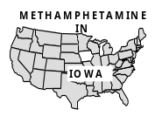Child and Adolescent Wellness
- A decrease of $150,000 to reduce funding for the Physician Care for Children Program due to Healthy and Well Kids In Iowa (HAWK-I) Program coverage.
- An increase of $50,000 to improve access to dental care for low income children.
- Community Capacity
- An increase of $250,000 for core public health functions of local boards of health.
- An increase of $50,000 and 1.0 FTE position for the volunteer health care provider program.
- Infectious Diseases – An increase of $100,000 and 1.0 FTE position to expand surveillance and investigation of infectious diseases.
- Public Protection
- An increase of $79,000 and 1.0 FTE position to assist local boards of health in developing environmental health programs.
- An increase of $361,000 for relocation expenses and $444,000 for lease and maintenance expenses due to the demolition of Executive Hills (Boards of Dental, Medical, Nursing, and Pharmacy Examiners).
- An increase of $58,000 and 1.0 FTE position for administration of the Impaired Practitioner Program (Boards of Dental and Medical Examiners).
- Medical Examiner

- An increase of $357,000 and 4.0 FTE positions to transfer the Medical Examiner from the Department of Public Safety to the Department of Public Health.
- An increase of $175,000 and 1.0 FTE position for a Deputy Medical Examiner.
Human Rights Department of Human Rights
- Persons with Disabilities - An increase of $71,000 and 1.0 FTE position for a disability consultant.
- Status of Women - An increase of $76,000 for programs servicing displaced homemakers.
- Status of Southeast Asians - An increase of $60,000 for the creation of the Division on the Status of Southeast Asians.
Veterans Affairs Commission on Veterans Affairs
-  Iowa Veterans Home
- An increase of $55,000 for the annual cost adjustment for contracted housekeeping services.
- An increase of $736,000 for a negotiated adjustment and an inflation adjustment for contracted dietary services.
- Commission on Veterans Affairs
- An increase of $12,000 for a new copy machine.
- An increase of $10,000 for contracted computer systems support.
- An increase of $10,000 for training provided for County Commissions of Veterans Affairs. Restores funding to FY 1997 level.
STAFF CONTACT: Jennifer Dean (Ext. 14613) Valerie Thacker (Ext. 15270)
Governor’s FY 2000 Budget Recommendations - department of Human Services
Human Services The Governor is recommending $767.2 million from the General Fund and 5,611.0 FTE positions, an increase of $23.8 million (3.2%) and 64.4 FTE positions (1.2%) compared to estimated FY 1999. Following are the significant changes recommended:
Medical Services Medical Services – An increase of $10.8 million (2.6%). This includes:
- An increase of $4.5 million for Medical Assistance, including:
- An increase of $2.2 million due to a decrease in federal financial participation.
- An increase of $26.3 million to adjust provider reimbursement levels.
- A decrease of $28.4 million to apply Iowa’s share of the tobacco settlement to offset State Medical Assistance costs.
- An increase of $1.8 million to expand medical assistance to additional children.
- A decrease of $1.7 million due to changes in the number of Medical Assistance eligibles and utilization.
- An increase of $1.5 million to transfer funding for 41 group care beds from the Children and Family Services budget unit.
- An increase of $600,000 to modify the nursing home reimbursement methodology by increasing payment for direct care staff and reducing non-direct care cost reimbursements to the 65th percentile.
- An increase of $454,000 due to the federal cost-of-living adjustment for the Supplemental Security Income subsidy being lower than anticipated.
- A decrease of $350,000 to expand prior authorization for prescription medications.
- An increase of $338,000 for Medical Contracts, increasing contract expenditures.
- An increase of $964,000 for the State Supplementary Assistance Program to meet federal maintenance of effort requirements.
- An increase of $5.0 million to expand eligibility to 200.0% of the federal poverty level for the Children’s Health Insurance Program.
Adults, Children, Families Serving Adults, Children, and Families – An increase of $4.2 million (3.3%). This includes:
- A decrease of $3.7 million for child care services, transferring the Protective Child Care program to the Children and Family Services budget unit.

- An increase of $63,000 for the Iowa Juvenile Home in Toledo for inflation and increasing psychologist time.
- An increase of $364,000 for the State Training School in Eldora for inflation, treatment, and opening building costs.
- An increase of $10.7 million for Children and Family Services, including:
- A increase of $3.3 million, a transfer of the Court-Ordered Services for Juveniles budget unit to the Children and Family Services budget unit.
- An increase of $3.7 million, a transfer of the Protective Child Care program from the Child Care Services budget unit.
- A decrease of $1.5 million, a transfer of group care beds to the Medical Assistance budget unit.
- An increase of $2.3 million for an increased subsidized adoption caseload.
- A decrease of $135,000 for foster family shelter care.
- An increase of $107,000 for increased child abuse assessments.
- An increase of $42,000 for expansion of family foster home insurance coverage.
- An increase of $85,000 for the child protective assessment project.
- An increase of $27,000 for additional Attorney General services for termination of parental rights proceedings.
- An increase of $287,000 to serve additional children through subsidized guardianships.
- An increase of $107,000 for increased child abuse assessments.
- An increase of $395,000 to serve additional children through adoption.
- An increase of $2.0 million to increase School-Based Supervision.
- An increase of $3.3 million to increase rehabilitative treatment and supportive (RTS) services provider rates.
- A decrease of $2.7 million due to increases in average costs per case and federal financial participation.
- A decrease of $483,000 due to expected additional revenues from child support recovery efforts.
- A decrease of $3.3 million for Court-Ordered Services for Juveniles, transferring the budget unit to the Child and Family Services budget unit.
- An increase of $10,000 for Family Support Subsidies.
Economic Assistance Economic Assistance – An increase of $610,000 (1.5%). This includes:
- An increase of $3.3 million for the Family Investment and Promise Jobs Programs, including:

- An increase of $250,000 to continue redesigning financial assistance services.
- An increase of $3.2 million to replace federal child support recovery incentives previously transferred to the Family Investment Program with General Fund moneys.
- A decrease of $179,000 to delay Statewide expansion of the Electronic Benefits Transfer Program.
- A decrease of $120,000 for the Promise Jobs Program.
- An increase of $120,000 for Food Stamp Employment Training.
- An increase of $100,000 for evaluation services.
- No change in the Emergency Assistance Program.
- A decrease of $2.7 million in the Child Support Recovery Unit, including:

- A decrease of $3.2 million to replace General Fund moneys with federal child support recovery incentive funds.
- An increase of $347,000 for a State Disbursement Unit.
MI/MR/DD/BI Persons with Mental Illness/Mental Retardation/Developmental Disabilities/Brain Injuries – An increase of $9.1 million (10.3%). This includes:
- An increase of $16,000 for the Mental Health Institute at Independence for changes in federal financial participation.
- A decrease of $368,000 for the Glenwood State Hospital-School, including:
- A decrease of $586,000 due to an increase in receipts.
- An increase of $218,000 due to decreased federal matching rates.
- A decrease of $484,000 for the Woodward State Hospital-School, including:
- A decrease of $549,000 due to an increase in receipts.
- An increase of $65,000 due to decreased federal matching rates.
- A decrease of $53,000 for Developmental Disabilities Special Needs Grants, and transferring the Program to the Personal Assistance budget unit.
- An increase of $2.6 million for the State Cases Program.
- An increase of $53,000 for the Personal Assistance Program, transferring the Developmental Disabilities Special Needs Grant budget unit.
- An increase of $5.6 million for the Mental Health Property Tax Growth for FY 2000. The Governor recommends an increase of 1.57% for FY 2001, which is an increase of $3.6 million.
- An increase of $1.7 million for the Sexual Predator Commitment Program, which includes:
- A decrease of $269,000 for costs related to the Attorney General.
- An increase of $2.0 million for the Program.
- Managing and Delivering Services – A decrease of $952,000 (1.4%). This includes:
- A decrease of $479,000 for General Administration, including a decrease of $395,000 to move program specific positions and expenditures to the Family Investment Program budget unit.
- A decrease of $473,000 for Field Operations, for a vacancy factor.
- Other recommendations from the Governor are:
- An increase of $15.0 million for the Property Tax Relief Fund, in Section 426B.1 of the Code of Iowa.
- Computer equipment for the Mental Health Institutes at Clarinda, Independence, and Mt. Pleasant from the Technology Assurance Fund.
- Capitals funding for the Training School at Eldora from the Rebuild Iowa Infrastructure Fund.
- Funding for the Child Support Recovery Unit technology initiative from the Technology Assurance Fund.
- Funding for welfare reform system changes within the Economic Assistance Division from the Technology Assurance Fund.
STAFF CONTACT: Deb Anderson (Ext. 16764) Sue Lerdal (Ext. 17794)
Governor’s Recommendations - Justice System Appropriations Subcommittee
Justice System The Governor is recommending $470.5 million from the General Fund and 7,957.8 FTE positions for the eight departments of the Justice System Appropriations Subcommittee. This is an increase of $42.4 million (9.9%) and 433.5 (5.8%) FTE positions compared to estimated FY 1999. The significant changes include:
Dept. of Justice Department of Justice
- An increase of $389,000 to conduct the legal proceedings under the Sexually Violent Predator Act, which took effect July 1, 1998, and to transfer funding from the Department of Human Services that is currently used for this purpose.

- An increase of $350,000 for State assistance to the Legal Services Corporation for legal representation in civil cases for eligible individuals in poverty.
- An increase of $200,000 and 3.0 FTE positions to increase the Criminal Appeals Division by three Assistant Attorneys General.
- An increase of $176,000 to increase funding for domestic abuse, rape, and sexual assault grants by 10.0%.
Dept. of Corrections Department of Corrections
- Institutions - An increase of $15.8 million and 173.1 FTE positions. The major changes include:
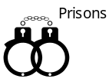
- An increase of $11.0 million and 132.8 FTE positions for prison expansions at the Mitchellville and Ft. Dodge institutions.
- An increase of $2.1 million and 6.9 FTE positions to support the growing inmate population.
- An increase of $451,000 and 11.0 FTE positions for programming for reintegration of inmates in long-term administrative segregation.
- An increase of $972,000 and 6.7 FTE positions for increased inmate medical treatment costs and for the costs of AIDS medications.
- An increase of $449,000 and 4.0 FTE positions for computer technology upgrades. The Governor is recommending $615,000 for computer upgrades be funded from the Technology Assurance Fund.
- A decrease of $43,000 in funding from the General Fund and an increase of 11.0 FTE positions for the Sex Offender Hormonal Intervention Program. The Program will be housed at the Mt. Pleasant institution and has a recommended budget of $457,000 from the General Fund and new funding of $65,000 in other revenues.
- An increase of $375,000 and 9.5 FTE positions to replace expiring federal funding for substance abuse programs at the Clarinda and Anamosa institutions.
- Central Office – An increase of $2.2 million and 3.0 FTE positions compared to estimated FY 1999. The major changes include:
- An increase of $2.2 million to house women inmates out-of-state.
- An increase of $332,000 to provide inmate education at the expanded facilities.
- An increase of $104,000 and 2.0 FTE positions for additional training officers at the Mt. Pleasant Training Center.
- An increase of $80,000 and 1.0 FTE position to coordinate the Department’s victim programs across the State.
- A decrease of $500,000 to transfer funding for the Sex Offender Hormonal Intervention Program to the Mt. Pleasant Institution.
- Community-Based Corrections – An increase of $5.4 million and 136.3 FTE positions compared to estimated FY 1999. The major changes include:
- An increase of $1.9 million and 51.0 FTE positions for additional Probation/Parole Officers to supervise medium- and high-risk offenders.
- An increase of $2.0 million and 64.4 FTE positions for additional staffing at the residential facilities.
- An increase of $793,000 and 16.4 FTE positions for the Sex Offender Hormonal Intervention Program.
- An increase of $502,000 and 4.0 FTE positions for computer technology upgrades. The Governor is recommending $333,000 for computer upgrades be funded from the Technology Assurance Fund.
- An increase of $246,000 and 3.3 FTE positions to replace expiring federal funding for Youthful Offender Programs in the First and Fourth Districts and for the Sex Offender Treatment Program and the Youth Intervention Program in the Fifth District.
- An increase of $100,000 to replicate the District VI Youth Leadership Model in District V.
Judicial Branch Judicial Branch
- An increase of $740,000 and 11.0 FTE positions to fund HF 2471 (Appellate Court Judges Act) passed by the 1998 General Assembly, which increased the number of Court of Appeals Judges from six to nine. This increase includes funding for the three judges and staff.
- An increase of $2.0 million and 31.5 FTE positions to fund six additional District Court Judges, four District Associate Judges, and additional court reporters, court attendants, law clerks, and a case coordinator.
- An increase of $2.3 million and 18.0 FTE positions for seven employees currently paid from the Enhanced Court Collections Fund, and eleven personal computer specialists paid from the Court Technology Fund, plus operating expenses for the Iowa Court Information System (ICIS).
- An increase of $289,000 and 6.0 FTE positions for three Iowa Court Information System (ICIS) trainers, two personal computer specialists, and a project accountant to the court technology staff.

- An increase of $100,000 for education and training of non-judicial employees.
- An increase of $484,000 to renovate or remodel areas of courthouses where the county has provided additional space.
- An increase of $242,000 and 10.2 FTE positions to increase clerical support in Juvenile Court and expand the Court Appointed Special Advocate (CASA) Program.
- An increase of $210,000 for the Juvenile Victim Restitution Fund to cover increases in program costs.
- An increase of $259,000 to fund the Judicial Retirement System.
Law Enforcement Acad. Iowa Law Enforcement Academy
- An increase of $80,000 and 1.5 FTE positions for telecommunicator training and related administrative functions.
- A decrease of $80,000 to eliminate State funding for the Drug Abuse Resistance Education Program (D.A.R.E.).
Public Defense Department of Public Defense
- An increase of $152,000 for the Military Division to support air bases at Des Moines and Sioux City that have been expanded by federal expenditures. The funding serves as State match to receive $2.1 million in federal funds.
- An increase of $271,000 for the Emergency Management Division due to a change in the Federal Emergency Management Agency’s (FEMA) match requirements. Beginning in Federal Fiscal Year 2000, a 50.0% State match will be required for some grants that previously had not required a state match.

Public Safety Department of Public Safety
- Governor’s Alliance on Substance Abuse (GASA) – An increase of $471,000 and 13.0 FTE positions to transfer the agency to a Division within the Department of Public Safety. There is no change in funding compared to estimated FY 1999.
- Iowa State Patrol - An increase of $9.2 million due to a shift in funding sources. Funding for the Highway Patrol is being transferred from the Motor Vehicle Use Tax to the General Fund over a four-year period beginning in FY 1997, as required by SF 481 (Transportation and Capitals Appropriations Act of 1995). The Act appropriated $9.0 million from the General Fund for FY 1997 and increased the appropriation annually over the next three years, through FY 2000.
- An increase of $186,000 to fund 12.0 FTE positions for troopers currently funded with the federal Community Oriented Policing (COPS) Grant which expires in FY 2000.
- An increase of $440,000 and 5.0 FTE positions for the methamphetamine lab response team.
- Division of Criminal Investigation
- An increase of $81,000 and 2.0 FTE positions for criminalists to reduce the turnaround time on drug analysis cases to meet speedy trial guidelines.
- An increase of $42,000 and 1.0 FTE position for a criminalist on the methamphetamine lab response team.
- Division of Narcotics Enforcement
- An increase of $506,000 and 6.0 FTE positions for agents to combat the growing methamphetamine problem. 
- An increase of $421,000 and 6.0 FTE positions for agents on the methamphetamine lab response team.
- Fire Marshal
- An increase of $24,000 to update the Iowa Building Code to comply with provisions of the Americans with Disabilities Act. 
- An increase of $78,000 and 1.0 FTE position for a Fire Marshal Special Agent for the methamphetamine response team.
- Automated Fingerprint Information System (AFIS) – An increase of $24,000 for maintenance of the Automated Fingerprint Information System.
Inspections/Appeals Department of Inspections and Appeals
- Indigent Defense – A decrease of $511,000. This decrease takes into account a $5.00 per hour attorney fee increase. The FY 1999 appropriation included funding for a proposed increase in attorney fees as well as a proposed plan to pay all juvenile indigent defense claims up front rather than reimbursing the counties afterward. This proposal did not pass the General Assembly.
- Public Defender - An increase of $389,000 and 2.0 FTE positions to handle civil commitment hearings of sex offenders who are likely to repeat crimes if released from prison.
STAFF CONTACT: Dwayne Ferguson (Ext. 16561) Christina Schaefer (Ext. 16301)
Governor’s FY 2000 Budget Recommendations - agencies under the Legislative Oversight Committee
Oversight & Commun. Sub. The Governor is recommending $23.6 million from the General Fund and 269.0 FTE positions for the three entities of the Oversight and Communications Appropriations Subcommittee. This is an increase of $43,000 (0.2%) and 2.0 (0.7%) FTE positions compared to estimated FY 1999. During the 1998 Legislative Session, all General Fund appropriations requested by the Iowa Telecommunications and Technology Commission were appropriated to other departments for payment of costs related to the Iowa Communications Network (ICN). However, as the Commission is again making the requests rather than the other departments for video subsidization and debt service, this analysis compares changes from estimated FY 1999 as if they had been appropriated to the Commission.
Significant Changes Significant General Fund Changes Recommended:
- Iowa Telecommunications and Technology Commission - An increase of $43,000 (0.3%) and 2.0 (2.0%) FTE positions compared to estimated FY 1999. The Commission is the governing entity of the ICN. For FY 1999, the General Assembly appropriated $16.6 million from the General Fund for video subsidization and operations ($3.8 million to the Department of Education) and debt service ($12.8 million to the Treasurer of State). In FY 2000, the majority of the Commission’s operating revenues will come from an enterprise fund using ICN revenues generated from fees collected for voice, data, video, and other services. The change includes:
- An increase of 2.0 FTE positions for operating computer support systems, software design, development, implementation, integration and maintenance.
- A decrease of $36,000 from video subsidization, as the ICN is covering the cost of 2.0 FTE positions transferred from Iowa Public Television to handle scheduling on the network through receipts.

- An increase of $79,000 for network debt service due to decreased interest on investments. These funds are appropriated to the Treasurer of State and used for payment of debt service when the ICN notifies the Treasurer that payment is due.
- The Governor is recommending a status quo General Fund appropriation for both the Information Technology Services Division of the Department of General Services and for the ICN-related activities of Iowa Public Television and the Regional Technology Councils.
STAFF CONTACT: Douglas Wulf (Ext. 13250) Glen Dickinson (Ext. 14616)
Governor’s FY 2000 Budget Recommendations - Department of Transportation
Dept. of Transportation The Governor is recommending $257.7 million and 3,904.5 FTE positions for the Department of Transportation (DOT) for FY 2000. This is an increase of $8.2 million (3.3%) and 33.5 FTE positions (0.9%) compared to estimated FY 1999. Of this amount, $4.3 million is being requested from the General Fund, an increase of $302,000 (7.6%) and $253.7 million from other funds, an increase of $7.9 million (3.2%).
General Fund Changes Significant General Fund Changes Recommended:
- An increase of $302,000 for the Railroad Assistance and Rail Economic Development Programs to fund the programs at the level of projected rail-related loan repayments.
Other Fund Changes Significant Other Fund Changes Recommended - The following changes include requests from the Primary Road Fund and Road Use Tax Fund:
- An increase of $508,000 to upgrade the central processing unit at the DOT. Of this, $233,000 is a one-time cost and $275,000 is the annual increase for the software licenses.

Driver’s License
- An increase of $102,000 and 2.0 FTE positions for data processing personnel to assist with the implementation of HF 2424 (County Driver’s License Act).
- An increase of $495,000 for the installation and operation of higher capacity telecommunication lines to connect field offices to the DOT’s Local Area Network.
- An increase of $445,000 for final implementation of the Electronic Records Management System.
- An increase of $112,000 and 2.0 FTE positions for producing electronic maps and data, conducting additional environmental analyses; and providing salary increases for hourly, non-permanent employees.
- An increase of $186,000 for the increased cost of salt used in snow removal.
- An increase of $150,000 for costs associated with work zone safety.
- An increase of $250,000 for increased costs associated with making the International Registration Plan System compliant with the Year 2000 date change.

Year 2000
- An increase of $500,000 to redesign and modernize the driver’s license master record file. This project will require an additional $500,000 in FY 2001.
- An increase of $313,000 and 5.0 FTE positions for additional uniformed officers to handle increased federal vehicle safety inspection requirements, enforcement needs due to growth in commercial vehicle traffic, and for conducting training and safety seminars for the motor truck industry.
- An increase of $200,000 for the automation of the motor carrier registration and fuel tax reporting requirements for electronic commerce.
- An increase of $1.1 million and 17.5 FTE positions for salary and support costs associated with implementing requirements in the federal Transportation Equity Act for the 21st Century (TEA-21).
- An increase of $420,000 and 6.0 FTE positions for salary and support costs associated with implementing the Department’s “Can-Do Process,” which is designed to expedite highway construction projects.
- An increase of $2.0 million to the Materials and Equipment Replacement Revolving Fund for the inflationary cost associated with replacing equipment.
- An increase of $493,000 for additional costs associated with the driver’s license photo imaging equipment lease. The increase is due to the transfer of driver’s license issuance functions to 42 county treasurers’ offices in FY 2000.
STAFF CONTACT: David Reynolds (Ext. 16934)
Governor’s FY 2000 Recommendations - Infrastructure, Recreation, Environmental, and Cultural Projects
RIDA For FY 2000, the Governor is recommending the establishment of a Rebuild Iowa Distribution Account (RIDA). The Account will incorporate a mechanism to specifically fund technology, recreation, environmental, and cultural projects in addition to infrastructure-related projects.
FY 2000 Recomm. The Governor is recommending a total of $235.2 million for infrastructure, technology, recreation, environment, and cultural projects from six funding sources for FY 2000. Of this, $62.8 million was appropriated in prior legislative sessions and $172.4 million are new recommendations. The following table shows the total funds being recommended by source.

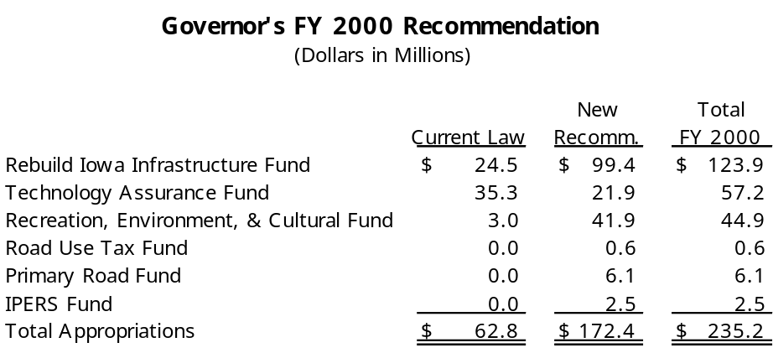

Recommendations Significant Rebuild Iowa Infrastructure Fund Recommendations:
Corrections Department of Corrections
- $3.8 million for the addition of 120 beds at the Iowa Medical and Classification Center in Oakdale. This project will also require $2.5 million in FY 2001.
- $2.0 million for infrastructure improvements to community-based correction facilities.
Econ. Development Department of Economic Development - $5.0 million for continued funding for the Physical Infrastructure Financial Assistance Program. The Program provides financial assistance for business or community infrastructure development or redevelopment projects that result in the creation of quality, high-wage jobs, and involve substantial capital investment.
Education Department of Education - $10.0 million for a school infrastructure assistance program entitled the “Rebuild Iowa Schools Fund.” The funds will be used to buy down the interest on loans and bonds issued by school districts for the purpose of making improvements to school facilities. The Governor is recommending increasing the funding for this program by $10.0 million annually over the next five years.
General Services Department of General Services
- $8.8 million for major maintenance improvements to State facilities. Of this, $800,000 will be appropriated for improvements to facilities on the Capitol Complex.

- $4.4 million for continued interior restoration of the State Capitol Building.
- $5.9 million for continued renovation of the Old Historical Building.
- $4.0 million for continued renovation of the Lucas Building.
- $1.1 million for renovation of the tunnel that connects the Lucas Building with the State Capitol Building.
- $1.7 million for moving and relocation expenses associated with the relocation of State employees on the Capitol Complex.
- $1.5 million to replace electrical and water distribution systems at the Eldora Training School.
Judicial Branch Judicial Branch - $10.0 million for the construction of a new judicial building located on the Capitol Complex. This project will require an additional $10.0 million in FY 2001 to complete the construction.
Board of Regents Board of Regents
- $1.3 million for major maintenance to Regents institution facilities.
- $3.2 million for construction of a 35,000 square foot recreation complex at the Iowa School for the Deaf.
- $27.9 million for tuition replacement which reimburses student fees used to pay the debt service on Academic Revenue Bonds. In prior years, tuition replacement has been funded from the General Fund.
State Fair Authority State Fair Authority
- $3.0 million for the partial cost of reconstruction of the Varied Industries Building at the Iowa State Fairgrounds.
- $1.1 million for infrastructure improvements to county fairs.
Technology Assurance Fund Significant Technology Assurance Fund Recommendations:
Education Department of Education
- $30.0 million for funding of school technology for K-12 school districts. Current law, which sunsets in FY 2001, appropriates $30.0 million annually for school technology enhancements from the General Fund. The Governor is recommending removing the sunset and continuing the $30.0 million annual appropriation from the Technology Assurance Fund.

- $5.0 million for Iowa Public Television to continue the conversion of eight television transmitter sites from analog to digital technology and to provide initial pass-through capability at the headquarters. The Governor is also recommending $8.2 million in FY 2001 for the conversion. The transmitter conversion project is estimated to cost a total of $30.2 million. The Federal Communications Commission requires the conversion to a digital signal to be completed by FY 2003.
- $1.5 million for the replacement and upgrade of computer automation equipment and software at the Division of Vocational Rehabilitation Services.
Management Department of Management - $2.0 million to assist cities and counties in the development of local technology infrastructure. The Governor is recommending funding for this program be increased to $10.0 million in FY 2001.
Telecommunication Comm. Iowa Telecommunications and Technology Commission - $2.7 million to pay the on-going costs of maintenance and leases for the Network.
Recreation/Environment Significant Recreation, Environment, and Cultural Fund Recommendations:
- Department of Agriculture
- $7.0 million for the Soil Conservation Cost Share Program. In prior years, this Program has been funded from the General Fund. In FY 1999, this Program was funded from the General Fund at $6.5 million.
- $1.0 million for the Loess Hills Development and Conservation Fund, which is used to stabilize stream beds for the purpose of protecting roads, bridges, and utility infrastructure in the Loess Hills region.
- $1.4 million for the establishment of a watershed protection program to help prevent pollution of Iowa’s water resources.
- Department of Cultural Affairs - $1.5 million for continuation of the Historical Preservation Grant Program. The Program is used to fund the restoration, preservation, and development of historical sites.
- Department of Economic Development - $10.0 million for the establishment of a Community Attraction and Tourism Program to provide financial incentives for cultural and recreation projects in local communities.
- Department of Natural Resources
- $15.0 million for the Resource Enhancement and Protection (REAP) Fund. In prior years, the REAP Program has been funded from the General Fund. The Governor is recommending $20.0 million in funding for the REAP Program in FY 2001.
- $2.3 million for boating access and lake restoration projects that meet Marine Fuel Tax funding requirements. The Governor is recommending that Marine Fuel Tax receipts be deposited into the newly recommended Rebuild Iowa Infrastructure Fund.

- $1.0 million to establish a surface and groundwater quality monitoring system for the State. The funds will be used to regularly monitor Iowa’s lakes, reservoirs, and wetlands.
- Department of Transportation - $2.0 million for continued funding of the Recreational Trails Program.
Primary Road Fund Significant Primary Road Fund Recommendations:
Department of Transportation
- $2.5 million for costs associated with construction of field maintenance facilities.
- $400,000 for the installation of waste water treatment systems at field maintenance facility locations to be determined by the DOT. The Department was appropriated $300,000 in FY 1999.
- $625,000 for the construction of salt storage facilities throughout the State. The Department was appropriated $500,000 in FY 1999.

- $300,000 for the replacement of roofs on field maintenance facility locations to be determined by the DOT. The Department was appropriated $300,000 in FY 1999.
- $400,000 for the replacement of roofs on buildings located on the DOT’s Ames Complex.
- $300,000 to construct an addition to the regional materials testing laboratory in Cedar Rapids.
- $1.4 million for Phase II of the DOT Administration Building rehabilitation. The Department was appropriated $1.3 million in FY 1999 for Phase I.
- $200,000 for continued improvements to DOT facilities throughout the State for compliance with Americans with Disabilities Act (ADA) requirements. This is the same level of funding the DOT received in FY 1999.
IPERS Fund Significant IPERS Fund Recommendations:
Department of Personnel - $2.5 million from the Iowa Public Employees Retirement (IPERS) Fund for the purchase or construction of an IPERS headquarters to replace the existing leased facility. The Department was appropriated $4.0 million from the IPERS Fund in FY 1999 for the acquisition and remodeling of an IPERS headquarters building. The Department was not able to acquire an existing facility and is now proposing to use the $4.0 million in addition to the $2.5 million to construct a new facility.
STAFF CONTACT: David Reynolds (Ext. 16934)
Governor’s Recommendation for Establishment of a Rebuild Iowa Distribution Account
RIDA The Governor is recommending the establishment of a Rebuild Iowa Distribution Account (RIDA), which will collect the resources necessary to fund infrastructure, technology, environmental, recreational, and cultural projects. Included in the Governor’s recommendation, all gambling revenues will be deposited into the Distribution Account (current law allocates the first $60.0 million to the General Fund), as well as the interest earnings from the Cash Reserve and Economic Emergency Funds. In addition, the Governor is recommending the transfer of $5.0 million annually from the Underground Petroleum Storage Tank Fund into the Distribution Account. The current fund balance in the Rebuild Iowa Infrastructure Fund will also be transferred to the Rebuild Iowa Distribution Account.
Three Funds The Governor is recommending appropriations from the Distribution Account to three separate funds from which appropriations would be made for individual projects. Included in the recommendation are minimum appropriation amounts for each fund to be established by the Code of Iowa. The funds and minimum appropriations are listed below:
- Rebuild Iowa Infrastructure Fund: $100.0 million
- Technology Assurance Fund: $50.0 million
- Recreation, Environment, and Cultural Fund: $40.0 million
The following table shows the Governor’s estimated revenues for the Rebuild Iowa Distribution Account for FY 2000 and FY 2001 and the recommended appropriations for each of the three funds.
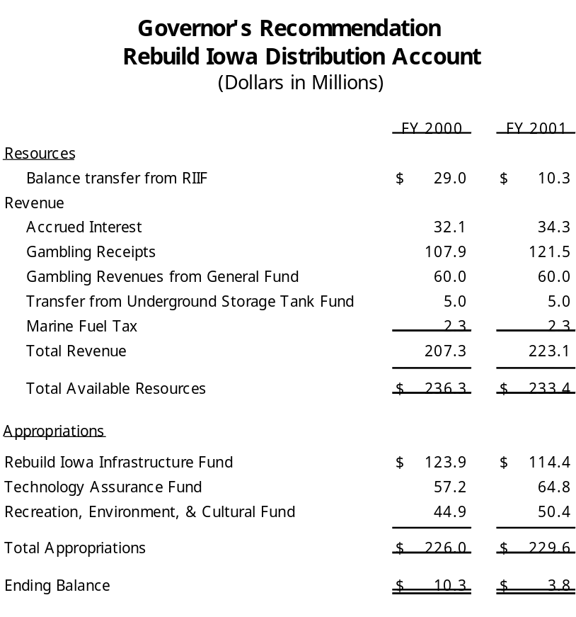
STAFF CONTACT: David Reynolds (Ext. 16934)
Governor’s FY 2000 Recommendations - Summary of Education initiatives
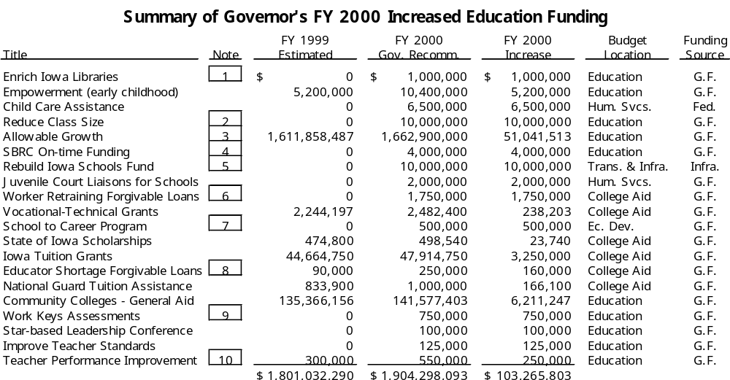
1 |  | Governor proposes an increase of $1.0 million each year for three years until
 |  | total funding equals $3.0 million.
2 |  | Governor proposes an increase of $10.0 million each year for five years until
 |  | total funding from the State General Fund equals $50.0 million. Under this proposal, the State funding would be supplemented by federal funding of $10.0 million for total Program funding of $60.0 million in FY 2004.
3 |  | Governor's proposal includes an increase of $6.1 million for FY 2000 for budget
 |  | guarantee. Governor proposes a growth rate of 4.0% for FY 2001 with an estimated increased cost of $60.6 million.
4 |  | Governor proposes an appropriation to the School Budget Review Committee
 |  | (SBRC) to assist schools on an individual basis with funding due to increased enrollments.
5 |  | Governor proposes an interest buy down program from State gambling revenues
 |  | to assist school districts with infrastructure needs. The funding would increase $10.0 million each year for five years for total State funding of $50.0 million in FY 2004. The funding in FY 2000 would be supplemented by $10.0 million of federal funds for total funding of $20.0 million in FY 2000.
6 |  | Eligibility for the forgivable loan program would be determined by a proposed
 |  | Iowa Skills Forecasting Council to be chaired by the Lt. Governor. Loans would be for skilled worker shortage areas with preference given to low income workers.
7 |  | The School to Career Program was established as a standing appropriation during
 |  | the 1998 Legislative Session with funding for the Program to begin in FY 2000.
8 |  | The General Assembly appropriated $90,000 for an Industrial Technology
 |  | Forgivable Loan Program for teachers for FY 1999. The Governor's recommendation incorporates that funding with new funds of $160,000 to address the shortage of teachers in specific subject areas.
9 |  | Work keys assessments to be given to high school freshmen. Students would
 |  | be retested as seniors to determine progress. Areas to be tested include reading for information, applied math, listening, and writing.
10 |  | Increased funding for FY 2000 is to be used for teacher induction programs.
Technology Funding
School Technology In addition to the initiatives listed above, the Governor is recommending that the cap on the funding for school technology be eliminated. Currently, the Department of Education is receiving an appropriation of $30.0 million per year for a four-year period to distribute to schools on a per pupil basis for technology needs. This funding is set to expire on June 30, 2001. Under the Governor’s recommendation, the $30.0 million funding would become a permanent standing appropriation.
STAFF CONTACTS: Mike Lipsman (Ext. 17799) Paige Piper/Bach (Ext. 14613) Mary Shipman (Ext. 14617)

