**Department of Human Rights**

**Division of Persons with Disabilities**

**Annual Performance Plan Report**

**September 2007**

**Table of Contents**

**Introduction…………………………………………Page 3**

**Agency Overview…………………………………..Pages 4 - 7**

**Resource Allocations……………………………..Page 8**

**Key Results…………………………………………Pages 9 - 16**

**Agency Performance Plan Results……………..Pages 17 - 18**

**Commission of Persons with Disabilities……..Page 19**

**Local Committees…………………………………Page 20**

**Because We Acted……………………………….Page 21**

**Photos………………………………………………Page 22**

**Agency Contact Information… ………………..Page 23**

**Introduction**

I am pleased to present the Division of Persons with Disabilities, Iowa Department of Human Rights, Performance Report for fiscal year 2007 (July 1, 2006 – June 30, 2007). This report is published in accordance with the Accountable Government Act to improve decision-making and increase accountability to stakeholders and citizens.

This report contains performance information regarding our primary programs including, the Youth Leadership Forum, the College Leadership Forum, the State Access Grant and the Client Assistance Program.

Major accomplishment this year included the following: continuation of our core programs, collaborating with the Iowa Department of Public Health to conduct on-site access reviews in substance abuse/mental health treatment facilities across Iowa, serving as a key player in establishing new areas of refuge, signage and other issues related to preparedness and emergency evacuation for persons with disabilities in the State Capitol, co-planning/facilitating the Homeland Security Conference to include persons with disabilities and other marginalized groups, and last but not least, continuing to hear from our constituents that we are the only service provider who has called them back with the information they have needed and has also “really cared”.

**Agency Overview**

**Vision:**

All Iowans with disabilities are able to access employment matching their abilities, interests and economic needs.

**Mission:**

The Division and or Commission of Persons with Disabilities will promote the employment of Iowans with Disabilities and reduce barriers to employment by providing information, referral, assessment and guidance, training, and negotiation services to employers and citizens with disabilities.

Core Functions:

* Advocacy
* Community Coordination and Development

Key Services, Products and/or Activities:

Employment - Training, Information and Referral for Persons with Disabilities

Our main charge, mandated by the Iowa Code, is to promote the employment of persons with disabilities. We offer individualized consultation as well as training regarding employment issues for employers and persons with disabilities. Increasingly important is providing accurate referrals for persons with disabilities for resources outside of the scope of employment. Some of these referrals include transportation, housing, education, recreation and healthcare.

**Youth Leadership Forum**

In partnership with the Iowa Department for the Blind and Iowa Vocational Rehabilitation Services, we sponsor a leadership training program for students with disabilities. Approximately 30 juniors and seniors with disabilities are selected each year, diverse in their type of disability, gender, ethnicity and geographical location. This forum prepares high school students with disabilities for post-secondary education and employment.

College Leadership Forum

In partnership with the Iowa Department for the Blind and the Iowa Vocational Rehabilitation Services, sponsor a leadership training program for college students with disabilities. This forum prepares college students with disabilities for employment.

Client Assistance Program

This federal program is mandated by the Rehabilitation Act and must operate independently of other agencies providing rehabilitation and independent living service. Services include information and referral, advice, interpretation of laws, regulations and policies, administrative review of decisions, assistance at fair hearings or legal procedures, and negotiation between clients and service providers such as the following:

* Iowa Department for the Blind
* Iowa Vocational Rehabilitation Services
* Independent Living Centers
* Community Rehabilitation Facilities where the above agencies purchase services
* Other vendors that sell services to the agencies listed above

Iowa Access Grant

In partnership with Deaf Services Commission and the Iowa Department for the Blind, this program serves to increase access to goods and services in State government for persons with disabilities.

Iowa Department of Public Health Collaboration/Access Surveys

We enhanced our online building access survey making it easier for agencies to submit them for our review. During this past fiscal year, we reviewed 26 state leased spaces, and conducted one on-site review.

Homeland Security/Emergency Preparedness

The Administrator continued to serve as the Department of Human Rights Point of Contact for Homeland Security.This year we worked collaboratively with members of Homeland Security/Emergency Management, the Department of Human Services, and the American Red Cross to develop the Special Needs Annex in the State of Iowa Emergency Response Plan.

Evacuation Chair Training

Division staff continued to provide training regarding the use of the Emergency Evacuation Chairs for persons with disabilities throughout the State Capitol Complex. Participants included legislators, security guards, and complex staff.

Agency Customers and Stakeholders:

We not only have customers or stakeholders that reside in Iowa, but those who request our assistance from other states as well. Categorically, our primary customers or stakeholders are as follows:

* Persons with Disabilities
* Friends and Family Members of Persons with Disabilities
* Small and Large Employers
* State agencies including other divisions within Human Rights
* City, County and Local Governments
* The Governor, Lt. Governor and Iowa Legislators
* Architects and Contractors
* Concerned Citizens

Collaborations:

* Animal Rescue League of Iowa
* Polk County Conservation
* Drake University
* Wells Fargo
* Iowa Diversity Conference
* Des Moines Area Community College Human Services Advisory Committee
* Parent Educator Connection
* Social Security Administration
* ASK Resource Center
* Food Bank of Iowa
* Toys for Tots
* State Rehabilitation Council
* Self Advocacy and Leadership for Youth
* My Transitions Iowa
* Medicaid for Employed People with Disabilities
* Iowa Rehabilitation Association
* Iowa Department of Cultural Affairs
* Iowa Workforce Development
* Iowa Department of Public Health
* Iowa Secretary of State
* Iowa Finance Authority
* Iowa Department of Transportation
* Iowa Department of Human Services
* Iowa Department of Civil Rights
* Iowa Department of Corrections
* Iowa Department of Inspections and Appeals
* Iowa Communications Network
* Iowa Department of Economic Development
* Homeland Security/Emergency Management
* Iowa Department of Administrative Services - General Services
* Iowa Department for the Blind
* Iowa Vocational Rehabilitation Services
* The Governance Group, the Support Team and the Employers Disability Resource Network (EDRN)

Delivery Mechanism to Provide Services and Products to Customers:

We deliver our services and products via our website, electronic mail, traditional mail, telephone, fax, or in person. We provide individualized consultation, training and referral services pertaining to many disability issues.

Organizational Structure including Commission:

The Division of Persons with Disabilities is one of eight divisions within the Department of Human Rights. The Administrator reports to the Governor and the Commission provides policy direction. The governor also appoints 24 Commissioners who serve a two-year term and are required by statute to meet quarterly. Commissioners may be reappointed to serve additional terms. The Administrator supervises the staff. The Department Director coordinates and supervises the Human Rights Administrative Council, comprised of the Division Administrators.

Number of Staff:

Our staff consists of a full time Division Administrator and three disability consultants. The Administrator is appointed by the Governor, is confirmed by the Senate and serves at will.

Location:

The Division of Persons with Disabilities, in the Iowa Department of Human Rights, is located on the Second Floor of the Lucas State Office Building in Des Moines, Iowa.

Resource Allocations

Budget:

Our budget for fiscal year 2006-2007 consisted of $212,714 state appropriated dollars as well as an additional $ 89,253 of federal match revenues. The Client Assistance Program received $114,583 of federal funds requiring no state match; the division also received

$2,059 and $ 1,338 from the Department of Public Health and the Division of Vocational Rehabilitation Services, respectively. These, too, were federal funds requiring no state match. Total state and federal funds of $419,947 were received by the Division of Persons with Disabilities.

KEY RESULTS

## CORE FUNCTION

**Name:** Youth with disabilities are trained to be successful employees.

**Description:** Percentage of Youth LeadershipForum graduates with disabilities employed or preparing for employment.

**Why we are doing this**: Governor Vilsack has set a goal of doubling the number of Iowans with post secondary education. The goal is important to Iowa’s economic development with regard to the availability of trained people for high-skilled, high-wage jobs, and also to improve the earning power of Iowans with disabilities. Studies show that the more education that a person has acquired, the higher their earnings.

**What we're doing to achieve results:** As a result of participation in the

YLF and CLF forums, Iowa youth with disabilities are prepared for employment.

|  |  |  |  |  |  |  |  |  |  |  |  |  |
| --- | --- | --- | --- | --- | --- | --- | --- | --- | --- | --- | --- | --- |
| ***Results***   |  |  |  | | --- | --- | --- | | ***Performance Measure****:* Percentage of Youth Leadership Forum graduates with disabilities that are employed or preparing for employment  ***Outcome Target***  *85%:* | | **Percentage of YLF Graduates Employed or**  **Preparing for Employment**  Employed or  Preparing for  Employment  85%  Other  15% | | **What was achieved:** 85% of the students graduating from YLF are employed or are preparing for employment. | | | | **Data Sources:** Survey results from Youth Leadership Forum graduates of 2006 | | | | **Resources:** .43 FTE - 43% YLF 07 funds | | | |

KEY RESULTS

## CORE FUNCTION

**Name:** Iowans are offered information and referral on employment, quality healthcare (including access to mental health care and substance abuse treatment), independent living, education, housing, transportation, service animals and recreation opportunities.

**Description:** Percentage of customers satisfied with information received

**Why we are doing this**: Governor Vilsack has set a goal of increasing by 50,000 the number of employed workers with college experience. Iowans with disabilities receive appropriate training for employment through rehabilitation agencies and other services. Therefore it is important that appropriate services are identified to assist Iowans with disabilities to become employed.

**What we’re doing to achieve results:** Resources are identified and provided through training programs, individualized consultation, and website information to assist employers and employees to obtain and retain employment and needed support services.

|  |  |  |  |  |  |  |  |  |  |  |  |  |
| --- | --- | --- | --- | --- | --- | --- | --- | --- | --- | --- | --- | --- |
| ***Results***   |  |  |  | | --- | --- | --- | | ***Performance Measure****:* Percentage of customers satisfied with information received  ***Outcome Target***  *90%* | |  | | **What was achieved:** 98% of customers are satisfied with services they receive staff. | | | | **Data Sources:** Division of Persons with Disabilities Database | | | | **Resources:** Percentage of state appropriated 07 funds for two staff and Administrator  along with Client Assistance Program federal 07 funding. | | | |

KEY RESULTS

## CORE FUNCTION

**Name:** Iowans with disabilities receive quality vocational rehabilitation services

**Description:** Percentage of Client Assistance Program (CAP) recipients finding resolution without legal action.

**Why we are doing this**: Governor Vilsack has set a goal of increasing by 50,000 the number of employed workers with college experience. Iowans with disabilities receive appropriate training for employment through rehabilitation agencies. Therefore it is important that appropriate services are provided and identified concerns are negotiated to assist Iowans with disabilities to become successfully employed.

**What we're doing to achieve results:**

All individuals have the right to file complaints or immediately participate in an impartial hearing. CAP is required to assist applicants and clients through advisory, negotiation, administrative review, and median processes if assistance is requested by an eligible individual. Only after those avenues are considered does CAP move toward appeal with a hearing officer and then toward litigation. Resolution at a lower level saves tax dollars.

|  |  |  |  |  |  |  |  |  |  |  |  |  |
| --- | --- | --- | --- | --- | --- | --- | --- | --- | --- | --- | --- | --- |
| *Results*   |  |  |  | | --- | --- | --- | | ***Performance Measure****:* Percentage of Client Assistance Program clients finding resolution without legal action  ***Outcome Target***  *90%* | | **100%** | | **What was achieved:** Litigation costs were minimized, problems were resolved, and services were provided through advisory, negotiation, administrative review, and mediation services  from CAP. These services result in employment for Iowans with disabilities. | | | | **Data Sources:** Data calculated annually by staff of the Division of Persons with Disabilities  and audited by the Rehabilitation Services Administration. All records are counted. No exceptions have been noted in audits. | | | | **Resources:** 1.8 FTE - 100% Client Assistance Program 07 federal funding | | | |

KEY RESULT

## SERVICES/ PRODUCTS/ ACTIVITIES

**Name:** Facilitate the Youth Leadership Forum and College Leadership Forum

**Description:** Percentage of students rating YLF and CLF as good, very good and excellent.

**Why we are doing this:** Governor Vilsack has set a goal of doubling the number of Iowans with post secondary education. The goal is important to Iowa’s economic development in regard to the availability of trained people for high-skilled, high-wage jobs, and also to improve the earning power of Iowans with disabilities. Studies show that the more education a person has acquired, the higher their earnings.

**What we're doing to achieve results:** By participating in these forums, Iowa youth with disabilities are prepared for employment.

|  |  |
| --- | --- |
| ***Results*** |  |



***Performance Measure:***

Percentage of Students rating YLF and CLF as good, very good or excellent. 100%

***Performance Target:***

95%



**What was achieved:** Students are satisfied with our services and we exceeded our performance target.

**Data Sources:** Results of student satisfaction surveys and closing session from YLF and CLF.

**Resource:** .43 FTE YLF and .43 FTE CLF 07 funding

KEY RESULT

## SERVICES/ PRODUCTS/ ACTIVITIES

**Name:** Advocate for applicants or clients to receive appropriate services from the rehabilitation agencies

**Description:** Percentage of customers resolving disputes through advocacy, mediation and negotiation.

**Why we are doing this:** Governor Vilsack has set a goal of increasing by 50,000 the number of employed workers with college experience. Iowans with disabilities receive appropriate training for employment through rehabilitation agencies. Therefore it is important that appropriate services are provided and disputes are resolved to allow those services to continue.

**What we're doing to achieve results:** Provide negotiation between agencies or employers and eligible clients for the Client Assistance Program. Investigate and respond to reported inequities in rehabilitation systems and make recommendations.

|  |  |  |  |
| --- | --- | --- | --- |
| ***Results***   |  |  |  | | --- | --- | --- | | ***Performance Measure****:*  Percentage of customers resolving disputes through advocacy, mediation, and negotiation.  ***Performance Target****:*  90% | **100%** |  | |

**What was achieved:** No legal action was required to assist individuals in receiving appropriate services.

**Data Source:** Annual reports of agencies funded under the Rehabilitation Act and audited by Rehabilitation Services Administration.

**Resource:** 1.8 FTE – CAP 07 federal fundingKEY RESULT

## SERVICES/ PRODUCTS/ ACTIVITIES

**Name:** Educate Iowans with disabilities on rights and responsibilities

**Description:** Percentage of customers rating the service as good or very good

**Why we are doing this:** Governor Vilsack has set a goal of increasing by 50,000 the number of employed workers with college experience. Many Iowans with disabilities want to work but do not know resources, rights, and responsibilities relative to training and employment.

**What we're doing to achieve results:** Provide information on employment , housing, emergency preparedness, service animals, mental health, access to goods and service, and substance abuse issues, giving information on rights and responsibilities under the Americans with Disabilities Act, the Rehabilitation Act, Family Medical Leave Act, Federal Housing, Help America Vote Act and the Civil Rights Act. Research, attend training, and collaborate with partners to stay current on disability issues

|  |  |  |
| --- | --- | --- |
| ***Results***   |  |  | | --- | --- | | ***Performance Measure****:*  Percentage of customers rating the service as good or very good.  ***Performance Target****:*  90% |  | |

What was achieved: Customer satisfaction surpassed expectations of staff. Customers were satisfied with our services.

Data Source: Persons with Disabilities database.

Resource: Percentage of all staff and administrator – state 07, CAP 07, 50E7

KEY RESULT

## SERVICES/ PRODUCTS/ ACTIVITIES

**Name:** Educate Iowans with disabilities on rights and responsibilities

**Description:** Ranking of Iowa among 50 states in employment of persons with disabilities

**Why we are doing this:** Governor Vilsack has set a goal of increasing by 50,000 the number of employed workers with college experience. Many Iowans with disabilities want to work but do not know resources, rights, and responsibilities relative to training and employment.

**What we're doing to achieve results:** Provide information on employment , housing, emergency preparedness, service animals, mental health, access to goods and service, and substance abuse issues, giving information on rights and responsibilities under the Americans with Disabilities Act, the Rehabilitation Act, Family Medical Leave Act, Federal Housing, Help America Vote Act and the Civil Rights Act. Research, attend training, and collaborate with partners to stay current on disability issues

|  |  |  |
| --- | --- | --- |
| ***Results***   |  |  | | --- | --- | | ***Performance Measure****:*  Ranking of Iowa among 50 states in employment of persons with disabilities  ***Performance Target****:*  Top 15 | Iowa ranks 15 | |

What was achieved: Baseline data ranking of 15

Data Source: 2005 American Community Survey (ACS)

Resource: Percentage of all staff and administrator – state 07, CAP 07, 50E7

KEY RESULT

## SERVICES/ PRODUCTS/ ACTIVITIES

**Name:** Educate Iowans with disabilities on rights and responsibilities

**Description:** Percentage of requests from government agencies reviewed to be determined physical and program access

**Why we are doing this:** Physical access and program access to state, county and local government services should be available to all Iowans regardless of disability as required in compliance with the Americans with Disabilities Act.

**What we're doing to achieve results:** Market services to state government agencies. Make recommendations on how to better meet the needs of Iowans with disabilities. Offer training on the Americans with Disabilities Act (ADA) and other related legislation.

|  |  |  |
| --- | --- | --- |
| ***Results***   |  |  | | --- | --- | | ***Performance Measure****:*  Percentage of requests from government agencies reviewed to be determined physical and program access  ***Performance Target****:*  90% | 100% | |

What was achieved: 100% of requests were reviewed

Data Source: Persons with Disabilities database

Resource: Percentage of all staff and administrator – state 07, CAP 07, 50E7

AGENCY PERFORMANCE PLAN RESULTS

**FY 2006 - 2007**

|  |  |  |  |  |
| --- | --- | --- | --- | --- |
| **Name of Agency: Department of Human Rights, Division of Persons with Disabilities** | | | | |
|  | | | | |
| **Agency Mission:** The Division of Persons with Disabilities exists to promote the employment of Iowans with disabilities and reduce barriers to employment by providing information, referral, assessment, guidance, and training and negotiation services to employers and citizens with disabilities. | | | | |
| **Core Function:** Advocacy | | | | |
| **Performance Measure (Outcome)** | **Performance Target** | | **Performance Actual** | **Performance Comments & Analysis** |
| **1.** Percentage of Youth Leadership Forum (YLF) graduates with disabilities that are employed or preparing for employment. | 85% | | 85% | **What Occurred:** Percentage of YLF graduates with disabilities are employed or are preparing for employment; met performance target  **Data Source:** Youth Leadership Survey for 2006 alumni |
| 2. Percentage of Client Assistance Program (CAP) clients finding resolution without legal action. | 90% | | 100% | **What Occurred: :** No CAP cases resulted in legal action; exceeded performance expectation; exceeded performance target  **Data Source:** CAP case records and report |
| **Service, Product or Activity:** | | | | |
| **Performance Measure** | **Performance Target** | | **Performance Actual** | **Performance Comments & Analysis** |
| 1. Percentage of students rating YLF & CLF as good, very good, excellent. | 95% | 100% | | **What Occurred:** 100% of YLF and CLF students rated programs as good, very good or excellent; performance target exceeded  **Data Source:** YLF comments during final ceremonies and CLF Surveys |
| 2. Percentage of customers rating service good or very good. | 90% | | 98% | **What Occurred:** 98% of customers CAP service good or very good  **Data Source**: Persons with Disabilities database |
| 3. Percentage of recommended changes in policy that are implemented | 75% | | 100% | **What Occurred:** No changes in policy was deemed required  **Data Source:** CAP program manager |
| **Core Function:** Community Coordination and Development | | | | |
| **Performance Measure (Outcome)** | **Performance Target** | | **Performance Actual** | **Performance Comments & Analysis** |
| Percentage of customers  Rating service as good or very good | 95% | 98% | | **What Occurred:** 98% of customers satisfied with service; performance target exceeded  **Data Source:** Persons with disabilities database |
| Percentage of Complaints resolved | Baseline not yet established | N/A | | Data not yet available, establishing baseline |
| **Service, Product or Activity:** | | | | |
| **Performance Measure** | **Performance Target** | | **Performance Actual** | **Performance Comments & Analysis** |
| 1. Ranking of Iowa among 50 states in employment of persons with disabilities | 15 | 15 | | **What Occurred:**  Iowa is currently ranked at number 15  **Data Source:** 2005 American Community Survey (ACS) |
| 2. Percentage of requests from government agencies reviewed to determine physical and program access | 100% | 100% | | **What Occurred:** 100% of requests for services and trainings were met.  **Data Source:** Persons with disabilities database |

**Commission of Persons with Disabilities**

The Commission of Persons with Disabilities activity facilitated/participated in three major events this year:

* The Commission of Persons with Disabilities Governor’s Annual Awards Program
* The Commission of Persons with Disabilities Legislative Reception in January
* Building Bridges at the Iowa State Fair in August

The Commissions three Task Forces are listed below:

* Legislative
* Access/Reduction of Barriers
* Marketing/Communications

The members of the Commission during fiscal year 2006-2007 are listed below:

* Mary Ament – Waukon
* Janet Arnold - Sheldon
* Dr. Joel Barnett - Pocahontas
* Rev. Milton Cole Junior - West Des Moines
* Thomas Crabb - Des Moines
* Susan Curtland - Robins
* Eileen Eimers - Des Moines
* Barbara Faber - West Des Moines
* Joe Hays - Truro
* Kathy Hill - Windsor Heights
* Lori Imming - Blue Grass
* Mary K. Moravek - Mechanicsville
* Steven Oberbroeckling - Des Moines
* Michael Pack, Sr. - Des Moines
* Liz Smith - Woodward
* Lora Shramek - Amana
* Liz Smith - Woodward
* Amanda Stevenson - Storm Lake
* Karen Tedrow - Libertyville
* Gene VanGrevenhof - Fort Dodge
* William Wallace - Odebolt
* Frances Wilke - Ames
* William Wallace - Odebolt
* Dean Williams - Sergeant Bluff

Page 19

**Iowa Commission of Persons with Disabilities Local Committees**

**Cedar Rapids**

Citizens for People with Disabilities

Rachel Petit

[Petit@linncounty.org](mailto:Petit@linncounty.org)

319-892-5800

Meetings the third Tuesday of the month in November, February, May

and August only at 12:00 – 2:00 P.M.

Kirkwood Resource Center, Third Floor

1030 5th Avenue SE

Cedar Rapids, Iowa

**Clinton**

Clinton Coalition for Disabled Persons

Evelyn Dymkowksi

[edymkows@clinton.net](mailto:edymkows@clinton.net)

563-242-6845

Meetings on the first Thursday of the month at 7:30 P.M.

Canticle

841 13th Avenue North

Clinton, Iowa

**Des Moines**

Citizens Disability Council

Nicole Goble

[godailsilenzio@gmail.com](mailto:godailsilenzio@gmail.com)

641-344-0932

Meets the second Tuesday of the month at noon

No meetings December through February

Des Moines Central Library

1000 Grand Avenue, Des Moines

**Iowa City**

Johnson County Coalition of Persons with Disabilities

Louise Young

[lhtlofyoung@yahoo.com](mailto:lhtlofyoung@yahoo.com)

319-466-4280

Meets the first Monday of the month at 6:30 P.M.

Bill’s Small Mall – Tea Room

401 S. Gilbert

Iowa City, Iowa

**Sioux City**

Siouxland Committee – Abilities First

Cecille Hanson

[doemc@cableone.net](mailto:doemc@cableone.net)

712-255-8011

Meets the third Monday of the month at noon

Wesley United Methodist Church

3700 Indian Hills Dr

Sioux City, Iowa

**Because We Acted…………….**

* Ashley was hired as a Student Disabilities Coordinator at a Regent University
* After attending college out of state, Jason was able to find employment in the area of his degree and move back to Iowa
* Handrails were installed on the west steps of the Capitol.
* Jeffrey was able to expand (or extend) his job search beyond his degree to include other opportunities that could utilize his talents in research and investigations.
* Jody knows what her options are with her landlord as he continues to violate her rights as a Service Dog owner.
* Kevin was met with and then referred to the Iowa Department of Economic Development, Targeted Small Business for the assistance he needed so he could continue operating his small business and not give up on his future and livelihood.
* Tammy has information regarding an accommodation for her disability and is going to ask her employer to accommodate her so can remain employed and they will retain a long term employee.
* Visitors with disabilities have an accessible path of travel from parking lot 19 to the Capitol as well as the Lucas State Office Building
* Jamie was able to receive the increase in funding from IVRS he needed to attend Gallaudet University to study Sign Language and Deaf Culture.
* Geri was able to fund alternative funding sources to assist her in getting the van modifications she needed so she could continue to work.
* Seven areas of rescue assistance have been designated in the Capitol and are considering areas of rescue assistance within the other buildings on the complex
* Gene was able to appeal the denial of his unemployment benefits since he had been unfairly dismissed from his job due to his disability and he also was able to file an ADA complaint against the employer with the Iowa Civil Rights Commission.
* Joe was able to receive funding from IVRS to take the additional education courses he needed to increase in self-employment options.

**Annual Governor’s Awards Ceremonies sponsored by the**

**Commission of Persons with Disabilities**

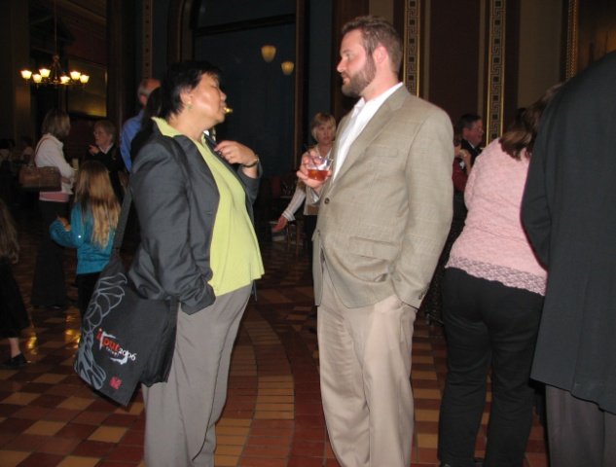 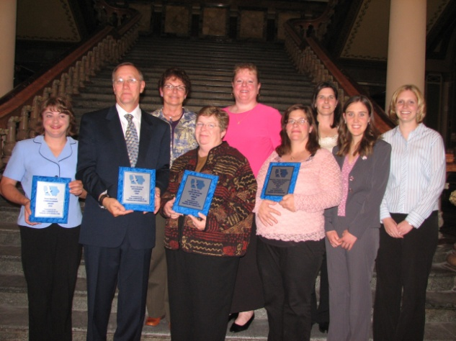

Cyndi Chen and Joe Mowers Award Recipients (MTRCS)

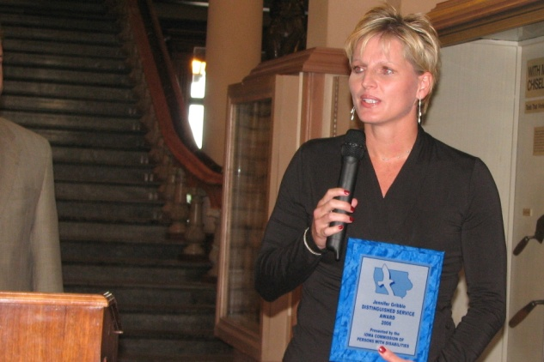 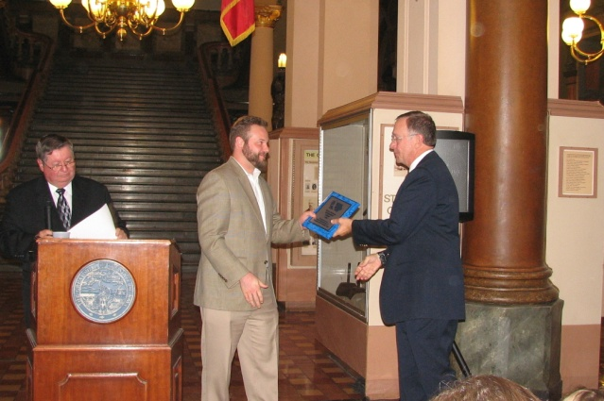

Jennifer Gribble Joe Mowers and Dr. Stensrud

and Hy-Vee, Inc., below

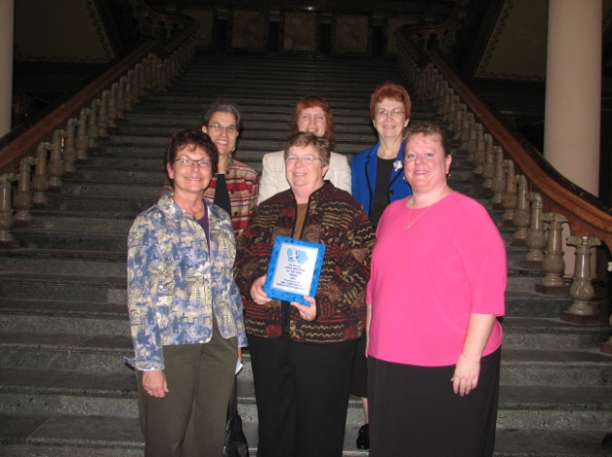 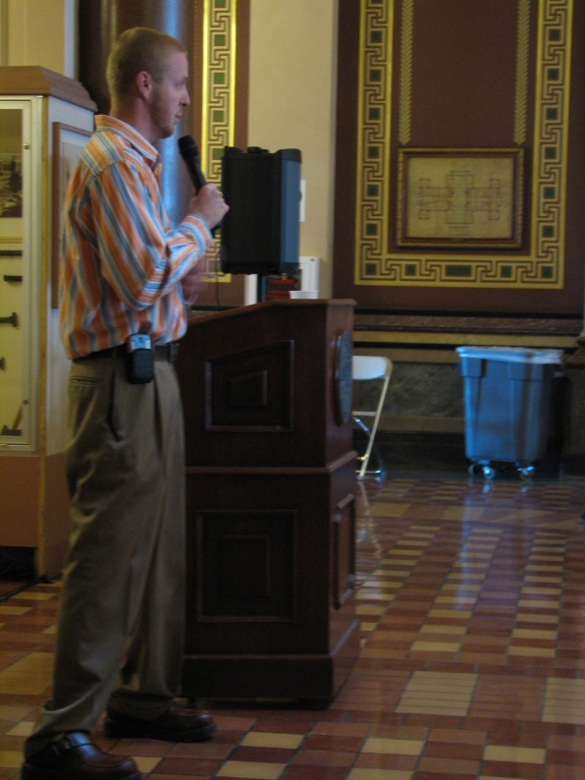

B.J. Jackson

**Contact Information**

Copies of this report may be obtained by contacting:

Jill Fulitano Avery

Administrator,

Department of Human Rights,

Division of Persons with Disabilities

Lucas State Office Building, Second Floor

321 E. 12th Street

Des Moines, Iowa 50319

515-242-6334

[Jill.avery@iowa.gov](mailto:Jill.avery@iowa.gov)

[www.state.ia.us/dhr/pd](http://www.state.ia.us/dhr/pd)