Iowa Department of Human Services



Targeted Case Management Unit

2006 Annual Report

The year 2006 emphasized setting goals and working hard to achieve them and a new motto called Medical Necessity.  Both our consumers and field staff shined this past year. We served 291 new consumers; the majority of these were our new CMH children. They make our life exciting. We also closed 143 more cases than the year before. Our data indicates that the majority of consumers are served five years or less by DHS TCM. Discharge can occur for many reasons, most of our consumers have learned how to advocate and provide for their own health and safety. Our 134 case managers carried a weighted caseload of 35 by the end of the year. Our Medicaid model requires activity on behalf of the consumers be documented in a narrative format. Our TCM’s document 85 contacts a month for an average duration of 20 minutes. This far exceeds the minimum expectation. No wonder consumers and families rate their TCM satisfaction at a 97%. | 
The safety of the consumers we serve continues to be our focus. I remember 20 years ago very few people thought our consumers could live and work safely in a community setting. It is a challenge but we have come so far. I am very pleased with the quality of the case management crisis plans and have seen the outcome data demonstrate the success of these individual plans.

Our CMH children worked hard to achieve outcomes and these are featured in this report.
Of the 5 states participating in this program Iowa’s children far exceed the others in school attendance and achievement.

Throughout 2006 we experienced a number of successes in other areas as well. We conducted focus groups throughout the state to gather input from a variety of participants in TCM. The development of a mock survey report was also accomplished and the 2006 conference was a great success. Our summer surprise was an Audit experience with OIG. We refocused our processes from functional language to medical necessity. Our staff participated in special trainings and rediscovered their clinical language and skills.

From an administrative viewpoint, the best decisions of 2006 involved centralizing financial business functions under one supervisor, conducting staff surveys, supervisors signing all consumer OAPs, TCM staff recording the financial commitment of consumer plans, evaluating our potential involvement in an Elderly Waiver and deciding not to participate.

Overall, the DHS TCM unit had a very successful and exciting 2006. With more hard work throughout the next year, we hope to accomplish our goals while continuing our high standard of customer service. We are confident that 2007 will bring additional success to the consumers and families we serve as well as the staff who work on their behalf.

Diane Diamond,
Bureau Chief, DHS TCM

Our Consumers

The Department of Human Services Targeted Case Management Unit serves consumers with mental retardation, chronic mental illness, developmental disabilities, brain injury and children with serious emotional disturbance. Our case managers help consumers gain access to appropriate living environments, needed medical services, and interrelated social, vocational and educational services. Below is a look at the consumers we served in 2006. These figures include all consumers who were served for at least one month during 2006.

Total Number of Consumers Served |  | 4680
Age | 0-17 | 18-34 | 35-64 | 65+
Number of Consumers | 963 | 1457 | 2134 | 126
Diagnosis | MR | MR Child | CMI | DD | BI | SED
Number of Consumers | 2410 | 653 | 923 | 215 | 245 | 234

State Quarter
Female | 2123
Male | 2557
Years with TCM | 0-5 | 6-10 | 11+
Number of Consumers | 2978 | 1028 | 674

Consumers referred to TCM for service are checked to ensure they meet eligibility requirements. If the consumer meets eligibility and wishes to receive TCM services a case is opened. A case may close for any number of reasons including but not limited to: voluntary withdrawal by the consumer, change of case management providers or the consumer progressing to a point where services are no longer needed. Below is a breakdown of referrals, opened and closed cases for 2006.

Referrals for service | 893
Opened Cases | 759
Closed Cases | 625

The average referral was assigned to a case manager 3.1 days after first being entered into the TCM system. The average length of time for a determination to be made regarding a referred case (accepted or rejected) was 29.4 days.
Consumer Data
Consumers who had one or more medical hospitalization | 329 | Consumers with a criminal conviction | 51
Consumers with one or more psychiatric hospitalization | 301 | Consumers with a founded abuse report | 26
Consumers who had one or more 23-hour observation | 55 | Consumers who live in their own or a relative’s home | 3,840
Consumers who work | 2,187 | Avg monthly income for working consumers | $225.17
Consumers by work setting |  | Avg montly income by work setting
Competitive | 394 | Competitive | $516.10
Supported | 478 | Supported | $327.08
Sheltered | 1,668 | Sheltered | $146.51


Des Moines Skyline

Case Manager Data
Number of case  managers in 2006 | 134
OAPs completed | 4,654 | Number of narrative contacts made | 136,391
Avg number of goals per OAP | 3.44 | Total narrative minutes | 2,679,252
Avg number of service activities per goal | 3.3 | Average duration per narrative contact | 19.64

Consumer Safety

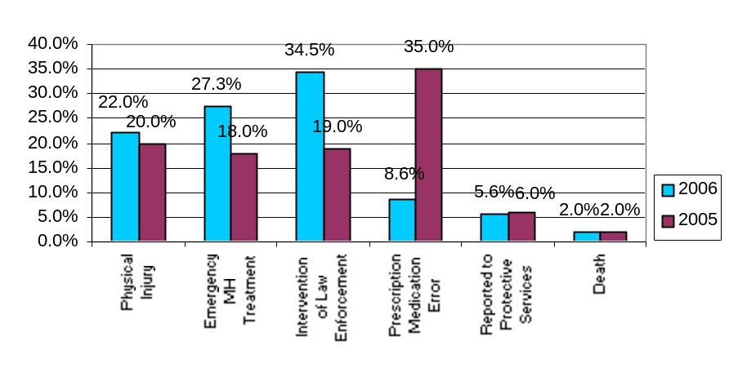Figure 1. Frequency Distribution of all Incidents in 2006 (by incident type) | - Incidents involving the intervention of law enforcement were the most common in 2006 (n=497, 34.5%) as compared to 19% (n=273) in 2005.  - The next two most frequent types of incidents were those involving emergency mental health treatment (n=361, 27.3%) and physical injury (n=291, 22.0%). In 2005 emergency mental health was 18% (n=267) and physical injury was 20% (n=294)  - The remaining three incident types occurred at frequencies of less than 10%. In 2005 prescription medication errors were the highest number of incident reports (35% n=507). In 2006 we redefined prescription medication errors to only include those errors by staff, not consumer refusals, which are significantly high.  - There were 27 consumer deaths in 2006; these amounted to 2.0% of all incidents.
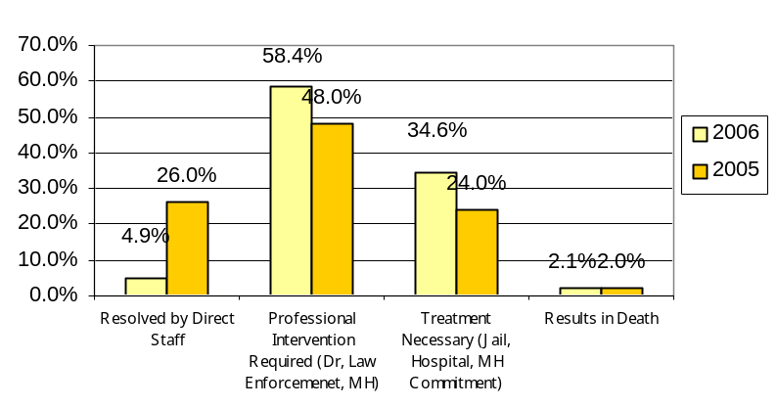Figure 2. Frequency Distribution of all Outcomes in 2006 (by incident severity)  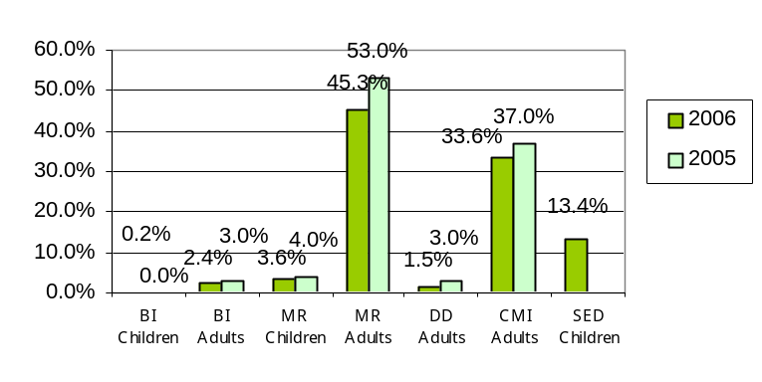 | - Over half of the reported incidents in 2006 required professional intervention (n=769, 58.4%).  - A significant proportion (n=455, 34.6%) of incidents resulted in treatment involving jail, hospital care, or mental health commitment.  - Relatively few incidents were resolved by direct staff (64, 4.9%), however, a large number of incidents required assistance beyond the capacity of direct care staff. This is significantly lower than last year, as most of the incidents resolved by direct staff were prescription medication errors.
Figure 3. Frequency Distribution of all Incidents in 2006 by Consumer Diagnosis | - MR adults (n=600, 45.3%) and CMI adults (n=443, 33.6%) were involved in the majority of incidents in 2006.  - Children with an SED diagnosis were involved in numerous incidents (n=175, 13.4%). SED Children were not tracked in 2005  - All BI consumers, DD adults, and MR children combined contributed to less than 10% of the total number of incidents.

Child Safety

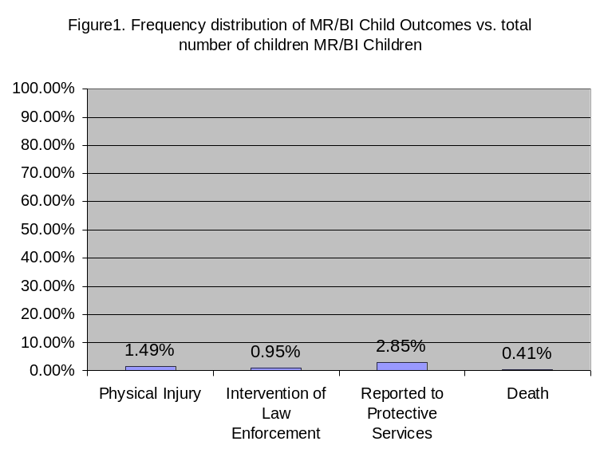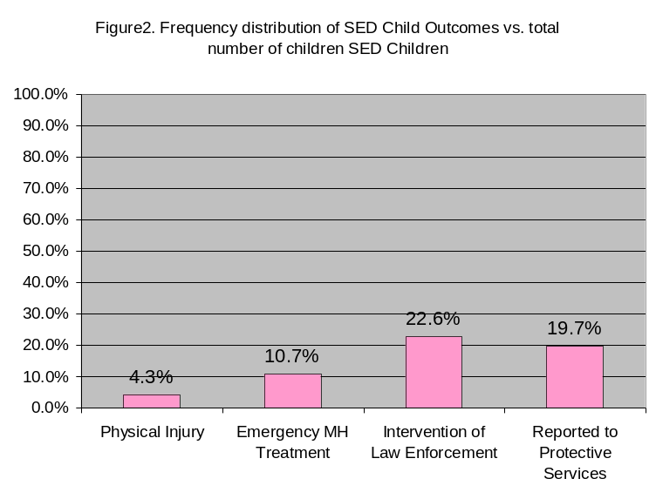

Figure 1
- DHS Case Management Served 653 mentally retarded children and 83 brain-injured children in 2006.
- 2.85% or 21 out of 736 children had an incident that involved a report to protective services.
- 1.49% or 11 out of 736 children had an incident that involved a physical injury.
- 0.95% or 7 out of 736 children had an incident that involved the intervention of law enforcement.
- There were 3 deaths among MR and BI children. All were due to illness.
- A total of 41 MR/BI children or 6% of the population had one or more incident during the year.

Figure 2
- In 2006 DHS Case Management served 234 children with a serious emotional disturbance.
- 53 of the 234 children or 22.6% had an incident that involved the intervention of law enforcement.
- 46 of the 234 children or 19.7% had an incident that involved a report to protective services.
- 25 of the 234 children or 10.7% had an incident that resulted in emergency mental health treatment.
- 10 of the 234 children or 4.35% had an incident that resulted in physical injury.
- A total of 114 SED children or 48.7% of the population had one or more incident during the year.
- The children served in 2006 (the start of the CMH waiver program) were referred to Case Management from Child Welfare.

Child Mental Health Outcomes

Outcome Results were tabulated for 186 SED diagnosed children who received TCM services in the first year of the CMH waiver (October 2005 – September 2006)

- All children have received a dental exam within the past 12 months
139 of 186 (74%) have received a dental exam within the past 12 months

- All children have received a physical exam within the past 12 months
157 of 186 (84%) have received a physical exam within the past 12 months

- Children have lived in their own homes during entire past year?
152 of 186 (82%) children lived in their own home for the entire past 12 months

- School Success – Promoted to next grade level?
169 of 173 (98%) children aged 7 and above were promoted to the next grade

- Attendance at School Appropriate –
159 of 173 (92%) children aged 7 and above missed no more than 3 days of school. 3 of these 159 children were also involved with Law Enforcement.

- Arrested by Law Enforcement?
174 of 186 (94%) children currently served by the waiver have not been arrested See Summary attachment for additional information on this outcome.

- List Community Activities –
153 of 186 (82%) children are involved in community and school activities including sports, church, work, 4-H and Y Club activities. Even the youngest children in the group are involved in activities outside the home.

- Children are safe in their own homes.
By case manager assessment 178 of 186 (96%) children are safe,
By case manager assessment 4 are not safe
By case manager assessment 4 are possibly not safe
Protective services has been contacted for all of those children for whom there was a safety concern. The TCM supervisors are monitoring these cases with the TCM.
Quality Improvement

The DHS Targeted Case Management Unit is the case management provider of choice to 4,500 consumers. To maintain this relationship, the Unit works continuously to provide excellent services to its consumers and to safeguard its accreditation.

Quality Team. The Quality Team identifies problems and solutions in policy and practice. The team serves as a customer service and support to case managers and supervisors by providing technical support, training, and feedback. Quality Team services include continuous hands-on training with case managers; updated training materials; more streamlined programs, policies, and procedures; in-depth case reviews for every case manager and supervisor, consultations, specialized studies, and data collection and analysis.

Quality Case Reviews and Documentation Improvements. To assist in maintaining high quality standards, the “case-reading” members of the Quality Team provide feedback to the case managers and supervisors on the quality of case documentation. The case reviews identify areas for improvement and training as well as examples of best practices to be replicated. In 2006, 390 cases were reviewed, compared to 377 cases reviews in 2005.

Data from the case readings is collected to measure Unit performance for several indicators and is used to help plan additional training and determine if policy as well as procedures need clarification. The highlight of 2006 was the steady improvement in the quality of work of case managers as evidenced by the case reading data.

The chart below compares 2006 with years 2005 and 2004, and clearly shows improvements in all key indicators from 2004 to 2006, with the average score for all indicators rising from 65% to 89%. Improvements were also made for every indicator in 2006 over 2005. The average of all indicators grew from 85% in 2005 to 89% in 2006. In 2007, the Quality Team will continue to work with supervisors and case managers to continue this upward trend in these and other key indicators.

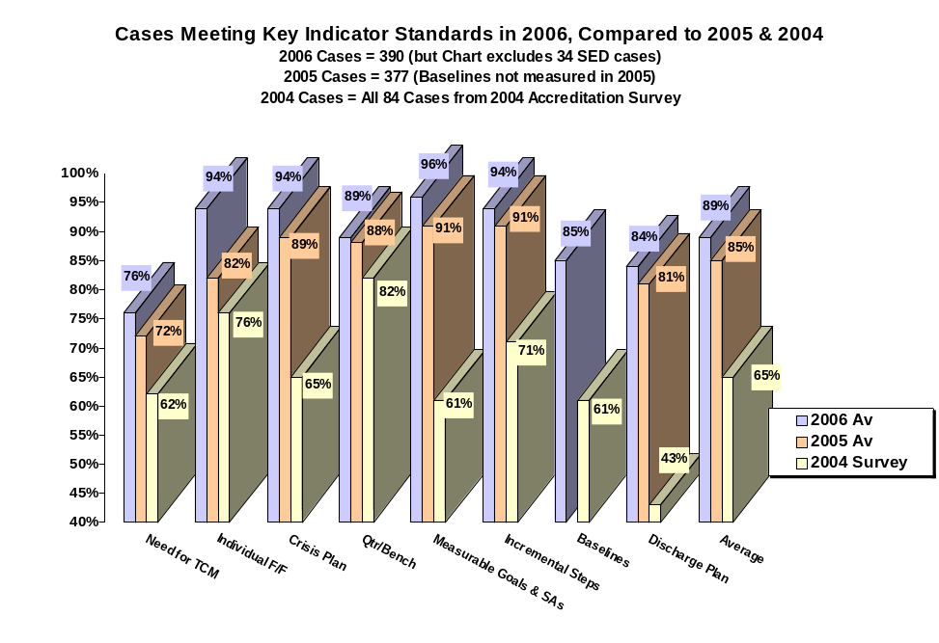 | The Unit’s 3-year Corrective Action Plan, based on the 2004 Accreditation Survey, and the Unit’s self-initiated 2006 Practice Survey and Report provided the focus for training, clarification of policy, and streamlining of documentation and forms. The Quality team members also participate in accreditation surveys of other TCM agencies and providers to gain additional insights on accreditation standards and to bring back examples of best practices from other TCM agencies.  Policy Clarification and Streamlining, Administrative Handbook, and Best Practice Book. During 2006, policies in several key areas were clarified. Toward the end of 2006, the DHS-TCM Administrative Handbook of policies and procedures was rewritten to incorporate revisions from Iowa Administrative Code Chapter 24 as well as new Medicaid and documentation standards. Improvements were also made to the Best Practice Book, a hands-on daily guide for case managers. As 2006 drew to a close, the Best Practice Book was going through a new edition and was expected to be finished in the Spring of 2007.

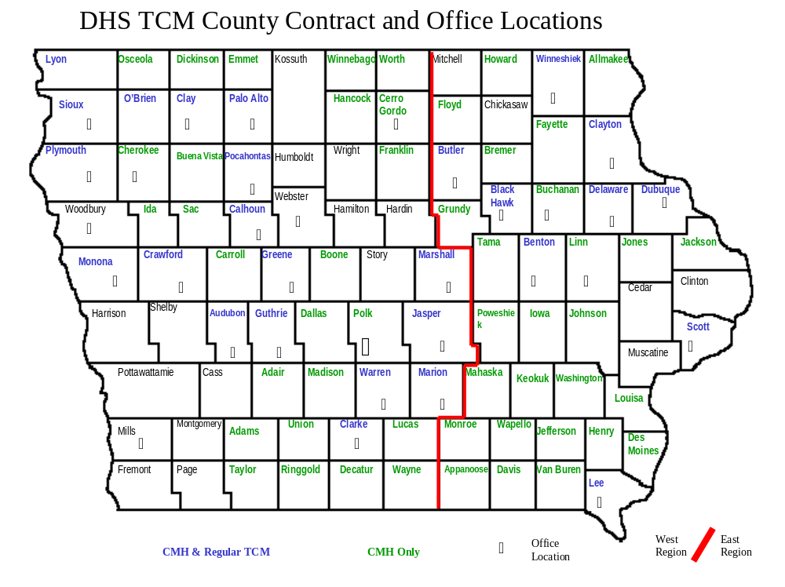

State Rock: Geode
Division Administrator: Jeanne Nesbit East Region Administrator: Kathy Jordan
Bureau Chief: Diane Diamond West Region Administrator: Linda Conrad

DHS Case Management employs an additional 13 Social Work Supervisors who supervise 134 Case Managers. In 2006 an accounting supervisor was added to supervise the Unit’s 8 accounting related positions. Additionally 14 workers cover the areas of clerical support, computer support and quality assurance.
Advisory Board

The Advisory Board of the DHS Targeted Case Management Unit serves as a consultative body. The board meets at least three times annually to review Unit operations. Officials in contracted counties, provider agency staff, consumers and guardians can all be considered for membership. Membership is voluntary. Terms do not expire, however members are free to withdraw at anytime. Board members missing three or more consecutive meetings are considered to have voluntarily withdrawn and may be replaced.

The following persons were members of the 2006 DHS Targeted Case Management Advisory Board:

- Jill Eaton – CPC, Marshall County and Board Chair

State Tree: Oak Tree
- Terry Johnson – Administrator, Genesis Development
- Mary Williams – CPC, Benton County
- Louise Galbraith – CPC, Crawford County
- Jan Heikes – CPC, Winneshiek County
- Lori Elam – CPC, Scott County
- Chris Sparks – Administrator, Exceptional Persons Incorporated
- Lori Nosekabel – CPC, Clarke County

Non board member meeting attendees for 2006 included:

- Theresa Armstrong –Executive Officer, DHS TCM
- Kathy Peters – Accounting Supervisor, DHS TCM
- Kurt Brinkman – Accountant, DHS TCM
- Joe Wolfe – Social Work Supervisor, DHS TCM
- Jeffery Tourdot – Mental Health Coordinator, Scott County

In 2006 the Advisory Board recommended changes to the survey process for both CPCs and Consumers of the DHS Case Management Unit. These changes will be made for 2007. The Board also reviewed the Unit’s budget, case weight system and audit information.
2006 Survey Results

Every year the DHS Case Management Unit conducts surveys with the counties and the consumers we serve. Data is collected to help us analyze everything from our management of county funds to our ability to meet consumer needs and of course satisfaction with the services provided. Below is some of what we learned from the 2006 survey results.

Consumer Survey

- 1614 surveys were sent out to consumers or their guardians.
- 920 surveys were returned for a return rate of 57%
- 50.1% of surveys were completed and returned by guardians
- The remaining 48.2% were returned by consumers who either completed it themselves or indicated they had help completing it from a friend, family member, or agency employee.
- The remaining 1.7% of respondents did not indicate a response to this question.

Prior to 2006 most questions on the consumer survey had three possible responses: Yes, No and Not Sure. For 2006 however, our Advisory Board recommended removing the option of “Not Sure” feeling that most people when forced to choose fell into either the yes or the no category. The affects of this can be seen in the survey results.

- Overall consumer satisfaction with DHS Case Management services rose from 87.9% in 2005 to 97.2% in 2006. These numbers are however not comparable due to the change in question format.
- 98.4% of consumers and/or their guardians feel their case manager respects their skills and abilities
- Only 82.1% of consumers and/or their guardians report meeting with their case manager prior to planning goals. This meeting, known in Case Management as the pre OAP meeting is an important first step in the goal planning process. This is an area the unit hopes to improve in for 2007.

The Unit’s over all consumer survey results can be found in the appendix of this document.

CPC Survey

DHS Case Management is good at providing information:

- Case Management is very good at keeping the CPC informed when changes are necessary – Audubon, Guthrie, Green County CPC
- Case Managers and supervisors keep the CPC informed of issues and situations affecting the county. – Benton County CPC
- The format used to update the Board of Supervisors regarding consumer services is wonderful and is now being used by TCM’s in other counties. – Clarke County CPC

It is important to our CPCs to work with local case managers.

- CPC likes to have the assigned case manager located in Clayton County. – Clayton County CPC
- More distant workers present more communication difficulty. – Crawford County CPC
- Can’t always get a hold of workers particularly those not located in Delaware County. – Delaware County CPC
- Floaters may not always know the ins and outs of the county plan. – Lee County CPC

The average overall satisfaction with DHS Case Management by our county partners was a 9.2 out of 10. Two counties, O’Brien and Warren scored us a 7 in over all satisfaction. DHS Case Management has a policy to address any score below an 8 and will be working with these two counties to address their concerns. A breakdown of all counties scores can be found in the appendix of this document.

This year our Advisory Board recommended changes to the way we survey county CPCs. A revised survey format will be presented to the board at the first meeting of 2007.
SFY 2006 Financial Information

The DHS Targeted Case Management Unit operates as a Medicaid provider. The Bureau operates on a projected rate for reimbursement of services and then retrospectively settles with various funders on actual costs incurred.

The federal share in SFY 2006 was 63.64%. The State of Iowa and the counties with which we contract split the remainder of costs, or 18.18% each. The Bureau does not receive an appropriation and operates solely upon revenues generated for services provided. The basis for allowable reimbursable costs is only those actual costs directly associated with providing TCM.

The Bureau's salary costs represent 83. 98% of total expenses and are limited to staff who directly provide TCM, and staff who support those who provide TCM. Support costs include items such as rent, travel, training, technology, office equipment and supplies, postage and telephones.

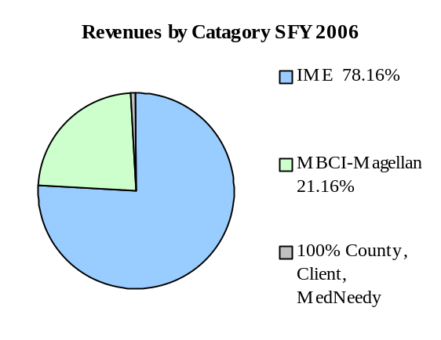
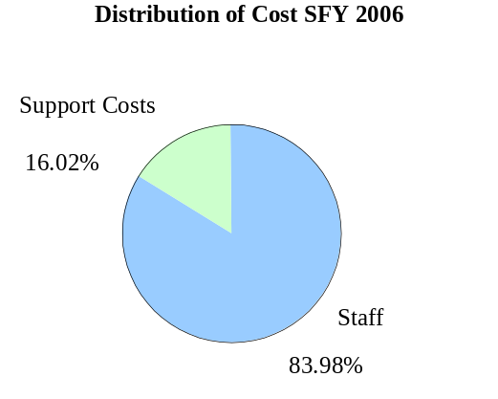

- TCM services provided are billed as a unit of service to specific Medicaid diagnostic criteria. A unit of service is defined as a billable contact within the month for each consumer receiving TCM. The number of units of service provided were 47,804 compared to 45,255 the previous year. This was a 5.63% increase over the prior year.
- State Fiscal Year (SFY) 2006 incorporates the timeframe of July 1, 2005 through June 30, 2006.
- In SFY06, TCM acquired the “Child Mental Health” Waiver (CMH). During this time 610 families and children were served. For the first 9 months of the waiver, we billed 1,156 units at a cost of $988,233.
- The DHS TCM financial team consists of 9 members: one Accountant, five Account Technicians, an Administrative Assistant, a Secretary 1, and a Public Service Supervisor.



