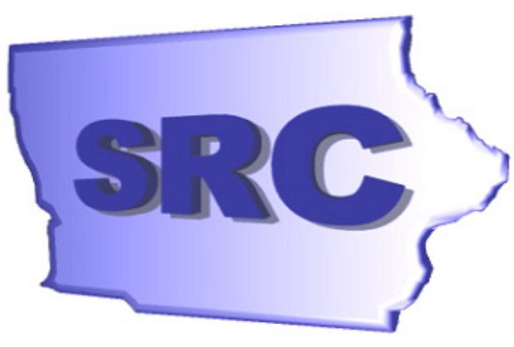

Iowa
State Rehabilitation Council

2005-2006
Annual Report

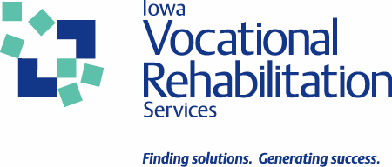
State Rehabilitation Council
Iowa Vocational Rehabilitation Services
510 East 12th Street
Des Moines, Iowa 50319

From the Chair

Harlietta Helland

December 31, 2006

To the Honorable Thomas J. Vilsack, Governor, State of Iowa:

The Iowa State Rehabilitation Council (SRC) is pleased to present the 2006 Annual Report.

In partnership with Iowa Vocational Rehabilitation Services (IVRS), Department of Education, we seek to maximize resources to ensure that people with disabilities meet their employment, independence, and economic goals. The pool of Iowans with disabilities includes individuals moving from school to work, those incurring accidents or serious disease/illness, and people who are aging. Each Iowa citizen is at risk of becoming disabled. Disability occurs within all cultures and economic strata. There will always be Iowans needing the individualized employment services provided by IVRS to achieve meaningful employment outcomes.

The SRC developed a committee structure to improve our ability to provide meaningful input to IVRS and the State of Iowa. During the past year we provided guidance on the IVRS State Plan to provide rehabilitation services, completed outreach activities to identify and assess needs of Iowans with disabilities, supported IVRS staff to increase awareness and seek new approaches to service delivery, and actively pursued additional funds to serve eligible individuals and move them from a waiting list to active services.

We are pleased to report that approximately 92% of those Iowans successful through IVRS services remain in Iowa to work and pay taxes. The 5 year return on investment per client was $9.27 for every $1 in state tax dollars spent on rehabilitation. The SRC is proud of the success of IVRS as an investment in Iowa’s future.

Sincerely,

Harlietta Helland
Chair

From the Division Administrator

Stephen A. Wooderson

December 31, 2006

To the Honorable Thomas J. Vilsack, Governor, State of Iowa:

It is my pleasure to submit this Annual Report for Iowa Vocational Rehabilitation Services (IVRS). IVRS, a division of the Iowa Department of Education, is committed to working for and with individuals who have disabilities to achieve their employment, independence and economic goals. This document contains information highlighting the accomplishments of IVRS this year.
Federal Fiscal Year 2006 was a year of challenge and opportunity. We began the year with higher than expected client services expenditures which ultimately led us to placing all new consumers on a waiting list. This permitted IVRS to balance our revenues and expenses, but restricted our ability to serve larger numbers of Iowans with disabilities. However, it did create opportunity for dialogue, and due to additional funds appropriated by the legislature, IVRS was able to once again take individuals off the waiting list by the first of July. We will once again see in this coming year the increase of persons becoming employed and a decrease on the burden of public assistance. In cooperation with the State Rehabilitation Council (SRC), we continue to see positive trends in customer satisfaction. Additionally, the quality improvement efforts of our field offices are resulting in measurable improvements in service delivery.
In 2006, IVRS has taken a proactive leadership role in employer development. As we move forward in our vision of achieving equal access for all Iowans, IVRS is increasing the staff skills needed and expectations for developing new and expansive relationships with business and industry. The shift in thinking requires IVRS staff to understand that we have valuable expertise we can offer to employers, which enhances their bottom line. By offering our services first, it also permits us to link employers with the qualified applicants needed to fill their human capital needs.
After the range of challenges and opportunities, it is exciting to end a year on such a positive note. With that in mind, I wish to express my appreciation for the support of the SRC. The last two years the SRC has been chaired by Ms. Kathryn Baumann-Reese of Des Moines, and our vice-chair has been Mr. Terry Johnson from Jefferson, Iowa. Those responsibilities have now been assumed by Harlietta Helland as chair and Craig Cretsinger as our vice-chair. The SRC continues to increase their knowledge and understanding of their roles and responsibilities and assisted IVRS in communicating the goals and objectives of our agency to lawmakers and members of the larger community.
I also cannot pass up the opportunity to express my pride for the staff of IVRS. Their work is clearly driven by the Agency Mission, Vision and Values. They are dedicated to providing quality services leading toward quality outcomes. As we move into a new year, it is my pledge that we will continue to challenge old beliefs, meet higher standards and expectations, work closely with our partners, improve communications, utilize our resources wisely, and celebrate our achievements.
Sincerely,

IOWA VOCATIONAL
REHABILITATION SERVICES

Stephen A. Wooderson
Administrator

State Rehabilitation Council

2005 - 2006

Mission

“Iowans in partnership with IVRS to assure that people with disabilities meet their employment, independence, and economic goals.”

Introduction

The Iowa State Rehabilitation Council (SRC) is a body of citizens, in partnership with the Iowa Vocational Rehabilitation Services (IVRS), appointed by Governor Thomas Vilsack, under the authority of the Rehabilitation Services Act of 1973, as amended, to provide guidance and advice on issues impacting rehabilitation in the State of Iowa. The Council reviews, analyzes, and advises the IVRS regarding the state’s vocational rehabilitation programs.

Establishment of the SRC

The Iowa State Rehabilitation Council (SRC) was established in 1993 as mandated by the 1992 amendments to the Rehabilitation Act. The SRC was originally established as an advisory council, and later the name was changed with the 1998 amendments to the Rehabilitation Act of 1973.

Council Duties

Review, analyze, and advise the Iowa Vocational Rehabilitation Services (IVRS) regarding the performance of the responsibilities of IVRS under Title I, particularly responsibilities relating to:

    - Eligibility;
    - The extent, scope and effectiveness of services provided; and
    - Functions performed by IVRS that affect or that potentially affect, the ability of individuals with disabilities to achieve employment outcomes under Title I.

In partnership with IVRS:

      - Develop, agree to, and review State goals and priorities in the State Plan.
      - Evaluate the effectiveness of the vocational rehabilitation program and submit reports of progress to the Commissioner in accordance with the State Plan.

Advise IVRS regarding the activities authorized to be carried out and assist in the preparation of the State Plan and amendments to the plan, applications, reports, needs assessments, and evaluations required by Title I.

Conduct a review and analysis (to the extent possible) of the effectiveness of, and consumer satisfaction with:

      - The functions performed by IVRS;
      - Vocational rehabilitation services provided by State VR agencies and other public and private entities responsible for providing vocational rehabilitation services to individuals with disabilities under the Vocational Rehabilitation Act; and
      - Employment outcomes achieved by eligible individuals receiving services under Title I, including the availability of health and other employment benefits in connection with such employment outcomes.

Prepare and submit an annual report to the Governor and the Secretary on the status of vocational rehabilitation programs operated within the State, and make the report available to the public.

To avoid duplication of efforts and enhance the number of individuals served, coordinate activities with the activities of other councils within the State, including:

      - The Statewide Independent Living Council;
      - The advisory panel of the Individuals with Disabilities Education Act;
      - The State Developmental Disabilities Council of the Developmental Disabilities Assistance and Bill of Rights Act;
      - The State Mental Health Planning Council; and
      - The State Workforce Investment Board.

Provide for coordination and the establishment of working relationships between IVRS and the Statewide Independent Living Council and centers for independent living within the State.

Perform such other functions, consistent with the purpose of the Vocational Rehabilitation Act, Title I, as the State Rehabilitation Council determines to be appropriate, that are comparable to the other functions performed by the Council.
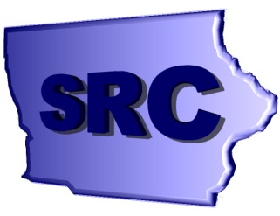

Membership of the SRC

The Council must be composed of at least 15 members who are appointed by Governor Thomas Vilsack. Membership includes representatives from:

  - Statewide Independent Living Council;
  - The Parent Training and Information Center;
  - Client Assistance Program;
  - Qualified vocational rehabilitation counselor;
  - Community rehabilitation program service providers;
  - Four representatives of business, industry, and labor;
  - Disability groups that include: individuals with physical, cognitive, sensory, and mental disabilities; and representatives of individuals with disabilities who have difficulty representing themselves;
  - Current or former applicants for, or recipients of, vocational rehabilitation services;
  - State educational agency responsible for the public education of students with disabilities;
  - State Workforce Investment Board;
  - Administrator of the Iowa Vocational Rehabilitation Services as an ex- officio, non-voting member.

Activities of the SRC
(October 1, 2005 – September 30, 2006)

Committee Activities

The SRC established three committees in its Bylaws: Outreach, Finance, and Planning and Evaluation. Each committee established Objectives and Activities/Tasks to reach those objectives. The ones for this time period are set out below.

OUTREACH COMMITTEE

Committee objectives for FY’06:
- Request additional state funds to meet federal match.
- Continue development and assist local offices in receptions for employers, legislators, etc.
- Continue to develop success stories for distribution.
- Recruit new SRC members.
- Disseminate information to members that requires attention.

ACTIVITIES/TASKS TO REACH OBJECTIVES:
- Legislative Reception is scheduled for February 7, 2007.
- Determine amount of state dollars needed to meet federal match.
- Position paper will be sent to members for approval.
- Determine waiting list significance on economic development and Return on Investment.
- Map display for personnel and waiting list.
- Develop position paper – color coded with above map.
- In conjunction with the Finance Committee, do a visual on where the federal money goes when Iowa does not meet match.
- Share responsibility for recruitment with all Council members and other councils, commissions, and boards.
- Incorporate new branding into displays.
- Send letters of recognition to all IVRS staff or other groups who assist with success.

FINANCE COMMITTEE

COMMITTEE OBJECTIVES FOR FY’06:
- Provide general education to the Council on financial operations.
- Influence State funding decisions.

ACTIVITIES/TASKS TO REACH OBJECTIVES:
- Educate SRC on budget offer process.
- Educate SRC on non-federal match requirements.
- Develop and chart history of recent IVRS budget issues.
- Communicate SRC responsibilities to Governor and Legislature.
- Estimate VR capacity if fully funded, calculate return on investment.

PLANNING AND EVALUATION COMMITTEE

COMMITTEE OBJECTIVES FOR FY’06:
- Review and recommend changes based on the results of the client satisfaction survey.
- Review and recommend changes to the State Plan.
- Complete Annual Report.
- Review and become knowledgeable of Agency policy.
- Conduct needs assessment as required by the State Plan.

ACTIVITIES/TASKS TO REACH OBJECTIVES:
- - Distribute copy of survey to committee.
- Distribute results data to committee.
- Discuss at next SRC meeting and recommend changes.
- - Distribute State Plan attachments.
- Discuss goals and objectives at February meeting and recommendations
at spring meeting.
- - Have committees submit activities at each SRC meeting for the Annual
Report.
- Review other state annual reports.
- - Review State Plan needs assessment from 2006.
- Determine plan for 2007 needs assessment.
- Report assessment results to SRC.
- Determine recommendations to IVRS.

Input and Recommendations to IVRS

- SRC recommends needs assessments/open meetings be a Council activity.
- SRC recommends having a Council member involved in the Quality Assurance and Leadership Board (QAALB) in order to play a more active role in policy-making.
- SRC recommends reducing the number of days from eligibility to plan development to 120 days, rather than 180 days.
- SRC recommends that IVRS request enough money from the Iowa Legislature to match all available federal VR dollars.

The SRC membership hosted a legislative reception to educate members of the Iowa Legislature and others about IVRS, its services, and those whom we serve. Seventy-five legislators attended the reception. Information on IVRS successful clients was presented on a county basis, which the legislators appeared to find helpful. A data sheet about each IVRS area office had been prepared and was presented to each legislator representing one or more of the counties served by that area office. A position paper (found at the end of this report) spelling out what the SRC would like the legislature to do was also distributed.

Impartial Hearing Officer Recruitment

IVRS continues to search for qualified candidates to perform the function of an impartial hearing officer. Currently there are only two hearing officers, and only one officer who will work outside of a 30 mile radius of Des Moines. IVRS continues to request assistance from the SRC in identifying and recruiting hearing officers.

SRC Member Recruitment and Appointments

SRC members recognized the importance of having a full council meeting the requirements of the Rehabilitation Act. They recruited individuals with disabilities to seek appointments to the SRC by Governor Vilsack. Some members contacted the Governor’s Office encouraging that appointments be made in a timely manner. This has resulted in a full council, fully meeting the requirements in the Rehabilitation Act.

Regional Continuing Education Program (RCEP)Training Modules

RCEP 7 has released a set of four training modules in PowerPoint with the overall general title of “The Public Mandate: A Federal Overview”. The modules were:

- History of Vocational Rehabilitation;
- The Rehabilitation Act;
- Principles and Policies;
- The Role of SRCs.

The modules are on the IVRS website and are used to orient new SRC members. The SRC viewed and discussed all four of the modules. Each new member receives a copy and has been encouraged to use it to educate other groups with whom they work.

Dr. Christine Lewis – The Role of the SRC

A couple of the members had heard Dr. Lewis present on the role of the SRC at a regional forum. They felt that the training would be useful to all of the SRC. Arrangements were made to bring Dr. Lewis to Iowa to meet with as many of the SRC as could make themselves available. A significant number attended and found the presentation useful.

Waiting List

Due to financial restraints, IVRS continues to place all newly eligible clients on the waiting list. During the period of February through July of 2006, IVRS was unable to remove any clients from the waiting list. Then at the end of July after careful financial management and direct service delivery instead of purchasing services, all clients considered most significantly disabled (MSD) were removed from the waiting list, and some clients considered significantly disabled (SD) were removed. Each month since then IVRS removes all clients from the MSD waiting list and some clients from the SD waiting list. The number of clients being removed from the waiting list and placed in an active status has been identified as the result of a statistical budgetary formula that has proven accurate and allows for at least 500 clients moving off the waiting list and entering active services each month.

Customer Satisfaction Survey

In Fiscal Year 2006 the State Rehabilitation Council continued conducting a Client Satisfaction Survey. The survey was developed in FY ’01 and distributed at the end of the year. In FY ’02, the process was changed so that the survey was mailed out at the end of the month in which the client’s file was closed. This change was implemented in the hope that it would increase the response rate. The overall response rate in FY ’06 was 24.6%, down slightly from 26% the previous year. The employed (successfully rehabilitated) clients returned completed surveys at a rate of 29.6%, and 16.8% of those not successfully rehabilitated client surveys were completed and returned.

Consumer Satisfaction Survey Results - Successfully Rehabilitated
4.15
4.21
3.81
4.29
3.97
3.98
4.27
4.28
4.27
3.87
4.39
4.05
4.30
3.97
3.98
4.12
3.97
4.09
4.03
4.11
1.00
2.00
3.00
4.00
5.00
The explanation I was given about available service was
The help I received in understanding my disability was
The job counseling I received was
The services received in obtaining job skills were
The financial assistance I received in obtaining job skills was
The encouragement I received in making choices about my goals
and services was:
The help I received in getting a job was
The IVRS staff I worked with was
The speed in which services were provided was
I would rate the overall services from IVRS
Extremely helpful Quite Helpful [Average] Slightly Helpful Not Helpful
FY05
FY06

Consumer Satisfaction Survey Results - Not Successfully Rehabilitated
3.61
3.32
3.37
2.76
3.63
3.14
3.14
3.55
3.14
2.92
3.55
3.34
3.45
3.14
3.14
3.14
3.34
3.18
3.43
3.14
1.00
2.00
3.00
4.00
5.00
The explanation I was given about available service was
The help I received in understanding my disability was
The job counseling I received was
The services received in obtaining job skills were
The financial assistance I received in obtaining job skills was
The encouragement I received in making choices about my goals
and services was:
The help I received in getting a job was
The IVRS staff I worked with was
The speed in which services were provided was
I would rate the overall services from IVRS
Extremely helpful Quite Helpful (Average) Slightly Helpful Not Helpful
FY05
FY06

IRSS

The Iowa Rehabilitation Services System (IRSS) is intended to modernize systems used to help serve our clients and to improve those client services by making IVRS more efficient. Early in this calendar year we halted development during the time we had our greatest fiscal challenges in order to maximize dollars available for client services. As the end of the year approached, we once again restarted our efforts.

The technical business requirements, diagrams for web pages, and a framework of the system have been developed. These materials are now being used as a foundation for building the rest of IRSS. We hope to have some pieces of IRSS fielded during calendar year 2007.

For IRSS to be completely successful, it must do an excellent job of meeting the needs of the business. No one knows those needs better than the IVRS staff. All agency staff involved in rehabilitation services, financial services, planning and development have been encouraged to influence the design of IRSS. Key members of the staff have participated in numerous planning and design sessions. Most additional staff members had face-to-face opportunities to influence the IRSS design when key project leaders visited each area office and each support organization in Des Moines.

Prior to the halt in development of IRSS early in 2006, we had been contracting with an external development team. Our focus now is to utilize as many internal resources as possible to complete the IRSS design. Implementation may be phased in over a longer period of time, but we believe it will permit for greater flexibility in making modifications and increase our ability to maintain the IRSS infrastructure.

IVRS Leadership in the Nation

Fiscal year 2006 was a year for national leadership for Iowa Vocational Rehabilitation Services

Ticket to Work

The Ticket to Work program continues to provide reimbursement of cost for services from clients who became employed as a result of IVRS services. The total amount reimbursed to IVRS from Social Security for expenditures on clients who had tickets during Federal Fiscal Year 2006 totaled $1,345,834.19.

VR-Business Network

Effective partnerships between Vocational Rehabilitation and business have existed for many years. Recently there has been a call to action for public VR agencies to coordinate efforts in strengthening and leveraging new relationships between VR and employers at multiple levels (National, Regional, State and Local).

The National VR-Business Network is an initiative supported by the Council of State Administrators of Vocational Rehabilitation (CSAVR) to actively work with business, consumers and VR state agencies to develop/strengthen VR-business relationships. The vision of the network is to create a coordinated approach to serving business customers through a national VR team that specializes in employer development, business consulting and corporate relations.

In Iowa, IVRS has launched the Iowa Business Network which is our State initiative that compliments the work of the National Network through strategic planning and action steps that:
- recognize employers as a valued customer of the agency;
- identify the business customer’s needs as they relate to the recruitment and retention of qualified employees with disabilities in the workplace;
- builds agency capacity to address the identified needs.

IVRS Leadership in Iowa

In 2005 – 2006, IVRS undertook new ventures to provide innovative services to persons with disabilities

Menu of Services

The Menu of Services is a collaborative effort with Community Rehabilitation Programs to improve the provision of services to IVRS clients and to establish a payment system that provides a shared risk approach for the outcomes identified. During this year information was gathered from partners to establish new rates for the services offered under the Menu of Services. We do anticipate adding some new services to the Menu as we begin to look at Supported Employment Services and how they are provided as well as creating opportunities to work with our partners in new ways. We are also working with DHS in regard to waiver services to see if there can be shared funding for Supported Employment Services.

One of the objectives in switching to the Menu of Services was to decrease recidivism for clients receiving Supported Employment Services. IVRS will be taking a closer look at the data to see what impact the Menu of Services has had in regard to that issue. IVRS will also try to identify what services impact employment outcomes the most and what are best practices in the delivery of those services.

Iowa Youth Leadership Forum

In partnership with the Iowa Division of Persons with Disabilities and the Iowa Department for the Blind, IVRS sponsors the Iowa Youth Leadership Forum (YLF). YLF is an innovative leadership training program for high school juniors and seniors with disabilities. Twenty-eight individuals participated from across the State of Iowa in this intense five-day training program.

Information is shared on occupational and career choices, the history of disability legislation and advocacy, and assistive technology for independence. Barriers to personal and professional success are identified and individual plans are developed to deal with those barriers. Individual participants develop a personal leadership plan that will be implemented to assist with their successful transition into the world of work or into a post-secondary environment.

Goals for the forum are to increase employment and self-sufficiency for young people with disabilities, improve each participant’s knowledge of the resources available to assist them in becoming successful adults, and expose the participants to professionals with disabilities who are recognized leaders and role models.

Students with disabilities who are involved in post-secondary training were invited to attend the college leadership forum (CLF). Ten participants were involved in a three-day training program located at Iowa State University. Participants were students with disabilities, and the training was targeted at empowering them to reach their employment goals. Forum topics included setting goals toward transition and independence, ADA and self-advocacy, principles of leadership, the experience of disability, technology and resources, reasonable accommodations, resume writing and job search skills.

The Iowa Division of Persons with Disabilities has been advised for future programming that all individuals participating in YLF and CLF will need to be IVRS eligible and active clients. This is due to an interpretation change by the Rehabilitation Services Administration regarding how our contracted dollars and our resources are used in serving potential individuals.

Entrepreneurs with Disabilities

The Entrepreneurs with Disabilities Program (EWD) is designed for the IVRS or Iowa Department for the Blind client whose goal is to achieve self-sufficiency through the operation of a business. The EWD program is a collaborative effort between the Iowa Department of Education, IVRS, Iowa Department for the Blind, and the Iowa Finance Authority.

The purpose of the EWD program is to provide technical and financial assistance to qualified individuals with disabilities who are seeking self-sufficiency by establishing or expanding a small business. Through the EWD program, IVRS provides clients with:
- feasibility studies and market research;
- technical assistance;
- business and marketing consultants (who work directly with the entrepreneur);
- assistance in leveraging money to establish a business;
- post-business support and follow-up;
- equipment purchase for starting or expanding a business.

Technical assistance is provided to each applicant as he/she works to start, expand, or acquire a business. The applicant works cooperatively with the consultant(s) to ensure active participation in the business planning/development process.

Financial assistance may be provided for the purpose of purchasing business equipment, rent, or other start-up, expansion, or acquisition costs identified in an approved business plan. Total financial assistance provided to an individual shall not exceed 50% (up to $10,000) of the financial package.

During the past federal fiscal year, seventy applications were processed for the EWD Program and twenty-eight new businesses started operations.

Governance Group

In Iowa strong collaboration among state agencies interested in strengthening employment services to Iowans with disabilities has resulted in the creation of a Governance Group of seven agency leaders who meet on a quarterly basis. IVRS’ administrator facilitates the activities of the group, who in 2003 developed a Memorandum of Agreement (MOA) designed to establish an ongoing commitment to collaboration at all levels of service delivery. This MOA continues to provide a foundation for collaboration and ongoing resources to local administrative and service staff as well as providing a forum for sharing current and future best practices among partners.

Currently the Governance Group provides oversight for the following initiatives –

Federal Initiatives:
- Improving Transition Outcomes Grant (funded through DOL);
- Disability Navigator Grant (funded through SSA);
- Iowa Work Incentives Planning and Assistance (WIPA) Grant (funded through SSA).

State Initiatives:
- System change efforts in the identification and services to welfare recipients with disabilities through the creation of Promise Jobs Disability Specialists (a collaborative effort through DHS, IWD and IVRS);
- Employer Disability Resource Network of state and federal partners are working together to “identify, develop and mobilize resources, supports and services that will add value to Iowa business hiring persons with disabilities.

Assistive Technology

Many IVRS clients can benefit from assistive technology, but it is difficult for staff to know where to find individuals qualified to provide this service. While IVRS has had an agreement with ISU to provide Assistive Technology support, the cost of the agreement detracts from direct services to clients. So IVRS is
considering alternatives to the current agreement that will still provide quality services.

IVRS Partnerships in Education

As a division of the Department of Education, IVRS continues to serve students with disabilities at all levels of secondary and postsecondary education. Partnering with education professionals is an important activity of the division to effectively provide rehabilitation services.

Iowa High School Districts

Recognizing the need to assist youth with disabilities transition into the world of work, IVRS assigns a rehabilitation counselor to every high school in Iowa. High schools refer students with disabilities for vocational rehabilitation services in their junior or senior year.

Iowa Regents, Private and Community Colleges

IVRS maintains a staffed office on the campus of thirteen of the fifteen community colleges in Iowa and maintains intensive service arrangements with the three Regents institutions. IVRS college counselors work closely with college personnel to ensure that IVRS students with disabilities receive necessary accommodations.

State Alignment Grant-Improving Transition Outcome

Iowa Vocational Rehabilitation Services administers Improving Transition Outcomes, a grant funded project specific to youth with disabilities ages 14-24 with the goal of creating a community-wide system of inclusion, support, and engagement for youth as they transition into their adult roles. Products include innovative community demonstrations that are sustaining and replicating; MyTransitionIowa.org, a statewide website specifically for youth and family members; and an on-line data collection system categorized by the Guideposts for Success. Outcomes include significantly increased referrals to VR, youth-directed vocational exploration resulting in pursuit of employment or post-secondary education, and transition focused community collaboration teams. VR has been a critical partner at the state and local levels.

Transition Alliance Programs (TAP)

The Transition Alliance Program (TAP) was established as a result of recommendations from the Iowa Transition Project and is designed to address identified gaps in services to youth with disabilities. The TAP is a joint venture between the Iowa Vocational Rehabilitation Services and local school districts, area education agencies, the Department of Human Services, community colleges, and the business community. Together these partners develop the structure of the program, monitor its implementation in participating schools, and evaluate each program’s procedures and outcomes, consistent with the requirements of the Rehabilitation Act of 1973, as amended, and the Individuals with Disabilities Education Act.

The program focuses on assisting individuals with disabilities to transition from school to employment by providing career exploration, paid and unpaid work experience, post-secondary planning, vocational skills training, job skills preparation, life skills training, job coaching supports, job development and job placement. The goal of the TAP is that through the development and implementation of a new pattern of services for youth with disabilities, individual participants will increase their opportunities for successful employment in the competitive labor market.

Special features of the program include:
- year round (12 month) services;
- services provided in community based settings;
- provision of necessary and individualized job supports to achieve competitive employment;
- follow-along for a minimum of one year after employment;
- follow-up per individual need through age 25;
- community based independent living skills training;
- community based workplace social skills training;
- connection of work and school to promote a course of study that is meaningful and motivating.

In Fiscal Year ’06, there were fourteen Transition Alliance Programs operational. For FFY 2007, there will be eleven programs operational. The Iowa School for the Deaf received a new grant that will allow them to provide transition services to all of their students. The Davenport School District elected not to renew because of IVRS waiting list issues, and the Iowa Valley Community College TAP elected not to renew due to differences in service delivery from the community college perspective. The Marshalltown School District is researching whether or not they want to continue in the development of their own program without the community college as the primary fiscal agent. Approximately 800 IVRS clients received services through the Transition Alliance Programs. IVRS successfully rehabilitated over 100 students during the fiscal year through the provision of these services as compared to 79 the previous year.

Due to staff capacity issues and restrictions in funding, no additional TAPs will be added this fiscal year. There have been requests from other districts to enter into an agreement with IVRS to provide TAP services. The staff capacity issue remains a limiting factor in being able to expand.

Iowa Department of Education

IVRS and the Bureau of Children, Family and Community Services (BCFCS) collaborate extensively on meeting the needs of students with disabilities. IVRS is a member of the Special Education Advisory Panel, which is composed of educators, parents, students, and interested community members. IVRS and the BCFCS developed an interdepartmental agreement to enhance collaboration and communication at the local level in serving students as they transition from school to post-school activities.

Collaboratively BCFCS and IVRS joined forces to develop systemic change in the schools in Iowa. As such, an RFP was issued for high schools and AEAs to work with business and industry to redesign their curriculum to prepare a workforce for the global economy and meet the standards established by No Child Left Behind. The first grant was awarded in October 2006.

Olmstead Real Choices Executive Order

The Council is assisting IVRS in the identification of policies, actions, and processes that could be carried out in ways that will encourage services being provided in the least restrictive environment possible. Within the Department of Education, IVRS has taken the lead in developing the strategies to move Olmstead ideals forward throughout the whole of the Department of Education. During this past year, the Department of Education has completed its Olmstead plan and submitted it to the Olmstead Real Choices Committee for approval.

IVRS Partnerships with Iowa Communities

IVRS continues to strengthen and expand services to Iowans with disabilities by establishing solid partnerships with local community programs.

Community Rehabilitation Programs

IVRS continues to work closely with the Community Rehabilitation Programs (CRPs) to maintain a close partnership to insure clients are provided quality services in a timely manner. IVRS also uses twice yearly meetings of the Community Rehabilitation Advisory Board to receive feedback on the effect actions of IVRS have on the CRPs and to identify emerging issues for the CRPs. In the spring, regional meetings are held with CRPs to share information about IVRS and discuss issues that affect the relationship between IVRS and the CRPs. The past year has been especially challenging as IVRS looks to provide more direct services to clients. This has changed the need for services from CRPs, and we have spent time identifying other services that are needed by IVRS clients that can be provided by the CRPs. This will continue to be a focus through the next year.

Iowa County System

At one time or another, IVRS has established contractual partnerships with one-third of Iowa’s 99 counties to increase or improve services to clients with mental retardation and/or mental illness. Through these partnerships, IVRS has explored new methods of service delivery, trial methods for transportation in local areas, increased collaboration in local school districts, coordination of community programs and a number of other service issues. IVRS continues to explore opportunities to improve services through the county system. IVRS administration regularly meets with the Iowa State Association of Counties and their partners to work toward the resolution of funding and programmatic issues. Several IVRS staff participated in work groups established to redesign the way services are provided to persons with disabilities through the county system.

Iowa’s Promise

Iowa Vocational Rehabilitation Services is a participating partner in the work group of the Iowa Collaboration for Youth Development (ICYD) and Iowa’s Promise. The goal of these initiatives is to ensure that all Iowa youth have the opportunity to be safe, healthy, successful and prepared for the future. To that end, state agencies have made a commitment to work with their regional and community partners to help build capacity to serve young people and connect their own programs and initiatives to collaboratively support state and local youth development efforts. IVRS supports the ICYD and Iowa’s Promise framework and has promoted the five promises within our organization:

- Ongoing relationships with caring adults;
- Safe Places with structured activities during non-school hours;
- Healthy start and future;
- Marketable skills through effective education;
- Opportunities to give back through community service.

DMACC Memorandum of Agreement (MOA)

This year IVRS entered into a cooperative agreement with the Des Moines Area Community College, Iowa Department for the Blind and the Veteran’s Administration. The purpose of the agreement is to organize individual agency efforts into a collaborative, proactive, customer-based activity that leverages resources of each organization to improve access for persons with disabilities to the Central Iowa labor market.

Project Goals

- Business and Industry: To increase outreach to business and industry through the delivery of technical assistance, consultation and training by IDB, VA and IVRS staff.
- DMACC students: To bring the employment life and academic experience for students with disabilities into balance through practical application of learning.
- DMACC faculty and staff: To increase the numbers of persons with disabilities employed on all DMACC campuses.

By June 2007 we anticipate having a timeline established for the development of strategies, measurable outcomes, timeline and assignment of tasks. A direct services committee of field staff will then be given a charter to begin to implement agreed-to strategies by the start of the 2007-2008 academic year.

IVRS Continuous Quality Improvement

For the past three years, IVRS has seen steady and significant improvement in successful outcomes.

IVRS continues to see an increase in services to individuals with most significant disabilities. Average Hourly Earnings for clients who enter competitive employment exceeded the federal standard for the last three years. After rehabilitation, a majority of IVRS clients consistently show their own earnings as their primary source of support.

RSA Performance Standards and Indicators

VR Standard 1 = Employment Outcomes

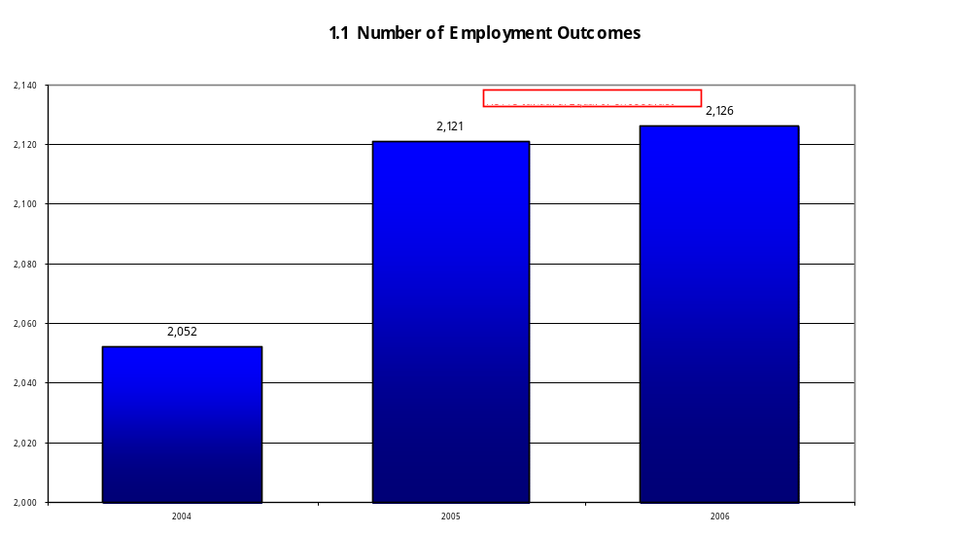
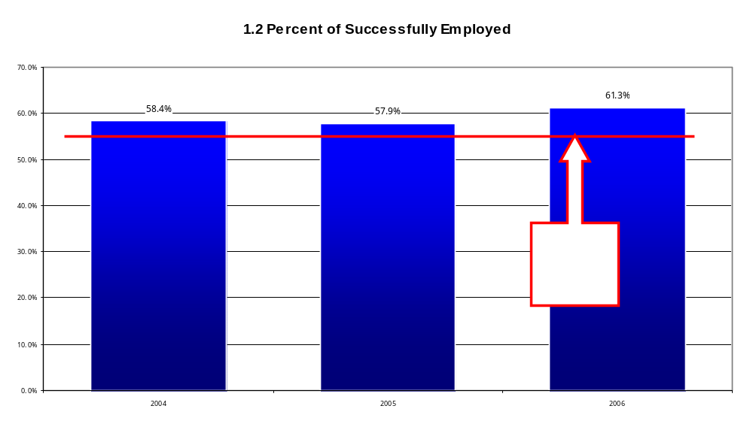

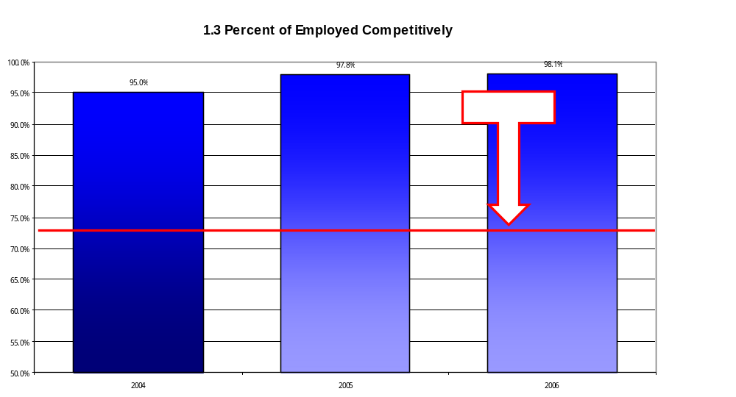
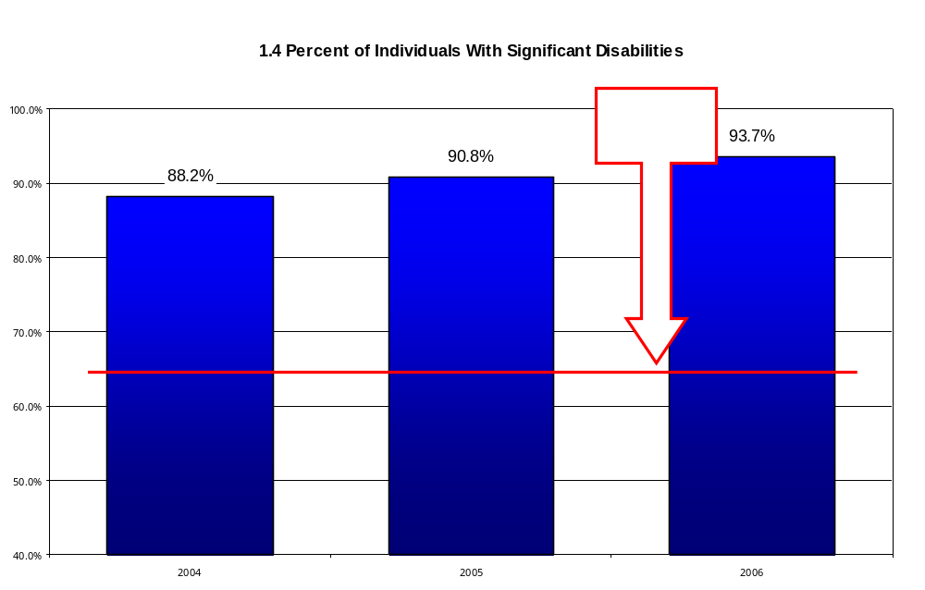

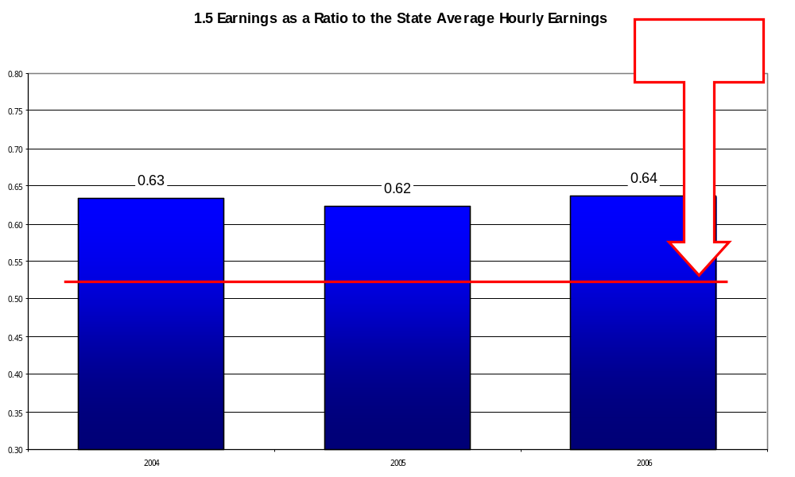
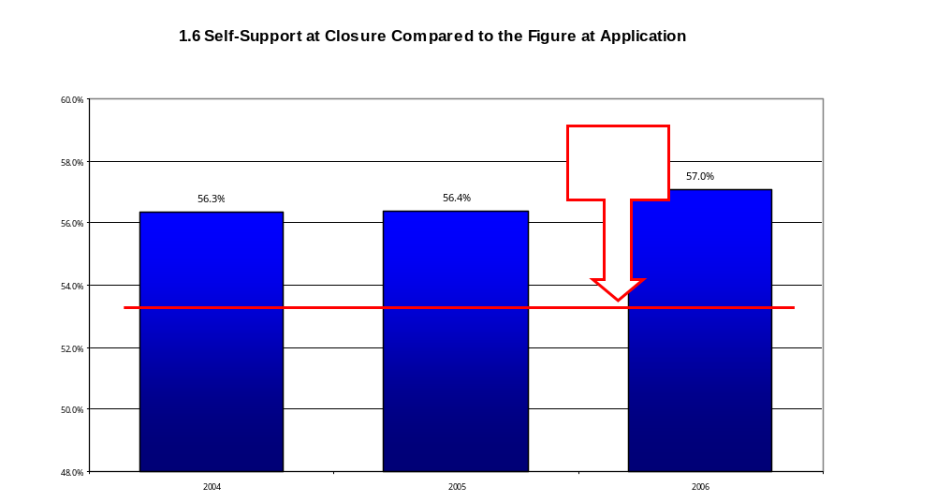

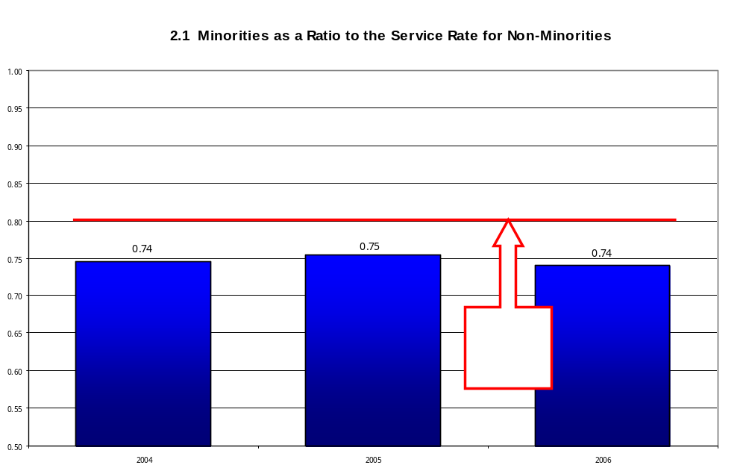

SAVING TAX DOLLARS – INVESTING IN IOWA’S FUTURE

State Rehabilitation Council
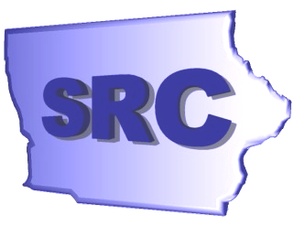

Position Paper

The State Rehabilitation Council is a body of citizens, appointed by the Governor, in partnership with the Iowa Vocational Rehabilitation Services (IVRS), under the authority of the Rehabilitation Act of 1973, as amended in the Workforce Investment Act. The Council reviews, analyzes, and advises the Iowa Vocational Rehabilitation Services, Department of Education, regarding its programs.

IVRS makes available individualized services to Iowans with disabilities
- counseling on adjusting to a specific disability
- making the environment usable with a disability
- partnering with community resources
- preparing for work skills required in Iowa’s economy
- identifying and using job placement services
- transitioning from tax user to tax payer

IVRS invests in Iowans with disabilities
  - 2,121 Iowans with disabilities obtained competitive employment in FFY 2005.
  - It is estimated that in their first year of employment, these Iowans will cumulatively earn $35,600,916.
  - The 5 year return on investment per client is $9.27 for every $1 in state tax dollars.

IVRS saves Iowa tax dollars
- Approximately 92% of successful clients remain in Iowa to work and pay taxes.
- 438 of the successful clients were using Iowa tax dollars as their primary support before being rehabilitated. Of those, 75 were receiving Temporary Assistance to Needy Families (TANF) at application.
- Rehabilitation of those TANF recipients saves Iowa $274,092 per year in tax expenditures. In the next 5 years, this will be $1,370,460 saved in tax expenditures on TANF.

Based on increased demand for services and cost of services provided, the Council urges the Governor and the Iowa Legislature appropriate an additional $336,519 in FY 2007 in order to fully match the federal dollars available.

Steve Wooderson, Administrator
Iowa Vocational Rehabilitation Services
515-281-6731
www.IVRS.state.ia.us

SRC Member Biographies

2005 - 2006

Kathryn Baumann-Reese
Ms. Baumann-Reese is serving her second full term on the SRC. She lives in Des Moines and serves as the Administrator of the Deaf Services Commission of Iowa, Department of Human Rights. She represents disability groups on the SRC.

Angela Creech
Ms. Angela Creech (Angie) is a native Iowan, now living in Eastern Iowa, who graduated from the University of Iowa with an MA in Rehabilitation Counseling (2004). She is a member of the Iowa Self-Advocacy & Leadership for Youth with the Disabilities Council. Appointed to the State Independent Living Council, she is the SRC representative on behalf of the SILC. She is employed at the Evert Conner Center in Iowa City.

Craig Cretsinger
Mr. Cretsinger graduated from Spencer High School in 1970. From there he proceeded to Iowa Lakes Community College where he graduated in 1972 with an A.S. degree. In June of 1972 he was involved in a semi-truck accident while working construction for Spencer Construction Company. As the result of the accident, he is now a C-6 partial quadriplegic, uses a manual chair and is quite self-sufficient. He received a degree in Architectural Drafting and Design Technology in Minneapolis, Minnesota. After doing architectural work for four years, he opened and ran a retail sporting goods store in Spencer. Currently he is the IWD Disability Navigator in Spencer.

Barbara Guy
Dr. Barbara Guy is the Transition and Work Experience Consultant for the Bureau of Children, Family, and Community Services in the Iowa Department of Education. She joined the Department of Education from the University of Minnesota, where she was the Director of the National Transition Network. While at the University of Minnesota, she also served as principle investigator of several research and technical assistance projects related to the secondary transition of youth with disabilities. She represents the Department of Education on the SRC.

Lisa Heddens
Ms. Heddens is the Family Support Coordinator for the Parent Training and Information Center of Iowa (PTI), which is a federally-funded grant of the U.S. Department of Education which advocates on behalf of children and their families under the provisions of the Individuals with Disabilities Education Act (IDEA). She represents PTI on the SRC. Lisa is a member of the Iowa House of Representatives. Her background experience is in elementary education and as an advocate with Iowa Protection and Advocacy, as the Project PRIDE and Partners in Policymaking Coordinator. Lisa resides in Ames, Iowa with her husband, Jeff, and their two children, Makenzie and Paul, who has Down Syndrome.

Harlietta Helland
Ms. Helland is the Client Assistance Program (CAP) representative to the SRC. As the CAP representative, she has no term limit. Harlietta has served on the SRC since 1995. As a client advocate, she represents applicants and clients of IVRS. Ms. Helland’s office is in Des Moines; however, she serves the entire state of Iowa and travels frequently. Ms. Helland resides in Marshalltown.

Terry L. Johnson
Mr. Johnson of Jefferson, Iowa was appointed to the SRC in 2003. He is the CEO of Genesis Development, a rehabilitation organization. His 30 years in the disability field has led to many experiences and interests in the needs of people with disabilities. Mr. Johnson represents community rehabilitation programs on the SRC.

Karen Keninger
Ms. Keninger is a Program Administrator at the Iowa Library for the Blind. Karen has been blind since birth. Ms. Keninger is in her second term on the SRC. She has worked for the Iowa Department for the Blind for ten years. Karen served as a Rehabilitation Consultant for five of those years.

Joe Mara
Joe Mara is a second-term member of the SRC, who lives in Carroll, Iowa. He attended high school at Cedar Rapids Regis, but graduated with a GED diploma in 1978 from Kirkwood Community College in Cedar Rapids. Mr. Mara is actively involved with various disability issues.

Matthew Milner
Matt Milner began his first term on the SRC in 2006. He lives in Ottumwa and is a reporter with The Ottumwa Courier and is married with two children. He represents business and labor but has also benefited from vocational rehabilitation services in adjusting to the effects of Meniere's Disease.

Marsha Mott
Ms. Mott is in her second term as an appointee to the SRC. She lives in Clear Lake with her husband, Russ, and family. She is beginning her twelfth year as a Vocational Rehabilitation Counselor in the Mason City Area Office. She has a general caseload and is the office Transition Counselor. Marsha will represent VR counselors.

Allan Oberlander
Mr. Oberlander began his tenure on the SRC in 2000. He resides in Des Moines and represents business and industry on the SRC. He served on the Board of VSA Iowa (providing arts opportunities to individuals with disabilities) for six years, including one year as chair. He has recently been elected to the Special Olympics of Iowa Board. Al is an architect with RDG Planning & Design of Des Moines.

Mari Reynolds
Mari Reynolds is a Des Moines native and graduate of North High School and Grand View College, with a double major in Psychology and Human Services and a minor in Sociology. She has a younger brother, born with multiple disabilities, who is now transitioning to adulthood. She has worked at the ASK Resource Center for four years, for the Parent Training and Information Center of Iowa as a Family Support Coordinator and Events Planner for over a year, and has completed three courses on mediation. She has also attended many IEP meetings, is knowledgeable about the Individuals with Disabilities Education Act, and has organized Literacy for Leaders, a day camp focusing on the importance of reading for children residing in Des Moines’ Enterprise Communities, for the last four years.

Donald Rowen
Mr. Rowen is in his second term to the SRC. He represents labor. Mr. Rowen has worked in the labor movement for over 45 years. He is the retired Executive Vice President of the Iowa Federation of Labor, AFL-CIO. He is a Korean War Army veteran. He has served 12 years as a board member of Des Moines Area Community College. He is serving his fifth three year term on the Polk County Health Services.

Lora Shramek
Mrs. Shramek is a first-term member of the SRC. She graduated from the University of Iowa with a BBA in Industrial Relations/Human Resources and has an MBA from Nova Southeastern University. Lora has a disability and represents a disability group on the Council. She has also been appointed to the Commission of Persons with Disabilities. Lora lives with her husband and son in Amana and works as the Administrator for Johnson County Human Resources.

Ellen Sokolowski
Ms. Sokolowski resides in Atlantic and represents the Iowa Rehabilitation Association, an advocacy group, on the SRC. Ellen is employed with IVRS in Council Bluffs as a Vocational Rehabilitation Counselor at IWCC. She was reappointed to the SRC in July of 2005.

Christine Urish

Christine Urish, PhD, OTR/L, BCMH, for the past thirteen years has been a faculty member in the occupational therapy program at St. Ambrose University in Davenport, Iowa. Currently she holds the rank of full professor. She is a graduate of the Rehabilitation Counseling Program at the University of Iowa. She is President of NAMI Scott County, Iowa and President of the Iowa Occupational Therapy Association. Dr. Urish was appointed to the SRC in 2006 to represent advocacy groups.

Vivian Ver Huel
Ms. Ver Huel is a first-term member of the SRC. She is a rehabilitation teacher at the Iowa Department for the Blind where she has worked for the past seventeen years. She is based in the Des Moines office and provides rehabilitation services throughout south central Iowa.

Robert Watson
Mr. Watson is the Marketing Specialist for the Great River Regional Waste Authority. He is the founder of Lee County Works, a program which establishes a work training environment for individuals with mental disabilities.

Stephen A. Wooderson
Mr. Wooderson has worked in the vocational rehabilitation profession since 1981. He began his career as a counselor and has served at all levels of supervision and management prior to his appointment as Administrator of the Iowa Vocational Rehabilitation Services on December 6, 2002.

In Memory - Marcia Stasch
The SRC lost a friend in September of this year. Ms. Marcia Stasch, SRC member and long time disability-rights advocate, passed away in Mason City. Marcia had served as chair of the Iowa Statewide Independent Living Council and on the board of the Iowa Program for Assistive Technology. She was appointed to the IVRS State Rehabilitation Council by Governor Thomas Vilsack in 2005.

In addition to her statewide advocacy work, Marcia served on the Mason City Task Force on Accessibility and the Mason City Human Rights Commission. Marcia will be remembered for her bulldog tenacity while advocating for the rights of persons with disabilities, and her tender heart and compassionate soul in reaching out to others in need.

