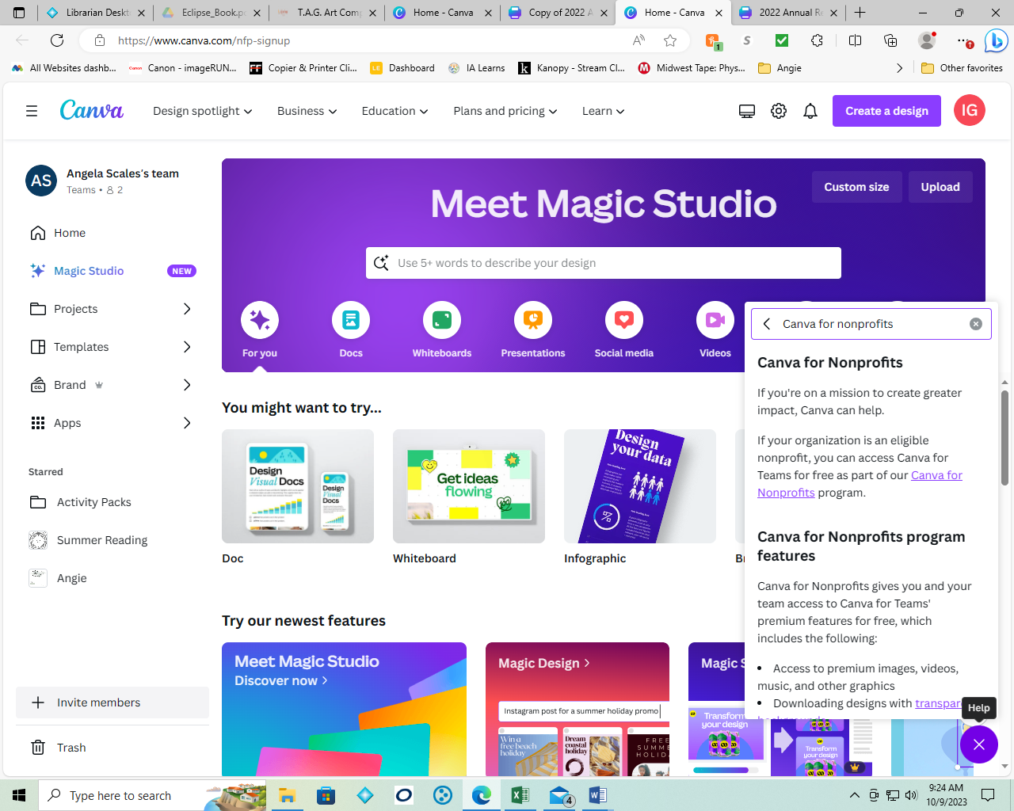

In your free Canva account, click on the purple circle (it will have a ? instead of X)

In the search bar type in ‘Canva for Nonprofits’

Scroll down and read the information, there will be instructions and a link to the application.