Tech Brief

DEVELOPMENT OF QUALITY STANDARDS FOR INCLUSION OF HIGH RECYCLED ASPHALT PAVEMENT CONTENT IN ASPHALT MIXTURES-Phase IV

**March 2022**

**March 2022**

**RESEARCH PROJECT TITLE:**

Development of Quality Standards For Inclusion of High Recycled Asphalt Pavement Content in Asphalt Mixtures – Phase IV

**SPONSOR:**

Iowa Highway Research Board

(TR-770)

**PRINCIPAL INVESTIGATOR:**

Hosin “David” Lee, Ph.D., P.E.

Iowa Technology Institute and Professor of Civil and Environmental Engineering

University of Iowa

hlee@uiowa.edu

**Co-PRINCIPAL INVESTIGATOR:**

Chris Williams, Ph.D., P.E.

Institute for Transportation and

Professor of Civil, Construction and Environmental Engineering

Iowa State University

rwilliam@iastate.edu

# Background

***Individual Highlights:***

Inside Story 2

Inside Story 3

Inside Story 4

Inside Story 5

Inside Story 6

Inside Story 7

Last Story 8

***Special Interest Articles:***

• Add a highlight or your point of interest here.

• Add a highlight or your point of interest here.

• Add a highlight or your point of interest here.

Public highway agencies encourage the use of recycled asphalt materials (RAM) in constructing pavements to the maximum extent possible with an equal performance. According to the 2020 NAPA’s report, average reclaimed asphalt pavement (RAP) percent used in Iowa is 19%, below the national average of 21.1%, and only 5% of RAP mixtures utilizes a softer binder, below the national average of 18%, and only 3% of RAP mixtures includes a rejuvenator, below the national average of 4%.

The main benefit of this research is to help pavement engineers identify the most appropriate rejuvenators by performing appropriate laboratory tests and implementing high RAM mixtures with softer binders or rejuvenators in the field, which will improve the performance and sustainability of asphalt pavements in Iowa.

# Benefits

To achieve the main objectives, the following five tasks have been performed: 1) surveyed RAM stockpiles and evaluate different equipment/methods for fractionating RAP materials, 2) applied FTIR for evaluating rejuvenators and DCT, HWT, SCB-IFIT tests for mixtures with high RAM contents with various rejuvenators, 3) evaluated the effects of the fractionation and the aging, 4) built test sections using high RAP contents with various rejuvenators and monitored the condition after one year since construction, and recommended changes in specifications for mixtures with up to 50% RAM materials.

The main purpose of this research is to evaluate mixtures up to 45% RAM with rejuvenators for Iowa DOT and local public agencies by performing laboratory tests and field implementation to determine effects of rejuvenators, fractionation and aging.

# Objectives

# Problem Statement

Low temperature cracking potential is a primary concern with high RAM mixtures. To minimize a low temperature cracking, various rejuvenators and softer binders have been utilized. Although the current Iowa DOT’s specification allows RAP materials up to 30%, limited construction projects have been performed, which utilized more than 20% RAP materials.

**TECH ADVISORY COMM:**

Jeffrey Schmitt, Iowa DOT

Ashley Buss, Iowa DOT

William Dotzler, Iowa DOT

Scott Schram, Iowa DOT

Angela Kersten, Scott County

Todd Kinney, Clinton County

Brian Moore, ICEASB

Scott Dockstader, APAI

Andrew Larson, APAI

Andrew Cascione, Flint Hills

Brett Finnegan, L.L. Pelling

John Hinrichsen, DMACC

Erv Dukatz, Flyereld Consulting

Ted Huisman, ISU

**ITI:**

Iowa Technology Institute (ITI) is a multidisciplinary research hub that conducts trailblazing basic and applied research.

[www.iti.uiowa.edu](http://www.iti.uiowa.edu)

The sponsors of this research are not responsible for the accuracy of the information presented herein. The conclusions expressed in this publication are not necessarily those of the sponsors.

# Research

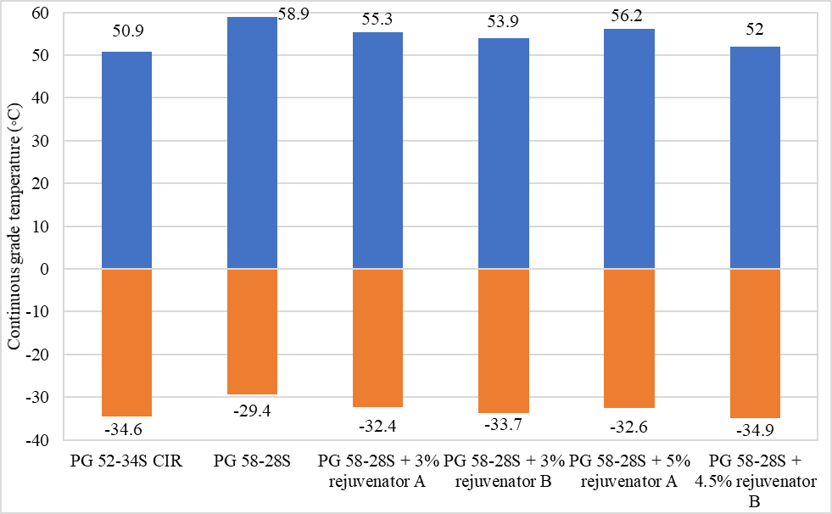

# Key Findings



Two issues regarding the child’s environment were evaluated relative to their insurance coverage: their level of engagement in school as measured by a series of questions and reported problems with substance use in the home. About one in five uninsured children had low engagement in school however they had the highest percentages who were highly engaged in school (43%).

Uninsured children were much more likely to be in a home with a substance use problem. Almost one in four uninsured children were in a home with a substance use problem compared to 13 percent of children in Medicaid and 9 percent of privately insured children.

The following conclusions are derived:

1. Rejuvenators lowered both critical high and low temperatures of virgin binder of PG 58-28S.
2. 34% and 45% High RAP mixtures with rejuvenators were compacted well exceeding 93% field density.
3. Based on HWT test results, field mixtures with rejuvenators performed better in rutting performance than ones without rejuvenators.
4. Based on the DCT test results, 34% RAP with a soft binder (34R Bump) mixture endured the highest fracture energy.
5. Based on SCB-IFIT test results, rejuvenators could improve cracking resistance.
6. Based on test results of both DCT and SCB-IFIT, there is a good correlation between FI values of SCB and fracture energy values of DCT.
7. All test sections performed very well with very little distress. Rejuvenators were effective in delaying an initiation of cracking.
8. Aging of laboratory prepared mixtures with rejuvenators decreased rutting in HWT tests but increased cracking potential in SCB-IFIT tests.
9. Both 34% and 45% RAP mixtures with rejuvenators were successfully implemented.

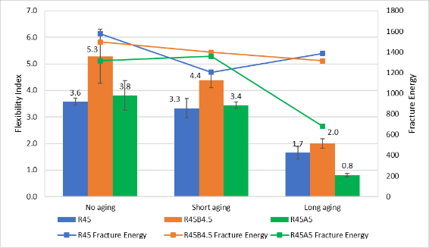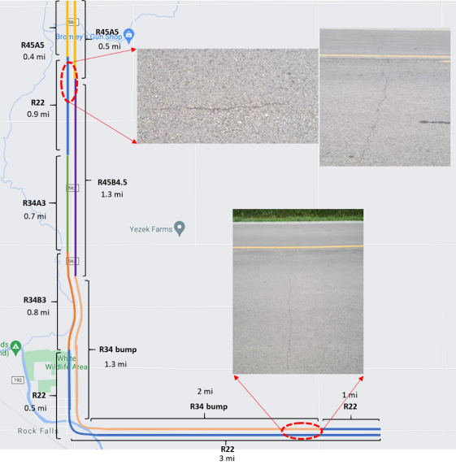

1. Develop an approval process for rejuvenators that incorporates long-term aging of the material.
2. Perform a feasibility study of a fractionation of RAP materials in two stockpiles.
3. Consider increasing the maximum RAM percentage up to 50% for some mixes. Additional options for RAM use and binder formulations may provide greater flexibility to contractors and binder suppliers.
4. Evaluate WMA with high RAM. Additional study of WMA with RAM could be useful to verify if it meets both economic and sustainability requirements.
5. Adopt a test procedure like SCB-IFT test for high RAM mixtures up to 50% as a performance test after evaluating different testing procedures based on sample preparation, specimen conditioning and testing, training needs, new equipment cost, repeatability and field validation.
6. Monitor high RAM project sites to determine the effectiveness and limitations of design, construction and performance of high RAM mixtures.
7. Develop a comprehensive asphalt recycling strategy encompassing high RAM mix up to 50%, CIR and HIR in consideration of both economic and sustainability analyses.

# Future Studies

## Tech Brief:

### DEVELOPMENT OF QUALITY STANDARDS FOR INCLUSION OF HIGH RECYCLED ASPHALT PAVEMENT CONTENT IN ASPHALT – PHASE IV 2MIXTURES

Two issues regarding the child’s environment were evaluated relative to their insurance coverage: their level of engagement in school as measured by a series of questions and reported problems with substance use in the home. About one in five uninsured children had low engagement in school however they had the highest percentages who were highly engaged in school (43%).

Uninsured children were much more likely to be in a home with a substance use problem. Almost one in four uninsured children were in a home with a substance use problem compared to 13 percent of children in Medicaid and 9 percent of privately insured children.