TR 770- Development of Quality Standards for Inclusion of High Recycled Asphalt Pavement Content in Asphalt Mixtures – Phase Ⅳ

FINAL REPORT

Hosin “David” Lee, Ph.D., P.E., Professor, Principal Investigator
Iowa Technology Institute
University of Iowa, Iowa City, IA 52242
E-mail: skytrust@gmail.com

Byungkyu Brian Moon, Graduate Research Assistant
Iowa Technology Institute
University of Iowa, Iowa City, IA 52242
E-mail: byungkyu-moon@uiowa.edu

Chris Williams, Ph.D., Professor, Co-Principal Investigator
Institute for Transportation
Iowa State University, Ames, IA 50010
E-mail: rwilliam@iastate.edu

MARCH 2022

Disclaimer
The contents of this report reflect the views of the authors, who are responsible for the facts and the accuracy of the information presented herein. The opinions, findings, and conclusions expressed in this publication are those of the authors and not necessarily those of the sponsors.

The sponsors assume no liability for the contents or use of the information contained in this document. This report does not constitute a standard, specification, or regulation. The sponsors do not endorse products or manufacturers. Trademarks or manufacturers' names appear in this report only because they are considered essential to the objectives of the document.

Statement of Non-Discrimination
Federal and state laws prohibit employment and/or public accommodation discrimination on the basis of age, color, creed, disability, gender identity, national origin, pregnancy, race, religion, sex, sexual orientation or veteran’s status. If you believe you have been discriminated against, please contact the Iowa Civil Rights Commission at 800-457-4416 or Iowa Department of Transportation's affirmative action officer. If you need accommodations because of a disability to access the Iowa Department of Transportation’s services, contact the agency's affirmative action officer at 800-262-0003.

Technical Advisory Committee

Jeffrey Schmitt, Iowa DOT, Jeffrey.schmitt@iowadot.us
Ashley Buss, Iowa DOT, ashley.buss@iowadot.us
William Dotzler, Iowa DOT, william.dotzler@iowadot.us
Scott Schram, Iowa DOT, Scott.Schram@iowadot.us
Angela Kersten, Scott County, Angela.Kersten@scottcountyiowa.com
Todd Kinney, Clinton County, tkinney@clintoncounty-ia.gov
Brian Moore, ICEASB, brian.moore@iceasb.org
Scott Dockstader, APAI, scottd@apai.net
Darwin Larson, APAI, darwinl@apai.net
Andrew Cascione, Flint Hills Resources, andrew.cascione@fhr.com
Erv Dukatz, Flyereld Consulting, flyereld@gmail.com
Brett Finnegan, LL Pelling, brettf@llpelling.com
John Hinrichsen, DMACC, Hinrichsen.john@yahoo.com
Theodore Huisman, ISU, thuis@iastate.edu

TABLE OF CONTENTS

1 INTRODUCTION 1
1.1 Key Findings from Previous Phase 2
2 Literature Review on rejuvenators 3
2.1. Vegetable Oil 3
2.2. Petroleum Aromatic Extract 4
2.3. Petroleum Paraffinic Oil 5
2.4. Tall Oil 6
2.5. Rejuvenators containing Naphthenic oils: 7
3 Recycled Asphalt Material Stockpiles and Processing methods 9
3.1 Survey of RAM Usage and Stockpiles in Iowa 9
3.2 RAP Processing Equipment 12
3.3 Fractionation Operations 13
4 Laboratory evaluation of high raP mixtures with REJUVENATORS 15
4.1 Fourier Transform Infrared (FTIR) Test on Binder from RAP Materials 15
4.2 Evaluation of RAP Mixtures with Six Rejuvenators using Hamburg Test 22
5 Laboratory Evaluation of Fractionated High RAP mixtures 23
5.1 HWT Test Results of Fractionated and Non-fractionated Mixtures 25
5.2 SCB-IFIT Test Results 26
6 Evaluation of Mixtures with RecYCLED Asphalt Shingle and Rejuvenators 29
6.1 HWT Test Results 30
6.2 SCB-IFIT Test Results 31
7 Field EVALUATION OF high RAP Mixtures with rejuvenators 33
7.1 Rejuvenators 33
7.2 Mixture Types for Test Sections 33
7.3 Performance Grading of Rejuvenated Asphalt Binders 35
7.4 HWT test result of Field Mixtures 37
7.5 Disk-Shaped Compact Test Results 38
7.6 Semi-Circular Bending Test Results 39
7.7 Performance Space Diagram of Flexibility Index versus Fracture Energy 40
7.8 Field Densities of Six Test Sections 41
7.9 Condition Survey of Test Sections after One Year 42
8 AGING OF HIGH RAP MIXTURES WITH REJUVENATORS 44
8.1 Aging Test Specimens 44
8.2 AASHTO R 30: Standard Practice for Mixture Conditioning of Hot Mix Asphalt 44
8.2.1 Mixture Conditioning for Volumetric Mixture Design 45
8.2.2 Short-Term Aging of Loose Mixtures 45
8.2.3 Long-Term Aging Conditioning of Compacted Samples 46
8.3 HWT Test of Aged High RAP Mixtures with Rejuvenators 47
8.4 SCB-IFIT test of Aged High RAP Mixtures with Rejuvenators 48
9 development of specifications for high ram mixtures 50
9.1 Five Surrounding State DOT’s specifications on RAM materials 50
9.2 Iowa DOT’s specification on the use of RAM materials 50
10 SUMMARY and conclusionS 53
11 FUTURE STUDIES 55
References 56
Appendix A 59
Appendix B 60

LIST OF TABLES

Table 2-1. The Performance of Rejuvenators based on Vegetable Oils 4
Table 2-2. The Performance of Rejuvenators Consists of Petroleum Aromatic Extract 5
Table 2-3. The Performance of Rejuvenators Consists of Petroleum Paraffinic Oils 6
Table 2-4. The Performance of Rejuvenators Consists of Tree Tall Oils 7
Table 2-5. The Performance of Rejuvenators Consists of Naphthenic Oils 8
Table 3-1. Survey Results about the use and stockpiles of recycled asphalt materials 9
Table 3-2. Pros and Cons of Milling, Screening, and Crushing Operations (West et al. 2016) 13
Table 3-3. Illinois DOT’s RAP Stockpile Classification System 14
Table 4-1. Details of rejuvenators 17
Table 4-2. Sulfoxide and Carbonyl index values for each binder type performed during Phase 3 19
Table 4-3. Sulfoxide and Carbonyl index values for each binder type during Phase 4 21
Table 5-1. Sieve Test Results of Classified RAP materials 23
Table 5-2. Aggregates Gradation 24
Table 5-3. Components of 34% and 45% RAP Mixtures 25
Table 5-4. SCB Test Results for Mixtures 28
Table 6-1. Description of Asphalt Mixtures 11% RAS and with rejuvenators 29
Table 6-2. Aggregates Gradation 29
Table 6-3. SCB-IFIT test results for 11% RAS mixtures 31
Table 7-1. Description of six test sections with different RAP and rejuvenator amounts 34
Table 7-2. DSR, BBR Tests Results of Six Different Binders that Used in Field Test Sections 36
Table 7-3. DCT Test Results of Laboratory Compacted Loose Mixtures from Five Test Sections 38
Table 7-4. SCB-IFIT Test Results for 34% RAP Mixtures 40
Table 7-5. Field densities of six test sections 41
Table 8-1. Three Laboratory Aged High-RAP Mixtures 44
Table 8-2. AASHTO R 30: Standard Practice for Mixture Conditioning 45
Table 8-3. HWT Test Results of Aged and Not-aged Mixtures with 45% RAP and Rejuvenators 47
Table 8-4. SCB Test Results for Laboratory Aging Mixtures 49
Table 9-1. Maximum Allowable RAP/RAS Usage Specification for Five Surrounding States 50
Table 9-2. Allowable RAP Usage by Weight (IM 510 Appendix C) 51
LIST OF FIGURES

Figure 3-1. Summary of a total tonnage of asphalt mixtures produced in 2019 10
Figure 3-2. Summary of tons of RAP/RAS received to your facilities in 2019 10
Figure 3-3. Summary of average RAP/RAS percentage used in asphalt mixes in 2019 11
Figure 3-4. Summary of Excess RAP and RAS in inventory at the end of 2019 11
Figure 3-5. RAP processing unit with a screen before the crusher (West et al. 2016) 12
Figure 4-1. FTIR test equipment used for this study 16
Figure 4-2.FTIR absorbance spectrum of PAV aged asphalt sample (Hofko et al. 2017) 17
Figure 4-3. FTIR test results of the aged and rejuvenated samples for one dosage of rejuvenators (C16: 16% Rejuvenator “C”; B10: 10% Rejuvenator “B”; A15: 15% Rejuvenator “A”) 20
Figure 4-4. Oxidation levels of eight different binder types 20
Figure 4-5. Oxidation levels of eight different binder types 22
Figure 4-6. HWT test results of 30%RAP mixes with six different rejuvenators 22
Figure 5-1. Combined extracted aggregate gradations for 34% and 45% RAP mixtures 24
Figure 5-2. HWT test results of fractionated/non-fractionated mixtures with 34% and 45% RAP 26
Figure 5-3. A typical force-displacement curve from SCB test and parameters for evaluation 27
Figure 5-4. SCB test results of 34% and 45% RAP mixtures 28
Figure 6-1. Combined aggregate gradation of a mix with 11% RAS 30
Figure 6-2. HWT test results for 11% RAS mixtures 31
Figure 6-3. SCB-IFIT test results for 11% RAS mixtures 32
Figure 7-1. Construction of Six Test Sections in Cerro Gordo County 34
Figure 7-2. Combined aggregate gradation chart for all mixtures 35
Figure 7-3. Continuous performance grades of six different binders used for field test sections 37
Figure 7-4. HWTT results for all eight mixtures 38
Figure 7-5. DCT test results of laboratory compacted loose mixtures from test sections 39
Figure 7-6. SCB-IFIT test results of four samples from test sections and two control samples 40
Figure 7-7. Performance space diagram to predict cracking potential at four test sections 41
Figure 7-8. Field densities of six test sections 42
Figure 7-9. Test sections without rejuvenators with cracking in one year after construction 43
Figure 8-1. HWT test results for three stage aged mixtures 48
Figure 8-2. SCB-IFIT test results for lab aging mixtures 49

INTRODUCTION
Public highway agencies encourage the use of recycled asphalt materials (RAM) in constructing pavements to the maximum extent possible with an equal performance. Low temperature cracking potential is a primary concern with high RAM mixtures, which is caused by the aging of asphalt through the oxidation. To minimize a low temperature cracking, various rejuvenators have been utilized in the past instead of bumping down a PG grade of the specified virgin asphalt for high RAM mixes.
According to the 2019 NAPA’s report, asphalt mixture producers are steady on their use of Reclaimed Asphalt Pavement (RAP), showing average percent used in asphalt pavement remains at 21.1% (21% or more in 20 states and 19% in Iowa) based on total reported tons of RAP divided by reported total tons asphalt mixtures produced (NAPA 2020). Among states using soft binders (27 states) and rejuvenators (15 states), 18% of RAP mixtures (5% in Iowa) were produced using softer binders whereas 4% of RAP mixtures (3% in Iowa) produced using a rejuvenator.
Asphalt mixture producers continue to decrease their use of recycled asphalt shingle (RAS), using 921,000 tons of RAS during 2019, which is a 12.5 percent decrease from the 1,053,000 tons used in 2018. Only 28 states including Iowa used some RAS in HMA. Among states using soft binders (16 states) and rejuvenators (7 states), 20% of RAS mixtures (0% in Iowa) were produced using softer binders whereas 8% of RAS mixtures (0% in Iowa) produced using a rejuvenator.
Aging process of asphalt is a combination of reversible and permanent changes. Reversible changes are referred to as molecular association like wax crystallization whereas permanent changes occur as a result of physical changes like loss of lighter molecules or chemical changes like oxidation. Oxidation is a chemical reaction between asphalt and oxygen such that carbon and sulfur atoms increase within asphalt molecules. Oxidation is considered as a dominant factor in a long-term asphalt aging phenomenon. The term “rejuvenation” is defined as a restoration of the virgin asphalt condition.
The main purpose of this research is to evaluate high RAM mixtures with both rejuvenators and fractionated RAM materials for Iowa DOT and local public agencies by performing laboratory tests and field implementation. Main tasks of this research are to:
  - Survey Recycled Asphalt Materials (RAM) stockpiles and evaluate different equipment/methods for fractionating RAP materials.
  - Apply FTIR for evaluating rejuvenators and DCT, HWT, SCB-IFIT tests for RAM contents with various rejuvenators.
  - Evaluate the effects of the fractionation and the aging.
  - Build test sections using high RAP contents with various rejuvenators and monitor condition of a test section with high RAP contents.
  - Develop specifications for HMA mixtures with high RAM contents, rejuvenators, and fractionation.

Key Findings from Previous Phase
In previous phases of this research, the effects of different rejuvenators were evaluated by applying each of them to aged asphalt binder and high-RAP mixtures. It was found that rejuvenators were effective in decreasing the aging level of hardened asphalt binder. The previous study identified the analytical method to find the most appropriate rejuvenators for Iowa’s high RAP mixtures, which are resistant to both low temperature cracking and rutting while reducing the production cost and the environmental impacts. Based on the limited laboratory experiments and field test sections, the following conclusions were derived from the phase 3 study:
- Rejuvenators lowered both PG high- and low-temperature limits of aged asphalt binder.
- Optimum dosage rate of each rejuvenator was identified using the Bending Beam Rheometer (BBR) test.
- Fourier Transform Infrared (FTIR) test indicated rejuvenators were effective in restoring original properties of the aged binder.
- Cryo-SEM was used to capture surface images of the rejuvenated asphalt binders at -165 °C, where significantly less cracking was observed.
- Rejuvenated asphalt binders exhibited G-R values between the aged asphalt and virgin asphalt. A significant correlation was observed between carbonyl indices and G-R values.
- Based on the Disc-shaped Compact Test (DCT) result, it was concluded that high-RAP mixtures with rejuvenators were more resistant to a low–temperature cracking than the high-RAP mixtures without it.
- Test sections using rejuvenators were successfully constructed in Crawford and O’Brien Counties in Iowa. DCT test result of field samples confirmed that rejuvenators improved a low–temperature cracking susceptibility.

Literature Review on rejuvenators
First, an extensive literature review was performed on the fundamental characteristics of various rejuvenators and past performance evaluation results are summarized in this chapter. In general, rejuvenators add the aromatic and resin functionality in the aged asphalt, and they can be categorized into the following five types based on their sources: vegetable oil, petroleum aromatic extract, petroleum paraffinic oil, tall oil and naphthenic oil. Literature review results are summarized below with respect to dosage rate, RAP content, the laboratory performance test results for cracking, rutting, moisture susceptibility and low temperature cracking. All performance test results were collected from the published literatures not based on the manufacturer/manufacturer-sponsored research but based on the independently funded research.

2.1. Vegetable Oil
Triglycerides and fatty acids are derived from virgin or waste vegetable oils, which can be used as a rejuvenator. However, virgin vegetable oils are preferred over waste oils because waste oils may contain undesirable oxides due to an extensive heating process. One of the most common vegetable oils is a soybean oil. Three types of rejuvenators are discussed below and laboratory test results of high RAP mixes using them are summarized in Table 2-1.

1) Anova by Cargill
Based on the research performed by Cargill, field cores with 45% RAP and Anova endured 197 cycles before a failure under the overlay tester, which represents 25 times improvement over a control mix without a rejuvenator (Sylvester and Hassan 2017). Asphalt mixtures with 100% RAP and Anova exhibited a rut depth of 4.3 mm at 10,000 passes in Hamburg wheel tracking (HWT) device, which is similar to a control mix without a rejuvenator. Mixes with 50% RAP and Anova exhibited 600 J/m² fracture energy at -24˚C.

2) NH300PL and NH303PL by Namheung
These rejuvenators are composed of soybean oil and fatty acids. Asphalt mixes with 30% RAP and NH300PL and NH303PL exhibited 11.5mm and 7.9 mm rut depths at 20,000 passes in HWT test, respectively. The stripping inflection point (SIP) was greater than 10,000 passes for both products.

3) Waste Vegetable Oil and Grease
100% RAP specimens with rejuvenators based on waste vegetable oil (WVO) and waste vegetable grease (WVG) exhibited 5.4 kPa and 5.9 kPa of fracture work density (FWD), respectively, which are similar to the control mix without a rejuvenator (Zaumanis et al. 2015). Asphalt mixtures with WVO and WVG exhibited 11.5mm and 7.9 mm rut depths at 20,000 wheel passes, respectively, along with the SIP greater than 10,000 wheel passes. The specimens with WVO and WVG exhibited indirect tensile strengths of 3,400 kPa and 3,250 kPa, respectively, which are less than 3,919 kPa of the control mix without a rejuvenator.

4) Delta S by Collaborative Aggregates
35% RAP with Delta S exhibited 13.41 mm rut depth at 20,000 passes with a SIP value greater than 10,000 and FI value of 3.43 (Castro 2017). Under the overlay tester, the 35% RAP with Delta-S failed at 10 cycles, less than 300-cycle requirement.

5) ReJUVN8 by Sripath Technologies
Disk-Shaped Compact Tension (DCT) and Semi-Circular Bending (SCB) test results of 5% RAS with ReJUVN8 were 710 J/m² and 0.38 kJ/m², respectively. The rut depth was just 2.8mm at 20,000 passes in HWT test (Arguirre et al. 2017).

Table 2-1. The Performance of Rejuvenators based on Vegetable Oils
Rejuvenator | Dosage | RAP Content | Cracking | Rutting | Moisture Susceptibility | Low Temp Prop.
Anova (Sylvester and Hassan 2017) | 3-5% of total binder | 45% RAP  50% RAP  100% RAP | 45% RAP: OT: 197cycles | 100% RAP:  HWT: 4.3mm@10,000 | N/A | 50% RAP:  DCT: 600 J/m²  @-24˚C
NH300PL NH3003PL | 5% of total binder | 30% RAP | N/A | HWT:  11.5mm@20,000  7.9mm@20,000 | HWT:  Inflect>10,000 Inflect>10,000 | N/A
waste vegetable oil  or grease (Zaumanis et al. 2015) | 12% of total binder | 100% RAP | FWD:  5.4 kPa  5.9 kPa | HWT: 4.2mm@10,000  9mm@10,000 | HWT:  Inflect@8,000  Inflect>10,000 | IDT:  3,400 kPa  3,250 kPa
Delta-S  (Castro 2017) | 5% of total binder | 35% RAP | FI: 3.43  OT: 10 cycles | HWT:  13.4mm@19,020 | HWT:  Inflect>10,000 | N/A
ReJUVN8 (Arguirre et al. 2017) | 5% of total binder | 5% RAS | SCB:  0.38 kJ/m2 | HWT: 2.8mm@20,000 | N/A | DCT: 710 J/m²
OT: Texas Over Test, HWT: Hamburg Wheel Tracking, DCT: Disk-Shaped Compact Tension
IDT: Indirect Tensile Test, FWD: Fracture Work Density from IDT test

2.2. Petroleum Aromatic Extract
Aromatic extracts are produced as a by-product of a petroleum refining process to produce lubricating oil. Five rejuvenators are discussed below, and their performance test results are summarized in Table 2-2.

1) Hydrolene by Holly Frontier
With this rejuvenator, Flexibility Index (FI) improved from 4.0 (20% RAP with no Hydrolene) to 4.3 (30% with 4% Hydrolene) but went down to 3.9 (40% RAP with 7.5% Hydrolene) and 3.0 (50% RAP with 9% Hydrolene). However, it did not improve a low temperature cracking behavior using the asphalt concrete cracking device (ACCD) test. The rut depth increased from 3.6 mm to was 4.1 mm in Asphalt Pavement Analyzer (APA) test. It did not have a significant effect on Tensile Strength Ratio (TSR) values (Nazzai and Kim 2019).

2) Cyclogen L by TRICOR
50% RAP and 20% RAP plus 5% RAS exhibited 700 and 900 cycles in overlay tester, respectively. Based on the Indirect Tensile Test (IDT), 50% RAP and 20% RAP plus 5% RAS exhibited low cracking temperatures of -24.4℃ and -22.5℃ (Tran et al. 2012).

3) Valero 130A by Valero
Both 25% and 45% RAP mixtures with Valero 130A passed the requirement of 500 cycles under the overlay tester. However, For the APA test, the rut depth was 3.65 mm, slightly higher than the control mix without a rejuvenator (Bennert et al. 2015).

Table 2-2. The Performance of Rejuvenators Consists of Petroleum Aromatic Extract
Rejuvenator  /Reference | Dosage | RAP/RAS Content | Cracking | Rutting | Moisture Susceptibility | Low Temp Prop.
Hydrolene  (Nazzai and Kim 2019) | 4%  7.5%  9% | 30% RAP  40% RAP  50% RAP | 5.2 (30%)  4.3 (40%)  3.3 (50%) | APA_{@8000}:  4.2mm  3.1mm  4.0mm | TSR:  0.9  0.91  0.81 | ACCD  -30°C  -30.1°C  -30.3°C
Cyclogen L  (Tran et al. 2012) | 12% of total binder | 50% RAP; (20% RAP/ 5% RAS) | OT:  700  900 | APA_{@8000}:  5.0mm  4.1mm | TSR:  0.86  0.9 | IDT:  -24.4  -22.5
Valero 130A  (Bennert et al. 2015) | N/A | 25% RAP  45% RAP | OT:  500 cycles  135 cycles | APA:  3.6mm  3.8mm | N/A | N/A
OT: Texas Over Test, HWT: Hamburg Wheel Tracking, DCT: Disk-Shaped Compact Tension, ACCD: Asphalt Concrete Cracking Device, IDT: Indirect Tensile Test, APA: Asphalt Pavement Analyzer, FI: Flexibility Index, TSR: Tensile Strength Ratio, SCB: Semi-Circular Bending

2.3. Petroleum Paraffinic Oil
Paraffinic oil-based rejuvenators are essentially re-refined lubricating oils. Three rejuvenators are discussed and the performance test results are summarized in Table 2-3.

1) Storbit by SOTRIMPEX
Penetration index of the binder with Storbit increased. However, asphalt mixtures with Storbit did not improve low temperature cracking resistance. (Zaumanis et al. 2015)

2) Valero VP165 by Valero
Asphalt mixtures with Valero VP165 improved the fatigue cracking performance with higher cycles under the overlay tester (Bennert et al. 20153). However, the rut depth 25% RAP and 45% RAP with Valero VP165 under the APA was 4.3mm and 4.68mm, respectively, which were slightly higher than control mixtures of 25% RAP (2.28 mm) and 45% RAP (2.42mm).

3) Chevron Delo (400 LE SAE 15 W40)
The TSR values were satisfactory. However, the rut depth with Chevron Delo increased under the APA test (DeDene 2011).

Table 2-3. The Performance of Rejuvenators Consists of Petroleum Paraffinic Oils
Rejuvenator | Dosage | RAP/RAS Content | Cracking | Rutting | Moisture Susceptibility | Low Temp Prop.
Storbit  (Zaumanis et al. 2015) | 18.26% of total binder | 100% RAP | PI: 3.29 | N/A | N/A | IDT:  1,900 kPa
Valero VP165  (Bennert et al. 2015) | N/A | 25% RAP;  45% RAP | OT:  472 cycles;  771 cycles | APA:  4.3mm;  4.68mm | N/A | N/A
Chevron Delo 400LE SAE 15W30  (DeDene 2011) | 4% of T. Binder  8% of T. Binder | 25% RAP | N/A | APA_{@8000}:  3.4mm (4%)  5.1mm (8%) | TSR:  .93 (4%)  .80 (8%) | N/A
OT: Texas Over Test, IDT: Indirect Tensile Tension, TSR: Tensile Strength Ratio, APA: Asphalt Pavement Analyzer, PI: Penetration Index

2.4. Tall Oil
Tall oils can be obtained from the paper industry as by-products (pine trees), which is in the same chemical family as some warm-mix asphalt and some emulsifiers. Two rejuvenators are discussed, and the performance test results are summarized in Table 2-4.

1) Sylvaroad RP1000 by KRATON
When Sylvaroad RP1000 was added, the Flexibility Index (FI) values of 30%, 40% and 50% RAP mixtures decreased from 4.5 to 4.2 but increased from 2.7 to 3.0 and 4.2 to 5.2, respectively. Based on APA test results, a rut depth slightly increased for 30%, 40% and 50% RAP mixtures from 3.4mm to 3.8mm, from 3.2mm to 3.7mm, and 3.0mm to 3.6mm, respectively. Based on Asphalt Concrete Cracking Device (ACCD) test results, similar cracking temperatures were observed for three different RAP mixtures. The TSR values for 30%, 40% and 50% RAP mixtures changed from 0.98 to 0.96, same at 0.84, and from 0.83 to 0.84, respectively. (Nazzai and Kim 2019).

2) Distilled Tall Oil
Asphalt mixtures with distilled tall oil exhibited a similar level of IDT test result of 3,943 kPa as the control sample and the HWT test results were satisfactory. However, asphalt mixtures with distilled tall oil exhibited a FWD value of 5.2 kPa, which is smaller than a control mix (5.6 kPa) (Zaumanis et al. 2015).

Table 2-4. The Performance of Rejuvenators Consists of Tree Tall Oils
Rejuvenator | Dosage | RAP/RAS Content | Cracking | Rutting | Moisture Susceptibility | Low Temp Prop.
Sylvaroad  RP1000 (Nazzai and Kim 2019) | 8% of total binder | 30% RAP  40% RAP  50% RAP | FI (wo/w):  4.5/4.2  2.7/3.0  4.2/5.2 | APA_{@8000} (wo/w)  3.4/3.8mm  3.2/3.7mm  3.0/3.6mm | TSR (wo/w):  0.98/0.96  0.84/0.84  0.83/0.84 | ACCD  -29.9°C  -32.1°C  -34.1°C
Distilled  Tall Oil  (Zaumanis et al. 2015) | 12% of total binder | 100% RAP | FWD:  5.2 kPa | HWT₁₀₀₀₀:  2.9mm | HWT:  Inflect>10,000 | IDT:  3,943 kPa
IDT: Indirect Tensile Tension, FWD: Fracture Work Density (From IDT), HWT: Hamburg Wheel Tracking, TSR: Tensile Strength Ratio

2.5. Rejuvenators containing Naphthenic oils:
These types of rejuvenators are engineered hydrocarbons for asphalt modification. Three rejuvenators are discussed and the performance test results are summarized in Table 2-5.

1) SonneWarmix RJ by Sonneborn Inc
Asphalt mixtures with SonneWarmix RJ improved both rutting resistance and moisture susceptibility of the 40% RAP and 5% RAS with a much better performance with 35% RAP + 5% RAS mixtures. It improved the fatigue cracking resistance in overlay tester. Based on the Thermal Stress Restrained Test (TSRST) result, it improved the low temperature cracking resistance (Mogawer et al. 2013).

2) BituTech by Engineered Additives
Asphalt mixtures with BituTech exhibited a similar performance as those with SonneWarmix RJ in both rutting resistance and moisture susceptibility. Compared to the asphalt mixtures with SonneWarmix RJ, BituTech further increased the fatigue cracking resistance in overlay tester. The TSRST data showed that BituTech can improve the low temperature cracking resistance (Mogawer et al. 2013).

2) HyPrene L150 by Ergon
Asphalt mixtures with HyPrene L150 endured only 106 cycles under the overlay tester, which is lower than a control mix with 176 cycles. However, OT result has significantly improved to 596 when the RAP content was increased from 25% to 45%. Under APA, the rut depth was 3.13mm for 25% RAP and 4.36mm for 45% RAP mixtures with HyPrene L150, which were slightly higher than the control mixtures of 25% RAP (2.28 mm) and 45% RAP (2.42mm) (Bennert et al. 2015).

Table 2-5. The Performance of Rejuvenators Consists of Naphthenic Oils
Rejuvenator | Dosage | RAP/RAS Content | Cracking | Rutting | Moisture Susceptibility | Low Temp Prop.
SonneWarmix RJ  (Mogawer et al. 2013) | 9.28% of total binder | 40% RAP;  5% RAS;  (35% RAP + 5% RAS) | OT:  420 cycles  430 cycles  230 cycles | HWT_{10,000}:  4.73mm  12.53mm  1.51mm | HWT:  All Inflect >10,000 | TSRST:  -27.36°C  -26.19°C  -27.26°C
BituTech  (Mogawer et al. 2013) | 9.28% of total binder | 40% RAP;  5% RAS;  35% RAP+5% RAS | OT:  1,280 cycles  1,020 cycles  380 cycles | HWT_{10,000}:  6.25mm  11.43mm  1.58mm | HWT:  All Inflect >10,000 | TSRST:  -27.40°C  -24.45°C  -25.25°C
HyPrene L150  (Bennert et al. 2015) | N/A | 25% RAP;  40% RAP | OT:  106 cycles;  596 cycles | APA:  3.13mm;  4.36mm | N/A | N/A
OT: Texas Over Test, HWT: Hamburg Wheel Tracking, APA: Asphalt Pavement Analyzer, TSRST: Thermal Stress Restrained Test

Recycled Asphalt Material Stockpiles and Processing methods
For a stockpile of RAP materials, it is most critical to keep moistures away. The moisture absorption of RAP materials is very high because it consists of various particle sizes conglomerated together due to asphalt. The best practice to minimize the accumulation of moisture in stockpiles is to cover the stockpile with a shelter to prevent precipitation from getting to the RAP. Covers or tarpaulins should be avoided as this trap’s moisture in the pile. RAP stockpiles should be limited to 20 feet in height to reduce the potential for self-consolidation of the stockpile (West 2010). As a result, most contractors are trying to keep inventories low and produce material only as needed.
In the nation, the estimated amount of RAP stockpiled at the end of the 2019 construction season increased to 138.04 million tons (1.38 million tons in Iowa), which is a 20 percent increase from the 110.31 million tons (0.25 ton in Iowa) at the end of the 2018 construction season (NAPA 2020). 1.143 million tons of RAS (0.0251 million tons in Iowa) were reported as stockpiled at year-end 2019, which is a 16.5 percent decrease from the 1.368 million tons (0.0306 million tons in Iowa) at the end of 2018. In this study, a survey was performed to determine the use and stockpile of RAP and RAS at the end of 2019 and processing methods to fractionate RAM are discussed.

Survey of RAM Usage and Stockpiles in Iowa
We have performed a survey to estimate the use and stockpile of RAM by the asphalt pavement industry in Iowa. The survey consisted of ten questions, which was sent to thirty-two contractors in Iowa, and seven companies replied. Based on the survey, contractors used mixtures with RAP the most, followed by mixtures with RAS and virgin mixtures. A total RAP stockpile at the end of 2019 construction season was 63,500 tons out of 188,100 tons acquired over the 2019 construction season and a RAS stockpile (by one company) was 10,000 tons out of 2,500 tons acquired over the 2019 construction season. The survey results are summarized at Table 3-1 and Figure 3-1 to Figure 3-4.
Table 3-1. Survey Results about the use and stockpiles of recycled asphalt materials
Asphalt mixture produced (tons) |  |  | Amount acquired in 2019 season (tons) |  | Stockpiles at the end of 2019 (tons)
None | RAP | RAS | RAP | RAS | RAP | RAS
447,195 | 1,013,000 (24% RAP) | 682,900 (4% RAS) | 188,100 | 2,500 | 63,500 | 10,000
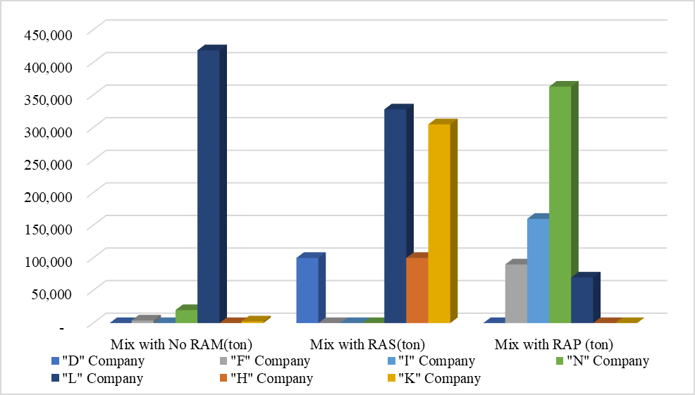
Figure 3-1. Summary of a total tonnage of asphalt mixtures produced in 2019

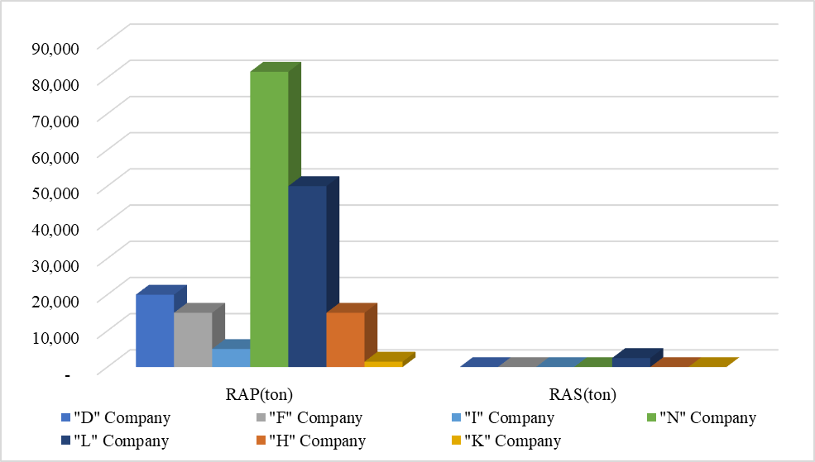
Figure 3-2. Summary of tons of RAP/RAS received to your facilities in 2019

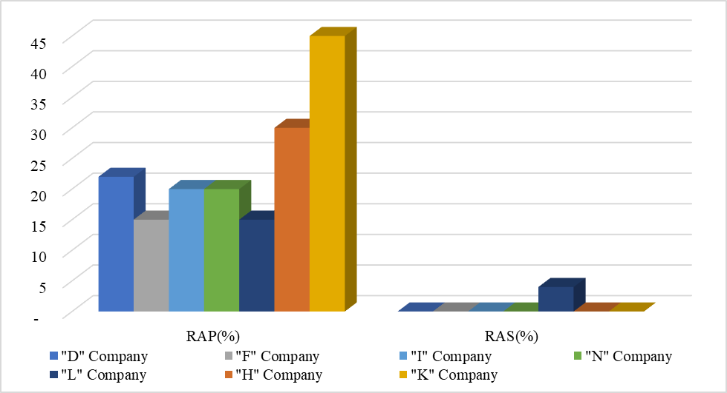
Figure 3-3. Summary of average RAP/RAS percentage used in asphalt mixes in 2019

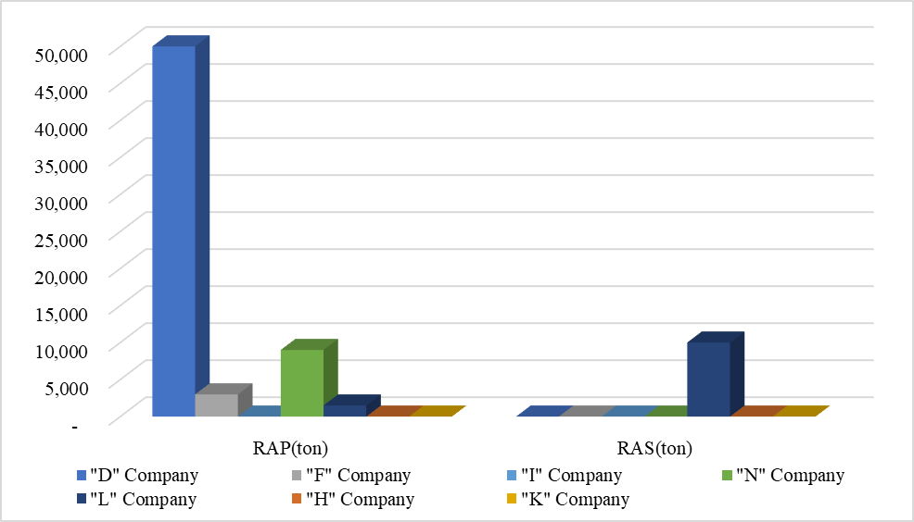
Figure 3-4. Summary of Excess RAP and RAS in inventory at the end of 2019

RAP Processing Equipment
RAP processing involves steps to create consistent materials that can be used for high RAP mixes. The RAP processing increases a control while lowering a variability. Milled RAP materials from traceable sources produce consistent properties and may not require further processing. It may be desirable to screen or fractionate RAP from a traceable source to remove oversize particles or to separate RAP into coarse and fine stockpiles to increase the amount of RAP that can be used in high RAP mixes. Whether or not the RAP is fractionated, a scalping screen will prevent lumps from entering the hot mix plant, including those that form in even fine fractionated stockpiles (West 2010).
Typical jaw and cone crushers and hammermill crushers create too many fine materials whereas horizontal-shaft impactors, roller, or mill-type breakers break up chunks of pavement not aggregates. Therefore, it is important to set up a crushing operation such that the RAP is screened before it enters the crusher, which will allow the finer RAP particles to bypass the crusher. Figure 3-5 shows a portable RAP crushing unit that is equipped with a screen deck in line before the crusher where only RAP particles retained on the screen will pass through the crusher (West et al. 2016). A simple extracted gradation check of RAP samples should be performed before and after the in-line crusher to determine if it is breaking down RAP aggregates too fine. The advantages and disadvantages of RAP processing methods is summarized at Table 3-2 (West et al. 2016).
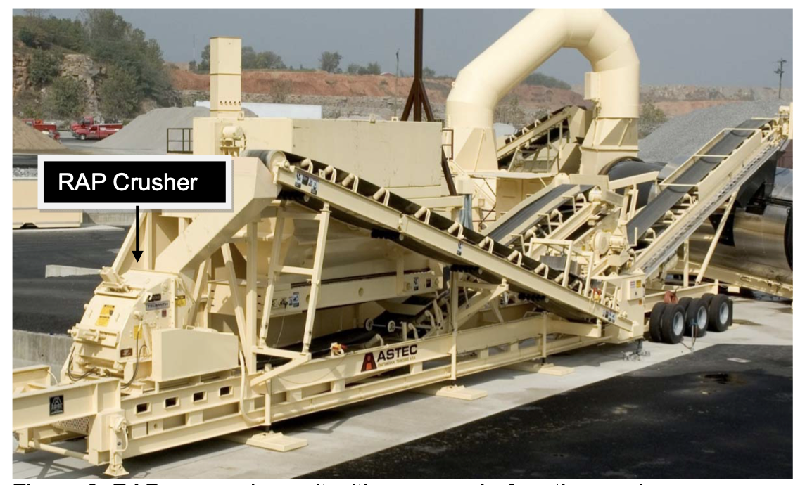
Figure 3-5. RAP processing unit with a screen before the crusher (West et al. 2016)

Table 3-2. Pros and Cons of Milling, Screening, and Crushing Operations (West et al. 2016)
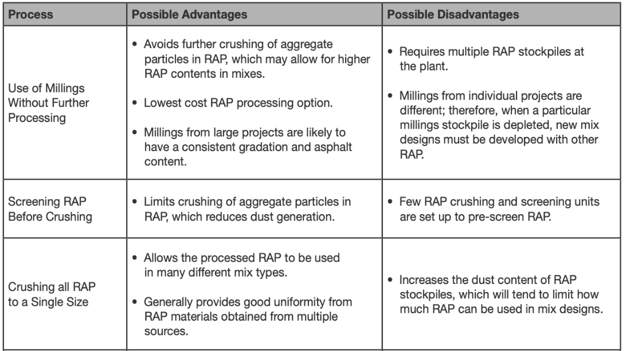

Fractionation Operations
While recycled asphalt materials (RAM) are being widely used around the country, their usage has been limited due to a difficulty in meeting the required aggregate gradation. Creating separate stockpiles through the fractionation process would result in consistent asphalt content and aggregate gradation, which would allow for the use of increased percentages of RAP. Particularly, for high-RAP mixes, a fractionation allows engineers to better control the quality of materials. Fine RAP materials are used in reduced proportions in the mix, thereby decreasing the amount of fine aggregate materials in the high-RAP mixtures. On the contrary, because the asphalt binder content on finer RAP materials would be higher than coarser RAP materials, to maximize the use of RAP asphalt binder, a higher quantity of finer RAP materials should be used than coarser RAP materials.
Among 27 states, not including Iowa, which use a fractionation, 21% of RAP was fractionated, which went down from 24% in 2018 (NAPA 2020). The most common fractionating sizes were 3/4″, 3/8″ and No. 4 and, in some cases, the plus 3/4″ size material was returned to a crusher and the crushed material was then returned to the screening unit (West and Marasteanu 2013). However, in Virginia, RAP materials were fractionated at 1/4″, 5/8″ and 1-inch sieves and, in Illinois, all RAP materials are fractionated by screening into a minimum of two size fractions with the separation occurring on or between the #4 (4.75 mm) and 1/2 in. (12.5 mm) sieves. Table 3-3 shows a fractionation requirement of two sizes for RAP stockpiles in Illinois.
Table 3-3. Illinois DOT’s RAP Stockpile Classification System
Fractionated RAP (FRAP) | Homogenous RAP | Conglomerate RAP | Non-Quality
Requirements  - May represent more than one aggregates type or quality  - At least C quality  - Min. two size fractions  - 100% pass 1.5, ¾, or 1/2inches | Requirements  - Same aggregate  - At least C quality  - Similar gradation A/C | Requirements  - May represent more than one aggregates type or quality  - Unknown/Poor Aggregate | Requirements  - RAP stockpiles that do not meet the requirements of the stockpile categories

Laboratory evaluation of high raP mixtures with REJUVENATORS

The previous research identified FTIR, DCT and HWT tests as potential test procedures for evaluating high RAM mixtures. Because the PAV-aged asphalt samples were used for the FTIR test in the previous study, to be closer to the actual phenomenon, in this study, the binder obtained from RAP was adopted. HWT and DCT tests were then performed on RAM mixtures with various rejuvenators to determine how these rejuvenators affect a moisture susceptibility and a low-temperature cracking of high-RAP mixtures, respectively.

Fourier Transform Infrared (FTIR) Test on Binder from RAP Materials
Fourier-Transform Infrared (FTIR) test is commonly used to identify certain molecules or functional groups and the concentration of those molecules within a sample. FTIR spectrometers are less expensive than conventional spectrometers since producing an interferometer is easier than the fabrication of a monochromator (Smith 2011). In addition, measurement of a single spectrum is much faster for the FTIR technique as the information at all frequencies can be collected simultaneously (Ramasamy 2010).
The asphalt absorbs different wavelengths and create a unique interferogram of reflected lights, which is then processed using Fourier transform algorithm to derive the transmittance level for each wavelength (Sun et al. 2014). The FTIR measures amounts of Infrared light that are absorbed by asphalt at wavelengths between 4,000 cm⁻¹ to 400 cm⁻¹. To analyze the aging condition of asphalt quantitatively, the peak areas of oxygenated functional groups of sulfoxide (S=O) and carbonyl (C=O), which represent the degrees of asphalt aging, should be observed at 1032cm⁻¹ and 1699cm⁻¹, respectively (Chen et al. 2014). Rejuvenators are expected to decrease these sulfoxide and carbonyl peaks found in the aged asphalt (Chen et al. 2014; Cong et al. 2015).
4.1.1. FTIR Test Procedure
To run the test using the FTIR equipment, as shown Figure 4-‎1, the following steps should be taken:
- Take specific amount of binder (the same for all samples) and dilute it using a solvent (Tetrahydrofuran, THF, was used for this study).
- Shake very well to make the blend homogeneous (2-3 minutes is adequate).
- Put salt windows (NaCl in this case) under the instrument and take the background spectrum.
- Pour adequate amount of the diluted sample between two windows and place them under the instrument.
- Examine the spectrum and save it.
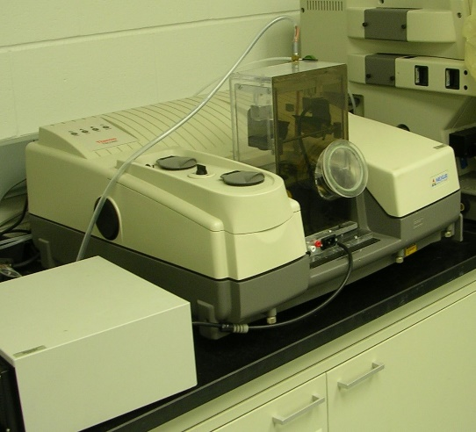
Figure 4-1. FTIR test equipment used for this study

FTIR results for rejuvenated binder can be performed by analyzing FTIR spectra of the sulfoxide (S=O) peak occurring at 1032 cm⁻¹, which corresponds to the oxidation of compounds containing sulfur, and the carbonyl (C=O) peak at 1699 cm⁻¹, which corresponds to the oxidation of carbonyl compounds. The saturated C-H peak occurs at 1459 cm⁻¹, which is used as a reference point. To determine the degree of oxidation, sulfoxide index (SI) and carbonyl index (CI) can be calculated using Equation 4-1 and Equation 4-2, where a larger value indicates a higher degree of oxidation (Chen et al., 2014). Figure 4-2 shows an integration of an area of an example FTIR spectrum using a baseline method.

Sulfoxide Index (4-1)
Carbonyl Index (4-2)
where,
, and are absorption peak areas of sulfoxide, carbonyl and saturated C-H group, respectively
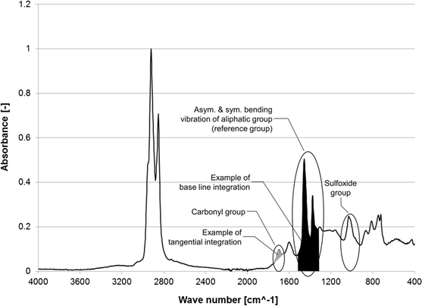
Figure 4-2.FTIR absorbance spectrum of PAV aged asphalt sample (Hofko et al. 2017)
4.1.2. FTIR Test Results
The FTIR tests were performed to determine the effect of rejuvenators on restoring the oxidation of the aged binder to a virgin binder. In the previous study, for the FTIR test, we have used extracted binder from the PAV-binder. However, for this study, to evaluate the actual effect of rejuvenators on RAP, we obtained test samples by scratching asphalt from the heated RAP. As summarized in Table 4-1, A total of six rejuvenators (including three rejuvenators used in phase 3) were evaluated for their effectiveness in restoring RAP binder to a virgin binder.

Table 4-1. Details of rejuvenators
Product name | Property | ID used in Phase3/Phase4 | Research Phase
NH300PL | Bio-Based oil | R1 | Phase 4
NH303PL | Bio-Based oil | R2 | Phase 4
ANOVA | Bio-Based oil | A/R3 | Phase 3,4
Cyclogen | Petroleum oil | C/R4 | Phase 3,4
Sylvaroad | Refined tall oil | B/R5 | Phase 3,4
TUFFTREK4002 | Bio-Based oil | R6 | Phase 4
      - PAV binders tested during Phase 3
To simulate the long-term aging of the binder, the PAV aging procedure (40-hr, double, at 100 °C under 2.1 MPa) was applied and this PAV-aged binder was blended with varying dosages of three rejuvenators. As can be seen from Table 4-2, there existed significant differences among average values of sulfoxide and carbonyl indices of eight different asphalt binder types.
Figure 4-3 shows the spectrum of each rejuvenator with a single dosage rate to observe differences among rejuvenators. To indicate a chemical reaction between two materials, there should be a new peak for a certain wavenumber or a horizontal shift in spectra. Since all binder types produced similar spectra, it can be concluded that the chemistry of asphalt binder has not been greatly affected by rejuvenators. A consistent vertical shift in spectra was observed with some changes in peak values which may confirm that the reaction between rejuvenators and aged binder is mostly physical rather than being chemical. It should be noted that SI and CI values did not change linearly as the amount of a rejuvenator increased. Therefore, it can be postulated that there might be some chemical reactions between rejuvenators and the aged asphalt binder. It is interesting to note that spectra for aged and virgin binder are very similar although chemical reactions should have occurred during the aging process.
Figure 4-4 (a) shows a plot of the SI values of eight binder types. As expected, the PAV-aged samples exhibited a significant increase in the SI value. The rejuvenated asphalt samples exhibited lower SI value than the PAV-aged asphalt but higher SI value than that of the virgin asphalt binder. Figure 4-4 (b) shows CI values of the same samples. As can be seen from Figure 4-4, all rejuvenators reduced the oxidation levels of both sulfur and carbon whereas Rejuvenator “C” and Rejuvenator “A” were more effective in reducing the level of carbon oxidation than Rejuvenator “B”. Overall, the standard deviations of SI and CI values, shown as error bar representing one standard deviation on top of each bar, seemed to be quite large, which indicates a high variability in FTIR measurements. It can be postulated that these high variabilities in measurements were caused by the FTIR instrument because the same sample was used for six repeated measurements for each binder type.

Table 4-2. Sulfoxide and Carbonyl index values for each binder type performed during Phase 3
 | C-H area | S=O area | C=O area | Sulfoxide Index | Carbonyl Index | avg SI | avg. CI | stv. SI | stv. CI
Virgin Binder | 12.25 | 0.821 | 0.668 | 6.70 | 5.45 | 7.03 | 5.40 | 0.612 | 0.425
 | 13.05 | 0.829 | 0.641 | 6.35 | 4.91
 | 10.86 | 0.789 | 0.595 | 7.27 | 5.48
 | 8.95 | 0.693 | 0.498 | 7.74 | 5.56
 | 10.22 | 0.784 | 0.618 | 7.67 | 6.05
 | 12.38 | 0.799 | 0.612 | 6.45 | 4.94
PAV | 20.16 | 1.562 | 1.423 | 7.75 | 7.06 | 8.20 | 7.94 | 1.042 | 0.812
 | 22.02 | 1.537 | 1.498 | 6.98 | 6.80
 | 16.25 | 1.546 | 1.4 | 9.51 | 8.62
 | 18.064 | 1.58 | 1.503 | 8.75 | 8.32
 | 17.56 | 1.586 | 1.528 | 9.03 | 8.70
 | 18.475 | 1.328 | 1.508 | 7.19 | 8.16
A7.5 | 15.623 | 1.119 | 0.889 | 7.16 | 5.69 | 7.94 | 6.31 | 0.517 | 0.635
 | 14.265 | 1.16 | 0.861 | 8.13 | 6.04
 | 12.956 | 0.982 | 0.825 | 7.58 | 6.37
 | 11.251 | 0.975 | 0.846 | 8.67 | 7.52
 | 15.515 | 1.236 | 0.936 | 7.97 | 6.03
 | 14.686 | 1.194 | 0.909 | 8.13 | 6.19
A15 | 17.32 | 1.231 | 1.013 | 7.11 | 5.85 | 7.69 | 5.69 | 0.560 | 0.333
 | 17.23 | 1.463 | 1.051 | 8.49 | 6.10
 | 15.89 | 1.155 | 0.85 | 7.27 | 5.35
 | 16.18 | 1.2 | 0.856 | 7.42 | 5.29
 | 16.98 | 1.29 | 1.012 | 7.60 | 5.96
 | 15.97 | 1.319 | 0.891 | 8.26 | 5.58
C8 | 15.698 | 0.984 | 0.9325 | 6.27 | 5.94 | 7.39 | 6.57 | 1.049 | 0.722
 | 15.248 | 1.075 | 0.923 | 7.05 | 6.05
 | 16.245 | 1.186 | 1.135 | 7.30 | 6.99
 | 14.658 | 1.285 | 1.123 | 8.77 | 7.66
 | 15.021 | 0.965 | 1.036 | 6.42 | 6.90
 | 14.909 | 1.271 | 0.8775 | 8.53 | 5.89
C16 | 17.06 | 1.325 | 0.907 | 7.77 | 5.32 | 7.36 | 5.42 | 0.531 | 0.467
 | 16.258 | 1.132 | 0.886 | 6.96 | 5.45
 | 15.0653 | 1.12 | 0.804 | 7.43 | 5.34
 | 15.135 | 0.984 | 0.828 | 6.50 | 5.47
 | 17.012 | 1.3 | 0.805 | 7.64 | 4.73
 | 12.4057 | 0.977 | 0.768 | 7.88 | 6.19
S5 | 19.08 | 1.356 | 1.298 | 7.11 | 6.80 | 7.77 | 6.95 | 0.368 | 0.232
 | 16.287 | 1.302 | 1.156 | 7.99 | 7.10
 | 17.064 | 1.321 | 1.212 | 7.74 | 7.10
 | 15.954 | 1.272 | 1.156 | 7.97 | 7.25
 | 14.846 | 1.208 | 0.989 | 8.14 | 6.66
 | 16.809 | 1.29 | 1.138 | 7.67 | 6.77
S10 | 15.894 | 1.202 | 1.067 | 7.56 | 6.71 | 7.46 | 5.91 | 0.173 | 0.689
 | 16.517 | 1.267 | 0.974 | 7.67 | 5.90
 | 18.09 | 1.309 | 1.059 | 7.24 | 5.85
 | 17.846 | 1.301 | 0.968 | 7.29 | 5.42
 | 16.891 | 1.281 | 1.12 | 7.58 | 6.63
 | 17.519 | 1.304 | 0.863 | 7.44 | 4.93

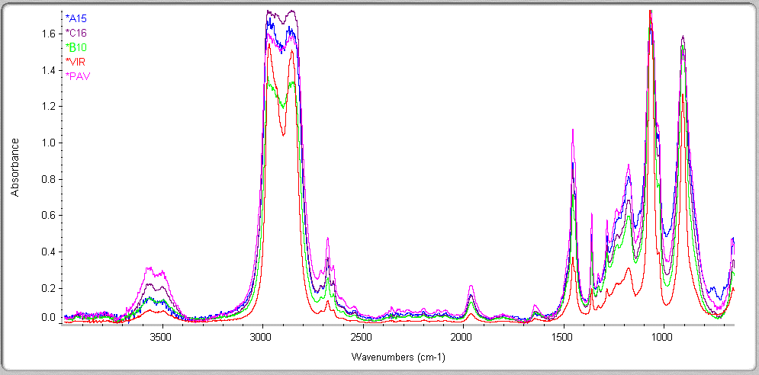
Sulfoxide
Saturated C-H group
Carbonyl
Figure 4-3. FTIR test results of the aged and rejuvenated samples for one dosage of rejuvenators (C16: 16% Rejuvenator “C”; B10: 10% Rejuvenator “B”; A15: 15% Rejuvenator “A”)
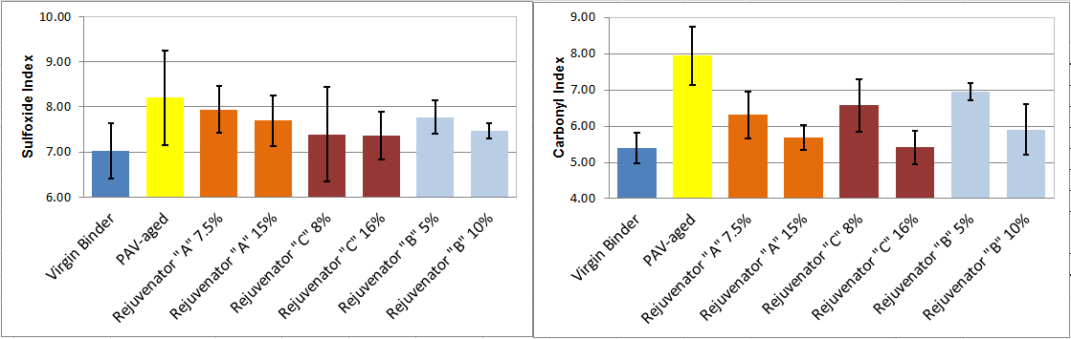
(a) Sulfoxide index (b) Carbonyl index
Figure 4-4. Oxidation levels of eight different binder types
      - Scratched binder from RAP tested during phase 4
For this study, test samples were obtained by scratching a binder from the heated RAP. We then mixed the scratched binder with each of six rejuvenators at 10% dosage rate. The FTIR test results are summarized in Table 4-3 and plotted in Figure 4-5. Figure 4-5(a) shows quite similar SI value for PAV-aged and scratched RAP binder of 4.56 and 4.67 respectively and all rejuvenators decreased SI value except R3. Figure 4-5(b) shows CI value of a scratched RAP binder (0.6) was significantly lower than that of PAV-aged binder (4.46). All rejuvenators increased CI value except R5. It can be postulated that carbonyl oxide content is too low in RAP binder compared to that of PAV resulting in consistently lower CI values in all RAP binder with rejuvenators.

Table 4-3. Sulfoxide and Carbonyl index values for each binder type during Phase 4
 | C-H area | S=O area | C=O area | Sulfoxide Index | Carbonyl Index | avg SI | avg. CI | stv. SI | stv. CI
PAV | 6.653 | 0.3 | 0.28 | 4.51 | 4.21 | 4.56 | 4.46 | 0.288 | 1.177
 | 12.13 | 0.6 | 0.52 | 4.95 | 4.29
 | 11.56 | 0.5 | 0.56 | 4.33 | 4.84
 | 7.05 | 0.3 | 0.43 | 4.26 | 6.10
 | 8.438 | 0.4 | 0.24 | 4.74 | 2.84
RAP | 13.196 | 0.705 | 0.063 | 5.34 | 0.48 | 4.67 | 0.60 | 0.408 | 0.157
 | 11.728 | 0.523 | 0.075 | 4.46 | 0.64
 | 10.478 | 0.456 | 0.0799 | 4.35 | 0.76
 | 27.317 | 1.209 | 0.1958 | 4.43 | 0.72
 | 13.519 | 0.644 | 0.0536 | 4.76 | 0.40
R1 | 9.119 | 0.432 | 0.04 | 4.74 | 0.44 | 4.52 | 2.92 | 0.632 | 2.796
 | 7.563 | 0.37 | 0.08 | 4.89 | 1.06
 | 17.27 | 0.685 | 1.2714 | 3.97 | 7.36
 | 18.867 | 0.709 | 0.3595 | 3.76 | 1.91
 | 10.375 | 0.544 | 0.4 | 5.24 | 3.86
R2 | 14.082 | 0.615 | 0.03 | 4.37 | 0.21 | 3.94 | 0.74 | 1.391 | 0.676
 | 4.987 | 0.3 | 0.03 | 6.02 | 0.60
 | 14.604 | 0.399 | 0.1265 | 2.73 | 0.87
 | 17.358 | 0.452 | 0.0311 | 2.60 | 0.18
 | 10.248 | 0.41 | 0.1882 | 4.00 | 1.84
R3 | 2.27 | 0.2 | 0.03 | 8.81 | 1.32 | 5.10 | 0.89 | 2.088 | 0.797
 | 11.831 | 0.48 | 0.1033 | 4.06 | 0.87
 | 10.485 | 0.454 | 0.0072 | 4.33 | 0.07
 | 9.086 | 0.35 | 0.18 | 3.85 | 1.98
 | 12.459 | 0.554 | 0.0238 | 4.45 | 0.19
R4 | 15.314 | 0.665 | 0.03 | 4.34 | 0.20 | 3.28 | 1.21 | 1.025 | 0.837
 | 1.81 | 0.07 | 0.02 | 3.87 | 1.10
 | 11.749 | 0.274 | 0.199 | 2.33 | 1.69
 | 13.245 | 0.507 | 0.0961 | 3.83 | 0.73
 | 5.1908 | 0.106 | 0.1218 | 2.04 | 2.35
R5 | 6.615 | 0.33 | 0.03 | 4.99 | 0.45 | 3.81 | 0.44 | 0.804 | 0.126
 | 12.024 | 0.4 | 0.05 | 3.33 | 0.42
 | 10.568 | 0.312 | 0.069 | 2.95 | 0.65
 | 14.826 | 0.624 | 0.05 | 4.21 | 0.34
 | 14.089 | 0.5 | 0.05 | 3.55 | 0.35
R6 | 6.66 | 0.4 | 0.04 | 6.01 | 0.60 | 4.51 | 0.70 | 1.430 | 0.482
 | 8.2 | 0.43 | 0.03 | 5.24 | 0.37
 | 19.238 | 0.636 | 0.03 | 3.31 | 0.16
 | 6.633 | 0.178 | 0.07 | 2.68 | 1.06
 | 19.477 | 1.031 | 0.257 | 5.29 | 1.32
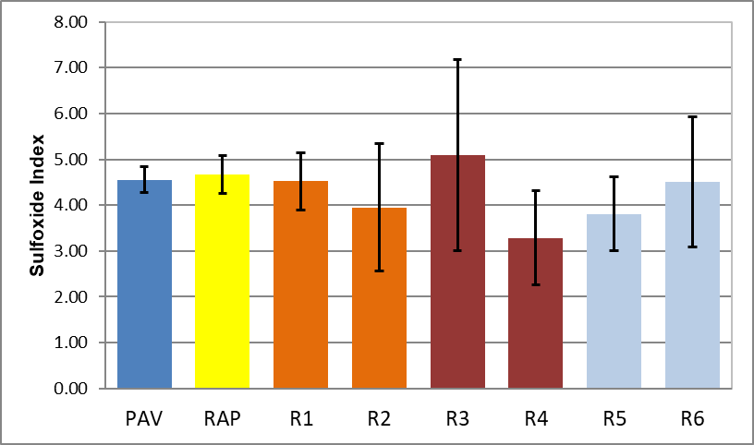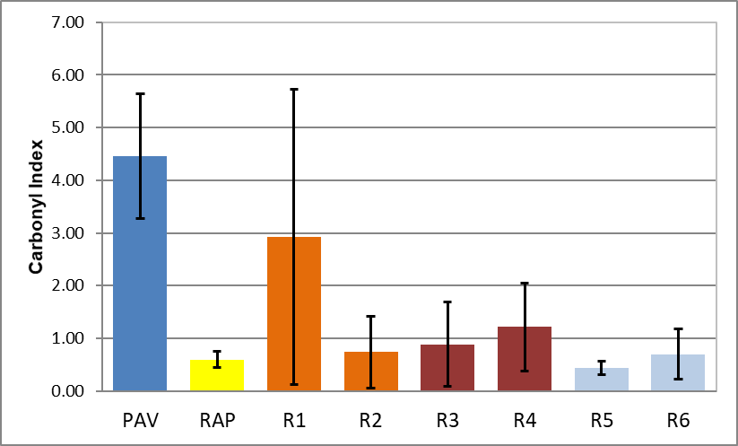
(a) Sulfoxide index (b) Carbonyl index
Figure 4-5. Oxidation levels of eight different binder types

Evaluation of RAP Mixtures with Six Rejuvenators using Hamburg Test
Following AASHTO T324, the Hamburg Wheel-Tracking (HWT) test was performed on specimens submerged under water at a temperature of 50ºC. The HWT measures the mixture's ability to resist the moisture sensitivity and rutting. The specimens were prepared with air voids at 7 ± 0.5% with a diameter of 150 mm and a height of approximately 60 ± 0.5 mm.
First, RAP materials were divided into three categories of coarse (sieve size between 25~12.5mm), middle (sieve size between 9.5~1.18mm) and fine (sieve size between 0.6mm~75 μm). To obtain consistent specimens, RAP materials from coarse, middle and fine categories were added in original proportions of 30%, 40%, and 30%, respectively. The specimens with 30% RAP materials and six rejuvenators were subjected to HWT test and HWT test results are plotted in Figure 4-6. As can be seen from Figure 4-6, the control mix (without Rejuvenator) reached maximum rut depth of 20mm at 15,500 passes. Four rejuvenated mixtures (R2 with 4.2mm, R1 with 9.4mm and R6 and R4 with 20mm) exhibited less rutting than the control mix whereas mixtures with R3 and R4 reached maximum rutting depth of 20mm at lower loading repetitions than the control mix.
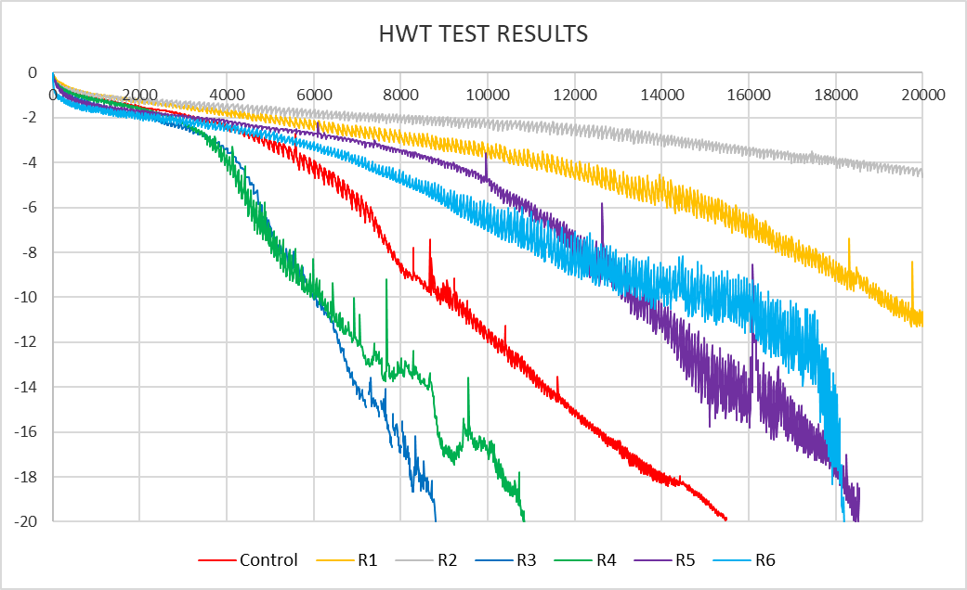
Figure 4-6. HWT test results of 30%RAP mixes with six different rejuvenators

Laboratory Evaluation of Fractionated High RAP mixtures

The main objective of this task is to determine if a fractionation into two stockpiles (coarse and fine) would improve the performance of high RAP mixes. First, as shown in Appendix A, classified RAP was obtained from a local contractor, which include 4.86% binder and 46% crushed particles. Second, as shown in Table 5-1, to identify the sieve size to divide RAP materials into two stockpiles, RAP materials were sieved. As can be seen from Table 5-1, gradation of RAP materials was coarse due to the conglomerates of RAP materials stuck together with virtually none passing sieve No. 100. To divide RAP materials into two groups with each being similar, sieve No. 4 was selected (54.2% coarse and 45.8% fine).
To evaluate the impact of fractionation of the RAP mixtures, 34% RAP and 45% RAP mixtures were prepared by adding appropriate amounts of aggregates at the laboratory. As can be seen from Table 5-2, different proportions of three aggregate stockpiles were added to 34% and 45% RAP materials resulting in the combined extracted aggregate gradations as shown in Figure 5-1. The extracted aggregate gradation from RAP materials is shown in Appendix A.
Table 5-1. Sieve Test Results of Classified RAP materials
Sieve Size | Weight (g) |  |  |  |  |  |  |  |  |  |  | Total Weight of each (g) | % remain weight | % Passing | Cumulative % Retained
 | 1 | 2 | 3 | 4 | 5 | 6 | 7 | 8 | 9 | 10 | 11
1/2" | 180.3 | 92.8 | 150.3 | 168.8 | 188.3 | 143.4 | 121.2 | 126.1 | 114.7 | 142.7 | 150.7 | 1579.3 | 9.6 | 90.4 | 9.6
3/8" | 156.7 | 131.6 | 138.5 | 154.1 | 153.8 | 129.6 | 126.9 | 173.1 | 137.5 | 179.1 | 156.8 | 1637.7 | 9.9 | 80.5 | 19.5
No. 4 | 561.6 | 507.1 | 516.9 | 534.0 | 522.5 | 542.9 | 462.3 | 519.1 | 482.3 | 540.0 | 529.7 | 5718.4 | 34.7 | 45.8 | 54.2
No. 8 | 336.0 | 387.6 | 324.9 | 334.3 | 358.3 | 338.0 | 345.7 | 315.9 | 338.5 | 300.0 | 322.5 | 3701.7 | 22.4 | 23.4 | 76.6
No. 16 | 136.0 | 201.3 | 154.1 | 168.8 | 218.4 | 171.1 | 188.6 | 158.0 | 183.6 | 135.2 | 152.7 | 1867.8 | 11.3 | 12.0 | 88.0
No. 30 | 74.9 | 167.8 | 109.1 | 132.4 | 126.1 | 160.2 | 173.2 | 143.1 | 169.9 | 114.7 | 147.0 | 1518.4 | 9.2 | 2.8 | 97.2
No. 50 | 38.6 | 31.0 | 21.6 | 28.0 | 6.6 | 28.5 | 4.1 | 66.9 | 76.9 | 62.9 | 60.3 | 425.4 | 2.6 | 0.3 | 99.7
No. 100 | 9.7 | 0.8 | 3.0 | 1.0 | 1.3 | 1.4 | 2.4 | 3.2 | 4.0 | 5.0 | 2.0 | 33.8 | 0.2 | 0.1 | 99.9
No. 200 | 2.8 | 0.9 | 0.1 |  | 0.2 | 0.1 | 0.5 | 0.1 | 0.7 | 0.5 | 0.8 | 6.7 | 0.0 | 0.0 | 100.0
Pan | 1.6 | 0.1 |  |  |  |  |  |  |  |  |  | 1.7 | 0.0 | 0.0 | 100.0

Table 5-2. Aggregates Gradation
Mixture |  | 45% RAP |  |  |  |  | 34% RAP
Aggregate |  | 1/2" Clean | Man. Sand | Nat. Sand | RAP | Comb. | 1/2" Clean | 3/8 AC Stone | Man. Sand | Nat. Sand | RAP | Comb.
Percent in mix |  | 16.0 | 23.0 | 16.00 | 45.0 | 100.0 | 20.0 | 5.0 | 22.0 | 19.00 | 34.0 | 100.0
% Pass | 3/4 in. | 100 | 100 | 100 | 100 | 100 | 100 | 100 | 100 | 100 | 100 | 100
 | 1/2 in. | 88.4 | 100 | 100 | 95 | 95.9 | 88.4 | 100 | 100 | 100 | 95 | 96.0
 | 3/8 in. | 54 | 100 | 100 | 89 | 87.7 | 54 | 100 | 100 | 100 | 89 | 87.1
 | #4 | 4.7 | 81.8 | 93 | 71 | 66.4 | 4.7 | 90.1 | 81.8 | 93 | 71 | 65.3
 | #8 | 1.8 | 33.4 | 79 | 54 | 44.9 | 1.8 | 55 | 33.4 | 79 | 54 | 43.8
 | #16 | 1.7 | 13.7 | 61 | 41 | 31.6 | 1.7 | 35.3 | 13.7 | 61 | 41 | 30.6
 | #30 | 1.7 | 6.7 | 39 | 31 | 22.0 | 1.7 | 25.8 | 6.7 | 39 | 31 | 21.1
 | #50 | 1.7 | 3.1 | 10 | 20 | 11.6 | 1.7 | 20.5 | 3.1 | 10 | 20 | 10.7
 | #100 | 1.6 | 1.5 | 0.8 | 14 | 7.0 | 1.6 | 15.6 | 1.5 | 0.8 | 14 | 6.3
 | #200 | 1.4 | 0.8 | 0.3 | 12 | 5.9 | 1.4 | 11.4 | 0.8 | 0.3 | 12 | 5.2

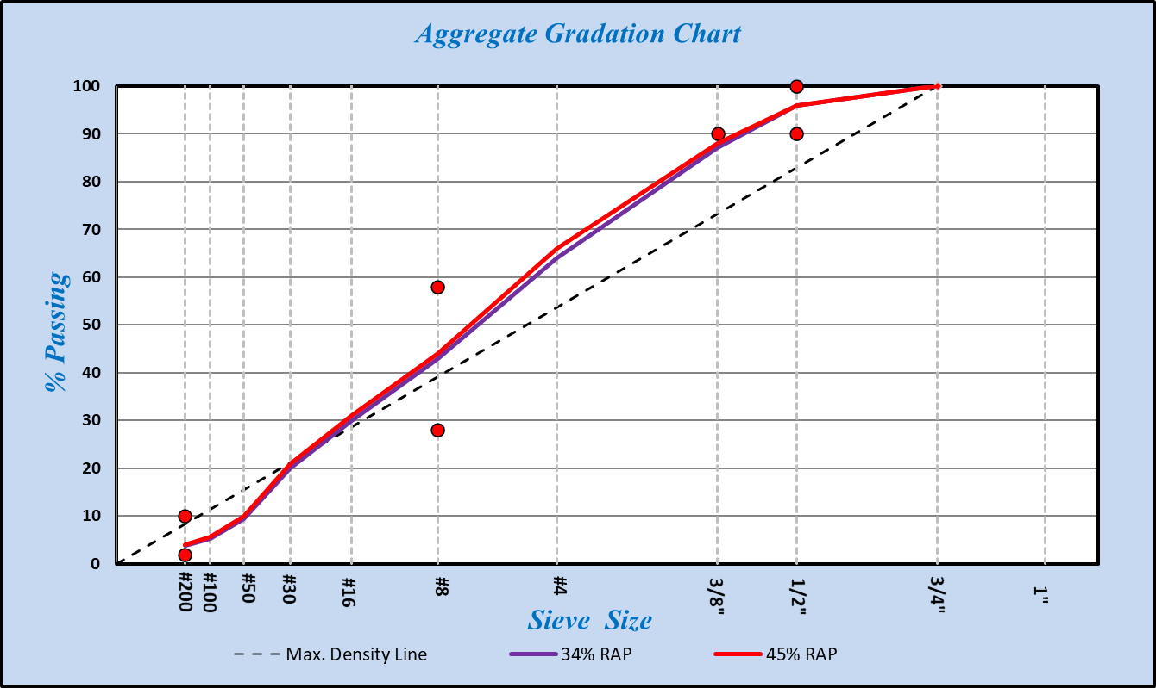
Figure 5-1. Combined extracted aggregate gradations for 34% and 45% RAP mixtures

HWT Test Results of Fractionated and Non-fractionated Mixtures
Fractionated mixtures were prepared by adding appropriate amounts from two different RAP stockpiles sieved at No.8 whereas non-fractionated mixtures were prepared by adding appropriated amount from a single RAP stockpile. As a result, it is expected that fractionated RAP mixtures will be more consistently graded than non-fractionated mixtures. As summarized in Table 5-3, four mix types of two RAP contents with and without fractionation were prepared.

Table 5-3. Components of 34% and 45% RAP Mixtures
No | ID | Fractionation | Binder | RAP | Total AC (%)
1 | 34%RAP_No Frac | No | PG58-28S | 34% | 5.18
2 | 34%RAP_Frac | Yes | PG58-28S | 34% | 5.18
3 | 45%RAP_No Frac | No | PG58-28S | 45% | 5.39
4 | 45%RAP_Fract | Yes | PG58-28S | 45% | 5.39

The HWT test results for both fractionated and non-fractionated mixtures with 34% and 45% RAP are plotted in Figure 5-2. As can be seen from Figure 5-2, for 34% RAP mixtures, fractionated mixture exhibited 5mm rut depth, whereas non-fractionated mixtures exhibited 9.8mm rut depth at 20,000 load cycle. Similarly, for 45% RAP mixtures, 6mm, and 12mm rut depth were observed with fractionated and non-fractionated mixture, respectively. It can be concluded that fractionation of the RAP can improve moisture susceptibility in both 34% and 45% mixtures. It should be also noted that 34% RAP mixtures performed better than 45% RAP mixtures while all mixture met the criterion of a minimum stripping inflection point (SIP) of 10,000 passes.

Figure 5-2. HWT test results of fractionated/non-fractionated mixtures with 34% and 45% RAP

SCB-IFIT Test Results
The SCB-IFIT tests were performed by following the AASHTO TP124. Samples for SCB-IFIT test were made with 150mm diameter and 160mm height and specimens were compacted to a target air void of 7%±0.5%. The compacted samples were then cut for the SCB test specimens with 50 mm thickness discarding the top and bottom 30mm of 160mm tall specimen. The notch was made at 15mm in length and 1.5mm of width. All specimens were conditioned at 25ºC for 2 hours before performing a test.

A typical force-displacement curve from SCB test is illustrated in Figure 5-3, which show work of fracture (W_{f}) as an area under the curve and a post-peak slope at inflection point after the peak point (m). These parameters were used to calculate a fracture energy (G_{F}) using Equation 5-1 and flexibility index (FI) using Equation 5-2.
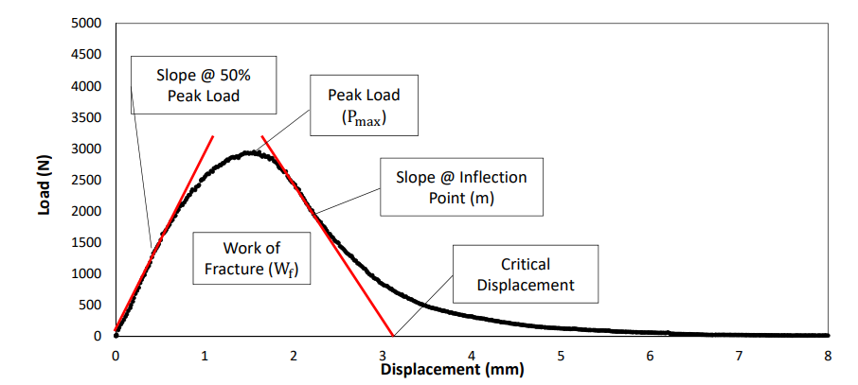
Figure 5-3. A typical force-displacement curve from SCB test and parameters for evaluation

Fracture Energy (G_{F}) can be calculated using an equation below:
(5-1)

where,
W_{F} is work of fracture,
B is specimen thickness, and
L is ligament length.

The flexible index (FI) can be calculated an equation below:

(5-2)

where,
G_{F} is fracture energy calculated by dividing work of fracture by the ligament area,
m is the post-peak slope at inflection point after the peak point, and
A is a unit conversion from field to lab. (0.01, lab-compacted specimen)

A total of 16 samples were prepared: four samples for each of four combinations of fractionated/non-fractionated and 34%/45% RAP materials. The SCB-IFIT test results are summarized in Table 5-4 and plotted in Figure 5-4 with an error bar representing one standard deviation. For 34% RAP mixtures, compared to the non-fractionated mixture, fractionated mixture endured the higher fracture energy with almost same post-peak slope, which resulted in the higher FI value than non-fractionated mixture. Similarly, for 45% RAP mixtures, the fractionated mixture obtained the higher FI than non-fractionated mixture. Given the limited test results, it can be concluded that fractionation can improve a cracking resistance of both 34% and 45% RAP mixtures. It should be also noted that, overall, 34% mixtures performed better than 45% RAP mixtures.

Table 5-4. SCB Test Results for Mixtures
ID | PEAK LOAD (KN) | STDEV | Fracture Energy  (J/m²⁾ | STDEV | Post-Peak Slope  (kN/mm) | STDEV | FI | STDEV
34%RAP_No | 4.48 | 0.11 | 1283.25 | 160.80 | -5.96 | 0.49 | 2.19 | 0.45
34%RAP_Frac | 5.25 | 0.13 | 1685.43 | 21.60 | -6.00 | 0.28 | 2.81 | 0.09
45%RAP_No | 6.31 | 0.25 | 1602.17 | 123.48 | -9.36 | 0.57 | 1.71 | 0.04
45%RAP_Frac | 6.36 | 0.42 | 1534.39 | 266.34 | -8.30 | 0.40 | 1.85 | 0.31

Figure 5-4. SCB test results of 34% and 45% RAP mixtures

Evaluation of Mixtures with RecYCLED Asphalt Shingle and Rejuvenators

Recycled asphalt shingles (RAS) materials were obtained from a local contractor, as shown in Appendix B that shows 98% extracted aggregates passing No.4 sieve with 19.35% binder content. As summarized in Table 6-1, asphalt mixtures were prepared with 11% RAS (27% by binder replacement) and three rejuvenators at a constant dosage rate of 3%. It should be noted only 67 percent of the asphalt binder from RAS was assumed “active,” where 67% of the binder from RAS was considered in calculating a total binder content. Table 6-2 shows the aggregate gradations and the combined gradation is plotted in Figure 6-1.

Table 6-1. Description of Asphalt Mixtures 11% RAS and with rejuvenators
No | ID | Rejuvenator | Binder | Total AC (%) | % Binder from RAS | % Binder replacement
1 | 11%RAS_Control | - | PG58-28S | 5.38 | 1.43 | 27
2 | 11%RAS_TUFF | TUFF TREK
3 | 11%RAS_300PL | NH 300PL
4 | 11%RAS_303PL | NH 303PL

Table 6-2. Aggregates Gradation
Mixture |  | 3/4 Clean | 3/8 to Dust | T4 Man Sand | Sand | RAS | Combined
Percent in mix |  | 18.0 | 12.0 | 33.0 | 26.0 | 11.0 | 100.0
%Pass | 3/4 in. | 100 | 100 | 100 | 100 | 100 | 100
 | 1/2 in. | 55 | 100 | 100 | 100 | 100 | 91.9
 | 3/8 in. | 19 | 90 | 100 | 100 | 100 | 84.2
 | #4 | 7 | 29 | 99 | 95 | 95 | 72.6
 | #8 | 2 | 14 | 74 | 90 | 85 | 59.2
 | #16 | 1 | 10 | 40 | 79 | 70 | 42.8
 | #30 | 1 | 8 | 20 | 53 | 50 | 27.0
 | #50 | 1 | 7 | 8 | 16 | 45 | 12.8
 | #100 | 1 | 6 | 5 | 2 | 35 | 6.9
 | #200 | 1 | 5.5 | 3.8 | 1 | 25 | 5.1

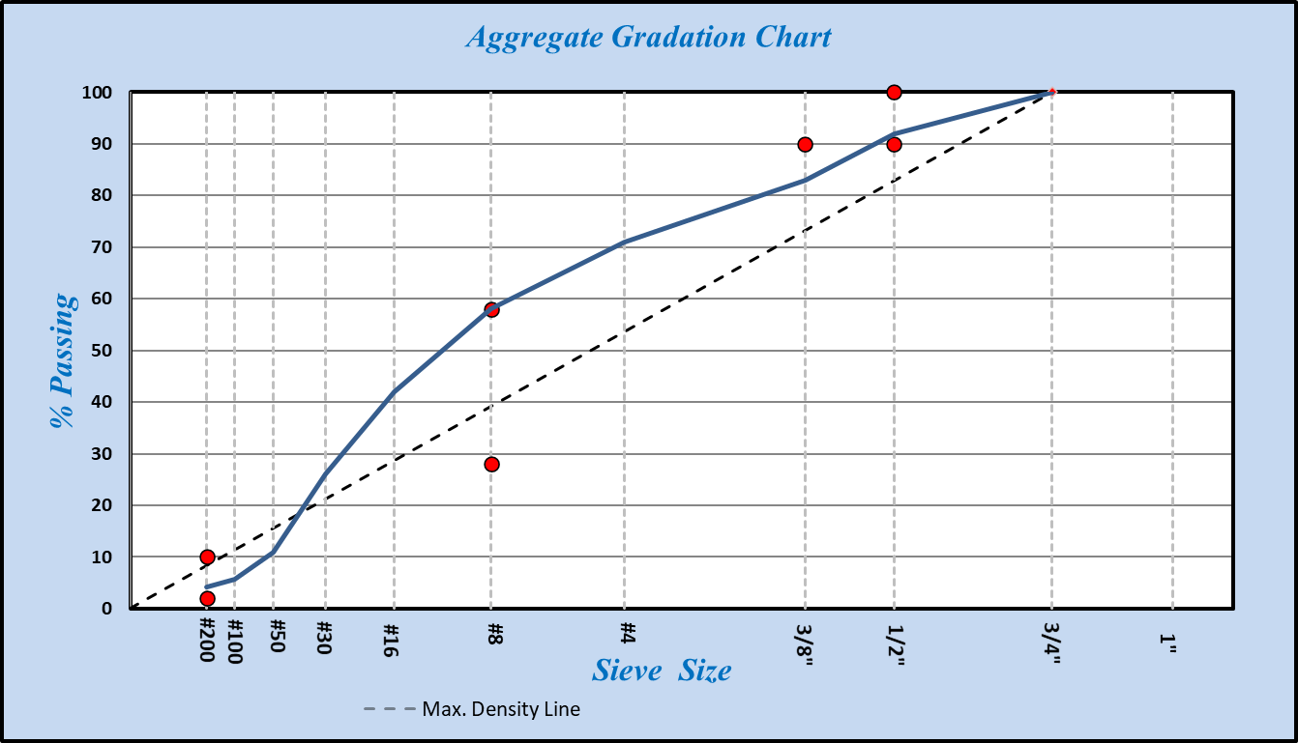
Figure 6-1. Combined aggregate gradation of a mix with 11% RAS

HWT Test Results
HWT test results of four mixes with 11% RAS are shown in Figure 6-2, where a control exhibited the smallest rut depth of 4.4mm at 20,000 passes, followed by 303PL, TUFF, 300PL. It should be noted that all mixtures met the criterion of a minimum SIP of 10,000 passes. Based on the limited test results, overall, 11% RAS mixtures performed well where rejuvenators might have caused a softening effect on RAS mixtures.

Figure 6-2. HWT test results for 11% RAS mixtures

SCB-IFIT Test Results
A total of 16 test specimens with 11% RAS were prepared for SCB-IFT test: four specimens with no rejuvenator as a control and three different rejuvenators. The SCB-IFIT test results are summarized in Table 6-3 and plotted in Figure 6-3. 11RAS_300PL exhibited the highest FI value followed by 11RAS_Control, 11RAS_TUFF, and 11RAS_303PL. Overall, all mixtures exhibited similar FI values, indicating three used rejuvenators did not have a significant impact on improving the cracking resistance of RAS mixtures.

Table 6-3. SCB-IFIT test results for 11% RAS mixtures
ID | PEAK LOAD (KN) | STDEV | Fracture Energy(J/m²⁾ | STDEV | Post-Peak Slope(kN/mm) | STDEV | FI | STDEV
11RAS_Control | 2.50 | 0.09 | 918.35 | 66.16 | -2.98 | 0.11 | 3.09 | 0.30
11RAS_TUFF | 2.36 | 0.09 | 811.11 | 88.24 | -2.81 | 0.21 | 2.91 | 0.44
11RAS_300PL | 2.49 | 0.28 | 934.49 | 41.16 | -2.83 | 0.74 | 3.51 | 0.82
11RAS_303PL | 2.03 | 0.30 | 684.81 | 121.10 | -2.47 | 0.50 | 2.81 | 0.39

Figure 6-3. SCB-IFIT test results for 11% RAS mixtures

Field EVALUATION OF high RAP Mixtures with rejuvenators
The main purpose of this task is to determine if the high RAP mixes with different amounts of rejuvenators would perform well in the field. To evaluate the effects of rejuvenators on high RAP mixture, on August 3-4, 2020, six test sections with 1.5-inch surface layer (on top of 1.5-inch intermediate layer) of three different RAP contents and two types of rejuvenators were constructed on two-lane highways of S62 and B20 by Heartland Asphalt Co. in Cerro Gordo County, Iowa. A total length of seven test sections was 6.2 miles with each test section being approximately 0.8 mile.
Construction operations of fractionated high RAP mixtures with rejuvenators were monitored and field loose mixtures were collected for testing at the laboratory.

Rejuvenators
Two bio-based rejuvenators were used for building test sections: Invigorate and Tufftrek. To improve the chemical properties of aged elements within RAP, Invigorate, a partially epoxidized soybean oil, is reported to trigger chemical reactions inside RAP to break down asphaltene aggregation and reverse the effects of oxidation (Podolsky, 2021). Invigorate is produced by partially epoxidizing commercial grade soybean oil. Instead of superficially change the viscosity of the binder, it claims to repair the chemical damage in lower-quality binders to address the aged elements within recycled asphalt.

Tufftrek uses renewable oil technology and is a 100% bio-based feedstock. It has both polar and non-polar components and non-polar fatty acid chains orient with the non-polar oily fraction in asphalt, and the polar components orient with the polar asphaltenes. Tufftrek helps disperse the asphaltenes within the oily/maltene fraction, improving molecular mobility of the asphaltenes and converting asphaltene structure from gel to sol with a greater stress relaxation capacity (GP-chemical brochure). Tufftrek acts like an emulsifier by stabilizing asphaltenes as it reduces viscosity, which in turn reduces fatigue and low-temperature cracking..

Mixture Types for Test Sections
Table 7-1 summarizes six types of mixtures with two different rejuvenators (3% and 5% of Invigorate and 3% and 4.5% of Tufftrek) and three different RAP contents (0%, 34% and 45% by binder replacement). Tufftrek was preblended at the terminal and Invigorate was added to the asphalt at the asphalt mixing plant. It should be noted that the amount of Invigorate may be different from the specified design amount because the asphalt pumping at the asphalt mixing plant may not have been consistent during the blending process. Locations of six test sections with combinations of three RAP contents and two rejuvenators are illustrated in Figure 7-1.

Table 7-1. Description of six test sections with different RAP and rejuvenator amounts
No | ID | Binder | RAP | Rejuvenator | AC (%)
1 | R22 | PG58-28S | 22% | None | 5.3
2 | R34bump | PG52-34S CIR | 34% | None | 5.18
3 | R34A3* | PG58-28S | 34% | Invigorate 3% | 5.18
4 | R34B3 | PG58-28S | 34% | Tufftrek 3% | 5.18
5 | R45A5* | PG58-28S | 45% | Invigorate 5% | 5.39
6 | R45B4.5 | PG58-28S | 45% | Tufftrek 4.5% | 5.39

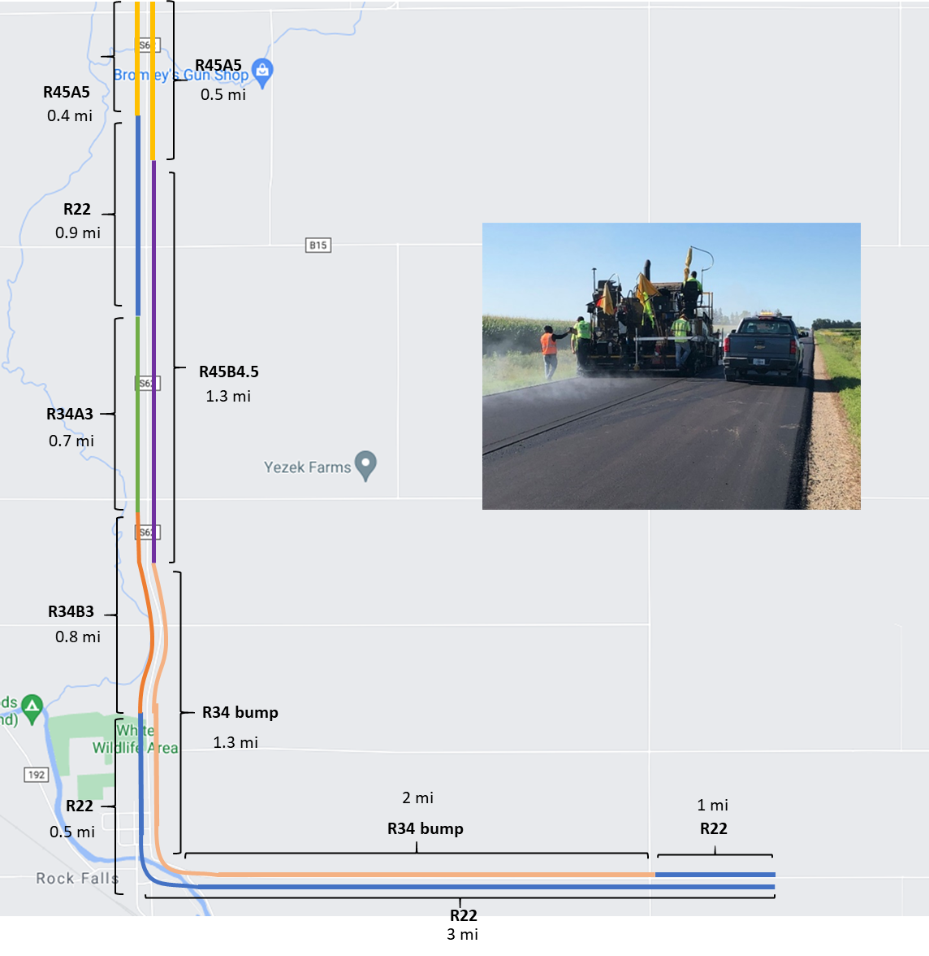
Figure 7-1. Construction of Six Test Sections in Cerro Gordo County
Combined aggregate gradations for all mixtures are plotted in Figure 7-2. As can be seen from Figure 7-2, all mixtures satisfied the volumetric criteria with similar gradations.

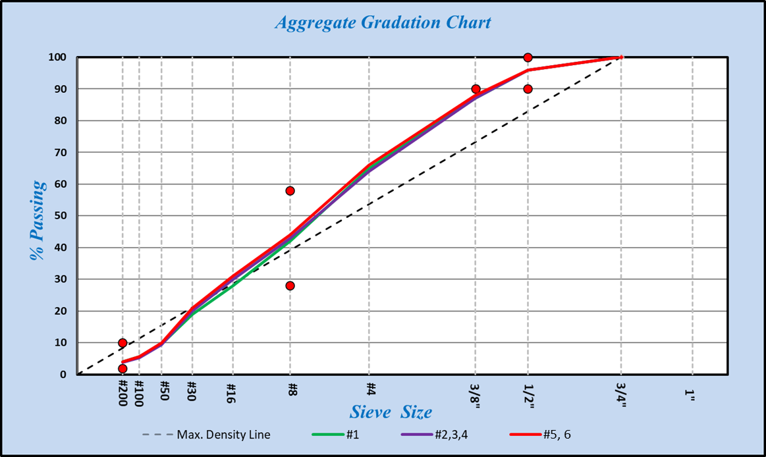
Figure 7-2. Combined aggregate gradation chart for all mixtures

Performance Grading of Rejuvenated Asphalt Binders
To verify the grade of the control asphalt binder (PG 58-28S) and rejuvenated blends, Dynamic Shear Rheometer (DSR) testing (ASTM D7175-08 and AASHTO T 315-10) and Bending Beam Rheometer (BBR) testing (ASTM D6648-08 and AASHTO T 313-10) were performed by Flint Hills, Inc. on unaged, short-term aged, and long-term aged asphalt blends. The short-term laboratory aging of the samples was performed using a Rolling Thin-Film Oven (RTFO) in accordance with ASTM D2872-12 at 163 °C for 85 minutes. The long-term laboratory aging was performed on the asphalt binders using pressure aging vessel (PAV) as per ASTM D6521-13 for a duration of 20 hours at 100 °C and 2.1 MPa pressure.
The DSR test was conducted to determine critical high temperature at an oscillation frequency of 10 rad/s (1.59 Hz). The test started at an initial testing temperature of 46°C, followed by subsequent testing in 6.0°C increments until a specimen fails. For unaged and RTFO binders, 25-mm diameter parallel plates with 1 mm gap geometry was used, for PAV binders, 8-mm diameter plates with 2 mm gap was used. The critical high temperatures were be obtained when the |G*|/sin(δ) value of specimen reached 1.00 kPa, 2.20 kPa 5.0 MPa for unaged, RTFO and PAV specimens, respectively.
The BBR test was used to evaluate the low temperature grade of samples by measuring the center point deflection of the beam at 240 sec. The stiffness (S) and creep rate (m-value) were determined at a loading time of 60 s. The continuous Performance Grade (PG) range results were determined based on both the critical high and low temperatures of the samples, which indicates the temperature susceptibility of the asphalt binder and the working range of temperatures. The continuous grade range and DSR, BBR test results were summarized in Table 7-2 and plotted in Figure 7-3.
The results clearly showed that addition of rejuvenators decreased both critical high and low temperatures of control binder (PG 58-28S), but similar temperature ranges were observed. In addition, the rutting parameter of the rejuvenated binder blends was strongly affected by the amount of the rejuvenator by decreasing critical high temperature more. It can be postulated that rejuvenators have an impact on softening asphalt binders while maintaining similar temperature susceptibility compared to control binder.

Table 7-2. DSR, BBR Tests Results of Six Different Binders that Used in Field Test Sections
Test/testing temperature(°C) |  | PG 52-34S CIR | PG 58-28S | PG 58-28S + 3% rejuvenator A | PG 58-28S + 3% rejuvenator B | PG 58-28S + 5% rejuvenator A | PG 58-28S + 4.5% rejuvenator B
DSR  (unaged, kPa) | 46 | 1.989 | 6.628 | 3.5 | 2.886 | 3.963 | 2.159
 | 52 | 0.855 | 2.756 | 1.522 | 1.267 | 1.713 | 0.981
 | 58 | 0.422 | 1.140 | 0.704 | 0.586 | 0.794 | 0.468
 | Fail Temp | 50.9 | 58.9 | 55.3 | 53.9 | 56.2 | 52.0
DSR  (short-term aged, kPa) | 46 | 4.4 | 17.8 | 11.1 | 7.4 | 11.2 | 5.6
 | 52 | 1.8 | 7.3 | 4.9 | 3.1 | 4.8 | 2.4
 | 58 | 0.862 | 3.216 | 2.169 | 1.413 | 2.111 | 1.101
 | Fail Temp | 50.6 | 60.6 | 57.9 | 54.7 | 57.6 | 52.8
DSR  (long-term aged, kPa) | 19 |  | 4042
 | 16 |  | 6136 | 4440
 | 13 | 3270 | 9412 | 6460 | 4440 | 6361 | 3896
 | 10 | 5210 |  | 9500 | 6990 | 9601 | 6146
 | 7 | 8210 |  |  | 10600 | 13994 | 9334
 | Fail Temp | 10.2 | 17.5 | 15.0 | 12.2 | 14.9 | 11.3
BBR Stiffness  (20hr PAV, MPa) | -18 | 115 | 256 | 166 | 129 | 165
 | -24 | 288 | 526 | 374 | 316 | 362 | 263
 | -30 | 630 | 676 |  |  |  | 620
 | Low PG | -34.6 | -29.4 | -32.4 | -33.7 | -32.6 | -34.9
BBR m-value  (20hr PAV) | -18 | 0.418 | 0.334 | 0.368 | 0.406 | 0.364
 | -24 | 0.349 | 0.28 | 0.3 | 0.326 | 0.295 | 0.353
 | -30 | 0.26 | 0.243 |  |  |  | 0.263
 | Low PG | -37.2 | -32.1 | -34.0 | -36.0 | -33.6 | -33.6
Final Continuous PG |  | PG 50.9-34.6 | PG 58.9-29.4 | PG 55.3-32.4 | PG 53.9-33.7 | PG 56.2-32.6 | PG 52.0-34.9
PG Temp Range |  | 85.5 | 88.3 | 87.7 | 87.6 | 87.7 | 86.9

Figure 7-3. Continuous performance grades of six different binders used for field test sections

HWT test result of Field Mixtures
To prepare HWT test specimens, loose field mixtures with rejuvenators were collected from the field and compacted at the laboratory. In addition, as control samples, HWT test specimens with 34% and 45% RAP without rejuvenators were prepared at the laboratory using the same aggregates, RAP materials and asphalt binder that were collected from the field. The HWT test results of all eight mixtures are plotted in Figure 7-4. As can be seen from Figure 7-4, both field mixtures of 22% RAP and 34% RAP with a softer binder failed at around 8,000 passes due to the moisture damage. However, Tufftrek helped decrease a rut depth whereas Invigorate did not help compared to control mixtures. All mixtures with rejuvenators met the criterion of a minimum Stripping Inflection Point (SIP) of 10,000 passes.
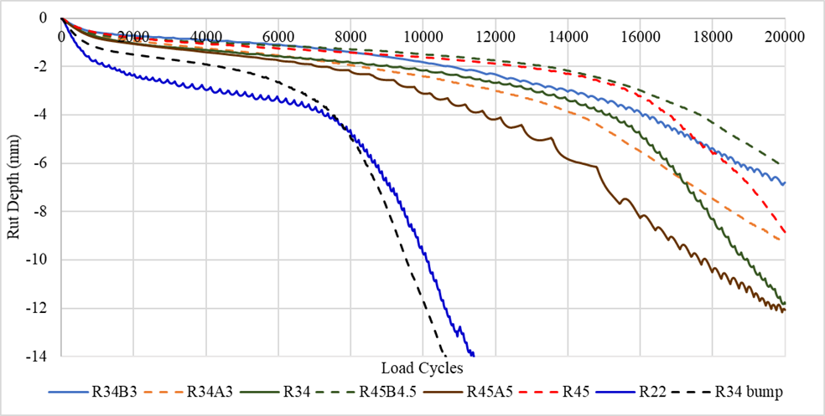

Figure 7-4. HWTT results for all eight mixtures

Disk-Shaped Compact Test Results
To evaluate low-temperature cracking performance, Disk-shaped Compact Tension (DCT) test was performed following ASTM D7313. Loose mixtures collected from the field test sections were compacted at laboratory at 10°C higher than the low-temperature limit of PG grade of virgin binder. The DCT test results for all mixtures are summarized in Table 7-3 and average fracture energy with standard deviations are plotted in Figure 7-5. As can be seen in Table 7-3, 34R bump mixture endured the highest fracture energy followed by R34A3, R34B3, R45B5 and R45A4.5. It should be noted that average fracture energy value for the R34B3 mix could be considered as 445.5 J/m² if one outlier is discarded. Given the limited test results, it can be concluded that 34% RAP with a softer binder produced mixtures more resistant to low-temperature cracking than ones with rejuvenators. For 34% RAP mixes, Invigorate provided a higher resistance to low-temperature cracking than Tufftrek.

Table 7-3. DCT Test Results of Laboratory Compacted Loose Mixtures from Five Test Sections
ID | Mix | Air Voids % | Fracture Energy (J/m²) @ -18°C | Average Fracture Energy
R34 Bump | 34% RAP 52-34 Binder Bump | 7.41 | 429.0 | 480.3
 |  | 7.25 | 479.0
 |  | 7.09 | 533.0
R34B3 | 34% RAP 3% Rejuvenator B | 6.80 | 298.0 | 396.3
 |  | 7.41 | 449.0
 |  | 7.55 | 442.0
R45B4.5 | 45% RAP 4.5% Rejuvenator B | 7.25 | 344.0 | 363.0
 |  | 7.12 | 417.0
 |  | 6.96 | 328.0
R34A3 | 34% RAP 3% Rejuvenator A | 7.45 | 433.0 | 440.3
 |  | 7.39 | 400.0
 |  | 6.89 | 488.0
R45A4.5 | 45% RAP 4.5% Rejuvenator A | 7.11 | 343.0 | 332.0*
 |  | 6.97 | 301.0
 |  | 7.29 | 352.0
*Due to an inconsistent pumping rate at the asphalt plant, DCT test was performed on additional field samples with the same 45% RAP and 4.5% Invigorate content from a different project to produce an average fracture energy of 477.3 J/m².

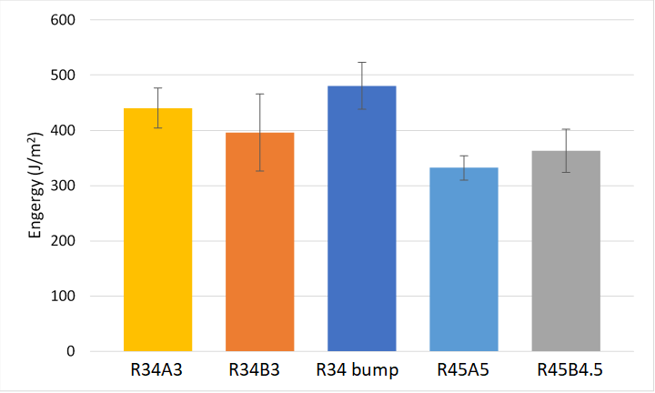
Figure 7-5. DCT test results of laboratory compacted loose mixtures from test sections

Semi-Circular Bending Test Results
A total of 24 samples were prepared: four samples for each of four combinations of two rejuvenators and two different RAP contents (16 samples) and four samples for two different RAP contents without rejuvenators (8 samples). The SCB-IFIT test results are summarized in Table 7-4 and plotted in Figure 7-6. For 34% RAP mixtures, the R34A3 sample endured the highest fracture energy with the lowest post-peak slope, which resulted in the highest FI value followed by R34B3 and R34 samples. For 45% RAP mixtures, the R45B4.5 sample obtained the highest FI value followed by R45A5 and R45 samples. Given the limited test results, it can be concluded that rejuvenators improved a cracking resistance of high RAP mixtures.

Table 7-4. SCB-IFIT Test Results for 34% RAP Mixtures
ID | PEAK LOAD (KN) | STDEV | Fracture Energy(J/m²⁾ | STDEV | Post-Peak Slope(kN/mm) | STDEV | FI | STDEV
R34 | 3.8965 | 0.431361 | 1567.5 | 166.8 | -4.746 | 0.970455 | 3.459 | 0.859203
R34A3 | 3.871 | 0.27712 | 1717.0 | 53.5 | -3.77275 | 0.705399 | 4.7535 | 1.10176
R34B3 | 3.908 | 0.197404 | 1671.1 | 96.9 | -4.11125 | 0.094534 | 4.06975 | 0.303543
R45 | 4.20675 | 0.419951 | 1572.9 | 153.3 | -4.893 | 0.699941 | 3.25075 | 0.338219
R45A5 | 3.952 | 0.127532 | 1629.9 | 136.1 | -4.526 | 0.380986 | 3.63475 | 0.505296
R45B4.5 | 4.2385 | 0.126668 | 1835.9 | 109.5 | -4.55325 | 0.55434 | 4.1275 | 0.79939
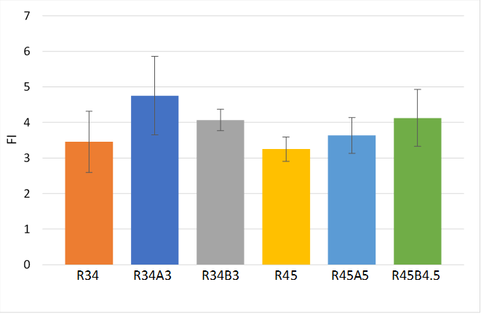
Figure 7-6. SCB-IFIT test results of four samples from test sections and two control samples

Performance Space Diagram of Flexibility Index versus Fracture Energy
A performance space diagram is plotted in Figure 7-7, where the FI is plotted in y-axis and the fracture energy in x-axis. As can be seen Figure 7-7, for 34% RAP mixtures, compared to R34B3, R34A3 samples increased fracture energy and FI values by 17% and 11%, respectively. For 45% RAP mixtures, however, compared to rejuvenator A, rejuvenator B increased fracture energy and FI values by 14% and 10%, respectively.

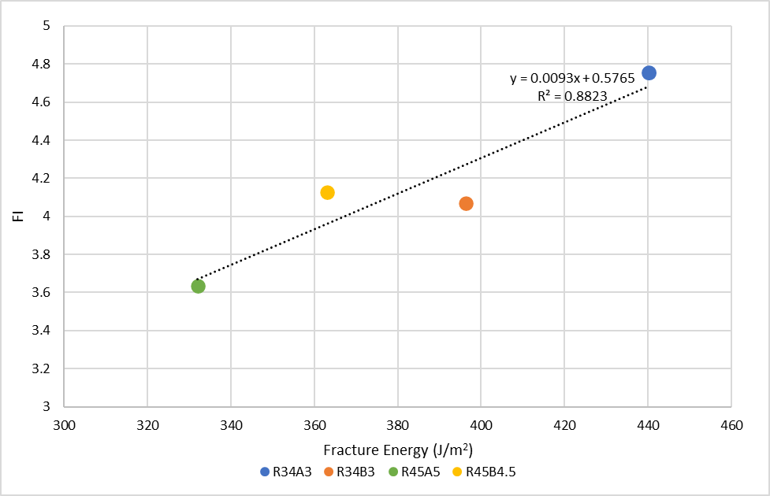
Figure 7-7. Performance space diagram to predict cracking potential at four test sections

Field Densities of Six Test Sections

Table 7-5 summarizes the field densities measured from six test sections. The test section with 45% RAP and 5% Invigorate exhibited the highest field density followed by 34% RAP and 3% Invigorate. Field densities of the remaining four test sections with Tufftrek and without a rejuvenator were similar and met the minimum density requirement of 93%. The average and standard deviation of field densities of six test sections are plotted in Figure 7-8.

Table 7-5. Field densities of six test sections
No | R22 | R34 bump | R34A3 | R34B3 | R45A5 | R45B4.5
1 | 93.3 | 94.0 | 94.0 | 94.2 | 95.8 | 94.8
2 | 94.7 | 93.4 | 94.7 | 93.9 | 95.4 | 95.5
3 | 94.1 | 92.7 | 92.5 | 93.8 | 96.3 | 94.2
4 | 94.8 | 93.6 | 93.2 | 93.7 | 95.0 | 94.6
5 | 94.4 | 92.5 | 93.2 | 94.3 | 94.0 | 92.4
6 | 92.3 | 93.8 | 94.3 | 93.2 | 94.6 | 93.2
7 | 91.7 | 95.6 | 93.9 | 94.6 | 95.3 | 93.6
8 | 94.5 | 93.5 | 94.0 | 95.1 | 95.1 | 92.4
Average | 93.7 | 93.6 | 93.7 | 94.1 | 95.2 | 93.8
STDEV | 1.10 | 0.88 | 0.66 | 0.55 | 0.66 | 1.06

Figure 7-8. Field densities of six test sections

Condition Survey of Test Sections after One Year
Condition survey of all test sections was performed after one year since construction. Overall, all test sections performed very well with very little cracking and no rutting. As can be seen from Figure 7-9, several cracks were observed from test sections with 22% RAP without rejuvenator and 34% RAP with a softer binder. There was no rutting in all test sections.
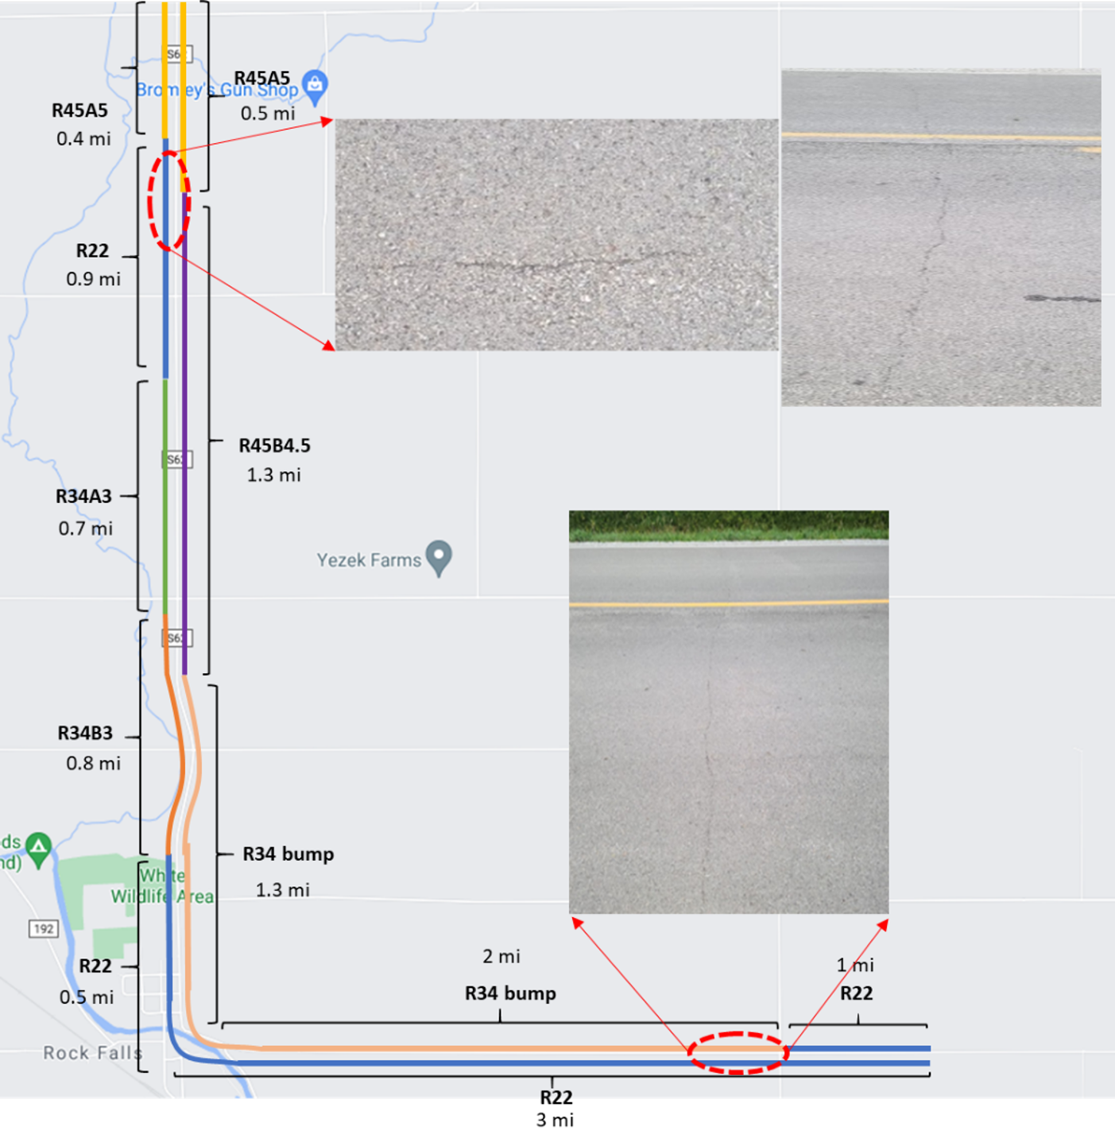
Figure 7-9. Test sections without rejuvenators with cracking in one year after construction

AGING OF HIGH RAP MIXTURES WITH REJUVENATORS
Ageing of HMA mixtures has been well researched in the past, but little research has been performed on aging of high RAP mixtures with rejuvenators. The main purpose of this task is to determine if the rejuvenated RAP mixture properties are stable over time without accelerating the aging process. Field mixtures were evaluated to determine if the ageing in the field accelerated or decelerated compared to the laboratory ageing.
Due to the complex field conditions, asphalt binder aging factors are normally evaluated in the controlled laboratory environment (Zhu 2015). In the past, to simulate every one year of aging in the field, the heating for 12 hours in the oven at 85 °C was recommended for each year in the field (Bell, 1994). To simulate five to ten years of aging in the field, AASHTO R 30 recommends a short-term aging in the oven at 135°C for four hours followed by a long-term aging at 85 °C for 120 hours. For a practical and relatively quick ageing method for the mix design, 12 hours or up to 24 hours ageing at 135°C were also suggested (Blankenship 2015). Recently, to match chemical composition changes, a longer aging times at lower temperatures have been proposed (Kim et al., 2018).

Aging Test Specimens
To evaluate the aging effects on rejuvenated high RAP mixes (45% RAP), the test specimens were prepared using pre-blended binders of PG 58-28S with rejuvenators collected from the field (5% Invigorate and 4.5% TuffTrek). Table 8-1 summarizes compositions of three different mixtures for aging tests.
Table 8-1. Three Laboratory Aged High-RAP Mixtures
No | ID | Binder | RAP Content | Rejuvenator/Dosage rate | Optimum Binder Content(%)
1 | R45A5 | PG58-28S | 45% | Invigorate 5% | 5.39
2 | R45B4.5 | PG58-28S | 45% | TuffTreck 4.5% | 5.39
3 | R45 | PG58-28S | 45% | None | 5.39

AASHTO R 30: Standard Practice for Mixture Conditioning of Hot Mix Asphalt
AASHTO R 30 is the most widely used asphalt aging procedure for over 25 years. It offers two loose mix aging procedures, two different compaction methods and one long-term oven aging procedure. The conditioning steps for the AASHTO R 30 Ageing procedures are summarized in Table 8-2.

Table 8-2. AASHTO R 30: Standard Practice for Mixture Conditioning
Conditioning Types | Conditioning Procedures
Loose Mixture:
Mixture Conditioning for Volumetric Mixture Design (Short-term aging) | 2h ± 5 min at compaction temperature (above 135 ˚C of mixture temperature or 150°C of oven temperature was used as compaction)
Mixture Conditioning for Short-Term Aging | 4h± 5 min at 135 ± 3˚C.
Compacted Mixture:
Long-Term Aging of Specimen | Addition 120h (5 days) ± 30 min at 85 ± 3°C after short-term aging.

Mixture Conditioning for Volumetric Mixture Design
The mixture conditioning procedure for volumetric mix designs applies to laboratory-prepared, loose mixture only. No mixture conditioning is required when conducting QC/QA testing on plant-produced mixture. Mixture conditioning procedure is described below:
- Place the mixture in a pan, and spread the mixture to an even thickness ranging between 1 to 2 in. (25 and 50 mm)
- Place the mixture and pan in a forced-draft oven for 2 h ± 5 minutes at a temperature equal to the mixture's compaction temperature ± 5°F (± 3°C). (Note: The compaction temperature range of an HMA mixture is defined as the range of temperatures where the unaged binder has a kinematic viscosity of approximately 0.28 ± 0.03 pa-s (280 ± 30 mm2 /s) measured in accordance with ASTM D 4402. The target compaction temperature is generally the mid-point of this range. The mixture design compaction temperature should be 300 ± 9°F (150 ± 9°F) for dense graded mixtures and 260 (150) for open graded mixtures).
- Stir the mixture after 60 ± 5 minutes to maintain uniform conditioning.
Recent NCHRP study (Newcomb et al., 2015) suggested that Step 2 in mixture conditioning to revised to change the conditioning temperature from “the mixture's compaction temperature ± 5°F (± 3°C)” to “135 ± 3˚C for HMA or 116 ± 3˚C for WMA”. The reason for change is that 1) AASHTO R 30 is focused on HMA and does not address WMA, 2) 2 hours of oven aging at 135°C for HMA and 116°C for WMA was found to be sufficient for short-term aging, regardless of compaction temperature.

Short-Term Aging of Loose Mixtures
Mixture conditioning procedure for short-term aging of loose mixtures is described below.

- Place the mixture in a pan, then spread the mixture to an even thickness ranging between 1 to 2 in (25 and 50 mm)
- Place the mixture and pan in a forced-draft oven for 4h ± 5 minutes at a temperature of 275 ± 5˚F (135 ± 3˚C)
- Stir the mixture every 60 ± 5 minutes to maintain uniform conditioning

Long-Term Aging Conditioning of Compacted Samples
The long-term mixture conditioning procedure may be applied to laboratory-prepared samples following short term aging, to plant-mixed HMA, or to compact roadway samples when needed to simulate long term aging effects. This mixture conditioning step is used when samples will be tested for mechanical properties, such as Indirect Tensile creep or strength. Laboratory-prepared mixture should be conditioned following the procedure described for short-term aging above. Plant-mixed material does not need to be short term aged. Mixture conditioning procedure for long-term aging of loose mixtures is described below.
- Long-term Aging of Laboratory Compacted Mixtures
- Compact the HMA sample according to T 312 to the level of compaction required for the tests to be conducted. Do not extrude the specimen from the mold.
- Condition the compacted sample by cooling in the mold to 140° ± 5°F (60° ± 3°C). This typically takes about 2 hours.
- The ends of the specimen may not be parallel. The ends are squared up by applying a static load in a testing device. Increase the load from 0 kN at a rate of 16 ± 0.01 kip/min. (72.00 ± 0.05 kN/min). Release the load at the same rate when the ends of the specimen are level or when the load reaches a maximum of 12.5 kip (56 kN).
- Remove the specimen from the testing machine and allow to cool 16 ± 1 hours at room temperature. The sample should be extruded from the compaction mold after cooling for 2-3 hours.

- Long-term Aging of Field Compacted Mixtures
- Cool the test specimen at room temperature for 16 ± 1 h
- Place the specimen in the oven at 185 ± 5°F (85 ± 3°C) for 120 ± 0.5 h
- After 120 ± 0.5 h, turn the oven off, open the oven doors, and allow the test specimen to cool to room temperature. This typically takes about 16 hours. Do not touch or remove the specimen from the oven until the end of this cooling period.
Recent NCHRP study (Kim et al., 2018) suggested that Step 2 in long-term aging for compacted roadway specimens be changed to modify the conditioning temperature from “185 ± 5°F (85 ± 3°C)” to “95 ± 3°C” and the conditioning duration from “120 ± 0.5 h” to “using equation below (Equation 8-1)”. (Typically, 6 to 7 days of oven aging is equivalent to 8 years of field aging and 13 to 17 days of oven aging is equivalent to 16 years of field aging)
(8-1)

where,
t_{oven} = oven aging duration, D = depth correction factor, A = frequency factor, E_{a} = activation energy, R = universal gas constant, T_{i} = pavement temperature.

Recent NCHRP study (Kim et al., 2018) suggested that Step 3 in long-term aging for compacted roadway specimens be removed. The reason for changes is that the single time and temperature combination used in AASHTO R 30 is inaccurate for all climates throughout the country. The procedure claims to age the asphalt by 5-10 field years. However, in some areas the aging from AASHTO R 30 occurs in less than 5 years in the field. To solve these issues, oven aging time should be dependent on climate, and temperature should be increased to 95°C to reduce time in the oven. A temperature of 100°C or higher can cause chemical changes not present in field mixtures (which is why 95°C was recommended). Also, loose mixture should be placed in the oven instead of compacted mixture because it ages faster and more evenly.

HWT Test of Aged High RAP Mixtures with Rejuvenators
The laboratory mixed and compacted specimens with 45% RAP and rejuvenators of Invigorate and Tufftrek were prepared and conditioned as no-aging, short-term aging, long-term aging following AASHTO R30. The HWT test results of each mixture are summarized in Table 8-3 and plotted in Figure 8-1. For Invigorate mixes, the unaged mix failed at 10,800 passes, the short-term aged mix failed at 16,000 passes and the long-term aged mix exhibited only 1mm rut depth at 20,000 passes. Similarly, for Tufftrek mixes, the unaged mix failed at 8,250 passes, the short-term aged mix failed at 13,880 passes, and the long-term aged mix exhibited only 1mm rut depth at 20,000 passes. For the control mixes without a rejuvenator, the unaged, short-term aged and long-term aged mixes, rut depth were 19mm, 14mm and 1mm, respectively. Overall, both no aging and short-term aged asphalt mixtures with rejuvenators did not perform as well as the mixtures without a rejuvenator. However, based on the limited data, both short-term and long-term aging improved the moisture susceptibility of asphalt mixtures with rejuvenators more than specimens with no rejuvenator.

Table 8-3. HWT Test Results of Aged and Not-aged Mixtures with 45% RAP and Rejuvenators
Item | R45A5 |  |  | R45B4.5 |  |  |  | R45
 | No aging | Short aging | Long aging | No aging | Short aging |  | Long aging | No aging | Short aging | Long aging
Rut Depth | -20 @10,800 | -20 @16,055 | -1@20,000 | -20 @8,250 |  | -20 @13,880 | -1@20,000 | -19 @20,000 | -14 @20,000 | -1@20,000
SIP | 4,800 | 9,600 | - | 4,800 |  | 7,000 | - | 15,600 | 13,650 | -

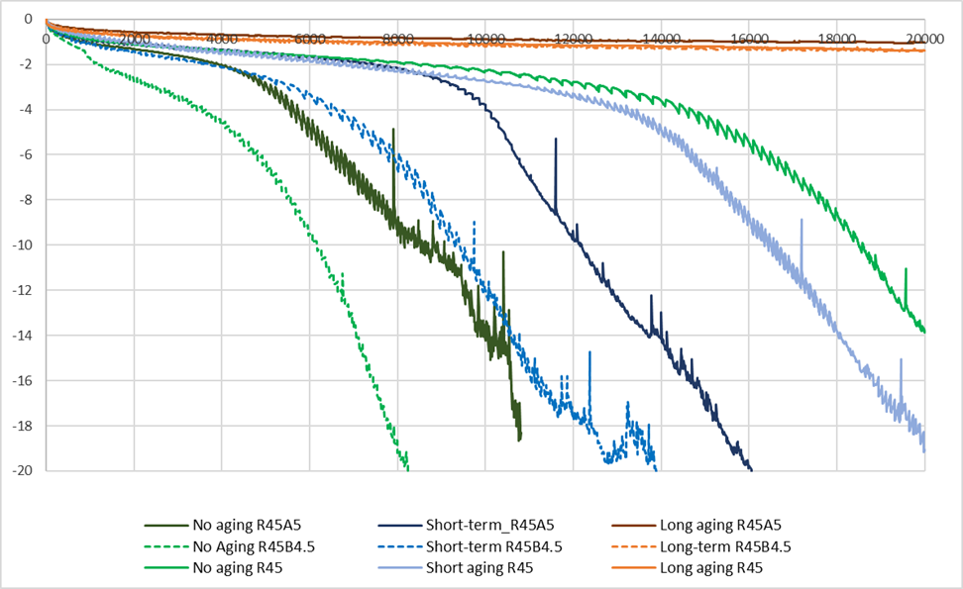
Figure 8-1. HWT test results for three stage aged mixtures

SCB-IFIT test of Aged High RAP Mixtures with Rejuvenators
The SBC-IFIT tests were performed following the AASHTO TP124. Samples for SCB-IFIT test were made with 150mm diameter and 50mm height and compacted to a target air void of 7%±0.5%. The notch was made at 15mm in length and 1.5mm of width. All specimens were conditioned at 25ºC for 2 hours before performing a test.
Two samples were prepared for each mixture type with three different aging conditions. SCB-IFIT test results are summarized in Table 8-4 and plotted in Figure 8-2. For all aging conditions, R45B4.5 mix exhibited similar fracture energy to the control sample but higher than R45A5 mix. As a result, R45B4.5 mix showed the highest FI than others for all aging conditions. Given the limited test results, although the aging decreased the cracking resistance of all mixes, Tufftrek was more effective in maintaining the cracking resistance than Invigorate as compared to the control sample without a rejuvenator.

Table 8-4. SCB Test Results for Laboratory Aging Mixtures
Mixtures |  | FRACTURE ENERGY (J/m²) |  |  | Flexibility Index
 |  | 1 | 2 | Average | 1 | 2 | Average
R45 | No aging | 1433.9 | 1723.2 | 1,578.5 | 3.7 | 3.4 | 3.55
 | Short-term aging | 1551.5 | 859.0 | 1,205.2 | 3.7 | 3.0 | 3.35
 | Long-term aging | 1235.5 | 1537.2 | 1,386.3 | 1.4 | 1.9 | 1.65
R45B4.5 | No aging | 1475.4 | 1520.3 | 1497.9 | 4.3 | 6.3 | 5.3
 | Short-term aging | 1499.3 | 1295.7 | 1397.5 | 4.7 | 4.1 | 4.4
 | Long-term aging | 1467.6 | 1162.9 | 1315.3 | 2.2 | 1.8 | 2.0
R45A5 | No aging | 1570.5 | 1058.9 | 1314.7 | 4.4 | 3.3 | 3.85
 | Short-term aging | 1418.2 | 1300.1 | 1359.2 | 3.3 | 3.6 | 3.45
 | Long-term aging | 658.9 | 705.1 | 682 | 0.7 | 0.9 | 0.8

Figure 8-2. SCB-IFIT test results for lab aging mixtures

development of specifications for high ram mixtures
The main purpose of this task is to develop a specification for high RAM mixtures with rejuvenators. First, five surrounding state DOT’s specifications on the use of RAM materials have been reviewed and compiled. Second, the existing Iowa DOT’s specifications were reviewed for a possible modification along with a possible new specification about using rejuvenators.

Five Surrounding State DOT’s specifications on RAM materials
Table 9-1 summarizes specifications from five state DOT’s of Wisconsin, Illinois, Missouri, Nebraska and Minnesota on the use of RAM materials. As shown in Table 9-1, Nebraska allows the highest amount of RAP materials up to 65% with softer binder of 58S/H/V/E-34 followed by Missouri which allows up to 50% RAP materials. When both RAP and RAS are used, Missouri adopts a formula that the total RAM binder content is equal to RAP + 2*RAS. Minnesota allows the use of RAP above 20% if 58-28 or 64-28 binder is used. None of these states do not provide specifications for rejuvenators.

Table 9-1. Maximum Allowable RAP/RAS Usage Specification for Five Surrounding States
State | RAP |  | RAS |  | RAP and RAS together
 | No-Additives | With Softer binder | No-Additives | With Softer binder | No-Additives | With Softer binder
Wisconsin | 25 | N/A | 20 | N/A | 25 | N/A
Illinois | 30 | 30 | N/A | N/A | N/A | N/A
Missouri | 30 | 50 | 30 | 40 | 30 | 50
Nebraska | N/A | 65 | N/A | N/A | N/A | N/A
Minnesota | 20 | >20 | N/A | N/A | 20 | >20
Iowa | 20 | 30 | 15 | 15-25 | 15 | 15-25

Iowa DOT’s specification on the use of RAM materials
The current Iowa DOT’s specification “Section 2303 Flexible Pavement (Revised 10/19/2021)” states:

- RAP not used in HMA becomes the property of the Contractor.
- No adjustments will be made to the contract unit price for required changes to the asphalt binder grade.
- For surface mixtures, 70% of the total asphalt binder shall be virgin.
- Up to 5% RAS by weight of total aggregate may be used in the design and production of an asphalt mixture. The percentage of RAS used is considered part of the maximum allowable RAP percentage.

Allowable RAP Usage for each mixture designation and type of RAP materials is summarized in Table 9-2 in IM 510 Appendix C.

Table 9-2. Allowable RAP Usage by Weight (IM 510 Appendix C)
Mix Designation | Aggregate Quality Type | Unclassified RAP | Classified RAP
HMA ST S | A | 0% | Limited by binder replacement
HMA ST I | B | 10% | No Limit
HMA ST B | B | 10% | No Limit
HMA HT S | A | 0% | Limited by binder replacement
HMA HT I | A | 0% | No Limit
HMA HT B | B | 10% | No Limit
HMA VT S | A | 0% | Limited by binder replacement
HMA VT I | A | 0% | No Limit
HMA VT B | B | 10% | No Limit
* ST- standard traffic, HT- high traffic, VT- very high traffic, S- surface, I- intermediate, B- base

Iowa DOT’s specification “IM 510 Method of Design of Asphalt Mixtures” states:

For mixtures not containing RAS
When the amount of recycled binder from RAP exceeds 20.0% of the total asphalt binder, the designated binder grade will be adjusted by lowering both the high and low temperature PG grade by 6°C while maintaining the AASHTO M332 traffic designation letter on the contract. The MSCR test temperature shall be the new adjusted high temperature PG grade (i.e. PG 58-28H becomes PG 52-34H with a test temperature of 52°C). If the anticipated RAP binder percent exceeds 30.0% of the total, the selection of the binder grade shall be based on testing performed by the Contracting Authority.

For mixtures containing RAS, adjust the contract binder grade as follows:
a. When the amount of recycled binder is inclusively between 15.0% and 25.0%, adjust the grade by lowering both the high and low temperature PG grade by 6°C while maintaining the AASHTO M332 traffic designation letter on the contract. The MSCR test temperature shall be the new adjusted high temperature PG grade (i.e. PG 58-28H becomes PG 52-34H with a test temperature of 52°C).
b. When the amount of recycled binder exceeds 25.0% of the total asphalt binder, the selection of the binder grade shall be based on testing performed by the Contracting Authority.

When binder replacement exceeds 30.0% (25.0% for mixtures containing RAS), grade selection is based on fracture energy as measured by the Disk-Shaped Compact Tension Test (DCT) (ASTM D7313-07a) at no additional cost to the contracting authority. The average of two specimens shall meet the following minimum fracture energy requirements tested at 10°C warmer than the low climatic temperature (normally specified as the low temperature PG grade on the contract):
• Very High Traffic (VT) 690 J/m2
• High Traffic (HT) 460 J/m2
• Standard Traffic (ST) 400 J/m2

The adjusted grade shall meet the same MSCR recovery requirements as the contract binder grade. No adjustments will be made to the contract unit price for required changes to the asphalt binder grade.
The IM 510 specification can be simplified as follow:

For mixtures not containing RAS:
- If RAP binder > 20% and <= 30%, lower virgin PG grade by 6°C.
- If RAP binder > 30%, the selection of the binder grade shall be based on testing performed by the Contracting Authority.

For mixtures containing RAS:
- If RAM binder >=15.0% and <=25.0%, lower virgin PG grade by 6°C
- If RAP binder > 25%, the selection of the binder grade shall be based on testing performed by the Contracting Authority.
- If RAP binder > 30.0% (or RAM binder > 25.0% for mixtures containing RAS), grade selection is based on fracture energy as measured by DCT.

Currently, there is no Iowa DOT specification that discuss the effective binder content from RAP and RAS but the following is practiced: “100% of asphalt binder from RAP is assumed “active,” whereas only 67 percent of the asphalt binder from RAS is assumed “active.” The pending research project, NCHRP 09-68 will investigate binder availability in recycled asphalt materials.

Currently, although the current specification allows RAP materials higher than 30%, no such project is being constructed in Iowa. Based on the successful implementation of test sections with RAP materials up to 45%, it is recommended that the current specifications should be modified, which could allow RAP contents up to 50% by binder replacement with simpler and less expensive testing procedures like SCB-IFT test as an alternate test procedure.

SUMMARY and conclusionS

Previously, Fourier Transform Infrared (FTIR) test indicated that rejuvenators were effective in decreasing the aging level when applied to the PAV binder. When FTIR was performed on the actual binder from RAP, rejuvenators were effective in lowering the aging level evidenced by lower SI values. However, FTIR failed to show the effectiveness of rejuvenators in lowering the aging level based on CI values.
RAP materials were fractionated into two stockpiles separated at No.4 sieve. Fractionated asphalt mixtures were prepared by recombining the equivalent amount from each stockpile as the original stockpile. Based on the HWT test results of fractionated mixtures for both 34% and 45% RAP mixtures exhibited smaller rut depths at 20,000 passes. In addition, fractionated asphalt mixtures exhibited higher FI values than the control mixtures. Therefore, given the limited test results, it can be concluded that fractionation can improve both cracking and rutting resistances of high RAP mixtures.
To determine the effectiveness of rejuvenators in RAS mixtures, 11% RAS mixes (27% by binder replacement) with three different rejuvenators at a 3% dosage rate. The control mix without rejuvenators exhibited the smallest rut depth of 4.4mm at 20,000 passes and all mixtures performed very well to exceed the SIP of 10,000 passes. Overall, all RAS mixtures exhibited similar FI values, indicating little effect of rejuvenators in improving the cracking resistance of RAS mixtures.
To evaluate field performance of rejuvenated high RAP mixtures, six test sections with two different rejuvenators (Invigorate and Tufftrek) and three different RAP contents (0%, 34% and 45%) were constructed in Cerra Gordo county. Tufftrek was preblended at the terminal, but Invigorate was added to the asphalt at the asphalt mixing plant. Tufftrek lowered the high and low critical temperature by 5.95°C and 4.9°C, respectively, whereas Invigorate lowered the high and low critical temperatures by 3.15°C and 3.1°C. It is important to understand the field produced mixes with the Invigorate had lower than expected dosages of the Invigorate as calibration of the additive pump was inaccurate leading to a lower dose than called for in the design. A certified, terminal-blended asphalt formulation is preferred.
The HWT test results indicate both field mixtures of 22% RAP and 34% RAP with a softer binder failed at around 8,000 passes due to a moisture damage. All mixtures with rejuvenators met the minimum stripping inflection point (SIP) criterion of 10,000 passes for standard traffic in Iowa. Based on the DCT tests, the 34% RAP mixtures with a softer binder performed better than mixtures with rejuvenators. However, based on the SCB-IFIT test results, 34% RAP with 3% Invigorate exhibited the highest FI value whereas 45% RAP with 5% Invigorate exhibited the lowest FI.
45% RAP and 5% Invigorate exhibited the highest field density followed by 34% RAP and 3% Invigorate. Field densities of the remaining four test sections were similar and met the minimum density requirement of 93%. Based on the condition survey performed after one year since construction, all test sections performed very well with very little cracking and no rutting. However, several hairline cracks were observed from test sections with 22% RAP without rejuvenator and 34% RAP with a softer binder.
Based on the short-term and long-term aging tests performed at the laboratory, the long-term aging enhanced the rutting and moisture susceptibility of rejuvenated mixes. Based on the SCB-IFT tests, the aging decreased the cracking resistance of all mixes. However, Tufftrek was more effective in maintaining the cracking resistance than Invigorate when compared against the control sample without a rejuvenator, but the lower performance from the Invigorate could be from the pump issues resulting in a lower dosage occurring in the mix production
The specific findings from this study are summarized below:

- Rejuvenators consistently lowered both critical high and low temperatures of virgin binder of PG 58-28S.
- 34% and 45% High RAP mixtures with rejuvenators were compacted well exceeding 93% field density.
- Based on HWT test results, field mixtures with rejuvenators performed better in rutting performance than ones without rejuvenators.
- Based on the DCT test results, 34% RAP with a soft binder (34R Bump) mixture endured the highest fracture energy.
- Based on SCB-IFIT test results, rejuvenators could improve cracking resistance.
- Based on test results of both DCT and SCB-IFIT, there is a good correlation between FI values of SCB and fracture energy values of DCT.
- Based on a condition survey of test sections performed after one year since construction, all test sections performed very well with very little distress. Test sections without rejuvenators developed several hairline cracks. Rejuvenators were effective in delaying an initiation of cracking.
- Aging of laboratory prepared mixtures with rejuvenators decreased rutting in Hamburg tests but increased cracking potential in SCB-IFIT tests.
- Both 34% and 45% RAP mixtures with rejuvenators were successfully implemented.

FUTURE STUDIES

As discussed at the TAC meeting and subsequent feedback from TAC members, the following tasks are proposed for future studies.

- Develop an approval process for rejuvenators that incorporates long-term aging of the material.
- Perform a feasibility study of a fractionation of RAP materials in two stockpiles.
- Consider increasing the maximum RAM percentage up to 50% for some mixes. Investigate various economic conditions that determine whether the increased stiffness from the RAM can be economically off-set with rejuvenators and softer binder grades. Additional options for RAM use and binder formulations may provide greater flexibility to contractors and binder suppliers.
- Evaluate WMA with high RAM. WMA containing RAP and RAS showed similar cracking and rutting resistance performance compared to HMA with RAP and RAS. Additional study of WMA with RAM could be useful to verify if it meets both economic and sustainability requirements.
- Adopt a test procedure like SCB-IFT test for high RAM mixtures up to 50% as a performance test after evaluating different testing procedures based on evaluation factors such as sample preparation, specimen conditioning and testing, training needs and applicability, new equipment cost, repeatability and field validation.
- Monitor high RAM project sites (3 project sites in each district) to determine the effectiveness and limitations of design, construction and performance of high RAM mixtures up to 20% and develop QA/QC aspect of using softer binders and rejuvenators.
- Develop a comprehensive asphalt recycling strategy encompassing high RAM mix up to 50%, CIR and HIR in consideration of both economic and sustainability analyses.

References
- Arguirre, M. A., M. M. Hassan, S. Shirzad, L. N. Mohammad, S. B. Cooper. (2017). Performance of Asphalt Rejuvenators in Hot-Mix Asphalt Containing Recycled Asphalt Shingles. Transportation Research Record: Journal of Transportation Research Board. Vol 2633, pp. 108-116.
- Bennert, T., C. Ericson, D. Pezeshki. (2015). Rejuvenating Agents with RAP in Hot Mix Asphalt, New Jersey Department of Transportation.
- Bowers, B. F., B. Huang, S. Xiang, B. C. Miller. Investigation of reclaimed asphalt pavement blending efficiency through GPC and FTIR. Construction and building materials. Vol 50 (2014), pp. 517-523.
- Castro, A. (2017). Evaluation of a Surface Mixture with Delta-S Rejuvenator on NCAT Pavement Test Track. [Master dissertation, University of Auburn]
- Chen, M., B. Leng, S. Wu, Y. Sang. (2014). Physical, chemical and rheological properties of waste edible vegetable oil rejuvenated asphalt binders. Construction and Building materials, Vol 66, pp. 286-298.
- Cong, P., P. Xu, S. Chen. (2014). Effects of carbon black on the anti aging, rheological and conductive properties of SBS/asphalt/carbon black composites. Construction and Building Materials, Vol 52, pp. 306-313.
- Copeland, A. (2011). Reclaimed asphalt pavement in asphalt mixtures: State of the practice (No. FHWA-HRT-11-021). United States. Federal Highway Administration. Office of Research, Development, and Technology.
- DeDene, C. D. (2011). Investigation of using waste engine oil blended with reclaimed asphalt materials to improve pavement recyclability. [Master dissertation, Michigan Technological University]
- Georgia-Pacific. (2022). TUFFTREK 4002 MODIFIRER [Brochure]. https://gp-chemicals.com/wp-content/uploads/2021/12/16670-GP-Chem-TUFFTREK-Asphalt-Brochure_ONLINE__120621.pdf
- Hajj, E. Y., A. J. Hand, R. Chkaiban, T. B. Aschenbrener. (2019). Index-based tests for performance engineered mixture designs for asphalt pavements (FHWA-HIF-19-103)
- Hofko, B., M. Z. Alavi, H. Grothe, D. Jones, J. Harvey. (2017). Repeatability and sensitivity of FTIR ATR spectral analysis methods for bituminous binders. Materials and Structures, Vol 50(3), pp. 1-15.
- Illinois DOT, Article 1031.06(c)(1) and 1031.06(c)(2) of the Standard Specifications-Effective with January 2022) https://idot.illinois.gov/Assets/uploads/files/Doing-Business/Specialty-Lists/Highways/Design-&-Environment/BDE-Special-Provisions/80441.pdf
- Iowa DOT, Section 2303. Flexible Pavement - Revised 10/19/2021 https://iowadot.gov/erl/current/GS/content/2303.htm
- Johnson, E., M. Watson, R. Olson, K. H. Moon, M. Turos, M. Marasteanu. (2013). Recycled Asphalt Pavement: Study of High-RAP Asphalt Mixtures on Minnesota County Roads. Minnesota Department of Transportation, Report No. MN/RC, 15.
- Kim, Y. R., C. Castorena, M. D. Elwardany, F. Y. Rad, S. Underwood, G. Akshay, R. R. Glaser. (2018). Long-term aging of asphalt mixtures for performance testing and prediction. (NCHRP 09-54)
- Kim, Y. R., H. F. Haghshenas, G. Nxengiyumya. (2019). Research on High-RAP Asphalt mixtures with Rejuvenators – Phase II. Nebraska DOT.
- Minnesota DOT, Section 2360 Plant mixed asphalt pavement-effective with 2022. http://www.dot.state.mn.us/pre-letting/spec/2005/2021-2360.pdf
- Missouri DOT, Section 490. Bituminous asphalt mixes-Revised December 2017. “https://www.modot.org/media/1029”
- Mogawer, W. S., A. Booshehrian, S. Vahidi, A. J. Austerman. (2013). Evaluating the effect of rejuvenators on the degree of blending and performance of high RAP, RAS, and RAP/RAS mixtures. Road Materials and Pavement Design, Vol. 14(sup2), pp.193-213.
- Nazzai, M., S. Kim. (2019). Optimizing the Effective Use of RAP in Local Roadways, (No. FHWA/OH-2019-14), Ohio Department of Transportation.
- Nebraska DOT, Section 1028. Superpave asphaltic concrete. https://dot.nebraska.gov/media/10343/2017-specbook.pdf
- Newcomb, D., A. E. Martin, F. Yin, E. Arambula, E. S. Park, A. Chowdhury, J. M. Signore. (2015). Short-term laboratory conditioning of asphalt mixtures (No. Project 09-52).
- Pan, P., Y. Kuang, X. Hu, X. Zhang. (2018). A comprehensive evaluation of rejuvenator on mechanical properties, durability, and dynamic characteristics of artificially aged asphalt mixture. Materials, Vol 11(9), pp. 1554.
- Podolsky, J. H., A. Arabzadeh, B. Saw, R. C. Williams,E. W. Cochran, H. Lee.(2021). Performance of field produced rejuvenated 30% RAP surface mix in Northwest Iowa. Road Materials and Pavement Design, 1-16.
- Ramasamy, N. B. (2010). Effect of polyphosphoric acid on aging characteristics of PG 64-22 asphalt binder. [Master dissertation, University of North Texas]
- Rodezno, C., R. Moraes, F. Yin, M. Fortunatus. (2021). Recycled Asphalt Binder Study (No. WHRP 0092-19-04). Wisconsin Highway Research Program.
- Smith, B. C. (2011). Fundamentals of Fourier Transform Infrared Spectroscopy, Second Edition, CRC Press, Taylor & Francis Group, Boca Raton, Florida.
- Sun, M. J., L. S. Shi, Z. Y. Jin, N. Li, X. Tao. (2014). Synthesis of novel cationic asphalt emulsifier and its investigation by online FTIR spectrophotometry. In Advanced Materials Research (Vol. 989, pp. 189-193). Trans Tech Publications Ltd.
- Sylvester, T., T. Hassan. (2017). Rejuvenation vs. Softening of Recycled Binders. Illinois Asphalt Pavement Association. Springfield, IL, March 13.
- Tran, N. H., A. Taylor, R. Willis. (2012). Effect of Rejuvenator on Performance Properties of HMA Mixtures with High RAP and RAP Contents, National Center for Asphalt Technology.
- Veeraragavan, R. K., R. B. Mallick, M. Tao, M. Zaumanis, R. Frank, R. L. Bradbury. (2017). Laboratory Comparison of Rejuvenated 50 Percent Reclaimed Asphalt Pavement and Hot-Mix Asphalt with Conventional 20 Percent RAP Mix (No. 17- 04140).
- West, R. C., N. H. Tran, A. J. Taylor, R. J. Willis. (2016). Comparison of Laboratory Cracking Test Results with Field Performance of Moderate and High RAP Content Surface Mixtures on the NCAT Test Track. In 8th RILEM International Symposium on Testing and Characterization of Sustainable and Innovative Bituminous Materials (pp. 979-991). Springer, Dordrecht.
- West, R., M. Marasteanu. (2013). Improved Mix Design, Evaluation, and Materials Management Practices for Hot Mix Asphalt with High Reclaimed Asphalt Pavement Content. NCHRP Report 752, TRB.
- West. R. (2010). Reclaimed asphalt pavement management: best practices. Auburn, AL: National Center for Asphalt Technology, NCAT Draft Report.
- Williams, R. C., A. A. Cascione, E. W. Cochran, N. B. Hernández. (2014). Development of Bio-Based Polymers for Use in Asphalt (No. IHRB Project TR-639). Institute for Transportation, Iowa State University. Ames, IA.
- Wisconsin DOT, 22 Spec 460. Hot Mix Asphalt Pavement-Effective with November 2021. https://wisconsindot.gov/rdwy/stndspec/ss-04-60.pdf
- Xie, Z., N. H. Tran, G. Julian, A. Taylor, L. D. Blackburn. (2017). Performance of asphalt mixtures with high recycled contents using rejuvenators and warm-mix additive: field and lab experiments. Journal of Materials in Civil Engineering, 29(10), 04017190.
- Zaumanis, M., R. B. Mallick, F. Robert. (2015). Evaluation of different recycling agents for restoring aged asphalt binder and performance of 100% recycled asphalt. Materials and Structures. Vol. 48, pp. 2475-2488.
- Zhu, C. (2015). Evaluation of Thermal Oxidative Aging Effect on the Rheological Performance of Modified Asphalt Binders [Doctoral dissertation, University of Nevada, Reno].

Appendix A
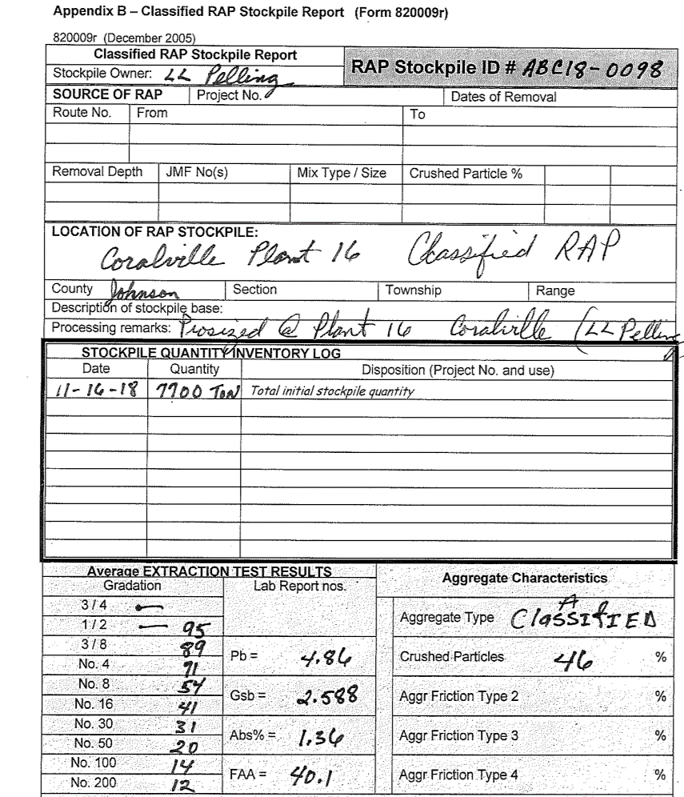

Appendix B

