**Investigation of Performance Mixtures Engineered**

**Mix (PEM) Mix Design with Reduced Cement**

**Final Report**

**for**

**MLR-21-01**

January 2021

Construction & Materials Bureau



Investigation of Performance Mixtures Engineered

Mix (PEM) Mix Design with Reduced Cement

Final Report

for

MLR-21-01

By

Todd D. Hanson

Concrete Materials Engineer

[*todd.hanson@iowadot.us*](mailto:todd.hanson@iowadot.us)

Construction & Materials Bureau

Iowa Department of Transportation

Ames, Iowa 50010

June 2021

**Technical Report Documentation Page**

*General instructions: To add text, click inside the form field below (will appear as a blue highlighted or outlined box) and begin typing. The instructions will be replaced by the new text. If no text needs to be added, remove the form field and its instructions by clicking inside the field, then pressing the Delete key twice.*

*Please remove this field before completing form.*

|  |  |  |  |  |  |  |
| --- | --- | --- | --- | --- | --- | --- |
| **1. Report No.**  MLR-21-01 | **2. Government Accession No.** | | | **3. Recipient’s Catalog No.** | | |
| **4. Title and Subtitle**  Investigation of Performance Enhanced Mixtures (PEM) with Reduced Cement | | | | **5. Report Date**  August 2020 to January 2021 | | |
| **6. Performing Organization Code** | | |
| **7. Author(s)**  Todd Hanson, Concrete Materials Engineer, [https://orcid.org/0000-0002-4832-1124](https://gcc01.safelinks.protection.outlook.com/?url=https%3A%2F%2Forcid.org%2F0000-0002-4832-1124%3Flang%3Den&data=01%7C01%7Ctodd.hanson%40iowadot.us%7C8681835d207540848edc08d860b88113%7Ca1e65fcc32fa4fdd86920cc2eb06676e%7C1&sdata=670kFymsGOyYPAYfkIYLfESYaEJbIhBpfafLLeuay8U%3D&reserved=0) | | | | **8. Performing Organization Report No.**  **MLR-21-01** | | |
| **9. Performing Organization Name and Address**  Iowa Department of Transportation  Construction & Materials Bureau  800 Lincoln Way  Ames, Iowa 50010 | | | | **10. Work Unit No.** | | |
| **11. Contract or Grant No.** | | |
| **12. Sponsoring Agency Name and Address**  FHWA  1200 New Jersey Ave. SE  Washington, DC 20590-9898  <https://www.pooledfund.org/Details/Study/620> 80% FHWA, 20% Iowa DOT | | | | **13. Type of Report and Period Covered**  Final Report (August 2020 to January 2021) | | |
| **14. Sponsoring Agency Code**  FHWA Office of Preconstruction, Construction, and Pavements HICP-40 | | |
| **15. Supplementary Notes**  Conducted in cooperation with the U.S. Department of Transportation, Federal Highway Administration. | | | | | | |
| **16. Abstract**  A performance engineered mix (PEM) design was utilized on I-29 in Harrison county in Iowa. In 2019, the standard quality management concrete (QMC) mix was used. In 2020, the PEM mix was used with a reduced cement content. Comparing testing between the two mixes revealed similar to better results with the PEM mix design, including better smoothness. | | | | | | |
| **17. Key Words**  PEM, performance engineered mixtures, SAM Number, resistivity, concrete pavement, calcium oxychloride potential, AASHTO PP-84 | | | **18. Distribution Statement**  No restrictions. | | | |
| **19. Security Classif. (of this report)**  Unclassified | | **20. Security Classif. (of this page)**  Unclassified | | | **21. No. of Pages**  45 | **22. Price** |
| Form DOT F 1700.7 (8-72) | | Reproduction of completed page authorized | | | | |

Contents

Introduction 2

Project Location 2

Project Design 3

Materials and Mix Design 4

Project Data 9

w/c ratio 9

SAM Air Testing 11

Workability – Box Test 15

Resistivity 17

Pavement Smoothness 19

Other Testing 21

Summary and Conclusions 22

Recommendations 22

Acknowledgements 24

Appendix A – Average w/c and Moistures - QMC 2019 25

Appendix B - Average w/c and Moistures - PEM 2020 27

Appendix C – SAM Air Content and SAM Number – QMC 2019 30

Appendix D – SAM Air Content and SAM Number – PEM 2020 32

Appendix E – Resistivity - QMC 2019 33

Appendix F – Resistivity – PEM 2020 34

Appendix G – Oregon State University Test Results 35

# Introduction

Based on the success of the Performance Engineered Mixture (PEM) shoulder placement on US 20 in Woodbury County in 2018, Cedar Valley Corporation requested to perform a similar trial on the I-29 Harrison County project. In 2019, the mainline and inside 6-foot shoulder was placed with the traditional QMC mix design. The first 4.07 miles of the outside shoulder was placed with an A-6-C20 mix. The remaining 2.83 miles of the outside shoulder was placed with a mix with reduced cement content of 484 lbs/yd3.

After the successful outside shoulder placement, utilizing the reduced cement mix in the fall of 2019, it was decided to investigate the use of a similar mix on the mainline placement in 2020.

# Project Location

The project is located on the southbound lanes of I-29 in Harrison County, Iowa. The following table includes the beginning and ending of project based on direction of travel by mileposts, stations, and lat./long.

**Table 1. Project Location**

|  |  |  |  |  |
| --- | --- | --- | --- | --- |
|  | Milepost | Station | Latitude | Longitude |
| BOP | 89.75 | 1830+00 | 41 33 52 | 95 55 05 |
| EOP | 76.54 | 1133+00 | 41 43 50 | 96 02 38 |

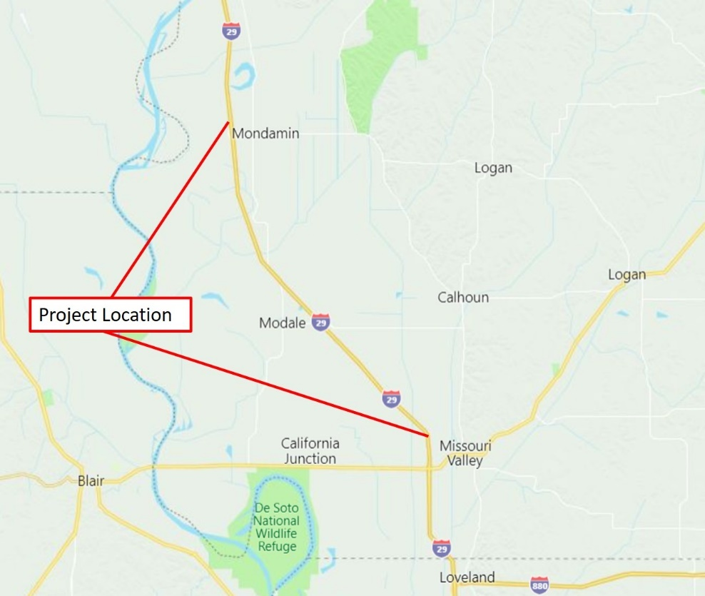

**Figure 1. Project Location Map**

# Project Design

This grade and replace project IMX-029-5(345)77—02-43 was let March 19, 2019. Pavement was designed as a 11-inch plain jointed pavement on 6 inches of granular subbase and 12 inches of special backfill. Pavement section is 24-foot wide, with 10 foot outside and 6 foot inside full depth shoulders. Transverse joint spacing is 17 feet with dowel baskets.

During construction, the contractor elected to place the inside 6-foot shoulder with the 24-foot mainline. The outside 10-foot shoulder was placed in a separate operation.

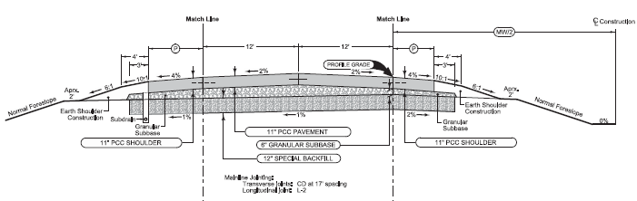

**Figure 2. I-29 Pavement Cross Section**

# Materials and Mix Design

The materials used in the mix for 2019 and 2020 remained the same, with the exception of the coarse aggregate. Cementitious materials include Ash Grove Type IP cement containing a 25% replacement with Class F fly ash and Nebraska City Class C fly ash at a 20% weight replacement of the cement. The fine/intermediate aggregate source was from North Valley. North Valley is a Class V gravel with material retained on the ½ inch sieve to the #100 sieve.

The only difference between each year was the coarse aggregate source. In 2019, the coarse aggregate was from Weeping Water Mine. In 2020, the coarse aggregate came from the Ft. Calhoun Mine. The fine/intermediate aggregate source was from North Valley. North Valley is a Class V gravel with material retained on the ½ inch sieve to the #100 sieve. A closeup view of the aggregates may be found on Figures 3 and 4.

The location of the various mix designs used may be found in Table 2. The batch weights for each mix used may be found in Tables 3 through Table 6. The average coarseness and workability chart for the mainline may be found on Figures 5 and 6. The average combined grading on the Tarantula Curve may be found on Figures 7 and 8.

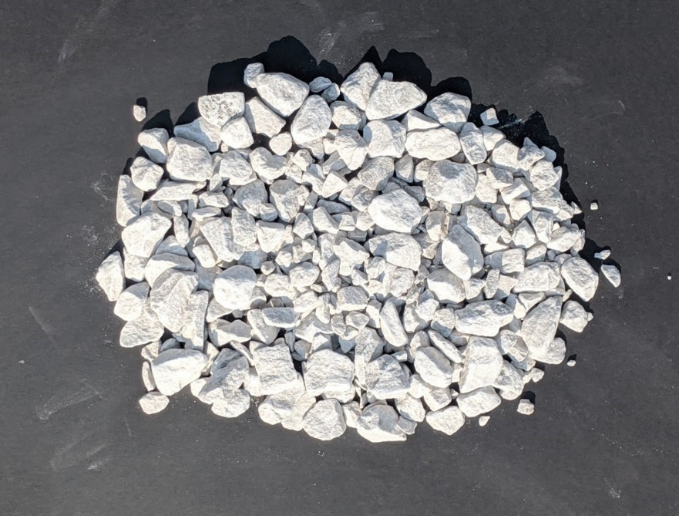  
**Figure 3. Ft. Calhoun Coarse Aggregate (2020)**

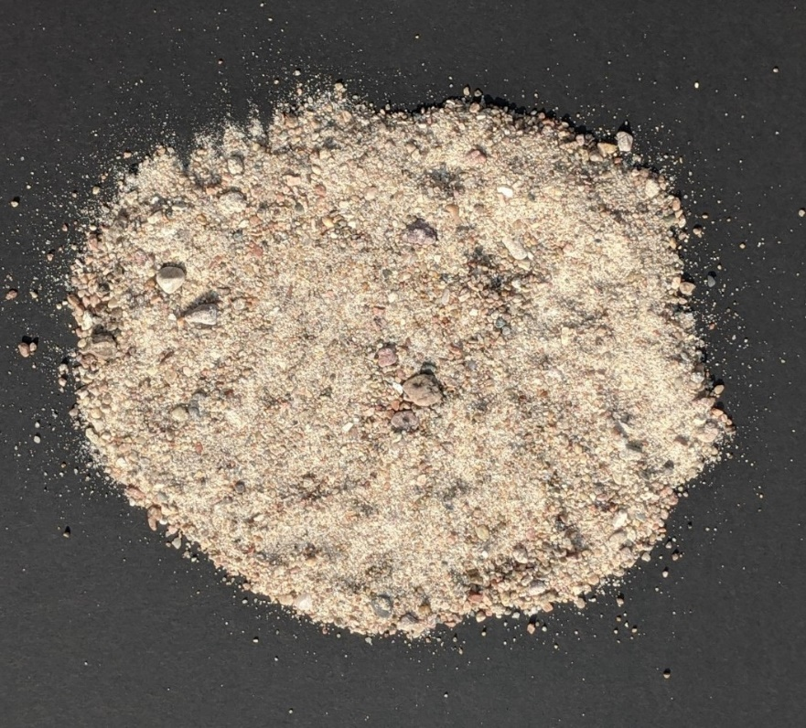

**Figure 4. North Valley Sand-Gravel Aggregate (2020)**

**Table 2. Mix Type and Location**

|  |  |  |  |
| --- | --- | --- | --- |
| Mix Design | Begin Station | End Station | Date |
| QMC | 1834+00 | 1470+00 | 8/13/19 to 9/27/19 |
| A-6-C20 | 1834+00 | 1619+30 | 8/22/19 to 10/3/19 |
| PEM Shoulder | 1619_30 | 1470+00 | 10/3/19 to 10/8/19 |
| QMPEM | 1470+30 | 1133+00 | 8/18/20 to 9/1/20 |
| QMPEM (Shoulders) | 1470+30 | 1133+00 | 9/15/20 to 9/22/20 |

**Table 3. QMC Mix Design 2019**

|  |  |  |
| --- | --- | --- |
| Material | Source | Weight (lbs/yd3) |
| Cement | Ash Grove Type IP(25) | 426 |
| Fly Ash (20%) | Nebraska City, Class C | 107 |
| Coarse Aggregate (45%) | Weeping Water | 1427 |
| Fine Aggregate (55%) | North Valley – Cl. V | 1708 |
| Water (basic w/c=0.40) 0,42 max | Willow Creek near Modale | 213 |

**Table 4. A-6-C20 Shoulder Mix Design 2019**

|  |  |  |
| --- | --- | --- |
| Material | Source | Weight (lbs/yd3) |
| Cement | Ash Grove Type IP(25) | 463 |
| Fly Ash (20%) | Nebraska City, Class C | 116 |
| Coarse Aggregate (40%) | Weeping Water | 1188 |
| Fine Aggregate (60%) | North Valley – Cl. V | 1744 |
| Water (basic w/c =0.474, 0.532 max | Willow Creek near Modale | 274 |

**Table 5. PEM Shoulder Mix 2019**

|  |  |  |
| --- | --- | --- |
| Material | Source | Weight (lbs/yd3) |
| Cement | Ash Grove Type IP(25) | 387 |
| Fly Ash (20%) | Nebraska City, Class C | 97 |
| Coarse Aggregate (45%) | Weeping Water | 1476 |
| Fine Aggregate (55%) | North Valley – Cl. V | 1761 |
| Water basic w/c 0.40, max 0.42 | Willow Creek near Modale | 194 |

**Table 6. PEM Mix Mainline & 10 ft. Outside Shoulders 2020**

|  |  |  |
| --- | --- | --- |
| Material | Source | Weight (lbs/yd3) |
| Cement | Ash Grove Type IP(25) | 399 |
| Fly Ash (20%) | Nebraska City, Class C | 100 |
| Coarse Aggregate (45%) | Ft. Calhoun | 1441 |
| Fine Aggregate (55%) | North Valley – Cl. V | 1752 |
| Water (basic w/c 0.40, 0.42 max. | Willow Creek near Modale | 200 |

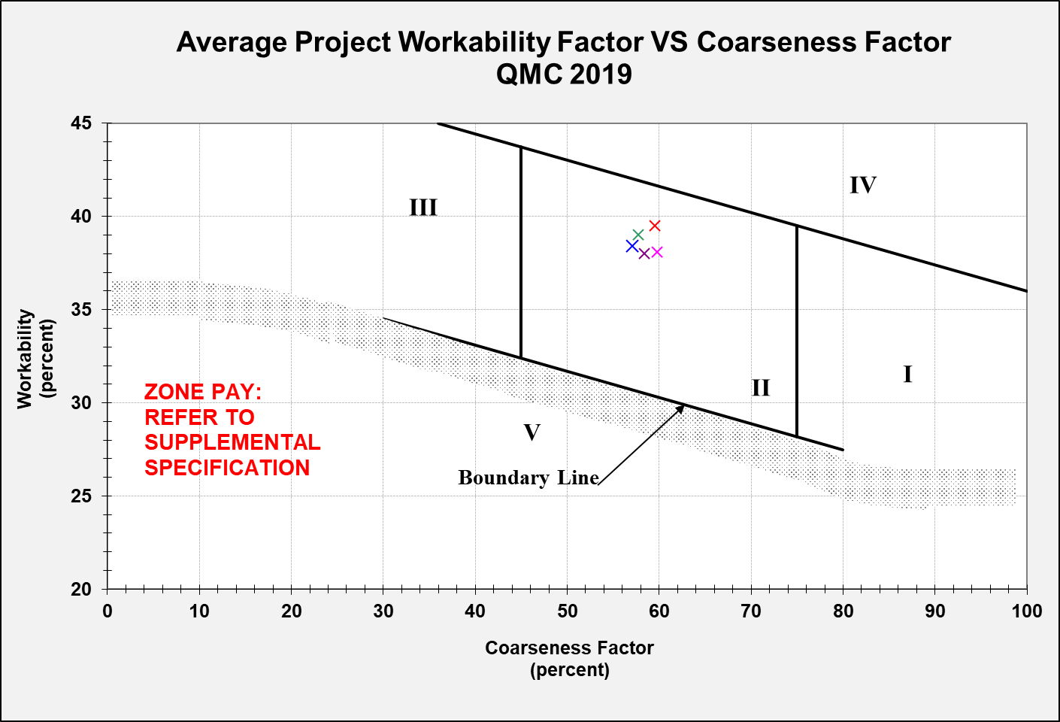

**Figure 5. Coarseness Workability Chart – QMC 2019**

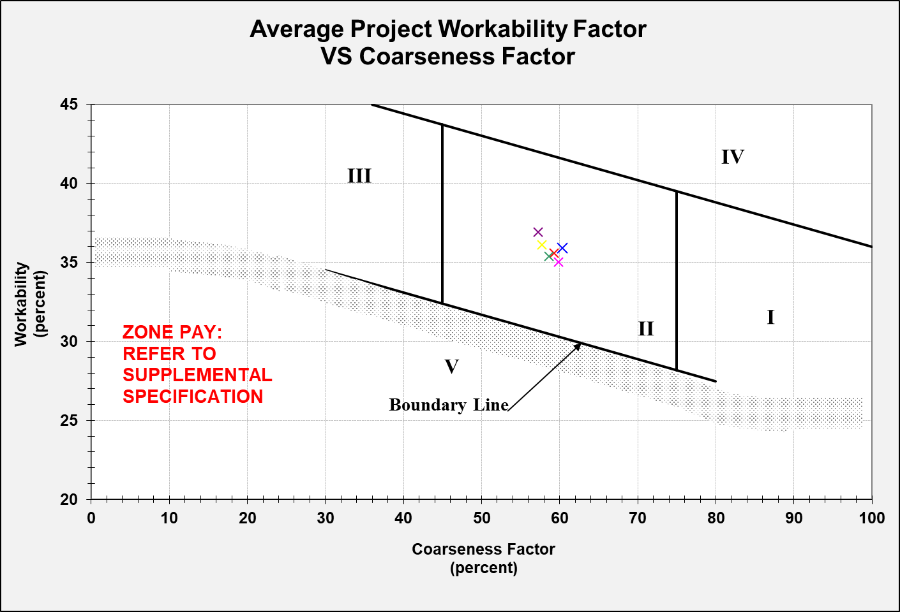

**Figure 6. Coarseness Workability (Adjusted) Chart – PEM 2020**

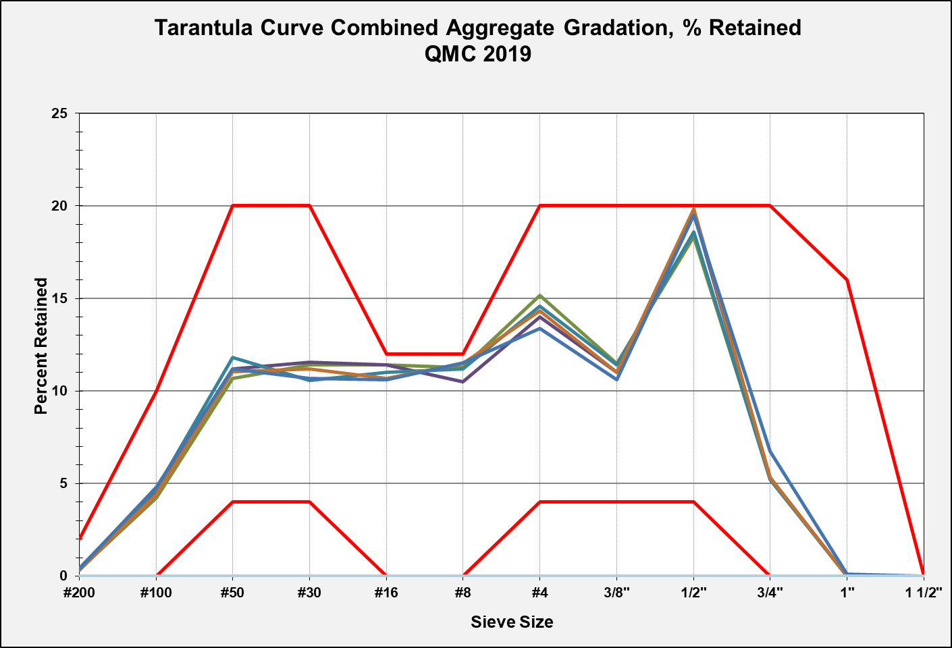

**Figure 7. Tarantula Curve Combined Gradation – QMC 2019**

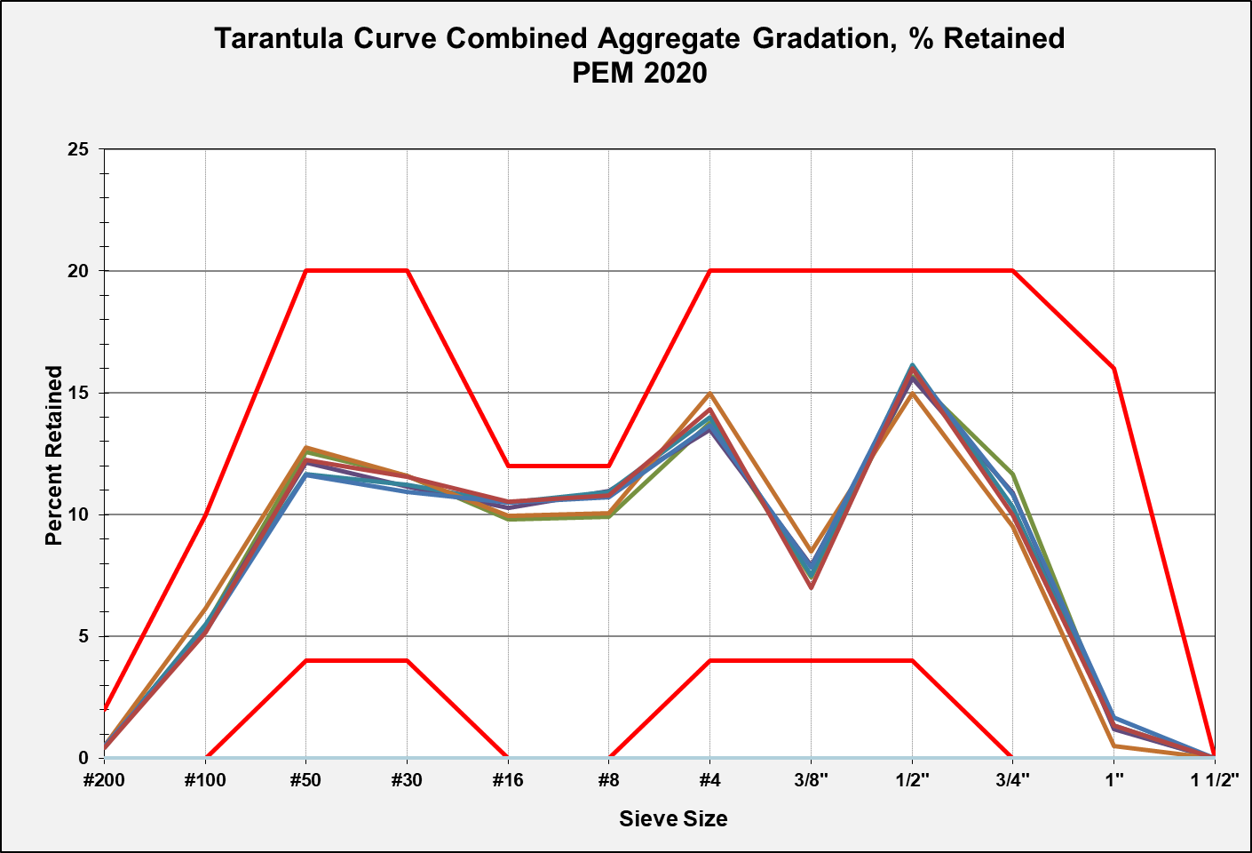

**Figure 8. Tarantula Curve Combined Gradation – PEM 2020**

# Project Data

Standard mix for shoulders was A-6-C20. Average w/c ratio during production was 0.393. PEM shoulder mix with reduced cement content of 484 lbs per cubic yard. Average w/c ratio was 0.413. Based on the

## w/c ratio

The w/c ratio is determined from batch weight at the plant. The average w/c ratio for the QMC mix in 2019 was 0.396. The average w/c ratio for the PEM mix in 2020 was ratio 0.390. Based on the control charts, it appears that the daily results for the w/c ratio for the PEM mix were lower than that of the QMC mix. The w/c ratio control chart for each year may be found on Figures 9 and 10.

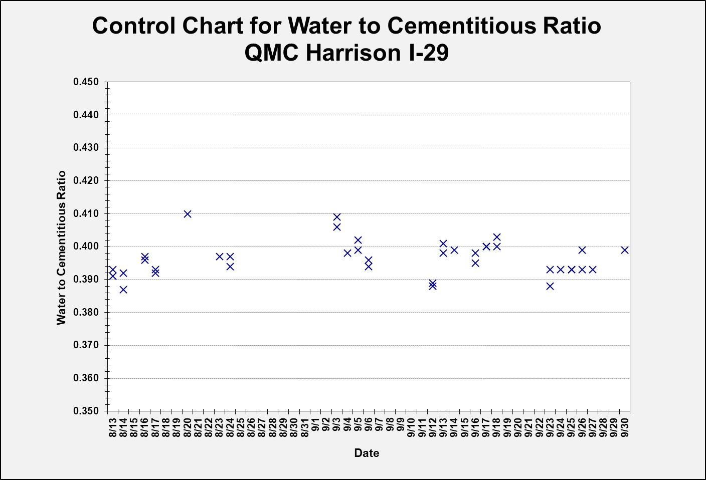

**Figure 9. w/c Ratio Control Chart – QMC 2019**

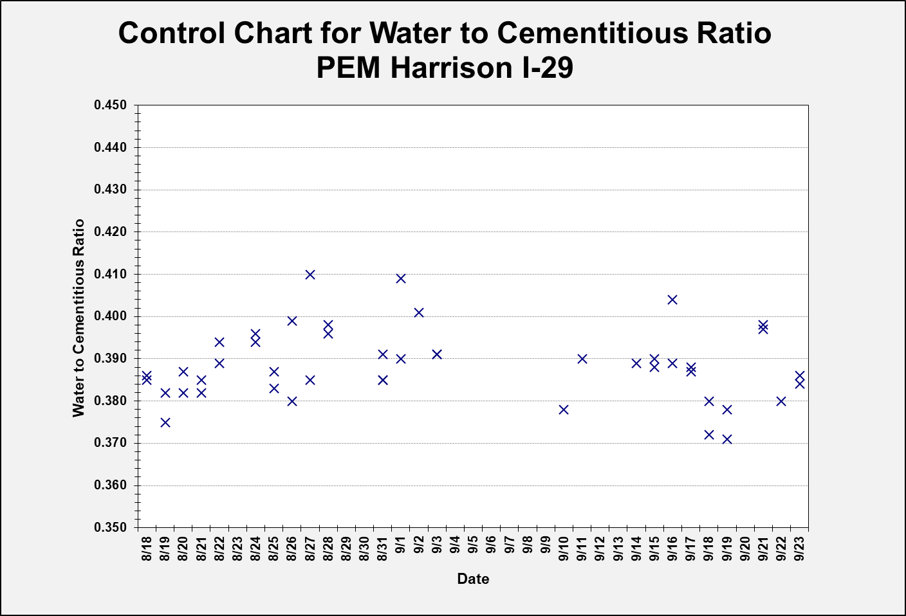

**Figure 10. w/c Ratio Control Chart – PEM 2020**

## SAM Air Testing

On the 2019 portion of the project, utilizing the QMC mix, Super Air Meter (SAM) number and SAM air content was tested at the plant. On the 2020 portion, utilizing the PEM mix, the SAM number and SAM air content was tested at the plant and the same truck was tested on the grade. Two SAM air meters were used to accomplish testing at the plant and grade.

Based on the control charts, it appears the SAM number for the PEM mix was lower overall, with more results less than 0.20, than the QMC mix. Control charts for the SAM number may be found on Figures 12 and 13. The SAM air content at the plant average was 9.5%, with a standard deviation of 0.76, while the SAM air content on the grade average was 8.9%, with a standard deviation of 0.86. The SAM number at the plant average was 0.13, with a standard deviation of 0.050, while the SAM number on the grade average was 0.18, with a standard deviation of 0.063. The plant versus grade results of the SAM air content and SAM number may be found on Figures 14 and 15.

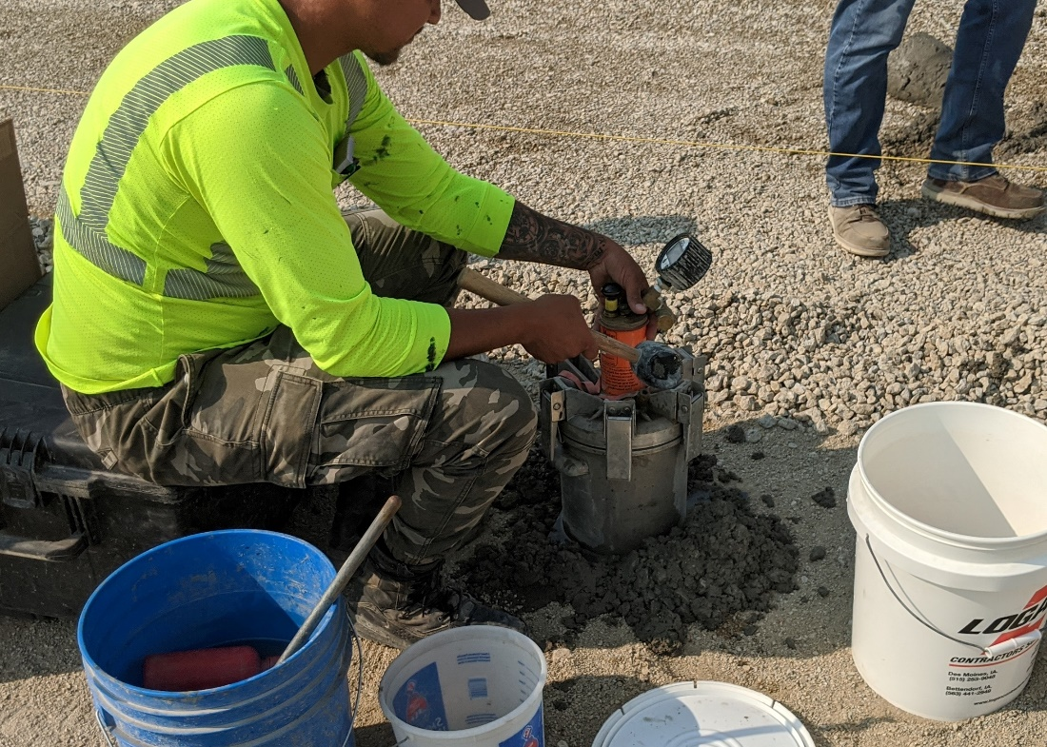

**Figure 11. SAM Testing on Grade – I-29 Harrison (2020)**

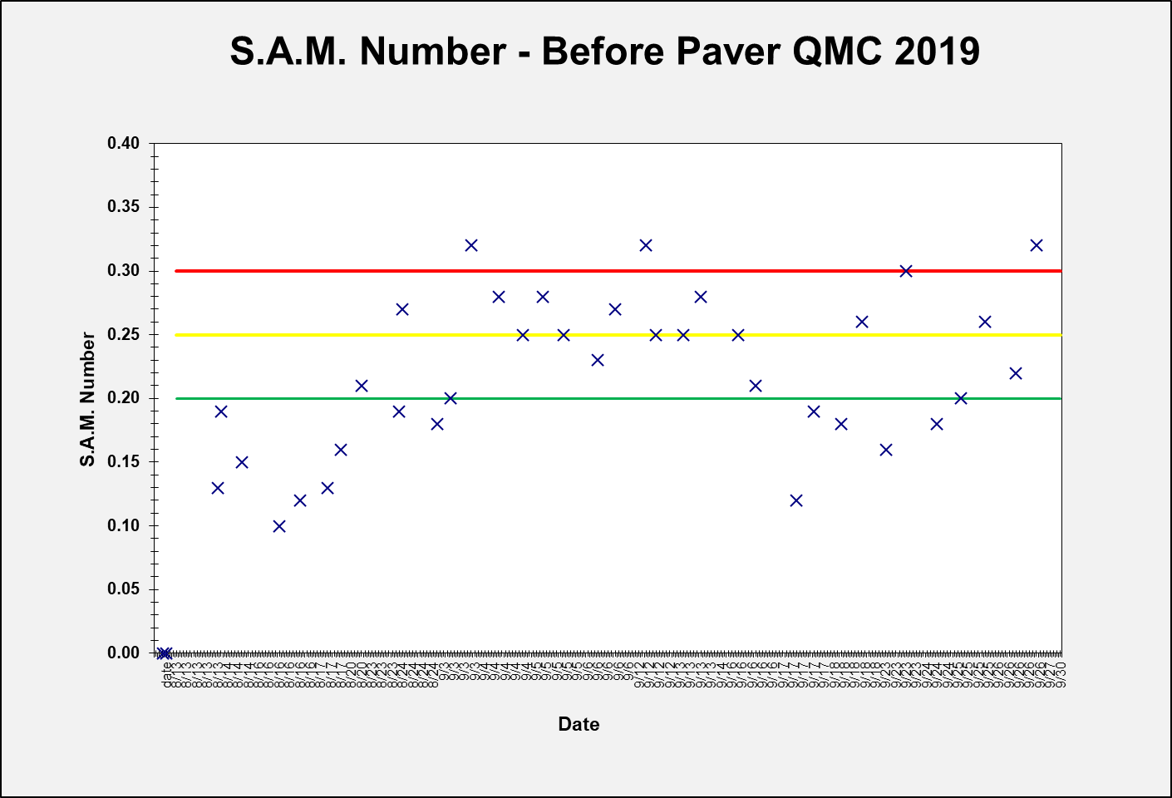

**Figure 12. SAM Number Before Paver – QMC 2019**

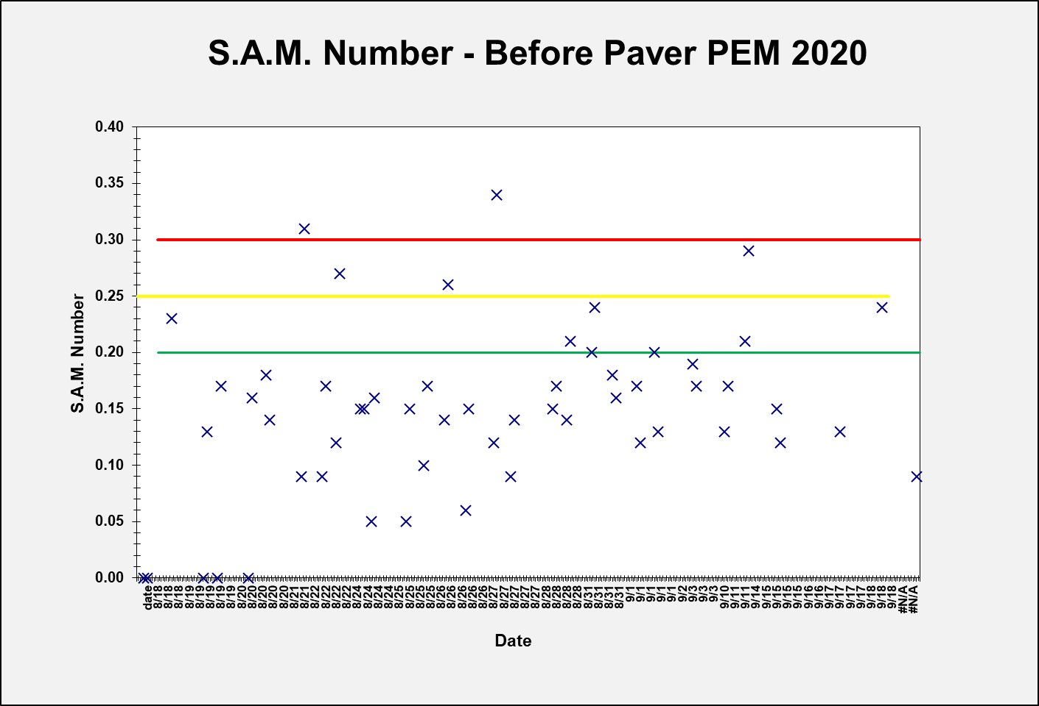

**Figure 13. SAM Number Before Paver – PEM 2020**

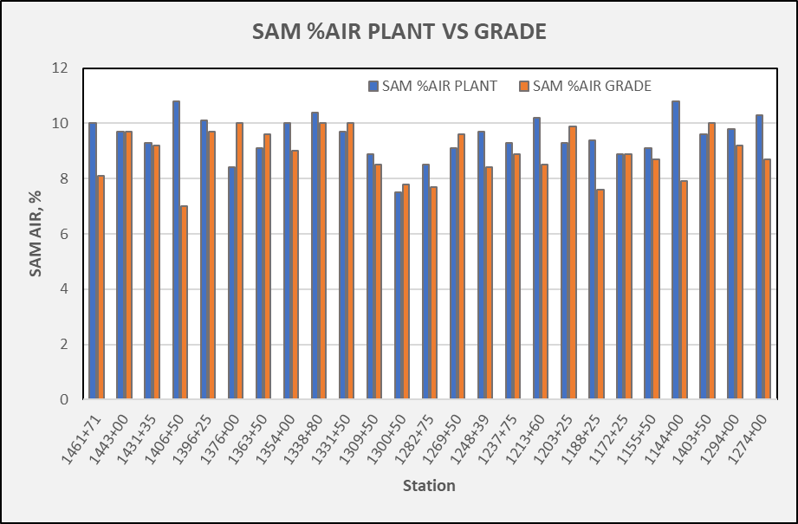

**Figure 14. SAM Meter % Air Content – Plant vs. Grade – PEM 2020**

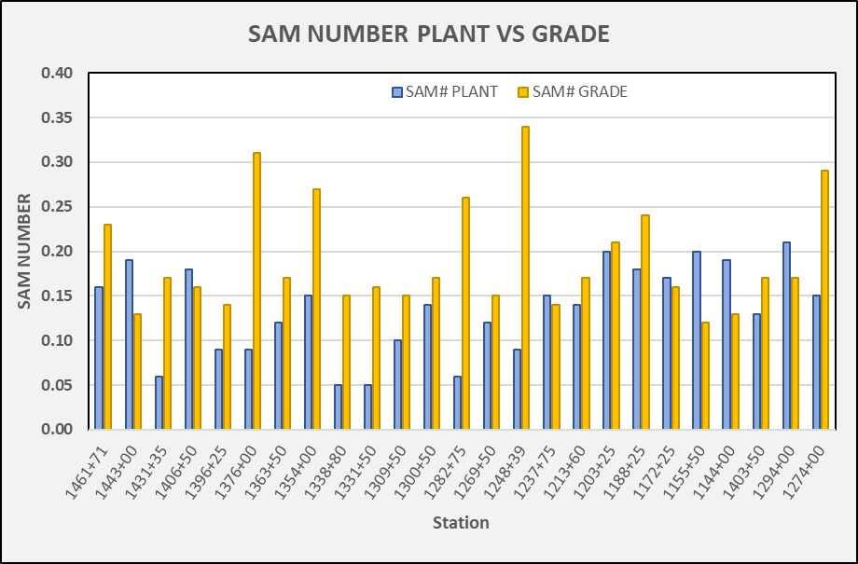

**Figure 15. SAM Number Plant vs. Grade – PEM 2020**

## Workability – Box Test

The box test was performed once per day during normal production. In 2019, the box test was performed at the plant. In 2020, the box test was performed on the grade. All box test ratings were a “1”, with the exception of one test result with a “2” rating in 2019. Results may be found on Figures 17 and 18.

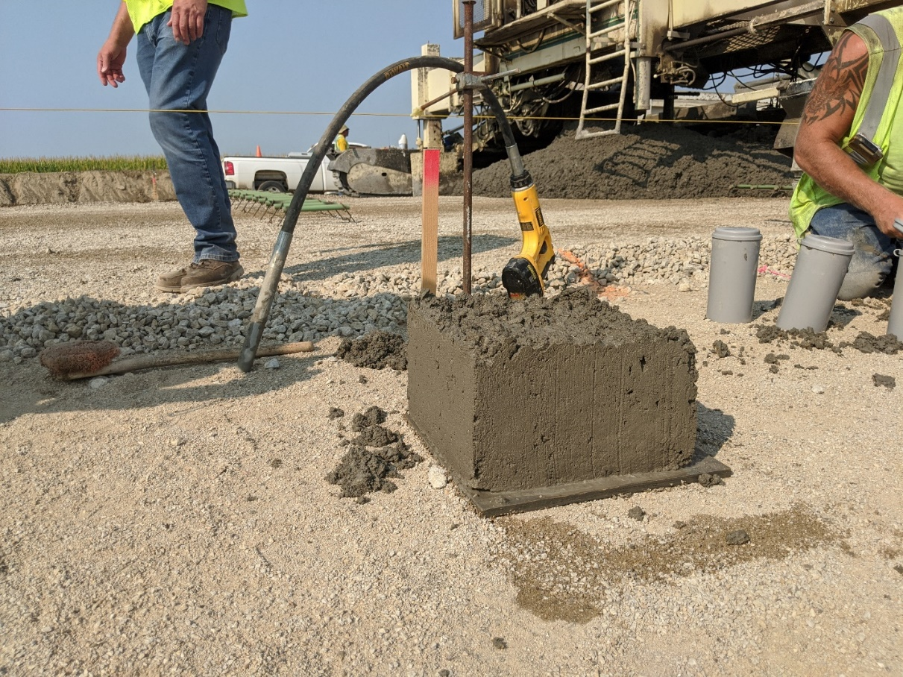

**Figure 16. Box Test on Grade – I-29 Harrison 2020**

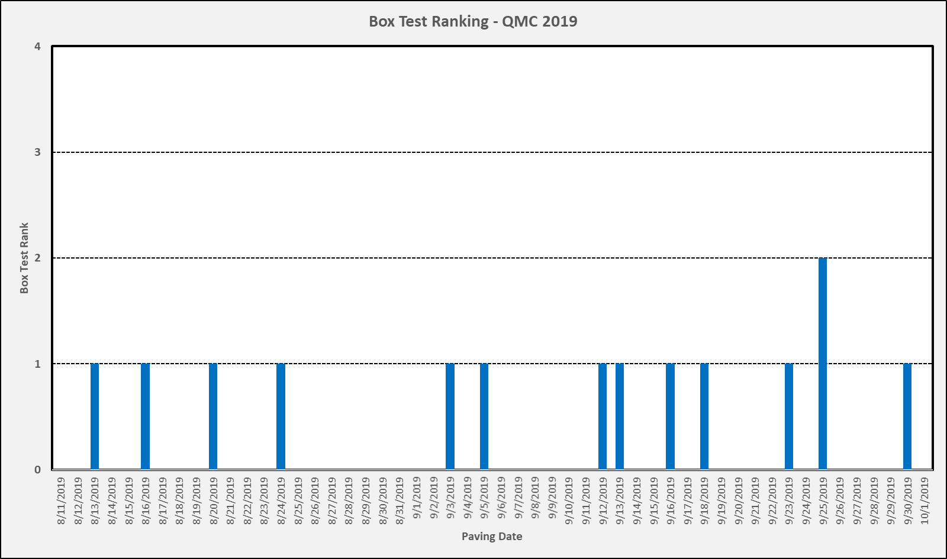

**Figure 17. Box Test Workability Ranking – QMC 2019**

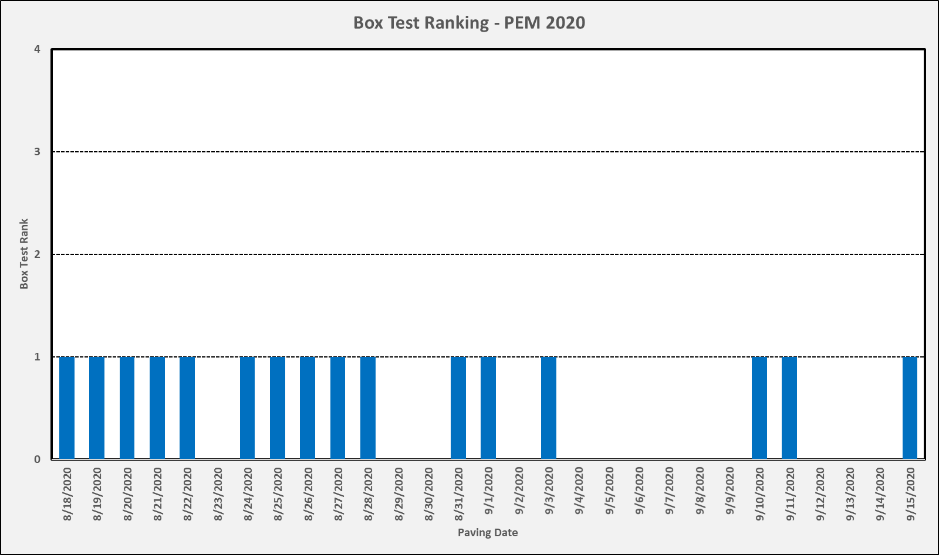

**Figure 18. Box Test Workability Ranking – PEM 2020**

## Resistivity

Cylinders were cast every day and placed in a 5-gallon bucket with a well-sealed lid, with 3.5 gallons of water and 102.6g NaOH, 143.90g KOH and 27g Ca(OH)2 into. Resistivity testing was performed by the contractor on the project at 3 and 7 days. The buckets were delivered to Iowa State University laboratory for testing at 28 and 56 days. Overall, the resistivity for the PEM mix is higher at 56 days than the QMC mix. Results for the QMC mix in 2019 may be found in Figure 19 and results for the PEM mix in 2020 may be found in Figure 20.

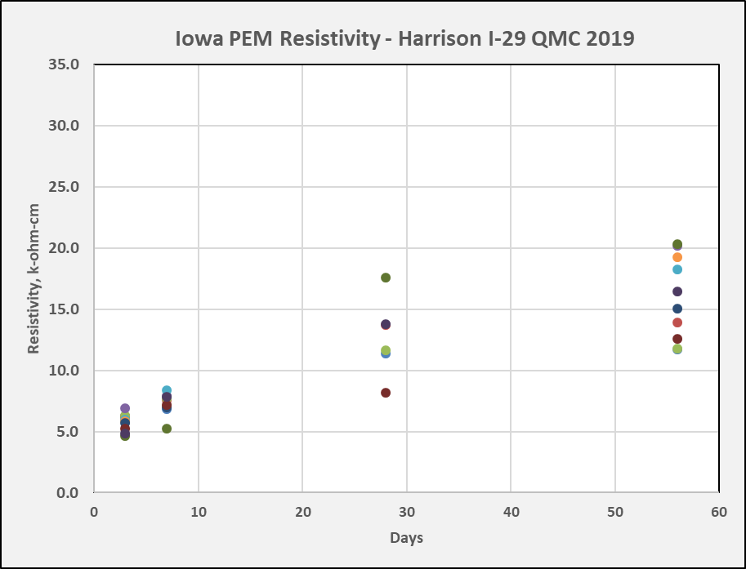

**Figure 19. Resistivity Test Results – QMC 2019**

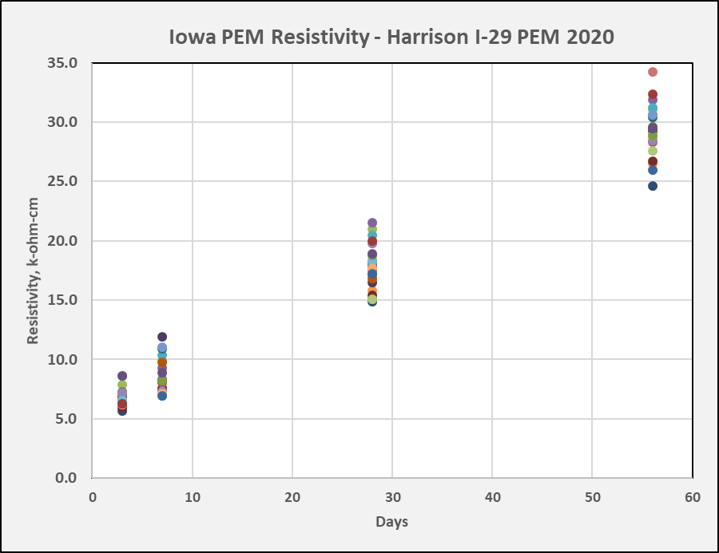

**Figure 20. Resistivity Test Results – PEM I-29 Harrison 2020**

# Pavement Smoothness

Pavement smoothness was performed by the contractor using zero blanking band, with verification performed by the Iowa DOT. In 2019, the average profile index was 24.87 inches per mile for the 6.69 miles of mainline paving. In 2020, the average profile index was 19.36 inches per mile for the 5.98 miles of mainline paving. 2019 QMC paving 142 segments achieved 58.45% of the maximum incentive. 2020 PEM paving 144 segments achieved 72.66% of the maximum incentive. Overall, the PEM mix with reduced cement content achieved better smoothness compared to the QMC mix.

The mix placement went very well with no issues with workability and finishing. The pavement edge of the extruded slab was very sharp and clean. See Figures 21 and 22.

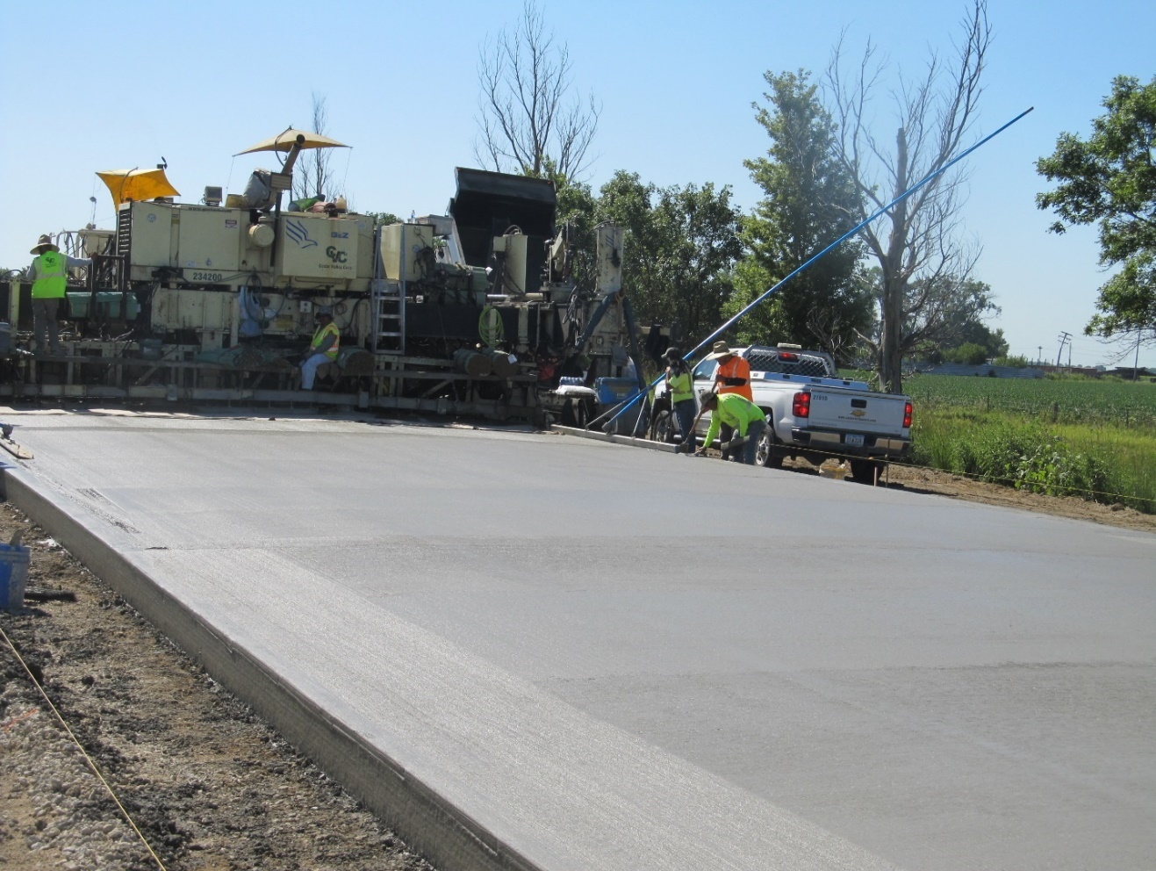

**Figure 21. Overall View Pavement Slab Behind Paver – Harrison I-29 (2020)**

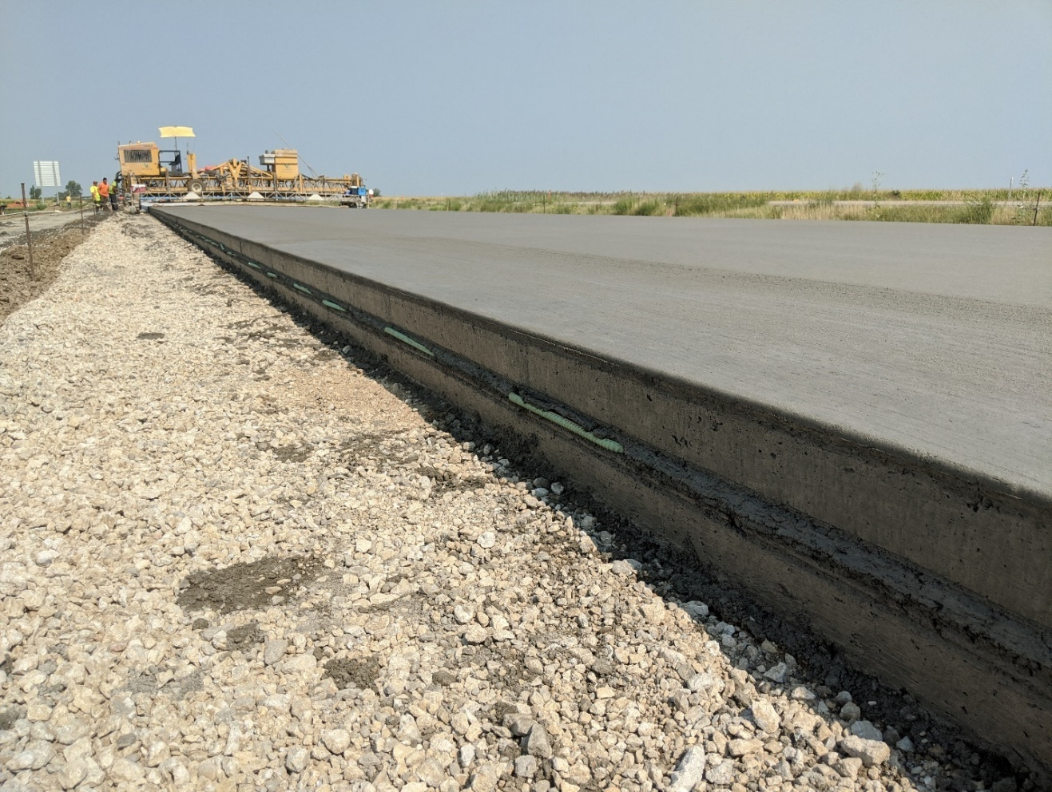

**Figure 22. Closeup of Pavement Slab Edge – Harrison I-29 (2020)**

# Other Testing

Twelve cylinders were sent to Oregon State University for further testing. Results are included in the Appendix.

# Summary and Conclusions

Overall, the PEM mix with a reduced cement content performed equal to or better than the QMC mix. The following conclusions were found.

* The average w/c ratio was slightly lower for the PEM mix at 0.390 versus the QMC mix at 0.396.
* Overall, the SAM number for the PEM mix had more test results less than 0.20, than the QMC mix
* The box test results were fairly equal for both, with one rating of a “2” for the QMC mix
* Overall, the smoothness based on zero blanking band for the pavement placed with the PEM mix was lower and achieved higher incentives for the contractor versus the pavement placed with QMC mix.

# Recommendations

Based on the results of the testing and placement utilizing the PEM mix with a reduced cement content, the following recommendations

* Get more contractors involved to get familiar with the PEM testing and mix designs
* Investigate effect of other aggregate types and shapes on reduced cement mixes.
* Validate these mixes utilizing the PEM test protocols
* After investigation, recommend changes to the QMC Developmental Specification to include a reduced cement mix design mix validated with PEM testing

# Acknowledgements

Special thanks to the following people for helping to facilitate this research, performing tests, and gathering data. Craig Hughes and John Quandahl from Cedar Valley Corporation, Dan King from the Iowa Concrete Paving Association, Dean Herbst, Rollin Nemitz, Ross Wood, and Baron Hannah from the Iowa Department of Transportation, and Peter Taylor and Gordon Smith from the National CP Tech Center.

# Appendix A – Average w/c and Moistures - QMC 2019



# Appendix B - Average w/c and Moistures - PEM 2020



# Appendix C – SAM Air Content and SAM Number – QMC 2019



# Appendix D – SAM Air Content and SAM Number – PEM 2020



# Appendix E – Resistivity - QMC 2019



# Appendix F – Resistivity – PEM 2020



# Appendix G – Oregon State University Test Results



