







In 2005 the DHS Case Management Unit began serving seriously emotionally disturbed children under the CMH (Children’s Mental Health) Waiver. The CMH Waiver is intended to allow children to remain in a family setting while receiving services and allows the case manager to work closely with the family on outcomes for the child.
2005 New Faces & New Places
1

The year2005 was one of expansion for DHS TCM.

In May of 05 we learned that a new waiver program (the Children’s Mental Health Waiver) to serve children with serious emotional disturbances would become part of our work life. A total of 300 children would become eligible to receive CMH waiver services. The summer was spent in selection of the first wave of possible participants and putting office space and staff into place. By Oct we were up and running. What that in reality meant to us was:
- 78 new county contracts
- 2 new supervisors
- 16 new case managers, all of whom have had some experience with the population
- 1 new office and the expansion of 7 other office locations
- 7 separate training events designed to learn about the consumers, the program, as well as a new assessment tool.

As of February 2006 we are successfully serving 154 children under the CMH Waiver program. Overall, compared to last year DHS Case Management is serving 800 more consumers. We added 25 staff positions and our budget involves 2 million more in revenue. We have successfully implemented a case weight of 1 TCM to 35 consumers for non CMH Waiver case managers.

From a policy point of view we have focused on case assignment and monitoring. We have reaped the benefits of our focus on faster referrals and data shows we have reduced the time to process a referral from 44 days to 25 days.

The expansion of business forced us to look at our business process and evaluate a realistic workload in that area. With a total of 36 office locations that require extensive leasing procedures and 26 service contracts we added a position to assume that work. Pre-authorization and billing made us aware of cash flow issues and we added an account tech as well as a business manager to aid in this area.

Each side of our business (East and West) is now equivalent to what our total business was in 2001. Thus my title page of “New Faces and New Places” reflects consumers, staff and locations. I am grateful for the support of our unit leaders that never said, “You want what by when?” This was a remarkable year and I am in awe of what was accomplished by so very few in what seemed such a short time. We have dedicated staff, talented supervisors, leaders with vision and guts, and support staff that keeps the unit running.

On the horizon I see a new emphasis on the Medical Model and to that end my age and experience is an asset. I am looking forward to 2006 as a time to get to know our new consumers and staff and sharpen our skills in the areas of assessment, program planning and monitoring.

Diane Diamond
Bureau Chief, DHS Targeted Case Management

Table of Organization
2


DHS Case Management employs an additional 13 Social Work Supervisors who supervise 144 Case Managers. An additional 27 employees cover the areas of Accounting, Clerical Support, IT, and Quality Assurance.

Advisory Board
3

Chris Sparks, Exceptional Persons Inc
Jan Heikes, Winneshiek Co CPC
Jill Eaton, Marshall Co CPC
Joann Hagen, Parent Winneshiek Co
Kristi Dierking, Warren Co CPC
Lori Elam, Scott Co CPC
Lori Nosekabel, Clarke Co CPC
Louise Galbraith, Crawford Co CPC
Mary Williams, Benton Co CPC
Ted Ely, Audubon, Greene Guthrie Co CPC
Terry Johnson, Genesis Development


The Advisory Board serves as consultative body for Unit operations. Officials in contracted counties, provider agency staff, consumers and guardians can all be considered for membership. Membership is voluntary.

County and Office Locations
4
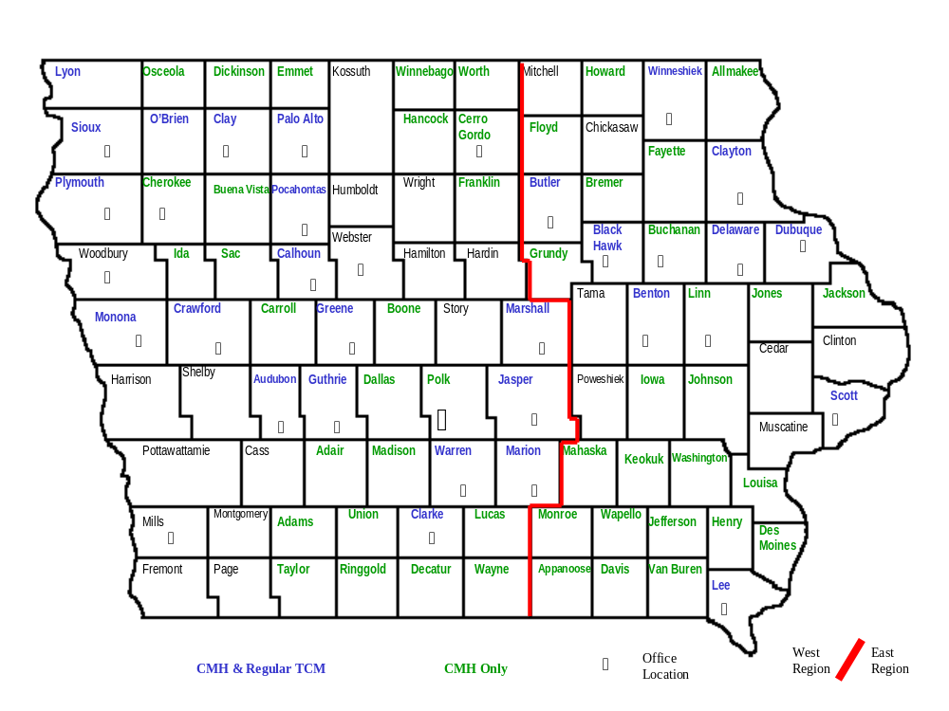
In 2005 DHS TCM entered into contracts with 78 counties to provide service under the Children’s Mental Health Waiver. This included 51 new counties in addition to the 27 already served by DHS TCM for MR, CMI, DD and BI consumers. As a result of the CMH Waiver an additional office was added in Linn County and offices were expanded in Clark, Polk, Black Hawk, Scott, Dubuque, Cerro Gordo and Lee counties.

County CPC Comments On Service
5

County | Areas to improve* | Overall Satisfaction
Audubon | None | 10 – Very satisfied
Benton | None | 9 – Case mgrs provide excellent service
Black Hawk | Coordination of placements, cost effective program plans | 8 – Primarily happy with the job TCMs do
Butler | None | 10 – Case mgr is doing a good job
Calhoun | None | 10 – No comments
Clarke | None | 10 – No complaints
Clayton | None | 9 – Question about billing cycle
Crawford | None | 9 – No comments
Delaware | None | 10 – Great group, easy to work with
Dubuque | None | 8 – More positive comments this year
Greene | None | 10 - Very satisfied
Guthrie | None | 10 - Very satisfied
Jasper | None | 9 – No comments
Lee | None | 10 – No comments
Lyon | None | 10 – Communication always, good no problems
Marion | None | 10 – No comments
Marshall | None | 10 – Great, signed a three-year contract
Monona | None | 10 – Over all DHS TCM does an excellent job
Palo Alto | Cost-effective program plans | 9 – Wants a TCM in her office
Plymouth | None | 9.75 – Go to the board with annual plans
Pocahontas | None | 9 – No Comments
Scott | Providing requested info, coordination of placements, cost-effective program plans | 8 – Case mgrs need to be more proactive in providing information to the CPC office in a timely manner
Sioux | None | 10 – No Comments
Warren | Application of county management plan, Referrals, coordination of placements, cost-effective program plans | 8 – A particular case manager found another provider because rates were out of line. She worked really well with the CPC and initiated the change.
Winneshiek | None | 10 – I hope we retain staff, a lot of turnover
* A score of less than 8 in any area of the survey results in a corrective action plan implemented by the supervisor
Surveys were conducted with county CPCs in counties that had a contract in place with DHS TCM at the beginning of the calendar year. O’Brien and Clay counties signed contracts with the Unit later in the year. They will be surveyed in 2006.

Referral Process
6

Days between referral date & date case management initiated | Number of referrals for 2004 | Number of referrals for 2005
0-30 | 431 | 470
31-60 | 107 | 69
61-90 | 42 | 33
91-120 | 27 | 12
121-150 | 24 | 9
151-180 | 15 | 4
181-210 | 4 | 2
211-240 | 9 | 1
241-270 | 8 | 1
271-300 | 3 | 3
301-330 | 5 | 0
330-365 | 8 | 0
 | 2004 | 2005
Average days between referral date and date case management initiated | 44 | 25

The 2004 county satisfaction survey brought to our attention an issue with referrals. Our county partners felt we needed to improve the amount of time it takes for a referral to be processed. We made this a goal in 2005 and were able to reduce the average number of days for a referral to become an active case by 19. For those referrals not accepted for case management, a determination took 25 days in 2005 as opposed to 45 in 2004.

Our Consumers
7
Total Number  Of  Consumers | 4389*
Age | 0-17 | 18-34 | 35-64 | 65+
Number of Consumers | 798 | 1369 | 2090 | 132
Diagnosis | MR | MR Child | CMI | DD | BI | SED**
Number of Consumers | 2278 | 639 | 999 | 196 | 210 | 76
Female | 1977
Male | 2412
Years With TCM | 0-5 | 5-10 | 10+
Number of Consumers | 2594 | 1098 | 697
 | Open in 2005 | 667 |  | Closed in 2005 | 482
* Represents the total number of consumers who received case management services for at least
one month in 2005. As of December 2005, the DHS TCM Unit was actively serving 3978 consumers.
** SED (Severe Emotional Disturbance) is the diagnosis of children on the CMH Waiver. This was a
new diagnosis in 2005.

Consumer Satisfaction Survey
8

County | # Satisfied Consumers* |  | County | # Satisfied Consumers*
Audubon | 18 of 19 surveys (95%) |  | Lee | 29 of 35 surveys (83%)
Benton | 20 of 23 surveys (87%) |  | Lyon | 7 of 7 surveys (100%)
Black Hawk | 104 of 112 surveys (92%) |  | Marion | 13 of 14 surveys (93%)
Butler | 36 of 41 surveys (88%) |  | Marshall | 28 of 31 surveys (90%)
Calhoun | 20 of 21 surveys (95%) |  | Monona | 7 of 7 surveys (100%)
Clarke | 11 of 15 surveys (73%) |  | O’Brien | No survey in 2005**
Clay | No survey in 2005** |  | Palo Alto | 11 of 13 surveys (85%)
Clayton | 23 of 24 surveys (96%) |  | Plymouth | 18 of 20 surveys (90%)
Crawford | 25 of 26 surveys (96%) |  | Pocahontas | 15 of 15 surveys (100%)
Delaware | 33 of 38 surveys (87%) |  | Scott | 59 of 70 surveys (84%)
Dubuque | 146 of 170 surveys (86%) |  | Sioux | 26 of 28 surveys (93%)
Greene | 9 of 10 surveys (90%) |  | Warren | 17 of 19 surveys (89%)
Guthrie | 9 of 9 surveys (100%) |  | Winneshiek | 13 of 17 surveys (76%)
Jasper | 33 of 41 surveys (80%) |  | State Cases | 59 of 84 surveys (70%)
Additional Information:
- Total Surveys Returned 909; Total Surveys Sent Out 1515; Return Rate 60%
- Consumers who feel more a part of their community since working with case management: 715 out of 909 (78.7%)
- Consumers who set the goals in their case management plan: 706 out of 909 (77.7%)
- Consumers who decide what kind of services and activities they would like: 771 out of 909 (84.8%)
- Consumers who feel their case manager respects their skills and abilities: 843 out of 909 (92.7%)
- Over all consumer satisfaction with case management services: 799 out of 909 (87.9%)

Surveys were sent to a minimum of 50% of the consumer population in a given county. In instances where 50% of the consumers would not provide an adequate sample size, or at the request of the CPC, additional surveys were sent out. Surveys are sent to a random selection of adult consumers who have received case management services for at least one year.

* Number of satisfied consumers out of number of surveys returned. ** County had not contracted with DHS TCM for more than a year at the time of the survey.



Consumer Data
9
Consumers who had one or more medical hospitalization | 336 | Consumers with a  criminal conviction | 49
Consumers with one or more psychiatric hospitalization | 301 | Consumers with a  founded abuse report | 19
Consumers who had one or more 23-hour observation | 43 | Consumers who live in their own or a relative’s home | 3572
Consumers in a work setting | 2191 | Average income for working consumers | $239.15
Consumers by work setting* |  | Average income by work setting
Competitive | 357 | Competitive | $478.92
Supported | 449 | Supported | $428.30
Sheltered | 1658 | Sheltered | $147.04
OAPs completed in 2005 | 4445** | Narrative contacts in 2005 | 119,376
Average number of  goals per OAP | 3.29 | Total narrative minutes in 2005 | 2,294,205
Average number of  service activities per goal | 3.5 | Average duration per narrative contact | 19.2 minutes
Data is taken from consumer assessments, OAPs and narratives. Narrative data is based on all face-to-face, collateral, combined and phone contacts made on behalf of consumers who were actively served by DHS Case Management for all or part of the time period 1/1/2005 to 12/31/2005. Data regarding OAPs is based on all OAPs completed for active consumers during the same time frame. All other data comes from consumer assessments completed by the case manager again during calendar year 2005.

* Some consumers have multiple work settings
** Some consumers may have more than one OAP during the year as goals change

Safety
10
Calendar year 2005 was a year of beginnings and a year of endings. Incidents that were categorized as “other” were no longer compiled. While useful data was obtained, Chapter 24 of the Iowa Administrative Code did not mandate it, and with limited resources it, was decided to discontinue tracking these types of incidents and use our time to address more serious incidents, such as child protective concerns. Also, late in 2004, additional service providers were mandated to submit incidents to our targeted case management unit. Finally, a new Home and Community Based Waiver for children with serious emotional disturbances began in October. It is anticipated this new program may initially produce a large number of incidents. The data below represents outcomes for 2003-2005.
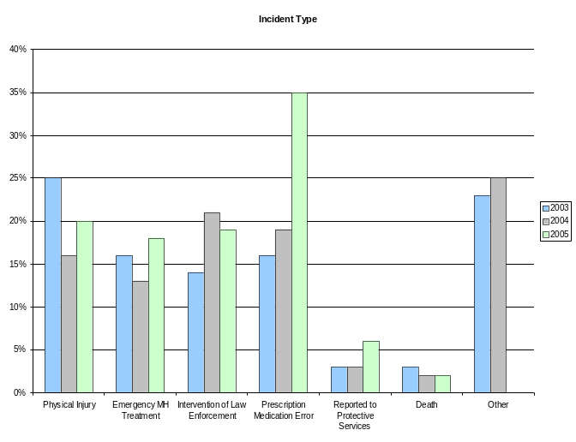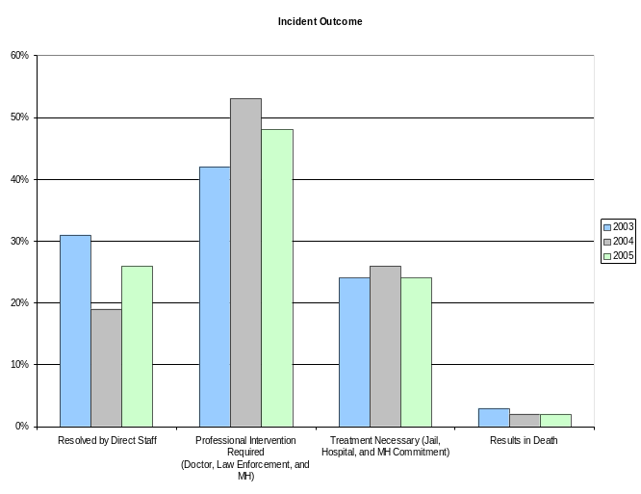
Incidents by Type
In 2005, the most reported incident, by type, were prescription medication errors. This year 35% (n = 507) fell into this category. This represents a sixteen percent increase over last year’s report. It is believed this is attributable to more accurate reporting of medication errors. Physical injuries accounted for 20% (n = 294) of the total number of incidents. This is a four percent increase over last year but still five percent less than was reported in 2003. The intervention of law enforcement accounted for 19% (n = 273), a two percent decrease over last year.

In 2005, 18% (n = 267) sought mental health treatment, a five percent increase over last year. Concerns related to protective concerns comprised 6% (n = 80), an increase of three percent from last year. This is attributed to the new HCBS child welfare program. Always sad to report are the individuals we serve that die during the year. In 2005 2% (n = 26) of the total incidents reported were for individuals who died.

Incidents by Outcome
In 2005, professional intervention was required in 48% (n=686) of the reportable incidents, a 5% decrease over 2004. As compared with last year, direct staff were able to resolve a greater percentage of incidents 26% (n=376) or 7% more than the previous year. Treatment was necessary in 24% (n = 359) or 2% fewer cases this year. And, as mentioned above, there were 26 deaths in 2005.

Safety
11

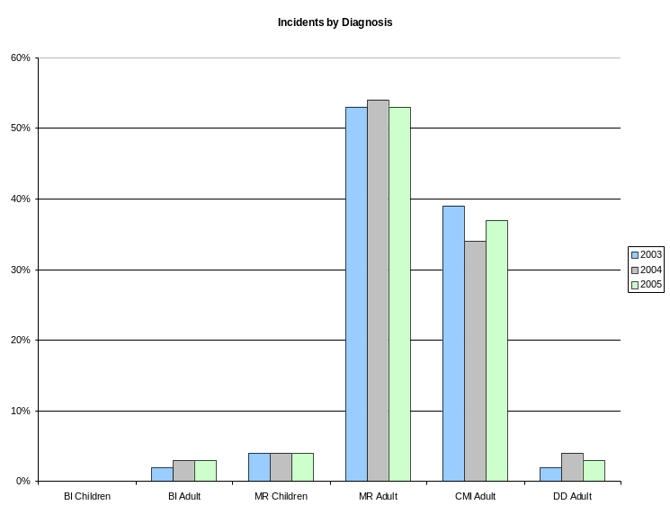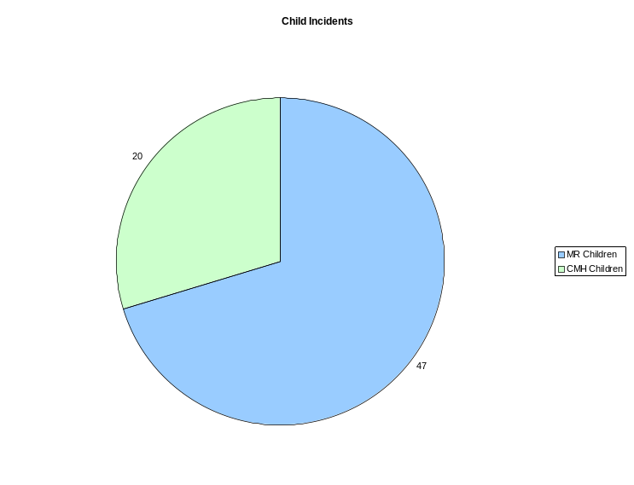

Incidents by Diagnosis
Given that our MR and CMI population make up the majority of our consumer base, it is to be expected that the majority of our incidents would be from this population. In 2005, 90% of our incidents came from these two groups, up 2% from last year.

Individuals with a chronic mental illness or those who are mentally retarded often represent a challenge to direct providers in ensuring their safety. As we notify providers of incidents by consumer, they will be able to see trends in their consumer’s behavior, which will allow them to intervene more appropriately.

Child Incidents
Incidents involving children more than doubled this past year. This is accounted for by the introduction of our child mental health program (CMH) for children with serious emotional disturbances. While the total number of incidents involving children comprised only 5% (n = 67) of our total incidents, roughly 30% (n = 20) came from the new child waiver program. In 2005, 40% (n = 27) of the incidents involving children were child protective concerns. Of those, 19% (n = 5) came from the CMH program. As with our other children incidents that involve child protective concerns, among our CMH population, are subject to a “safety review” and on going monitoring by a licensed social worker and our safety committee. This process has provided additional oversight and provided numerous intervention strategies to address acute and chronic
child protective concerns. For example, in one case a medical concern (wetting the bed) was being addressed as a behavioral concern. The child was getting in trouble for wetting the bed. With our oversight, we determined this may be a medical issue. A referral was made to a doctor who prescribed medication, and the consumer is now staying dry through the night.

Quality Improvement
12
The DHS Targeted Case Management Unit is the IAC Chapter 24 provider of choice to 27 counties and is Iowa’s largest provider. To maintain this relationship, the Unit works continuously to build high quality standards into its service delivery to its consumers and to maintain its case management accreditation. This is accomplished through the coordinated work of management and the Quality Team to provide continuous quality training of case managers, case reviews of every case manager, revised training materials, and policy improvements.

Quality Team. The Quality Team provides leadership on Quality issues by identifying problems and solutions in policy and practice. It serves as a customer service and support to case managers and supervisors by providing technical support, training, and feedback. Services include program and policy improvements, case reviews, training documents, consultations, specialized studies, hands-on training with case managers, and data collection.

Policy Streamlining and Documentation Improvements. The highlight of 2005 was continuing to build upon the quality of work as documented by the case managers in consumer case files. In 2005, the Unit exceeded the overall 2005 goal of meeting documentation standards. This improvement by the case managers was supported by the Quality Team’s work in clarifying policy, streamlining documentation and forms, and training based on the Unit’s 3-year Corrective Action Plan, written in 2004. Improvements in case documentation were also mirrored in improved Assessments, OAPs, Social Histories, and Narratives. The Quality Team will work with supervisors and case managers to continue this trend in 2006. The Quality team leader and other team members participated in accreditation surveys of other TCM agencies and providers to gain additional insights on accreditation standards and to bring back examples of best practices from other TCM agencies that can be replicated. Updates in the training implementation plan were also developed, and the Quality Team is mid-point in designing and completing a Practice Accreditation Survey which will provide data in early 2006 to update the Corrective Action Plan and highlight best practices.

Administrative Handbook and Best Practice Book. In 2005, the policies and procedures in the DHS-TCM Administrative Handbook were updated to incorporate changes from the Corrective Action Plan. Also revised in 20o5 were portions of the Best Practice Book, a training and working tool for all case managers that puts the Administrative Handbook and IAC Chapter 24 into a user-friendly daily guide.

Quality Case Reviews. Written quality case reviews, or readings, of randomly selected cases are done by members of the Quality Team. The case review provides feedback to the case manager and supervisor on the quality of case documentation as required by the Administrative Handbook and IAC Chapter 24 and identifies areas for improvement and training. In 2005, 377 cases were reviewed, compared to 276 cases reviews in 2004. The diagnosis breakout of these cases, shown below in the table, matches the overall breakout of cases.
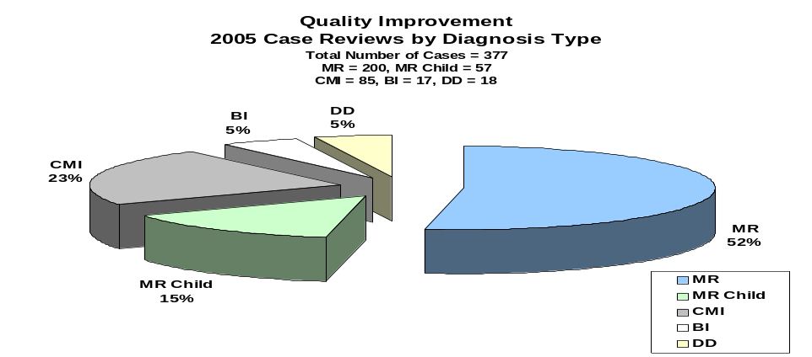
The DHS TCM Quality Team consists of five central office staff, three social worker trainers and three supervisors. It is lead by the Unit’s program planner.
SFY 2005 Financial Information
13

The DHS Targeted Case Management Unit operates as a Medicaid provider. The Bureau operates on a projected rate for reimbursement of services and then retrospectively settles with various funders on actual costs incurred.

The federal share in SFY 2005 was 63.64%. The State of Iowa and the counties with which we contract split the remainder of costs, or 18.18% each. The Bureau does not receive an appropriation and operates solely upon revenues generated for services provided. The basis for allowable reimbursable costs is only those actual costs directly associated with providing TCM.

The Bureau's salary costs represent 83.09% of total expenses and are limited to staff who directly provide TCM, and staff who support those who provide TCM. Support costs include items such as rent, travel, training, technology, office equipment, and telephones.

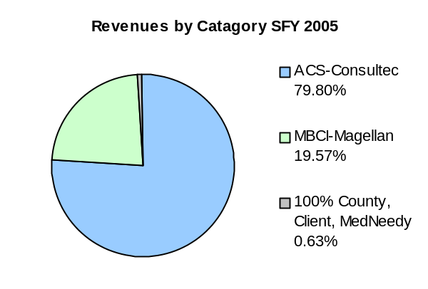
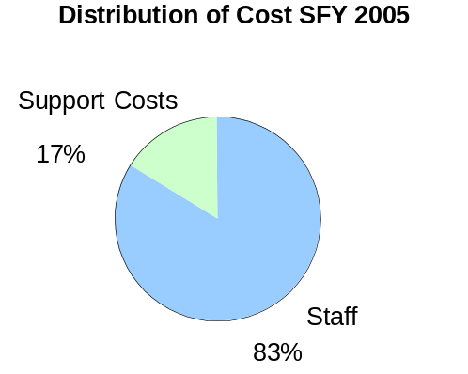

- TCM services provided are billed as a unit of service to specific Medicaid diagnostic criteria. A unit of service is defined as a billable contact within the month for each consumer receiving TCM. The number of units of service provided were 45,255 compared to 41,992 the previous year. This was a 7.77% increase over the prior year.
- During SFY 2005 the TCM unit operated under a two-tier rate mechanism. The consumers billed to Magellan received services at a weighted 1:25 staff to consumer ratio and those billed to other payers were served at a weighted 1:35 ratio.
- State Fiscal Year (SFY) 2005 incorporates the timeframe of July 1, 2004 through June 30, 2005.
- Proving problematic for the unit this year were internal issues arising from the preauthorization of consumers for TCM services rendered under T-19. Deficiencies in training revealed the need to focus on this issue. Turnover in staff and the need for technical support of account techs resolved itself during the fiscal year with the addition of an Executive Officer 1.

The DHS TCM financial team consists of two financial professionals performing the functions of Accountant and Budget Analyst. Four full time field account technicians complement them. The Financial Audit Division of the Auditor of State is scheduled to perform a full financial audit for SFY 2005 in March 2006.

