**Fiscal Year 2005**

**IOWAccess Revolving Fund Annual Report**

January 31, 2006

**State of Iowa**

**Fiscal Year 2005**

**IOWAccess Revolving Fund**

**Annual Report**

**🙞🙜**

**The IOWAccess Advisory Council**

Sheila Castaneda – Citizen Representative - Chairperson  
Richard Neri - Finance Sector Representative - Vice Chairperson    
David Redlawsk - Citizen Representative   
Tina Schmidt - Citizen Representative  
Miriam Ubben - Citizen Representative

Kelly Hayworth – City Government Representative  
Mary Maloney – County Government Representative  
Thomas Gronstal - Executive Branch  Representative  
Lawrence Lentz - Federal Government Representative  
Quent Boyken – Legal Services Sector Representative  
Barb Corson – DAS Customer Representative  
Herb Strentz – Media Representative  
Justice Marsha Ternus - Judicial Branch Representative  
Glen Dickinson - Legislative Branch Representative

Senator Bob Brunkhorst - General Assembly

Senator Jeff Danielson - General Assembly   
Representative Vicki Lensing - General Assembly

**🙞🙜**

ia flag

This report was produced in compliance with Iowa Code section 8A.224 to be submitted to the General Assembly not later than January 31, 2006. A copy of this publication has been filed in compliance with Iowa Code sections 8A.202(e) and 305.10.

This report is available at the Iowa Publications Online website at <http://publications.iowa.gov/> and is filed under the Department of Administrative Services.

© Copyright Iowa Department of Administrative Services, January 2006.

**Fiscal Year 2005**

**IOWAccess Revolving Fund**

**Annual Report**

**Contents**

Page

[Acknowledgements 2](#_Toc126059642)

[Foreword 3](#_Toc126059643)

[Executive Summary 4](#_Toc126059644)

[State Government Accomplishments Using IOWAccess Funding 5](#_Toc126059645)

[IOWAccess Business Model 7](#_Toc126059646)

[IOWAccess Convenience Fees Approved in Fiscal Year 2005 7](#_Toc126059647)

[IOWAccess Project Process 8](#_Toc126059648)

[IOWAccess Financials 11](#_Toc126059652)

[IOWAccess Revolving Fund Statement of Changes in Net Assets (Income Statement) - June 30, 2005 12](#_Toc126059653)

[IOWAccess Revolving Fund Statement of Net Assets (Balance Sheet) - June 30, 2005 13](#_Toc126059654)

[Fiscal Year 2006 IOWAccess Budget Projection 14](#_Toc126059656)

[Appendix 1. Duties and Responsibilities of the IOWAccess Advisory Council 16](#_Toc126059657)

[Appendix 2. Legislative Language Mandating This Report 17](#_Toc126059658)

[Appendix 3. Calendar Year 2006 IOWAccess Advisory Council Meeting Dates 18](#_Toc126059659)

### 

### Index of Tables and Figures

Page

[Figure 1. FY05 IOWAccess Project Lifecycle 8](#_Toc126059688)

[Table 1. IOWAccess Projects through June 30, 2005 10](#_Toc126059689)

[Figure 2. IOWAccess Revolving Fund Balance at the End of Fiscal Year 2005 13](#_Toc126059690)

### Acknowledgements

The IOWAccess Advisory Council express its’ appreciation to the Iowa Department of Administrative Services - Information Technology Enterprise, specifically Diane Van Zante, Kit Krogmeier, and Tom Shepherd for their support of the Council’s activities throughout Fiscal Year 2005 and Tom Shepherd for his work in assembling, proofing, and editing this report.

Please direct any questions or comments about this *IOWAccess Advisory Council Annual Report* to Tom Shepherd at [tom.shepherd@iowa.gov](mailto:tom.shepherd@iowa.gov) or (515) 281-6902.

### Foreword

I am pleased to present this Fiscal Year 2005 IOWAccess Revolving Fund Annual Report to the citizens of Iowa, the General Assembly, and the Legislative Services Agency. In the past ten years, we have learned that e-Government and state web portals are not a “Field of Dreams”. Not only must you build them, they must be easy to use and they must provide value to our constituents before they will come.



**Mollie Anderson**

Director, Iowa Department

of Administrative Services

The IOWAccess appropriation and the revenues generated by convenience fees have been used to provide an array of valuable services, which are highlighted in this report. The funding for e-Government projects made available through IOWAccess:

* Fosters an entrepreneurial environment that encourages innovative application development and empowers state agencies.
* Improves inter-agency and inter-governmental cooperation.
* Treats e-Government as a business proposition by focusing on practical, value-added projects.
* Maintains an enterprise-wide approach by working to eliminate redundant “stove pipe” efforts.

IOWAccess funding also allows state government to act quickly to address pressing public policy issues. IOWAccess funds were used to integrate the State of Iowa Sex Offender Public Registry with the National Sex Offender Public Registry ([www.nsopr.gov](http://www.nsopr.gov)) within thirty days of its inception. The National Sex Offender Public Registry receives 7.6 million hits per week (or about 13 hits per second – 24 hours per day, 7 days per week).

IOWAccess is transforming the relationship between citizens and State government.  Citizens are in charge of their relationship with government by increasingly accessing state services and data through IOWAccess applications that are convenient, secure, easy to use, and responsive to their needs. 

Finally, I would like to acknowledge the dedication and hard work of the citizen, public employee, and legislative members of the IOWAccess Advisory Council. They have maintained the highest standards in their stewardship of IOWAccess.

Signed,



Mollie Anderson

Chair

Iowa Technology Governance Board

Hoover State Office Building - Level A

Des Moines, IA 50319

### Executive Summary

IOWAccess was established as the State of Iowa’s web portal nine years ago. Since its inception in 1997, IOWAccess has been connecting Iowans with their government by utilizing the accessibility and technology of the Internet.

According to recent surveys, 82.1% of Iowans have access to the Internet. Research from the National Governor’s Association Center for Best Practices indicates that among the public’s highest priority for improvements at the State and local levels of government are:

* Improved and more widely accessible governmental services. Most citizens expect more for less in many of their consumer and business purchases - they have similar expectations for government services.
* Government’s more efficient use its’ resources.
* Providing easier and quicker access to information and more direct contact with officials in all branches of government through e-mail and web sites. There is a growing expectation for more, not less, of this interactive environment.

The funding for IOWAccess applications fosters agency partnerships; improves the availability, quality, use, and sharing of data; provides a unique source of funds for innovative e-Government programs; and is used as an adjunct to federal and state funding to improve the effectiveness of government programs, consistent with the goals of IOWAccess.

The funding of IOWAccess projects is monitored by an advisory council representing state government and the general public. Project funding and other recommendations from this council are forwarded to the Director of the Department of Administrative Services, who, after a review, submits them to the Technology Governance Board[[1]](#footnote-2) for final review and approval. This “advise and consent” process ensures that IOWAccess expenditures are targeted at relevant electronic government services. All projects funded through IOWAccess are: a) consistent with established leadership priorities; b) properly planned; and c) have clearly defined timelines, measurable results, and a return on investment.

This report highlights the Fiscal Year 2005 accomplishments of IOWAccess, including the Internet address for the programs and applications that are electronically delivering services to Iowa citizens. You will also find links to electronic government research from Iowa State University. Unlike many of the reports legislators, government leaders, and citizens read, this IOWAccess Revolving Fund Annual Report invites your participation. Visit the websites and try the services of interest. In addition to normal business hours, we’re open weekends, holidays, and late at night – whenever it’s convenient for you.

Certain services offered through IOWAccess charge a convenience fee. You will find a recap of the convenience fees recommended for approval by the IOWAccess Advisory Council in Fiscal Year 2005 and a breakdown of the costs associated with each fee. You will find a description of the IOWAccess business model and the processes, based on industry best practices, employed by IOWAccess to fund and monitor projects, along with a table showing all projects funded through June 30, 2005.

The Financial Section contains an Income Statement and Balance Sheet for Fiscal Year 2005 as well as a financial projection of the Fiscal Year 2006 budget.

### State Government Accomplishments Using IOWAccess Funding

pr

**Purchasing Results Website** – “Giving citizens frequent opportunities to make substantive contributions to budget decisions is integral to sound state budgeting. In Iowa, citizens and public organizations not only have access to budget information; they also play a vital and institutionalized role in shaping the state budget.” This was the description given to the State of Iowa Purchasing Results website by the Pew Trust Government Performance Project, recommending it as a “best practice” for adoption by state and local governments.

URL: <http://purchasingresults.iowa.gov/>

DOEHeader_r3_c2

**Department of Education** - **Online Teacher License Renewal Application**. The planning phase was originally funded 11/3/2003 with the implementation funding approved on 1/12/05. The application was available to teachers statewide on 4/19/2005.

URL: <https://www.iowaonline.state.ia.us/boee/controller.aspx?cmd=default>



**Department of Inspections and Appeals** - **Food and Consumer Safety Bureau Food Establishment Inspections Online**. The planning phase was originally funded 11/3/2003 with the implementation funding approved on 5/11/05. The application was available on the internet11/9/2005.

URL: <http://foodandlodgingreports.iowa.gov/>



**Department of Natural Resources** **– Online State Park Campground And Cabin Reservation System**. The planning phase was originally funded 9/10/04. The web site and reservation service became available statewide 1/2/2006.

URL: <https://eservices.iowa.gov/iowaparks/>

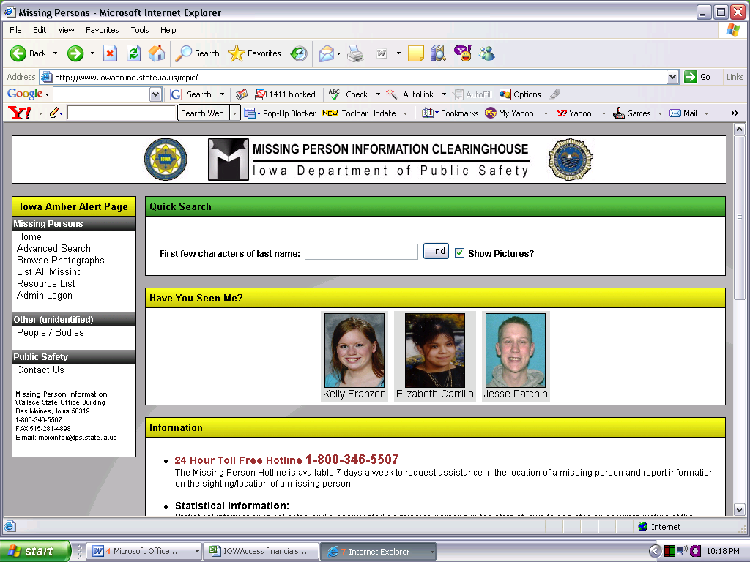

**Department of Public Safety** **- Missing Person's Reports On-line**. The planning phase was originally funded 9/10/2004 and was completed 5/2/2005

URL: <http://www.iowaonline.state.ia.us/mpic/>

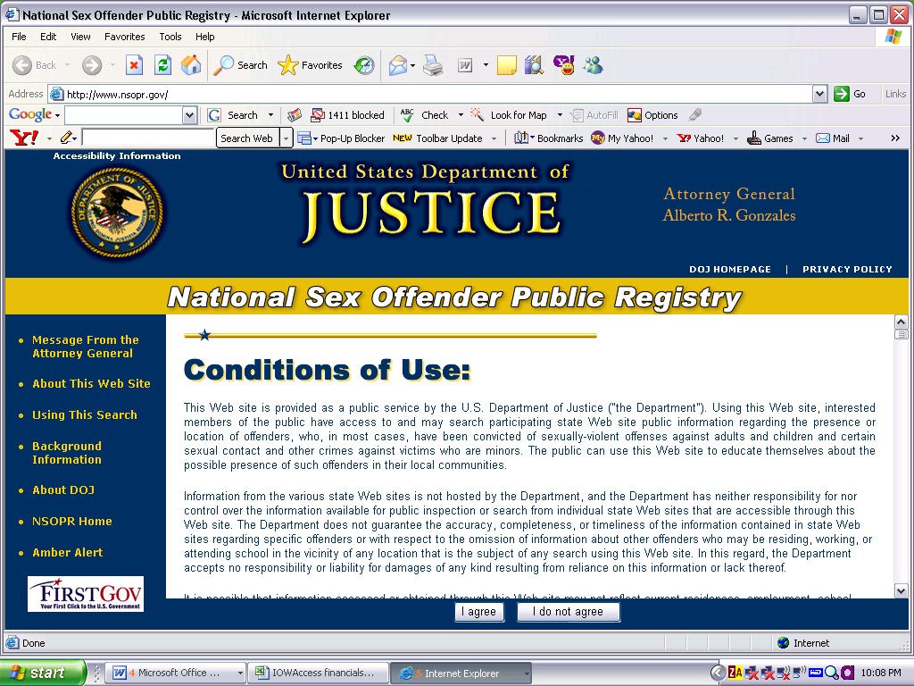

**Department of Public Safety – Linking the Iowa Sex Offender Registry to the National Sex Offender Public Registry.** The IOWAccess discretionary fund was used to link the Iowa Sex Offender Registry to the National Sex Offender Registry on 8/19/2005.

URL: [www.nsopr.gov](http://www.nsopr.gov/)

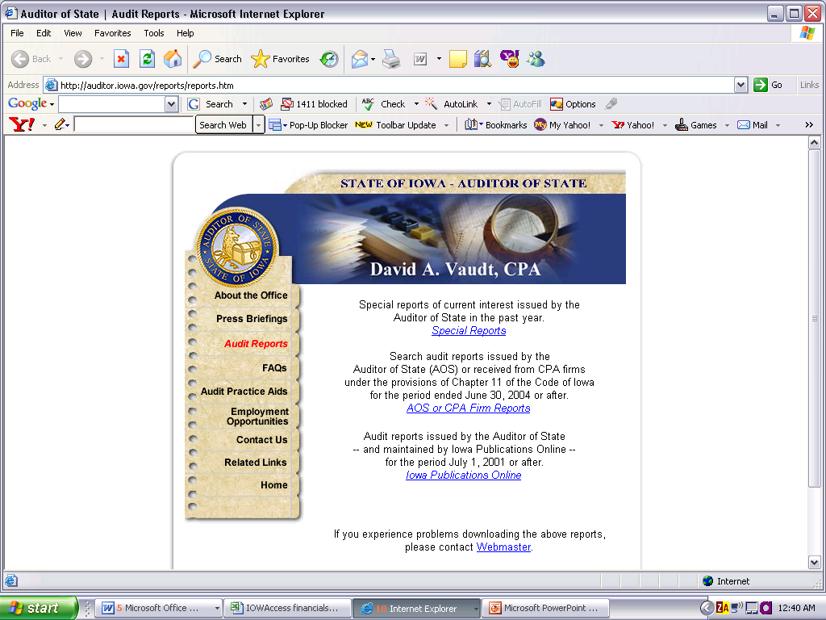

**State Auditor's Office - State Audit Reports Online.** The planning phase was originally funded 9/10/2004. The project was completed and the audit reports were accessible from the internet in July, 2005.

URL: <http://auditor.iowa.gov/reports/reports.htm>

ia flag ***Iowa Ethics and Campaign Disclosure Board***

**Iowa Ethics and Campaign Disclosure Board - Web Reporting System Public Access Improvements**. The implementation phase was originally funded 11/3/2003. The web reporting system was available on the internet in February 2005.

URL: <http://www.state.ia.us/government/iecdb/forms_brochures/formsindex.htm>

Research Funded by IOWAccess

**Iowa State University**

**Iowa State University - E-Government Research Project.** This is a research study conducted by the Public Policy and Administration Program in the Department of Political Science at Iowa State University. The study focused on anticipating demand and understanding financing strategies fore-Government**.** The project funding was originally approved 6/17/2004 and the final report was delivered in December, 2005. The report is available from the Department of Administrative Services website at: <http://das.ite.iowa.gov/governance/IAC/documents/index.html>

**Iowa State University – 28E Research Project.** This is a research study to identify management skills and processes that contribute to the effectiveness of networks related to 28Eagreements created for economic development purposes. The study was conducted by the Public Policy and Administration Program in the Department of Political Science at Iowa State University. The report is available from the Department of Administrative Services website at: <http://das.ite.iowa.gov/governance/IAC/documents/index.html>

### IOWAccess Business Model

Nine years ago, the State of Iowa implemented IOWAccess. IOWAccess operates under the authority of the Iowa Department of Administrative Services with oversight from the IOWAccess Advisory Council. IOWAccess was created by an act of the Iowa Legislature in 1997 to assist in providing Iowans electronic access to state, county, local and federal information and services. The IOWAccess Advisory Council consists of nineteen council members, including five persons representing the primary customers of IOWAccess; six persons representing lawful custodians, including one representative each from the legislative branch (not a member of the general assembly), the judicial branch, the executive branch, city government, county government, and the federal government; four members representing a cross section of the citizens of the state; and four members of the general assembly.

The Department of Administrative Services - Information Technology Enterprise contracts with Iowa Interactive, Inc., a wholly-owned subsidiary of NIC, Inc. to be the network manager. NIC, Inc. is a leading e-Government solutions provider with similar agreements with the following 19 states: Alabama, Arkansas, Colorado, Hawaii, Idaho, Indiana, Kansas, Kentucky, Maine, Montana, Nebraska, New Hampshire, Oklahoma, South Carolina, Rhode Island, Tennessee, Utah, Vermont and Virginia.

The final extension to the original Iowa Interactive contract expired September 30, 2005. The State of Iowa competitively bid the contract for IOWAccess development and support services and Iowa Interactive was awarded the new contract.

### IOWAccess Convenience Fees Approved in Fiscal Year 2005

Iowa Code section 8A.201(6) provides a definition of value-added services[[2]](#footnote-3). The IOWAccess Advisory Council is authorized to recommend rates to be charged for value-added services performed through IowAccess. The term “convenience fee” is used by the Information Technology Enterprise to refer those rates.

Pursuant to code section 8A.204, the Iowa Department of Management was notified on March 23, 2005 that the IOWAccess Advisory Council had recommended, and the Information Technology Council had approved the charging of “convenience fees” for the following services:

Online Teacher License Renewal - This application provides educational practitioners the opportunity to renew teaching licenses on-line, resulting in increased convenience and speed of processing for the practitioner. Additionally, the online system provides greater public access to licensure files and to information regarding teaching assignments and authority. The fee to renew a 5-year teaching license is $60. The Board of Educational Examiners will add a $3 convenience fee to renew the license online. The convenience fee will cover costs for the ePayment fee ($.26), credit card issuer fee ($1.69), bank fee ($.15), credit card authorizer fee ($.25) and ongoing server hosting and application maintenance fees ($.65).

Cabin and Campground Reservation – This system allows the public to reserve cabins, campgrounds, lodges, and picnic shelters using an Internet application. The application provides interactive campground maps, campsite photographs, and information on the availability of facilities. A convenience fee of $2 per transaction was approved to cover the cost of developing, hosting, and maintaining the online application. A credit card fee of 2.75% will also be added to those reservations being paid by credit card.

### IOWAccess Project Process

The IOWAccess revolving fund was established for the purpose of maintaining, developing, operating, and expanding IOWAccess. Consistent with these duties and requirements, the IOWAccess Advisory Council, with the assistance of the Department of Administrative Services - Information Technology Enterprise has established a process for governmental entities to request funding for the planning and execution of various e-Government projects. The Council has implemented a process, based on information technology project management best practices, to assess the relative merits of the projects submitted and make recommendations for funding projects to the Director of the Department of Administrative Services.

Figure 1. FY05 IOWAccess Project Lifecycle

IOWAccess Process

Phase 1 - Initiation – This requires the investment of a small amount of resources, resulting in a reliable estimate of the cost of gathering and documenting detailed requirements. The initiation phase can be completed at no cost to either the IOWAccess revolving fund or the customer (in this case the state agency or branch of government), other than the time needed to complete the deliverables. Consequently, no IOWAccess funding is used for the initiation phase. The deliverables from this phase include a concept paper generally describing the e-Government process or application and an assessment document that includes information about the scope of the project and a cost estimate for completion of the planning phase.

Phase 2 - Planning - The goal of the planning phase is to develop accurate cost estimates and well-defined deliverables for the e-Government process or application. The planning phase documents detailed customer business requirements presented in an array of documentation. The planning phase requires the preparation of a draft service level agreement between the owner of the application and the service provider in order to provide an accurate estimate of ongoing operational costs. It also provides statements of work and a completion timeline for the application. Finally, a Return on Investment analysis must be completed using the State of Iowa’s award winning ROI Process. Governmental entities can request funding from IOWAccess for up to 100% of the planning phase costs. IOWAccess involvement in the project terminates at conclusion of Planning Phase if execution funding is not sought or approved. The agency has access to the deliverables from the planning process and can proceed using funding sources other than IOWAccess.

Phase 3 - Execution – This phase is the actual implementation and roll-out of the project and includes:

* + - Application programming and testing.
    - Creation of the final Service Level Agreement
    - Development of an operational budget including ongoing hosting and maintenance costs.

IOWAccess Phase 3 funding can be used for the application programming, testing, and migration of the completed application to a production environment. Phase 3 funding can also be used to pay the web hosting fees for the application (with the approval of the IOWAccess Advisory Council).

### Table 1 (on the next page) contains a list of IOWAccess projects funded thorough June 30, 2005.

Table 1. IOWAccess Projects through June 30, 2005

| **Approved Projects** | **Amount Approved** |  | **Amount Spent** |  | **Amount Remaining** |
| --- | --- | --- | --- | --- | --- |
| Soil Conservation Grant Application Planning | $ 10,000.00 |  | $ 6,408.96 |  | $ 3,591.04 |
| Audit Report Web Server Project | $ 3,850.00 |  | $ 4,954.52 |  | $ (1,104.52) |
| WRS Public Access Improvements | $ 20,000.00 |  | $ 20,719.02 |  | $ (719.02) |
| Miscellaneous Contribution Tracking | $ 7,000.00 |  | $ 15,834.73 |  | $ (8,834.73) |
| Lobbyist/Client Tracking System | $ 18,500.00 |  | $ 21,342.27 |  | $ (2,842.27) |
| Ethics & Campaign Disclosure Board Hosting Fees | $ 12,000.00 |  | $ 12,000.00 |  | - |
| Commerce Professional Licensing Systems | $ 5,498.35 |  | $ 6,851.79 |  | $ (1,353.44) |
| Web Teacher License Renewal | $ 445,059.00 |  | $ 441,959.60 |  | $ 3,099.40 |
| Web Teacher License Renewal Hosting Fees | $ 12,000.00 |  | - |  | $ 12,000.00 |
| Child Development Home Registration Renewals | $ 199,124.00 |  | $ 27,917.83 |  | $ 171,206.17 |
| Food Stamps Web Intake | $ 100,000.00 |  | $ 11,484.17 |  | $ 88,515.83 |
| Targeted Small Business On Line | $ 45,000.00 |  | $ 1,480.55 |  | $ 43,519.45 |
| Targeted Small Business On Line hosting fees | $ 12,000.00 |  | - |  | $ 12,000.00 |
| Social Gambling On-Line | $ 55,000.00 |  | $ 14,692.03 |  | $ 40,307.97 |
| Social Gambling On-Line hosting fees | $ 12,000.00 |  | - |  | $ 12,000.00 |
| Food Inspections On-line | $ 125,000.00 |  | $ 142,967.35 |  | $ (17,967.35) |
| Food Inspections On-line hosting fees | $ 12,000.00 |  | - |  | $ 12,000.00 |
| 28E project (ITE & ISU) ITE | $ 120,660.00 |  | $ 45,782.95 |  | $ 74,877.05 |
| Iowa E-Government Policy Research | $ 114,068.00 |  | $ 5,334.33 |  | $ 108,733.67 |
| Full-time position to support IowAccess | $ 100,000.00 |  | - |  | $ 100,000.00 |
| Enterprise Lyris E-Mail List Manager | $ 163,715.35 |  | $ 100,720.78 |  | $ 62,994.57 |
| Law Enforcement Email Subscription Management | $ 6,815.41 |  | $ 6,815.41 |  | - |
| Campground Reservations Online | $ 15,000.00 |  | $ 15,000.00 |  | - |
| Criminal History Online | $ 47,375.00 |  | $ 3,828.08 |  | $ 43,546.92 |
| Missing Person's Report - planning phase | $ 5,000.00 |  | $ 3,705.21 |  | $ 1,294.79 |
| Electronic Tax Administration | $ 414,000.00 |  | $ 231,440.25 |  | $ 182,559.75 |
| Interactive Phone Book | $ 59,768.16 |  | - |  | $ 59,768.16 |
| Akamai Internet Backup Services | $ 11,750.00 |  | - |  | $ 11,750.00 |
| Small Project Reserve – ITE Enterprise | $ 150,000.00 |  | - |  | $ 150,000.00 |
| State of Iowa Purchasing Results Website | $ 50,688.00 |  | - |  | $ 50,688.00 |
| Iowa Supreme Court Commissions Project | $ 38,875.00 |  | $ 11,716.91 |  | $ 27,158.09 |
| Civil Rights Complaints Automation | $ 75,000.00 |  | $ 1,353.69 |  | $ 73,646.31 |
| Food Inspections On-line - Phase II | $ 53,333.17 |  | $ 20,840.96 |  | $ 32,492.21 |
| Missing Persons Reports Online | $ 40,000.00 |  | $ 4,314.09 |  | $ 35,685.91 |
| State Patrol In-Car Computers | $ 400,000.00 |  | - |  | $ 400,000.00 |
| Total | **$ 2,960,079.44** |  | **$ 1,179,465.48** |  | **$ 1,780,613.96** |

### 

### mast

### IOWAccess Financials

### IOWAccess Revolving Fund Statement of Changes in Net Assets (Income Statement) - June 30, 2005

|  |  |  |  |  |
| --- | --- | --- | --- | --- |
|  |  |  |  |  |
|  | **FY05** |  | **YTD** |  |
|  | **Budget** |  | **FY 2005** |  |
| **Resources:** |  |  |  |  |
| Interest Income | $20,000 |  | $65,232 |  |
| Transfers, DOT Certified copy fees | $1,000,000 |  | $1,000,000 |  |
| Fees-ICIS | $170,000 |  | $238,151 |  |
| Fees-DMVR | $2,700,000 |  | $2,191,104 |  |
| **Total Revenues** | $3,890,000 |  | $3,494,487 |  |
|  |  |  |  |  |
| **Expenditures:** |  |  |  |  |
| Personal Services | $91,500 |  | -- |  |
| Travel | $4,900 |  | 181 |  |
| Council Travel | $1,000 |  | 523 |  |
| Iowa Interactive: | $1,305,000 |  | 1,059,075 |  |
| Transfers to Judicial | $153,000 |  | 214,336 |  |
| ICIS Web-Hosting Support | $17,000 |  | 23,815 |  |
| ITE Support Costs: |  |  |  |  |
| Communication | $27,864 |  | $25,445 |  |
| Support - Infrastructure/Application | $565,202 |  | $565,322 |  |
| Support, Application - Projects | $1,546,720 |  | $770,944 |  |
| Support, Application - DMVR | $159,815 |  | $159,815 |  |
| Data Processing, maintenance, licenses | $2,500 |  | --0 |  |
| Data Processing - non-inventory | $10,500 |  | $16,750 |  |
| Other Expenses & Obligations | $5,000 |  | $2,148 |  |
| **Total Expenditures** | $3,890,000 |  | $2,838,352 |  |
| **Increase (decrease) in Net Assets** | | | **$656,135** |
| **Net Assets beginning of Year** | | | **$1,756,565** |

### IOWAccess Revolving Fund Statement of Net Assets (Balance Sheet) - June 30, 2005

|  |  |
| --- | --- |
| **ASSETS:** | **AMOUNTS** |
| Cash | $ 2,508,899.85 |
| Accrued Appropriation | -- |
| Accounts Receivables | -- |
| **Total Assets** | **$ 2,508,899.85** |
| **LIABILITIES:** |  |
| Accounts Payable | $ 96,200.25 |
| **Net Assets** | **$ 2,412,699.60** |
| Balance of Obligated Funding for Projects  (From Table 1 on page 10) | $ 1,780,613.96 |
| **Unobligated Cash** | **$ 632,085.64** |

Figure 2. IOWAccess Revolving Fund Balance at the End of Fiscal Year 2005

### 

### Fiscal Year 2006 IOWAccess Budget Projection

|  | **July**  **2005** | **August**  **2005** | | **September**  **2005** | | **October**  **2005** | | | **November**  **2005** | | | **December**  **2005** | **January**  **2006** | | | **February**  **2006** | | | **March**  **2006** | | | **April**  **2006** | | **May**  **2006** | | | **June**  **2006** | | | **FY 2006** |
| --- | --- | --- | --- | --- | --- | --- | --- | --- | --- | --- | --- | --- | --- | --- | --- | --- | --- | --- | --- | --- | --- | --- | --- | --- | --- | --- | --- | --- | --- | --- |
| **Revenues:** |  |  | |  | |  | | |  | | |  |  | | |  | | |  | | |  | |  | | |  | | |  |
| Interest Income | 1,767 | 1,767 | | 1,767 | | 1,767 | | | 1,767 | | | 1,767 | 1,767 | | | 1,767 | | | 1,766 | | | 1,766 | | 1,766 | | | 1,766 | | | 21,200 |
| Appropriation |  |  | | 1,000,000 | |  | | |  | | |  |  | | |  | | |  | | |  | |  | | |  | | | 1,000,000 |
| Fees-DMVR | 196,308 | 192,927 | | 188,682 | | 195,879 | | | 162,942 | | | 138,936 | 156,495 | | | 153,024 | | | 187,977 | | | 164,307 | | 154,986 | | | 189,084 | | | 2,081,547 |
| **Total Revenues** | 198,075 | 194,694 | | 1,190,449 | | 197,646 | | | 164,709 | | | 140,703 | 158,262 | | | 154,791 | | | 189,743 | | | 166,073 | | 156,752 | | | 190,850 | | | 3,102,747 |
|  |  |  | |  | |  | | |  | | |  |  | | |  | | |  | | |  | |  | | |  | | |  |
| **Expenditures:** |  |  | |  | |  | | |  | | |  |  | | |  | | |  | | |  | |  | | |  | | |  |
| ***Technology Governance Board*** | | |  | |  | | |  | | |  | | |  | | |  | | |  | | |  | | |  | | |  | |
| - Personal Services | 20,833 | 20,833 | | 20,833 | | 20,833 | | | 20,833 | | | 20,833 | 20,833 | | | 20,833 | | | 20,833 | | | 20,833 | | 20,833 | | | 20,833 | | | 250,000 |
| - Travel / Per Diem | 416 | 416 | | 416 | | 416 | | | 416 | | | 416 | 416 | | | 416 | | | 416 | | | 416 | | 416 | | | 416 | | | 4,992 |
| ***IOWAccess Advisory Council*** | |  | |  | |  | | |  | | |  |  | | |  | | |  | | |  | |  | | |  | | |  |
| - Travel |  | 300 | |  | |  | | | 300 | | |  |  | | | 300 | | |  | | |  | | 300 | | |  | | | 1,200 |
| ***Other Expenditures*** |  |  | |  | |  | | |  | | |  |  | | |  | | |  | | |  | |  | | |  | | |  |
| Professional Services for e-Government Maintenance | 94,882 | 93,248 | | 91,196 | | 94,675 | | | 78,755 | | | 67,152 | 75,639 | | | 73,962 | | | 90,856 | | | 79,415 | | 74,910 | | | 91,391 | | | 1,006,081 |
| ***ITE Support Costs*** |  |  | |  | |  | | |  | | |  |  | | |  | | |  | | |  | |  | | |  | | |  |
| Internet Connections / Communication Costs | 2,272 | 2,272 | | 2,272 | | 2,272 | | | 2,272 | | | 2,272 | 2,272 | | | 2,272 | | | 2,272 | | | 2,272 | | 2,272 | | | 2,272 | | | 27,264 |
| Infrastructure/Application Support | 47,110 | 47,110 | | 47,110 | | 47,110 | | | 47,110 | | | 47,110 | 47,110 | | | 47,110 | | | 47,110 | | | 47,110 | | 47,110 | | | 47,110 | | | 565,320 |
| Application Support -IGOV | 13,318 | 13,318 | | 13,318 | | 13,318 | | | 13,318 | | | 13,318 | 13,318 | | | 13,318 | | | 13,318 | | | 13,318 | | 13,318 | | | 13,318 | | | 159,816 |
| Data Processing - license fees, software & hardware |  |  | |  | |  | | |  | | | 5,000 |  | | |  | | |  | | |  | |  | | | 5,000 | | | 10,000 |
| Other Expenses |  |  | |  | |  | | |  | | | 1,950 |  | | |  | | |  | | |  | |  | | |  | | | 1,950 |
| ***IOWAccess Projects: Application Development & Support*** | | | | | | |  | | |  | | | | |  | | |  | | |  | | | |  | | |  | | |
| Remaining balance on projects approved prior to 7/1/2005 | 1,858,154 |  | |  | |  | | |  | | |  |  | | |  | | |  | | |  | |  | | |  | | | 1,858,154 |
| New project costs | 125,000 | 125,000 | | 125,000 | | 125,000 | | | 125,000 | | | 125,000 | 125,000 | | | 125,000 | | | 125,000 | | | 125,000 | | 125,000 | | | 125,000 | | | 1,500,000 |
|  |  |  | |  | |  | | |  | | |  |  | | |  | | |  | | |  | |  | | |  | | |  |
| **Total Expenditures** | 2,161,986 | 302,497 | | 300,146 | | 303,624 | | | 288,005 | | | 283,052 | 284,589 | | | 283,211 | | | 299,805 | | | 288,364 | | 284,159 | | | 305,340 | | | 5,384,777 |
|  |  |  | |  | |  | | |  | | |  |  | | |  | | |  | | |  | |  | | |  | | |  |
| **Cash Balance Brought Forward** | 2,424,237 | 460,326 | | 352,523 | | 1,242,826 | | | 1,136,848 | | | 1,013,552 | 871,204 | | | 744,877 | | | 616,457 | | | 506,395 | | 384,104 | | | 256,697 | | | 2,424,237 |
|  |  |  | |  | |  | | |  | | |  |  | | |  | | |  | | |  | |  | | |  | | |  |
| **Net cash, operations** | **460,326** | **352,523** | | **1,242,826** | | **1,136,848** | | | **1,013,552** | | | **871,204** | **744,877** | | | **616,457** | | | **506,395** | | | **384,104** | | **256,697** | | | **142,207** | | | **142,207** |

### Appendix 1. Duties and Responsibilities of the IOWAccess Advisory Council

Pursuant to Iowa Code section 8A.221, the IOWAccess Advisory Council is charged with the duty to:

1. Recommend to the Technology Governance Board rates to be charged for access to and for value-added services performed through IOWAccess.
2. Recommend to the director the priority of projects associated with IOWAccess.
3. Recommend to the director expected outcomes and effects of the use of IOWAccess and determine the manner in which such outcomes are to be measured and evaluated.
4. Review and recommend to the director the IOWAccess total budget request and ensure that such request reflects the priorities and goals of IOWAccess as established by the advisory council.
5. Review and recommend to the director all rules to be adopted by the department that are related to IOWAccess.
6. Advocate for access to government information and services through IOWAccess and for data privacy protection, information ethics, accuracy, and security in IOWAccess programs and services.
7. Receive status and operations reports associated with IOWAccess.
8. Other duties as assigned by the director.

The IOWAccess Advisory Council shall also:

* Advise the director with respect to the operation of IOWAccess and encourage and implement access to government and its public records by the citizens of this state.
* Serve as a link between the users of public records, the lawful custodians of such public records, and the citizens of this state who are the owners of such public records.
* Ensure that IOWAccess gives priority to serving the needs of the citizens of this state.

### Appendix 2. Legislative Language Mandating This Report

**Iowa Code Section 8A.224 - IowAccess revolving fund**

An IowAccess revolving fund is created in the state treasury. The revolving fund shall be administered by the department and shall consist of moneys collected by the department as fees, moneys appropriated by the general assembly, and any other moneys obtained or accepted by the department for deposit in the revolving fund. The proceeds of the revolving fund are appropriated to and shall be used by the department to maintain, develop, operate, and expand IowAccess consistent with this subchapter. The department shall submit an annual report not later than January 31 to the members of the general assembly and the legislative services agency of the activities funded by and expenditures made from the revolving fund during the preceding fiscal year. Section [8.33](http://nxtsearch.legis.state.ia.us/NXT/gateway.dll?f=xhitlist$xhitlist_x=Advanced$xhitlist_vpc=first$xhitlist_xsl=querylink.xsl$xhitlist_sel=title;path;content-type;home-title$xhitlist_d=%7bcode%7d$xhitlist_q=%5bfield%20folio-destination-name:'sec_8_33'%5d$xhitlist_md=target-id=0-0-0-5426) does not apply to any moneys in the revolving fund and, notwithstanding section [12C.7](http://nxtsearch.legis.state.ia.us/NXT/gateway.dll?f=xhitlist$xhitlist_x=Advanced$xhitlist_vpc=first$xhitlist_xsl=querylink.xsl$xhitlist_sel=title;path;content-type;home-title$xhitlist_d=%7bcode%7d$xhitlist_q=%5bfield%20folio-destination-name:'sec_12C_7'%5d$xhitlist_md=target-id=0-0-0-5440) , subsection 2, earnings or interest on moneys deposited in the revolving fund shall be credited to the revolving fund.”

### Appendix 3. Calendar Year 2006 IOWAccess Advisory Council Meeting Dates

* Wednesday, January 11, 2006, 1:00-3:30 p.m.
* Wednesday, March 8, 2006, 1:00-3:30 p.m.
* Wednesday, May 10, 2006, 1:00-3:30 p.m.
* Wednesday, July 12, 2006, 1:00-3:30 p.m.
* Wednesday, September 13, 2006, 1:00-3:30 p.m.
* Wednesday, November 8, 2006, 1:00-3:30 p.m.

**Meeting Location for All IOWAccess Advisory Council Meetings:**

Hoover Bldg., B Level, Conference Rooms 2 & 3

1. In Fiscal Year 2005, recommendations were approved by the Information Technology Council. [↑](#footnote-ref-2)
2. Iowa Code section 8A.201(6) - "Value-added services" means services that offer or provide unique, special, or enhanced value, benefits, or features to the customer or user including, but not limited to, services in which information technology is specially designed, modified, or adapted to meet the special or requested needs of the user or customer; services involving the delivery, provision, or transmission of information or data that require or involve additional processing, formatting, enhancement, compilation or security; services that provide the customer or user with enhanced accessibility, security or convenience; research and development services; and services that are provided to support technological or statutory requirements imposed on participating agencies and other governmental entities, businesses, and the public. [↑](#footnote-ref-3)