Iowa Law Enforcement Academy

PERFORMANCE
REPORT

Performance results Achieved
for Fiscal Year 2004

TABLE OF CONTENTS

SECTION PAGE

INTRODUCTION . . . . . . . . . . . . . . . . . . . . . . . . . . . . . . . . . . . . . . . . . 3

AGENCY OVERVIEW . . . . . . . . . . . . . . . . . . . . . . . . . . . . . . . . . . . . . . 4

STRATEGIC PLAN RESULTS . . . . . . . . . . . . . . . . . . . . . . . . . . . . . . . . 8

PERFORMANCE PLAN RESULTS . . . . . . . . . . . . . . . . . . . . . . . . . . . 14

RESOURCE REALLOCATIONS . . . . . . . . . . . . . . . . . . . . . . . . . . . . . 16

AGENCY CONTACTS . . . . . . . . . . . . . . . . . . . . . . . . . . . . . . . . . . . . . 17

INTRODUCTION

I am pleased to present Iowa Law Enforcement Academy’s performance report for fiscal year 2004 (July 1, 2003 to June 30, 2004). This report contains valuable information about the training and services the Iowa Law Enforcement Academy provided for Iowans during the past fiscal year.
Major accomplishments of the year included placing all ILEA employees on the internet system; performance plans for non-contract personnel; training over 5,000 peace officers, jailers, and dispatchers; and having several instructors publish articles.
The Iowa Law Enforcement Academy, despite continued cuts in budget and revenues, increased the number of peace officers, jailers, and telecommunicators trained to an all time high of 5,607 persons. The over-all number of newly certified peace officers decreased during this fiscal year resulting in a severe drop in revenue for the Academy.
The Academy is the sole regulator of law enforcement, jailer and telecommunicator training in Iowa. However, the Academy has competition from the regional Level I and Level II training academies. Persons with a 2-year or 4-year degree in police science or criminal justice can choose to attend the Level II short course training at Hawkeye Technical Community College or Western Iowa Technical Community College. Agencies can also request permission to attend the Cedar Rapids or Des Moines Police Departments academies. The Academy remains competitive and continues to train by far the largest number of Iowa peace officers.
The Academy is confronted with two primary operational strategic challenges:
- Budgetary constraints
- Lack of personnel
Each of these challenges has a different set of problems and issues associated with it. The budgetary constraints resulted in the academy going into the negative by approximately $150,000 in FY 2004. This was due in large part to only five basic academy classes being held in FY 2004 (normally there are six each year). Only five classes were held because of decrease number of peace officers being hired by Iowa law enforcement agencies due to city/county budget problems. It was necessary to move reversion monies from the DPS to the Academy. The Academy currently has two instructors and one support staff vacancy due to the budget cuts.
The lack of personnel results in the administration teaching more classes leaving less time for administrative and leadership matters. It also requires the academy to rely more on outside instructors.
Even with these constraints the Academy is looked to for the best training in the state. The Academy is proud of its service to Iowa law enforcement, the criminal justice system, and our communities.
Sincerely,

E.A. “Penny” Westfall, Director

AGENCY OVERVIEW

The Iowa Law Enforcement Academy (ILEA) was created by an act of the Iowa legislature in 1967 with its purpose being to upgrade law enforcement to professional status. The specific goals were to maximize training opportunities for law enforcement officers, to coordinate training and to set standards for the law enforcement services.
The Iowa Law Enforcement Academy Council oversees the Academy. The Council is established by the Iowa Code. The Council has a membership of seven persons. The Iowa Code specifies the seven members must include a:
- Sheriff
- Police officer from city with greater than 50,000 population
- Police officer from city with less than 50,000 population
- Representative from the Department of Public Safety
- A state senator and representative are appointed as ex-officio, non-voting members. Two federal agencies (the FBI and DEA) serve in an advisory capacity.
The voting members are appointed by the governor with senate confirmation and serve four-year terms. There is no limit on the number of terms that can be served.
The Academy Council establishes minimum standards for Iowa law enforcement and grants officer’s certification. The Academy Council has the responsibility to decertify or to suspend the officer’s certification when necessary. In a manner, the Academy “polices the police.”
The Academy provides residential training sessions varying in length from the 13-week basic training schools to one-day specialty and inservice seminars. The Academy can provide housing for 112 persons at any one time. The physical facility consists of dormitory rooms, classrooms, a cafeteria providing meals three times a day, a physical fitness center, photography and video production studio, and administrative offices. The Academy is located on Camp Dodge in Johnston, Iowa. ILEA shares firearm ranges and tactical facilities with the Iowa National Guard.
The Academy in addition to maximizing training opportunities for all Iowa’s peace officers is responsible for providing basic and in-service training for all county and city jailers and telecommunicators in Iowa. The Iowa Law Enforcement Academy also establishes standards and training requirements for the reserve peace officers in Iowa.
The ILEA provides certification training for over 240 entry-level law enforcement officers every year through six 13-week basic classes. Records are kept on all Iowa peace officers showing that each officer has met the hiring standards and has become certified within one year of being hired.
The Academy conducted over 150 inservice schools in FY 2004 at various locations around the state and at the academy. Over 5,600 Iowa peace officers, jailers, and telecommunicators attended this training. The Academy maintains and updates training files on approximately 6,000 active full and part-time peace officers in Iowa. All active status peace officers must obtain twelve hours of continuing education on an annual basis (or thirty-six hours over three years).
Two hundred thirty telecommunicators attended basic entry-level telecommunicators training and inservice schools. Records are maintained for each of the Iowa telecommunicators.
40-hour basic schools for jailers and jailer inservice schools were held across the state and at the academy. One thousand thirty-eight jail employees attended this training. Records are maintained for each Iowa jailer.
ILEA administers a program of psychological, cognitive and standards testing for all sworn personnel and jailers. The Academy conducts statewide testing of the cognitive examination, the National POST (Police Officer Standard Test), and the personality instrument, the MMPI-2 (Minnesota Multiphasic Personality Inventory-2). The MMPI test volume is one of the largest databases of law enforcement applicants in the country (more than 14,000 evaluation done by ILEA since 1986). Over three-fourths of all psychological tests of Iowa law enforcement applicants are evaluated by ILEA. ILEA conducted 215 POSTS tests and worked with over 550 MMPI-2 tests during FY 2004.
ILEA staff provides evaluation expertise and advice concerning the classification results of the MMPI-2 as well as council on fitness for duty, training issues, and disciplinary matters while considering an individual’s MMPI-2. Emphasis is placed on high-risk and liability issues, such as the potential for aggressive behavior, including domestic abuse and other violence-prone tendencies.
ILEA conducts supervisory promotional testing of sheriff’s deputies upon request, and is the only one authorized by the test company to retain a scoring key.
The Academy maintains and updates required files on all reserve peace officers in the state. These records include information on hiring standards, current active reserve officers, and weapon certifications for the reserve officers. All reserve peace officers that want to carry weapons must submit information that reflects their training and qualification. Background investigation and fingerprint record checks with the Iowa Division of Criminal Investigation and Federal Bureau of Investigation must be completed before weapons certification is granted.
The Academy oversees and approves the training provided at the recognized regional training facilities across Iowa (Cedar Rapids Police Department, Des Moines Police Department, Department of Public Safety, Hawkeye Community Technical Community College, and Western Iowa Technical Community College.) The Cedar Rapids Police Department, Department of Public Safety, and Des Moines Police Department conduct Level I basic academy training (full academy). Hawkeye Community Technical Community College and Western Iowa Technical Community College conduct Level II (short course). ILEA is responsible for approving the curriculum and instructors at each program. Officer certification is given by ILEA once proof of successful completion is provided to the academy.
The over 600 law enforcement agencies in Iowa rely on the Academy not only for training but also for leadership, advise, and research. The Academy instructors serve as expert witnesses for grand jury proceedings and civil cases filed against agencies and individual officers. The academy instructors are currently working with approximately fourteen grand jury and civil proceedings.
Vision: The Iowa Law Enforcement Academy vision is “Excellence in Training – Training the Best Peace Officers, Jailers, and Telecommunication Specialists in the Nation.”
Mission: The Iowa Law Enforcement Academy mission is “Professionalism through Training.”
Guiding Principles (Values):
- Service
- Teamwork
- Excellence
- Ethics
- Professionalism
The Iowa Law Enforcement Academy goals are to:
- Provide essential, timely, and cost-effective law enforcement, jailer, and telecommunication specialists training at both entry and inservice levels.
- Maintain and enforce reasonable standards for the law enforcement service that re critically necessary for the protection of the public that is served.
The Academy’s core function is
education.
The Academy owns and maintains the Iowa Law Enforcement Academy located on Camp Dodge in Johnston, Iowa. The United States Congress gave 9 acres of land located on Camp Dodge to the Iowa Law Enforcement Academy for the purpose of training Iowa peace officers. The Academy also maintains eleven vehicles. Seven vehicles are used in training Iowa peace officers during the basic training and for driver training instructor certification and re-certification classes. The Academy also owns and maintains three other vehicles as well as a bus. The instructors while training and/or testing at various locations across the state use these vehicles. The bus is used to transport students to training activities.
The Academy provides 24/7 Web access for information concerning class and testing schedules as well as other information about the academy.
The Academy’s reporting relationship begins with the governor, to whom the director reports. The assistant director works with the director in overseeing the remaining personnel. A public service supervisor oversees the secretaries and clerks reporting to the assistant director.
There are thirty authorized positions at the Iowa Law Enforcement Academy. Currently 27 positions are filled. Three are supervisory, twelve are instructors and twelve are support including accountant and maintenance personnel.

ILEA

Organizational Chart
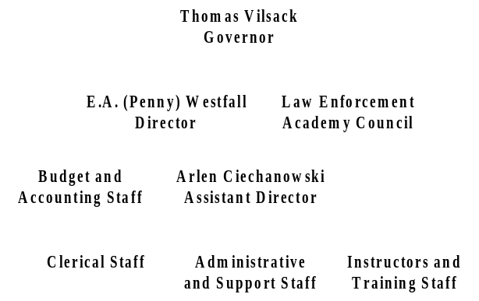

The general fund budget for the Academy in FY 2005 is approximately $1,075,000.
The Academy has four primary customer groups: criminal justice community including law enforcement agency command staff, peace officers, jailers, telecommunicators, county attorneys, and judges; approved regional training academies; Iowa Law Enforcement Academy Council; and the public.
Although not identical, all customer groups have similar requirements – that of well-trained peace officers, jailers and telecommunicators who protect communities and are willing to give their lives in doing so; that understand and protect everyone’s constitutional rights by not entering homes without legal justification, not
making arrests without probable cause and using only the force necessary in carrying out their duties; and that only use deadly force when no other alternatives are available.
A large part of the Academy’s success is directly related to the priority placed on:
- building and maintaining a positive relationship with customers and suppliers;
- knowing what customers’ needs and expectations are;
- working with staff and suppliers to ensure that those needs and expectations are met.
The Academy maintains open communication with customers and suppliers through:
- telephone access Monday through Friday 24 hours a day.
- Regular meetings with law enforcement associations and their lobbyists.
- Surveys sent to customers at the end of each basic training academy class.
- Bi-annual survey sent to chiefs, sheriffs, and other state agency commanders.
- Meetings held across state with law enforcement personnel.
- Student evaluations completed on cafeteria supplier and outside instructors.
This communication process provides the customer, supplier and the academy real-time information regarding the needs and expectations of all parties.

Strategic Plan Results

Key Strategic Challenges and Opportunities

The Academy is confronted with two primary operational strategic challenges:
- Budgetary constraints
- Lack of personnel
The Iowa Law Enforcement Academy is responsible for overseeing the training of and compliance with all rules found in 501 Iowa Administrative Code for peace officers, jailers, telecommunicators, reserve peace officers and training academies. There are approximately 6,000 certified peace officers in Iowa. Each peace officer must receive basic training within one year of being hired. All certified peace officers must receive twelve hours of continuing education training each year (or 36 hours in three years).
There are five approved law enforcement academies in addition to the Iowa Law Enforcement Academy. The approved Level I Basic Training Regional Academies are Cedar Rapids Police Department, Des Moines Police Department and the Iowa Department of Public Safety. Hawkeye Technical Community College and Western Iowa Technical College are approved to conduct the short training Level II Basic program. This program is available for anyone who has a two or four-year degree in police science or criminal justice.
Training requirements are also established for jailers and telecommunicator specialists. The Iowa Law Enforcement Academy is responsible for offering this training or approving the training provided at the local level.
There are approximately 1,500 reserve peace officers in Iowa. The reserve peace officers are to receive 150 hours of training over a three-year period as required by ILEA. Rules concerning personal hiring standards for reserve peace officers became effective June 2, 2004. The Iowa Reserve Peace Officer Association is working with the Academy to review training standards and to potentially establish a certification program for reserve peace officers. The Academy currently approves weapon certification for reserve officers.
There has been an increase in violence in our society over the last several years. It appears that more officers are being injured or killed in the line of duty. Approximately 150 officers were killed in this country during 2003. Iowa law enforcement agencies are experiencing the economic down turn and are facing hiring freezes or even lay-off of personnel. The increased violence and decrease in law enforcement officers in many agencies underscores the need for up-to-date training and training facilities.
The Academy is exploring all options to continue to provide the best law enforcement, jailer, and telecommunicator training in the state with these key strategic challenges.

Goal #1: Provide up-to-date and state-of-the-art training to peace officers, jailers, and telecommunicators by well-trained instructors with adequate equipment in a state-of-the-art facility.

Strategies:

- Obtain funding for two vacant instructor positions.
- Obtain funding for needed equipment
- Obtain approval and funding for new joint criminal justice training facility
- Find quality up-to-date national training that will keep ILEA instructors on the cutting edge.
- Find quality up-to-date training for ILEA support personnel.

Measures/Results

Performance Measure:

Percent of persons successfully completing basic training programs.

Data Sources:
Iowa Law Enforcement Academy

 | 2002 | 2003 | 2004
Number Enrolled | 261 | 209 | 180
Number Certified | 251 | 201 | 174
% Completed | 96% | 96% | 97%

Data Reliability:
The actual number of students entering the basic academy training was compared to the number of students graduating and being certified by the Academy.

What was achieved:
The number of persons completing the basic training at the academy did increase by 1%. It would be helpful to determine the percentage of students graduating from each of the regional academies.

Analysis of results:
Further study should be done to determine the reason for leaving the basic training. Some students are dismissed for discipline reasons while others are unable to complete the training due to injuries or inability to meet requirements. Comparisons should be made with other regional academies.

Link(s) to Enterprise Plan:
The goal aligns with the Governor’s security value.
Goal #2: Become less reliant upon general fund monies.

Strategies:

- Search out possible federal grants and funding
- Search out foundations that provide money for education purposes
- Develop private giving program initiative to raise money for ILEA

Measures/Results

Performance Measure
Increase other funds leveraged by the ILEA by 5% each of the next 3 to 5 years.

Data Sources:
Legislative Services Agency

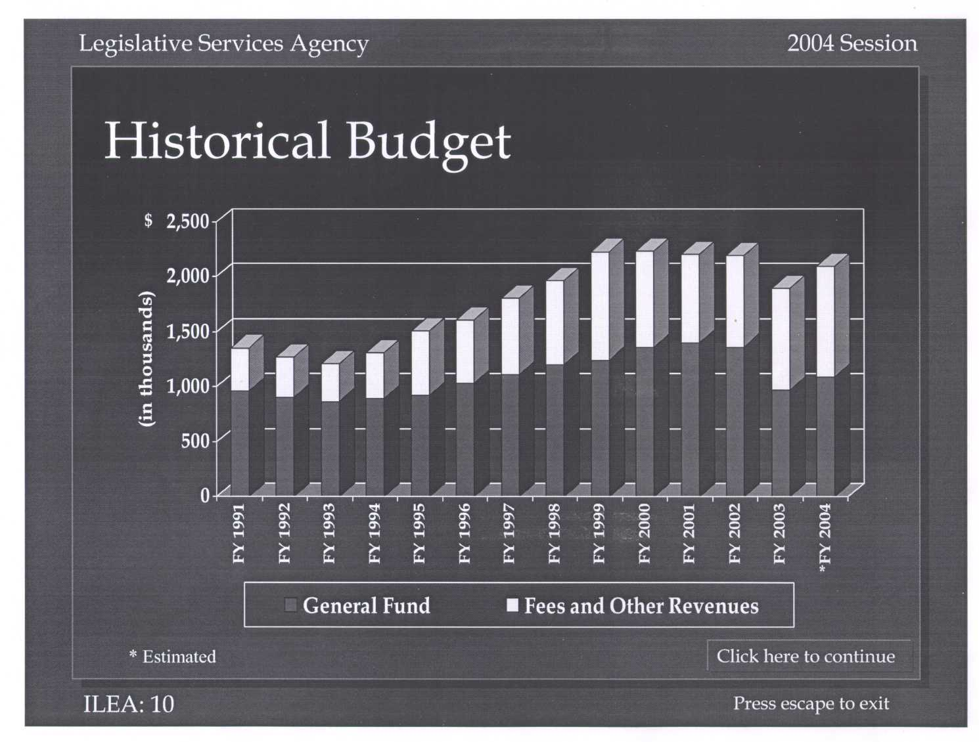

Data Reliability:
The Legislative Services Agency develops its information from the Department of Management, agency’s budget, and appropriation bills.

What was achieved:
The percentage of general funds as a part of the Academy’s total budget has decreased quite a bit over the last couple of years.

Analysis of results:
The general fund appropriations are approximately 50% of the Academy’s total budget.

Link(s) to Enterprise Plan:
This goal aligns with the Governor’s responsibility value.

Goal # 3: Expand current ILEA market by developing training for reserve officers, security personnel and sponsored individuals who have not yet been hired by a law enforcement agency.

Strategies:
- Develop training program for private security industry personnel that will include annual joint conference, special training classes and joint law enforcement/security industry personnel training.
- Develop training program for reserve peace officers that will meet 150-hour basic training requirements.
- Develop marketing plan to bring sponsored individuals not yet hired by a law enforcement agency to ILEA.

Measures/Results

Performance Measure:
Non-traditional persons attending ILEA training including security personnel, reserve peace officers, and sponsored but not yet hired individuals.

Data Sources:
Iowa Law Enforcement Academy

Number of Persons | 2004 | 2005
Sponsored but not hired | 0 | 1
Reserve Peace Officers | 0 | 0
Security Personnel | 0 | 0

Data Reliability:
ILEA will collect total number of non-traditional individuals attending ILEA training.

What was achieved:
The data displayed are the baselines from which future analysis will proceed. Development of this training is continuing at this time.

Analysis of results:
The sponsored but not yet hired and reserve peace officers are currently the most promising area to increase revenue. Work will continue in these areas.

Link(s) to Enterprise Plan: None

Goal #4: Become the research source for law enforcement issues in Iowa.

Strategies:
- Encourage staff to conduct research and publish articles on a local and national level
- Give research projects to students attending the basic training programs.

Measures/Results

Performance Measure:
Number of articles submitted and/or published by staff

Number of Articles | 2003 | 2004
 | 2 | 6

Data Reliability:
Information was taken from individual performance plan reviews and publications.

What was achieved:
Number of articles submitted and/or published by staff increased.

Analysis of Results:
This is actually an output measure. Number of calls/questions received after publication will show more of the impact on becoming research source for law enforcement.

Link(s) to Enterprise Plan: None

Goal #5: Increase the level of professionalism of law enforcement officers, jailers, and telecommunicator specialists in Iowa by providing testing services as needed, educational opportunities, and assuring compliance with required standards.

Strategies:
- Develop a partnership with a university program to establish evening and weekend undergraduate and graduate program at ILEA.
- Provide training to law enforcement agencies concerning ILEA required standards.
- Develop Ethics and Professionalism train-the trainer program.
- Develop a command staff training and certification program.
- Develop a command staff discussion forum where current topic and publications are discussed.
- Develop better mechanism to assure compliance with required standards.
- Develop one-day testing procedures for all required hiring standards conducted by ILEA staff quarterly around the state.

Measures/Results

Performance Measure:
Number of officers decertified each year
Number of Officers Decertified | 2003 | 2004
 | 4 | 1

Data Reliability:
Information is taken from the ILEA Council minutes of action taken.

What was achieved: The data displayed are the baselines from which future analysis will proceed. New procedures are in place to increase the number of decertifications.

Analysis of results: No analysis is possible at this time.

Link(s) to Enterprise Plan: None

Performance Plan Results

Core Function
Education

Name: Iowa Law Enforcement Academy

Description:
The Iowa Law Enforcement Academy provides the best basic, specialty, and supervisory training to Iowa peace officers, jailers, and telecommunicators. This training includes instructor certification in several areas such as firearms, defensive tactics, driving, and jail training. The training is conducted both at the Academy located on Camp Dodge in Johnston as well as across the State of Iowa. Over 5,600 law enforcement personnel were trained in fiscal year 2004.
The Academy is the sole regulator of law enforcement, jailer, and telecommunicator training in Iowa. The Academy oversees three Level I regional basic training academies at Des Moines Police Department, Cedar Rapids Police Department, and Department of Public Safety and two Level II short program basic training academies at Hawkeye Technical Community College and Western Iowa Technical Community College. The staff psychologists conducts psychological and cognitive testing for those people being hired in all law enforcement agencies and those considered for promotion in the Sheriffs’ Offices. The Academy sets the standards for continuing education requirements of the law enforcement personnel. The Academy sets the standards for hiring and training of Iowa reserve peace officers. The Academy is responsible for certifying all peace officers in the state of Iowa and for decertifying those officers that violate the established standards of behavior for Iowa peace officers.

Why are we doing this: The Iowa Law Enforcement Academy was created by statute in 1967 to improve the professionalism of Iowa peace officers through standardized training. Over the years the Academy has become the number one source of law enforcement training. The Academy oversees all basic training of peace officer, jailers, and telecommunicators.

Results

Performance Measure:
Percent of officers completing basic 13-week training class.

Performance Target:
100% of officers enrolling in the basic 13-week training class

Data Sources:
Iowa Law Enforcement Academy

 | 2002 | 2003 | 2004
Number Enrolled | 261 | 209 | 180
Number Certified | 251 | 201 | 174
% Completed | 96% | 96% | 97%

Data Reliability:
Information is obtained from ILEA enrollment and graduation information.

Why are we using this measure:
The Academy is working to develop the best measure for this core function. This measurement may be adjusted in the future. Generally, agencies that are satisfied with training they receive will use the academy again.

What was achieved:
The number of students completing the training and receiving certification increased by 1% in 2004.

Analysis of results:
Further study should be done to determine the reason for leaving the basic training. Some students are dismissed for discipline reasons while others are unable to complete the training due to injuries or inability to meet requirements. Comparisons should be made with other regional academies.

Factors affecting the results:
Some students leave the academy due to inability to meet necessary requirements. Others are sent home due to injury or as discipline. These factors should be explored further.

Resources used:
Iowa Law Enforcement Academy staff and record information.
Resource Reallocations

The Iowa Law Enforcement Academy has vacant two instructors and one support staff positions due to budget constraints. It has been necessary to reallocate the work primarily to other ILEA staff. The director and assistant director are each teaching more classes to cover at least part of the vacant instructor positions responsibility. This takes them away from administrative and leadership responsibilities. Outside instructors from other agencies are also utilized to cover this shortfall. Use of outside instructors can result in a lack of standardized training if the instructor changes from session to session. For example, three different instructors have taught traffic accident investigation over the last two years. Each instructor had a slightly different teaching style. Each outside instructor works for a law enforcement agency and at times could not make it to the scheduled class due to work conflicts. This resulted in last minute changes in the student’s schedule.
The support staff position work has been reallocated to other staff resulting in greater overtime and/or comp time. All these reassignments will continue until budgets increase sufficiently to allow new hires.
Approximately thirty percent of one instructor’s time was reallocated to a rural family violence grant that ILEA partnered with the Attorney General’s Office in fiscal year 2004. ILEA received approximately $30,680 from this grant during fiscal year 2004 to develop and deliver training material to rural Iowa criminal justice personnel. ILEA partnered with the Attorney General’s Office on this grant because of the importance of the training topic and to help cover budget shortfalls. The Department of Justice eliminated this federal grant in fiscal year 2005. ILEA will not be able to continue delivering this rural violence training.
AGENCY CONTACTS

Copies of Iowa Law Enforcement Academy’s Performance Report are available on the ILEA Web site at www.state.ia.us/government/ilea/. Copies of the report can also be obtained by contacting Director Penny Westfall at 515-242-5214.

Iowa Law Enforcement Academy
Box 130 Camp Dodge
Johnston, Iowa 50131

(515) 242-5357

