Iowa Department of Education

Performance

Report

Performance Results Achieved

for Fiscal Year 2004

Table of Contents

INTRODUCTION 1

AGENCY OVERVIEW 2

STRATEGIC PLAN RESULTS 4
Goal 1 4
Goal 2 7
Goal 3 14

PERFORMANCE PLAN RESULTS 19
CORE FUNCTION – Resource Management 19
Resource Management SPA Summary Table 22
CORE FUNCTION – Education 23
Education SPA Summary Table 27
CORE FUNCTION – Regulation and Compliance 32
Regulation and Compliance SPA Summary Table 35

RESOURCE REALLOCATIONS 36

AGENCY CONTACTS 37

Introduction

Iowans value education. Year after year this is a priority for the citizens of Iowa as evidenced by their willingness to invest their time and energy at the local level, and spend a major portion of the state’s revenues to support a system of education that provides quality educational opportunities for learners of all ages. The purpose of this report is to provide a brief summary of what we are getting for that investment, to show how we are working to improve the system, and to identify challenges that need to be addressed in the years ahead.

Our educational system has a long and proud tradition of excellence. Many measures indicate that Iowa schools are among the best in the nation. Graduation rates are at 90%, and standardized test scores are near the top in the nation. These results are supported by strong community involvement, with student learning goals and graduation requirements established at the local level by school boards in partnership with parents, teachers, school administrators, and other community members. Over 83% of our high school graduates indicate they intend to pursue postsecondary education or training.

Despite this success, not all students are achieving at high levels. Student achievement data indicate that a significant achievement gap exists for students who are poor, minority or disabled. In addition, employers want employees with better communication skills and advanced skills in math and science. A high school diploma alone is no longer enough for many of the jobs of the 21st Century. If we want to transform Iowa’s economy, we must transform Iowa’s education system, meeting the needs of all students and preparing them to be successful at the postsecondary level and into the new economy workforce.

What are we doing to achieve these goals? Research indicates that one of the most significant factors for improving student achievement is improving instruction. Therefore, the state is implementing Teacher Quality legislation designed to attract talented people into the profession of teaching, provide strong support for beginning teachers, and ongoing professional development tied specifically to achieving local district student achievement goals. Because we know that most of the jobs that pay a wage that will support a family require postsecondary education or training, we are promoting more relevance and rigor in the high school curriculum, in order to improve students’ chance at success at the postsecondary level. And because more of our young children come to school without the readiness skills they need to be successful in school, we are focusing on improving access to high quality preschool and early childhood settings.

The Department of Education helps local school districts and community colleges go beyond compliance with the minimum standards required by law, and strive for continuous improvement. We work to build capacity at the local level, through support systems such as the area education agencies. We are also working to improve the transition from secondary to postsecondary by increasing opportunities for rigorous coursework through sharing activities, AP Online and postsecondary enrollment options. As stated in the report from the Iowa Learns Council, education is everyone’s business. More than ever before, we all have a stake in the success of our education system. More education and higher levels of achievement mean better income and higher standards of living for students, greater productivity for businesses, a more vibrant economy and a better quality of life for all of us.

Agency Overview

Mission:
Our Mission is to champion excellence in education through superior leadership and service. We are committed to high levels of learning, achievement and performance for all students, so they will be come successful members of their community and the workforce.

Guiding Principles:
- All students can learn.
- Students respond best to high expectations.
- All students must feel safe and respected at school.
- Educators need ongoing support and professional development to improve student achievement.
- Local schools, communities and families have the primary responsibility for improving student performance.
- The primary roles of the state are to help communities meet the learning needs of all their students and to assure that the educational welfare of students is protected.
- Leadership decisions will be data-driven.
- A quality education system is essential to a sound economy.

Major Services, Products and Customers:
The Department of Education, in conjunction with the State Board, is responsible for supervising the state’s prekindergarten-12 schools, area education agencies, and community colleges, and for approving practitioner and administrator preparation programs. In order to address the strategic plan goals and carry out their core functions, the Department (excluding the Division of Vocational Rehabilitation Services, the Division of Library Services and Iowa Public Television)

is organized into three divisions and the Office of the Director.

The Office of the Director has the primary responsibility for providing leadership for the system of education in Iowa from the pre-kindergarten through community college levels. The Director provides this leadership in conjunction with the State Board of Education. This Office also provides a liaison function with state and federal legislative groups, coordinates communication services, provides legal services, and has primary responsibility for establishing priorities and coordination of Department activities and initiatives.

The Division of Early Childhood, Elementary, and Secondary Education has responsibility for local school district, nonpublic school, and area education agency accreditation and continuous improvement processes. This Division oversees many federal programs including, but not limited to, competitive and non-competitive grants in a variety of school program areas, Title I, Individuals with Disabilities in Education Act, US Department of Agriculture nutrition programs, Safe and Drug Free Schools, and implementation of No Child Left Behind. In addition the Division includes early childhood programs, school transportation, implementation of Iowa’s Teacher Quality legislation, and approval of postsecondary teacher and administrator preparation programs.

The Division of Community Colleges and Workforce Preparation has primary responsibility for community college accreditation and management information processes, and for secondary and postsecondary vocational programming statewide.

The Division of Financial and Information Services is responsible for financial and personnel services such as payroll, accounting and budgeting, purchasing, inventory, office support, and facility management. This Division provides technology support to internal and external customers, and is responsible for data collection and analysis including development of the Annual Condition of Education Report. It also allocates state and federal funding to local entities and provides technical support and information related to school finance.

The major products and services of the Department of Education include leadership, support, and monitoring of all aspects of education from pre-kindergarten through community college levels, with some program monitoring extending from birth to the end of college and beyond. These services include budget, program and compliance support; professional development; and technical assistance for schools and school districts, AEAs, and community colleges. The Department’s primary clients are those stakeholders that are impacted by the pre-kindergarten through community college programs. The Department’s programs support students, parents, instructional staff, administrators, local school boards, and community members.

Strategic Plan Results

STRATEGIC PLAN

Goal 1: All children will enter school ready to learn.

Key Strategic Challenges and Opportunities:
Research increasingly shows the importance of quality, early learning environments in a child’s development. Young children exposed to high-quality settings exhibit better language and math skills, better cognitive and social skills, and better relationships with classmates than do children in lower-quality care. Evaluations of well-run early-learning programs also have found that children in those environments were less likely to drop out of school, repeat grades, need special education, or get into future trouble with the law than similar children who did not have such exposure.

Strategies:
- Provide quality technical assistance to early childhood settings in building their capacity to implement quality program standards using the Iowa Quality Preschool Program Standards.

Participate in the early care, health and education system development and identify resources that contribute to this system.

Results
Performance Measure:  Percentage of children, ages three and four, who have participated in a preschool program that is NAEYC (National Association for the Education of Young Children) accredited and/or meets Head Start program performance standards, or meets a comparable set of standards.  Data Sources:  - DHS Access Data System  - NAEYC Website: Accredited Program Search  - Department of Education Shared Visions and District Data  - Head Start Program Information Report for 2002 – 2003: Total Actual Enrollment | 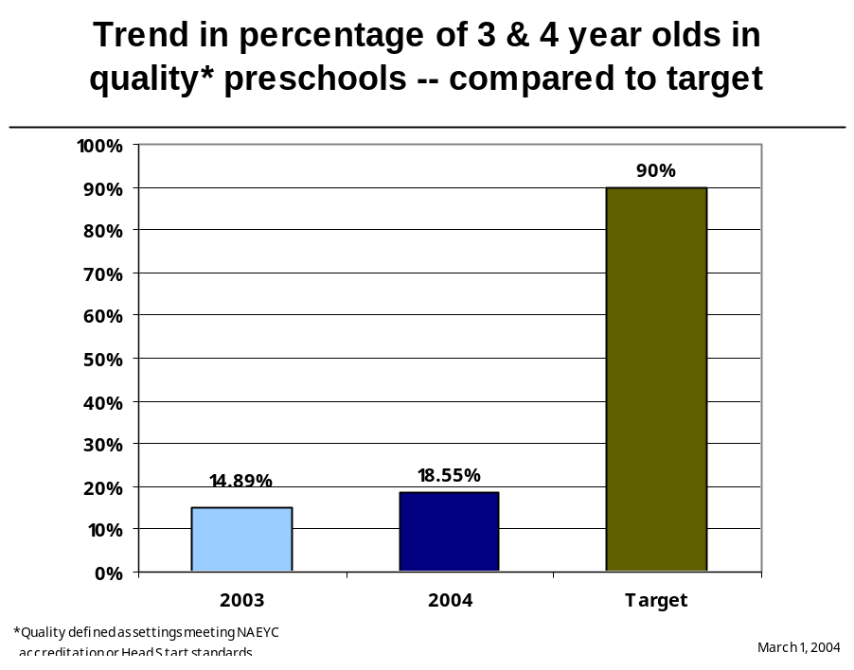

Data reliability: The data are collected from state and federal agencies and organizations responsible for monitoring preschool programs that meet accreditation standards set by the National Association of Education of Young Children (NAEYC) or the federal requirements for the Head Start Program Performance Standards. The NAEYC website reports the names of the current accredited preschool and child care programs in Iowa, and the Head Start Bureau reports child and program data in an annual Head Start Program Information Report. The Iowa Departments of Education and Human Services analyze this data to determine the number of programs meeting NAEYC accreditation standards or Head Start Program Performance Standards and the percent of children, ages 3 – 4, served in these programs. Every effort is made to reach an unduplicated count of children; particularly in programs that meet both NAEYC accreditation standards and Head Start Program Performance Standards. The Departments of Education and Human Services do not have a data system to efficiently determine the percent of children participating in programs; thus we utilize the other data sources as described.

What was achieved: The data shows a slight increasing trend in the percent of children participating in quality preschool programs.
Analysis of results: The Iowa Department of Education is working collaboratively with other state Departments and community partners to enhance the quality of early care and education environments in Iowa. The DE’s State Improvement Grant from the USDE will be used to support the implementation of the Iowa Quality Preschool Program Standards, which are based on the NAEYC standards and criteria. In addition, DE is a partner in the planning and implementation of the Iowa Department of Public Health’s Comprehensive Early Childhood Systems Grant that includes goals and strategies addressing the issues of quality early learning environments.
Link(s) to Enterprise Plan: This State Board and Department of Education strategic plan goal is directly related to Leadership Agenda and Enterprise Strategic Plan Goal 2 – 90% of children have a quality preschool experience and 90% of students have at least two years of higher education – and to Enterprise Strategic Plan strategies 2.1 and 2.3.

STRATEGIC PLAN

Goal 2: All K-12 students will achieve at high levels, prepared for success beyond high school.

Key Strategic Challenges and Opportunities:
Our educational system has a long and proud tradition of excellence. Many measures indicate that Iowa schools are among the best in the nation. Graduation rates are at 90%, and standardized test scores are near the top in the nation. These results are supported by strong community involvement, with learning goals guided by local school boards in partnership with parents, teachers, and other community members. Over 83% of our high school graduates indicate they intend to pursue postsecondary education or training.

Despite this success, not all students are achieving at high levels. Student achievement data indicate that a significant achievement gap exists for students who are poor, minority or disabled. In addition, employers want employees with better communication skills and advanced skills in math and science. A high school diploma alone is no longer enough for many of the jobs of the 21st Century. K-12 education must meet the needs of all students and must prepare students to be successful at the postsecondary level and into the new economy workforce.

Strategies:
- Develop skilled and knowledgeable area education agency teams to provide diagnostic and follow-up support, including the development of an improvement plan for sustained changes in student achievement, to schools and school districts identified as schools in need of improvement
- Provide area education agencies and school districts with training and support to alleviate barriers to student learning by focusing on the development of family and student assistance, community outreach and engagement, crisis/emergency assistance and prevention, safe and supportive school environments, and school transitions
- Provide professional development for the Statewide Reading Team in the discipline of reading and reading instruction with an expanded focus on kindergarten through grade 12 and on students who are struggling in learning to read
- Provide technical assistance to AEA Reading Teams to support their efforts of providing quality, timely professional development and support to schools
- Provide professional development for personnel from the area education agencies and urban school districts in mathematics and kindergarten through grade 12 mathematics instruction, including continued professional development for targeted middle school teams
- Develop an action plan in cooperation with area education agencies to build the system’s capacity in science and science instruction
- Promote and support improvement efforts in school districts and area education agencies by providing guidance for comprehensive improvement planning and conducting accreditation visits as required

Results
Performance Measure:  Percentage of Iowa fourth grade students performing at or above proficient level on ITBS reading comprehension test.  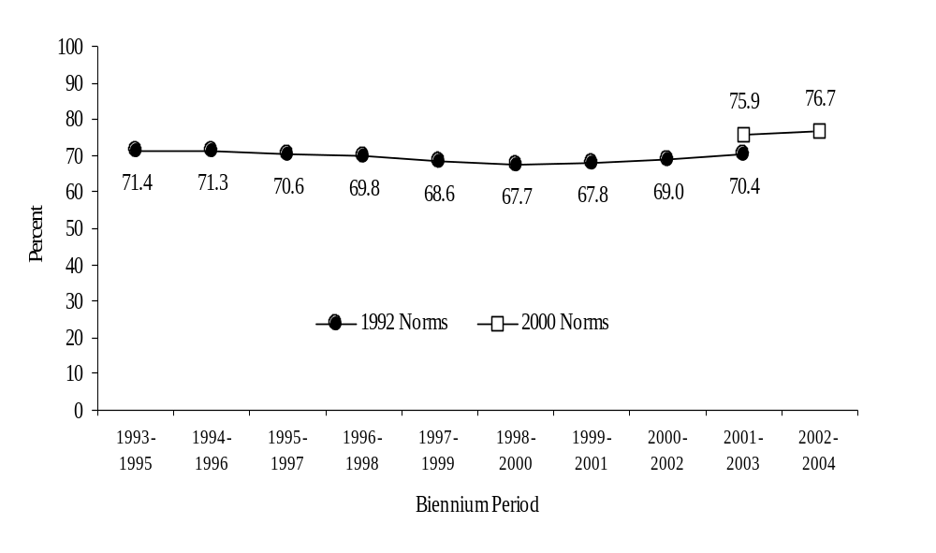  Data Sources:  Iowa Testing Programs, University of Iowa. | Percent of Iowa Fourth Grade Students  Performing at or Above Proficient Level on  ITBS Reading Comprehension Test  Biennium Periods 1993-1995 to 2002-2004

Performance Measure:  Percentage of Iowa eighth grade students performing at or above proficient level on ITBS math test.  Data Sources:  Iowa Testing Program, University of Iowa. | Percent of Iowa Eighth Grade Students  Performing at or Above Proficient Level on  ITBS Mathematics Test  Biennium Periods 1993-1995 to 2002-2004  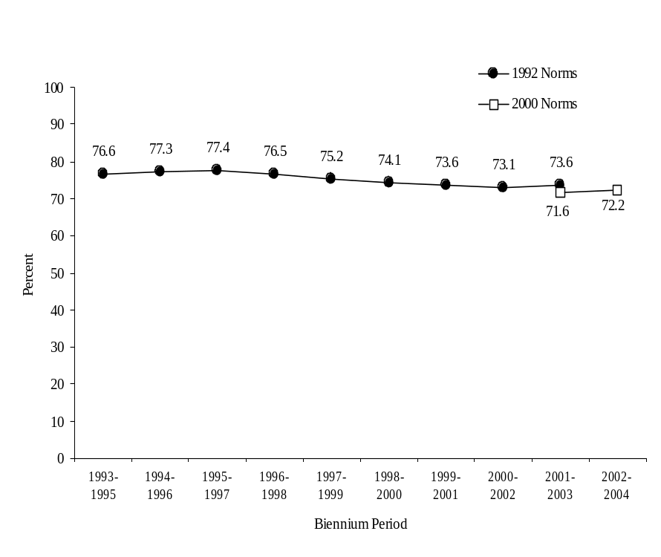

Performance Measure:  High School Graduation Rate.  Data Sources:  Iowa Department of Education, Bureau of Planning, Research, and Evaluation, Basic Educational Data Survey, High School Completion and Dropout Files. | Iowa Public School Graduation Rates  Graduating Classes of 1996 through 2003  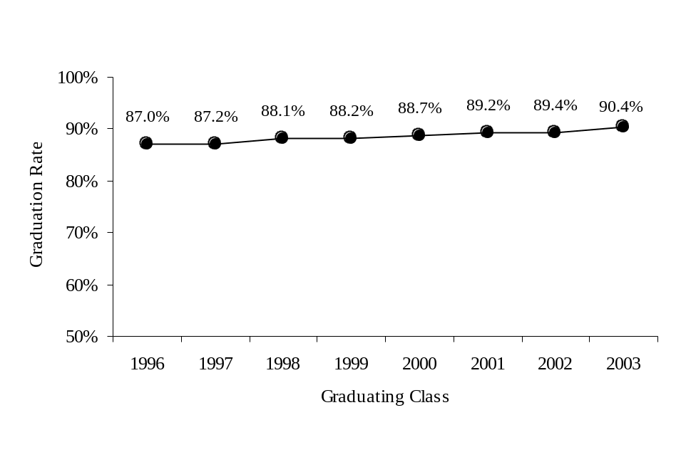

Performance Measure:  High School Graduation rate compared to other states.  Data Sources:  National Center for Educational Statistics, Public High School Dropout and Completers from the Common Core of Data: School Year 2000-01. | Four-Year High School Graduation Rates by State  1994-1995 through 2000-2001  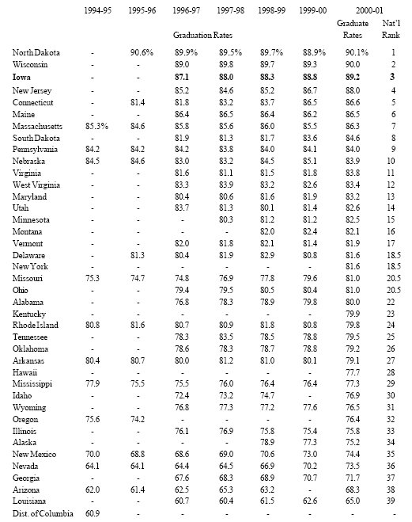

Performance Measure:  How Iowa students performed compared to their national peers in two different school years. Compares ITBS percentile rank ranges for Core Total scores. The Core Total is the average of the standard scores for Reading Total, Language Total, and Math Total.  Data Sources:  Iowa Testing Programs, University of Iowa. | Comparison of the Percent of Iowa Fourth Grade  Students Performing within Selected National Student Percentile Rank Ranges: Core Total Scores  1993-1994 vs. 2001-2002  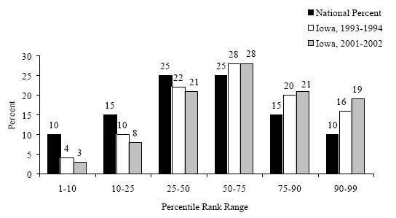  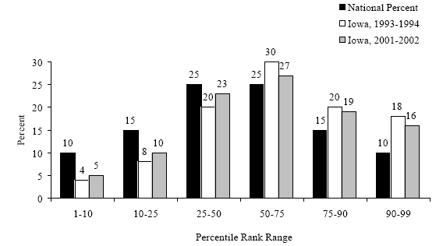  Comparison of the Percent of Iowa Eighth Grade Students Performing within Selected National Student Percentile Rank Ranges: Core Total Scores  1993-1994 vs. 2001-2002

Performance Measure:  ACT national ranking.  Data Sources:  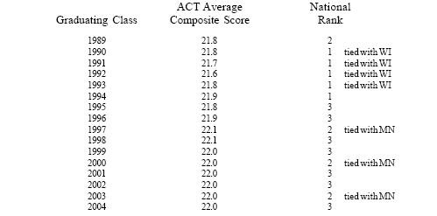  American College Testing Program, ACT assessment results, Summary Report for Iowa. | Iowa’s Rank in the Nation on Average Composite  ACT Scores Among States where ACT  is the Primary College Entrance Examination, 1989-2004

Data reliability: The data presented come from a number of reliable sources including the Basic Educational Data Survey, Iowa Department of Education, Bureau of Planning Research and Evaluation; The Iowa Testing Program, University of Iowa; and the American College Testing Program.

What was achieved: Data show a slight trend upward in most areas of student achievement. Iowa continues to rank favorably when compared to other states in the nation.

Analysis of results: We must maintain our focus on support at the local level and professional development if we are to improve instruction and increase student achievement.

Link(s) to Enterprise Plan: This State Board and Department of Education strategic plan goal is necessary if we are to achieve the Leadership Agenda and Enterprise Plan goal that 90% of students have at least two years of higher education. Students cannot succeed in higher education without at strong foundation at the K-12 level.

STRATEGIC PLAN

Goal 3: Iowans will pursue higher education that results in an improved quality of life supported by better economic opportunities through high skill employment.

Key Strategic Challenges and Opportunities:
Economic pressures are a strong force driving change in our educational system. While much of the current policy conversation is about assuring that all students attain some basic levels of literacy, we need to be very clear that the attainment of basic skills in reading, math and science will not be an adequate response to the economic pressures driving new student needs. Increasingly, employers want employees with more sophisticated communication skills and advanced skills in math and science. They want employees who understand different cultures and who can work with and learn with individuals of varying backgrounds.

In Iowa, 90% of our students complete high school. But today, jobs that can be accessed without some level of postsecondary completion will likely not support a family, even with two wage earners in the family. Much of the economic strength of the United States is driven by the productivity of its college-educated workforce. People with the most education tend to earn the most, and those with the least education tend to earn the least. If we are to stay competitive economically, if our children are to have the quality of life we have come to enjoy, it is critical that we increase the percentage of students who successfully transition from high school to higher education.

Strategies:
- Strengthen the transition from secondary to postsecondary, and from community colleges to four-year postsecondary programs.

- Advocate for increased funding for community colleges, in part, to reduce tuition.

Results
Performance Measure:  Percentage of public high school graduates / seniors pursuing or intending to pursue postsecondary education or training.  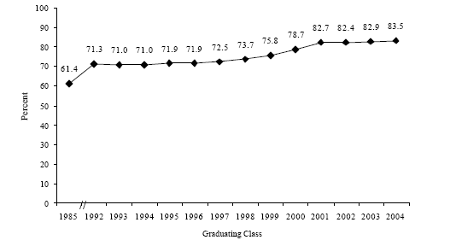  Data Sources:  Iowa Department of Education, Bureau of Planning, Research, and Evaluation, Basic Educational Data Survey. | Percent of All Iowa Public School Graduates/Seniors  Pursuing or Intending to Pursue Postsecondary Education/  Training, Graduating Classes of 1985 and 1992-2004

Performance Measure:  National rank on ACT  Data Sources:  American College Testing Program, ACT assessment results, Summary Report for Iowa. | Iowa’s Rank in the Nation on Average Composite  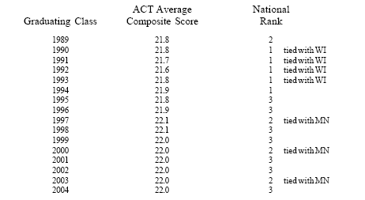  ACT Scores Among States where ACT  Is the Primary College Entrance Examination, 1989-2004

Performance Measure:  Percentage of Iowa ACT participants achieving an ACT score above the national average and an ACT score of 20 or above  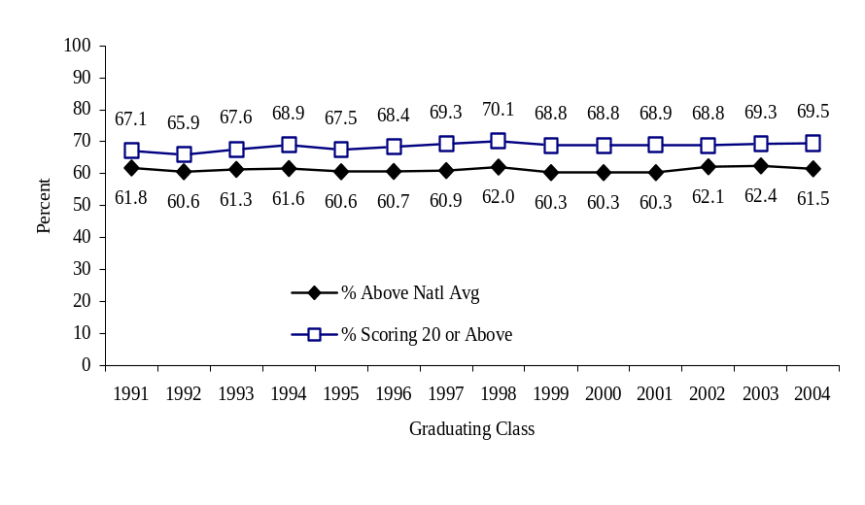  Data Sources:  American College Testing Program, The High School Profile Report for Iowa. | Percent of Iowa ACT Participants Achieving an  ACT Score Above the National Average and an  ACT Score of 20 or Above  1991-2004

Performance Measure:  Percent of Iowa ACT participants completing core high school program  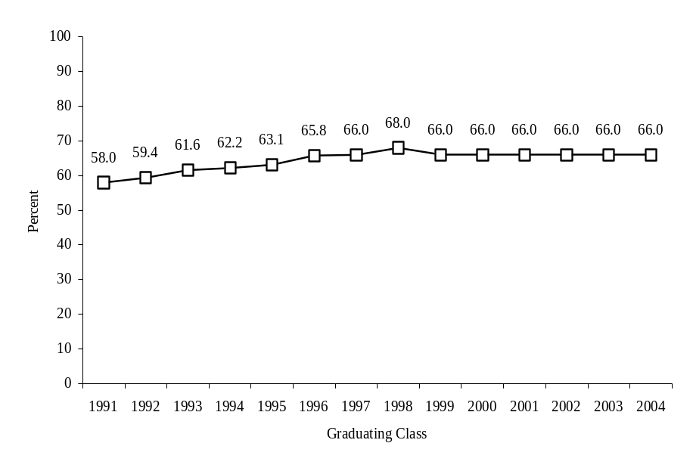  Data Sources:  American College Testing Program, The High School Profile Report for Iowa. | Percent of Iowa ACT Participants Completing  Core High School Program – 1991-2004

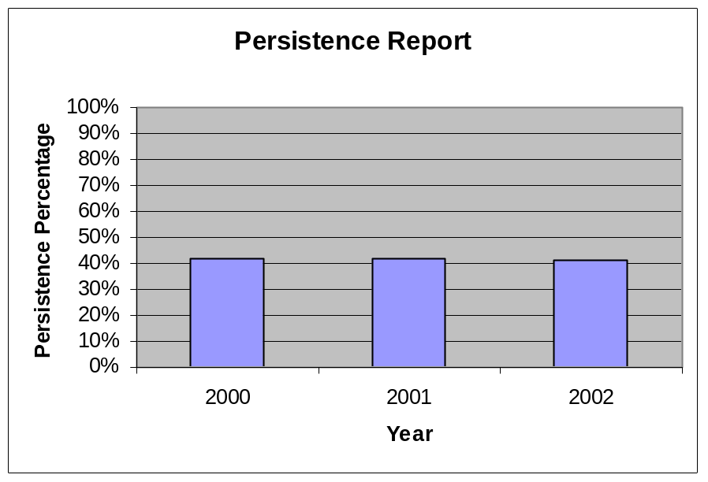
Performance Measure:  Community College Persistence Rate  (Persistence rate includes first-time, full-time students who complete a program within 150% of the program length.)  Data Sources:  Fiscal Year 1999-2003:  2001-2003 Condition of Iowa Community Colleges  Performance Measure:  Community College Award Recipients  Data Sources:  Fiscal Year 1999-2003:  2001-2003 Condition of Iowa Community Colleges  Performance Measure:  Community College Enrollment  Data Sources:  Fiscal Year 1999-2003:  2001-2003 Condition of Iowa Community Colleges  Fiscal Year 2004:  Management Information System (MIS). | 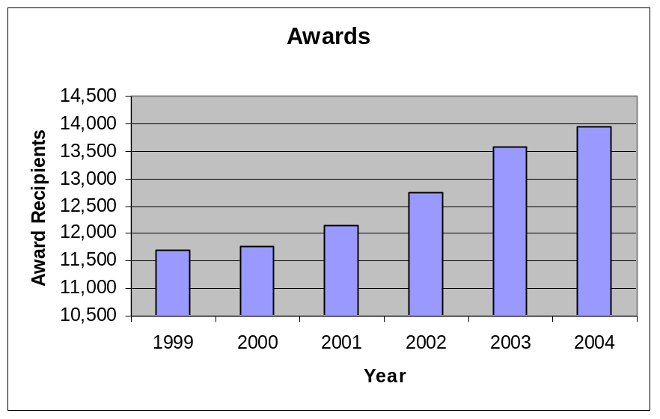  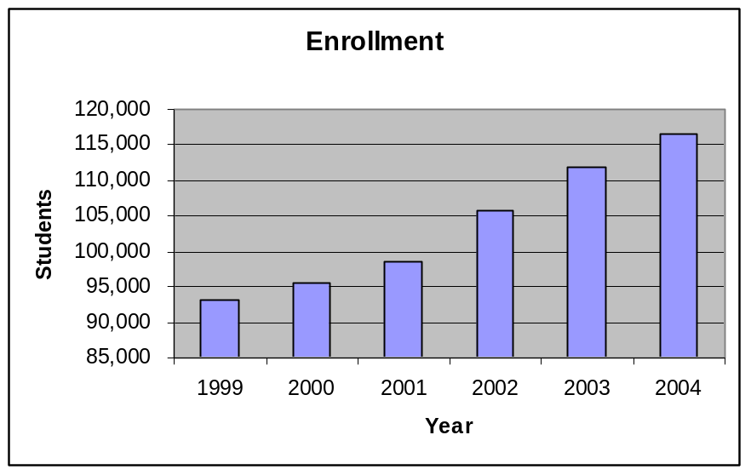

Data reliability: Data is submitted electronically to the DE consistent with the reporting requirements detailed in the Community College MIS Reporting Manual; report is developed utilizing audited data.

What was achieved: Iowans are completing post-secondary programs at community colleges, thus improving their likelihood of better economic opportunities through high skill employment.

Analysis of results: The persistence of community college enrollees through completion of programs has been relatively constant over the past 3 years, at approximately 41.4 %. Persistence percentage is based on completion within 150% of program length.

Credit awards granted to community college students has increased 19.37% over the past 6 years, while the total enrollment of community colleges has increased 25.02% over the same time period. Credit Awards include: AA, Associate of Arts; AS, Associate of Science; AGS, Associate of General Studies; AAA, Associate of Applied Arts; AAS, Associate of Applied Science, Diplomas, and Certificates.
Link(s) to Enterprise Plan: This State Board and Department of Education strategic plan goal relates directly to Goals 1 and 2 of the Leadership Agenda and Enterprise Strategic Plan (Goal 1 -- 50,000 more employed workers with college experience and 50,000 new high-paid, high-skill jobs that require two years postsecondary education within four years. Goal 2 – 90% of children have a quality preschool experience and 90% of students have at least two years of higher education).

Performance Plan Results

CORE FUNCTION

Name: Resource Management

Description:
Resource management includes the infrastructure necessary to administer and support all agency operations. This includes financial and personnel services such as payroll, accounting and budgeting; information technology enhancement, management and support; data, research and information services; and finance support for schools. In addition, this area includes leadership and strategic planning for education in Iowa, communication, legislative support, policy development, and legal services.

Why we are doing this?
In addition to supporting all agency operations and services, an important aspect of this core function is providing a vision and leadership for long-term educational planning, and the information needed statewide for policy development and resource allocation. This function also includes the dissemination of over two billion dollars in state aid and federal funds to support the operation of local school districts.

What we're doing to achieve results:
We are working to continuously improve the data and information available to state policymakers and local school districts. We have worked with local school districts in the development of a statewide individual student record system and with the community colleges on a community college management information system. We have also implemented Project EASIER and continue to convert to electronic transfer of data. Inherent in this is refining definitions to ensure consistency of reporting and reviewing reporting fields to ensure that types of data collected meet information needs.

Good information is essential to providing the leadership that results in improved student achievement.

Results
Performance Measure:  State Aid Payments to LEAs/AEAs  State Aid Payments to Community Colleges  Performance Target:  100% of payments for state aid, federal funds, and other allocations sent out to local school districts, community colleges and other customers on date specified for distribution.  Data Sources:  Integrated Information for Iowa (I3) | FY04 Performance Plan Report  State Aid Payments to LEA/AEA  FY 2000-2004  State Federal Total  FY 2000 1,863,586,427.76 202,901,183.93 2,066,487,611.66  FY2001 1,925.175,721.67 207,628,438.39 2,132,804,160.06  FY2002 1,918,197,983.72 253,615,595.69 2,171,813,579.41  FY2003 1,957,513,165.35 263,489,346.06 2,221,002,511.41  FY2004 1,943,833,692.99 304,637,646.01 2,248,471,339.00  FY04 Performance Plan Report  State Aid Payments to Community Colleges  FY 2000-2004  State Federal Total  FY 2000 142,021,282.00 10,016,472.11 152,037,754.11  FY2001 148,160,666.00 10,708,802.60 158,869,468.60  FY2002 140,038,607.00 10,636,040.80 150,674,647.80  FY2003 138,692,714.57 10,958,223.38 149,650,937.95  FY2004 136,955,866.30 11,010,975.89 147,966,842.19
Performance Measure:  Percent of public school districts participating in Project EASIER (Electronic Access System for Iowa Education Records).  Performance Target:  100%  Data Sources:  Iowa Department of Education  Bureau of Planning, Research, and  Evaluation, Project EASIER Site Records | Participating Public School Districts  In Project EASIER  1995-1996 to 2003-2004  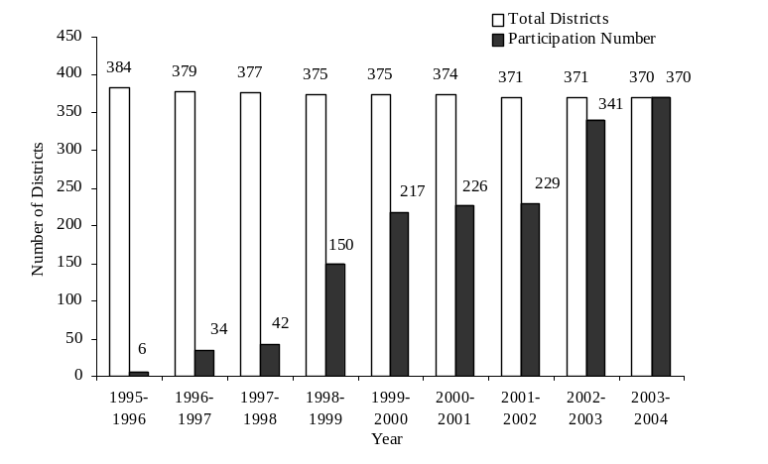

Data reliability: The payment data is the audited financial data for the state of Iowa and represents actual payments to the LEAs, AEAs, and Community Colleges for education programs.

Why we are using this measure: We are using this measure to show that funding is being distributed as required to the LEAs, AEAs, and Community Colleges and to show the trends in those funds.

What was achieved: All funds were distributed to the LEAs, AEAs, and Community Colleges as required.

Analysis of results: Federal funding for LEAs and AEAs is increasing at a faster rate than state funding for education. Federal funding for community colleges is remaining relatively constant while state resources are declining over the five-year period that was examined.

Factors affecting results: During the period examined, the results of difficult budget years for state funded programs are evident in the data

Resources used:
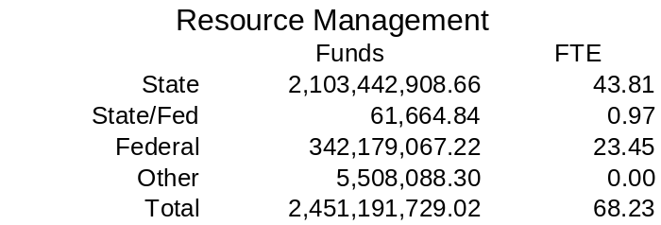

The following table presents targets and outcomes for the services, products, and activities (SPAs) in the Resource Management core function.

Services, Products and Activities Summary for the Resource Management Core Function

Services, Products, Activities | Performance  Measures | Performance  Target | Outcome | Comments
Collect, analyze and disseminate data. | Percent of LEA, AEA, and CC participating in data collection surveys. | 100% | 100%
- About schools and the pre K-12 education system. | Percent of districts participating in the Basic Educational Data Survey. | 100% | 100%
 | Percent of districts participating in a statewide individual student record system | 100% by June 30, 2004 | 100% | Fulfills U.S. Department of Education’s Performance-based Data Management Initiative
- About community colleges. | Percent of community colleges participating in the CC Management Information System. | 100% | 100%

CORE FUNCTION

Name: Education

Description:
It is the mission of the department to help communities meet the learning needs of all their children and adults. In this core function, we provide technical assistance and staff development to build capacity at the local level.

Why we are doing this?
We believe we can best help local school districts and community colleges by providing technical assistance and professional development to improve instruction and educational opportunities which result in increased student achievement.

What we’re doing to achieve results:
The Department is providing comprehensive professional development in the areas of mathematics and reading to the area education agencies and specific schools and school districts. Support is being provided to the area education agencies to assist schools identified in need of improvement and in the implementation of Iowa’s Professional Development Model through professional development and technical assistance activities. The Department is also coordinating efforts with other state agencies to develop community and family supports to eliminate or at least alleviate barriers that interfere with students’ ability to benefit from school programs and classroom instruction. All of these actions are designed to support schools in meeting their student learning goals and improve student achievement.

Results
Performance Measure:  Fourth grade reading proficiency  Data Sources:  Iowa Testing Programs, University of Iowa. | Percent of Iowa Fourth Grade Students Performing  at or Above Proficient Level on ITBS Reading Comprehension Test  Biennium Periods 1993-1995 to 2002-2004  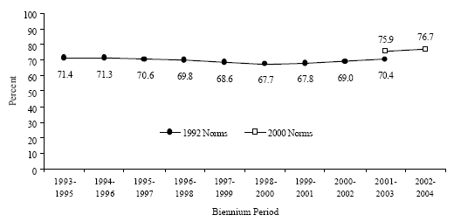

Performance Measure:  Eighth grade math proficiency  Data Sources:  Iowa Testing Programs, University of Iowa. | Percent of Iowa Eighth Grade Students  Performing at or Above Proficient Level on  ITBS Mathematics Test  Biennium Periods 1993-1995 to 2002-2004  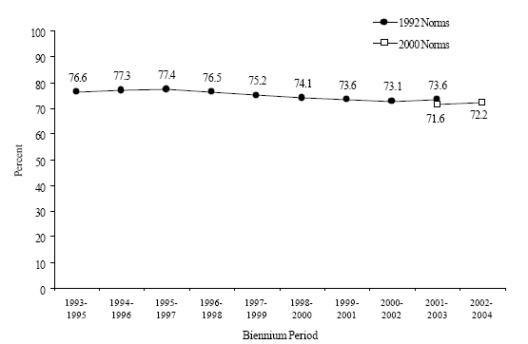

Performance Measure:  Graduation Rate  Data Sources:  Iowa Department of Education, Bureau of Planning, Research, and Evaluation, Basic Educational Data Survey, High School Completers and Dropout File. | Iowa Public School Graduation Rates  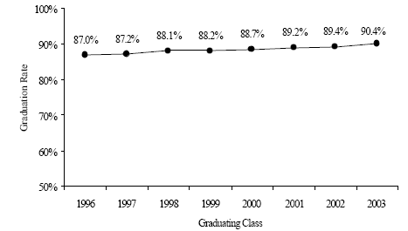  Graduating Classes of 1996 through 2003

Data reliability: The data presented come from a number of reliable sources including the Basic Educational Data Survey, Iowa Department of Education, Bureau of Planning Research and Evaluation; and The Iowa Testing Program, University of Iowa.

Why we are using this measure: Many of the activities in this core function are designed to improve instruction, and ultimately increase student achievement. These measures report on indicators of student achievement.

What was achieved: Data show a slight trend upward in most areas of student achievement. Iowa continues to rank favorably when compared to other states in the nation.

Analysis of results: We must maintain our focus on support at the local level and professional development if we are to improve instruction and increase student achievement

Factors affecting results: Additional time and resources are needed to implement district-wide professional development and district career development plans.

Resources used:
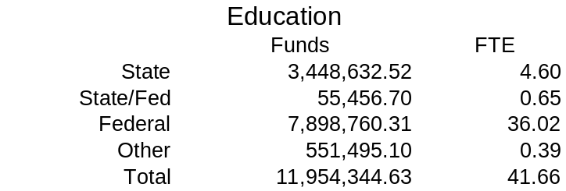

The following table presents targets and outcomes for the services, products, and activities (SPAs) in the Education core function.

Services, Products and Activities for the Education Core Function
Services, Products, Activities | Performance  Measures | Performance  Target | Outcome | Comments
- Conduct school improvement visits. | Percent of local school districts visited annually by school improvement team. | 20% | 20% | Twenty percent Iowa’s school districts received a school improvement visit during the 2003-04 school year.
- Develop and implement a research-based professional development model | Percent of districts whose professional development plans are approved. | 100% by 2004 | 100% by the end of December, 2004. | The development of Iowa’s Professional Development model was completed in January 2003. The support materials for the Model were completed in the spring of 2004.  In addition, initial training in the application of the Model was conducted from May 2003 through May 2004. The training, accomplished through 2 regional training sequences, provided 5 days of training to area education agency and school district personnel and 4 days of technical assistance to area education agencies in providing technical assistance and capacity building for scaling up support to school districts. The 2 sequences of this “professional development seminar series” reached 393 area education agency and school district personnel.  In support of the professional development model, content networks were formed in science, mathematics, and reading to identify and present findings on instructional practices that have a scientific research base. The initial work of the content networks was posted “online” on the Department’s website in November 2003.  Administrative rules and procedures for district career development plans, including professional development standards, became effective March 2004. Department review of district professional development plans, included as an integral part of each school district’s Comprehensive School Improvement Plan submitted in September 2004, is currently in process and will be completed before the end of December 2004.
Services, Products,  Activities | Performance  Measures | Performance  Target | Outcome | Comments
- Build the capacity of AEAs to provide intermediate support | Percent of AEAs accredited  Percent of local district respondents agreeing or strongly agreeing that AEA services met their professional needs. | 100%  95% | 100%  90.4% | All 12 of Iowa’s area education agencies are accredited, one conditionally.  The Department and area education agencies are cooperating in building capacity to provide local schools with timely and quality professional development and technical assistance in kindergarten through grade 12 mathematics and reading to local schools to help them meet their student achievement goals. There are currently 240 individuals representing the state’s 12 area education agencies and Reading First school districts participating in the Statewide Reading Team. In mathematics, there are 222 individuals from the state’s 12 area education agencies, 8 urban school districts, and selected middle schools participating in the 2-year, K-12 mathematics professional development endeavor.
 |  |  |  | The area education agencies and Department have organized an 11-member team to develop an action plan for developing the education system’s capacity to respond to school district needs in the area of science. It is anticipated that the initial phase(s) of the science capacity building plan will be engaged during the summer of 2005.

Services, Products,  Activities | Performance  Measures | Performance  Targets | Outcome | Comments
3. continued |  |  |  | The Department has led the development of the State Support Team for Schools in Need of Improvement which has provided the area education agencies with ongoing professional development and technical assistance necessary to provide timely, high-quality assistance to identified schools. Also, the Department has provided area education agency teams and school district teams with ongoing training and assistance in the implementation of Iowa’s Professional Development Model. Like the previously mentioned efforts, these efforts are designed to develop the educational system’s capacity to provide timely, quality assistance to school districts engaged in school improvement activities that target improved student achievement.
- Provide information and technical assistance to agencies receiving federal program funds | Percent of districts in compliance with USDA and USDE regulations (for funding purposes). | 100% | 100% | No USDA or USDE funds were withdrawn from the Department or any local or area education agency, or community college during the 2003-04 school year because of failure to comply with program or fiscal requirements. The Department provides local and area education agencies, and community colleges with program and fiscal guidance for federal programs via the Department’s website, direct mailing of guidance and instructions to all local and area education agencies, and community colleges, and direct response and problem solving activities to questions and concerns from local and area education agencies, and community colleges.
Services, Products, Activities | Peformance  Measures | Performance  Target | Outcome | Comments
- Provide technical assistance to practitioner preparation programs, especially as it relates to assessment practices and meeting program approval standards. Revise the approval process. | Percent of practitioner preparation programs participating in technical assistance. | 100% | 100% | In March 2003, a daylong workshop on Performance Based assessment and data management was conducted by the Department for practitioner preparation programs. Seventy-four participants attended and all of the state’s 31 practitioner preparation programs were represented. In the fall of 2004, a session was presented at the Iowa Association of Colleges for Teacher Education (IACTE) on data collection systems. 100% of the 31 institutions were in attendance. A grant proposal will be submitted in mid-December that will focus in part on data collection and management systems for Iowa’s practitioner preparation programs.
 |  |  |  | Beginning in August 2004, a new procedure was implemented to train new team members for program approval site visits. Representatives from Iowa’s institutions of higher education now serve as apprentice members, along with a trained and experienced partner, during two visits before becoming full team members.
 |  |  |  | Beginning in August 2004, preliminary reviews are conducted 1-2 months prior to the site visit. The preliminary reviews provide the institutions a chance to get feedback on their Institutional Report and to respond to questions and requests for additional information prior to the visit. Visits are now shorter, more thorough, and considerably more efficient.
Services, Products,  Activites | Performance  Measures | Performance  Target | Outcome | Comments
5. continued |  |  |  | A statewide committee was established to provide input on the Chapter 79 rules revision. To date, 4 meetings have been conducted and initial concepts were shared with all 31 of the universities and colleges with practitioner preparation programs at the spring 2004 and fall 200404 IACTE state conferences. It is anticipated that the revised rules will be presented to the State Board of Education in the summer of 2005.
 |  |  |  | The Iowa State Legislature granted authority to the Department to review all practitioner preparation programs that are offered in Iowa by out-of-state institutions.

CORE FUNCTION

Name: Regulation and Compliance

Description:
The department is charged with the responsibility of ensuring that schools and community colleges are in compliance with state and federal regulations. The department and state board provide stewardship for the education system through accreditation of school districts and nonpublic schools, community colleges and area education agencies; by approving teacher and administrator preparation programs; and through fiscal oversight and federal program oversight. The purpose for all regulation and compliance functions in the agency is to ensure that students in Iowa receive a quality education.

Why we are doing this:
Regulation and compliance ensure that minimum standards are met, and that money is being spent for the purposes for which it was appropriated. We must demonstrate compliance if we are to continue to qualify for state and federal funds.

What we're doing to achieve results:
The Department is currently reviewing Comprehensive School Improvement Plans from each local school district. These comprehensive plans show how districts are complying with both state and federal requirements. The Department is working to streamline the compliance process in order to focus more resources on assistance to schools for continuous improvement.

Results
Performance Measure:  The percent of LEAs, AEAs and community colleges that are accredited.  The percent of teacher preparation programs approved.  Performance Target:  100% of Iowa’s LEAs, AEAs and community colleges are accredited.  100% of the teacher preparation programs are approved.  Data Sources:  LEA, AEA and community college accreditation site visit reports and teacher preparation program review reports. | Education Institutions Meeting Accreditation  or Approval Standards  Number  Accredited  Number or Approved  Local School Districts 367 367  Area Education Agencies 12 12  Community Colleges 15 15  Teacher Preparation Programs 31 31

Data reliability: The data is reliable and reflects the total number of educational entities that are required to be accredited.

Why we are using this measure: To monitor compliance with accreditation and approval standards.

What was achieved: Iowa educational institutions are meeting accreditation or approval standards prescribed by Iowa Code and Administrative Rules.
What was achieved: 100% of Iowa’s LEAs and community colleges are accredited. 100% of AEAs are accredited, one conditionally. 100% of teacher preparation programs are approved.
Analysis of results: The one AEA that is conditionally accredited has submitted a plan of corrective action. An update on their progress will be submitted to the Department in spring 2005.
Factors affecting results: Shortage of staff at the Department for compliance and technical assistance to LEAs and AEAs makes it difficult to make on-site visits and Phase II visits in order to monitor compliance and provide follow-up.

Resources Used:
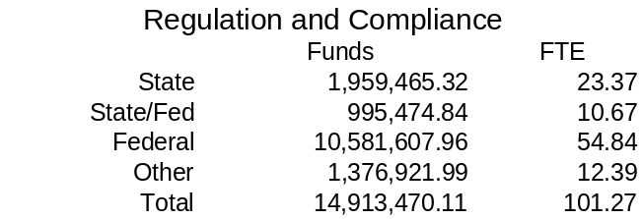

The following table presents targets and outcomes for the services, products, and activities (SPAs) in the Regulation and Compliance core function.

Services, Products and Activities for the Regulation and Compliance Core Function

Services, Products, Activities | Performance  Measures | Performance  Target | Outcome | Comments
- Accreditation activities | Percent of LEAs, AEAs, and CCs with on-site reviews | 20% | 20% | 20% of Iowa’s LEAs and AEAs received a school improvement visit during the 2003-2004 school year. We plan to continue reviewing 20% of LEAs, AEAs and CCs with on-site visits each year.
- Accredit Local school districts | Percent of local districts receiving desk audits annually  Percent of local districts receiving on-site reviews annually | 100%  20% | 100% | 100% of LEAs receive a desk audit annually. We plan to continue conducting desk audits for 100% of LEAs each year.
- Accredit area education agencies | Percent of AEAs receiving accreditation visits annually | 20% | 20%
- Accredit community colleges | Percent of community colleges receiving accreditation visits | 100% over a 5-year period. | 100% over a 5-year period
- Administration of federal programs (program and fiscal) including: NCLB, IDEA/Special Education, Perkins, Child Nutrition, Infrastructure) | Percent of federal programs approved for funding | 100% | 100%

Resource Reallocations

Over the past several years, the Department of Education has increased the use of technology to reduce operating costs. This has included greater use of the Internet and email for providing information to local school districts, area education agencies, community colleges, and other customers. The use of technology has helped us to lower our costs for postage, printing, and supplies as budgets were reduced. We have used technology to collect data and reports electronically rather than on paper. This has given us more accurate data and lessened the follow up that had been required in the past to ensure that all the data we received was accurate.

We have increased our use of the ICN to hold meetings making more efficient use of staff time as well as reduced travel costs for both staff and our education partners. It has enabled us to reach more people more quickly with the needed information.

We have also reallocated a number of staff positions from being funded with state resources to federal resources. This reallocation was due to having less state resources and increased federal requirements. The reallocation has enabled us to target staff efforts towards meeting federal requirements with federal resources and has helped us to maximize the use of our federal funds. By maximizing our staff paid with federal resources, we have been able to have our federal compliance work completed by the same staff who are in the local schools completing other reviews for state requirements. The reallocation has assisted us in meeting our requirements with less state resources and has enabled us to focus on the programs at the local level.

Agency Contacts

Copies of the Iowa Department of Education Performance Report are available on the Results Iowa web site at http://www.resultsiowa.org. Copies of the report can also be obtained by contacting Gail Sullivan at 515-281-5296 or gail.sullivan@iowa.gov.

Iowa Department of Education
Grimes State Office Building
Des Moines, Iowa 50319

More comprehensive information and data about education in Iowa can be found in the Annual Condition of Education Report on the Department of Education web site at http://www.state.ia.us/educate/fis/re/coer/index.html.

