IOWA DEPARTMENT FOR THE BLIND

PERFORMANCE REPORT

Performance Results
for fiscal year 2004

TABLE OF CONTENTS

SECTION | PAGE
INTRODUCTION |  | 3
DEPARTMENT OVERVIEW |  | 4
STRATEGIC PLAN RESULTS |  | 11
PERFORMANCE PLAN RESULTS |  | 17
AGENCY CONTACTS |  | 42

INTRODUCTION

I am pleased to present the performance report for the Iowa Department for the Blind for fiscal year 2004. This report is provided in compliance with sections 8E.210 and 216B.7 of the Code of Iowa. It contains valuable information about the services the Department and its partners provided for Iowans during the past fiscal year in the areas of vocational rehabilitation, library services, and resource management.

Major accomplishments of the year included the implementation of a transition mentoring program for young blind Iowans, national prominence in vocational rehabilitation as measured by the U.S. Rehabilitation Services Administration, and other initiatives described in this report.

Key strategic challenges, developments, and trends are also discussed in the “Department Overview” that follows.

Sincerely,

Allen C. Harris
Director, Iowa Department for the Blind

DEPARTMENT OVERVIEW

The Iowa Department for the Blind is the state agency charged with providing vocational rehabilitation, independent living, library, and other essential services to Iowans who are blind so that they can live independently and work competitively. The policies and procedures of the Department are grounded in state and federal law, including sections 216B, C and D of the Code of Iowa, the Rehabilitation Act of 1973, as Amended, and the Randolph-Sheppard Act. The Department has used these mandates and the expressed needs of our consumers to establish a highly successful service delivery system that has been emulated both nationally and internationally.

The Department’s three major service areas--vocational rehabilitation (VR), independent living (IL), and library--are provided through four organizational divisions: Field Operations, the Adult Orientation and Adjustment Center, the Business Enterprises Program (BEP), and the Library for the Blind and Physically Handicapped. The foundation that underlies all of our programs is our positive philosophy of blindness. This philosophy also underscores the Department's mission which guides the delivery of these services to our consumers:
The Iowa Department for the Blind is the means for persons who are blind to obtain for themselves universal accessibility and full participation as citizens in whatever roles they may choose.

The goal of the Department, then, is to provide blind Iowans with the services they need to ensure that they can participate competitively, competently, and fully alongside their sighted peers in the jobs and activities they may choose.

The Department's philosophy of blindness is based upon the belief that, “It is okay to be blind.” In fact, this concept is also our vision. The real problems of blindness do not lie in the physical loss of eyesight but in the misconceptions about blindness widely held by the general public and by many blind persons themselves. Because of these misconceptions, people who are blind are subject to discrimination that prevents them from achieving full integration into the economic and social life of their communities. Blind persons are individuals, and their ability to live independently and work competitively is contingent largely upon the effectiveness of the rehabilitation training they receive and the opportunities available to them. If dealt with properly, the effect of blindness on an individual's life can be reduced to the level of a mere characteristic with nuisance value.

The Department's values and principles, which stem from this positive philosophy of blindness, are the driving force of our agency. We affirm that:
- the Department must operate on the demonstrated truth that blindness need not be a barrier to leading a full life as a first-class citizen in society;
- blind persons have the same rights and responsibilities as all other citizens to self-determination, including the right to enjoy full integration into all aspects of society;
- blind persons must overcome the misconceptions and the discrimination that result from their status as a minority group;
- agencies and programs serving blind persons must help blind individuals and organizations succeed in fulfilling their aspirations;
- persons who are blind, both as individuals and as organized groups, must take the lead in determining the kinds of services they may need to empower themselves fully;
- all Department staff must be qualified individuals trained in the delivery of services based on the agency's philosophy;
- the Department must provide the widest possible range of pre-vocational, vocational rehabilitation, and independent living training, as well as Library and other ancillary services, so that all consumers have as much opportunity as possible to make informed plans and choices concerning life goals; and
- the Department in its staffing policy be cognizant of the importance of hiring qualified persons who may be blind.

Our agency is driven strongly by our mission, culture, and values. Our focus is on providing the quality services blind Iowans must have to achieve their VR and IL goals. Therefore, we measure results by the successful outcomes our clients achieve. Services provided in the Orientation Center are individualized so that students can go at their own pace in developing the skills and self-confidence necessary to adjust to blindness. Since our culture values equally the contributions of all staff, we have become a model for public and private employers by hiring qualified employees with disabilities. We insist that our computer software and hardware is accessible both to comply with the law and to meet the needs of all our staff, and we share what we have learned about assistive technology and job accommodations with private employers and with other branches of state government.

The Department’s central office is located in a six-story historic building in downtown Des Moines. This building houses the Department’s administrative offices and its four major divisions. Field offices are located in Cedar Rapids and Cedar Falls. All offices are accessible to people with disabilities.

The Department has 109.5 full-time equivalent positions (FTE’s). To meet the increasing demand for services, particularly from Iowa’s growing elderly population, we sometimes employ temporary and contract workers in addition to our FTE’s. We also rely heavily on volunteers to satisfy this need. In recent years, for example, 110 volunteers have done work equivalent to that of 15 FTE’s.

Our employees are dedicated to helping blind Iowans develop self-confidence and a positive attitude toward their blindness by providing them with the services, resources, and tools that enable them to achieve their goals. Our programs focus on the primary needs of blind persons, particularly their need to obtain competitive employment and economic parity with the rest of Iowa's work force. As a result, the VR Program, which works with blind persons toward achieving their vocational goals, is the centerpiece of our services.

The Department's other programs and initiatives support these efforts toward vocational rehabilitation. Training in Braille, cane travel, and the other skills of blindness is available both through the residential program at the Adult Orientation and Adjustment Center and in the community through rehabilitation teachers. BEP provides training and jobs in the food service industry. Through the production and distribution of materials in such alternative media as Braille, cassette and large print, the Library meets the information and reading needs of blind and other print-impaired readers. IL training helps blind Iowans who are elderly or severely multiply-disabled maintain the highest possible level of independence.

In addition to these core services, the Department provides a broad array of support and outreach services. As a central clearing house for valid information about blindness, we participate in public education and in-service training activities throughout the state. We cooperate with other agencies of state government to improve transition services for blind children. Through our Project ASSIST (Accessible Step-by-Step Instruction with Speech Technology) Program, we produce tutorials that make Windows computer applications accessible to blind users. We also sell items like talking clocks and Braille writing supplies that are helpful to blind persons in our Aids and Devices Store.

The Department is customer focused. Our primary customers are blind and severely visually impaired persons who have very specialized needs that cannot be met elsewhere. In developing our programs and policies, we actively seek and take seriously the input we receive from advisory councils, organizations of the blind, individual blind persons, and even blind staff who also make up part of our customer base. The three members of our policy-making Commission for the Blind are blind. Knowledgeable and politically active, our customers are highly interested in the policies, procedures and practices of our agency. They support our culture and participate in our strategic planning. In fact, the Department remains in existence because of the ongoing support and demands of our customers.
We serve a variety of other customers as well. Our Library serves individuals and institutions like the physically and reading disabled, nursing homes, campus offices for disabled students, restaurants, and others who need materials in alternative media. Through our VR Program, we serve such customers as area education agencies and employers, and through our IL Program, we provide in-service training to group homes, senior centers, and other community organizations.

Of the Department’s 109.5 FTE’s, 96 work in our central office, 8 in district offices, and 5.5 at other remote locations. Our staff work in the areas of administration, service provision, and support. Most of them are non-contract workers. Contract workers are covered by the American Federation of State, County, and Municipal Employees (AFSCME) agreement.

Most of our non-contract positions require a bachelor’s degree. Although the Rehabilitation Services Administration (RSA), our federal partner, is placing more emphasis on professional degrees, we have found it more effective to provide our staff with extensive in-house training in our culture and philosophy of blindness and then certify them ourselves as competent. This training is probably more extensive than that received by any other state employees. Our safety requirements are minimal and generally handled by our own maintenance staff. Complex safety issues are contracted out.

The Department’s Des Moines building includes the Library’s production and distribution units and 10.5 miles of shelved books, which borrowers can come in to browse. The Orientation Center’s 24-hour training and residential facilities are housed here as well. We have our own staff and equipment necessary to maintain the physical plant.

The Department has a computer network system for word processing, database, spreadsheet, email, and internet functions. Assistive technology makes the network accessible to all staff, and embossers are used to produce materials in Braille for our customers. A loaner pool of computer equipment is available to clients. The Library lends computers to volunteer Braille transcribers, recorders to volunteer narrators, and playback equipment to borrowers. The Department also has its own fleet of cars and maintains an inventory of food service equipment.

We must abide by requirements of various federal laws and regulations and the Code of Iowa, which requires us to maintain a registry of all blind Iowans. The RSA enforces federal rehabilitation regulations, such as Informed Client Choice and an established grievance procedure with mediation available through the Client Assistance Program (CAP). The Polk County Department of Health inspects food service sites. The National Library Service for the Blind and Physically Handicapped (NLS) audits the distribution of playback equipment and certification of eligibility for Library service. Like all governmental agencies, we are subject to the regulations of the Americans with Disabilities Act (ADA).

Reinforced by the law, the Department’s key customer requirements are rooted in the high expectations of the customers we serve. Our blind customers demand the individualized and quality services they need to reach their VR and IL goals without delay. Employers who hire our clients expect them to be qualified to do the job. Library borrowers expect efficient service. Suppliers and vendors expect prompt payment. The general public expects accurate information and services when needed, and taxpayers and legislators demand cost effectiveness and accountability for funds expended.

Most of our important customer requirements are based on such state and federal regulations as eligibility criteria. VR clients must be functionally blind, have the desire to work, and need VR services in order to be employed. A Center student must be on the VR caseload. The IL and Library Programs have eligibility requirements as well. Institutions like nursing homes that are Library borrowers must serve persons who are eligible for Library service.

We share a variety of special relationships with our customers and customer groups, some of whom are also our partners. The RSA, NLS, and Legislature--as representatives of the taxpayer--require reports on our results. Clients control the services they receive through Informed Client Choice. We require reports from community rehabilitation programs (CRP's), training institutions, physicians, and others from whom we purchase services for our clients. We develop collaborative agreements with a number of agencies, including Workforce Development (WFD), and with the Iowa Department of Economic Development (IDED) in helping blind clients set up their own businesses. We share federal moneys and fund joint projects with the Division of Vocational Rehabilitation Services (DVRS). We belong to the Consortium of User Libraries (CUL) so that we can have access to state-of-the-art circulation software. Our most important partnership, however, is the one we have with blind individuals and organizations, since we must have their constant input to provide the highest quality of services.

The Department works with a variety of suppliers of goods and services. We buy goods for ourselves and clients from a wide range of suppliers. We purchase direct services for our clients from educational and training institutions, CRP's, medical service providers, and others. We have an especially important relationship with the developers and vendors of assistive technology who produce the equipment many of our clients must have to achieve their goals. The NLS provides us with reading materials and playback equipment to distribute to our Library borrowers, and the state and federal government provide us with the funds we need to serve our customers.

Because no systemic mechanism for referrals is in place, the Department’s most important suppliers include the Social Security Administration (SSA), medical professionals, educational institutions, families, and others who refer to us the names of blind persons who need our services. We also have an important relationship with the Department of Corrections, the Telephone Pioneers, the Lions of Iowa, and others who supply the volunteers we need to maintain and expand our quality services. Because of our close relationship with them, organizations of the blind supply us with support, feedback, referrals, and volunteers.

While the NLS provides guidelines, the RSA and the state both fund and regulate our programs. They impose strict rules on how moneys can be spent and goods distributed, including requirements governing eligibility and the service delivery process. Rules governing confidentiality regulate the relationship of both our staff and volunteers with our customers.

Because the Department provides services to blind Iowans that are usually not available elsewhere, we do not have competitors in the usual sense. Recording for the Blind and Dyslexic (RFB&D), a nationwide nonprofit organization, and some local libraries carry books in alternative media, but their holdings are limited and the NLS equipment needed to use them is distributed through our Library. Because of our expertise in dealing with blindness, Worker’s Compensation and private rehabilitation organizations often consult and coordinate services for blind clients with us. Skills training is available through other sources, such as the Department of Veterans Affairs (VA) training centers, but many of these centers have additional eligibility requirements. Through our BEP and job placement programs, we compete indirectly with private food service businesses and with other candidates for jobs for which our clients have applied.

The Department determines its competitive success in a number of ways. We look at the federal Standards and Indicators to learn our ranking in relation to the performance of other public rehabilitation agencies. We compare our Library’s production and circulation figures with those from previous years to determine trends. We set our own standards for success by looking at such factors as the number of days between referral and contact, number of successful case closures, average hourly wage at case closure, and expressed client satisfaction.

Some changes are taking place that may make the environment in which we provide services more competitive. The Workforce Investment Act (WIA) is modifying the way job placement services are being provided to all job seekers. The SSA can give a “Ticket to Work” to disabled recipients who can then use it to purchase rehabilitation services of their choice. If Medicare funds become available to pay for the rehabilitation of blind persons, new regulations may be developed to govern the use of these funds. The changing demographics of the work force are forcing BEP to compete for private food service locations, and the growing availability of electronic books through the internet will affect the kinds and numbers of materials circulated and produced by our Library.

The most significant change taking place, however, is the move toward a noncategorical, community-based service delivery system for persons with disabilities. This approach is very expensive and ineffective for low incidence disabilities like blindness. There are not enough rehabilitation professionals who have received the substantial amount of training necessary to provide the specialized VR and IL services blind persons need, which makes it impossible to provide meaningful services to them on the community level.

The Department’s new thrusts in the types and methods of services provided are a result of changes in the law, the population we serve, and technology. WIA gives us a new set of partners and a challenging new approach to vocational rehabilitation. Iowa’s elderly population is growing, and with it, incidences of blindness. Medical advances have made it possible for premature infants and trauma victims to survive. Many of these people have multiple disabilities, and if one of these is blindness, we are designated as the service provider.

Developments in technology have also had a large impact on the kinds of services the Department provides. We give financial and other support to Newsline and the Iowa Radio Reading Information Service (IRIS), which make newspapers accessible to print-impaired persons. A new medium, e-text, is on the horizon for the Library, which means new equipment and training for staff and customers. More blind workers are reentering the service stream to receive the assistance necessary to cope with the technological changes in their jobs. Because the internet is now more accessible to blind computer users, we can use it for e-commerce and other ways of delivering services to our customers.

Since the passage of WIA in 1998, the Department is participating in a major new organizational alliance. The Act requires agencies like ours to partner with 22 diverse training and employment programs, such as community colleges, Job Corps, and IWD. We must collaborate in the writing of memos of understanding (MOU's) with 16 regional Workforce Investment Boards in Iowa. The Rehabilitation Act of 1973, as Amended, also requires organizational alliances between agencies such as ours and educational institutions.

The Department is developing new strategies to deal with these major thrusts. As a result of WIA, we have played an active role in developing MOU’s so that blind job seekers will have full access to the employment services they need. Because the Department’s major funding stream is for the provision of VR services, we are forced to limit the services we provide directly to elderly blind Iowans and instead rely more on the indirect provision of those services through self-help groups and community-based skills training efforts. Our staff also receives training to help them deal with disabilities other than blindness.

The Department is also developing strategies to take advantage of technological advances. We are installing a new state-of-the-art database system that will enable us to circulate Library materials, store and retrieve client information, and produce reports for our state and federal partners quickly and accurately. Through tutorials produced by the Project ASSIST Program, blind workers can learn quickly how to use common computer applications with assistive technology. We also plan to make applications for our services, Library holdings, and the purchase of computer tutorials and other items from our Aids and Devices Store available through our web site.

The Department must balance some unique factors in providing quality services to our customers. Except for public education and welfare, for whom we often serve as consultants, we are the sole provider of virtually all services needed by blind Iowans. The administration of our moneys is complex. Our budget relies heavily on federal matching funds. That funding follows the most expensive service needs rather than population trends. As a result, we can meet the needs of blind persons seeking vocational rehabilitation but not those of the many older Iowans who are losing their vision.

The success of the Department's programs is evident in the success achieved by blind Iowans. It is reflected in the many blind persons who can be seen traveling about independently, going to their jobs and to the community and family activities in which they participate.

STRATEGIC PLAN RESULTS

STRATEGIC PLAN

Key Strategic Challenges and Opportunities: Grow, retain, and attract a diverse and skilled work force. Enhance the quality of life for all Iowans.

Goal # 1: The Department will meet the above Governor’s leadership agenda goals by increasing the productivity of blind Iowans.

Strategies:
Strategy 1.1: Provide transition services to blind youth ages 14 and older who are beginning to exit the K-12 educational system.

Strategy 1.2: Achieve a quantity and quality of employment outcomes for blind Iowans consistent with the standards set by the federal Rehabilitation Services Administration.

Strategy 1.3: Increase availability and training in the use of assistive technology for consumers.

Strategy 1.4: Market the Orientation Center to targeted populations as the most effective forum for blind Iowans to obtain the skills and philosophy of blindness.

Results
Performance Measure:  - Percentage of individuals achieving competitive employment outcomes reporting own income as primary source of support at closure.  - Ratio of average VR wage to average state wage as a percentage.  - Competitive employment outcomes as a percentage of all employment outcomes.  - Percentage of individuals with employment outcomes.  - Number of individuals with employment outcomes.  Data Sources:  IDB client data system  RSA client data system | 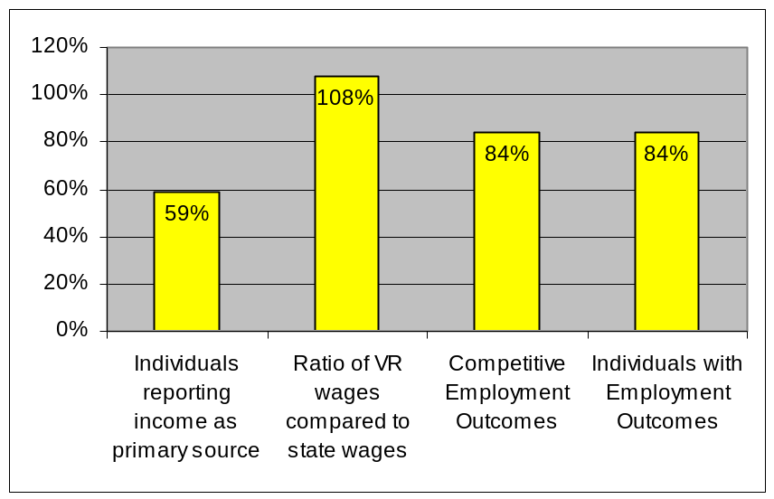  The above chart shows performance measures A-D as percentages.  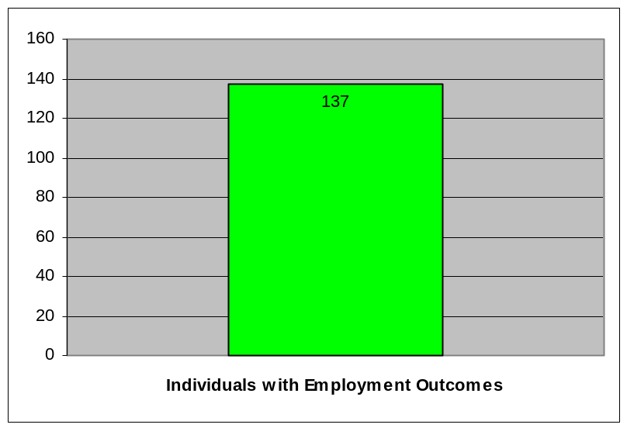  The above chart shows 137 individuals with employment outcomes.
Data reliability: The Rehabilitation Services Administration performs independent tests to verify accuracy and identify anomalies.

What was achieved: Critical quality services were provided efficiently to blind Iowa citizens. Services were provided to Iowa employers to assist them in hiring and promoting qualified blind individuals.

Analysis of results: The quality of jobs achieved by blind Iowans and the work done by staff was spectacular in light of the soft labor market, increased service demands, and budget limitations.
Link(s) to Enterprise Plan: Double the number of employed workers with college experience and create 100,000 high-paid, high-skill jobs that require two years post-secondary education within four years.

Key Strategic Challenges and Opportunities: Enhance the quality of life for all Iowans.

Goal # 2: The Department will meet the above Governor’s leadership agenda goals by increasing the independence of blind Iowans.

Strategies:
Strategy 2.1: Provide skills training and related Independent Living (IL) services.

Strategy 2.2: Assist individuals in developing a positive attitude about blindness by providing opportunities for peer interaction.

Strategy 2.3: Increase the capacity of community-based service providers to meet the needs of older individuals who are blind.

Results
Performance Measure:  Independent living goals achieved.  Data Sources:  Automated Case Management system | 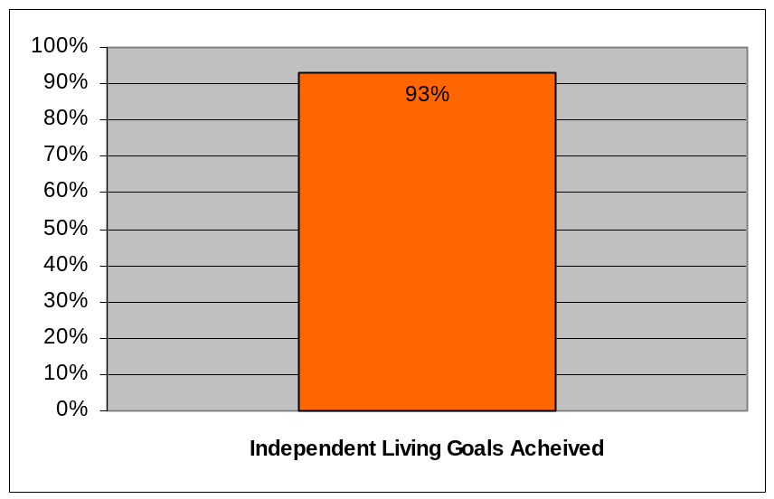  The above chart shows 93% of Independent Living Goals were achieved.
Data reliability: The Rehabilitation Services Administration performs independent tests to verify accuracy and identify anomalies.

What was achieved: As a result of services provided older Iowans who became blind or visually impaired were able to remain in their own homes with minor life style changes and avoid moves to more costly settings such as long-term care or assisted living facilities.

Analysis of results: Early intervention, basic training in non-visual techniques, contact with positive role models, and the provision of simple adaptive devices are all essential and effective services that enable older individuals to successfully adjust to blindness, thereby avoiding a major change in life style and loss of independence.
Link(s) to Enterprise Plan: Seniors, adults with disabilities, and those at risk of abuse have safe quality living options in their communities.

Key Strategic Challenges and Opportunities: Improve efficiency and expand the outreach of libraries, museums, and community arts programs to promote and provide quality lifelong learning opportunities for all Iowans.

Goal # 3: The Department will meet the above Governor’s leadership agenda goal by improving access to information for blind Iowans.

Strategies:
Strategy 3.1: Enhance access to a wide variety of materials through
the Iowa Library for the Blind and Physically
Handicapped.

Strategy 3.2: Provide effective training for blind computer users.

Strategy 3.3: Facilitate timely access to current print news media to all blind
Iowans.

Results
Performance Measure:  - Total readership (union of PID)  - Titles circulated  - Volumes circulated  - Total applications  Data Sources:  Automated circulation system | 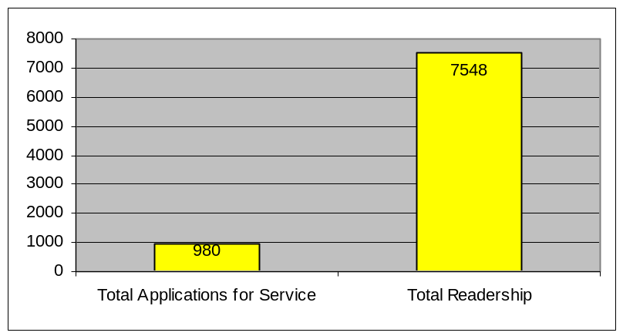  The above charts shows 980 applications for service and 7548 total readers.  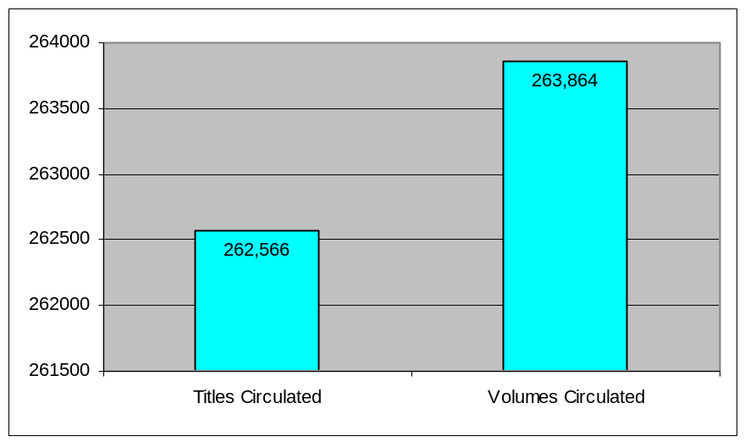  The above chart shows circulation totals for titles (262,566) and volumes (263,864).
Data reliability: Because all patrons are served through the automated system, and all transactions are captured by the system as part of its basic functionality, the resulting data is highly reliable.

What was achieved: 7,548 Iowans who cannot read standard print gathered and used information from books, magazines, educational, job-related, and personal materials to pursue education from kindergarten through advanced post-graduate degrees, acquire and maintain a wide variety of jobs, manage personal affairs (including medical and financial) participate in the democratic process, and read for leisure and personal enrichment.

Analysis of results: According to national census statistics, we are reaching only about one in seven Iowans who can benefit from our services. Those we serve are reading at a rate substantially higher than public library borrowers. This is likely due to the fact that we are the sole source of accessible reading material for most of them and that other forms of entertainment and information resources (such as television) are less satisfying to blind and severely visually impaired persons.

Link(s) to Enterprise Plan: 90% of children have a quality preschool experience and 90% of students have at least two years of higher education.

PERFORMANCE PLAN RESULTS

CORE FUNCTION

Name: Vocational Rehabilitation and Independent Living

Description: Provide vocational rehabilitation services to eligible Iowans with a defined disability seeking employment. Activities may include assessment; training; guidance and counseling; referrals; employer assistance; job placement rehabilitative technology services; post-employment follow-up; and coordination of community services.

Why we are doing this: The Iowa Department for the Blind is the state agency responsible for providing most of the services Iowans who are blind need to live independently and work competitively. The mission is to be the means for persons who are blind to obtain for themselves universal access and full participation as citizens in whatever roles they may choose.

What we're doing to achieve results: Critical services are targeted to the vocational and independent living needs of blind Iowans. Without these individualized services including counseling, transition, training and necessary accommodations, Iowans could not compete in two and four year post-secondary education, meet employer needs, and obtain high quality employment. Independent living services allow older Iowans to continue to be a part of their community and to postpone or avoid costly institutional care.

Results
Performance Measure:  * Ratio of average VR wage to  average state wage as a  percentage.  *Competitive employment  outcomes as a percentage of  all employment outcomes.  * Percentage of objectives to  increase independence met as  a percentage of all objectives  set.  Performance Target:  83% VR Wages  60% Competitive Employment  90% Independence Objectives  met  Data Sources:  Electronic client data  system; Rehabilitation  Services Administration  (RSA) Standards-(FFY  Oct. 2003-Sept. 2004) used  to access standards and  reporting data. | 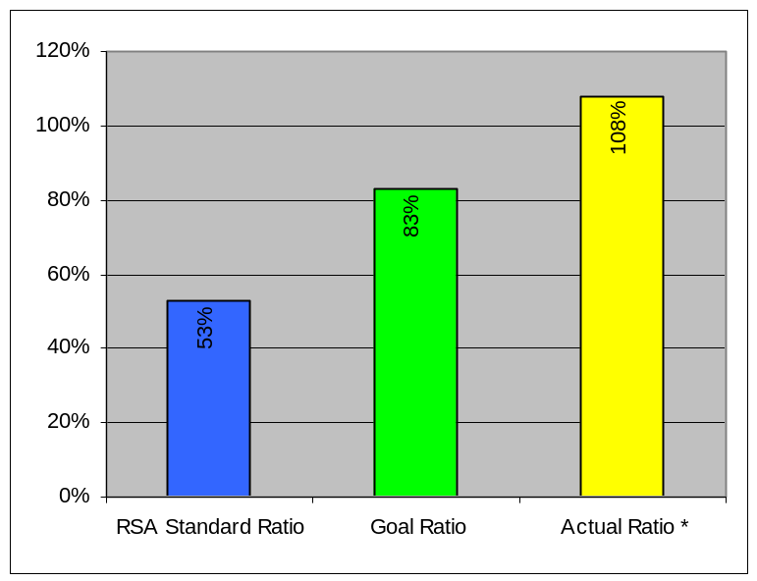  *WE STRONGLY BELIEVE THIS IS THE BEST IN THE NATION FOR ALL STATE AGENCIES SERVING THE BLIND. The above graph shows the ratio of VR wages as a percentage of state wages.  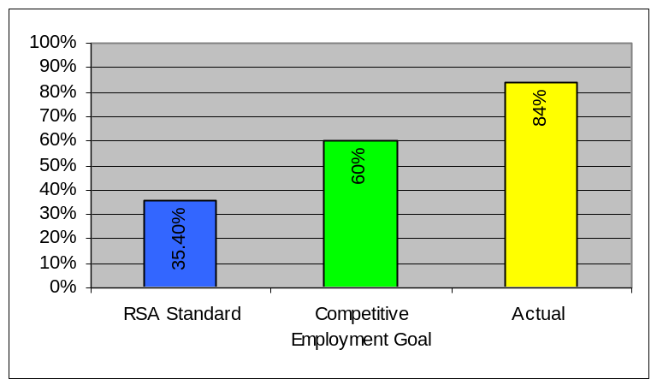  The above graph shows competitive employment as a percentage of all outcomes.  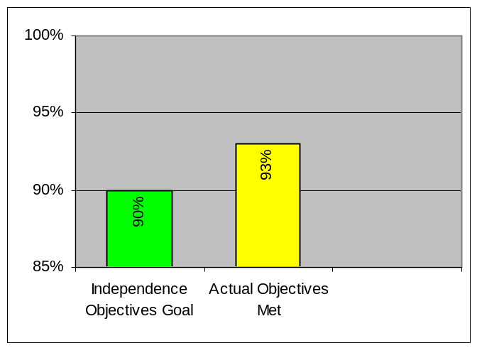  The above graph depicts the goal of objectives met to increase independence vs. actual percentage of objectives met.
Data reliability: The Rehabilitation Services Administration performs independent tests to verify accuracy and identify anomalies.
Why we are using this measure: These measures provide the most up-to-date data and allow for comparisons with required federal standards and other states.
What was achieved: Critical quality services were provided efficiently to blind Iowa citizens. Services were provided to Iowa employers to assist them in hiring and promoting qualified blind individuals. All target measures were exceeded; all Rehabilitation Services Administration (RSA) standards were exceeded.
Analysis of results: The quality of jobs achieved by blind Iowans and the work done by staff was spectacular in light the soft labor market, increased service demands, and budget limitations. A number of individuals served also have secondary disabilities.
Factors affecting results: Public and employer education is having positive results, yet a great deal needs to be achieved. The soft labor market made client job placement more demanding. Quality client services assisted clients to receive training, become more employable, and to become successfully employed. Limitation of the necessary number of qualified, trained professional and support staff have made the rehabilitation process particularly demanding. The large growth in the numbers of older Iowans with vision limitations needs more staffing. This is a vital investment in helping them to remain independent and not require residential/nursing home care.

Resources used: $6,829,254.

ACTIVITIES, SERVICES, AND PRODUCTS

Name: Vocational Rehabilitation

Description: Achieve a quantity and quality of employment outcomes for blind Iowans consistent with the standards set by the federal Rehabilitation Services Administration.

Why we are doing this: These services enable blind individuals to develop the confidence and skills to meet Iowa employer needs and job demands. Individuals develop the pride of achievement and self-sufficiency. They become an effective, contributing part of Iowa and become a part of their communities and not apart from the community.

What we’re doing to achieve results: The Department provides necessary services for Iowans who are blind to live independently and work competitively. The Vocational Rehabilitation (VR) services assist Iowans who are blind in preparing for, obtaining, and retaining employment. The highly trained VR Counselor and blind individual identify a vocational goal and the services needed to achieve the goal. This can involve assessment and evaluation of persons needs, skills and resources so that they can make an informed choice. Individuals often need training to acquire the skills of blindness and vocational training or post-secondary education. Job seeking skills are stressed and a job search plan is developed involving the client and counselor. The highly trained VR Counselors help the individual write a resume, practice interviewing, and locate job-search and placement resources. Job-site assessment and procurement of appropriate assistive technology devices and training in the use of adapted equipment is provided where necessary. Follow-up services after job placement can be critical to both the blind employee and the employer to insure that the individual is successful and the employer is satisfied with the reliability, productivity, reliability, and profitability. The Counselor is a resource to employers and their employees who develop vision problems so that the individual can maintain productivity and keep the job. The agency has a functional Memorandum of Agreement with the One-Stop Centers and other partners to coordinate the various job resources and opportunities and provide technical assistance to them.

Results
Performance Measure:  Number of referrals, number of  VR applications, number of  people accepted for service,  number of IPE’s developed,  number of people receiving VR  training, Percentage of  individuals achieving  competitive employment  outcomes reporting own income  as primary source of support at  closure, Number of individuals  with employment outcomes,  Percentage of individuals with  an Individualized Plan for  Employment (IPE) with  employment outcomes.  Number of student tours  provided, number of students  attending the Orientation Center.  Performance Target:  Develop baseline data in 2004  Data Sources:  IDB client data system  RSA client data system | 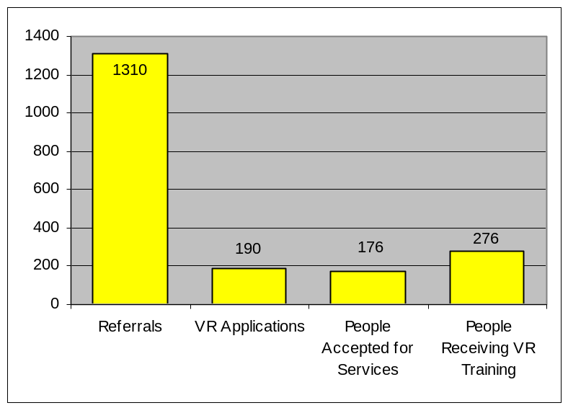  The above graph shows the number of referrals, vr applications,  people accepted for services, and people receiving vr training.  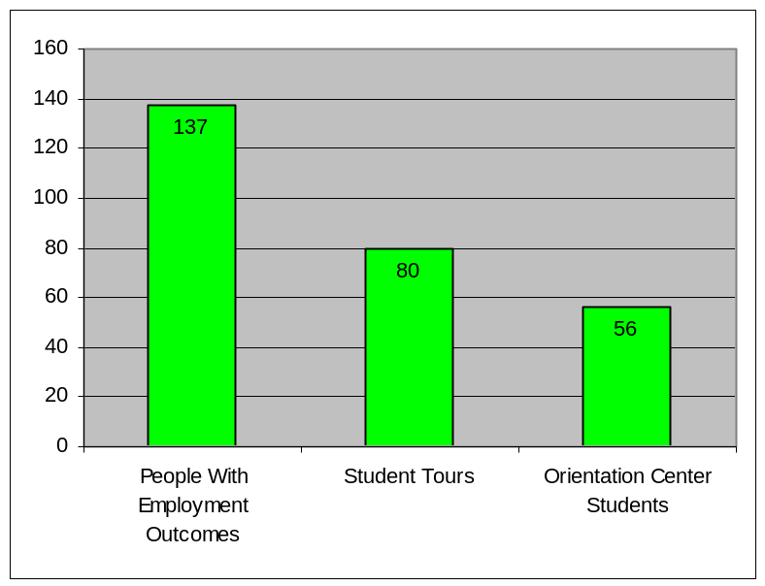  The above graph shows the number of people with employment outcomes, student tours, and students attending the orientation center.  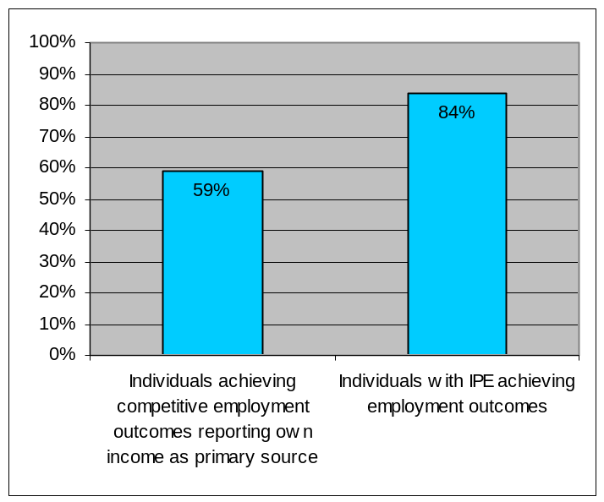 The above graph show the percentage of individuals reporting own income as primary source and individuals  with IPE’s achieving employment outcomes.

Data reliability: The Rehabilitation Services Administration performs independent tests to verify accuracy and identify anomalies.
Why we are using this measure: This allows evaluation of the quality of services, the success of blind individuals, and the effectiveness and efficiency of the service delivery system.
What was achieved: Quality rehabilitation services to blind individuals in Iowa while facing a soft Iowa labor market, limited budget and staff. Iowa employers were provided with qualified blind job applicants who exhibit competitive performance, productivity, reliability, and profitability. Employers received vital support services including screened, job-ready applicants; assistance with access issues, task analysis, job accommodation, supervisory training if needed, follow-up services after placement, assistance with awareness and diversity orientation and information needed information on the Americans with Disabilities Act compliance. Counseling and referral for employees who developed vision problems or accessibility problems with their job was provided.
Analysis of results: Most service standards were met or exceeded. However, the number of individuals served could increase with sufficient budget and staffing.
Factors affecting results: The effective work of highly trained Rehabilitation Counselors and Teachers is evident. The soft Iowa labor market and the need to market effectively to employers continue to be major challenges. We have assigned two VR Counselors to work more intensely with job placement. Client and employer need for technology resources and training is an increasing demand to make clients competitive and to assist clients succeed on the job. The transition program will be bringing more young blind clients in need of VR services, specialized training in attitude and blind skills and post-secondary education. Post high school training and education are extremely important and with the tuition increases and increases in the costs of other purchased services, this is a significant challenge. More trained professionals and support staff are needed to provide timely referral contact and concentrated case services.
Resources used: $5,915,424.

ACTIVITIES, SERVICES, AND PRODUCTS

Name: Assistive Technology

Description: Provide support and training in the use of assistive technology for consumers.

Why we are doing this: To enable blind Iowans to use technology in the workforce to maximize their productivity and their ability to compete with others on a basis of equality. Assistive technology increases personal independence and productivity and, when properly integrated into existing information technology infrastructures, facilitates employment and taxpaying potential for the blind.

What we're doing to achieve results: Conducting statewide technology seminars on non-visual access technology topics and disseminating recordings of those seminars to all interested persons. Providing training in the use of assistive technology to individual blind persons, including online training to receive certification as a Microsoft Office Specialist. Providing over-the-phone and on-site technical support to keep assistive technology functioning in employment situations. Offering non-visual access technology training to corporate information technology personnel to make it possible for this support to be conducted at the worksite. Developing and distributing tutorials in non-visual formats that enable blind computer users to teach assistive technology to themselves.

Results
Performance Measure:  Number of skills assessments,  worksite visits, training units,  technical training, contacts for  technical support  Performance Target:  Developing baseline date in  2004  Data Sources:  Electronic client data system,  program , and product  monitoring. | 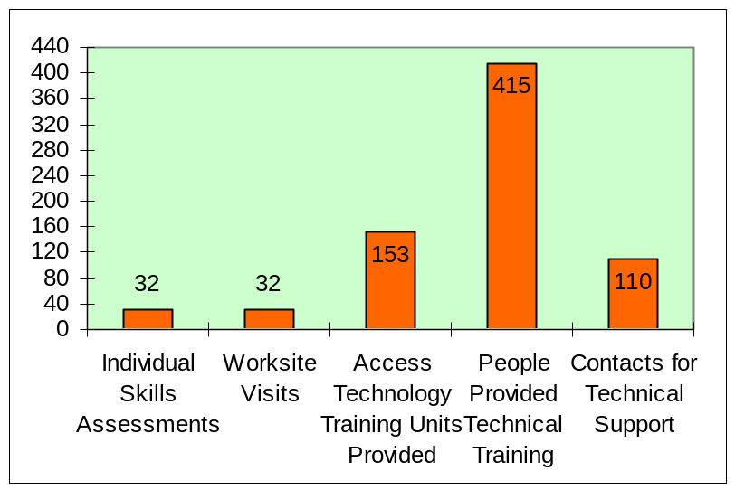  The above graph shows the number of skills assessments,  worksite visits, training units, technical training, and contacts for technical support
Data reliability: The Rehabilitation Services Administration performs independent tests to verify accuracy and identify anomalies.
Why we are using this measure: We’re doing this to meet the educational and employment needs of blind Iowans and the needs of Iowa employers.
What was achieved: Developing tutorials for persons whose only access to the computer relies on refreshable Braille. Typically, this is a person who is deaf-blind. Providing technical training in Microsoft Office Specialist certification using a distance learning approach, thereby maximizing the number of people who can profit from such training while minimizing the cost. Designing and conducting statewide seminars in non-visual access technology to alleviate the need for one-on-one training.
Analysis of results: As more and more employers incorporate information technology into available jobs, the need to integrate non-visual access technology into worksites is growing at a significant rate. As we achieve success in terms of placing blind people into competitive jobs (most of which demand the use of information technology), the demand on our technical resources continues to increase as worksites change their IT infrastructures to keep pace with the competitive market.
Factors affecting results: The soft labor market and increasing technology needs for students in training, blind Iowans newly hired, and effective blind employees who require services to maintain their jobs and to advance with job opportunities continue to demand increased assistive technology. The effective results point to the continuing challenges.
Resources used: $458,105

ACTIVITIES, SERVICES, AND PRODUCTS

Name: Independent Living

Description: Provide skills training and related independent living services.

Why we are doing this: These services enable individuals to develop the skills and confidence needed to postpone or avoid costly institutional supports and prolong the time they are able to continue as independent and contributing members of Iowa’s society.

What we're doing to achieve results: The Department has traditionally provided Independent Living services on an outreach basis through a home training program. Under this model individuals received training on a one-to-one basis. This allowed for maximum individualization of training, but it provided limited opportunity for positive peer interaction. Furthermore, as the number of referrals increased it became difficult to provide a meaningful level of teacher contact, and the amount of time between teacher visits/lessons increased. To address this growing demand for training without an accompanying increase in staff and resources, a new training model has been implemented to complement the home training approach. Specifically, small group training sessions have been conducted in a number of communities throughout Iowa. The training format has been designed to maximize flexibility in order to best meet the needs of each individual group. For instance, sessions may be attended by as few as four or as many as 14 individuals. Some sessions run approximately two and a half days, and others may run three to four days. However, while the format may vary, course content and training approach are consistent from group to group.

Results
Performance Measure:  - Number skill units provided  - Number individuals receiving training  - Number individuals participating in a self-help group  - Number group training sessions provided  - Number of in-service training sessions provided  Performance Target:  Developing Baseline data  In 2004  Data Sources:  IDB Client Data System  RSA Client Data System | 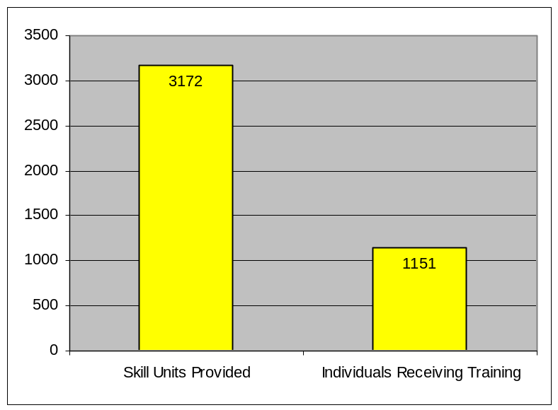  The above chart shows 3172 skill units provided and 1151 individuals receiving training.  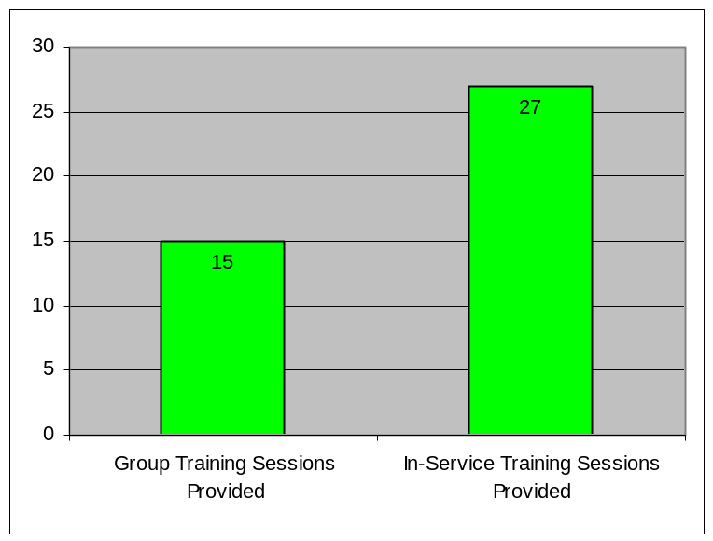  The above chart show 15 group sessions and 27 in-service training sessions provided.
Data reliability: The Rehabilitation Services Administration performs independent tests to verify accuracy, identify anomalies, reasonableness of data.
Why we are using this measure: As a result of services provided older Iowans who became blind or visually impaired were able to remain in their own homes with minor life style changes and avoid moves to more costly settings such as long-term care or assisted living facilities. Providing group training should result in an increase in the number of skill units provided, which in turn should improve an individual’s level of self-sufficiency and independence in carrying out activities of daily living.
What was achieved: Fifteen group training sessions were held in communities ranging from Dubuque to Sioux City and from Story City to Mount Pleasant. Over 70 individuals (aged 55 to 85 and older) participated in these training opportunities, and over 90% indicated they felt better able to live independently in their homes as a result.
Analysis of results: This approach appears to be successful and will be continued in the future. Unfortunately, limited staffing makes it unlikely that it will be expanded.
Factors affecting results: Group training sessions extending over the course of several days enabled individuals to receive concentrated training and provided opportunity for positive peer interaction. These two elements combined to increase the rate of individual progress over what had been accomplished by relying solely on home training. It should be noted that the vast majority of participants had all been involved in home training prior to attending a group training session. It does take guidance and counseling along with relationship building to encourage and support individuals in making the decision to participate in group training. Consequently it is necessary for teachers to maintain a strong presence in the field and continue their one-on-one contact with individuals who are newly blind. It is a challenge to strike a balance between the demand for one-on-one service and the demand for group opportunities.
Additionally, more needs to be done in the area of outreach to community service providers. Training should be provided on identifying functional losses due to a decrease in vision and when and how to make referrals to the Department. Outreach to service providers is seen as key to helping many older visually impaired Iowans access independent living services. Limited staffing levels in the field make any concerted effort in this regard unlikely.
Resources used: $455,725

CORE FUNCTION

Name: Library Services.

Description: Manages and circulates information in alternative media to blind, visually impaired, physically and reading disabled Iowans who cannot use standard print. Information is included in books, journals, magazines, databases, videos, state and federal documents, web pages, and newspapers.

Why we are doing this: Iowans who cannot read standard print because of disabilities need information to continue their education, acquire and maintain jobs, participate in community, democratic processes, and activities, and maintain a quality of life that includes mental stimulation, knowledge of current issues and events, and enjoyable leisure activities. The library makes all of this possible.

What we're doing to achieve results: Improving public information and outreach to serve more reading-disabled Iowans, upgrading the automated circulation system for more efficiency and better, more customer-centered service, increasing programming, cooperating with newspaper services to make them available to all patrons, producing newsletters to inform patrons of new and existing services, digitizing old Braille to preserve content and reduce space needs, recruiting new Braillists and narrators, upgrading Brailling and recording processes and programs.

Results
Performance Measure: Total  Readership (union of PID).  Performance Target:  6,137 Iowans using services.  Data Sources:  Automated circulation system. | 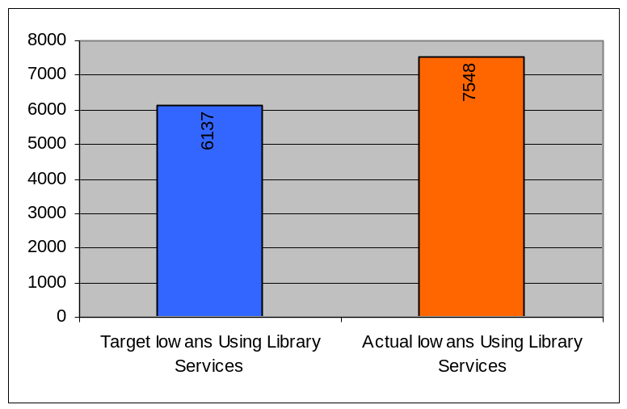  The above graph depicts target vs. actual Iowans using library  services.
Data reliability: Because all patrons are served through the automated system, and all transactions are captured by the system as part of its basic functionality, the resulting data is highly reliable.
Why we are using this measure: These are traditional measures of library service. They are accurately captured by the automated system, and reflect the scope and usage of library services.
What was achieved: 7,548 Iowans who cannot read standard print gathered and used information from books, magazines, educational, job-related, and personal materials to pursue education from kindergarten through advanced post-graduate degrees, acquire and maintain a wide variety of jobs, manage personal affairs (including medical and financial), participate in community activities and in the democratic process, and read for leisure and personal enrichment.
Analysis of results: According to national census statistics, we are reaching only about one in seven Iowans who can benefit from our services. Those we serve are reading at a rate substantially higher than public library borrowers. This is likely due to the fact that we are the sole source of accessible reading material for most of them and that other forms of entertainment and information resources (such as television) are less satisfying to blind and severely visually impaired persons.
Factors affecting results: Need for more space to house Braille and cassette collections and upcoming digital talking book collection. Insufficient staff to carry out critical projects to digitize Braille collection and establish professional-quality digital recording program. Continuing need to educate consumers in use of automated resources. Need to recruit and train Braillists able to do math, music and tactile drawings. Need for focused public information campaign to reach Iowans who could benefit from our services, including minority populations.
Resources used: $1,658,214

ACTIVITIES, SERVICES, AND PRODUCTS

Name: Circulation of library materials.

Description: Provide information and reader advisor services to patrons in person and
by telephone; circulate books using automated system.

Why we are doing this: Patrons cannot come to the library because they cannot drive. We circulate materials through the mail, and provide customer service via phone, E-mail and similar remote methods to ensure highest quality services to all patrons regardless of location within the state.

What we're doing to achieve results: Improving the automated circulation system to provide more finely-tuned and appropriate customer service; training staff in reference and reader advisor services; making books and magazines of local interest available to patrons; Improving public information and outreach to serve more reading-disabled Iowans; increasing programming; cooperating with newspaper services to make them available to all patrons; producing newsletters to inform patrons of new and existing services; digitizing old Braille to preserve content and reduce space needs.

Results
Performance Measure:  Number of items circulated.  Performance Target:  Circulate 200,000 books, 1200  videos, and 100,000  magazines.  Data Sources:  Automated circulation system. | 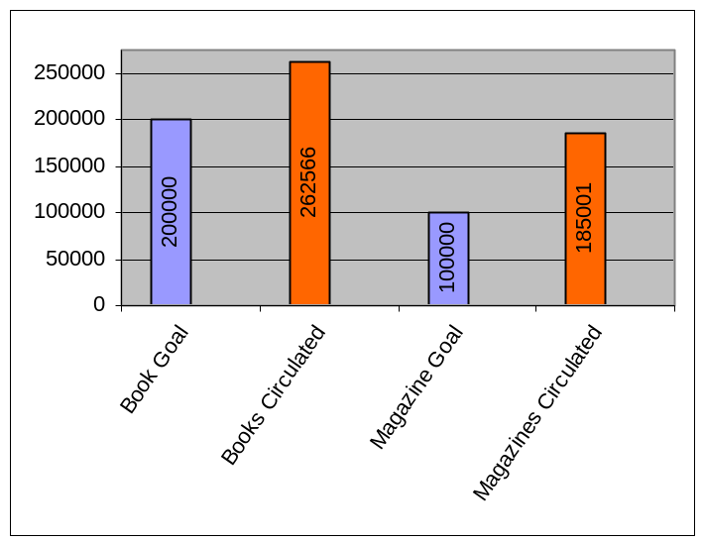  The above graph shows the circulation goals vs. the actual circulation of books and magazines.  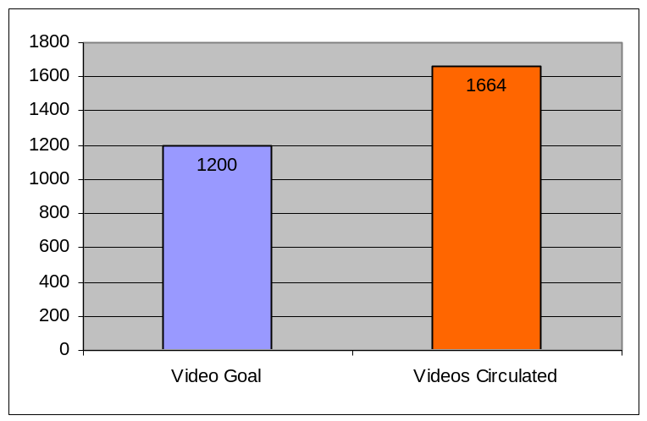  The above graph show the video circulation goal compared to the actual number of videos circulated.
Data reliability: Because all patrons are served through the automated system, and all transactions are captured by the system as part of its basic functionality, the resulting data is highly reliable.

Why we are using this measure: These are traditional measures of library service. They are accurately captured by the automated system, and reflect the scope and usage of library services.

What was achieved: 7,548 Iowans who cannot read standard print gathered and used information from books, magazines, newspapers, educational, job-related, and personal materials to pursue education from kindergarten through advanced post-graduate degrees, acquire and maintain a wide variety of jobs, manage personal affairs (including medical and financial), participate in community activities and in the democratic process, and read for leisure and personal enrichment.
Analysis of results: According to national census statistics, we are reaching only about one in seven Iowans who can benefit from our services. Those we serve are reading at a rate substantially higher than public library borrowers. This is likely due to the fact that we are the sole source of accessible reading material for most of them and that other forms of entertainment and information resources (such as television) are less satisfying to blind and severely visually impaired persons.

Factors affecting results: Need for more space to house Braille and cassette collections and upcoming digital talking book collection. Insufficient staff to carry out critical projects to digitize Braille collection.
Resources used: $761,313

ACTIVITIES, SERVICES, AND PRODUCTS

Name: Instructional Materials Center services.

Description: Work with Iowa schools and Area Education Agency personnel to fulfill requests for students’ textbooks in alternative media. Fulfill requests from college students and employed persons for educational and professional materials in alternative formats.

Why we are doing this: Educational and professional materials are not provided by schools and employers in alternative formats. For students and workers to have these materials, the IMC is an imperative intermediary.

What we're doing to achieve results: Researching nationwide resources to locate existing textbooks; working with volunteers and prison programs to transcribe material which is not already available.

Results
Performance Measure:  Number of educational and  vocational requests filled by the  Instructional Materials Center.  Performance Target: Fulfill  2,000 patron requests for  educational, training,  professional, and personal  materials in alternative formats.  Data Sources: Production  tracking system. | 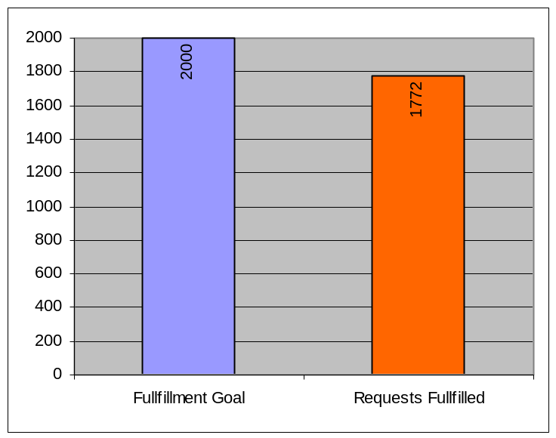  The above graph compares the request fulfillment goal with  actual requests fulfilled.
Data reliability: All requests are tracked through an automated system; data is highly reliable.
Why we are using this measure: It reflects the scope of need for this service.
What was achieved: 1,772 requests for educational and vocational materials were filled, permitting students and workers to have textbooks and work-related materials in a format they can use so they can continue their education and maintain employment.
Analysis of results: All requests were filled, but timeliness could be improved.
Factors affecting results: Need for more resources to Braille math, science, music, and foreign language textbooks; need to meet the growing demand for recorded textbooks in digital format.
Resources used: $461,457

ACTIVITIES, SERVICES, AND PRODUCTS

Name: Production of materials in alternative media.

Description: Transcription of print materials into Braille or other alternative media.

Why we are doing this: Students, employed persons, and other patrons need a wide variety of textbooks, job-related materials, personal information, and other printed items, which are not currently available in alternative format.

What we're doing to achieve results: Coordinating the work of 100 volunteer Braillists and narrators, inmates in four Iowa prisons, and Library staff to transcribe printed materials into alternative formats and produce copies for patrons; upgrading Brailling and recording processes to improve quality and turn-around time.

Results
Performance Measure:  Number of items produced in  alternative media.  Performance Target:  1,000 documents.  Data Sources:  Production tracking system. | 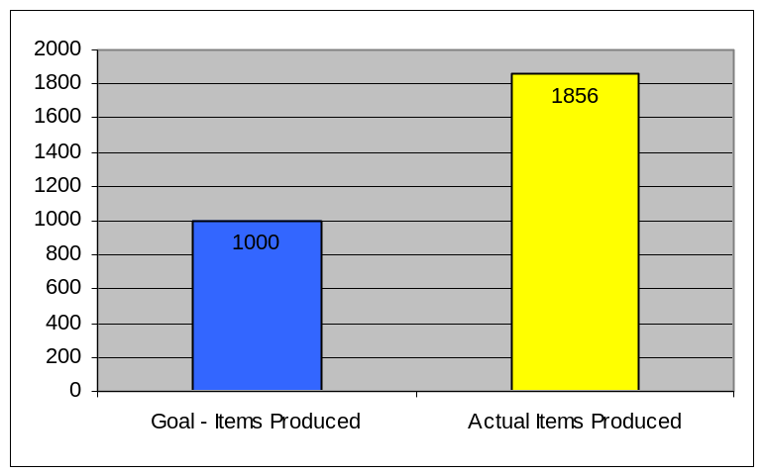The above graph show the production goal compared to the actual number of items produced.
Data reliability: All production is tracked in a Production Tracking System. These figures are drawn from that system and are highly reliable.
Why we are using this measure: This measure demonstrates the scope of the need for production services.
What was achieved: 1,856 items were produced in alternative format and used by students from pre-school through postgraduate to continue their education; employed Iowans were able to read work-related materials (e.g., handbooks, product brochures, memos, etc.) and thus remain competitively employed; reading-disabled Iowans were able to manage personal, medical, and financial affairs independently.

Analysis of results: Timely transcription of complex textbooks such as music, math and physics has not always been possible because of a lack of resources.
Factors affecting results: Insufficient resources to produce specialized Braille formats for music, mathematics, science, and foreign language materials; insufficient resources to convert all recording to digital format, which will dramatically improve both the quality and the usability of materials, especially textbooks.
Resources used: $435,444

CORE FUNCTION

Name: Resource Management.

Description: Provides all vital infrastructure needs necessary to administer and support agency operations. Key activities include financial and personnel services such as payroll, accounting and budget; purchasing of goods and services; media management; information technology enhancement, management and support; staff development; leadership; planning; policy development; maintenance of physical infrastructure and governance system development to achieve results for Iowans.

Why we are doing this: This function supports and supervises the Department’s programs and complies with key federal and state compliance requirements.

What we're doing to achieve results: In general, we exercise management functions necessary for the effective administration of the Department. Specifically, during 2004 this entailed a number of revenue enhancement and cost control efforts and other initiatives to improve services. For example:

EFORCE-Our new case management system has improved access to important client information by eliminating the need for complex software to be run on local and remote computers; all that is required is the standard browser that comes with the Windows operating system. Because the new system also stores narrative information (e.g., case notes), information about a client is much easier to find; in the past, paper files had to be searched laboriously for specific information. Finally, due to some proactive Web page designs, our case management system is much easier for our blind employees to use; with the press of a single key, it is possible to jump rapidly from one section of the page to another; and all elements of the system are completely accessible using non-visual access technology.

INFOEYES is a pilot virtual reference and information community for the visually impaired. The purpose of the pilot is to test the OCLC Question Point Enhanced software for providing information services for the visually impaired. The project includes 12 libraries in ten states. The Iowa Library for the Blind and Physically handicapped is happy to be a part of this project.

ALL IOWA READS is a new project sponsored by the Iowa Center for the Book. Its goal is to bring people together to read and discuss both the chosen book and the many themes and ideas generated by that discussion. Our library was one of over 100 Iowa organizations participating in this first year's project.

CAREER RESOURCE CENTER is another tool for use by Field Operations, Orientation and the Library. Vocational rehabilitation clients, orientation students, and other library users will find career related materials such as resume writing guides, job search strategies, and interviewing techniques in a wide-variety of formats and levels all in one convenient place. In addition, the Center offers Internet access, scanner, CCTV, facsimile, and printer. Internet resources are bookmarked for career related sites. Refreshable Braille display, JAWS, WindowEyes, Duxbury for Windows, Victor ReaderSoft, and the latest Adobe Acrobat are all available. The purpose of the Center is to help students and clients find a career of their choice and help them find successful employment.

PRISON BRAILLE PROGRAM-For years the default method for creating tactile drawings was the collage method. Using string, cut-out paper, sandpaper, even dental floss, participants in Iowa's prison Braille program create maps, diagrams, math figures, and drawings of all sorts to illustrate history, science, math, geography and other textbooks for blind students. With the aid of a Tactile Image Enhancer and swell paper, Braillists at the Anamosa State Penitentiary are experimenting with a new technique for creating these drawings. Using computer-drawing tools they created images, which are then printed onto swell paper. The swell paper is run through the Tactile Image Enhancer and creates a tactile duplicate of the print image. Their first project was a book on the history of architecture, which contained line drawings of everything from the pyramids to modern skyscrapers. The results are precise, clean and very usable. The files can be stored easily on computers and reprinted upon demand. This may prove to be an excellent method for producing drawings for textbooks in the future and reduce the extent to which we rely on out-of-state suppliers of this resource.

INSTRUCTIONAL MATERIALS CENTER, which serves approximately 500 students and employed persons, has been gradually phasing out paper records and outdated processes over the past several years. However, a change of staff is anticipated within the next year due to retirements. We plan to review all processes handled by this area, revise procedures to be more streamlined and to more fully utilize electronic resources, and train new staff in the revised processes. The result will be more efficient service delivery and more time for direct customer service in this area.

TRANSITION AND PATHFINDERS-This effort will match young adults ages 16 to 26 with successful, competent, and positive mentors who are blind or severely visually impaired. Through a series of workshops and other informational materials, these mentors and the young people with whom they are matched will learn about self-advocacy, blindness skills, the development of self-confidence, and career exploration. Young people participating in this program will have the opportunity to spend quality time with a mentor who can help deal with questions and concerns, talk about problems encountered because of vision loss and learn effective techniques for going to school, doing a job, or accomplishing everyday tasks. Mentors will also be able to offer advice on career exploration and self-advocacy.
We have developed training packets for each of our five workshops that will be held as our program begins, as well as a toolbox of information regarding the workshops for our mentors and participants to have and use. We are recruiting for this program.

BUSINESS ENTERPRISE PROGRAM-We have entered into a contract with Joe Blackstone Consulting. Some of our traditional business opportunities--federal properties, state locations and other local governmental entities--are no longer profitable. We are working with Mr. Blackstone to find and develop new and varied business locations, including some outside Iowa in the national park system and military facilities. Our interstate rest area vending program continues to be stable but we must supplement this with new and different businesses. We are working to reinvent the Randolph-Sheppard Program to meet current challenges and opportunities.

PROJECT ASSIST ONLINE offers online courses to prepare students for the Microsoft Office Specialist certification exams. We have completed a pilot program with students from Iowa. Students use the Internet to do their course work. During the summer we made improvements to the courses and recruited students.

The Project ASSIST Deaf-Blind staff has been finishing their first series of tutorials. These tutorials, which will be ready for release in the near future, use keyboard commands and screen reading software, in conjunction with a refreshable Braille display, to teach deaf-blind computer users how to use Microsoft Windows XP and other popular Microsoft applications. The tutorials feature step-by-step, specific instructions tailored to each individual combination of screen reader, Braille display and Microsoft application.

The first set of tutorials focuses on Windows XP in conjunction with JAWS for Windows and five different Braille displays. Future plans include tutorials for a word processor, a Web browser, an e-mail program and a computer-based TTY program, as well as tutorials using Window-Eyes as the screen reader. The project staff has done extensive research on the best techniques and strategies to be taught in these tutorials and are anxious to apply the lessons learned to future sets of tutorials.

Results
Performance Measures:  - Number of reportable comments in the annual audit.  - Number of compliance issues raised by federal agency during monitoring visit.  Performance Targets:  - No reportable comments in the annual audit pertaining to the Department.  - No compliance issues raised by federal agencies.  Data Sources:  The annual audit report  published by the Auditor  of State and the  monitoring report  published by the U.S.  Rehabilitation Services  Administration. | The annual audit report released on April 7, 2004 contained no comments related to the Department’s operations, compliance with the Code of Iowa or federal regulations. The annual monitoring review by the Rehabilitation Services Administration indicated the Department met or exceeded five of six federal performance standards. As noted in the RSA Annual Monitoring Review, "IDB has fully complied with applicable federal guidelines and regulations. IDB continues to demonstrate exceptional performance in submitting timely and accurate fiscal and statistical reports via the  SF-269, Financial Status Reports, and RSA-2, Annual Vocational Rehabilitation Program Cost Report. Their repeated absence of revising final SF-269 and RSA-2 reports is a testament to this exceptional performance." The lone issue cited for correction by the report suggests development of an agreement that will provide guidance to universities regarding vocational rehabilitation services.
Data reliability: Since the reports cited above are compiled by independent, objective agencies, the data in them should be regarded as reliable.
Why we are using this measure: These measures are indicative of how well the Department’s programs are administered in compliance with authorizing legislation as reported by knowledgeable, unbiased, disinterested parties.
What was achieved: The Department has achieved national prominence in performance standards most significant to the Rehabilitation Services Administration and to Iowans, namely the wages earned by those who go to work after receiving services from the Department for the Blind.
Analysis of results: The results as reported above (and elsewhere in this report) offer reasonable assurance that in all material respects the Department’s operations are competently administered.
Factors affecting results: An adequate, well-trained staff and appropriations that enable leveraging other sources of funds, satisfy matching requirements, and meet maintenance of effort requirements found in federal law.
Resources used: $1,015,905

ACTIVITIES, SERVICES, AND PRODUCTS

Name: Department administrative services.

Description: Financial and personnel services such as payroll, accounting and budget; purchasing of goods and services; media management; information technology enhancement, management and support; staff development; leadership; planning; policy development; maintenance of physical infrastructure and governance system; general department administration.

Why we are doing this: This function supports and supervises the overall work of the Department.

What we're doing to achieve results:
- The Department has closed unprofitable cafeteria operations in Des Moines at the federal building and at 524 4th Street. More similar changes are likely.
- We no longer print the biennial report required by 216B.7, Code of Iowa. This report is now posted to the web.
- We cancelled a contract with a private company engaged to produce an automated vocational rehabilitation case management system, saving approximately $ 50,000.
- The remodeling of the orientation center was deferred because of bids that were much higher than even our architect anticipated. For 2005 we re-bid the project in hopes of doing the work during the winter for the express purpose of getting it done less expensively. Bids were due October 12, 2004 and work has now commenced.
- We maintained staff vacancies last fiscal year worth $ 283,000.
- We apply for, and receive, E-rate discounts on telephone and internet access costs, amounting to a savings of $ 69,235 last year. We will do this again in 2005 and in 2006.
- In prior recent years we negotiated a contract with the independent living centers with an annual value of $ 170,000 for the purpose of increasing referrals and outreach to underserved populations. Last year the contract amounted to a maximum of $ 55,014 and required the contractor to meet certain specified performance measures. They did not meet all of the measures and we paid only $ 34,155 because they met some, but not all, of our expectations. It is unlikely this contract will exist at all this year or in 2006.
- We have recently renegotiated the lease on the Cedar Rapids district office at a savings.
- We have cancelled the service agreements on the office copy machines.
- We have cancelled the service agreements on the Juliet Braille printers.
- Recently, colleges and universities have shown some tendency to renege on their financial aid packages when they learn we are authorizing costs for the students. We recouped $ 13,000 last year.
- In April we renegotiated the agreement for rented space on 4th Street in Des Moines at a 50 % savings.
- We are moving documents, forms, and reports to electronic media vs. paper at a savings conservatively estimated at $ 21,440 so far. This number will improve.
- We are attempting to consolidate purchases from vendors so that they are large enough to avoid additional shipping costs.
- We have eliminated the subsidy pertaining to the operation of the cafeteria in the building, which has been converted to vending.
- We are currently reviewing vendor payment data to determine opportunities for better pricing.
- We are reviewing other opportunities as they arise, including those which would represent new sources of revenue, especially for new initiatives.

Results
Performance Measures:  - Percent of compliance with pre-audit regulations as measured by post-audit sampling by Department of Administrative Services.  - Percent of compliance with Accountable Government Act.  Performance Targets:  - 100 % compliance with pre-audit regulations.  - 100 % compliance with Accountable Government Act.  Data Sources:  - Letters from Department of Revenue and Finance and from the Department of Administrative services.  - Accountable Government Act documents developed and submitted by the Department for the Blind. | The Department achieved 100 % compliance with the Accountable Government Act. The chart below indicates compliance with pre-audit regulations for recent years.  - 94.72 %  - 96.60 %  - 95.54 %  - 96.21 %  - 96.52%  - 100.00%
Data reliability: The reliability of the data with regard to pre-audit compliance is a matter of the sampling techniques, sample size, etc., used by the Department of Revenue and Finance (beginning in 2004, the Department of Administrative Services) in determining the percentage of compliance with regulations. The Department for the Blind has no influence on these auditing procedures, and their results reflect only on the Department’s compliance with financial management policies of state government and not on the performance of other administrative tasks or functions.
The Department’s compliance with the Accountable Government Act is evidenced by the preparation, existence, and use of documents called for by the Act, i.e., strategic plan, performance plan, performance report, etc.
Why we are using this measure: These measures are used because the Department’s compliance with the related requirements is a verifiable matter of law and policy.
What was achieved: The Department has successfully implemented the requirements of the Accountable Government Act.
Analysis of results: The results indicate the Department’s diligence in observing the requirements of state government’s financial management policies generally and its integrity in processing accurate, timely transactions.
Factors affecting results: Competent, well-trained personnel are essential to the performance of these functions. Notwithstanding, the implementation of the I/3 accounting system on June 1, 2004, negatively affected the Department’s ability to maintain a current account status with its vendors, although this influence was temporary and for the most part occurred during the first two months of fiscal year 2005. This difficulty was largely overcome by October 1, 2004.
Resources used: $ 977,007.

ACTIVITIES, SERVICES, AND PRODUCTS

Name: Inbound call management.

Description: This function receives calls at the central switchboard and routs callers to the correct staff member.

Why we are doing this: Callers who may have multiple needs for services from the Department do not need to dial more than one telephone number in order for their issues to be addressed.

What we're doing to achieve results: New switchboard operators are trained frequently so that this function can be staffed at all times during business hours and the extent to which callers reach voice mail can be minimized. Automated messages can be taken overnight and on weekends when staff are not available.

Results
Performance Measure:  Percentage of calls  resulting in complaints.  Performance Target:  Zero complaints.  Data Sources:  Volume of calls- ICN  records.  Complaints – calls to  switchboard supervisor. | 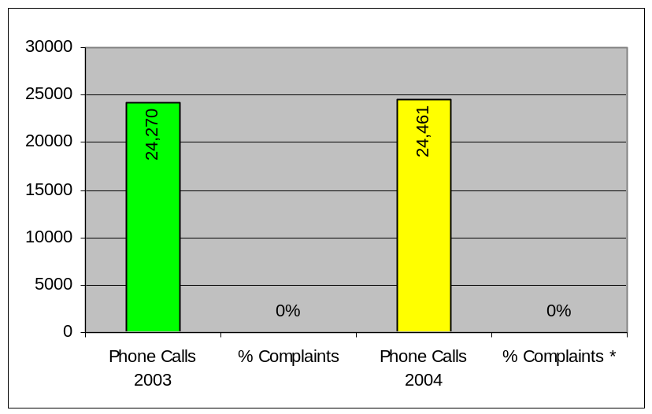  *Actual number of complaints in 2004 was 5. The above  graph shows the number of phone calls vs. the percentage of complaints for both 2003 and 2004
Data reliability: Information on the number of calls received is tracked by, and received from, the Iowa Communications Network. This data is believed to be highly reliable. This data reflects only inbound call traffic received at the switchboard, not all inbound calls received by the Department for the Blind at all telephone extensions. The number of complaints reflects those actually received by the switchboard function’s supervisor. Several Department employees participate in staffing the receipt of inbound calls.
Why we are using this measure: Because of an emphasis on customer service, the Department maintains standards on the prompt handling of calls and other forms of communication. Therefore, it is important that calls be routed correctly and promptly.
What was achieved: What we achieve with this function is quick attention to the needs of the clients we serve.
Analysis of results: The annual number of inbound calls is relatively stable and, due to the training efforts we undertake to maintain the staffing for this function, we have been able to maintain a high level of satisfaction with its effectiveness.
Factors affecting results: Staff training and their familiarity with the Department’s programs and services will influence the correct routing of calls.
Resources used: $ 38,898.

AGENCY CONTACTS

This report is also available at www.blind.state.ia.us. Copies of the report can also be obtained by contacting Bruce K. Snethen at 515-281-1293.

Iowa Department for the Blind
524 Fourth Street
Des Moines, Iowa 50309

515-281-1333 or 800-362-2587
TTY: 515-281-1355
facsimile 515-281-1263

www.blind.state.ia.us

