NEWS RELEASE | For Statewide Distribution

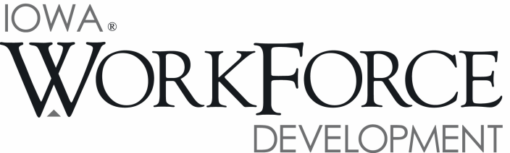
For Release: 9:00 a.m.  Date: September 15, 2017 | Contact: Cory Kelly (515) 330-5646
Iowa’s Unemployment Rate Increases Slightly to 3.3 Percent in August

DES MOINES, IOWA – Iowa’s seasonally adjusted unemployment rate increased slightly to 3.3 percent for August. The state’s jobless rate was 3.7 percent one year ago. The U.S. unemployment rate rose to 4.4 percent in August.

“The economy showed some minor improvements in August,” said Beth Townsend, Iowa Workforce Development Director. “Iowa businesses have steadily added jobs since April and advanced by 2,300 jobs this month with job gains continuing in healthcare, trade, and other services and the labor force participation rate remained at 68.4%.”

The number of unemployed Iowans increased to 55,200 in August. The current estimate is 7,800 lower than the year ago level of 63,000.

The total number of working Iowans decreased to 1,627,800 in August. This figure was 300 lower than July and 9,000 lower than one year ago.

Seasonally Adjusted Nonfarm Employment

August marked the fourth-consecutive gain for total nonfarm employment for the State of Iowa. The monthly increase of 2,300 jobs lifted the total to 1,590,100 jobs. Goods-producing industries were sluggish in August, paring 1,000 jobs. Conversely, service sectors gained 3,300 jobs. In total, five private super sectors lost employment this month versus four that gained employment. Government was unchanged this month with declines at the local and federal levels exactly offsetting the state government gains. Compared to last August, government is down 2,000 jobs due to local government losses.

The education and health services sector added the most jobs in August (+2,500) and was fueled by growth in healthcare and social assistance (+1,900). This month’s gain marks the ninth-straight gain for this super sector. Healthcare and social assistance alone has been responsible for a majority of this job growth. Elsewhere, retail trade expanded again this month (+800) leading to a gain of 1,600 jobs in trade, transportation and utilities. Transportation and warehousing also fared well in August and was up 700 jobs. Other gains this month were seen in other services (+1,300) and professional and business services (+1,000). Losses this month were largest in leisure and hospitality (-1,500) with declines nearly equal in both arts and entertainment (-800) and accommodations and food services (-700). Financial activities posted the first sector loss since last August (-1,300). Finance and insurance industries were responsible for most of the drop (-1,100), although real estate and rental activities shed 200 jobs. Construction has also trended down following record highs last year (-900). This month’s loss marks the fifth-straight decline for this industry.

Annually, nonfarm employment remains up 17,200 jobs. Healthcare and social assistance has been responsible for much of the growth with 9,300 jobs added, more than offsetting the small drop in the partner sector of educational services. Trade, transportation and utilities have gained 5,400 jobs due to expansion in wholesale trade and transportation and warehousing. Aside from information services (-1,500), annual losses have been limited to construction industries (-5,900) which are partly due to the completion of large-scale projects ending over the past twelve months. The preliminary August mark compares closely to the State’s 2014 level before the construction boom began.

Visit www.iowalmi.gov for more information about current and historical data, labor force data, nonfarm employment, hours and earnings, and jobless benefits by county.

###

An Equal Opportunity Employer/Program
Auxiliary aids and services are available upon request for individuals with disabilities.
www.iowaworkforcedevelopment.gov• www.iowajobs.org
MEDIA ALERT: An audio cut of comments about Iowa’s labor market situation is available by calling
(515) 281-6057. Statewide data for September 2017 will be released on Friday, October 20, 2017. Local data for September will be posted to the IWD website on Tuesday, October 24, 2017.

