NEWS RELEASE | For Statewide Distribution

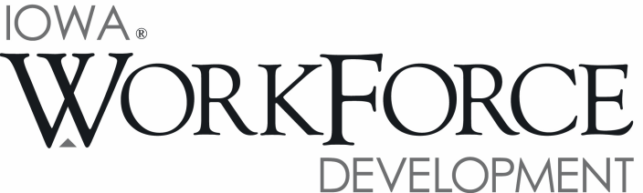
For Release: 9:00 a.m.  Date: April 21, 2017 | Contact: Cory Kelly (515) 330-5646
Iowa’s Unemployment Rate Decreases Slightly to 3.1 Percent

DES MOINES, IOWA – Iowa’s seasonally adjusted unemployment rate decreased slightly to 3.1 percent in March. The state’s jobless rate was 3.8 percent one year ago. The U.S. unemployment rate dropped to 4.5 percent in March.

“Unemployed Iowans continued to leave the labor force in March,” said Beth Townsend, Iowa Workforce Development Director. “The reduction in Iowa's total labor force represents a smaller pool of qualified applicants and is making it difficult for businesses to fill positions. Total nonfarm employment showed little hiring among Iowa businesses this month resulting in a net decline in jobs.”

The number of unemployed Iowans decreased to 51,900 in March from 53,800 in February. The current estimate is 12,100 lower than the year ago level of 64,000.

The total number of working Iowans increased to 1,640,200 in March. This figure was 500 higher than February and 2,900 higher than one year ago.

Seasonally Adjusted Nonfarm Employment

Iowa businesses pared jobs for the first time since November, lowering total nonfarm employment down to 1,580,600 jobs. This month’s decline was small in magnitude (-500), and generally due to losses in the private services sector. Government also contributed to this month’s drop with 500 jobs lost this month. Public sectors now lag behind last year’s mark by 700 jobs, whereas the state combined is up 8,100 jobs versus last March.

Within private sectors, leisure and hospitality posted the largest decline this month (-2,000). All of the losses in this sector this month were posted in arts, entertainment, and recreation. Accommodations and food services were unchanged since February. Most other sector declines this month were minor and included losses of 200 jobs in trade, transportation, and warehousing. This sector was hampered by larger than expected cutbacks in retail trade. Information services and professional and business services each shed 100 jobs in March. Job gains were led by construction (+1,100). This sector has added 2,700 jobs since January. Education and health services increased this month (+700) and have added jobs for four-consecutive months. Several sectors experienced incremental gains including manufacturing, finance, mining, and other services.

Annually, six of the ten private sectors have added jobs, led by professional and business services (+4,400). These gains have been fueled by increased staffing in administrative support and waste management services (+2,700). Education and health services have advanced steadily (+3,500), and finance has added jobs consistently since August and is up 3,100 jobs. Alternatively, losses continue to be led by manufacturing (-3,600) and primarily the result of cutbacks in durable goods factories (-3,100). Construction regressed slightly from last year’s historic highs and actually trails last year’s mark (-2,000). Information continues to reorganize and streamline services and is down 1,300 jobs versus one year ago.

Visit www.iowalmi.gov for more information about current and historical data, labor force data, nonfarm employment, hours and earnings, and jobless benefits by county.

###

An Equal Opportunity Employer/Program
Auxiliary aids and services are available upon request for individuals with disabilities.
www.iowaworkforcedevelopment.gov• www.iowajobs.org
MEDIA ALERT: An audio cut of comments about Iowa’s labor market situation is available by calling
(515) 281-6057. Statewide data for April 2017 will be released on Friday, May 19, 2017. Local data for April will be posted to the IWD website on Tuesday, May 23, 2017.

