NEWS RELEASE | For Statewide Distribution

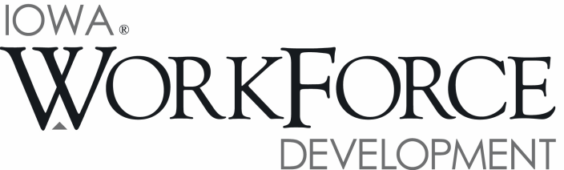
For Release: 9:00 a.m.  Date: August 19, 2016 | Contact: Courtney Maxwell Greene (515) 281-9646
Iowa’s Unemployment Rate Increases Slightly to 4.1 Percent in July

DES MOINES, IOWA – Iowa’s seasonally adjusted unemployment rate increased slightly to 4.1 percent in July from 4.0 percent in June. The state’s jobless rate was 3.6 percent one year ago. The U.S. unemployment rate remained at 4.9 percent in July.

“Iowa’s economy revealed both strength and weakness in July,” said Beth Townsend, Director of Iowa Workforce Development. “Even as the state’s unemployment rate crept up a tenth of a point to 4.1 percent, Iowa businesses still showed enough confidence to expand payrolls this month. Hiring in health care and professional and business services was particularly strong.”

The number of unemployed Iowans rose to 70,600 in July from 68,200 in June. The current estimate is 9,000 higher than the year ago level of 61,600.

The total number of working Iowans decreased to 1,640,500 in July. This figure was 2,300 lower than June and 3,200 higher than one year ago.

Seasonally Adjusted Nonfarm Employment

Total nonfarm employment in Iowa added 3,400 jobs in July and now rests at 1,584,700. This is the second-consecutive gain for the establishment survey and the fifth for 2016. Monthly declines occurred only twice so far in 2016, in February and May. Service industries added all of the jobs this month; goods-producing sectors shed 200 jobs. State government added 700 jobs, although this segment of government trails last year’s level by 600 jobs. Combined, government is up 4,200 jobs due to hiring at the local level.

Education and health care added 1,700 jobs to lead all sectors. Health care alone added 1,200 jobs due mostly to hiring in ambulatory health care services, which includes dental offices and clinics. Education services also advanced this month, erasing a slight decline last month of 200 jobs. Professional and business services snapped a two-month decline by adding 1,500 jobs in July. Gains this month were mostly focused in professional, scientific, and technical services. Administrative support and waste management pared jobs for the third-consecutive month (-400). The other services sector gained jobs for the second straight month (1,100) and has rebounded following four consecutive declines from February through May. Sector losses were limited to leisure and hospitality (-600), trade and transportation (-600), manufacturing (-400), and financial activities
(-300).

Compared to last July, total nonfarm employment remains up 23,700 jobs. Construction continues to sustain job growth in Iowa and is up 12,800 jobs alone. Education and health care also remains markedly up (+4,800) due to unwavering, inelastic demand for these essential services. Other annual gains included leisure and hospitality (+4,700), other services (+4,100), and financial activities (+2,900). Losses continue to plague the manufacturing sector (-7,100) which has lost more jobs than all other super sectors combined. Professional and business services has also pared jobs related to cutbacks (-1,900), and information services continues to trend down due to streamlining processes and reduced demand for print media (-1,200).

Visit www.iowaworkforcedevelopment.gov/labor-market-information-division for more information about current and historical data, labor force data, nonfarm employment, hours and earnings, and jobless benefits by county.

An Equal Opportunity Employer/Program
Auxiliary aids and services are available upon request for individuals with disabilities.
www.iowaworkforcedevelopment.gov• www.iowaworks.org • www.iowajobs.org

MEDIA ALERT: An audio cut of comments about Iowa’s labor market situation is available by calling
(515) 281-6057. Statewide and local data for August 2016 will be released on Tuesday, September 20, 2016.

