NEWS RELEASE | For Statewide Distribution

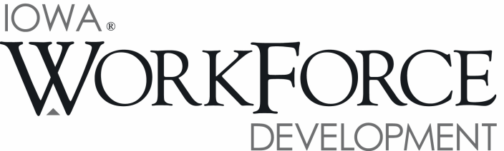
For Release: 9:00 a.m.  Date: July 22, 2016 | Contact: Courtney Maxwell Greene (515) 281-9646
Iowa Economy Gains 5,100 Jobs in June

DES MOINES, IOWA – Iowa’s seasonally adjusted unemployment rate increased slightly to 4.0 percent in June from 3.9 percent in May. The state’s jobless rate was 3.6 percent one year ago. The U.S. unemployment rate rose to 4.9 percent in June compared to 4.7 percent in May.

“Despite the increase in the unemployment rate in June, reaching the highest level since November 2014, Iowa’s businesses added 5,100 jobs last month,” said Beth Townsend, Director of Iowa Workforce Development. “IWD is working hard to develop programs such as doubling the number of Registered Apprenticeships in the next five years to help spur economic growth and close the skills gap. Good paying, secure jobs continue to be available in Iowa.”

The number of unemployed Iowans rose to 68,100 in June from 66,600 in May. The current estimate is 6,300 higher than the year ago level of 61,800.

The total number of working Iowans decreased to 1,642,900 in June. This figure was 1,900 lower than May and 6,300 higher than one year ago.

Seasonally Adjusted Nonfarm Employment

In June, total nonfarm employment expanded by 5,100 and now rests at 1,581,100 jobs total for Iowa. This month’s gain helps to partially offset an unusually large decline of 6,100 jobs in May. Private industry was responsible for nearly all of the movement this month as government added just a slight 100 jobs; however, government is up 3,800 jobs annually due mostly to expansion at the local level (+4,100 jobs or 1.5 percent). When public and private industries are combined, the state is up 21,200 jobs, or 1.4 percent.

Seasonal industries seemed to fare well this month and were led by construction (+2,100). Since 2011, Iowa’s construction industry has generally trended up due to both a positive outlook from businesses and increased demand for housing. These two factors have combined to help this sector grow at a pace far exceeding the state average. Trade and transportation also had a strong gain this month (+1,900) due to expansion in all industries, particularly wholesale trade. Arts and entertainment sectors fueled leisure and hospitality into a larger-than-seasonal increase of 1,700 jobs. Several other sectors added jobs this month including financial activities, education and health services, other services, and information services. Losses were limited to just three sectors this month and were led by professional and business services (-1,500). This sector has generally trended down over the past year as firms and individuals reduce demand for non-essential services to save money. Other losses this month included manufacturing (-600), which has seen just one monthly gain this year.

Annually, construction continues to boost total nonfarm gains and is up 12,200 jobs—an increase of 15.8 percent. The education and health care services sector also remains markedly up (+5,600) due to gains in both sectors, as does leisure and hospitality (+4,900). Four sectors are down compared to last June, with losses being heaviest in Iowa’s manufacturing sector (-7,700). All of the annual loss stems from the durable goods factories; nondurable goods are actually unchanged versus this time one year ago. Professional and business services have pared 3,200 jobs since last June primarily in administrative and support services. The losses may be a sign that firms are starting to forgo unnecessary contract services. Information services remains down 1,600 as labor-intensive businesses are slowly phased out by new technologies.

Visit www.iowaworkforcedevelopment.gov/labor-market-information-division for more information about current and historical data, labor force data, nonfarm employment, hours and earnings, and jobless benefits by county.

An Equal Opportunity Employer/Program
Auxiliary aids and services are available upon request for individuals with disabilities.
www.iowaworkforcedevelopment.gov• www.iowaworks.org • www.iowajobs.org

MEDIA ALERT: An audio cut of comments about Iowa’s labor market situation is available by calling
(515) 281-6057. Statewide data for July will be released on Friday, August 19, 2016. Local data for
July will be posted to the IWD website on Tuesday, August 23, 2016.

