NEWS RELEASE | For Statewide Distribution

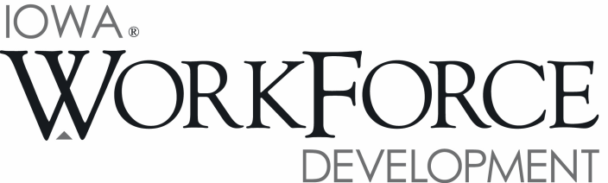
For Release: 9:00 a.m.  Date: April 15, 2016 | Contact: Courtney Maxwell Greene (515) 281-9646
Iowa’s Unemployment Rate Increases to 3.8 Percent in March

DES MOINES, IOWA – Iowa’s seasonally adjusted unemployment rate increased slightly to 3.8 percent in March from 3.7 percent in February. The state’s jobless rate was 3.7 percent one year ago. The U.S. unemployment rate increased to 5.0 percent in March.

“Although a few sectors of Iowa’s economy, such as construction, continue to expand, Iowa’s unemployment rate ticked up in March confirming signs of weakness in other sectors, particularly manufacturing.” said Iowa Workforce Development Director Beth Townsend. "However the good news is, as evidenced by the 54,000 jobs listed on our iowajobs.org website, Iowa employers are still hiring."

The number of unemployed Iowans rose to 65,300 in March from 63,200 in February. The current estimate is 2,400 higher than the year ago level of 62,900.

The total number of working Iowans decreased to 1,649,400 in March. This figure was 1,600 lower than February and 12,100 higher than one year ago.

Seasonally Adjusted Nonfarm Employment

Following a drop last month, Iowa nonfarm employment resumed adding jobs in March. The increase of 1,600 was modest, and generally the result of private industry bolstering employment. Government changed little versus February and hasn’t moved much compared to last March (-100) with state government declines being offset by hiring in local and federal government. With this month’s gain, Iowa nonfarm employment increased to 1,575,400 jobs total—15,300 jobs more than one year ago.

Construction posted the largest single gain this month (+3,600). The gain may partially be the result of firms starting work early this year coupled with the undertaking of new commercial and infrastructure projects. Employment in construction is expected to rise through 2016. Other sectors that added employment this month included trade and transportation, professional and business services, and leisure and hospitality.

Alternatively, the manufacturing sector felt the effects of waning demand this month (-3,000). Job loss was particularly heavy in durable goods factories (-2,400) and partially due to cutbacks within transportation equipment manufacturers. Education and health care shed jobs this month (-800). The loss was mostly centered within health care (-700). Iowa’s finance sector lost jobs for the first time in several months in March; however, the loss (-500) wasn’t severe and this sector remains markedly up compared to one year ago.

Compared to last year, Iowa nonfarm employment continues to trend up, although the pace has started to show signs of slowing down. Construction has been responsible for almost half of the jobs added (+7,500) and is expected to remain strong through the summer. Education and health care has also fared well versus one year ago (+4,600), as is true with trade and transportation (+4,400). The sectors not performing well over the past twelve months include manufacturing (-6,100), information (-1,600), and professional and business services (-1,500).

MEDIA ALERT: An audio cut of comments about Iowa’s labor market situation is available by calling
(515) 281-6057. Statewide data for April will be released on Friday, May 20, 2016. Local data for April will be posted to the IWD website on Wednesday, May 25, 2016.

Visit www.iowaworkforcedevelopment.gov/labor-market-information-division for more information about current and historical data, labor force data, nonfarm employment, hours and earnings, and jobless benefits by county.

An Equal Opportunity Employer/Program
Auxiliary aids and services are available upon request for individuals with disabilities.
www.iowaworkforcedevelopment.gov• www.iowaworks.org • www.iowajobs.org

