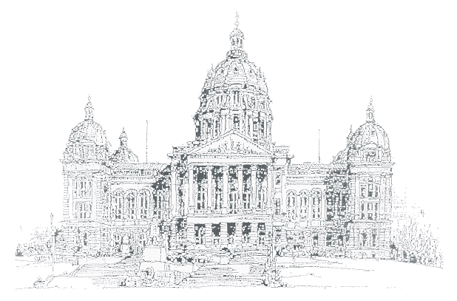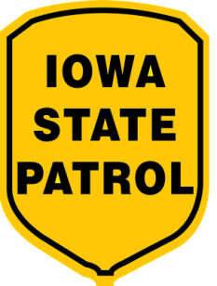

##### Issue II

**April 2004**

Capitol

Connections

|  |  |  |
| --- | --- | --- |
| **Kevin Techau** | A newsletter for State Employees on the Capitol Complex | **Robert Garrison** |
| **Commissioner** | From Iowa State Patrol District 16 | **Colonel** |



**Reminder to Yield to Pedestrians**

District 16 Troopers have been busy enforcing speed zones along Court Avenue in an effort to keep you safe. Many motorists have little or no regard for pedestrians crossing the roadways and this poses a significant risk to those visiting and working on the Capitol Complex. Troopers will continue to patrol main crosswalk areas, especially during peak morning and afternoon hours. If you are caught failing to yield to a pedestrian, it will cost you a total of $62.50.

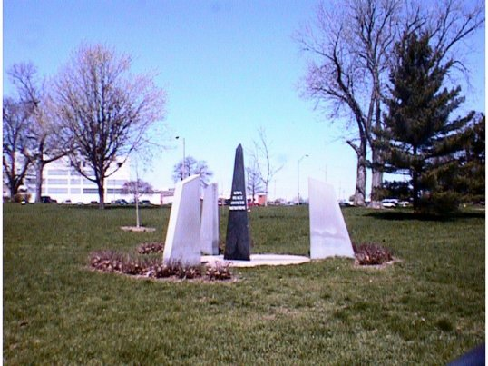

**Iowa Peace Officer Memorial Week**

**May 9 – 15, 2004**

C:\WINDOWS\Application Data\Microsoft\Media Catalog\Downloaded Clips\cl38\j0141063.wmf

Post 16 receives several lost and found items daily. We currently have several sets of keys, gloves (black), glasses, watches, etc. If you have a lost item, please check with us – we just might have what you have been looking for.

***Post 16 - 281-5608***

***PHOTO ID UPDATE***

C:\WINDOWS\Application Data\Microsoft\Media Catalog\Downloaded Clips\cl4f\j0198629.wmfAll scheduled pictures for Capitol Complex employees have now been completed. If you are a new complex employee, or a current complex employee that still needs an access card, please call Shawna Ferguson at 281-4231 to make an appointment.

**ENTER TO WIN !!!!!**

**How many people went through the security checkpoints at the Iowa State Capitol from January 1, 2003 to December 31, 2003?**

**The entry that is closest to the actual number will win an Iowa Department of Public Safety coffee mug.**

**Post 16 and Security Officer employees are not eligible to win.**

Capitol Connections Contest Entry Form

Last Name: ________________________________ First Name: _______________________________

Phone #: __________________ Email: ___________________________ Dept.: ___________________

C:\WINDOWS\Application Data\Microsoft\Media Catalog\Downloaded Clips\cl25\j0094151.wmfYour Guess: ______________________

Entries are due by May 1, 2004 at 4:00 p.m.

Send local mail to: Iowa State Patrol District 16

Attn: Tina Jensen

Lucas State Office Building, First Floor

**Car Safety Seats: A Guide for Families**

Every state requires that infants and children ride buckled up. However, state laws do not always require the safest way to transport a child. More children are still killed as passengers in car crashes than from any other type of injury. Using a car safety seat correctly can help prevent injuries to young children, but it is not as easy as you think. Just a little mistake in how the seat is used could cause serious injury to your child.

**Which is the "best" car safety seat?**

* No one car safety seat is "safest" or "best." The "best" car safety seat is one that fits your child's size and weight, and can be installed correctly in your car, and that you will use every time you drive.
* Price does not always make a difference. Higher prices can mean added features that may or may not make the car safety seat easier to use.
* When you find a car safety seat you like, try it out! Put your child in the car safety seat and adjust the harnesses and buckles. Make sure it fits in your car.
* Keep in mind that displays or illustrations of car safety seats in stores do not always show them being used correctly.

# Child Restraint Fact Sheet

## October, 2003

* **Surveys conducted by the University of Iowa for the Governor's Traffic Safety Bureau during 2003 measured Iowa's average child restraint usage at 84%, up 8% from the 2002 figure of 76%.**
* **During 2002, vehicle occupants killed in Iowa traffic crashes included six children under age six, down five from 11 killed in 2001.**
* **Nine traffic deaths for children under age six in vehicles were recorded in 2000.**
* **Three of the six children killed in 2002 were restrained in the vehicle while seven of the 11 children killed in 2001 were restrained.**
* **In addition to the fatalities, 60 - 80 young children are seriously injured in Iowa vehicle crashes each year.**
* **Iowa has had a child passenger safety restraint law in effect since January 1, 1985 requiring that all vehicle occupants under age 6 be restrained regardless of seating position.**
* **All 50 states have some type of child restraint law.**
* **A study completed in l988 by Dr. Jack Beno, Professor of Safety Education at Iowa State University, identified the following frequently observed types of misuse or non-use of child safety restraints:** 
  1. **safety harness too loose or not attached.**
  2. **child safety seat not properly attached.**
  3. **child sitting on lap.**
  4. **child safety seat facing in wrong direction.**
  5. **child standing on seat.**
* **In 1982, an Iowa observational survey of child restraint use indicated only 20% of young children were being restrained.**
* **By 1985, child restraint use had increased to 43% with gradual increases from 1986 to the present 84% usage.**

|  |
| --- |
| Top of Form  Bottom of Form |
| |  |  |  |  | | --- | --- | --- | --- | | **Proper Child Safety Seat Use Chart Buckle Everyone. Children Age 12 and Under in Back!** | | | | |  | **INFANTS** | **TODDLER** | **YOUNG CHILDREN** | | **WEIGHT** | Birth to 1 year at least 20-22 lbs. | Over 1 year and Over 20 lbs.-40 lbs. | Over 40 lbs. Ages 4-8, unless 4'9''. | | **TYPE of SEAT** | Infant only or rear-facing convertible | Convertible / Forward-facing | Belt positioning booster seat | | **SEAT POSITION** | Rear-facing only | Forward-facing | Forward-facing | | **ALWAYS MAKE SURE:** | Children to one year and at least 20 lbs. in rear-facing seats  Harness straps at or below shoulder level | Harness straps should be at or above shoulders  Most seats require top slot for forward-facing | Belt positioning booster seats must be used with both lap and shoulder belt.  Make sure the lap belt fits low and tight across the lap/upper thigh area and the shoulder belt fits snug crossing the chest and shoulder to avoid abdominal injuries | | **WARNING** | All children age 12 and under should ride in the back seat | All children age 12 and under should ride in the back seat | All children age 12 and under should ride in the back seat | |