**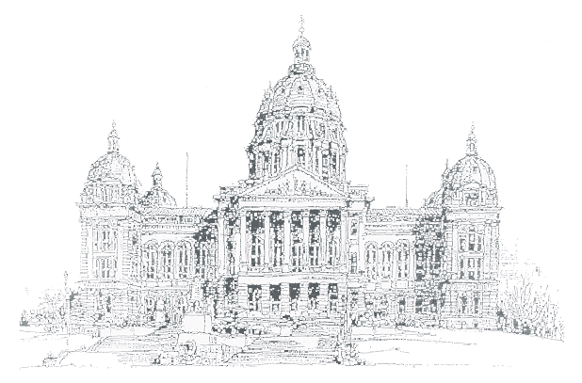**

##### Issue III

**July 2004**

Capitol

Connections

|  |  |  |
| --- | --- | --- |
| **Kevin Techau** | A newsletter for State Employees on the Capitol Complex | **Robert Garrison** |
| **Commissioner** | From Iowa State Patrol District 16 | **Colonel** |

In our April issue of the Capitol Connections Newsletter we asked the question “How many people went through the security checkpoints at the Iowa State Capitol from January 1, 2003 to December 31, 2003?” We would like to congratulate Lola Wilkening of the Department of Human Services for being the winner of the Department of Public Safety coffee mug. Her guess of 211,857 was closest to the actual number of 214,509. We had an overwhelming number of entries for this contest and we would like to thank all of you that participated.

C:\WINDOWS\Application Data\Microsoft\Media Catalog\Downloaded Clips\cl60\j0240559.wmf

**\*\* Parking Tickets \*\***

*Effective 7/1/2004*

* Fines increase to $10 per violation
* Late fee of $10 per violation after 30 days

Please take time to review the new administrative rules regarding parking on the capitol complex at:

[www.state.ia.us/DAS](http://www.state.ia.us/DAS)

Click on the Administrative Rules tab

**Music Under the Stars**

West steps of the Capitol – 6:30 p.m.

* July 4th – Iowa National Guard Band
* July 11th – Air National Guard Band of the Midwest
* July 18th, 25th, and August 1st – Des Moines Municipal Band
* August 8th – John Morgan Big Band

**Iowa State Fair Parking on the Complex**

C:\WINDOWS\Application Data\Microsoft\Media Catalog\Downloaded Clips\cl0\EN00963_.wmfThe Iowa State Fair will run from August 12 – 22, 2004. Parking will be available in Lot #8 (located on the west side of the Capitol building), as well as the parking structure located at Penn and Grand from 6:30 p.m. until midnight on weekdays and from 8:00 a.m. until midnight on each weekend during the fair. The bus stop location will remain in the same spot as previous years - the west side of E. 12th street near the bell. There will also be additional weekday, daytime parking at East High School. The cost to park and ride this year is fifty cents for adults and twenty-five cents for children 11 and under. Park and ride tickets are available at Dahl’s food stores for those wishing to purchase them in advance.