IOWA
RACING

AND

GAMING
COMMISSION

2010 Annual Report
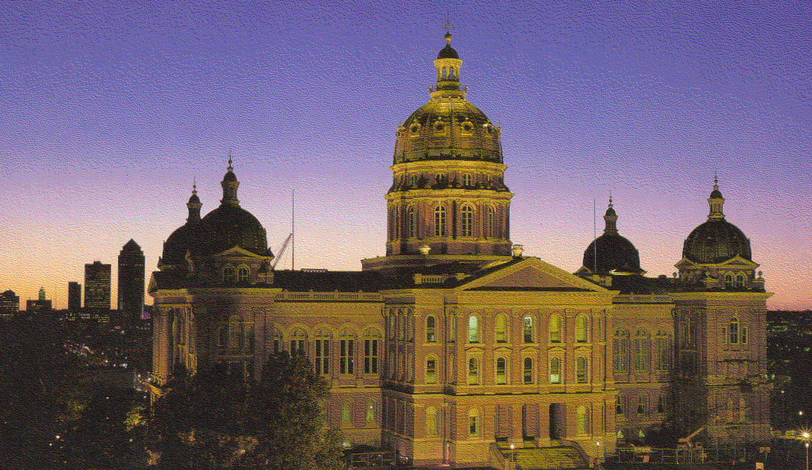

Toni Urban, Chair
Paul Hayes, Vice Chair
Kate Cutler, Commissioner
Andrea Rivera, Commissioner
Gregory Seyfer, Commissioner

LOCATION OF LICENSED FACILITIES

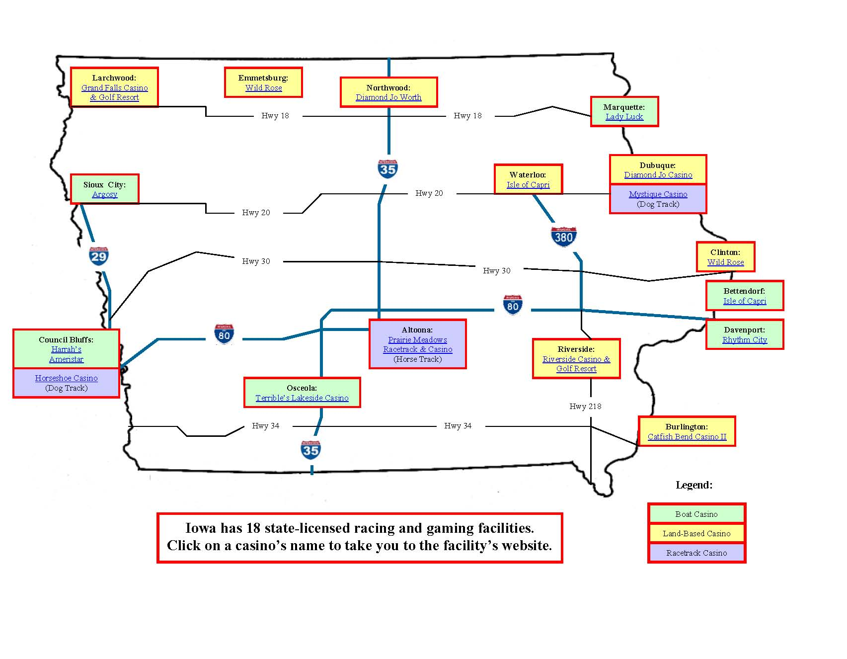

Table of Contents

2 | Location of Licensed Facilities | EXCURSION BOATS
4 | Letter to Governor | 24 | All Iowa Excursion Boat Totals
5 | Lifetime Voluntary Self-Exclusion Program | 25 | Harrah’s Council Bluffs Casino & Hotel
6 | Commission Meetings | 26 | Ameristar II
 |  | 27 | Lady Luck
RACETRACKS |  | 28 | Diamond Jo
10 | Horseshoe Casino/Bluffs Run Greyhound Park | 29 | Catfish Bend Casino
11 | Mystique Casino | 30 | Wild Rose - Clinton
12 | Prairie Meadows Racetrack & Casino | 31 | Argosy - Sioux City
14 | Laboratory Testing | 32 | Rhythm City Casino
15 | Iowa Breeder’s Fund | 33 | Isle of Capri-Bettendorf
RACETRACK CASINOS |  | 34 | Terrible’s Lakeside Casino
17 | All Iowa Racetrack Casino Gaming Totals | 35 | Riverside Casino and Golf Resort LLC
18 | Horseshoe Casino/Bluffs Run Greyhound Park | 36 | Diamond Jo - Worth
19 | Mystique Casino | 37 | Wild Rose – Emmetsburg
20 | Prairie Meadows Racetrack & Casino | 38 | The Isle Casino & Hotel at Waterloo
21 | Pari-Mutuel Revenue and Expenditures | 39 | Excursion Boat Revenue and Expenditures
22 | Iowa’s Wagering Dollar

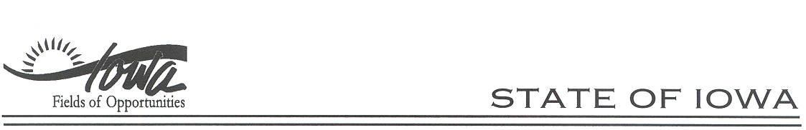
TERRY E. BRANSTAD, GOVERNOR
KIM REYNOLDS, LT. GOVERNOR
RACING AND GAMING COMMISSION
JACK P. KETTERER, ADMINISTRATOR

March 8, 2010

The Honorable Terry Branstad
Governor, State of Iowa
State Capitol
Des Moines, IA 50319

Dear Governor Branstad:

I am pleased to have the opportunity to submit the 2010 Annual Report on behalf of the Iowa Racing and Gaming Commission (the Commission). The Commission is committed to maintaining a vibrant gaming industry that provides economic growth and development for the State of Iowa while continuing to promote responsible gaming and ensuring continued participation in the "Buy Iowa First" program.

Although revenues at the casinos slipped during the year reflecting the general downturn in the economy, the gaming industry contributed more than $940 million to the state's economy, including over $280 million in gaming taxes. Over $38 million in contributions by the non-profit corporation licensees provided significant benefits to local and surrounding communities.

In 2009, the Commission opened the application process for prospective licensees and four counties applied. Through a very extensive and thorough process the Commission voted unanimously in May 2010 to provide a license to Lyon County, now known as Grand Falls Casino and Resort, due to open in May 2011. The Commission anticipates that Grand Falls Casino and Resort will be a tremendous asset to Iowa. After the process was concluded the Commission agreed that they would not even consider opening the application process again for at least four to five years because of the appearance of a saturation of casinos in the State.

At the behest of the Commission Prairie Meadows Racetrack and Casino, after numerous meetings with the various horsemen groups, entered into multi-year contracts with the thoroughbred and quarter horsemen groups; the standardbreds were granted ten racing days in 2010.

The Commission wishes to commend its staff for their continued hard work and dedication. Along with the DCI and the Attorney General's Office, our Administrator Jack Ketterer and his staff provide the commissioners, the gaming industry and the public thorough, timely and accurate information and analysis.

It continues to be a pleasure and privilege of the other commissioners and me to serve at your request on the Commission.

Sincerely,
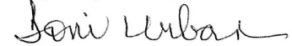
Toni Urban, Chair

LIFETIME VOLUNTARY SELF-EXCLUSION PROGRAM

This program was required by the 2004 General Assembly as part of HF2302. The Commission adopted an administrative rule requiring implementation by the licensed casino operators which became effective on November 3, 2004. The licensed casino operators launched the program on the same date.
Information on persons entering the program must be disseminated to all other licensees in Iowa. The individual is banned at every licensed casino in Iowa and if the individual is discovered in any licensed casino, any winnings will be forfeited and sent to the Iowa General Fund.
To date, approximately 4,886 people have entered the program and in excess of $925,000 has been forfeited.

COMMISSION MEETINGS

During 2010, the Iowa Racing and Gaming Commission (Commission) met twelve times, with five Executive Sessions being held. Minutes of each meeting are kept on file in the Commission office, and are available to the public upon request. The minutes are also available on the Commission’s website: www.iowa.gov/irgc/. Highlights of the meetings follow:

January 14, 2010: The Commission met at Stoney Creek Inn, Johnston, Iowa. The Commission received Division of Criminal Investigation (DCI) background reports in Executive Session. The Commission reviewed the equity and financing commitments the new license applicants had in place for their proposed projects, and approved contracts for several licensees. The following items were before the Commission for Prairie Meadows Racetrack & Casino (PMR&C): standardbred race dates; revised race dates for the thoroughbreds and quarter horses, a long term racing plan/metrics, a hotel update and the 45-day plan for the thoroughbred and quarter horse meets. The standardbred race dates, revised thoroughbred and quarter horse race dates and the 45-day plan were approved.

March 4, 2010: The Commission met at Stoney Creek Inn, Johnston, IA. The Commission approved the 45-day plan for the live race meet at Dubuque Greyhound Park & Casino, a change in the post times for the quarter horse meet at PMR&C, as well as updates on the racing plan and hotel. They also approved an amendment to the Credit Agreement for Isle of Capri Casinos, Inc., an amendment to the second Amended and Restated Excursion Boat Sponsorship and Operations Agreement between Iowa West Racing Association (IWRA) and Ameristar Casino Council Bluffs, Inc. (Ameristar) and an Amended and Restated Management Agreement between Wild Rose Entertainment, L.L.C. and Wild Rose Clinton, L.L.C. The Commission approved the renewal of the following Excursion Gambling Boat and Gambling Structure licenses and any contracts contained within the renewal: IWRA/Ameristar; IWRA/Harveys Iowa Management Co., Inc., (Harveys) d/b/a Harrah’s Council Bluffs Casino Hotel; Washington County Riverboat Foundation, Inc./Riverside Casino & Golf Resort d/b/a Riverside Casino & Golf Resort (RCGR); Scott County Region Authority/Isle of Capri Bettendorf, L.C. d/b/a Isle of Capri Bettendorf; Riverboat Development Authority/IOC Davenport, Inc. d/b/a Rhythm City Casino; Worth County Development Authority/Diamond Jo Worth, LLC d/b/a Diamond Jo Worth; Dubuque Racing Association (DRA)/Diamond Jo, LLC d/b/a Diamond Jo; Black Hawk County Gaming Association/IOC Black Hawk County, Inc. d/b/a/ Isle Casino & Hotel Waterloo; Missouri River Historical Development, Inc./Belle of Sioux City, L.P. d/b/a Argosy Casino Sioux City; Clarke County Development Corporation/HGI-Lakeside, Inc. d/b/a Terrible’s Lakeside Casino Resort; Clinton County Community Development Association/Wild Rose Clinton, L.L.C. d/b/a Wild Rose Clinton; Palo Alto County Gaming Development Corporation/Wild Rose Emmetsburg, L.L.C. d/b/a Wild Rose Emmetsburg; Southeast Iowa Regional Riverboat Commission/Catfish Bend Casinos II, L.C. d/b/a Catfish Bend Casinos II; and Upper Mississippi Gaming Corp./Isle of Capri, Marquette, Inc. d/b/a Lady Luck Casino Marquette. Notice regarding the Request for Proposals (RFP) for the Horse Racing Promotion Fund was given.

March 23, 2010: The Commission met at Stoney Creek Inn, Johnston, Iowa. The Commission heard presentations from the following applicants for a new excursion gambling boat or gambling structure license: Signature Management Group of Iowa, L.L.C./Tama County Community Enrichment, Inc.; Webster County Gaming, LLC/Heart of Iowa Foundation; Ingenus of Iowa, LLC/River Hills Riverboat Authority; and Lyon County Resort & Casino, LLC/Lyon County Riverboat Foundation, Inc. Executive Session was held for the purpose of receiving DCI background reports.

April 6-7, 2010: The Commission met at Stoney Creek Inn, Johnston, Iowa. The Commission met in Executive Session the evening of April 6th for the purpose of receiving DCI background reports. The Commission departed from Stoney Creek Inn on April 7th via motor coach to visit the sites for the excursion gambling boats/gambling structures proposed for Fort Dodge, Tama and Ottumwa.

April 14-15, 2010: The Commission and staff members departed from Stoney Creek Inn, Johnston, Iowa on April 14th via motor coach to travel to Council Bluffs, Iowa and then on to Larchwood, Iowa to visit the site for the proposed facility in Larchwood. The Commission held their regular meeting on April 15th at Ameristar. The Commission approved the third amendment to the Amended and Restated Excursion Boat Sponsorship and Operations Agreement between IWRA and Harveys; an agreement between PMR&C and the Iowa Horsemen’s Benevolent and Protective Association pertaining to racing at PMR&C for the 2010-2014 seasons; an agreement between PMR&C and the Iowa Quarter Horse Racing Association pertaining to racing at PMR&C for the 2010-2012 seasons; approved rules for Notice of Intended Action, reviewed the IWRA/Iowa Greyhound Association financial audit of the escrow account for the year ending December 31, 2009, and approved the distribution of the Horse Racing Promotion Fund to the Legacy Harness Horse Foundation in the amount of $3,337.80 for FY10. Regarding a violation of Iowa Code §99F.4(22) (Self-Exclusion Policy) at RCGR, the Commission determined that the circumstances of the situation excused RCGR from the violation due to vague wording in a Commission Resolution.

May 4, 2010: The Commission met at Stoney Creek Inn, Johnston, Iowa. Executive Session was held for the purpose of receiving DCI background investigation reports. The Commission received Public Comment regarding the proposed excursion gambling boats/gambling structures in Larchwood, Tama, Ottumwa and Fort Dodge in the morning, and asked questions of the applicants in the afternoon.

May 13, 2010: The Commission met at Stoney Creek Inn, Johnston, Iowa. The Commission members presented their individual process for evaluating the license applications before them, and granted a license to Lyon County Resort & Casino, LLC/Lyon County Riverboat Foundation, Inc. The Commission denied gaming licenses to Signature Management Group of Iowa, L.L.C./Tama County Community Enrichment, Inc.; Ingenus of Iowa LLC/River Hills Riverboat Authority; and Webster County Gaming, LLC/Heart of Iowa Foundation.

June 3, 2010: The Commission met at Stoney Creek Inn, Johnston, Iowa. Executive Session was held for the purpose of receiving DCI background investigation reports. The Commission approved a name change for the qualified sponsoring organization in Clinton, received an update on the bankruptcy proceedings for Herbst Gaming, Inc. (Terrible’s Lakeside Casino). The Commission heard reports from the licensees, except for the Isle of Capri properties, on their year-end financial audits. PMR&C representatives provided an update on the following: purses for the standardbred meet, the metrics being developed for the thoroughbreds, quarter horses and standardbreds, the hotel, and parking. There was a discussion regarding the schedule for racing-related capital improvements. The Commission approved a Stipulated Agreement with IOC Bettendorf for a violation of Iowa Code §99F.9(5) (Wagering – Age Restriction), and assessed an administrative penalty of $20,000. Notice was given that applications for the Dog Racing Promotion Fund for FY11 were due in the Commission’s Des Moines office by 4:30 PM on July 2nd. The Commission also approved an amendment to the Standards and Penalties for Violations of Voluntary Self-Exclusion Law and the regulatory fees for FY11, subject to final review and approval at the July Commission meeting.

July 29, 2010: The Commission met at Stoney Creek Inn, Johnston, Iowa. The Commission approved rules for final adoption; deferred action on a request by the Iowa Greyhound Association (IGA) to withdraw $5,000 from the escrow account to update a study originally conducted in 2001, and approved distribution of the Dog Racing Promotion Fund to the IGA. The Commission approved the 45-day plan for the harness meet at PMR&C; heard an update regarding the hotel, and reviewed a five-year projected capital improvement plan. The Commission gave final approval to the regulatory fees for FY11, and elected the Chair and Vice Chair for FY11.

August 26, 2010: The Commission met at Riverside Casino & Golf Resort, Riverside, Iowa. The Commission received reports on the year-end financial audits for the Isle of Capri properties; approved third party arbitration panel members for DRA/IGA and IWRA/IGA, and approved a request from IGA to withdraw $5,000 from the Bluffs Run/IGA Escrow Account to pay for study to be performed by Iowa State University. The Commission received reports from PMR&C management regarding the racetrack surface and the hotel. The Commission approved PMR&C’s request for an additional day of racing during the harness meet in the event of inclement weather and the ancillary agreement with the Iowa Harness Horsemen’s Association.

October 6-7, 2010: The Commission met at The Hotel Julien, Dubuque, Iowa. Executive Session was held for the purpose of receiving DCI background investigation reports. The Commission approved the purse agreement between DRA and IGA; granted race dates for 2011 at Mystique, and approved the renewal of the pari-mutuel and racetrack enclosure licenses for DRA. The Commission received an update on the hotel project at PMR&C, and heard a report from PMR&C management regarding the quarter horse meet and the track surface.

November 10, 2010: The Commission met at Stoney Creek Inn, Johnston, Iowa. There was a brief discussion related to charges by a special prosecutor appointed by the Attorney General. The Commission granted an operator’s license to HGI-Lakeside, LLC for the property in Osceola. The Commission approved the arbitration decision between Horseshoe Casino/Bluffs Run Greyhound Park (BRGP) and the IGA, granted racing dates for 2011 at Horseshoe Casino/BRGP, approved the renewal of the pari-mutuel and racetrack enclosure licenses for IWRA, and the 45-day plan for the 2011 live race meet. The Commission received comments from the Iowa Harness Horsemen’s Association and the Iowa Quarter Horse Racing Association regarding the racing dates submitted by PMR&C. The Commission received reports on the hotel project and the standardbred meet; granted race dates for 2011 at PMR&C, and approved the renewal of the pari-mutuel and racetrack enclosure licenses for PMR&C for 2011.

HORSESHOE CASINO
BLUFFS RUN GREYHOUND PARK
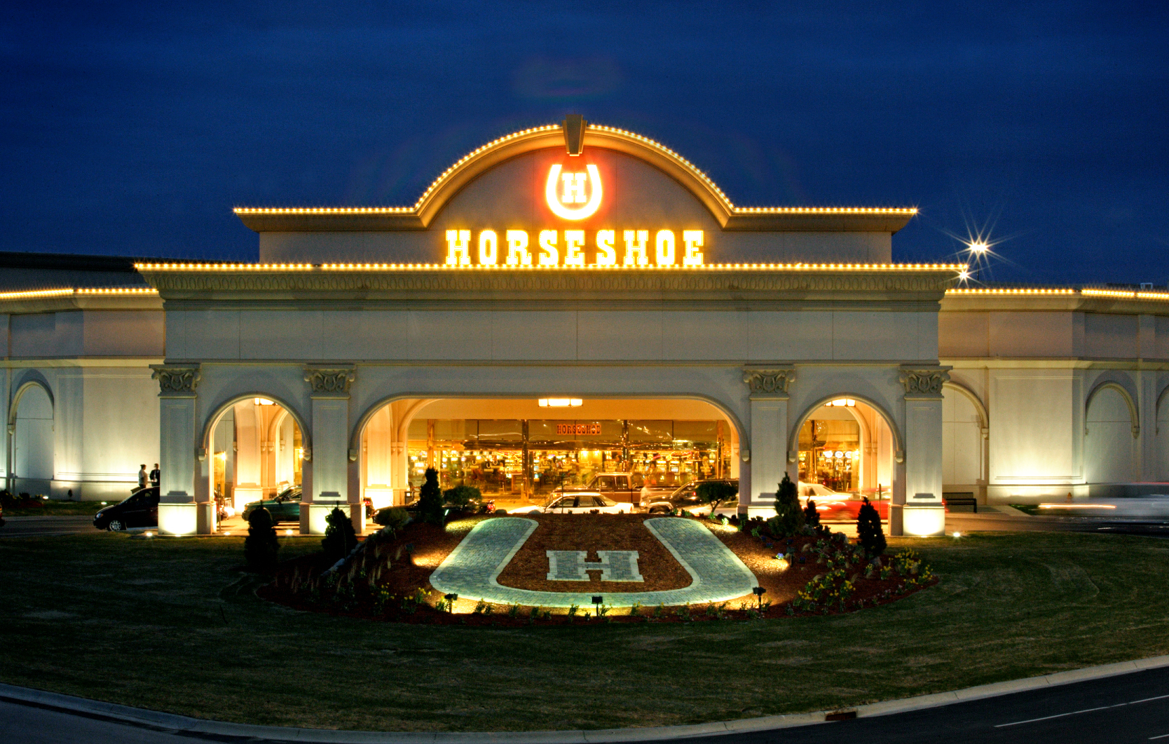
Council Bluffs, IA
2009 2010
Live Racing
Racing Dates | 1/1-12/31 | 1/1-12/31
Number of Performances | 299 | 302
Admissions | See simulcasting | See simulcasting
Total Mutuel Handle | $4,906,029 | $4,622,763
Track Commission | $1,151,966 | $1,087,790
Breakage | $17,484 | $15,525
Returned to Public | $3,736,578 | $3,519,448
Total Purses Paid (all sources) | $9,674,629 | $9,447,830
Simulcasting (Signals Sent-Live Greyhound)
Simulcast Handle | $28,890,563 | $35,758,476
Simulcasting (Signals Received-Greyhounds & Horses)
Simulcasting Dates | 1/1-12/31 | 1/1-12/31
Number of Performances | 7,736 | 7,338
Admissions | 2,462,423 | 2,436,096
Total Mutuel Handle | $15,526,956 | $14,870,937
Breakage | $72,764 | $71,720
Pari-Mutuel Revenues to State
State Tax | $281,570 | $298,210
Gambler's Treatment | $26,123 | $0*
Unclaimed Winnings | $92,672 | $95,330
* Deposits from gaming taxes to the Gambler’s Treatment Fund were ended on July 1, 2009 through legislation.

MYSTIQUE CASINO
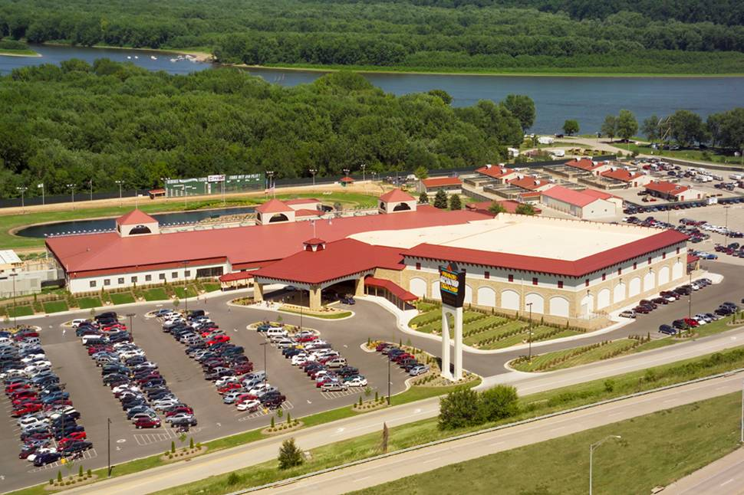
Dubuque, IA
2009 2010
Live Racing
Racing Dates | 4/25-10/25 | 4/24-10/24
Number of Performances | 161 | 160
Admissions | See Simulcasting | See Simulcasting
Total Mutuel Handle | $1,674,365 | $1,625,542
Track Commission | $369,757 | $356,519
Breakage | $11,092 | $10,928
Returned to Public | $1,293,516 | $1,258,095
Total Purses Paid (all sources) | $4,108,713 | $4,251,252
Simulcasting (Signals Received-Greyhounds & Horses)
Simulcasting Dates | 1/1-12/31 | 1/1-12/31
Number of Performances | 2,793 | 3,031
Admissions | 1,340,906 | 1,330,346
Total Mutuel Handle | $3,231,057 | $3,548,096
Breakage | $8,372 | $9,589
Pari-Mutuel Revenues to State
State Tax | $69,983 | $83,640
Gambler's Treatment | $0 | $0*
Unclaimed Winnings | $16,650 | $86,368
* Deposits from gaming taxes to the Gambler’s Treatment Fund were ended on July 1, 2009 through legislation.

PRAIRIE MEADOWS RACETRACK & CASINO
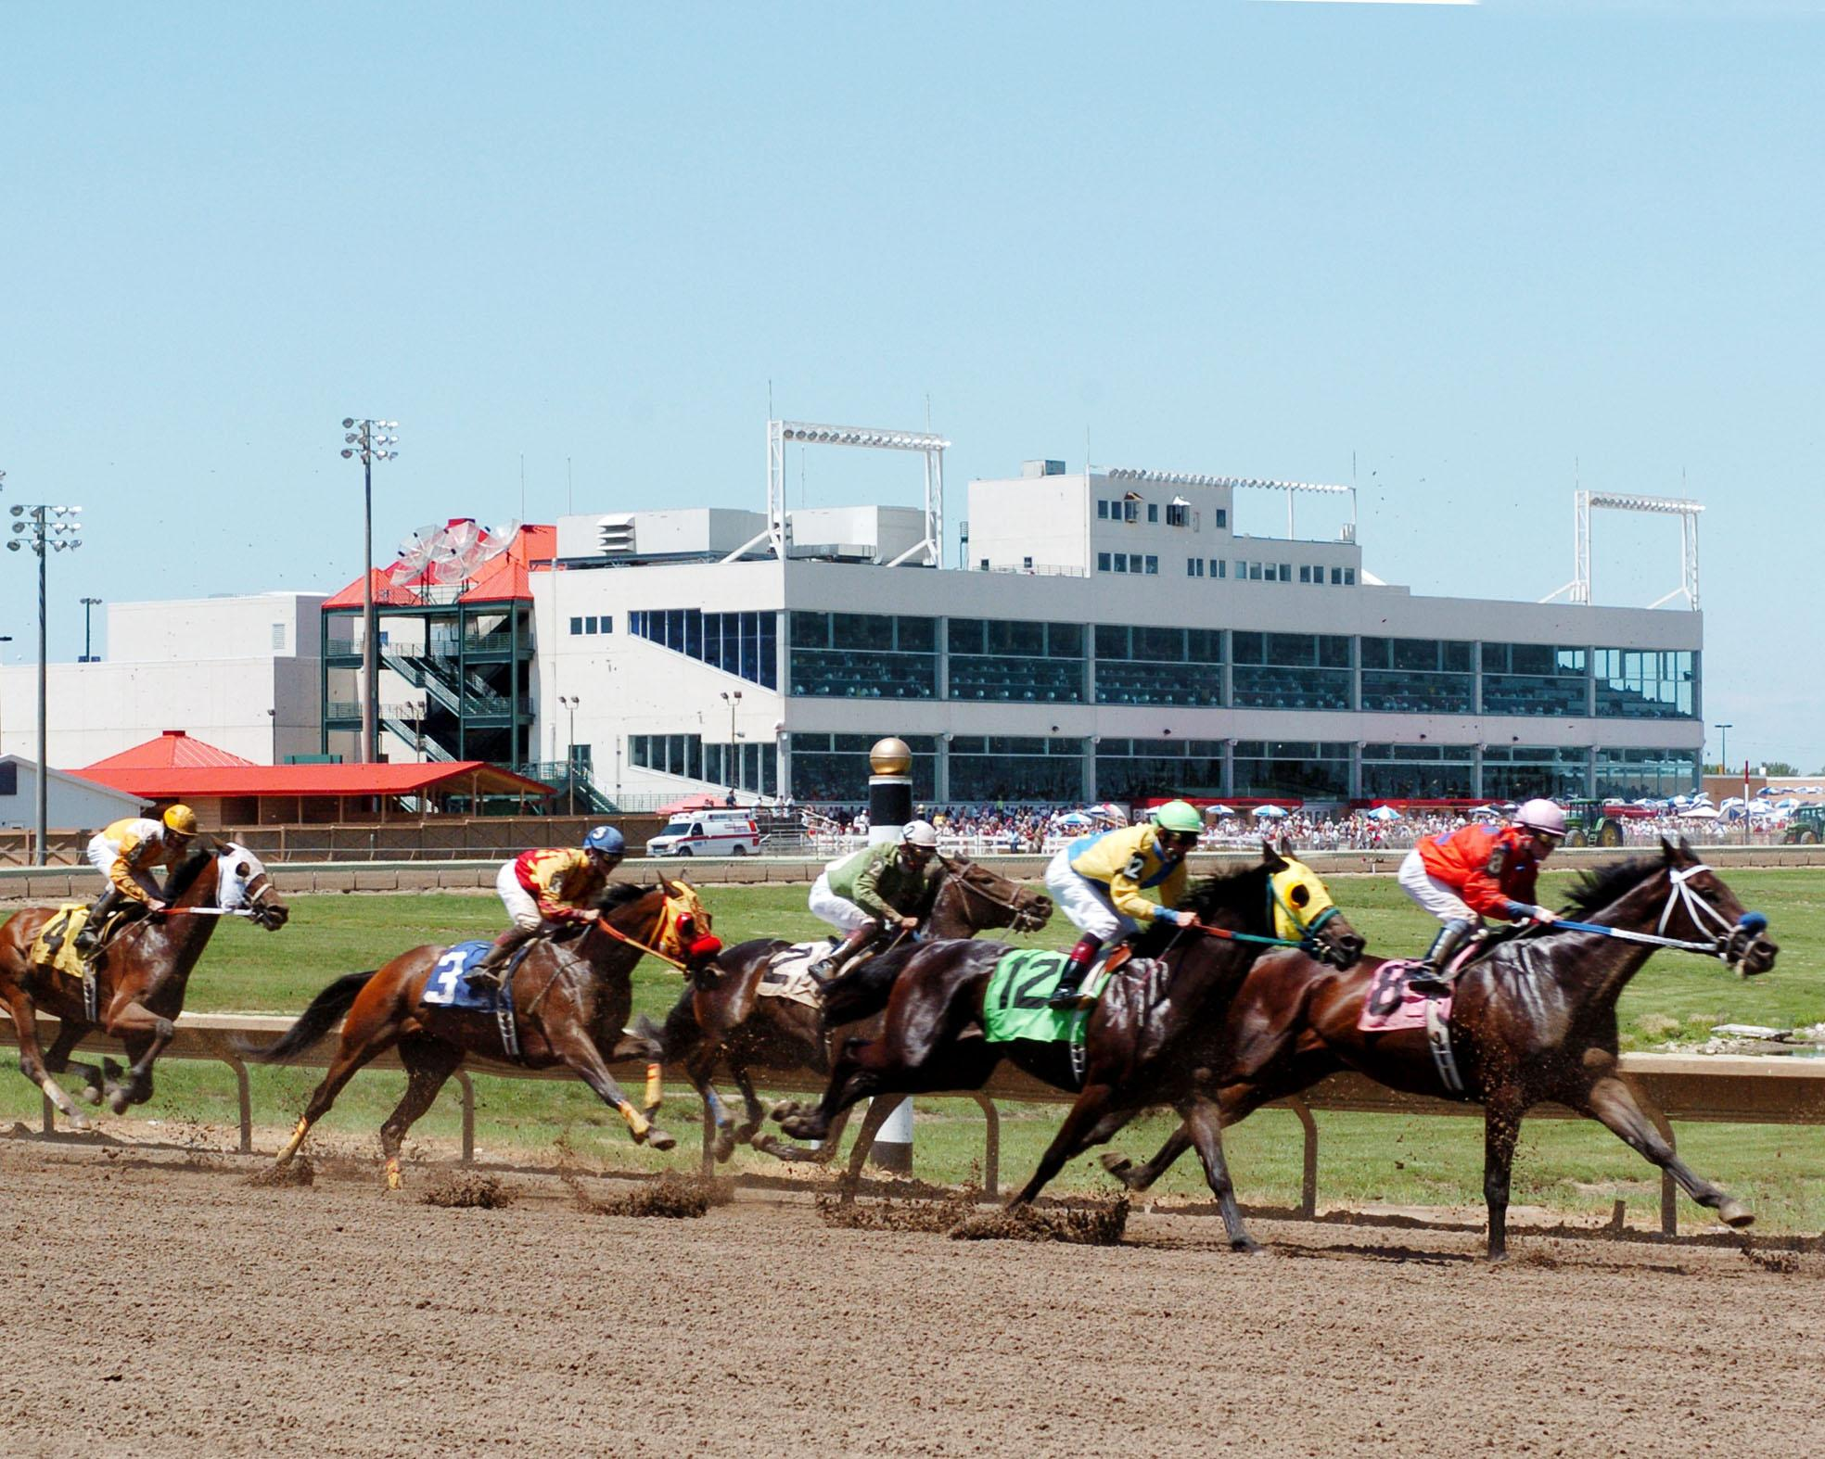
Altoona, IA

2009 2010
Live Racing
Racing Dates | 4/24-7/18 | 4/23-8/7
Racing Dates | 7/27-9/19 | 8/13-9/25
Racing Dates | 9/28-10/24 | 10/1-10/16
Number of Performances | 97 | 103
Admissions | See Simulcasting | See Simulcasting
Total Mutuel Handle | $4,592,015 | $4,365,682
Track Commission | $879,302 | $829,940
Breakage | $36,387 | $35,148
Returned to Public | $3,699,476 | $3,500,594
Total Purses Paid (all sources) | $17,813,873 | $16,034,396

2009 2010
Simulcasting (Signals Sent-Live Horse)
Simulcast Handle (commingled) | $41,557,957 | $37,724,719

HORSE RACING HANDLE – LIVE MEET

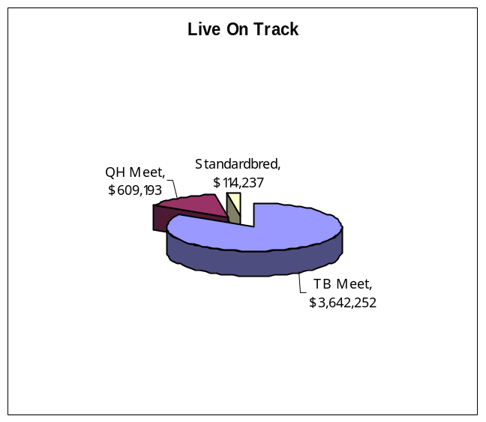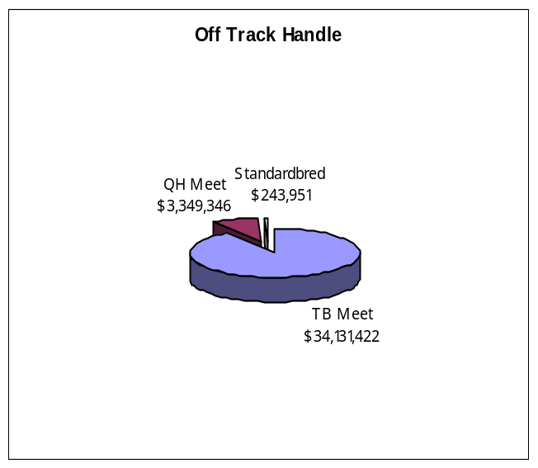

2009 2010
Simulcasting (Signals Received-Greyhounds & Horses)
Simulcasting Dates | 1/1-12/31 | 1/1-12/31
Number of Performances | 8,125 | 7,953
Admissions | 2,512,348 | 2,516,925
Total Mutuel Handle | $13,877,217 | $17,775,232
Total Mutuel Handle (Horse) | $12,505,230 | $16,255,266
Total Mutuel Handle (Greyhound) | $1,371,987 | $1,519,966
Breakage | $69,797 | $81,539

Pari-Mutuel Revenues to State
Unclaimed Winnings | $105,665 | $94,090

LABORATORY TESTING
The Iowa Racing and Gaming Commission, through comprehensive drug testing of participating animals, strives to protect the integrity of the sport of racing in Iowa. Iowa's urine and blood testing program is the backbone of the agency's policing functions. The drug testing program was conducted by Iowa State University Veterinary and Diagnostic Laboratory, the Commission’s racing chemist.
Through chemical analysis of urine and blood samples collected from racing animals at the tracks, the Commission ensures that foreign substances are not being administered to racing animals pursuant to Iowa Code Chapter 99D.25.
The following is a summary of the samples tested and positive tests reported by the Laboratory in 2010 for the Commission.

SAMPLES
 | URINE | BLOOD
Greyhound
Horseshoe Casino | 4,422
Mystique Casino | 2,330
Horse
Prairie Meadows Racetrack & Casino | 1,630 | 1,910

POSITIVE TESTS
Methocarbamol | 2
Phenylbutazone | 2
Trichloromethiazide | 1
Flunixin | 1
Mephentermine | 1
Picrotin/Picrotoxinin Tricloromethiazide | 1
Tripelennamine | 1
TOTAL POSITIVES | 9
IOWA BREEDERS' FUND

The Department of Agriculture maintains a database of thoroughbred, standardbred and quarterhorses that have qualified to be Iowa-foaled horses, as well as greyhounds that have qualified as Iowa-whelped dogs according to Iowa Code Chapter 99D.22 and Administrative Rules of the Department of Agriculture and Land Stewardship.
An amount equal to 12% of the winner's share of any purse won by an Iowa-foaled horse or Iowa-whelped dog is withheld by the licensee from the breakage and paid at the end of the race meeting to the Department of Agriculture and Land Stewardship for redistribution as breeders’ awards.
Iowa Code Chapter 99D.11 and 12 authorize distribution of the remaining breakage as follows:
At horse tracks, 2% of the remaining breakage is distributed to the Horse Promotion Fund and the balance of the breakage at horse tracks is distributed as purse supplements to the owners of winning Iowa-bred horses.
The remainder of the breakage at greyhound tracks is divided, with 25% funding a stakes race restricted to registered Iowa-whelped greyhounds, 2% funding the Dog Promotion Fund and 73% distributed as purse supplements to the owners of winning Iowa-whelped greyhounds.
One percent of the exotic wagers, including 3 or more horses, dogs or races, is distributed as provided in 99D.12 above.
The amounts created from the total breakage and a portion of the casino revenues as statutorily required, were paid out as follows in 2010:

THOROUGHBRED/QUARTERHORSE/STANDARDBRED

PRAIRIE MEADOWS RACETRACK & CASINO
Breeders Awards | $567,793
Purse Supplements to Owners of Iowa Breds | $2,239,638
Horse Racing Promotion Fund | $3,531
Carry-Over | $0

GREYHOUNDS
HORSESHOE CASINO AND BLUFFS RUN GREYHOUND PARK
Breeders Awards | $208,542
Purse Supplements to Owners of Iowa-whelped greyhounds | $2,860,622
Iowa Stakes | $500,000
Carry-Over | $0
Dog Racing Promotion Fund | $0

MYSTIQUE CASINO
Breeders Awards | $12,480
Purse Supplements to Owners of Iowa-whelped greyhounds | $909,308
Iowa Stakes | $260,000
Carry-Over (Breakage Only) | $0
Dog Racing Promotion Fund | $23,382

ALL IOWA RACETRACK CASINO
GAMING TOTALS
 | 2009 | 2010
Admissions | 6,315,677 | 6,283,367
Slot Drop | $2,715,147,934 | $2,717,029,773
Slot Coin In | $4,374,753,634 | $4,332,225,104
Slot Revenue | $392,847,115 | $392,502,431
Table Drop | $203,695,748 | $207,186,704
Table Revenue | $42,777,737 | $45,538,895
Adjusted Gross Revenue | $435,624,849 | $438,041,326
City Tax | $2,052,254 | $2,064,336
County Tax | $2,052,254 | $2,064,336
Gambler’s Treatment | $1,115,788 | $0*
Endowment Fund | $3,283,606 | $3,302,936
State Miscellaneous Fund | $820,902 | $825,735
Gaming Tax | $88,031,191 | $89,713,015
Regulatory Fee | $3,505,174 | $3,299,540
* Deposits from gaming taxes to the Gambler’s Treatment Fund were ended on July 1, 2009 through legislation.
HORSESHOE CASINO
BLUFFS RUN GREYHOUND PARK
GAMING
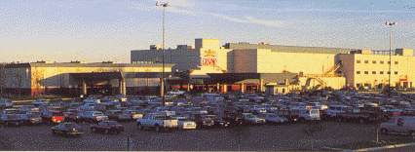
Council Bluffs, IA
 | 2009 | 2010
Admissions | 2,462,423 | 2,436,096
Slot Drop | $912,979,853 | $928,165,732
Slot Coin In | $1,566,294,354 | $1,619,735,478
Slot Revenue | $162,037,768 | $165,012,332
Table Drop | $106,545,786 | $113,770,661
Table Revenue | $22,024,559 | $25,039,236
Adjusted Gross Revenue | $184,062,327 | $190,051,568
City Tax | $868,854 | $898,800
County Tax | $868,854 | $898,800
Gambler’s Treatment | $473,877 | $0*
Endowment Fund | $1,390,166 | $1,438,079
State Miscellaneous Fund | $347,541 | $359,520
Gaming Tax | $37,755,668 | $39,547,176
Regulatory Fee | $1,163,505 | $1,090,053
* Deposits from gaming taxes to the Gambler’s Treatment Fund were ended on July 1, 2009 through legislation.
MYSTIQUE CASINO
GAMING
Dubuque, IA
 | 2009 | 2010
Admissions | 1,340,906 | 1,330,346
Slot Drop | $440,002,471 | $421,917,932
Slot Coin In | $692,636,834 | $628,164,029
Slot Revenue | $58,172,201 | $56,059,416
Table Drop | $18,555,014 | $19,850,022
Table Revenue | $4,026,485 | $4,418,495
Adjusted Gross Revenue | $62,198,686 | $60,477,911
City Tax | $288,038 | $279,435
County Tax | $288,038 | $279,435
Gambler’s Treatment | $152,874 | $0*
Endowment Fund | $460,862 | $447,096
State Miscellaneous Fund | $115,216 | $111,774
Gaming Tax | $11,368,682 | $11,177401
Regulatory Fee | $870,530 | $832,060
* Deposits from gaming taxes to the Gambler’s Treatment Fund were ended on July 1, 2009 through legislation.

PRAIRIE MEADOWS RACETRACK AND CASINO
GAMING
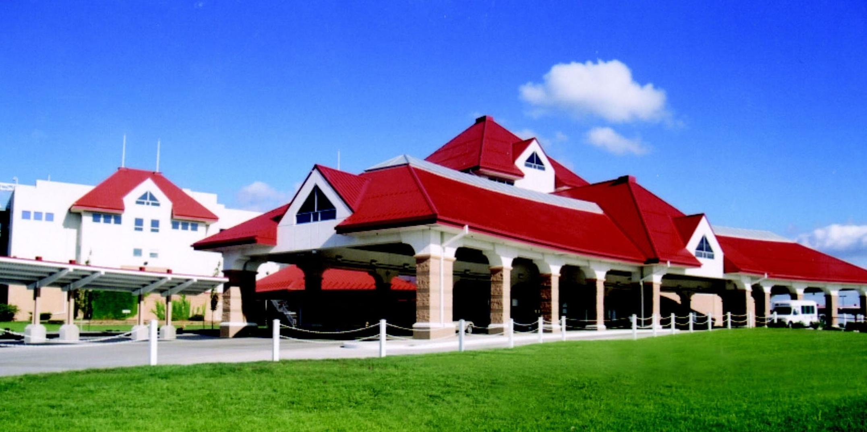
Altoona, IA
 | 2009 | 2010
Admissions | 2,512,348 | 2,516,925
Slot Drop | $1,362,165,610 | $1,366,946,109
Slot Coin In | $2,115,822,446 | $2,084,325,597
Slot Revenue | $172,637,146 | $171,430,683
Table Drop | $78,594,948 | $73,566,021
Table Revenue | $16,726,693 | $16,081,164
Adjusted Gross Revenue | $189,363,836 | $187,511,847
City Tax | $895,362 | $886,101
County Tax | $895,362 | $886,101
Gambler’s Treatment | $489,037 | $0*
Endowment Fund | $1,432,578 | $1,417,761
State Miscellaneous Fund | $358,145 | $354,441
Gaming Tax | $38,906,841 | $38,988,438
Regulatory Fee | $1,526,295 | $1,377,427
* Deposits from gaming taxes to the Gambler’s Treatment Fund were ended on July 1, 2009 through legislation.

PARI-MUTUEL REVENUE AND EXPENDITURES
2010
EXPENDITURES FOR REGULATION
Salary and Benefits | $1,786,026
Travel | $8,724
State Vehicle | $(2,084)
Office Supplies/Printing/Postage | $16,985
Equipment Maintenance | $3,560
Communications | $91
Rentals | $20,461
Professional, Scientific & Outside Services | $632,140
Intra State Transfers | $37,205
Advertising/Publicity | $0
ITD/IT Outside Services | $43,211
Reimbursements to Other Agencies | $17,656
Equipment | $11,632
TOTAL | $2,575,607
REVENUES TO STATE
Annual Licensing Fee | $3,000
Regulatory Fees | $3,299,540
Daily License Fees | $197,000
Occupational License Fees | $52,240
Fines | $13,600
Pari-Mutuel Tax | $381,849
Gaming Tax | $89,713,015
State Miscellaneous Fund | $825,735
Gambler’s Treatment | $0*
Unclaimed Winnings | $275,788
TOTAL | $94,761,767

REVENUES TO LOCAL GOVERNMENT
Gaming Taxes (City/County) | $4,128,672
Endowment Fund | $3,302,936
* Deposits from gaming taxes to the Gambler’s Treatment Fund were ended on July 1, 2009 through legislation.

IOWA'S WAGERING DOLLAR
IOWA'S PARI-MUTUEL DOLLAR
Actual percentage withheld from each wagering dollar depends on the type of wager. Chapter 99D.11(5) authorizes takeout up to eighteen percent on win, place, and show wagers; twenty-four percent on doubles (two dogs/horses/ races); and twenty-five percent on triples (3+dogs/horses/races). Pari-mutuel taxes may range from 0 to six percent on live races based on increasing levels of mutuel handle. Simulcast wagering is taxed at two percent of the pari-mutuel handle. (Chapter 99D.15)
Breakage (the odd cents by which the amount payable on each dollar wagered in a pari-mutuel pool exceeds a multiple of ten cents) is distributed to the owners and breeders of Iowa-foaled horses and Iowa-whelped dogs.
IOWA'S GAMING DOLLAR
Iowa's gaming industry consists of slot machines, table games, and other games of chance as authorized by the Commission. Slot machine statistics are kept on the total amount wagered and adjusted gross revenue. Each slot machine must have at least an eighty percent pay-out to the patron. Available data for table games includes the drop and the ratio of drop to the adjusted gross revenues.
The tax based on adjusted gross revenues from gambling games is: Up to $1,000,000, five percent; above $1,000,000 up to $3,000,000, ten percent; above $3,000,000 Excursion gambling boat – twenty-two percent; Racetrack enclosure in the same county as other licensees and issued a table games license but with adjusted gross receipts of less than $100 million – twenty-two percent; Racetrack enclosure in the same county as other licensees, issued a table games license and with adjusted gross receipts of more than $100 million – twenty-four percent and Racetrack enclosures with no other licensees in the same county – twenty-four percent
This tax is distributed one-half of one percent each to the city and county, eight-tenths of one percent to the County Endowment Fund, two-tenths of one percent to the State Miscellaneous Fund and the remainder to designated state funds.

TAX ASSESTMENT OFFSET
House File 2302 was passed during the 2004 Iowa Legislative session that imposed an assessment on the Riverboats in Iowa at 2.152% of estimated AGR for the 2004 calendar year. This tax assessment was paid in two parts, in June 2005 and June 2006 to help establish the rebuild Iowa infrastructure fund. To compensate the boats for the initial tax assessment they are allowed to take as an offset to their tax liability twenty percent of the assessment paid starting in the state’s fiscal year 2011 for the following 5 fiscal years. Below please note the offset that each of the boats is allowed to take for fiscal years 2011-2015.

Offset tax each year
FY2011 - FY2015
Lady Luck - Marquette | $ 353,229
Diamond Jo - Dubuque | $ 421,155
Wild Rose Clinton | $ 237,202
Catfish Bend | $ 267,623
Argosy - Sioux City | $ 391,543
Rhythm City | $ 654,673
Isle of Capri - Bettendorf | $ 865,259
Ameristar II | $ 1,423,040
Harrahs | $ 931,945
Terrible's Lakeside | $ 454,795

TABLE GAMES LICENSE FEE

Iowa code section 99F.4A(8) established the right of Iowa’s three racetrack casinos to begin offering table games of chance assuming they paid an initial license fee by June 1, 2005. The fee was determined by the adjusted gross receipts of the previous fiscal year. The tracks are allowed to offset the initial license fee against taxes owed during fiscal year 2009-2013. Prairie Meadows Racetrack and Casino and Horseshoe Casino/Bluffs Run Greyhound Park each paid $10million and are allowed an offset of $2million each of the five fiscal years. Mystique Casino, formerly Dubuque Greyhound Park, paid $3million and is allowed an offset of $600,000 each of the five fiscal years.
ALL IOWA EXCURSION GAMBLING BOAT/ GAMBLING STRUCTURE TOTALS
 | 2009 | 2010
Admissions | 16,269,750 | 15,685,048
Slot Drop | $5,712,805,062 | $5,826,012,520
Slot Coin In | $9,736,116,889 | $9,552,587,589
Slot Revenue | $868,271,678 | $858,613,343
Table Drop | $358,860,553 | $332,949,077
Table Revenue | $76,847,829 | $71,419,358
Adjusted Gross Revenue | $945,119,507 | $930,032,701
City Tax | $4,725,598 | $4,439,246
County Tax | $4,725,598 | $4,439,246
Gambler’s Treatment | $2,430,862 | $0*
Endowment Fund | $7,560,954 | $7,102,801
State Miscellaneous Fund | $1,890,240 | $1,775,692
Gaming Tax | $180,812,137 | $175,150,658
Regulatory Fee | $11,378,469 | $11,261,396
* Deposits from gaming taxes to the Gambler’s Treatment Fund were ended on July 1, 2009 through legislation.

HARRAH’S COUNCIL BLUFFS CASINO & HOTEL
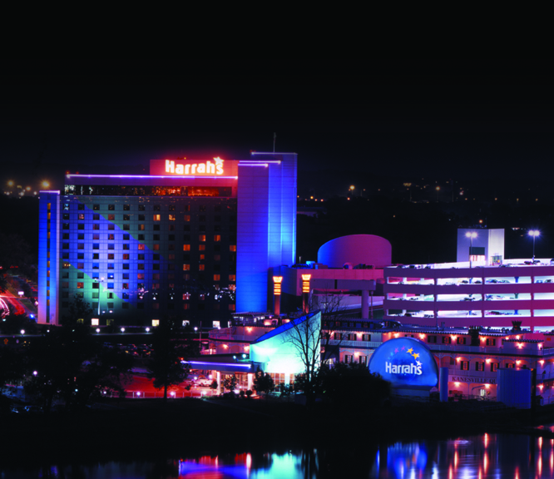
Council Bluffs, IA
 | 2009 | 2010
Admissions | 1,413,813 | 1,277,303
Slot Drop | $428,957,691 | $388,531,036
Slot Coin In | $813,464,999 | $724,519,555
Slot Revenue | $82,895,747 | $74,376,196
Table Drop | $33,745,854 | $25,489,182
Table Revenue | $6,397,442 | $5,133,869
Adjusted Gross Revenue | $89,293,189 | $79,510,065
City Tax | $446,466 | $367,051
County Tax | $446,466 | $367,051
Gambler’s Treatment | $233,912 | $0*
Endowment Fund | $714,345 | $587,283
State Miscellaneous Fund | $178,587 | $146,820
Gaming Tax | $17,214,726 | $14,682,064
Regulatory Fee | $918,177 | $883,802
* Deposits from gaming taxes to the Gambler’s Treatment Fund were ended on July 1, 2009 through legislation.
AMERISTAR II

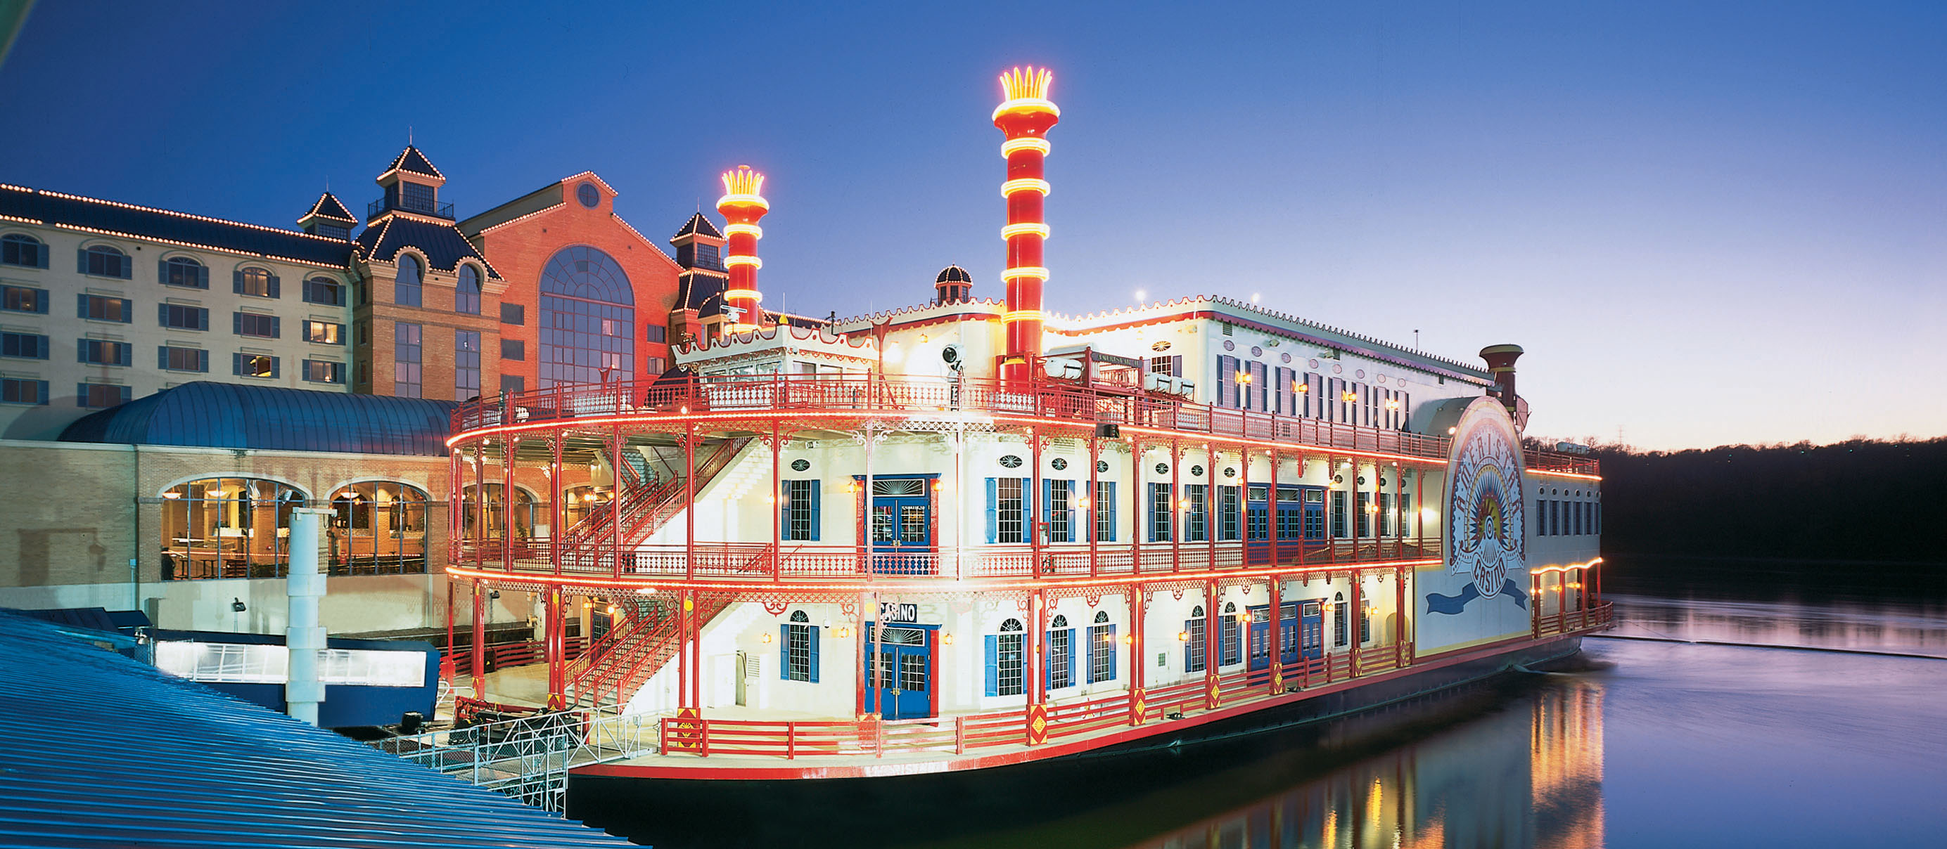
Council Bluffs, IA
 | 2009 | 2010
Admissions | 2,185,104 | 2,132,350
Slot Drop | $839,850,373 | $865,575,129
Slot Coin In | $1,544,885,873 | $1,562,684,695
Slot Revenue | $144,421,681 | $146,714,720
Table Drop | $61,493,111 | $60,256,745
Table Revenue | $13,522,327 | $13,056,119
Adjusted Gross Revenue | $157,944,008 | $159,770,839
City Tax | $789,720 | $757,194
County Tax | $789,720 | $757,194
Gambler’s Treatment | $409,966 | $0*
Endowment Fund | $1,263,552 | $1,211,511
State Miscellaneous Fund | $315,888 | $302,877
Gaming Tax | $30,768,835 | $30,287,768
Regulatory Fee | $909,805 | $914,834
* Deposits from gaming taxes to the Gambler’s Treatment Fund were ended on July 1, 2009 through legislation.

LADY LUCK
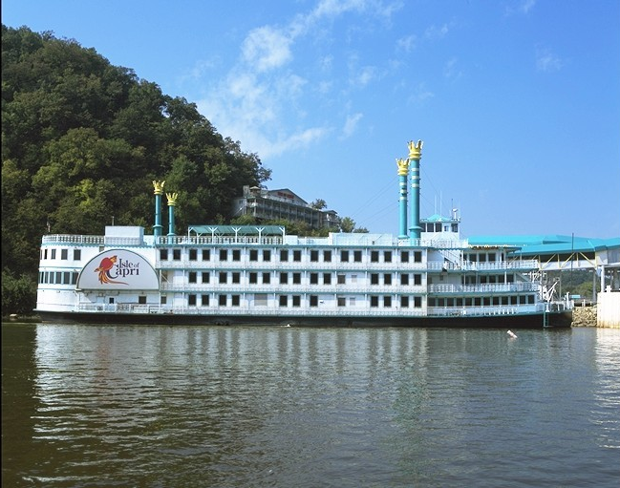
Marquette, IA
 | 2009 | 2010
Admissions | 392,315 | 372,599
Slot Drop | $206,439,473 | $211,560,735
Slot Coin In | $354,477,061 | $346,615,087
Slot Revenue | $28,951,931 | $28,001,416
Table Drop | $7,054,058 | $6,989,949
Table Revenue | $1,351,132 | $1,330,070
Adjusted Gross Revenue | $30,303,063 | $29,331,486
City Tax | $151,515 | $129,312
County Tax | $151,515 | $129,312
Gambler’s Treatment | $76,678 | $0*
Endowment Fund | $242,424 | $206,898
State Miscellaneous Fund | $60,606 | $51,724
Gaming Tax | $5,561,868 | $5,184,520
Regulatory Fee | $747,364 | $726,270
* Deposits from gaming taxes to the Gambler’s Treatment Fund were ended on July 1, 2009 through legislation.

DIAMOND JO
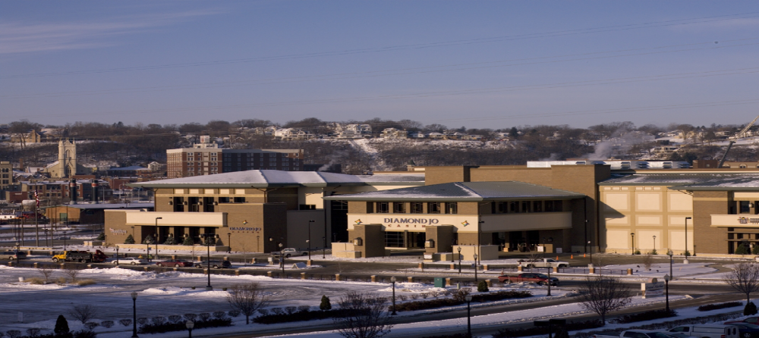
Dubuque, IA
 | 2009 | 2010
Admissions | 1,273,746 | 1,115,998
Slot Drop | $405,227,953 | $404,467,944
Slot Coin In | $706,823,687 | $677,232,752
Slot Revenue | $64,545,399 | $63,035,609
Table Drop | $30,607,953 | $26,290,218
Table Revenue | $5,988,284 | $4,860,156
Adjusted Gross Revenue | $70,533,683 | $67,895,765
City Tax | $352,668 | $320,589
County Tax | $352,688 | $320,589
Gambler’s Treatment | $183,356 | $0*
Endowment Fund | $564,269 | $512,942
State Miscellaneous Fund | $141,067 | $128,235
Gaming Tax | $13,513,380 | $12,823,558
Regulatory Fee | $779,786 | $787,296
* Deposits from gaming taxes to the Gambler’s Treatment Fund were ended on July 1, 2009 through legislation.

CATFISH BEND CASINO
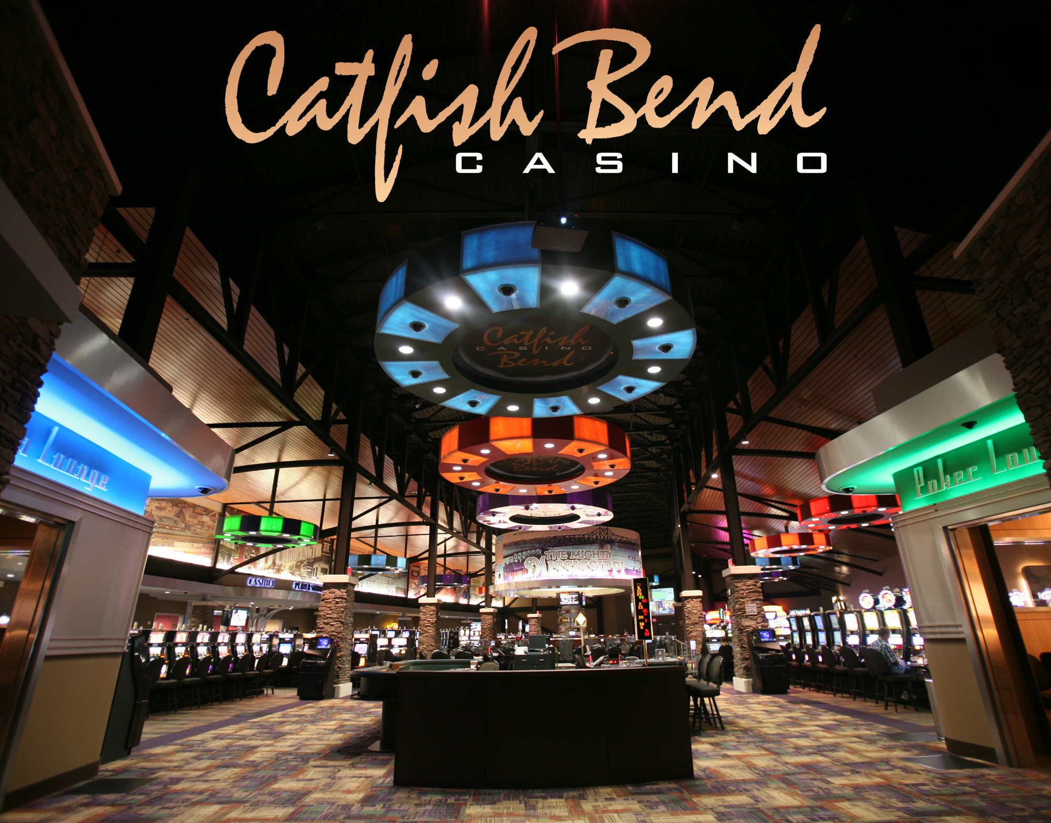
Burlington, IA
 | 2009 | 2010
Admissions | 806,051 | 767,506
Slot Drop | $245,467,836 | $242,591,749
Slot Coin In | $394,291,905 | $383,632,472
Slot Revenue | $34,761,412 | $34,534,783
Table Drop | $16,889,417 | $15,971,882
Table Revenue | $3,948,430 | $3,845,234
Adjusted Gross Revenue | $38,709,842 | $38,380,017
City Tax | $193,549 | $176,500
County Tax | $193,549 | $176,500
Gambler’s Treatment | $99,112 | $0*
Endowment Fund | $309,678 | $282,399
State Miscellaneous Fund | $77,420 | $70,600
Gaming Tax | $7,232,856 | $7,059,982
Regulatory Fee | $773,988 | $775,916
* Deposits from gaming taxes to the Gambler’s Treatment Fund were ended on July 1, 2009 through legislation.

WILD ROSE – CLINTON
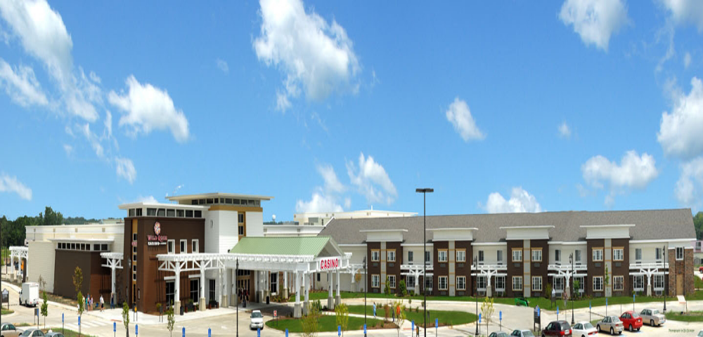
Clinton, IA
 | 2009 | 2010
Admissions | 809,874 | 771,313
Slot Drop | $231,094,993 | $244,124,551
Slot Coin In | $416,648,517 | $417,741,480
Slot Revenue | $37,001,255 | $37,551,557
Table Drop | $11,878,204 | $10,779,432
Table Revenue | $2,263,793 | $2,081,655
Adjusted Gross Revenue | $39,265,048 | $39,633,212
City Tax | $196,326 | $192,775
County Tax | $196,326 | $192,775
Gambler’s Treatment | $100,277 | $0*
Endowment Fund | $314,120 | $308,440
State Miscellaneous Fund | $78,530 | $77,111
Gaming Tax | $7,342,733 | $7,301,004
Regulatory Fee | $764,368 | $757,272
* Deposits from gaming taxes to the Gambler’s Treatment Fund were ended on July 1, 2009 through legislation.

ARGOSY – SIOUX CITY
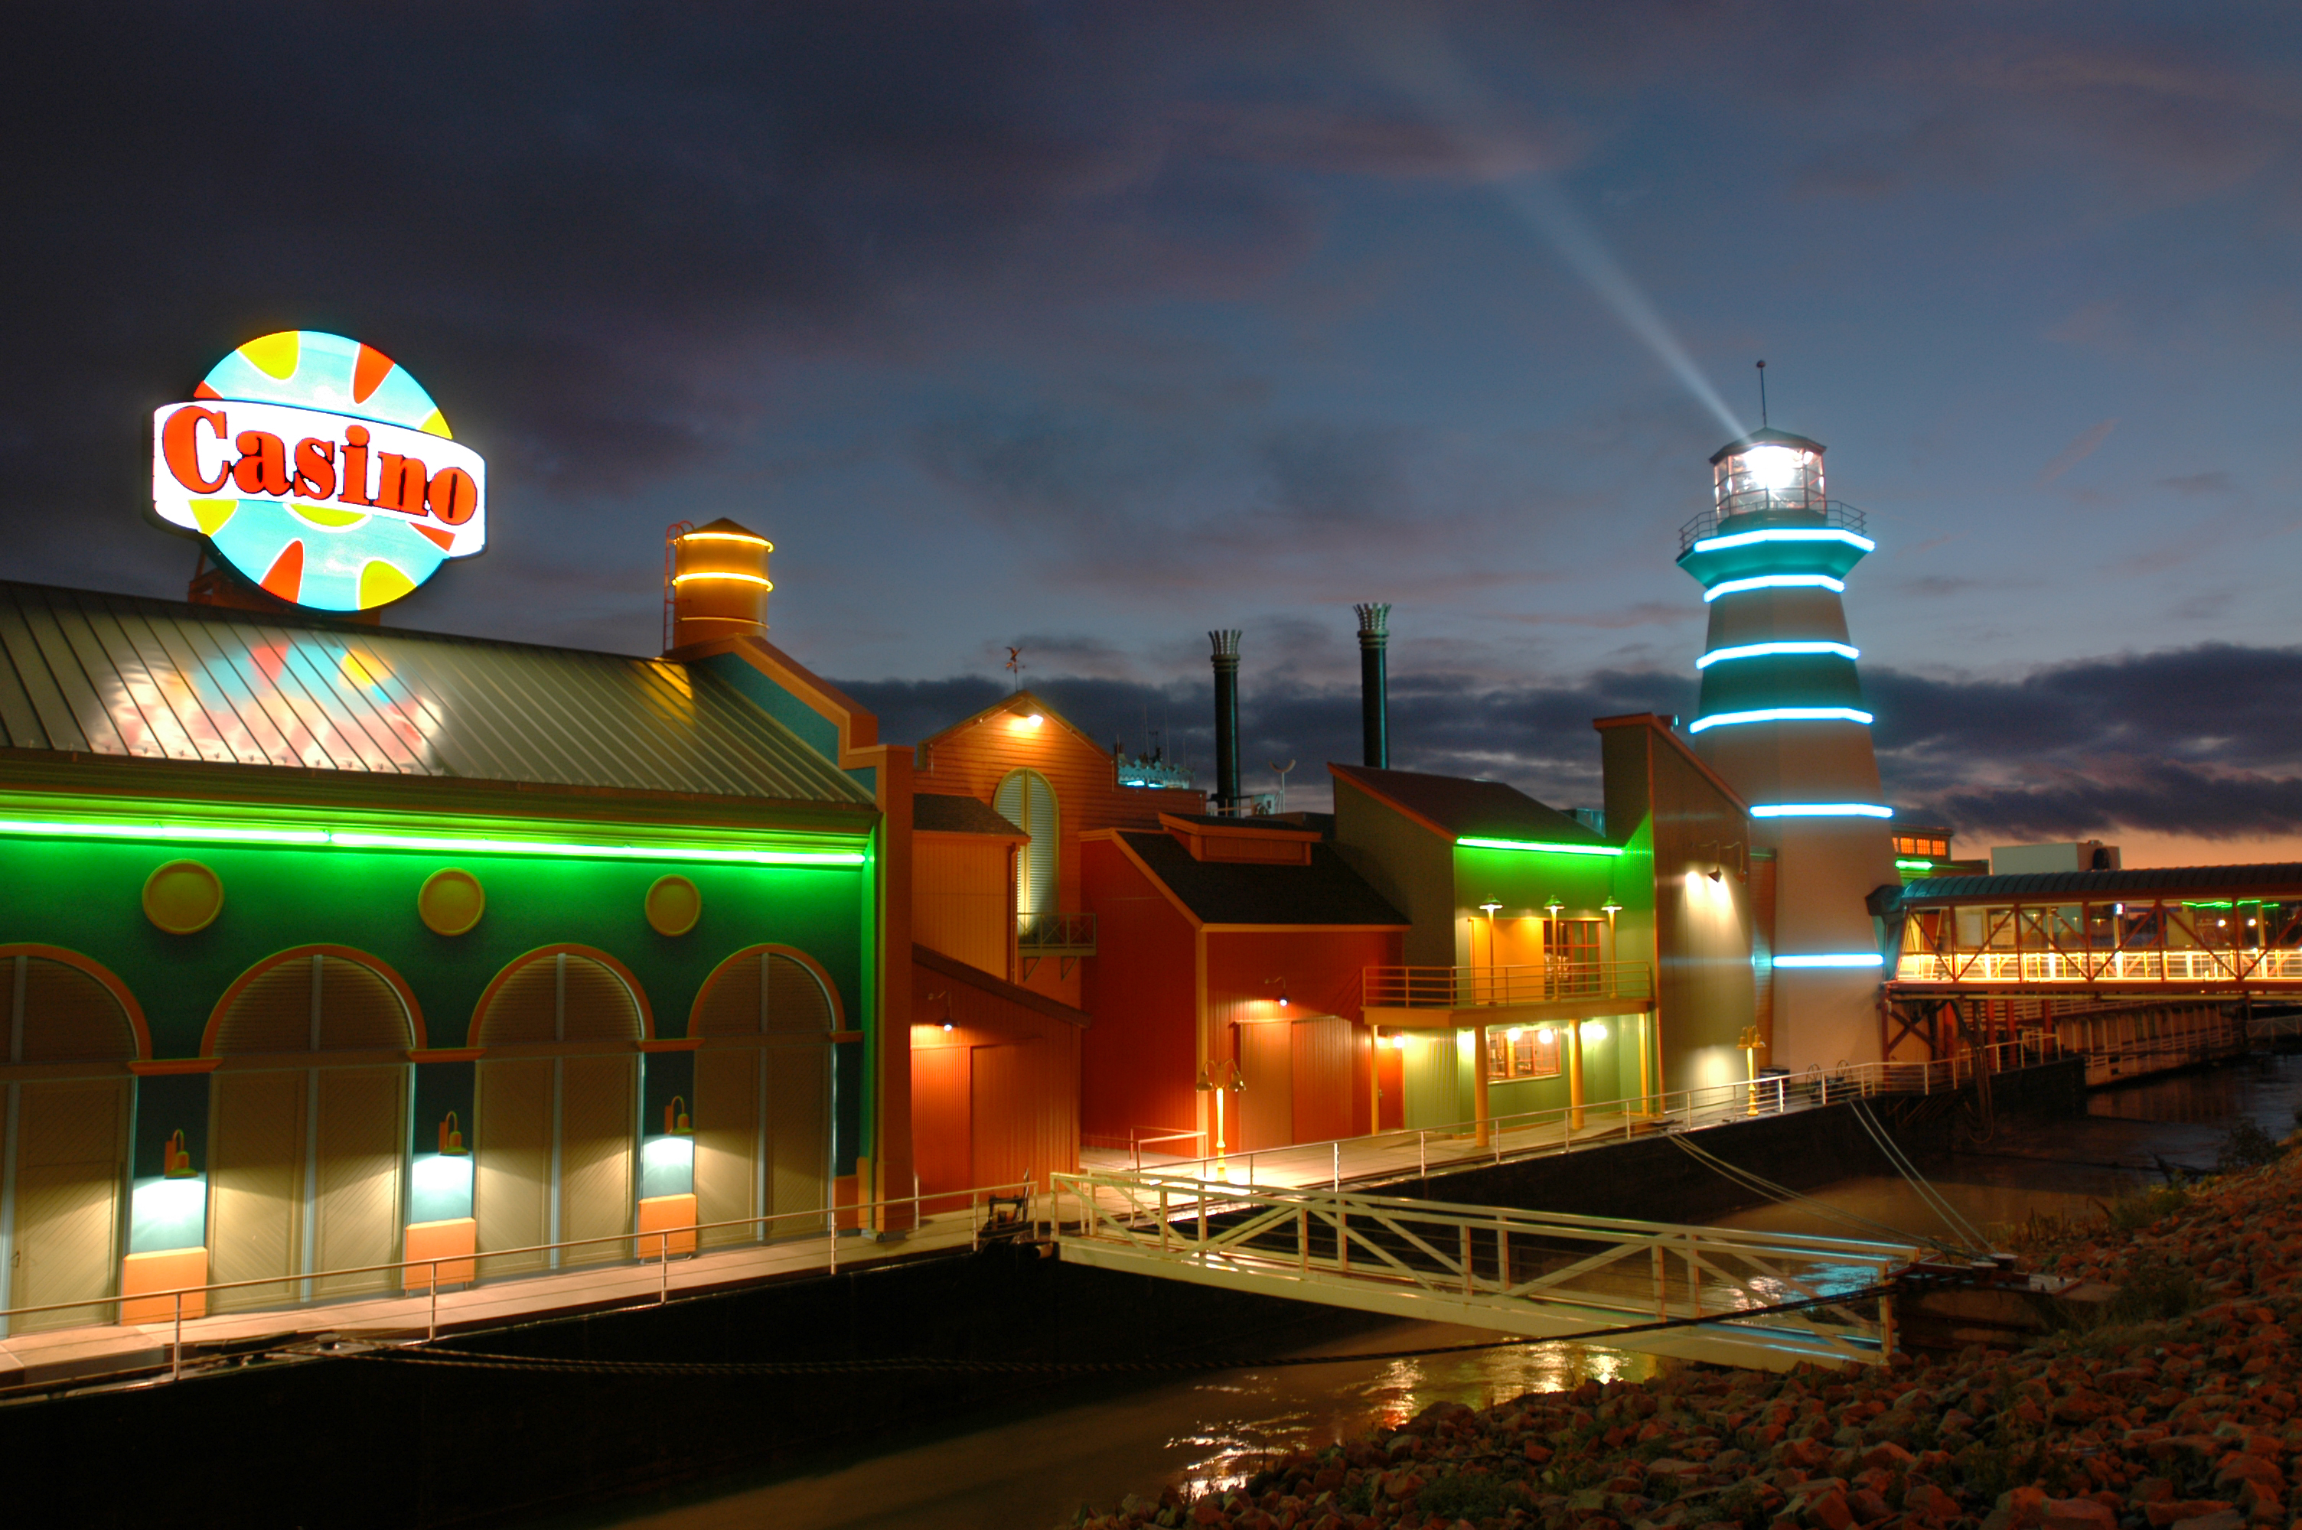
Sioux City, IA
 | 2009 | 2010
Admissions | 1,073,241 | 1,001,961
Slot Drop | $285,933,426 | $298,721,286
Slot Coin In | $563,298,165 | $549,762,381
Slot Revenue | $50,522,779 | $52,483,784
Table Drop | $26,415,856 | $24,043,430
Table Revenue | $6,307,049 | $6,201,640
Adjusted Gross Revenue | $56,829,828 | $58,685,424
City Tax | $284,149 | $275,211
County Tax | $284,149 | $275,211
Gambler’s Treatment | $144,155 | $0*
Endowment Fund | $454,639 | $440,337
State Miscellaneous Fund | $113,660 | $110,083
Gaming Tax | $10,811,811 | $11,008,410
Regulatory Fee | $764,602 | $755,780
* Deposits from gaming taxes to the Gambler’s Treatment Fund were ended on July 1, 2009 through legislation.
RHYTHM CITY CASINO
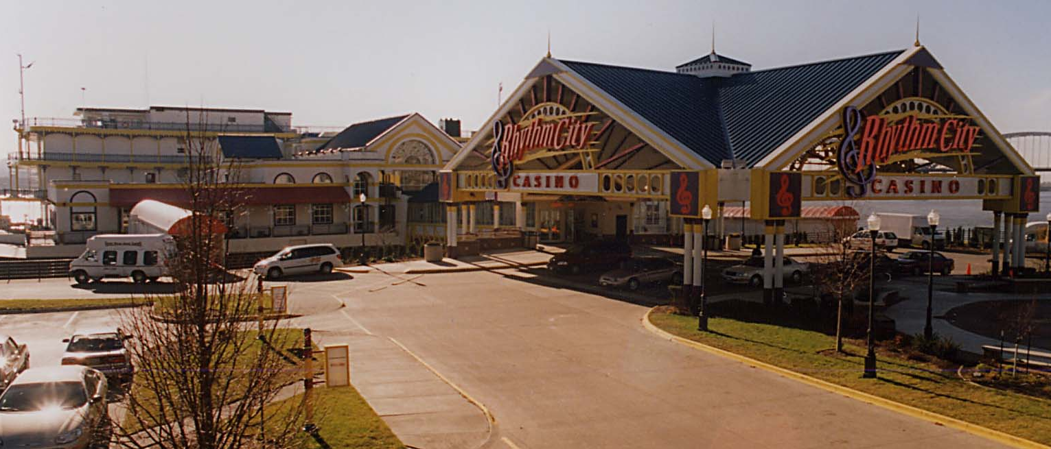
Davenport, IA
 | 2009 | 2010
Admissions | 954,423 | 953,024
Slot Drop | $384,886,146 | $375,442,003
Slot Coin In | $659,692,917 | $615,147,807
Slot Revenue | $54,201,039 | $51,059,957
Table Drop | $10,299,174 | $9,726,713
Table Revenue | $1,964,045 | $1,982,535
Adjusted Gross Revenue | $56,165,084 | $53,042,492
City Tax | $280,826 | $241,016
County Tax | $280,826 | $241,016
Gambler’s Treatment | $144,684 | $0*
Endowment Fund | $449,320 | $385,624
State Miscellaneous Fund | $112,331 | $96,405
Gaming Tax | $10,678,333 | $9,640,614
Regulatory Fee | $844,426 | $855,782
* Deposits from gaming taxes to the Gambler’s Treatment Fund were ended on July 1, 2009 through legislation.

ISLE OF CAPRI-BETTENDORF
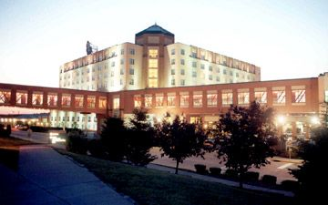
Bettendorf, IA
 | 2009 | 2010
Admissions | 1,173,636 | 1,153,370
Slot Drop | $558,899,415 | $569,301,604
Slot Coin In | $918,838,280 | $884,469,497
Slot Revenue | $76,730,438 | $73,335,478
Table Drop | $28,650,957 | $25,777,047
Table Revenue | $6,105,188 | $5,036,427
Adjusted Gross Revenue | $82,835,626 | $78,371,905
City Tax | $414,178 | $362,877
County Tax | $414,178 | $362,877
Gambler’s Treatment | $218,508 | $0*
Endowment Fund | $662,686 | $580,602
State Miscellaneous Fund | $165,671 | $145,150
Gaming Tax | $15,938,618 | $14,515,054
Regulatory Fee | $913,965 | $879,534
* Deposits from gaming taxes to the Gambler’s Treatment Fund were ended on July 1, 2009 through legislation.

TERRIBLE’S LAKESIDE CASINO
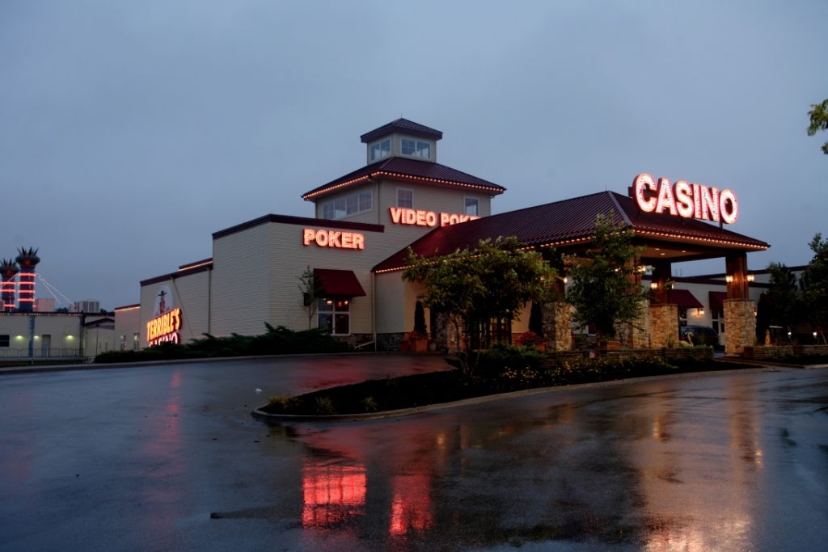
Osceola, IA
 | 2009 | 2010
Admissions | 830,038 | 786,130
Slot Drop | $328,484,895 | $342,810,637
Slot Coin In | $504,827,894 | $505,910,087
Slot Revenue | $46,250,331 | $45,668,860
Table Drop | $16,566,051 | $13,988,358
Table Revenue | $4,246,254 | $3,493,287
Adjusted Gross Revenue | $50,496,585 | $49,162,147
City Tax | $252,483 | $235,474
County Tax | $252,483 | $235,474
Gambler’s Treatment | $130,125 | $0*
Endowment Fund | $403,973 | $376,759
State Miscellaneous Fund | $100,993 | $94,189
Gaming Tax | $9,559,192 | $9,008,980
Regulatory Fee | $762,158 | $736,708
* Deposits from gaming taxes to the Gambler’s Treatment Fund were ended on July 1, 2009 through legislation.

RIVERSIDE CASINO AND GOLF RESORT LLC
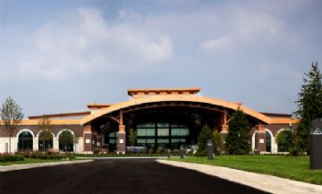
Riverside, IA
 | 2009 | 2010
Admissions | 2,058,408 | 1,997,800
Slot Drop | $578,647,412 | $604,386,064
Slot Coin In | $871,798,035 | $879,245,898
Slot Revenue | $77,255,839 | $77,297,237
Table Drop | $41,913,824 | $39,013,006
Table Revenue | $8,873,951 | $8,403,096
Adjusted Gross Revenue | $86,129,790 | $85,700,333
City Tax | $430,649 | $428,502
County Tax | $430,649 | $428,502
Gambler’s Treatment | $219,263 | $0*
Endowment Fund | $689,038 | $685,603
State Miscellaneous Fund | $172,260 | $171,400
Gaming Tax | $16,596,695 | $16,730,066
Regulatory Fee | $842,554 | $849,882
* Deposits from gaming taxes to the Gambler’s Treatment Fund were ended on July 1, 2009 through legislation.

DIAMOND JO – WORTH
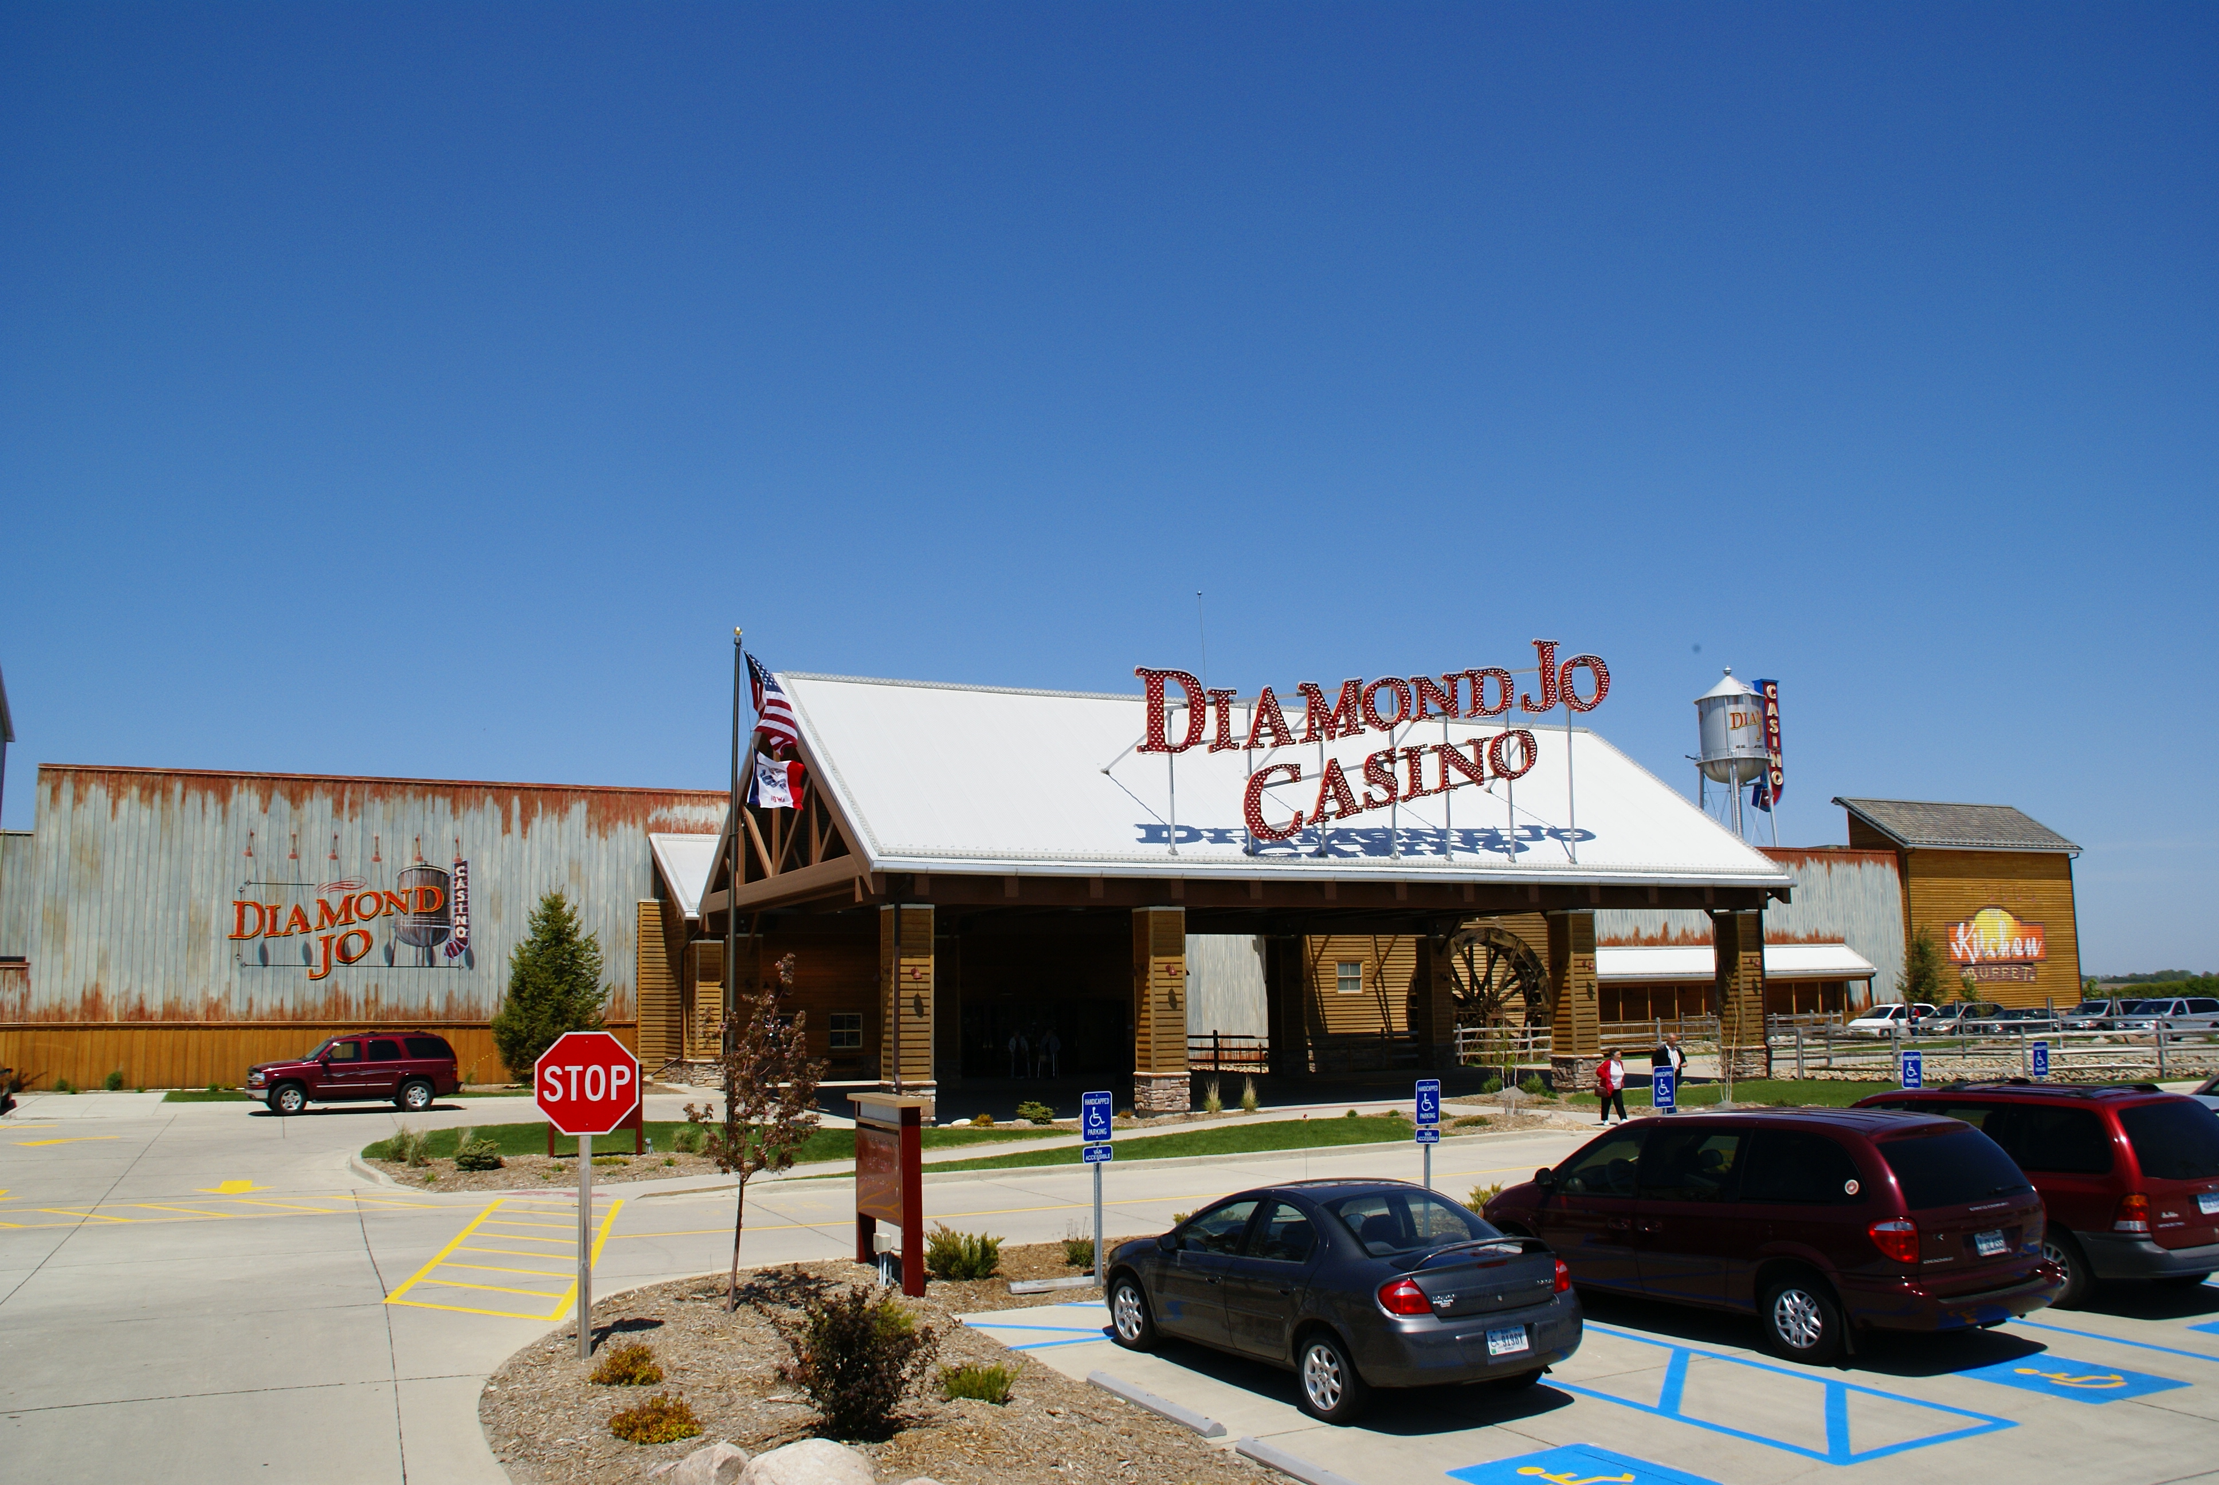
Northwood, IA
 | 2009 | 2010
Admissions | 1,235,944 | 1,278,092
Slot Drop | $457,692,988 | $472,382,547
Slot Coin In | $793,326,540 | $786,136,663
Slot Revenue | $72,654,807 | $74,121,704
Table Drop | $29,249,985 | $28,994,037
Table Revenue | $6,547,943 | $6,864,320
Adjusted Gross Revenue | $79,202,750 | $80,986,024
City Tax | $396,014 | $404,930
County Tax | $396,014 | $404,930
Gambler’s Treatment | $197,726 | $0*
Endowment Fund | $633,622 | $647,889
State Miscellaneous Fund | $158,406 | $161,972
Gaming Tax | $15,232,823 | $15,787,205
Regulatory Fee | $769,438 | $764,656
* Deposits from gaming taxes to the Gambler’s Treatment Fund were ended on July 1, 2009 through legislation.

WILD ROSE – EMMETSBURG
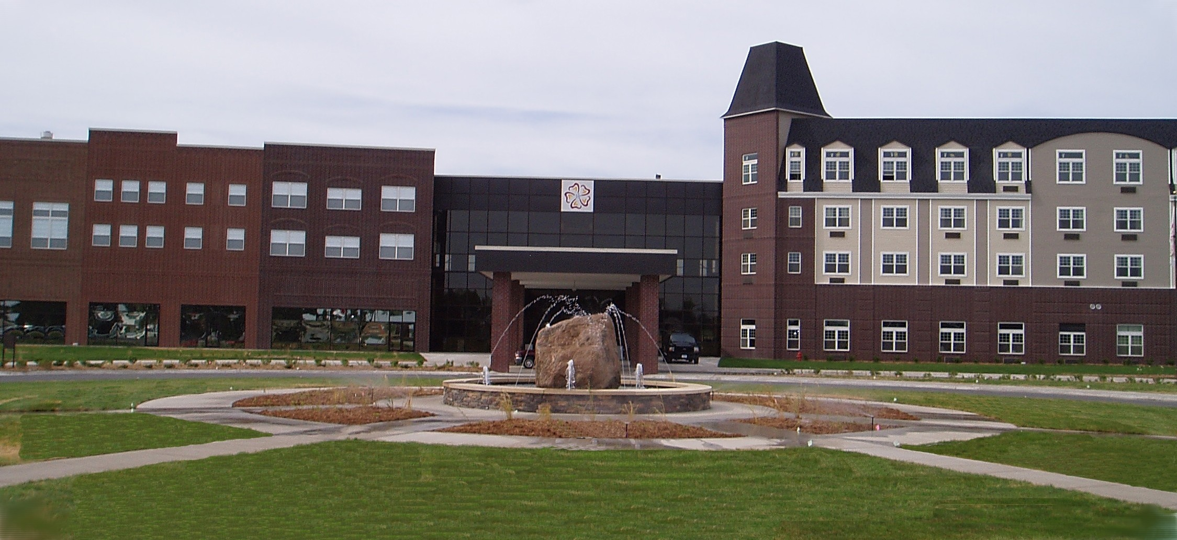
Emmetsburg, IA

 | 2009 | 2010
Admissions | 554,001 | 553,173
Slot Drop | $177,734,930 | $193,603,766
Slot Coin In | $305,206,537 | $314,313,148
Slot Revenue | $25,729,510 | $26,688,181
Table Drop | $11,831,632 | $13,263,345
Table Revenue | $2,516,261 | $2,550,634
Adjusted Gross Revenue | $28,245,771 | $29,238,815
City Tax | $141,229 | $146,194
County Tax | $141,229 | $146,194
Gambler’s Treatment | $71,520 | $0*
Endowment Fund | $225,966 | $233,911
State Miscellaneous Fund | $56,491 | $58,478
Gaming Tax | $5,138,800 | $5,466,597
Regulatory Fee | $749,548 | $731,628
* Deposits from gaming taxes to the Gambler’s Treatment Fund were ended on July 1, 2009 through legislation.
THE ISLE CASINO & HOTEL AT WATERLOO

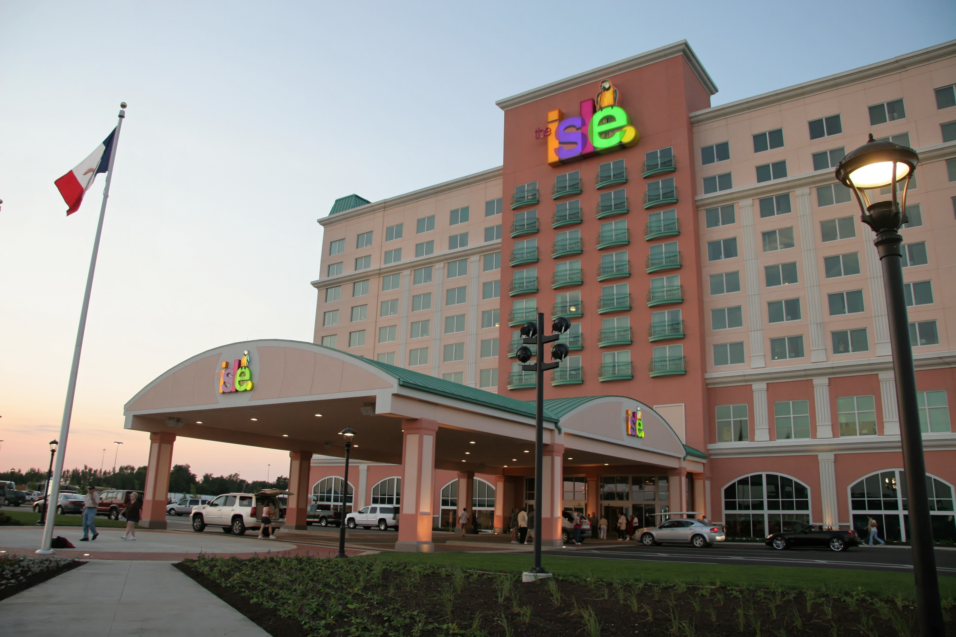

Waterloo, IA
 | 2009 | 2010
Admissions | 1,509,156 | 1,524,429
Slot Drop | $583,487,531 | $612,513,469
Slot Coin In | $888,536,479 | $905,176,067
Slot Revenue | $72,349,510 | $73,743,861
Table Drop | $32,264,479 | $32,365,733
Table Revenue | $6,815,730 | $6,580,316
Adjusted Gross Revenue | $79,165,240 | $80,324,177
City Tax | $395,826 | $401,621
County Tax | $395,826 | $401,621
Gambler’s Treatment | $201,580 | $0
Endowment Fund | $633,322 | $642,603
State Miscellaneous Fund | $158,330 | $160,648
Gaming Tax | $15,221,467 | $15,654,836
Regulatory Fee | $838,290 | $842,036
* Deposits from gaming taxes to the Gambler’s Treatment Fund were ended on July 1, 2009 through legislation.
EXCURSION GAMBLING BOAT/GAMBLING STRUCTURE REVENUE AND EXPENDITURES
2010
EXPENDITURES FOR REGULATION
Salary and Benefits | $2,224,130
Travel | $13,653
State Vehicle | $2,131
Office Supplies/Printing/Postage | $45,389
Equipment Maintenance | $21,500
Communications | $87,489
Rentals | $57,543
Professional, Scientific & Outside Services | $(48,042)
Intra-State Transfers | $30,501
Advertising/Publicity | $0
ITD/IT Outside Services | $64,480
Reimbursements to Other Agencies | $17,955
Equipment | $28,954
TOTAL | $2,545,683
REVENUES TO STATE
Annual Licensing Fees | $228,520
Regulatory Fees | $11,261,396
Occupational License Fees | $68,420
Manufacturers/Distributors License Fees | $30,000
Fines | $32,925
Gaming Tax | $175,150,658
Gambler's Treatment | $0*
State Miscellaneous Fund | $1,775,692
TOTAL | $188,547,611
REVENUES TO LOCAL GOVERNMENT
Gaming Taxes (City/County) | $8,878,492
Endowment Fund | $7,102,801
Many local governments charge an admission fee not to exceed $.50/person as authorized under 99F.10 which is not included above.
* Deposits from gaming taxes to the Gambler’s Treatment Fund were ended on July 1, 2009 through legislation.

