|  |  |
| --- | --- |
| *www.IowaABD.com* | *Lynn M. Walding, Administrator* |

|  |  |
| --- | --- |
|  | e - NEWS |
| *January 9, 2004* | |

1. Drinks With Dazzle

2. Iowans Buying More Alcohol, Trying More Expensive Brands

3. Boy Says He Drank Half-bottle of Vodka

4. New York Smoking Ban's Effect Appears Slight

5. Suspect Drops Beer, Flees, is Captured

6. US: Johnnie Walker gets Hispanic Boost

7. Nightclub Owner Offers Apology

8. Anheuser-Busch Achieves Record U.S. Beer Volume In 2003

9. Global Business Brief

10. Beer Losses Accelerating

|  |  |  |  |  |
| --- | --- | --- | --- | --- |
| http://www.indystar.com/images/clear.gif | |  | | --- | | http://www.indystar.com/images/pics2/image-106450-1402.jpg | | The "Mint Chocolate Chip" martini, center, highlights a trio of specialty drinks featuring high end liqueurs at the Vision Vapour Lounge on the city's north side. -- Steve Healey / The Star |      |  | | --- | |  | |

**1. Drinks With Dazzle**

### The Indianapolis Star

December 29, 2003

**Fancy concoctions satisfy the thirst for something exotic and sophisticated.**

Lisa Wegner raised a martini glass to admire the latest in a string of colorful drinks a chatty Vizion Vapour Lounge bartender had been recommending all night.

"Ooo, pretty," she cooed before taking a sip. "I like this."

Wegner, 36, of Geist, wasn't entirely sure what she was drinking (a Valentino, it turned out -- vodka, rum, peach schnapps, pineapple juice and grenadine), but it didn't make much difference. The point was, the drink was eye-catching.

"It's more impressive when a drink is pretty," she said. "The presentation makes a big difference."

A ritzy cocktail has always been perceived as classy. Who can forget James Bond's signature "martini, shaken, not stirred"? But lately, nightlife crowds have been pushing top-tier wines and spirits through the roof.

Adult beverage sales reached record levels last year in restaurants and bars, and sales of high-end wines and spirits are outpacing their medium- and low-end counterparts, according to Adams Beverage Group, which follows trends in the industry.

Take rum, for instance. In 2002, 17.9 million 9-liter cases of rum were sold in the United States, about $4.3 billion worth at retail. Premium and super-premium brands drove growth, increasing 4 percent each over the previous year, a period during which value brands fell 2 percent.

Flavored rums now account for more than 35 percent of all rums sold.

"A quality drink is a status symbol," said Tiziana Mohorovic, Adams Beverage Group's director of information services. "Going out had sort of gone out of vogue after Sept. 11, but sales are coming back again, and super premium drinks are driving most of the growth."

Some of it's the slowly improving economy, figures John McMahan, 35, of Broad Ripple, who stopped by Vapour Lounge on the Far Northside for a night out with his wife. People may not yet feel confident enough to buy an extravagant house or sports car, but a fancy drink is a fairly harmless indulgence.

"People feel a lot better about spending money on this kind of stuff," he said, holding up a brilliant blue martini. "Everybody likes to go out and have a nice time."

Pop culture accounts for as much of the trend as anything, said Jared Sigler, co-owner of Downtown's Fusion nightclub.

"Especially in the urban community, entertainers dictate what's going to be hot," he said. "Rappers and R&B artists are mentioning names like Grey Goose, Hennessy and Belvedere in their music. Patrons come in wanting what the stars are drinking."

For some people, buying an expensive, brand-name drink is a way to show off. The industry calls it "badging."

The Distilled Spirits Council of the United States credits the HBO series "Sex and the City" with jump-starting the cocktail culture with making specialty designer drinks a fashion accessory.



**2. Iowans Buying More Alcohol, Trying More Expensive Brands**

# By Frank Santiago – Des Moines Register

January 6, 2004

DES MOINES, IA -- Iowans belted down more liquor than ever before – and they paid more for it – this holiday season, new numbers show.

December’s record consumption and sales, officials say, reflect a stronger economy and a willingness, especially among 21- to 27-year-olds, to try different and more expensive brands.

“Almost anything blue sells,” Lynn Walding, administrator of the Alcoholic Beverages Division, said. “Overall sales have been brisk.”

In December, the agency said, state liquor sales hit $14.6 million, a 7 percent increase over the same month a year ago. Consumption increased to 345,809 gallons, a 5 percent jump from 2002.

The spirited drinking, said Walding, put a new name at the top seller list: Captain Morgan Spice Rum, which many customers like to mix with a cola.

Walding said the rum, a one-liter bottle of Captain Morgan that is sold mostly to taverns and restaurants, indicated holiday business at those places was good, too.

"Captain Morgan is popular among the 21- to 27-year olds who are one of the biggest consumer groups," he said. "This is a group that is more willing to try premium products and other brands."

Although Captain Morgan is closing in fast, the overall most popular brand in the state remains Black Velvet whiskey, which claims 7.3 percent of all sales. Hawkeye vodka is second with 4.9 percent, and Captain Morgan third with 4.1 percent.

Tom Duax of Central City Liquor in Des Moines, a wholesaler-retailer, said Iowans have developed a taste for more expensive and exotic brands.

"They're drinking better, not more," he said. "Walk down the vodka aisle and you'll see how the better-quality vodka sales have exploded."

Overall liquor sales have risen steadily in the state since the mid-1990s, according to agency figures. In the fiscal year that ended June 30, liquor sales passed $121 million, well above the $114 million the fiscal year before, which had been a record.

Consumption dropped steadily to a lowin 1995 of 2.4 million gallons, but has increased every year since. In fiscal 2003, Iowans bought 3 million gallons of alcohol, a record.

Walding said the yearly increases can be linked to more advertising in magazines, newspapers and television and more products brought to market.

A new popular seller, he said: Vanilla vodka.

#### Iowa liquor sales and consumption rise

**After several flat years in the 1980s and 1990s,**

**the figures have risen steadily.**

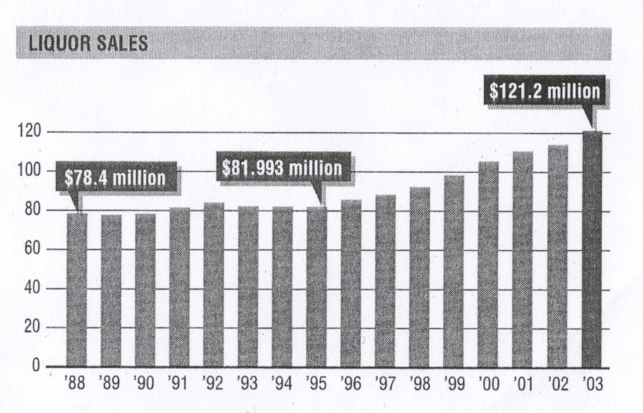

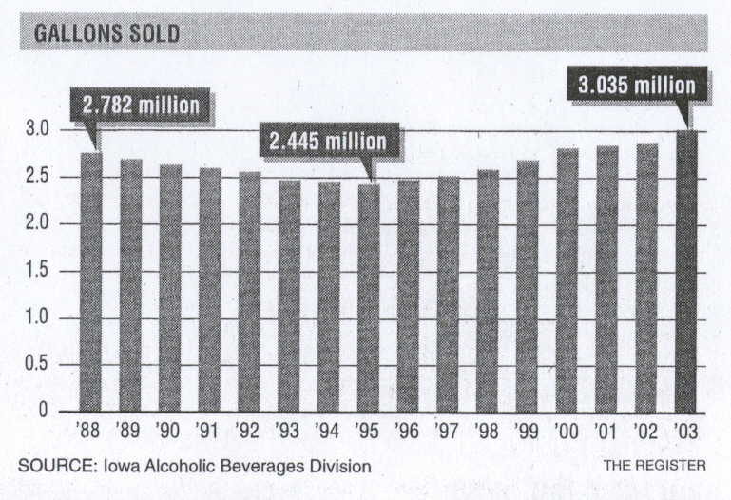



**3. Boy Says He Drank Half-bottle of Vodka**

**By Erin Jordan - *Des Moines Register***

**January 8, 2004**

**He had a blood-alcohol level four times the legal limit and was put on life support.**

**A 13-year-old boy who was put on life support after getting drunk with friends last week said Wednesday that he drank more than half a bottle of vodka.**

**Travis Talbot, a seventh-grader at Frank L. Smart Intermediate School in Davenport, said he and a friend, 12-year-old Shawn Yuille, didn’t plan to drink December 29. But school was out, and the boys visited an older teenage friend in a nearby apartment.**

**Talbot said that he had not had vodka before, but on that day he drank a little more than half a large bottle, straight up. His blood-alcohol content was .329 – more than four times the legal limit.**

**“I remember me sitting on a couch and accidentally hitting my head on the wall. I don’t remember anything after that,” Talbot said.**

**The case drew public attention after Yuille’s parents, Mark and Sandra Leckington, were charged with child endangerment causing serious injury for not taking an unconscious Talbot to the hospital for several hours.**

**The couple left Talbot and Yuille at home without supervision, police said, and only later called 911 at their son’s plea.**

**Talbot does not remember Yuille placing him in a bathtub full of cold water and splashing his face. “Shawn was trying to get me awake and stuff,” Talbot said Wednesday.**

**When paramedics arrived at the Leckingtons’ home, Talbot’s face was pale and his lips were turning purple, police reported. Talbot’s father, William, said his son was in a coma at University Hospitals in Iowa City for 14 hours.**

**Travis Talbot said Wednesday that he was tired and a little scared about what could have happened. The teen said he didn’t plan to drink again.**



**4. New York Smoking Ban's Effect Appears Slight**

By Winnie Hu - *The New York Times*

December 28, 2003

NEW YORK, NY -- When New York banned smoking in its bars and restaurants in March, opponents warned that the tough new law would drive away customers and devastate businesses. Supporters insisted that New Yorkers would adjust quickly.

Nine months later, the impact is hardly so clear-cut. An examination of government data, public polls, private surveys and interviews with customers, employees and owners of more than three dozen bars and restaurants shows the law affecting some businesses, but certainly not all.

Many bar owners and managers say the smoking ban has hurt business, eroding profits and, in some cases, forcing them to cut back hours or lay off workers. Others say they have seen virtually no effect.

Some restaurants and bars say that business is fine — even thriving, as the economy improves — particularly in places where food is a main draw. Further, a large majority of New Yorkers have said in recent polls that they are happy with the new law. One survey shows many regular restaurant-goers see a smoke-free environment as an attraction.

That does not mean, though, that some city night spots are not hurt. Happy-hour sales on Friday nights at the Whiskey Ward on the Lower East Side have dropped to barely $100, from $600, a co-owner says, and regulars have disappeared along with the ashtrays.

A co-owner of Patroon, a steakhouse in Midtown, says he no longer sees much of a cigar-puffing, after-dinner crowd. And in the meatpacking district, the owner of Hogs & Heifers, where Julia Roberts once was enticed to dance on the bar, says she is considering laying off four employees.

Then there are the many nuisances wrought by the smoking ban, which bar owners and bartenders say just makes it harder to scrape out a living.

"It's harder to keep track of everybody going in and out," said Chuck Zeilfelder, a bartender at Bourbon Street in Queens who opposes the ban. "It's common for people to leave money on the bar, and that becomes an issue — how much they left. Also, people leave their drinks on the bar and go out. The drinks get thrown out, and then you have to buy them another round on the house."

It is unclear whether the complaints about the smoking ban are anything more than growing pains, as a city that prides itself on its night life adjusts to the far-reaching new law. Certainly, where the city goes from here is of great interest to other places around the world, such as Ireland, Norway and Lexington, Ky., which are debating versions of the law.

The early evidence, however, is that many businesses are unharmed. In fact, though rumors swirl in an environment where every bit of news is touted by the side it favors, a reporter could not verify that one bar, restaurant or club, of the more than 20,000 in the city, had closed solely because of the smoking ban.

The ban also does not appear to have deterred businesses from opening. The New York State Liquor Authority received 127 license applications from city businesses last month, compared with 126 in November 2002. The number of licenses granted in that same period rose to 106 last month, from 75 the year before.

The city's Health Department, which enforces the smoking ban, has analyzed monthly employment numbers and found no overall job loss in the food-service and drinking industry.



**5. Suspect Drops Beer, Flees, is Captured**

# **Des Moines Register**

**January 8, 2004**

**WEST DES MOINES, IA -- A man was arrested by West Des Moines police, and a carload of stolen beer was recovered after a car chase early Wednesday.**

**The incident began when West Des Moines police responded to an alarm at 4:40 a.m. at the Vieux Carre nightclub and 3rd Base Sports Bar, 1720 25th St. in West Des Moines. Officer Troy Shelley saw a man carrying several flats of canned beer from the storage cooler behind the business. The man dropped the beer when he saw the officer, jumped into a blue Cadillac and drove off. Police pursued the car, but lost sight of it near the intersection of 19th Street and Ashworth Road.**

**A short time later, Iowa State patrol Trooper David Halverson saw the vehicle near Ankeny. After a short pursuit, the car was stopped just south of Ankeny.**

**The driver and only occupant of the car, Steven James Zohrer, 20, of 1006 S.E. Belmont St. in Ankeny was arrested. Police charged Zohrer with burglary, possession of burglary tools and eluding police. Officers said that 22 cases of beer and three kegs were found in the back seat and trunk of Zohrer’s vehicle.**



**6. US: Johnnie Walker gets Hispanic Boost**

**Anne Brockhoff *– Just-Drinks.com***

**January 5, 2004**

**Johnnie Walker has the Hispanic market to thank for a rise in sales, according to the Whisky’s US importer. Sales of Johnnie Walker Black Label Scotch in Hispanic markets helped drive growth of the brand by about 8% in 2003, said Manny Gonzalez, senior brand manager at Schieffelin & Somerset.**

**Hispanic markets like Florida, New York and New Jersey accounted for about one-quarter of the increase, he said. Johnnie Walker Black sales reached 643,000 cases in 2002. The gains come after a 40% boost in media spending in key Hispanic markets during the current fiscal year, which ends June 30. Vidal Partners a New York-based Hispanic agency is taking over that portion of the brand’s marketing for 2004, Gonzalez said.**

**“Florida, New York and New Jersey are still contributing a significant amount of growth,” Gonzalez said. “We see emerging markets like Boston, Houston and California contributing an even bigger share” of Hispanic sales in the future.**



**7. Nightclub Owner Offers Apology**

By Sherkiya Wedeworth –*Des Moines Register*January 5, 2004

CLIVE, IA -- The owner of a Clive nightclub said Sunday that he wants to apologize to the double-amputee soldier who says he was refused admittance into the club over the weekend.

Iowa National Guard Spc. Robert "B.J." Jackson and his wife, Abby, said Saturday they were barred from Crush nightclub because the soldier was wearing tennis shoes. Robert Jackson had both legs amputated below the knees after an ambush in Iraq, and the shoes fit his prosthetics.

"I would like the chance to meet the Jacksons and resolve this issue, including a personal apology about this misunderstanding from me," Crush owner Tom Baldwin said in a letter sent to the Iowa National Guard; U.S. Sen. Tom Harkin; attorney Roxanne Conlin, a Des Moines lawyer who said the issue is worthy of a discrimination suit; and the city of Clive.

Baldwin was adamant that the Jacksons did not explain to the bouncers that Jackson was an amputee. He said the couple left abruptly when they were told Jackson could not wear tennis shoes into the club.

The Jacksons and a friend said Saturday that Jackson showed the bouncers his prosthetic legs.

Baldwin said he has not had any communication with the Jacksons and looks forward to speaking with them, calling the situation a "learning experience."

"I don't want to say, 'Here, let's just forget about it and I'll buy you a drink.' I want to sit down with the Jacksons . . . and see what they want to do," Baldwin said.

He said he believes the situation is a misunderstanding that has been blown out of proportion.

"It's gone from a tennis shoe situation to a disability issue. It's just outrageous and goes against everything I believe," Baldwin said.

He said that he does not know how to contact the Jacksons and hopes that the word will get out that he wants to talk to them.



**8. Anheuser-Busch Achieves Record U.S. Beer Volume In 2003**

## Dow Jones Newswires

January 7, 2004

ST. LOUIS, MO -- Anheuser-Busch Cos. (BUD) reaffirmed its earnings guidance for 2003 and 2004 after reporting its best-ever U.S. beer sales volume for the year.

In a press release Wednesday, the brewer said it still expects 2003 earnings per share to be about 12% to 13% higher than a year ago, or $2.46 to $2.49 a share based on 2002 earnings of $2.20 a share. For 2004, Anheuser-Busch continues to expect earnings per share to grow about 12%.

The 16 analysts polled by Thomson First Call currently expect Anheuser-Busch to earn $2.48 a share in 2003, on average. Those analysts expect earnings of $2.78 a share in 2004, which is 12% higher than their average estimate for 2003.

Anheuser-Busch said its U.S. beer unit, Anheuser-Busch Inc., shipped 102.6 million barrels of beer to wholesalers in 2003, or about 0.8% more than it shipped in 2002.

Fourth-quarter shipments to wholesalers grew 0.5%.

Shipments were boosted mostly by Michelob ULTRA, the company's low carbohydrate brand, as well as a higher volume of Bud Light sales, Anheuser-Busch said.

Anheuser-Busch's common stock rose about 34 cents to $51.72 a share in after hours trading on INET.



**9. Global Business Brief**

**Wall Street Journal**

**January 28, 2004**

**Anheuser-Busch Cos.**

**A court rejected a claim by U.S. brewer Anheuser-Busch Cos. that Czech brewer Budvar AS was infringing its trademark in south Korea. Budvar, a state-run company, said a South Korean appellate court upheld Budvar’s rights for the Budejovicky Budvar trade name and company registry in the country. Budvar has waged a decades-long legal battle with Anheuser-Busch over rights for the Budweiser and Bud trade names in markets world-wide. Anheuser-Busch argued the use of the Budvar trademark and company name was a conflict with its own trademark. But the court ruled the Czech trademark isn’t in conflict with the U.S. company and doesn’t violate its rights, according to a statement from Budvar. Anheuser-Busch said the ruling doesn’t affect its rights to sell Budweiser in the country and simply allows Budvar to continue to use its trade name, not the Budweiser trademark. Anheuser-Busch said it disagreed with the court’s decision and was considering its legal options.**



**10. Beer Losses Accelerating**

Source: *Beernet Online*

January 6, 2004

Looks like December went out with a ... dud. Even though we were cycling pretty easy numbers, the month was soft for many distributors we talked with, though not as soft as scanner data made it out to reasons we’ve already discussed (grocery strikes, fires, Wal-Mart, etc.).

It looks like declines began to accelerate toward the end of the month as consumers didn’t get out to the stores as much this year during the holiday break. Many retail segments, not just consumer goods, showed weakness during the holidays as consumers stayed put.

The beer category in supermarkets was down 7.5% in the three weeks to Dec. 21, with sales even worse than that for the last of those weeks, according to IRI (and beer pricing only up 1.5%). I haven’t seen numbers that bad in a long time, particularly against easy comps. In fact, the only top brands to gain share in the last week in supermarkets (including Bud, Bud Light, Miller Lite, Coors Light, Heineken, and Corona) were Mich Ultra and Miller Lite.

As one distributor put it, "The price increases may have caught up with us." Or perhaps wine and spirits have caught up with us.

