FISCAL UPDATE January 21, 2002
Legislative Fiscal Bureau (515)-281-5279 FAX 281-8451
http://staffweb.legis.state.ia.us/lfb/
the governor’s fy 2003 budget recommendations
IN THIS ISSUE: | Governor’s FY 2003 Budget Rec., pg. 1 | Regents Performance Indicator Report, pg. 15
 | HF 2075-Endowment Reimbursement, pg. 4 | Personal Assistance/Family Sup. Svcs. Rpt., pg. 17
 | State of the Judiciary Summary, pg. 5 | Mental Health/Develop. Disabilities Rpt., pg. 17
 | Gov’s Rec. - School Foundation Aid, pg. 5 | Lottery Revenues and Expenditures, pg. 19
 | Medicaid Infrastructure Grant Workgroup, pg. 7 | Elder Affairs, Notice to Rescind Chapters, pg. 20
 | Human Services Council Special Meeting, pg. 7 | Ames Receives Rail Economic Dev. Grant, pg. 21
 | Soil Conservation Committee Meeting, pg. 8 | Cedar Falls Receives RISE Grant, pg. 22
 | Board of Regents Meeting, pg. 9 | Issue Review-Integrated Farm Mgmt Prgm., pg. 22
 | College Student Aid Commission Mtg., pg. 13 | Issue Review-Parking Structure Construction, pg. 23
 | Status of African-American Report, pg. 13 | Issue Review-LIHEAP, pg. 24
 | DOC Required Reports, pg. 14 | Issue Review-School Foundation Aid, pg. 25
 | South Iowa Regional Jail Board Report, pg. 14 | Issue Review-Road Use Tax Fund Overview, pg. 25
 | Drug Control Policy Report, pg. 14 | What’s New on the LFB Web Site?, pg. 27
Gov’s FY 2003 Budget The Governor released his FY 2003 Budget recommendations on Friday, January 18. The Governor's FY 2003 General Fund appropriation recommendation is $4.8 billion, an increase of $87.2 million (1.9%) compared to estimated FY 2002.
FY 2002
Gov.
FY 2003

The Governor is not recommending a General Fund supplemental appropriation for FY 2002. The Governor is recommending Other Funds as a source for $18.6 million in supplemental appropriations for Medicaid (see Table 1 for detail).
FY 2003
The Governor’s FY 2003 General Fund budget recommendation proposes revenue changes resulting in a net revenue increase of $62.5 million. The four largest revenue changes are:
- $48.0 million Economic Emergency Fund (EEF) to General Fund - Increase revenues by $48.0 million by transferring funds from the EEF to the General Fund. This requires legislative action.
- $30.4 million Iowa Veterans Home Net Budgeting – Decrease General Fund revenues by $30.4 million by implementing net budgeting at the Iowa Veterans Home. This decrease in revenues is offset by a $33.6 million decrease in the FY 2003 Governor’s recommended appropriation for the Iowa Veterans Home.
- $20.0 million Reserve Fund Interest - Increase revenues by $20.0 million by depositing the interest on the Reserve Funds into the General Fund. This was done for FY 2002, and the Governor’s proposal extends it an additional year. The interest on these funds had been deposited into the Rebuild Iowa Infrastructure Fund (RIIF).
- $16.0 million Tax Reciprocity - Increase revenues by an estimated $16.0 million by terminating the Iowa/Illinois tax reciprocity agreement.
Other Revenue Changes Other major revenue changes recommended by the Governor involve moving items funded from the General Fund in the past to non-General Fund sources. The Governor is recommending that $58.0 million be appropriated from the Motor Vehicle Use Tax to pay for expenditures funded from the General Fund in FY 2002. In addition, the Governor is recommending an $18.6 million supplemental appropriation in FY 2002 and $47.0 million in FY 2003 for Medicaid be funded from non-General Fund sources. Table 1 shows the recommended shifts.
Table 1 – Governor's FY 2002 Supplemental and FY 2003 Appropriations

Offsets to the General Fund

 |  |  |  |  | General Fund |  | Gov. Supp. |  | Gov. Rec.
 | Appropriation |  | Proposed Fund |  | Est. FY 2002 |  | FY 2002 |  | FY 2003

Public Safety
 | Public Safety Administration |  | Motor Vehicle Use Tax |  | $ 2,551,402 |  | $ 0 |  | $ 2,510,480
 | Investigation, DCI |  | Motor Vehicle Use Tax |  | 12,606,956 |  |  |  | 12,846,699
 | Undercover Funds |  | Motor Vehicle Use Tax |  | 129,804 |  |  |  | 129,804
 | Capitol Police |  | Motor Vehicle Use Tax |  | 1,323,575 |  |  |  | 1,323,575
 | Iowa State Patrol |  | Motor Vehicle Use Tax |  | 38,439,694 |  |  |  | 38,160,344
 | DPS/SPOC Sick Leave Payout |  | Motor Vehicle Use Tax |  | 288,139 |  |  |  | 288,139
Economic Development
 | Value-Added Ag Products |  | Motor Vehicle Use Tax |  | 2,727,450 |  |  |  | 2,727,450
 |  |  | Use Tax Total |  | $ 58,067,020 |  | $ 0 |  | $ 57,986,491
Human Services
 | Medicaid |  | Medical Asst. Supp. SLTF |  | $ 0 |  | $ 5,000,000 |  | $ 10,000,000
 | Medicaid |  | Hospital Trust Medical Supp. |  |  |  |  |  | 25,000,000
 | Medicaid |  | Tobacco Endowment |  |  |  | 13,600,000 |  | 12,000,000
 |  |  | Grand Total |  | $ 58,067,020 |  | $ 18,600,000 |  | $ 104,986,491

Medicaid The Governor's Medical Assistance (Medicaid) FY 2003 recommendation includes a reduction of $40.0 million compared to projected need, to be determined at a later date with the General Assembly by either increasing revenues specifically for funding Medicaid, or by decreasing expenditures for Medicaid.
FY 2003 Approps. The Governor’s FY 2003 General Fund budget recommendation proposes appropriations resulting in an increase of $87.3 million. The five largest changes (not discussed in the above sections) are:

- $55.6 million Salary Adjustment - The Governor’s FY 2003 General Fund budget recommendation includes an appropriation of $55.6 million for salary adjustment. This is an increase of $63.9 million compared to FY 2002. The FY 2002 Salary Adjustment Fund contained $9.0 million of one-time non-General Fund resource (Underground Storage Tank funds) that needs to be replaced for FY 2003 as on-going costs.
- $59.0 million School Aid - The Governor’s FY 2003 General Fund budget recommendation for School Aid is an increase of $59.0 million. This recommendation reduces allowable growth from 4.0% to 1.0%.

- $40.0 million Teacher Quality/Student Achievement - The Governor recommends $40.0 million to continue the Teacher Quality/Student Achievement Program for FY 2003. This Program was funded at $40.0 million in FY 2002 through an appropriation from Tobacco Settlement funds.
- $27.1 million Iowa Health Endowment - The Governor recommends a General Fund appropriation to the Iowa Health Endowment of $27.1 million to pay for debt service on capital projects. This is an increase of $19.8 million compared to FY 2002. This increase is offset by reducing the General Fund appropriation for the Board of Regents debt service by an additional $8.5 million and the Iowa Communications Network (ICN) debt service by an additional $11.3 million.
- $17.0 million New Administrative Agency - The Governor recommends $17.0 million for a combined administrative agency. This agency would include the Department of Personnel, Department of General Services, ICN, Information Technology Department, and the Financial Management Section of the Department of Revenue and Finance. The FY 2002 General Fund appropriation for all these entities was $20.0 million. The Governor is recommending a net reduction of $3.0 million.
Projected Ending Balance The Governor’s FY 2003 proposed expenditures are $200,000 lower than the 99.0% expenditure limitation. The Governor’s projected ending balance for FY 2003 is $60.9 million compared to $1.5 million in FY 2002, an increase of $59.4 million.
Reserve Funds For FY 2001, there was a $66.1 million transfer from the Economic Emergency Fund to the General Fund to offset a General Fund deficit. This reduced the Reserve Fund Balance to 8.7%, instead of the 10.0% of the General Fund’s requirement for FY 2002. The Governor is recommending transferring $48.0 million from the Economic Emergency Fund to the General Fund and $3.3 million to the Cash Reserve Fund to meet the 5.0% requirement. This would reduce the Reserve Fund balance to 7.5%, instead of the 10.0% of General Fund’s requirement for FY 2003. The following chart displays the Reserve Fund’s 10.0% requirement and the actual/proposed balance.
Chart 1 – 10.0% Reserve Fund Requirement v. Actual/Governor's Recommendation
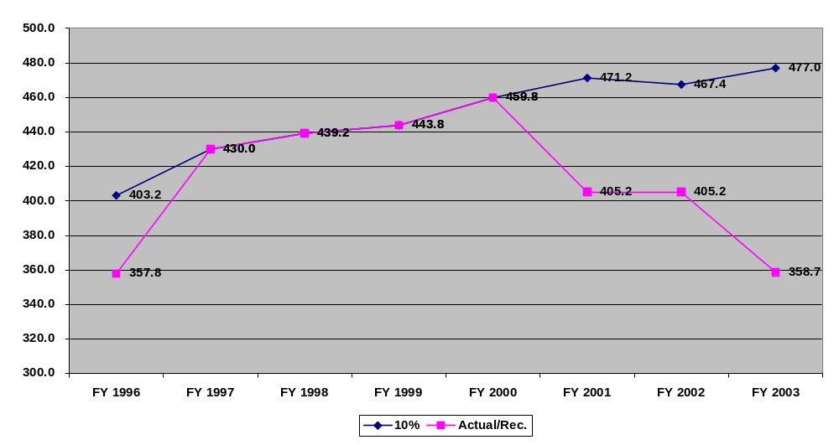
(Dollars in Millions)
LFB Analysis The Legislative Fiscal Bureau’s summary analysis of the Governor’s Recommendation is available on the LFB web site at:http://staffweb.legis.state.ia.us/lfb/.
STAFF CONTACT: Glen Dickinson (Ext. 14616) Dennis Prouty (Ext. 13509)
House Appropriations Committee passes HF 2075 - Endowment Reimbursement Bill
HF 2075 The House Appropriations Committee passed HF 2075 (Endowment Reimbursement Bill) that establishes a mechanism to reimburse the Endowment for Healthy Iowans $40.0 million beginning in FY 2003.

Endowment Reimbursement The General Assembly appropriated $40.0 million from the Endowment to fund the Teacher Quality Act in FY 2002. Senate File 531 (FY 2002 Administration and Regulation Appropriations Act) contained language that provided for the repayment of the $40.0 million from excess revenues in the Economic Emergency Fund at the end of FY 2001 and FY 2002. However, due to budget shortfalls, the funds will not be repaid by the end of FY 2002.
Transfer to Begin in FY 2003 Beginning in FY 2003, HF 2075 requires any funds that are in excess of the amount required to maximize the balance of the Economic

Emergency Fund be transferred annually to the Endowment for Iowa's Health Account until the total amount transferred reaches $40.0 million.
STAFF CONTACT: David Reynolds (Ext. 16934)
State of the Judiciary Summary
Annual State Message Chief Justice Louis Lavarato gave his annual State of the Judiciary to the General Assembly on January 16. The Chief reinforced the fact that access to Justice is the Judicial Branch’s greatest focus.

Response to 4.3% Reduction Due to the $5.2 million reduction that was implemented after the Second Extraordinary Session, the Judicial Branch eliminated the Court Appointed Special Advocate Program, which was later moved temporarily to the Ombudsman’s Office. Personnel within the Judicial Branch was also impacted by the reduction: 107 employees were laid off, 67 employees had their hours cut, 79 employees were downgraded from supervisory positions, and an additional 20 vacant positions were eliminated.
Impact on Clerk Offices Some key areas that were addressed in the Chief Justice’s speech were the impact of the budget cuts on the Clerk of Court offices in the 99 counties, the eleven satellite magistrate offices, electronic access, and streamlining efforts.
Chief’s Recommendation The Chief Justice recommended that in order to streamline services, unnecessary tasks should be eliminated or shifted to other agencies, a recommended statutory change should be made that would allow the Court the authority to determine the structure of the judicial districts (which has not occurred in over 30 years), and a statutory change should be made that would eliminate the mandate that there be a Clerk of Court official in every county.
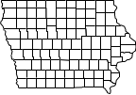
STAFF CONTACT: Jennifer Dean (Ext. 17846)
School Foundation Aid - Governor’s Recommendation
FY 2003 – School Aid The Governor recommends appropriating $1,784.1 million in State aid for allowable growth in FY 2003. This is a $59.0 million (3.4%) increase compared to the adjusted FY 2002 amount. The Governor is also recommending the following changes in FY 2003:

- Reduce the FY 2003 allowable growth rate to 1.0%. The FY 2003 allowable growth rate was set at 4.0% during the 2001 Legislative Session.
- Continue the $7.5 million State aid reduction to Area Education Agency Special Education (AEA) Support Services. This reduction was made during the FY 2001 Legislative Session in HF 755 (FY 2002 Standing Appropriations Act).
- Require that if the calculated State aid amount for allowable growth is greater than the appropriated amount, that difference be reduced to school districts on a per pupil basis. However, school districts would have the option to levy for that difference (estimated to be $11.0 million).
Allowable Growth The FY 2003 allowable growth rate was set at 4.0% during the 2001 Legislative Session. If no change is made during the 2002 Legislative Session, it is estimated that State school aid will increase approximately $147.7 million (8.6%) compared to the adjusted FY 2002 State aid amount.
FY 2004 Recommendation The Governor recommends a FY 2004 allowable growth rate of 3.0% for FY 2004. The Governor also recommends continuing the $7.5 million State aid reduction to Area Education Agencies. This is estimated to be an increase of approximately $76.3 million (4.3%) compared to the Governor’s FY 2003 recommendation.
FY 2002-2004 Funding The table below details State school aid amounts for FY 2002, current law FY 2003, the Governor’s proposal for FY 2003, and the Governor’s proposal for FY 2004.
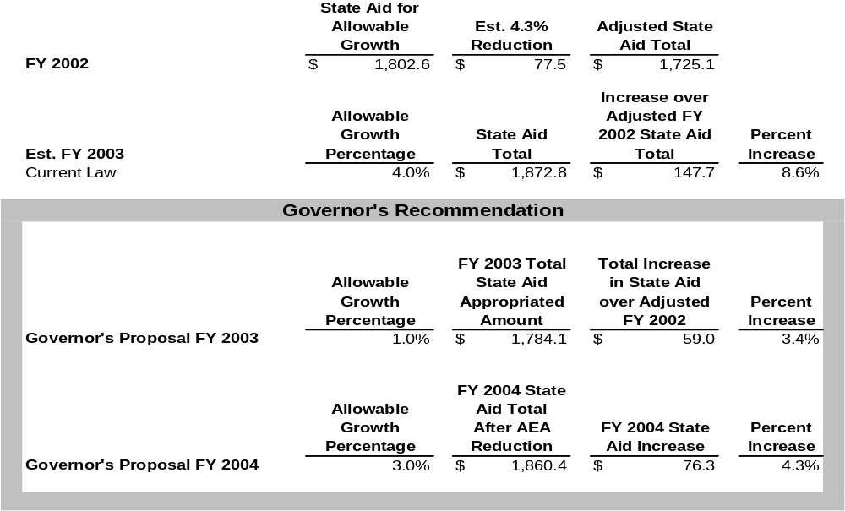
School Foundation Aid Funding Totals
(Dollars in Millions)
Current Law Current law requires the General Assembly to pass an allowable growth rate within 30 days of the submission of the Governor’s budget. The FY 2004 allowable growth rate is required to be approved by February 17 under current law.

More Information For further information pertaining to school aid amounts, contact the Legislative Fiscal Bureau.
STAFF CONTACT: Shawn Snyder (Ext. 17799)
January Meeting of Medicaid Infrastructure Grant Workgroup
Workgroup Meeting The Medicaid Infrastructure Grant Workgroup met on January 9 and conducted the following business:

- An update was given on the January 4 meeting with Lt. Governor Pederson to discuss the Personal Assistance Services (PAS) Program proposal and to seek assistance with funding. The Workgroup was told to look at cost avoidance. How will the PAS Program assist to keep people out of nursing facilities? There is a need to use this year to advocate for this Program. The Lt. Governor would help with telling the story. There is also a need to understand what the Legislature will support. The Workgroup was encouraged to keep advocating for this Program, even though it probably will not happen this year.
- Development of Work Plan Strategies: The Workgroup discussed plans to contact several groups to help advocate for the PAS Program and to give overviews of the Report sent to the Governor and Legislature. The objective is to identify partners and get support for the PAS Program as part of the Iowa Medicaid State Plan.
- Next meeting is scheduled for February 13.
STAFF CONTACT: Sam Leto (Ext. 16764)
Special January Council on Human Services Meeting
Special Council Meeting The Council on Human Services met January 16 and adopted an emergency administrative rule to comply with the 4.3% across-the-board reduction required by the Governor’s Executive Order 24 in October. The administrative rule change reduces most reimbursement rates within the Medical Assistance (Medicaid) appropriation by 13.2% beginning February 1, 2002, for the remainder of FY 2002 (or an annual rate reduction of 7.5% for FY 2002 compared to what was enacted by the General Assembly). The rule as written would reinstate the original FY 2002 reimbursement rates July 1, 2002 (FY 2003). This action is estimated to save $18.6 million in FY 2002. This includes the across-the-board reduction from Medicaid and from the State Supplementary Assistance Program of $841,000 due to a federal maintenance of effort requirement for that Program.

More Information Additional information is available upon request.
STAFF CONTACT: Sue Lerdal (Ext. 17794) Sam Leto (Ext. 16764)
State Soil Conservation Committee Holds Meeting
Committee Meeting The State Soil Conservation Committee met in Des Moines on January 10. Chairperson Russ Brandes called the meeting to order.
Presentations The following presentations were made:
Russ Brandes explained three candidates were being considered for the Soil Conservation Division Administrator position that is vacant and the position would be filled after the Secretary of Agriculture interviewed the candidates and made her decision.

State Soil Conservation Committee
John Sellers, Committee Member, reported there was a cost savings of $19,000 by holding the annual Conference for State Soil and Water Conservation District Commissioners in Marshalltown rather than in Des Moines. There were representatives from 63 of 100 Soil and Water Conservation Districts in attendance at the Conference.

Jim Gillespie, Division of Soil Conservation, reported there was a total of 301,000 acres in the Conservation Reserve Program (CRP) as of December 15, 2001. Gillespie reported that approximately 30,000 acres were enrolled in the Farmable Wetlands Pilot Program, a separate Program under the Conservation Reserve Enhancement Program (CREP).
Dean Lemke, Division of Soil Conservation, explained there are 54 potential sites for the Conservation Reserve Enhancement Program (CREP) and that feasibility assessments had been completed for 49 of the sites. The Division has implemented a digitized geographic information database that enables them to evaluate a potential site within a two-week time period. The goal of the Program is to remove nitrates from the water. Lemke also reported that 66 agriculture drainage wells have been closed as of January 9, 2002. He reported 13 wells are in the process of being closed and another nine wells will be closed in 2002. The following is a summary of the costs for these projects:
Project | Number of Wells | Estimated Cost | Cost Share Funds Reserved | % of Cost Share to Estimated Cost
Wells Closed | 66 | $5,158,558 | $3,868,281 | 75.0%
Wells In Process | 13 | 1,812,995 | 1,359,746 | 75.0%
New Projects | 9 | 1,016,880 | 762,660 | 75.0%
Total | 88 | $7,988,433 | $5,990,687 | 75.0%

Ken Towe, Acting Division Administrator, reported there are 13 projects approved for the Integrated Farm and Livestock Management Demonstration Farm Program for FY 2002. The Program was appropriated $850,000 from the Environment First Fund for FY 2002.
Next Meeting The next meeting will be held in Des Moines on February 7.
STAFF CONTACT: Deb Kozel (Ext. 16767)
Board of Regents Meeting
Board Meeting The Board of Regents met on January 16 at the University of Iowa.
Significant agenda items scheduled for the meeting included:
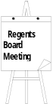
- Final Approval of Strategic Plans and Progress Reports.
- Annual Report on Performance Indicators. See separate Fiscal Update article.
- Annual Report of Professional Development Assignments for FY 2001. Each year, faculty members apply through their academic departments and colleges for professional development assignments. Each faculty member identifies the activities and intended outcomes of the proposed assignment. A total of 151 faculty members participated in professional development assignments during FY 2001. This is a decrease of 10.7% in assignments compared to the previous year. The total cost for the assignments was $6.6 million, a decrease of 11.9% compared to the projected costs presented to the Board in December 1999. This reduction was the result of 28 faculty members either deferring or canceling approved assignments.

- Request for Professional Development Assignments for FY 2003. The Board reviewed a total of 137 professional development assignment requests for FY 2003. These include 84 for SUI (5.2% of eligible faculty), 35 for ISU (2.5% of eligible faculty), and 18 for UNI (4.1% of eligible faculty). Total cost for the assignments is estimated at $6.8 million.
- Annual Report on Faculty Tenure. The Regents universities have a total of 6,550 faculty members for FY 2002. This is a decrease of 1 faculty member from the previous year. Tenure data includes:
- 2,813 (42.9%) are tenured faculty. This is a decrease of 13 (0.5%) from the prior year.
- 902 (13.8%) are tenure-eligible (probationary) faculty on a tenure track. This is a decrease of 27 (2.9%) from the prior year.
- 2,835 (43.3%) remaining faculty are not eligible for tenure. This is an increase of 39 faculty members (1.4%) compared to the prior year.
- Annual Report on Faculty Resignations. Resignations totaled 158 for FY 2001 as follows: SUI – 67; ISU – 55; and UNI – 36. The dominant reason for resignations continues to be the opportunity to advance careers at other institutions.
- Report from Priority Issue Study Group on K-12 Teacher and Administrator Shortage. This Group was established to explore what role the Colleges of Education at Regents universities could play in addressing educational problems within Iowa. The Group has held six meetings and lists the following as accomplishments to date:

- Provided descriptions of current institutional programs that are attempting to address teacher and administrative shortages.
- Provided data on graduates of teacher education and administrator programs.
- Representatives of the State Board of Education, Department of Education, and the Board of Educational Examiners have discussed perceptions of education issues in Iowa and potential solutions.
- Is in the process of selecting several objectives that can be met with a reasonable timeframe.
At the November 2001 meeting, the group agreed to focus on the area of assessment and requested that the name of the group be changed to the Priority Study Group on Pre-K to 12 Quality Education.
- Annual Report on Diversity. Total minority employment has risen from 6.0% in 1991 to 7.0% in 1996 and now stands at 8.2% for FY 2001, slightly less than the 8.3% for FY 2000.
- Report on Employment Upon Graduation. See results in the table below:
 | Number of Graduates | Number and  Percent  Responding | Respondents Reporting  Employment | Employed  In-state | Employed  Out-of-state
SUI | 4,172 | 1,268 (30.4%) | 1,062 (83.8%) | 445 (41.0%) | 617 (58.1%)
ISU | 4,068 | 3,773 (92.7%) | 3,011 (79.8%) | 1,599 (53.1%) | 1,412 (46.9%)
UNI | 2,420 | 1,127 (46.6%) | 797  (70.7%) | 557 (69.9%) | 240 (30.1%)
Total | 10,660 | 6,168 (57.9%) | 4,870 (79.0%) | 2,601 (53.4%) | 2,269 (46.6%)


- Biennial Report on Public Radio Stations. The Regents universities operate the following radio stations:
- SUI – WSUI and KSUI
- ISU – WOI-AM and KTPR-FM
- UNI - KUNI-FM, KUNY-FM, KHKE-FM, and KRNI-AM
Revenues for the stations are shown below:
 | Actual  FY 2000 | Actual  FY 2001 | Budgeted  FY 2002
SUI | $2,006,651 | $2,230,751 | $1,483,563
ISU | $2,741,185 | $2,911,332 | $3,140,000
UNI | $2,228,494 | $2,257,760 | $2,264,326
The large reduction for SUI for FY 2002 was the result of all video facilities and staff being transferred to the Department of Information Technology Services.

Revenues by source of income for FY 2001 include:
Source | SUI | ISU | UNI
University funds | 47.9% | 36.8% | 51.7%
Federal support | 11.4% | 10.0% | 13.4%
Fundraising | 11.2% | 31.3% | 22.9%
Other | 29.5% | 21.9% | 12.0%

- Report on Governor’s Budget and Legislative Actions. Major legislative priorities for the Board and institutions include:
- Authorization to issue $100.0 million of Hospital Revenue Bonds over a period of years for the SUI Hospitals and Clinics to upgrade facilities through capital improvement. State funds would not be required to repay the bonds. The bonds would be repaid with patient revenues.
- Additional funding for the State Hygienic Lab at SUI for unbudgeted expenses due to Homeland Security issues.
- Support for UNI targeted funding through other State agencies.
- Selected Federal Legislative Actions. This Report provides a summary of recent federal legislation affecting the Regents institutions and students. These include HR1 (Elementary and Secondary Education Act), HF 3061 (Education Appropriations for FFY 2002), and HR 3086 (Higher Education Relief Opportunities Act).
- Report from the Banking Committee. The Committee and the Board approved the following:

- Asset Allocation Policy.
- Selection of New Fund Managers.
- Adopted a resolution for sale of ISU Dormitory Bonds in the amount of $15.0 million.
- A preliminary resolution fixing a date of sale for SUI Utility Bonds in the amount of $15.0 million.
- A preliminary resolution fixing a date of sale for UNI Student Union Bonds in the amount of $12.9 million.
- Regents Merit System Classification Revisions. The Board approved revisions in the pay grade for pharmacy technicians and approved a new supervisory classification for facilities services coordinator.
- Award of Eisenhower Professional Development Grants. The Board approved allocation of $598,846 of federal funds to support seven projects that provide professional development opportunities for K-12 teachers relating to science and math.
- North Central Association (NCA) Reaccreditation for the UNI. The NCA voted at the October 1, 2001, to continue accreditation of the UNI for a maximum 10-year period.
- Revisions of University Public Safety Departments – The Board approved the use of Taser guns by public safety officers at the universities. The guns cost approximately $500 each and use dart-like probes that immobilize offenders with an electrical shock. The Board also approved changing the title of employees with law enforcement training from public safety officers to police officers at the University of Iowa and Iowa State University. The University of Northern Iowa requested that their officers continue to be titled public safety officers.

- Report on Organization Review (Phase I). At the May 2001 meeting, the Board approved a three-phase organizational review of the Board and the five institutions. A consulting firm from Tallahassee, FL, MGT of America, was selected to perform Phase I of the review. Phase I included identification of areas to be studied to improve efficiency, effectiveness, and accountability of the Regents enterprise. Phases II and III are intended to be short term and long-term in-depth studies of the areas identified in Phase I. Phase I is complete. The following 17 recommendations were made, listed by Phase:
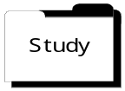
- Phase II (short-term studies)
- Review meeting schedule – reduce the number of meetings and travel costs.
- Review purchasing approval thresholds and delegate to institutional staff.
- Review academic delivery system to streamline and reallocate resources.
- Review revenue enhancement opportunities.
- Evaluate health benefit plans to manage costs and control future increases.
- Review purchasing policies and procedures.
- Review reallocations for the past five years.
- Review Individual Education Plans (IEPs) at the Iowa School for the Deaf to identify efficiencies to be obtained through technology.
- Review the role of advisory boards at the Special Schools.
- Study selected State statutes for revision to achieve efficiencies.
- Phase III (long-term studies)
- Examine models for assessing space needs.
- Review deferred maintenance process.
- Review governance reporting requirements.
- Monitor athletic programs.
- Review institutional administrative and support services to reduce duplication and operating costs.
- Review enterprise funds.
- Review administrative procedures at the Iowa Braille and Sight Saving School.
More Information Additional information regarding the November Board of Regents meeting, including the entire text of items mentioned above, is available on the Board’s web site at http://www2.state.ia.us/regents/meetings/DocketMemos/02Memos/jan02/jandocket.htm
Next Meeting The Board is not scheduled to meet in February. The next regular Board meeting is scheduled for March 13-14 at Iowa State University in Ames.
STAFF CONTACT: Mary Shipman (Ext. 14617)
College Student Aid Commission Meeting
Commission Meeting The College Student Aid Commission met on January 10 at the Commission office in Des Moines.
Action Significant agenda items included:
- Reviewed and approved a change in the Vocational-Technical Grant Program award process. The change will result in directing a larger share of the Grant funding to students not receiving federal Pell Grant assistance. This change will also increase the amount of financial aid used to fund direct education expenses and reduce the amount of Pell Grant refunds. Community college financial aid administrators requested this change in the Voc-Tech Grant procedure. The Commission approved increasing the maximum Voc-Tech Grant from $650 to $1,200 and will adjust administrative rules to implement the new award procedure. The increase in the maximum grant will not require additional State funding because fewer students will receive the grant. Representative Dolecheck, a legislative member of the Commission, has agreed to sponsor legislation increasing the maximum Voc-Tech Grant to implement this proposal.

- Authorized Commission staff to pursue and finalize an extension in the servicing contract with SallieMae Guarantee Services for a one-year period through October 2003.
- Authorized Commission staff to amend the Defaulted Partnership Loan Sale Agreement with Iowa Student Loan Liquidity Corporation to increase the purchase commitment amount from $2.0 million to $3.0 million.
- Approved the application of Grant University of Omaha, NE, for renewal of its registration with the Secretary of State.
- Approved endorsing proposed amendments to the Iowa Student Loan Liquidity Corporation Bylaws.
STAFF CONTACT: Mary Shipman (Ext. 14617)
Required Report from the Department of Human Rights, Status of AfricaN-Americans, Available
Report Received The Commission on the Status of African-Americans is required by Section 216A.149, Code of Iowa, to file an annual report with the Governor and the General Assembly that includes its activities for the previous fiscal year and its programmatic priorities for the current year beginning July 1. In addition, the Commission may submit with the report any recommendations pertaining to its affairs and shall submit recommendations for legislative consideration and other action it deems necessary.
Copies Available The Report has been received and copies are available upon request from the Legislative Fiscal Bureau (LFB), or may be accessed via the link to the Department of Human Rights on the LFB web site at: http://staffweb.legis.state.ia.us/lfb/subcom/health_hr/health_hr.htm
STAFF CONTACT: Lisa Burk (Ext. 16765)
Department of Corrections’ Required Reports
Reports Received The Legislative Fiscal Bureau has received the following reports from the Department of Corrections (DOC):
- Violator Program and Violator Aftercare Program
- Drug Court Evaluation Plan
- Intermediate Criminal Sanctions (Chapter 901B, Code of Iowa)
- Update on Vocational Programs Available for Inmates
Copies Available A copy of these reports may be obtained by contacting the Legislative Fiscal Bureau.
STAFF CONTACT: Beth Lenstra (Ext. 16301)
South Iowa Regional Jail Board Required Report
Report Received The Legislative Fiscal Bureau has received the report required by SF 530 (FY 2002 Justice System Appropriations Act) regarding multi-county jails from the South Iowa Regional Jail Board. Copies of the report may be received by contacting Dean Kaster (641) 856-5512 or Tracy Daugherty Jordan (641)-437-4376.
STAFF CONTACT: Beth Lenstra (Ext. 16301)
Required Report from the Governor’s Office of Drug Control Policy Received
Report Received The Governor’s Office of Drug Control Policy is required by Section 80E.1(b), Code of Iowa, to file an annual report with the Governor and the General Assembly by November 1, concerning the activities and programs of the Coordinator and other departments related to drug enforcement, substance abuse treatment programs, and substance abuse prevention and education programs. The Report must also include an assessment of needs with regard to programs related to substance abuse treatment and narcotics enforcement.
Copies Available The Report has been received and copies are available upon request from the Legislative Fiscal Bureau (LFB), or may be accessed via the link to the

Governor’s Office of Drug Control Policy on the LFB web site at: http://staffweb.legis.state.ia.us/lfb/subcom/health_hr/health_hr.htm.
STAFF CONTACT: Lisa Burk (Ext. 16765)
Board of Regents Performance Indicator Report
Performance Indicator Report At the January 16 meeting, the Board reviewed the Annual Report on Performance Indicators. This Report provides performance indicators and results in six categories with examples as listed below:

- Instructional Environment – instructor rank, class size, and instructional technology.
- Student Profile and Performance – enrollment, graduation and retention rates, licensure examination passage rates, and career placement.
- Educational Outreach and Service – distance education offerings, extension clients, and service to patients.
- Faculty Profile and Performance – resignations, retirement, new hires, and sponsored research.
- Institutional Diversity – percentage of minority faculty, staff, and students.
- Expenditures, Financing, and Funding – cost per student, deferred maintenance, appropriations, and contributions.
Common Data Sets The Report also provides 11 common data sets for all five Regents institutions that include:
- Average undergraduate class size. For combined upper and lower division classes, the average and target for each university is as follows: University of Iowa (SUI) average is 32.7 and the target is 32.0; Iowa State University (ISU) average is 25.7 and the target is 24.0; and the University of Northern Iowa (UNI) average is 25.6 and the target is 23.0.
- Number and percentage of general assignment technology-equipped classrooms. Results include: SUI actual is 50.0% and the target is 50.0%; ISU actual is 33.0% and no target was provided; and UNI actual is 95.0% and the target is 100.0%.
- Number, total, and percentage of tenured and tenure-track faculty resignations, retirements, and new hires. The resignations, retirements (includes early retirements), and new hires for FY 2001 by institution include: SUI – resignations 67 (3.4%), retirements 39 (2.0%), and new hires 156 (7.9%); ISU – resignations 55 (3.9%), retirements 50 (1.8%), and new hires 107 (7.5%); and UNI – resignations 36 (5.9%), retirements 15 (3.3%), and new hires 32 (5.2%)

- State appropriations requested for operations. The measure is reported in percent of increase requested and does not include salary funding. The following table shows the historical percent increase requested:

Year | SUI | ISU | UNI | ISD | IBSSS
FY 1996 | 4.0% | 4.0% | 4.0% | 2.7% | 3.5%
FY 1997 | 3.9% | 2.9% | 3.3% | 2.0% | 2.8%
FY 1998 | 3.0% | 3.0% | 3.2% | 1.7% | 2.2%
FY 1999 | 3.3% | 3.4% | 3.6% | 2.9% | 1.4%
FY 2000 | 3.5% | 3.7% | 3.8% | 3.6% | 3.6%
FY 2001 | 3.4% | 4.0% | 4.0% | 4.0% | 4.0%
FY 2002 | 1.9% | 2.2% | 3.3% | 3.4% | 3.3%
FY 2003 | 2.4% | 2.5% | 2.5% | 2.5% | 2.5%
- Number of annual contributors and dollars contributed in millions. For FY 2001, SUI data was not available, ISU reported 52,777 contributors and $70.1 million of gift income and UNI reported 17,565 contributors and $11.9 million of gift income. Total gift activity for ISU was not reported. The last year for which all three institutions reported was FY 2000. The results for that year include: SUI – 52,602 contributors and $172.0 million of income; ISU - 54,083 contributors and $112.5 million of income (ISU had $191.6 million when receipts and commitments are included); and UNI – 15,441 contributors and $10.6 million of income.
- Amount of capital improvement funds requested and appropriated. For FY 2002, SUI requested $19.2 million and received $16.0 million; ISU requested $22.5 million and received $10.9 million; and UNI requested $15.0 million and received $12.7 million. For FY 2003, the requests are as follows: SUI $26.2 million, ISU $23.4 million, and UNI $20.8 million.
- Deferred maintenance backlog and expenditures in millions. The total deferred maintenance reflects the institutional assessments and does not include deferred maintenance scheduled for correction as part of major renovation projects. Actual expenditures for deferred maintenance do not include major renovation projects. The backlog and actual expenditures for FY 2001 include: SUI - $33.5 million backlog and $3.8 million expended; ISU - $59.3 million backlog and $6.1 million expended; and UNI - $51.0 million backlog and $0.9 million expended.

- Percent of resources reallocated annually. The Board approved a five-year program beginning in FY 1997 requiring each Regents institution to reallocate at least 2.0% of its budget each year. The policy is intended to ensure the institutions use existing resources to improve quality and achieve efficiencies. The reallocation percentages for FY 2001 are as follows: SUI – 2.7%; ISU – 2.3%; and UNI – 3.9%. For FY 2002, the following reallocation percentages have been budgeted: SUI – 4.8%; ISU – 3.9%; and UNI – 5.1%.
- Fall enrollments by level (undergraduate, graduate, professional age, and residency). Enrollments for Fall 2001 include: SUI – undergraduate 19,603, graduate 5,319, professional 3,846, total 28,768; ISU – undergraduate 23,060, graduate 4,363, professional 400, total 27,823; and UNI – undergraduate 12,474, graduate 1,596, total 14,070. Students that are residents of Iowa include: SUI – 18,482; ISU – 20,024; and UNI – 13,010.
- Racial/ethnic composition of student, faculty, and staff populations in percentages. The racial/ethnicity percentages for FY 2001 for each of the institutions includes: SUI – students 9.1% (target 12.0%), faculty 12.2% (target 14.5%), professional and scientific 6.1% (target 7.5%) and merit 6.1% (target 7.0%); ISU – students 6.8% (target 8.5%), faculty 13.8% (target 10.0%), professional and scientific 7.7% (target 10.0%) and merit 4.5% (target 5.0%); and UNI – students 5.1% (target 8.5%), faculty 12.4% (target 12.0%), professional and scientific 7.6% (target 10.0%) and merit 9.4% (target 6.0%).

- Undergraduate student retention and graduation rates by ethnic/race composition in percentages. The six-year graduation rates for the most recent reporting year (entering class of 1995) includes: SUI – 64.7%; ISU – 63.7%; and UNI – 64.2%.
Report on the Internet The entire 79-page text of the Annual Report on Performance Indicators is available on the Board’s web site at http://www2.state.ia.us/regents/meetings/DocketMemos/02Memos/jan02/jangd05.pdf
STAFF CONTACT: Mary Shipman (Ext. 14617)
Summary of Annual Report on Personal Assistance and Family Support Services
Report Received The Legislative Fiscal Bureau has received a copy of the Annual Report on Personal Assistance and Family Support Services. The Report provides an overview of the various elements and makes several recommendations. The recommendations include:
- Utilize the expertise and experience of adult individuals and family members of children with disabilities as full partners in all advisory and policy development and review processes.
- Foster the unity of families and avoid inappropriate out-of-home placement of children who have disabilities.
- Support the involvement and independence of adults with disabilities by establishing a comprehensive system of Personal Assistance Services.
- Implementing changes to the Home and Community-Based Services Waivers that would allow for more flexibility, choice, and options for consumers of these Medicaid services.
Copies Available A copy of the Report is available from the Legislative Fiscal Bureau upon request or on the LFB web site at www.staffweb.legis.state.ia.us/lfb.
STAFF CONTACT: Sue Lerdal (Ext. 17794)
Summary of Annual Report from the Mental Health and Developmental Disabilities Commission
Report Received The Legislative Fiscal Bureau has received a copy of the Annual Report from the Mental Health and Developmental Disabilities Commission. The Report reviews the activities by the Commission and provides recommendations. The recommendations include:
- Restructuring of the legal mental health authority.
- Mental health and substance abuse treatment third party parity legislation.
- Defines set of core community services and uniform eligibility criteria for the core services.
- Replace “legal settlement” with a policy in which funding follows the individual.
- Combine the Mental Health and Developmental Disabilities Commission and the State County Management Committee. In the event that accreditation duties are moved from the Department of Human Services to the Department of Inspections and Appeals, the combined Committee should retain responsibilities for accreditation requirements.
- Improve coordination and communication between the Department of Human Services and the Department of Corrections.
- Create a coordinated system of mental health services for children.
- Support and funding for and implementation of the Iowa Plan for Community Development to comply with the Olmstead U.S. Supreme Court decision.
- Equitable access to services for individuals with brain injury and developmental disabilities without cognitive impairment.
- Enhance support and training for direct care workers.
- Funding for consumer-controlled personal assistance services for Iowans with disabilities.
- Expand a consumer-driven Statewide network to provide peer support and counseling.
- Restoration of the 4.3% across-the-board reduction of the mental health allowed growth appropriation.
- Maximize federal funding.
Copies Available A copy of the report is available from the Legislative Fiscal Bureau or on the LFB web site at www.staffweb.legis.state.ia.us/lfb/human_serv/human_serve/htm.
STAFF CONTACT: Sue Lerdal (Ext. 17794)
LOTTERY REVENUES AND EXPENDITURES THROUGH NOVEMBER
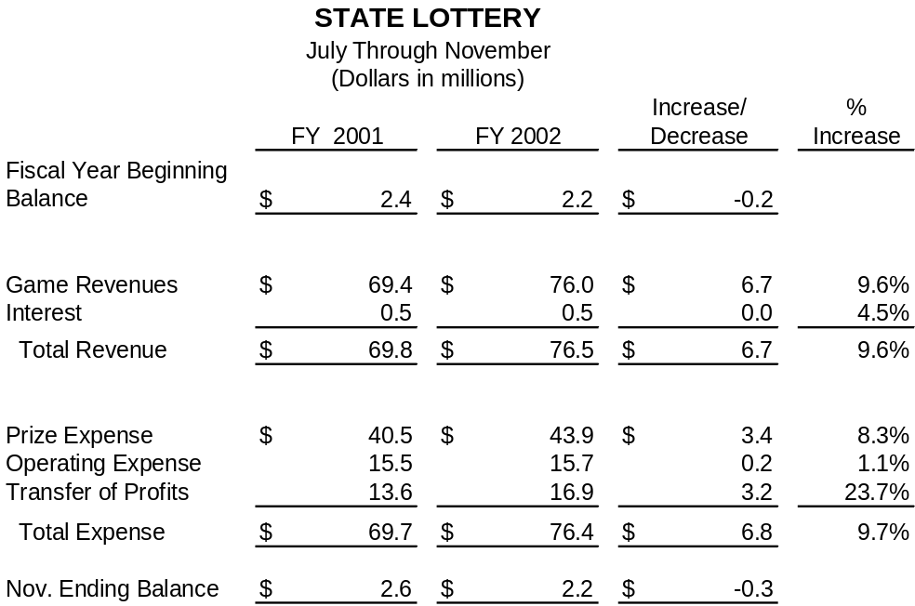
November Rev./Exp. Through November, FY 2002 Lottery game revenues increased $6.7 million from the FY 2001 level. Lottery prize expenses increased $3.4 million, operating expenses increased $0.2 million, and transfers to State funds increased $3.2 million. The following table details revenues, expenditures, and balances of the State Lottery. Rows and columns may not add, due to rounding.
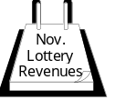
Comparison to FY 2001 Fiscal year sales through November, compared to the same time period of FY 2001, were as follows:
- Instant ticket sales decreased $2.5 million (7.6%).
- Pick 3 sales increased $235,000 (15.0%).
- Multi-State Powerball sales increased $9.9 million (47.8%).
- Rolldown sales decreased $218,000 (24.9%).
- Freeplay Replay sales decreased $210,000 (57.4%).
- Cash 4 Life sales decreased $481,000 (100.0%).
- Daily Game sales increased $18,000 (1.1%).
- Pull-tab sales decreased $153,000 (1.4%).
Ticket Sales Total Lottery sales through November were $76.0 million, an increase of $6.7 million (9.6%) compared to November 2000. July through November 2001 sales for the Daily Game, Powerball, and Pick 3 were above sales for the same period during FY 2001.
Estimated Transfers The December Revenue Estimating Conference (REC) projected FY 2002 Lottery profit transfers to the General Fund will total $32.5 million. Actual profit transfer for FY 2001 was $35.4 million. Therefore, the REC is currently estimating General Fund Lottery transfers will be $2.9 million (8.2%) lower in FY 2002 than in FY 2001. Through November, FY 2002 transfers to the General Fund are $3.2 million (23.7%) above FY 2001.
Sales Tax In addition to the amount transferred to the State as profits, the Lottery has transferred $3.2 million in sales tax during FY 2002.
STAFF CONTACT: Ron Robinson (Ext. 16256)
Department of Elder Affairs Files Notice to Rescind Chapters 24 and 25, Iowa Administrative Code
Administrative Rules The Department of Elder Affairs filed a notice to rescind 321 Iowa Administrative Code, Chapters 24 and 25, on January 4, 2002.
Adult Day Care/Respite Care The amendment rescinds chapters dealing with adult day care, facility-based respite care, and non-facility-based respite care. The Department indicates these rules are not needed because the Department does not provide oversight to the adult day service or respite industries. In addition, the Department indicates there is a need to establish a system of oversight and consumer complaint investigation for the adult day service industry; however, the Department lacks the resources to establish such a system at this time.
HF 655-Oversight of Services The 2001 General Assembly passed HF 655, an Act relating to the establishment of a system of oversight for adult day services, that directed the Department to implement a system of oversight and consumer complaint investigation for the adult day service industry in Iowa on July 1, 2002, or at such time as the General Assembly appropriated sufficient funding. The Act did not include an appropriation for FY 2002, and due to the current budget situation, no appropriation is anticipated for FY 2003.

Grant Application In August 2001, the Department applied for a grant from the federal Administration on Aging for funding to establish an oversight system, but the grant was not awarded. The Department has also explored public-private partnerships; however, this would still require some level of State funds.
Point-in-time Letters The Department has issued point-in-time letters to adult day service providers that gave these providers access to Medicaid reimbursement. The Department was not required by statute or administrative rule to provide these letters, and since the Department does not have oversight authority over these providers, the letters will no longer be issued. Adult day service providers, however, will continue to have access to becoming Medicaid providers through voluntary accreditation through the Rehabilitation Accreditation Commission and Joint Commission on Accreditation of Healthcare Organizations (CARF/JCAHO), a VA contract, or a contract with a local Area Agency on Aging (AAA).
Rules Assessment The need to rescind these chapters was identified while the Department was completing the rules assessment mandated by Executive Order Number 8. Consideration will be given to all written data, views, and arguments received by the Department of Elder Affairs on or before February 12, 2002.
STAFF CONTACT: Lisa Burk (Ext. 16765)
Ames Receives Rail Economic Development Grant
Grant Awarded The City of Ames filed a Rail Economic Development application in September requesting a grant of $100,000 to develop 800 feet of new rail line. Following the review, the amount of the local participation was changed, lowering the grant request to $73,000. According to the City, the rail improvement is necessary to provide additional service for Ball Plastic Container Corporation.

Contingency In October, the Department of Transportation (DOT) Commission approved the grant of $73,000 or up to 58% of the total project cost, whichever is less. Funding for the project is contingent on:
- Completion of the proposed economic development;
- Creation of 25 new jobs at Ball Plastic Container Corporation, in addition to 153 existing jobs within two years after completion of the Development project; and
- Fulfillment of the legislative requirements for the Rail Economic Development Program.
Rail Project According to the application, the rail project will assist in:
- Creation of 25 new jobs at Ball Corporation, and
- $20.8 million in associated capital investment.
Average Wage/Investment The Company’s average starting non-management wage rate is $16.00 per hour compared to 75% of Story County’s average wage rate of $8.35 per hour. The City proposes $53,000 local participation (42%) in the $125,000 rail project. The cost per job assisted will be $3,000, and there will be a total capital investment of $285 for each Development dollar requested.
STAFF CONTACT: Mary Beth Mellick (Ext. 18223)
Cedar Falls Receives Rebuild Iowa’s Sound Economy (RISE) Grant
RISE Grant Awarded The City of Cedar Falls filed a RISE Immediate Opportunity Grant application in August requesting $975,000 to grade and pave approximately 3,000 feet of Viking Road, west of Hudson Road. Signal installation and lane improvements on Hudson Road were also proposed as part of the project. According to the City, the project is necessary to provide access to the proposed Target regional distribution facility. The total cost of the road improvement project is $1.2 million.

Contingency In September, the Department of Transportation (DOT) Commission approved the grant of $975,000, or up to 80% of the total RISE eligible project cost, whichever is less, from the City share of the RISE fund. The grant was approved, contingent on the following conditions:
- Utilization of the proposed economic development;
- Creation of 445 new jobs at the proposed Target regional distribution facility in Cedar Falls within two years after completion of the RISE project; and
- Fulfillment of the legislative requirements for the RISE Program.
Project Benefits According to the application, the road project will assist in:
- Creation of 445 new jobs at the proposed Target facility, and
- $88.1 million in associated capital investment.
Average Wage/Investment The Company’s average starting wage for the new positions is approximately $13.41 per hour compared to 75% of Blackhawk County’s average wage rate of $9.32 per hour. The City proposes $244,000 (20%) local participation in the $1.2 million project. The RISE cost per job assisted will be $2,200, and there will be a total capital investment of $90.38 for each RISE dollar requested.
STAFF CONTACT: Mary Beth Mellick (Ext. 18223)
ISSUE REVIEW -- Integrated Farm Management Demonstration Program
Issue Review The LFB recently released an Issue Review that provides an overview on the Integrated Farm Management Demonstration Program. Included in this Review are the following:
- The Program was implemented for FY 2001 with the passage of SF 2371 (Water Quality Initiatives Act).
Issue Review

- The goal of the Program was to implement a voluntary Statewide program that demonstrates alternative farm practices that protect the State’s water resources.
- Funding of $850,000 from the Environment First Fund was appropriated; however, upon passage of SF 267 (FY 2001 Deappropriations Act), funding was reduced by $500,000.
- During FY 2001, there were 150 participants in the Program, and a number of field days were held in the fall to explain the results to producers.
- The Department of Agriculture and Land Stewardship received $850,000 for the Program for FY 2002 and has 13 projects underway.
Copies Available Copies of the Issue Review are available upon request from the LFB or can be viewed at the LFB web site: http://staffweb.legis.state.ia.us/lfb.
STAFF CONTACT: Deb Kozel (Ext. 16767)
Issue Review - Parking Structure Construction Proposal
Issue Review The Legislative Fiscal Bureau (LFB) recently released an Issue Review on funding for construction of the proposed parking structure located adjacent to the Capitol Complex.
Cost Comparisons The Issue Review provides cost comparisons between the Department of General Services’ proposal to lease an 850-stall parking structure and office building to options involving State ownership. The Issue Review was requested by the Capital Projects Committee of the Legislative Council. Members of the Committee wanted to ensure that the cost to taxpayers for the Department’s proposed lease option was not out-of-line with other funding methods.
Issue Review

Three Proposals The Issue Review analyzes the cost of three proposals over a 20-year period. The proposals include:
Department’s lease option.
State ownership through fully funding construction through appropriations.
State ownership through the issuance of revenue bonds.
Estimates Based on the analysis and estimates included in the Issue Review, the cost of the proposal to lease office and parking space was more favorable in terms of cost to that of State ownership. However, there will likely be additional cost to the Department of Public Safety for providing security at the new location. This cost was not included in the analysis due to lack of information. The following chart shows a comparison of the estimates.
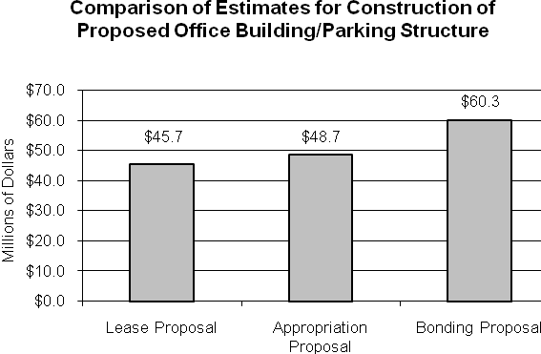
Copies Available A copy of the Issue Review is available on the LFB web site at http://staffweb.legis.state.ia.us/lfb/ or by requesting a copy from the LFB.
STAFF CONTACT: David Reynolds (Ext. 16934)
Issue Review - Low-Income Home Energy Assistance Program (LIHEAP)
Issue Review The Legislative Fiscal Bureau (LFB) recently released an Issue Review providing information on the Low-Income Home Energy Assistance Program (LIHEAP). The Program is a federally funded block grant that provides heating assistance payments to eligible low-income households.
Program Background The Issue Review includes background information on the establishment and purpose of the Program; the activities covered under the Assessment and Resolution and Emergency Crisis Intervention components of the Program, and the Weatherization Assistance Program. Federal guidelines and client eligibility are also discussed.
Issue Review

Funding Information Information on funding for the LIHEAP is provided, including the formula for calculating the percentage share the State will receive from the federal appropriation; FY 2002 projections for LIHEAP receipts and expenditures; and FY 2001 receipts and expenditures. In addition, the number of households assisted and the amount of LIHEAP payments distributed by the 18 individual Community Action Agencies is provided for FY 2001.

Cost Comparison Estimates for the level of funds needed for the LIHEAP for FY 2002 are difficult to project due to several unknown variables, including weather, fuel costs, and client participation levels. The Issue Review provides a residential rate comparison for MidAmerican Energy Company’s actual natural gas heating costs for FY 2001 compared to estimated costs for FY 2002. In addition, the residential rate comparison of natural gas costs for the Alliant Corporation is provided for FY 2000 and FY 2001.
Task Force The Issue Review also includes information on the Governor’s Energy Policy Task Force that has been appointed to study Iowa’s energy consumption, supplies, and efficiency, and the recommendations the Task Force proposed to provide energy assistance to low-income Iowans.
Copies Available A copy of the Issue Review is available on the LFB web site at http://staffweb.legis.state.is.us/lfb/ or by requesting a copy from the LFB.
STAFF CONTACT: Lisa Burk (Ext. 16765)
Issue Review - School Foundation Aid - FY 2002 Budget Reduction and FY 2003 Budget Alternatives
Issue Review The LFB recently released an Issue Review concerning the FY 2002 4.3% across-the-board budget reduction and allowable growth budget alternatives for FY 2003.
Alternatives Current law establishes the allowable growth rate at 4.0% for FY 2003. The increase in State aid for allowable growth is estimated to increase approximately $152.4 million (8.8%) compared to the adjusted FY 2002 amount. This Issue Review provides alternatives to funding allowable growth in FY 2003 that would reduce the amount of State aid for FY 2003.
Copies Available A copy of the Issue Review is available on the LFB web site at http://staffweb.legis.state.ia.us/lfb/ or by requesting a copy from the LFB.
STAFF CONTACT: Shawn Snyder (Ext. 17799)
Issue Review – Road Use Tax Fund Overview
Issue Review The LFB recently completed an Issue Review on the Road Use Tax Fund (RUTF), including background information, the types of programs funded through the RUTF, and forecasted revenues for FY 2002 – 2004.
Fund Distribution Approximately $1.0 billion is collected annually and deposited into the RUTF. The funds are distributed by formula to the Primary, Secondary, Farm-to-Market, and Municipal Road Funds, which are used by State and local jurisdictions for construction and maintenance of roads. However, before the revenues are distributed to the road funds, various allocations and appropriations are made from the Fund for programs, equipment purchases, and Department operations (referred to as “off-the-top” allocations).
Declining Revenues In FY 2001, the RUTF experienced the first revenue decline since 1981. Receipts to the Fund decreased by $147,000 (0.01%) compared to FY 2000. The Fund experienced decreases in motor vehicle use tax, fuel tax, driver’s license fees, and interest income:


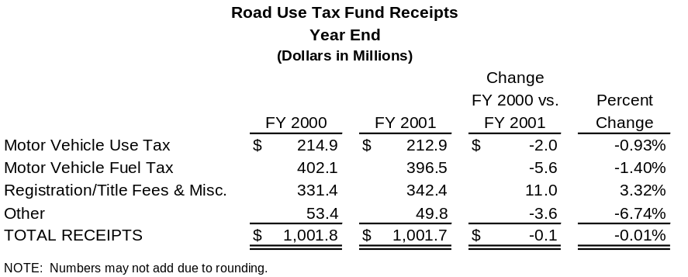
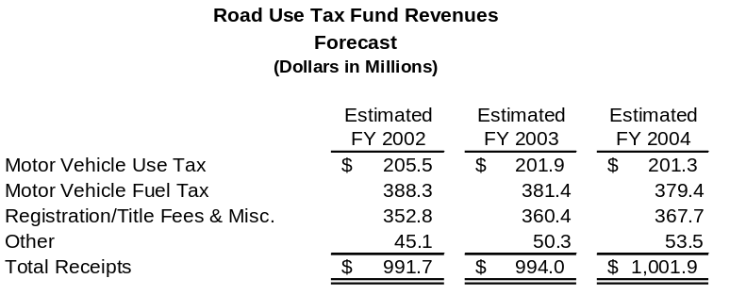
Revenue Forecast The estimated forecast for RUTF revenues for FY 2002 – 2004 is illustrated below:
Copies Available A copy of the Issue Review is available on the LFB web site at http://staffweb.legis.state.ia.us/lfb/ or by requesting a copy from the LFB.
STAFF CONTACT: Mary Beth Mellick (Ext. 18223)

What’s New on the LFB Web Site?
Most LFB files are in pdf (Adobe Acrobat Reader).

Governor’s Recommendation The LFB analysis of Governor’s budget recommendations for FY 2003 is now available at: http://staffweb.legis.state.ia.us/lfb/miscpubs/lagar_fy2003.pdf
Factbook The LFB annual publication of 2001 Iowa Factbook contains a great deal of information about the State of Iowa and Iowa State Government. The newest publication is now available at: http://staffweb.legis.state.ia.us/lfb/factbook/factbook.htm
Fiscal Update The January 15, 2002, version of the Fiscal Update, a weekly newsletter about State government finances, is available at: http://staffweb.legis.state.ia.us/lfb/fupdate/fupdate.htm
Daily Receipts Use the LFB web site and call up the daily General Fund receipts. http://staffweb.legis.state.ia.us/lfb/receipts/daily.html
STAFF CONTACT: Nicole Navara (Ext. 16766)

This document can be found on the LFB web site:
http://staffweb.legis.state.ia.us/lfb/fupdate/fupdate.htm

