IOWA
RACING

AND

GAMING
COMMISSION

2008 Annual Report

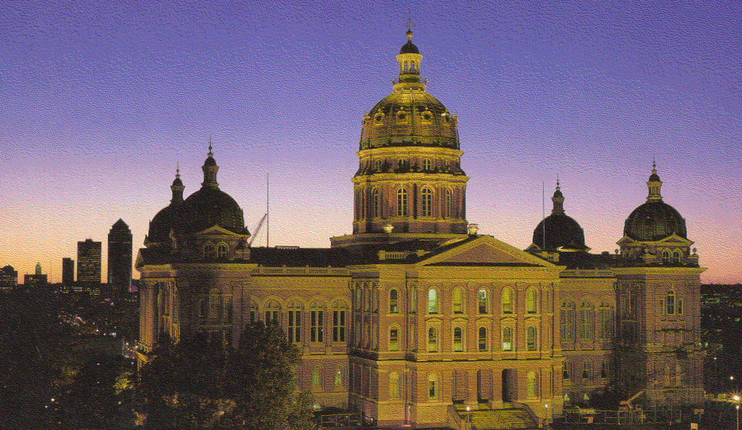
Gregory Seyfer, Chair
Diane Hamilton, Vice Chair
Kate Cutler, Commissioner
Paul Hayes, Commissioner
Toni Urban, Commissioner

LOCATION OF LICENSED FACILITIES

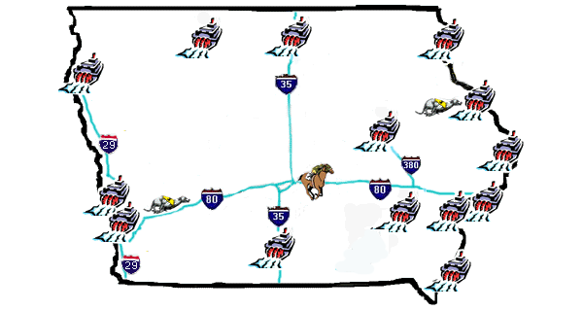

Wild Rose - Emmetsburg
Riverside Casino
Isle of Capri Waterloo
Dubuque Greyhound Park & Casino
Prairie Meadows Racetrack & Casino
Diamond Jo Worth
Lady Luck

Horseshoe/Bluffs Run
Argosy

Ameristar II
Harrah’s
Casino
Terrible’s Lakeside Casino
Diamond Jo Casino
Wild Rose -
Clinton
Isle of Capri
Bettendorf
Rhythm City Casino
Catfish Bend Casino
Table of Contents

2 | Location of Licensed Facilities | EXCURSION BOATS
4 | Letter to Governor | 22 | All Iowa Excursion Boat Totals
5 | Lifetime Voluntary Self-Exclusion Program | 23 | Harrah’s Council Bluffs Casino & Hotel
6 | Commission Meetings | 24 | Ameristar II
 |  | 25 | Lady Luck
RACETRACKS |  | 26 | Diamond Jo
9 | Horseshoe Casino/Bluffs Run Greyhound Park | 27 | Catfish Bend Casino
10 | Dubuque Greyhound Park & Casino | 28 | Wild Rose - Clinton
11 | Prairie Meadows Racetrack & Casino | 29 | Argosy - Sioux City
13 | Laboratory Testing | 30 | Rhythm City Casino
14 | Iowa Breeder’s Fund | 31 | Isle of Capri-Bettendorf
RACETRACK CASINOS |  | 32 | Terrible’s Lakeside Casino
16 | All Iowa Racetrack Casino Gaming Totals | 33 | Riverside Casino and Golf Resort LLC
17 | Horseshoe Casino/Bluffs Run Greyhound Park | 34 | Diamond Jo - Worth
18 | Dubuque Greyhound Park & Casino | 35 | Wild Rose – Emmetsburg
19 | Prairie Meadows Racetrack & Casino | 36 | The Isle Casino & Hotel at Waterloo
20 | Pari-Mutuel Revenue and Expenditures | 37 | Excursion Boat Revenue and Expenditures
21 | Iowa’s Wagering Dollar

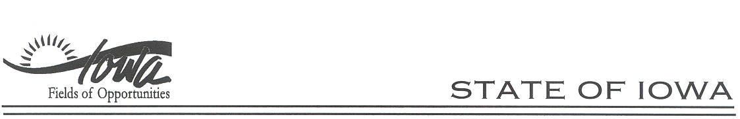
CHESTER J. CULVER, GOVERNOR
PATTY JUDGE, LT. GOVERNOR
RACING AND GAMING COMMISSION
JACK P. KETTERER, ADMINISTRATOR

February 19, 2009

The Honorable Chet Culver
Governor, State of Iowa
State Capitol
Des Moines, IA 50319

Dear Governor Culver:

On behalf of the Iowa Racing and Gaming Commission (the Commission) it is my pleasure to submit our 2008 Annual Report. The facts and figures provided demonstrate that, not withstanding a year end slow down in the economy, the gaming industry continues to prosper in the State of Iowa, once again contributing over $1 billion to the state’s economy, including over $300 million in gaming taxes.

Highlights of 2008 included the new land-based casino facility in Clinton which opened July 18, 2008, and the new land-based Diamond Jo Dubuque casino which opened on December 11, 2008. These facilities are truly land-based casino built entirely on land and not on water as was required prior to the May 2007 change in state law.

As a result of the continuing interest regarding the granting of new licenses, at our November 13, 2008 meeting the Commission selected the Innovation Group and GVA Marquette to perform studies to identify underserved and currently served, but underperforming gaming markets in Iowa. The two reports are to be submitted to the Commission at the June 4, 2009 meeting.

The Commission continues to be vigilant in insuring that Iowa vendors are the first and primary choice for supplying goods and services to the licensed facilities and that the state-wide voluntary self-exclusion program is enforced.

On behalf of the Commission, I want to once again commend our Administrator, Jack Ketterer, and his staff and thank them for their continuing dedication, professionalism and integrity. They set a standard for the industry.

I thank you for your consideration of this letter. It is my pleasure and privilege of the other commissioners and me to serve at your request on the Commission. It is our honor to serve your and the State of Iowa.

LIFETIME VOLUNTARY SELF-EXCLUSION PROGRAM

This program was required by the 2004 General Assembly as part of HF2302. The Commission adopted an administrative rule requiring implementation by the licensed casino operators which became effective on November 3, 2004. The licensed casino operators launched the program on the same date.
Information on persons entering the program must be disseminated to all other licensees in Iowa. The individual is banned at every licensed casino in Iowa and if the individual is discovered in any licensed casino, any winnings will be forfeited and sent to the Iowa Gambling Treatment Fund.
To date, approximately 3,180 people have entered the program and in excess of $700,000 has been forfeited and sent to the Gambling Treatment Fund.

COMMISSION MEETINGS

During 2008, the Iowa Racing and Gaming Commission (Commission) met eight times, with three Executive Sessions being held. Minutes of each meeting are kept on file in the Commission office, and are available to the public upon request. The minutes are also available on the Commission’s website: www.iowa.gov/irgc/. Highlights of the meetings follow:

January 10, 2008: The Commission met at Stoney Creek Inn, Johnston, Iowa. Rules were approved for final adoption. Amended race dates for 2008 were approved for Bluffs Run Greyhound Park. The Commission heard a review of Iowa Code Section 99F.6(4)a (Simultaneous Submission) for purse agreements by Jeff Peterzalek, Assistant Attorney General. Season approvals for the thoroughbred and mixed meets at Prairie Meadows Racetrack & Casino (PMR&C) were approved. A Stipulated Agreement with Catfish Bend Casino (CBC) for violation of Iowa Code §99F.9(5) (Wagering-age restriction) was approved. Dr. Keith Soring was introduced as the Director of Racing.

March 6, 2008: The Commission met at Stoney Creek Inn, Johnston, Iowa. Executive Session was held. Rules were presented under Notice of Intended Action. The season approvals for Dubuque Greyhound Park & Casino’s (DGP&C’s) live race meet were approved. The Commission reviewed the year-to-date economic impact reports submitted by the licensees. The Commission members held a discussion on the consideration of additional licenses and decided to name a sub-committee to establish a timeline for an RFP and study to be completed. A discussion was also held concerning future violations of the voluntary self-exclusion law and appropriate sanctions. The Commission approved the renewal of the following Excursion Gambling Boat and Gambling Structure licenses and any contracts contained within the renewal: Iowa West Racing Association (IWRA)/Ameristar Casino Council Bluffs, d/b/a Ameristar Casino (Ameristar); IWRA/Harveys Iowa Management Co., Inc., d/b/a Harrah’s Council Bluffs Casino Hotel (Harrah’s); Scott County Regional Authority/Isle of Capri Bettendorf, L.C. d/b/a Isle of Capri Bettendorf (IOCB); Riverboat Development Authority/IOC Davenport, Inc. d/b/a Rhythm City Casino; Washington County Riverboat Foundation, Inc./Riverside Casino & Golf Resort, LLC d/b/a Riverside Casino & Golf Resort (RCGR); Black Hawk County Gaming Association/IOC Black Hawk County, Inc. d/b/a The Isle casino & hotel waterloo (The Isle); Clarke County Development Corporation/HGI-Lakeside, Inc. d/b/a Terrible’s Lakeside Casino Resort (Lakeside); Worth County Development Authority/Diamond Jo Worth, LLC, d/b/a Diamond Jo Worth (DJW); Dubuque Racing Association (DRA)/Peninsula Gaming Company, LLC d/b/a Diamond Jo (DJ); Missouri River Historical Development, Inc./Belle of Sioux City, L.P. d/b/a Argosy Casino Sioux City (Argosy); Upper Mississippi Gaming Corp./Isle of Capri Marquette, Inc. d/b/a Isle of Capri Marquette (IOCM); Southeast Iowa Regional Riverboat Commission/Catfish Bend Casinos II, L.C. d/b/a Catfish Bend Casino II; Clinton County Community Development Association/Wild Rose Clinton, L.L.C. d/b/a Wild Rose Clinton; and Palo Alto County Gaming Development Corporation/Wild Rose Emmetsburg, L.L.C. d/b/a Wild Rose Emmetsburg (WRE). Notice regarding the Request for Proposals (RFP) for the Horse Racing Promotion Fund was given.

April 17, 2008: The Commission met at the Diamond Jo Worth Casino, Northwood, Iowa. The Commission approved meeting dates for fiscal year 2009. The Commission heard a presentation by Centerbridge Capital Partners PNG-B, L.P. and Fortress Investment Group, LLC on their proposed acquisition of Penn National Gaming, Inc., reviewed the licensees’ year-end financial audits except for the IOC properties, and the audit of the IWA/Iowa Greyhound Association escrow account. The Commission approved distribution of the Horse Racing Promotion Fund in the amount of $4,123.29 to the Legacy Harness Horse Foundation. The Commission appointed a sub-committee to work with Commission staff on developing a draft RFP before the June Commission meeting. The Commission heard a report from the subcommittee on the violations of the self-exclusion law and the penalties previously approved. The subcommittee reported that after receiving feedback from the licensees, revisions were needed to the previously established penalties.

June 5, 2008: The Commission met at the Wild Rose Emmetsburg Casino, Emmetsburg, Iowa. Executive Session was held. Rules were approved for final adoption. The Commission approved the following: the acquisition of Penn National Gaming, Inc. by Centerbridge Capital Partners PNG-B, L.P. and Fortress Investment Group LLC, and the assignment and restated ship mortgage for Herbst Gaming, Inc. The Commission heard a report from PMR&C on their analysis and evaluation of their racing program, which also established a racing committee to make long-range suggestions to the Board of Directors concerning the racing program. A Stipulated Agreement with DJW for violation of Iowa Code §99F.9(5) (Wagering-age restriction) was approved. Under Administrative Business, the Commission gave notice of the RFP for the Dog Promotion Fund, discussed the gambling setoff legislation, and approved the regulatory fees for fiscal year 2009 and the RFP format for a study on additional casino markets.

July 17, 2008: The Commission met at Stoney Creek Inn, Johnston, Iowa. The Commission heard a report from the National Center for Responsible Gambling, approved rules under Notice of Intended Action and elected a new Chair and Vice Chair for Fiscal Year 2009. The Commission also approved the season approvals for the harness meet at PMR&C, the distribution of the Dog Racing Promotion Fund to the Iowa Greyhound Association, and a Stipulated Agreement with WRE for a violation of Iowa Code §99F.8 (Licensee Bond). The Commission received a report from the Gaming Unit of Division of Criminal Investigation on the various services the agents provide at the licensed facilities and around the state. Under Administrative Business, the Commission received updates on proposed surveillance rules, the smoking ban and exemptions, and implementation of the offset legislation.

August 28, 2008: The Commission met at Riverside Casino & Golf Resort, Riverside, Iowa. Executive Session was held. The Commission reviewed the fiscal year end audits for the four Isle of Capri properties. The Commission approved a request, contingent upon compliance with Commission rules and Iowa law, from the Iowa Greyhound Association to conduct a Harley Davidson drawing at BRGP and to withdraw funds from the Escrow Account for expenses. The Commission approved Stipulated Agreements with PMR&C and Ameristar for violations of Iowa Code §99F.9(5) (Wagering – age restriction). Under Administrative Business, the Commission approved the Voluntary Self Exclusion Program Requirement to Establish a Process setting forth the criteria under which violations would be brought to the Commission, and reported that four responses had been received to the RFP for a study on additional casino markets. Further information about the selection process will be provided at the October Commission meeting.

October 9, 2008: The Commission met at Catfish Bend Casino, Burlington, Iowa. The Commission approved rules for final adoption, and received a report from the Chief Financial Officer for Isle of Capri in response to questions raised regarding the fiscal year end audit at the August meeting. The Commission approved the renewal of the following racetrack licenses, granted race dates, and approved racetrack enclosure gambling licenses for: IWRA/BRGP/Horseshoe Casino and DRA/DGP&C, including contracts. The Commission approved Stipulated Agreements with the following licensees for the stated violations: DJW (2 violations), Rhythm City Casino and Horseshoe Casino/Bluffs Run Greyhound Park for violation of Iowa Code §99F.4(22) (Self Exclusion Policy), Harrah’s for violation of Iowa Code §99F.9(6) (Credit), and PMR&C had two violations of Iowa Code §99F.9(5) (Wagering – age restriction). The Commission advised that they would be making a decision regarding the RFP for a study on additional casino markets at the November 13th Commission meeting.

November 13, 2008: The Commission met at Stoney Creek Inn, Johnston, Iowa. The Commission selected The Innovation Group and GVA Marquette to perform the study to identify underserved gaming markets in Iowa, and approved the season approvals for the 2009 live race meet at BRGP and the remodel of the DGP&C facility. After receiving comments from the various horsemens’ groups and public comment, the Commission approved the renewal of the racetrack license, granted race dates, and approved the renewal of the racetrack enclosure license for PMR&C, including contracts. The Commission requested that PMR&C present a long-range plan for racing for the next 5-10 years at the June 2009 Commission meeting. The Commission approved Stipulated Agreements with Argosy and WRE for violation of Iowa Code §99F.4(22) (Self Exclusion Policy), and Ameristar Casino for violation of Iowa Code §99F.4(19) (Adequate Security).

HORSESHOE CASINO
BLUFFS RUN GREYHOUND PARK
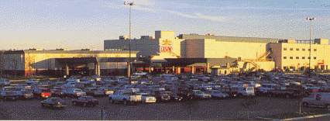
Council Bluffs, IA
2007 2008
Live Racing
Racing Dates | 1/1-12/31 | 1/1-12/31
Number of Performances | 300 | 301
Admissions | See Simulcasting | See Simulcasting
Total Mutuel Handle | $5,527,873 | $5,224,580
Track Commission | $1,293,818 | $1,225,561
Breakage | $20,482 | $18,819
Returned to Public | $4,213,573 | $4,300,785
Total Purses Paid (all sources) | $9,537,392 | $9,657,592
Simulcasting (Signals Sent-Live Greyhound)
Simulcast Handle | $30,718,065 | $29,584,227
Simulcasting (Signals Received-Greyhounds & Horses)
Simulcasting Dates | 1/1-12/31 | 1/1-12/31
Number of Performances | 9,297 | 7,977
Admissions | 2,911,497 | 2,654,230
Total Mutuel Handle | $14,350,120 | $13,782,816
Breakage | $77,207 | $88,142
Pari-Mutuel Revenues to State
State Tax | $276,394 | $285,486
Gambler's Treatment | $27,603 | $27,639
Unclaimed Winnings | $63,099 | $98,427

DUBUQUE GREYHOUND PARK & CASINO
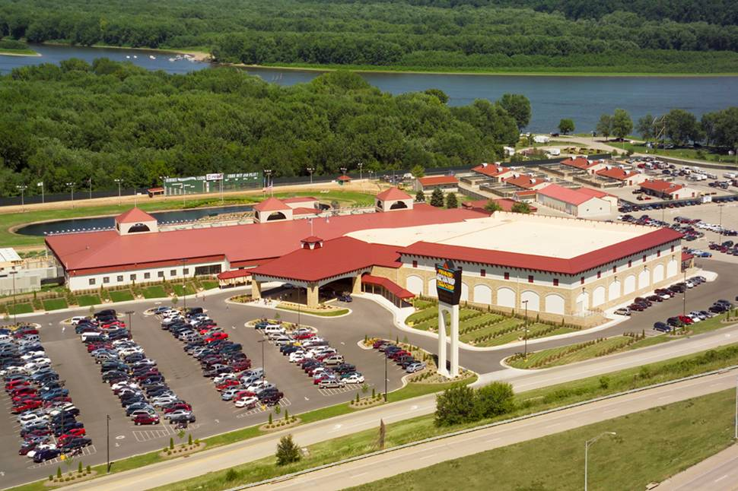
Dubuque, IA
2007 2008
Live Racing
Racing Dates | 4/28-10/28 | 4/26-10/26
Number of Performances | 162 | 162
Admissions | See Simulcasting | See Simulcasting
Total Mutuel Handle | $2,197,164 | $2,043,539
Track Commission | $489,255 | $452,550
Breakage | $13,299 | $13,202
Returned to Public | $1,694,610 | $1,577,788
Total Purses Paid (all sources) | $3,911,715 | $4,021,521
Simulcasting (Signals Received-Greyhounds & Horses)
Simulcasting Dates | 1/1-12/31 | 1/1-12/31
Number of Performances | 2,581 | 2,652
Admissions | 1,513,477 | 1,513,109
Total Mutuel Handle | $3,346,355 | $3,263,912
Breakage | $9,123 | $9,507
Pari-Mutuel Revenues to State
State Tax | $87,738 | $90,229
Gambler's Treatment | $10,986 | $10,217
Unclaimed Winnings | $60,201 | $111,175
PRAIRIE MEADOWS RACETRACK & CASINO
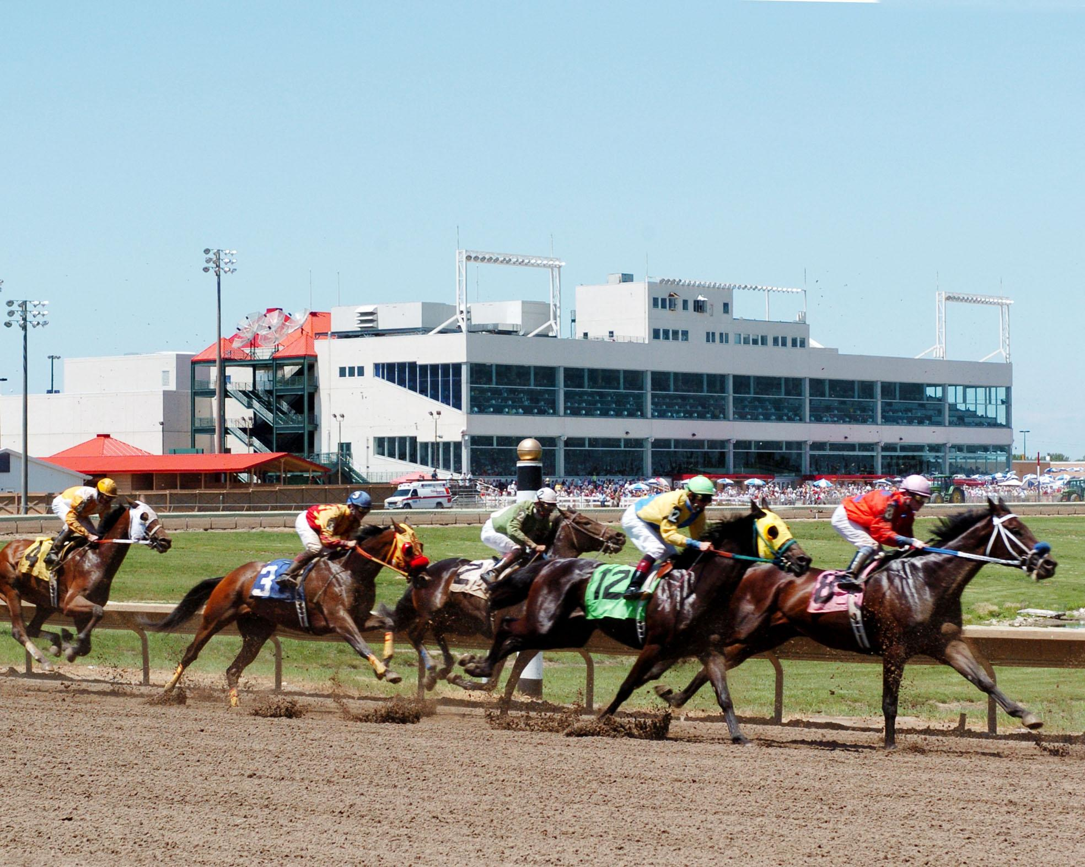
Altoona, IA

2007 2008
Live Racing
Racing Dates | 4/20-7/4 | 4/18-7/5
Racing Dates | 7/10-9/15 | 7/11-9/20
Racing Dates | 9/22-10/20 | 9/27-10/25
Number of Performances | 104 | 108
Admissions | See Simulcasting | See Simulcasting
Total Mutuel Handle | $5,464,968 | $5,176,178
Track Commission | $1,052,495 | $998,126
Breakage | $44,442 | $41,473
Returned to Public | $4,396,915 | $4,153,672
Total Purses Paid (all sources) | $18,338,161 | $18,788,415

2007 2008
Simulcasting (Signals Sent-Live Horse)
Simulcast Handle (commingled) | $46,913,226 | $54,933,854

HORSE RACING HANDLE – LIVE MEET

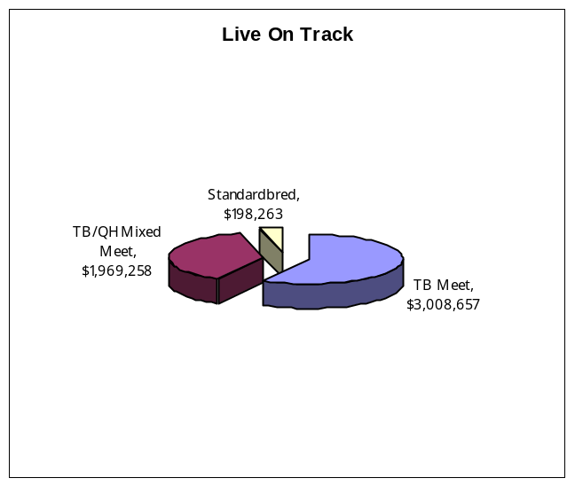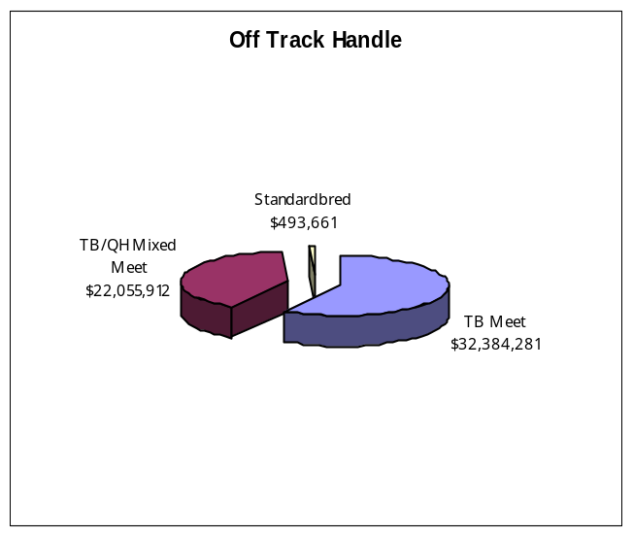

2007 2008
Simulcasting (Signals Received-Greyhounds & Horses)
Simulcasting Dates | 1/1-12/31 | 1/1-12/31
Number of Performances | 6,554 | 6,240
Admissions | 2,508,733 | 2,488,222
Total Mutuel Handle | $15,702,980 | $13,438,742
Total Mutuel Handle (Horse) | $13,963,801 | $11,859,762
Total Mutuel Handle (Greyhound) | $1,739,179 | $1,578,980
Breakage | $87,118 | $72,763

Pari-Mutuel Revenues to State
Unclaimed Winnings | $127,495 | $121,024

LABORATORY TESTING
The Iowa Racing and Gaming Commission, through comprehensive drug testing of participating animals, strives to protect the integrity of the sport of racing in Iowa. Iowa's urine and blood testing program is the backbone of the agency's policing functions. The drug testing program was conducted by Iowa State University Veterinary and Diagnostic Laboratory, the Commission’s racing chemist.
Through chemical analysis of urine and blood samples collected from racing animals at the tracks, the Commission ensures that foreign substances are not being administered to racing animals pursuant to Iowa Code Chapter 99D.25.
The following is a summary of the samples tested and positive tests reported by the Laboratory in 2008 for the Commission.

SAMPLES
 | URINE | BLOOD
Greyhound
Bluffs Run Casino | 4,380
Dubuque Greyhound Park & Casino | 2,352
Horse
Prairie Meadows Racetrack & Casino | 2,126 | 2,331

POSITIVE TESTS
Beta Stanozolol | 3
Flunixin | 3
Methocarbamol / Guaifenesin | 3
Sildenafil | 1
Testosterone | 1
Ephederine / Phenylpropanolamine | 1
TOTAL POSITIVES | 15
IOWA BREEDERS' FUND

The Department of Agriculture maintains a database of thoroughbred, standardbred and quarterhorses that have qualified to be Iowa-foaled horses, as well as greyhounds that have qualified as Iowa-whelped dogs according to Iowa Code Chapter 99D.22 and Administrative Rules of the Department of Agriculture and Land Stewardship.
An amount equal to 12% of the winner's share of any purse won by an Iowa-foaled horse or Iowa-whelped dog is withheld by the licensee from the breakage and paid at the end of the race meeting to the Department of Agriculture and Land Stewardship for redistribution as breeders’ awards.
Iowa Code Chapter 99D.11 and 12 authorize distribution of the remaining breakage as follows:
At horse tracks, 2% of the remaining breakage is distributed to the Horse Promotion Fund and the balance of the breakage at horse tracks is distributed as purse supplements to the owners of winning Iowa-bred horses.
The remainder of the breakage at greyhound tracks is divided, with 25% funding a stakes race restricted to registered Iowa-whelped greyhounds, 2% funding the Dog Promotion Fund and 73% distributed as purse supplements to the owners of winning Iowa-whelped greyhounds.
One percent of the exotic wagers, including 3 or more horses, dogs or races, is distributed as provided in 99D.12 above.
The amounts created from the total breakage and a portion of the casino revenues as statutorily required, were paid out as follows in 2008:

THOROUGHBRED/QUARTERHORSE/STANDARDBRED

PRAIRIE MEADOWS RACETRACK & CASINO
Breeders Awards | $667,459
Purse Supplements to Owners of Iowa Breds | $2,696,444
Horse Racing Promotion Fund | $3,846
Carry-Over | $0

GREYHOUNDS
HORSESHOE CASINO AND BLUFFS RUN GREYHOUND PARK
Breeders Awards | $171,049
Purse Supplements to Owners of Iowa-whelped greyhounds | $3,111,941
Iowa Stakes | $475,000
Carry-Over | $0
Dog Racing Promotion Fund | $0

DUBUQUE GREYHOUND PARK & CASINO
Breeders Awards | $11,760
Purse Supplements to Owners of Iowa-whelped greyhounds | $824,254
Iowa Stakes | $245,000
Carry-Over (Breakage Only) | $25,505
Dog Racing Promotion Fund | $21,640

ALL IOWA RACETRACK CASINO
GAMING TOTALS
 | 2007 | 2008
Admissions | 6,933,707 | 6,655,561
Slot Drop | $2,911,279,679 | $2,906,595,038
Slot Coin In | $5,121,327,828 | $4,900,082,148
Slot Revenue | $409,189,174 | $419,877,050
Table Drop | $213,773,242 | $215,918,360
Table Revenue | $46,048,677 | $47,054,752
Adjusted Gross Revenue | $455,237,855 | $466,931,805
City Tax | $2,276,189 | $2,208,787
County Tax | $2,276,189 | $2,208,787
Gambler’s Treatment | $2,276,189 | $2,208,787
Endowment Fund | $2,952,687 | $3,534,062
State Miscellaneous Fund | $450,999 | $883,516
Gaming Tax | $96,258,870 | $93,584,064
Regulatory Fee | $3,216,108 | $3,443,350
HORSESHOE CASINO
BLUFFS RUN GREYHOUND PARK
GAMING
Council Bluffs, IA
 | 2007 | 2008
Admissions | 2,911,497 | 2,654,230
Slot Drop | $1,026,373,779 | $963,978,200
Slot Coin In | $1,829,330,732 | $1,698,350,308
Slot Revenue | $173,044,945 | $173,230,545
Table Drop | $108,868,183 | $111,208,937
Table Revenue | $22,672,269 | $23,983,668
Adjusted Gross Revenue | $195,717,214 | $197,214,213
City Tax | $978,585 | $934,613
County Tax | $978,585 | $934,613
Gambler’s Treatment | $978,585 | $934,613
Endowment Fund | $1,271,038 | $1,495,381
State Miscellaneous Fund | $194,969 | $373,846
Gaming Tax | $42,100,366 | $40,188,347
Admission Fee/Regulatory Fee | $1,078,640 | $1,125,754

DUBUQUE GREYHOUND PARK AND CASINO
GAMING
Dubuque, IA
 | 2007 | 2008
Admissions | 1,513,477 | 1,513,109
Slot Drop | $536,521,212 | $560,879,186
Slot Coin In | $948,724,039 | $923,750,743
Slot Revenue | $66,502,266 | $69,700,167
Table Drop | $21,186,539 | $20,428,237
Table Revenue | $4,295,739 | $4,581,350
Adjusted Gross Revenue | $70,798,005 | $74,281,517
City Tax | $353,991 | $348,452
County Tax | $353,991 | $348,452
Gambler’s Treatment | $353,991 | $348,452
Endowment Fund | $459,783 | $557,525
State Miscellaneous Fund | $70,528 | $139,381
Gaming Tax | $13,573,280 | $13,589,669
Regulatory Fee | $784,792 | $855,185
PRAIRIE MEADOWS RACETRACK AND CASINO
GAMING
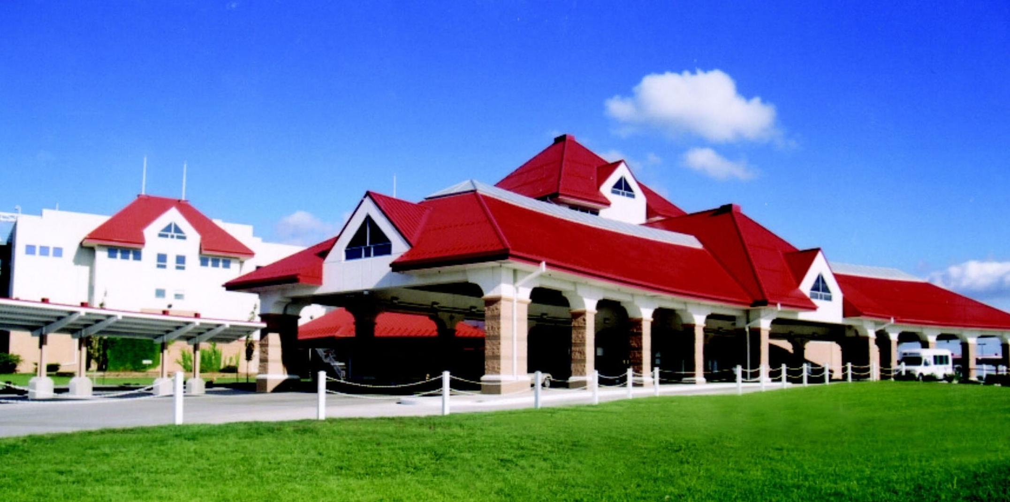
Altoona, IA
 | 2007 | 2008
Admissions | 2,508,733 | 2,488,222
Slot Drop | $1,348,384,688 | $1,381,737,652
Slot Coin In | $2,343,273,057 | $2,277,981,097
Slot Revenue | $169,641,963 | $176,946,338
Table Drop | $83,718,520 | $84,281,186
Table Revenue | $19,080,669 | $18,489,734
Adjusted Gross Revenue | $188,722,636 | $195,436,075
City Tax | $943,613 | $925,722
County Tax | $943,613 | $925,722
Gambler’s Treatment | $943,613 | $925,722
Endowment Fund | $1,221,866 | $1,481,156
State Miscellaneous Fund | $185,502 | $370,289
Gaming Tax | $40,585,224 | $39,806,048
Regulatory Fee | $1,352,676 | $1,462,414

PARI-MUTUEL REVENUE AND EXPENDITURES
2008
EXPENDITURES FOR REGULATION
Salary and Benefits | $1,919,991.00
Travel | $17,349.12
State Vehicle | $5,441.42
Office Supplies/Printing/Postage | $11,204.04
Equipment Maintenance | $2,382.60
Communications | $12.81
Rentals | $36,066.52
Professional, Scientific & Outside Services | $630,874.43
Intra State Transfers | $43,378.14
Advertising/Publicity | $0
ITD/IT Outside Services | $5,219.34
Reimbursements to Other Agencies | $17,753.26
Equipment | $109,245.18
TOTAL | $2,798,917.86
REVENUES TO STATE
Annual Licensing Fee | $3,000
Regulatory Fees | $3,455,174
Daily License Fees | $197,600
Occupational License Fees | $54,750
Fines | $99,800
Pari-Mutuel Tax | $403,353
Gaming Tax | $93,584,064
State Miscellaneous Fund | $883,516
Gambler’s Treatment | $2,217,854
Unclaimed Winnings | $330,627
TOTAL | $101,221,519

REVENUES TO LOCAL GOVERNMENT
Gaming Taxes (City/County) | $4,417,574
Endowment Fund | $3,534,062

IOWA'S WAGERING DOLLAR
IOWA'S PARI-MUTUEL DOLLAR
Actual percentage withheld from each wagering dollar depends on the type of wager. Chapter 99D.11(5) authorizes takeout up to eighteen percent on win, place, and show wagers; twenty-four percent on doubles (two dogs/horses/ races); and twenty-five percent on triples (3+dogs/horses/races). Pari-mutuel taxes may range from 0 to six percent on live races based on increasing levels of mutuel handle. Simulcast wagering is taxed at two percent of the pari-mutuel handle. (Chapter 99D.15)
Breakage (the odd cents by which the amount payable on each dollar wagered in a pari-mutuel pool exceeds a multiple of ten cents) is distributed to the owners and breeders of Iowa-foaled horses and Iowa-whelped dogs.
IOWA'S GAMING DOLLAR
Iowa's gaming industry consists of slot machines, table games, and other games of chance as authorized by the Commission. Slot machine statistics are kept on the total amount wagered and adjusted gross revenue. Each slot machine must have at least an eighty percent pay-out to the patron. Available data for table games includes the drop and the ratio of drop to the adjusted gross revenues.
The tax based on adjusted gross revenues from gambling games is: Up to $1,000,000, five percent; above $1,000,000 to $3,000,000, ten percent; above $3,000,000 Excursion gambling boat – twenty-two percent; Racetrack enclosure in the same county as other licensees and issued a table games license but with adjusted gross receipts of less than $100 million – twenty-two percent; Racetrack enclosure in the same county as other licensees, issued a table games license and with adjusted gross receipts of more than $100 million – twenty-four percent and Racetrack enclosures with no other licensees in the same county – twenty-four percent
This tax is distributed one-half of one percent each to the city, county and gambling treatment, eight-tenths of one percent to the County Endowment Fund, two-tenths of one percent to the State Miscellaneous Fund and the remainder to designated state funds.

ALL IOWA EXCURSION BOAT TOTALS
 | 2007 | 2008
Admissions | 16,425,668 | 16,215,804
Slot Drop | $5,227,922,484 | $5,529,530,753
Slot Coin In | $9,740,149,197 | $9,940,286,203
Slot Revenue | $826,098,658 | $869,588,435
Table Drop | $393,147,781 | $390,597,331
Table Revenue | $81,718,081 | $83,024,897
Adjusted Gross Revenue | $907,816,679 | $952,613,332
City Tax | $4,539,082 | $4,763,070
County Tax | $4,539,082 | $4,763,070
Gambler’s Treatment | $4,539,082 | $4,763,070
Endowment Fund | $5,960,545 | $7,620,909
State Miscellaneous Fund | $771,391 | $1,905,224
Gaming Tax | $173,403,887 | $180,019,605
Regulatory Fee | $10,807,406 | $10,577,908

HARRAH’S COUNCIL BLUFFS CASINO & HOTEL
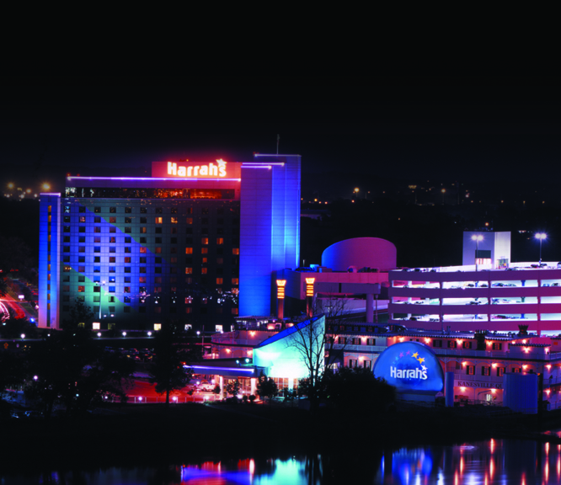
Council Bluffs, IA
 | 2007 | 2008
Admissions | 1,734,912 | 1,492,310
Slot Drop | $471,623,064 | $459,210,914
Slot Coin In | $970,330,009 | $905,274,978
Slot Revenue | $89,742,921 | $88,221,824
Table Drop | $43,448,506 | $40,505,799
Table Revenue | $8,449,804 | $7,297,152
Adjusted Gross Revenue | $98,192,725 | $95,518,976
City Tax | $490,963 | $477,596
County Tax | $490,963 | $477,596
Gambler’s Treatment | $490,963 | $477,596
Endowment Fund | $636,498 | $764,152
State Miscellaneous Fund | $97,023 | $191,038
Gaming Tax | $18,985,987 | $18,216,201
Regulatory Fee | $851,798 | $869,267
AMERISTAR II

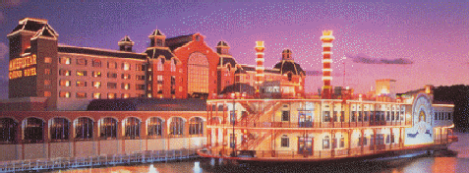
Council Bluffs, IA
 | 2007 | 2008
Admissions | 2,730,955 | 2,538,840
Slot Drop | $895,551,478 | $904,816,243
Slot Coin In | $1,754,702,594 | $1,703,236,261
Slot Revenue | $160,596,232 | $159,292,558
Table Drop | $75,973,667 | $73,026,987
Table Revenue | $16,349,867 | $16,496,478
Adjusted Gross Revenue | $176,946,099 | $175,789,036
City Tax | $884,731 | $878,945
County Tax | $884,731 | $878,945
Gambler’s Treatment | $884,731 | $878,945
Endowment Fund | $1,149,108 | $1,406,313
State Miscellaneous Fund | $176,252 | $351,578
Gaming Tax | $34,538,590 | $33,868,863
Regulatory Fee | $851,798 | $869,267

LADY LUCK
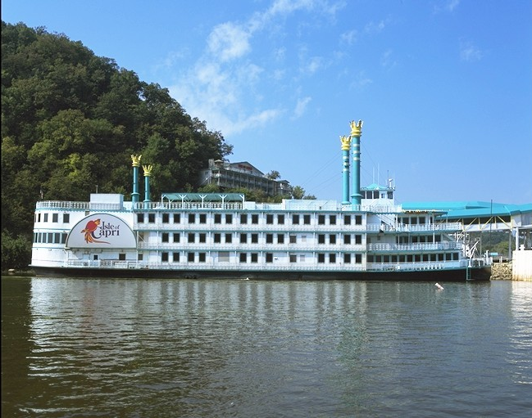
Marquette, IA
 | 2007 | 2008
Admissions | 474,078 | 397,895
Slot Drop | $215,475,409 | $201,794,847
Slot Coin In | $438,693,241 | $382,820,536
Slot Revenue | $34,317,843 | $31,145,137
Table Drop | $5,526,927 | $7,922,904
Table Revenue | $2,013,891 | $1,657,191
Adjusted Gross Revenue | $36,331,734 | $32,802,328
City Tax | $181,658 | $164,012
County Tax | $181,658 | $164,012
Gambler’s Treatment | $181,658 | $164,012
Endowment Fund | $234,732 | $262,419
State Miscellaneous Fund | $35,382 | $65,605
Gaming Tax | $6,767,892 | $5,986,454
Regulatory Fee | $706,566 | $724,900

DIAMOND JO
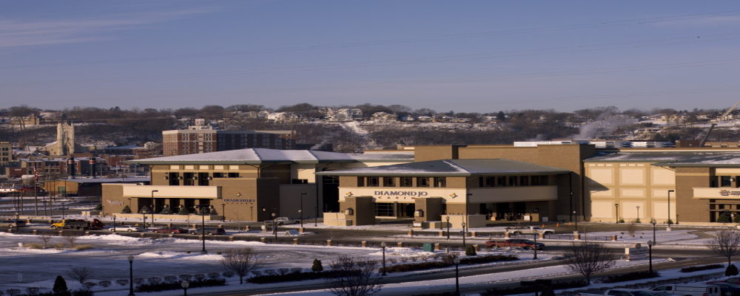
Dubuque, IA
Boat closed operations on December 7, 2008
New facility opened on December 11, 2008
 | 2007 | 2008
Admissions | 732,838 | 722,857
Slot Drop | $250,232,970 | $254,219,436
Slot Coin In | $526,338,303 | $514,255,211
Slot Revenue | $37,712,771 | $39,390,746
Table Drop | $16,189,333 | $15,962,777
Table Revenue | $2,812,051 | $3,208,555
Adjusted Gross Revenue | $40,524,792 | $42,599,301
City Tax | $202,624 | $212,997
County Tax | $202,624 | $212,997
Gambler’s Treatment | $202,624 | $212,997
Endowment Fund | $263,536 | $340,795
State Miscellaneous Fund | $40,608 | $85,198
Gaming Tax | $7,593,439 | $7,896,864
Regulatory Fee | $706,566 | $724,900

CATFISH BEND CASINO
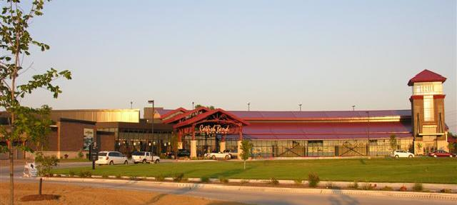
Fort Madison, IA and Burlington, IA
New Facility in Burlington opened June 11, 2007
Boat closed operations on November 15, 2007
 | 2007 | 2008
Admissions | 958,386 | 807,385
Slot Drop | $229,356,854 | $241,524,870
Slot Coin In | $381,620,059 | $402,877,149
Slot Revenue | $31,743,710 | $34,469,955
Table Drop | $15,077,852 | $17,677,053
Table Revenue | $3,233,679 | $4,159,728
Adjusted Gross Revenue | $34,977,389 | $38,629,683
City Tax | $174,887 | $193,148
County Tax | $174,887 | $193,148
Gambler’s Treatment | $174,887 | $193,148
Endowment Fund | $234,080 | $309,038
State Miscellaneous Fund | $39,463 | $77,259
Gaming Tax | $6,486,821 | $7,122,789
Regulatory Fee | $920,341 | $514,166

WILD ROSE – CLINTON
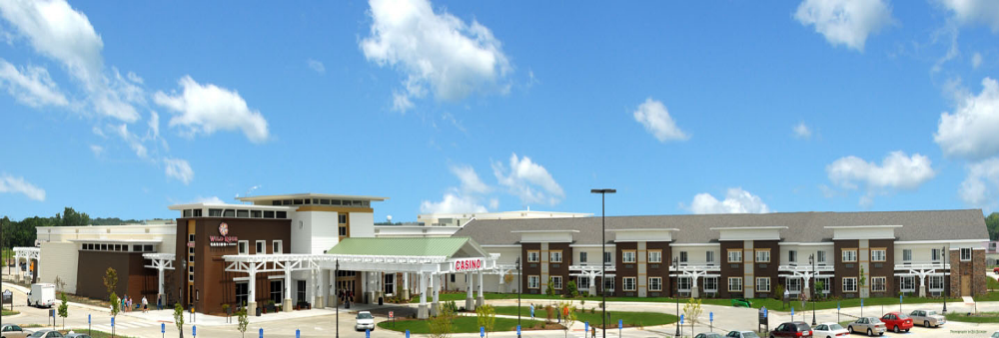
Clinton, IA
Boat closed operations on June 22, 2008
New facility opened on June 27, 2008
 | 2007 | 2008
Admissions | 432,067 | 641,294
Slot Drop | $164,095,237 | $201,090,599
Slot Coin In | $328,011,305 | $385,174,488
Slot Revenue | $25,626,203 | $33,288,596
Table Drop | $10,056,443 | $13,389,212
Table Revenue | $2,318,406 | $2,549,764
Adjusted Gross Revenue | $27,944,609 | $35,838,360
City Tax | $139,722 | $179,192
County Tax | $139,722 | $179,192
Gambler’s Treatment | $139,722 | $179,192
Endowment Fund | $180,945 | $286,707
State Miscellaneous Fund | $27,482 | $71,676
Gaming Tax | $5,110,217 | $6,578,481
Regulatory Fee | $706,566 | $724,900

ARGOSY – SIOUX CITY
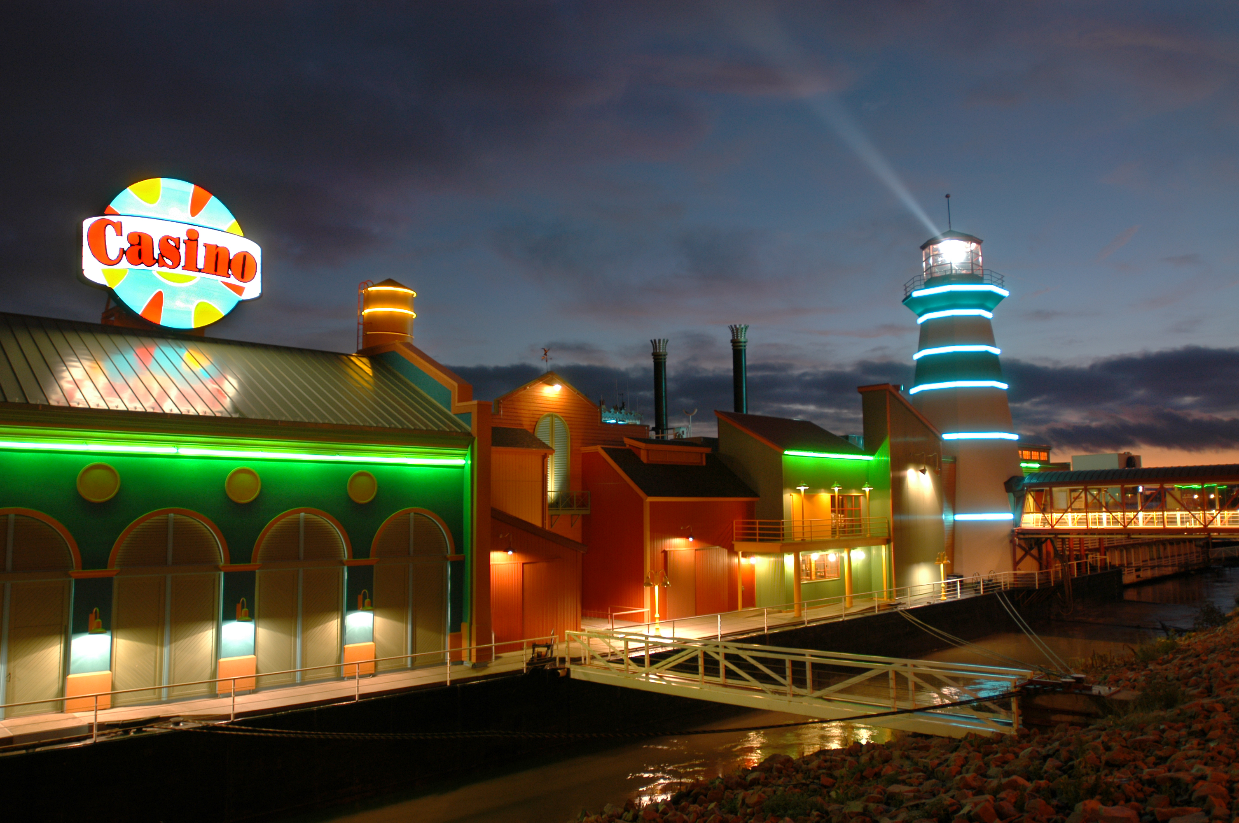
Sioux City, IA
 | 2007 | 2008
Admissions | 1,185,898 | 1,078,981
Slot Drop | $282,158,254 | $279,881,107
Slot Coin In | $596,842,281 | $569,407,386
Slot Revenue | $50,795,091 | $50,674,651
Table Drop | $29,344,781 | $28,727,153
Table Revenue | $6,678,540 | $6,618,265
Adjusted Gross Revenue | $57,473,631 | $57,292,916
City Tax | $287,368 | $286,465
County Tax | $287,368 | $286,465
Gambler’s Treatment | $287,368 | $286,465
Endowment Fund | $371,574 | $458,343
State Miscellaneous Fund | $56,137 | $114,586
Gaming Tax | $10,944,383 | $10,762,118
Regulatory Fee | $706,566 | $724,900

RHYTHM CITY CASINO
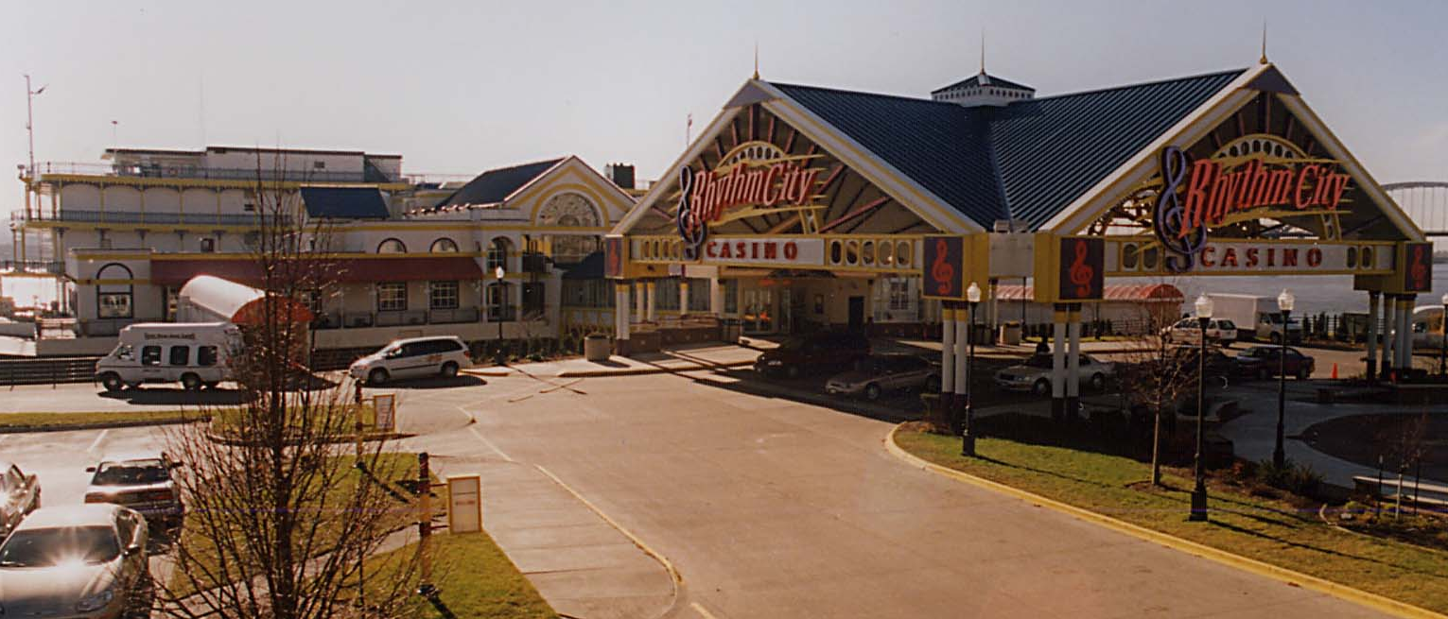
Davenport, IA
 | 2007 | 2008
Admissions | 1,055,087 | 914,652
Slot Drop | $416,008,546 | $379,700,120
Slot Coin In | $741,673,956 | $676,778,801
Slot Revenue | $58,308,791 | $54,555,846
Table Drop | $11,243,327 | $9,838,674
Table Revenue | $2,214,676 | $1,988,932
Adjusted Gross Revenue | $60,523,467 | $56,544,778
City Tax | $302,618 | $282,724
County Tax | $302,618 | $282,724
Gambler’s Treatment | $302,618 | $282,724
Endowment Fund | $390,717 | $452,358
State Miscellaneous Fund | $58,733 | $113,089
Gaming Tax | $11,547,862 | $10,616,232
Regulatory Fee | $812,459 | $793,088

ISLE OF CAPRI-BETTENDORF

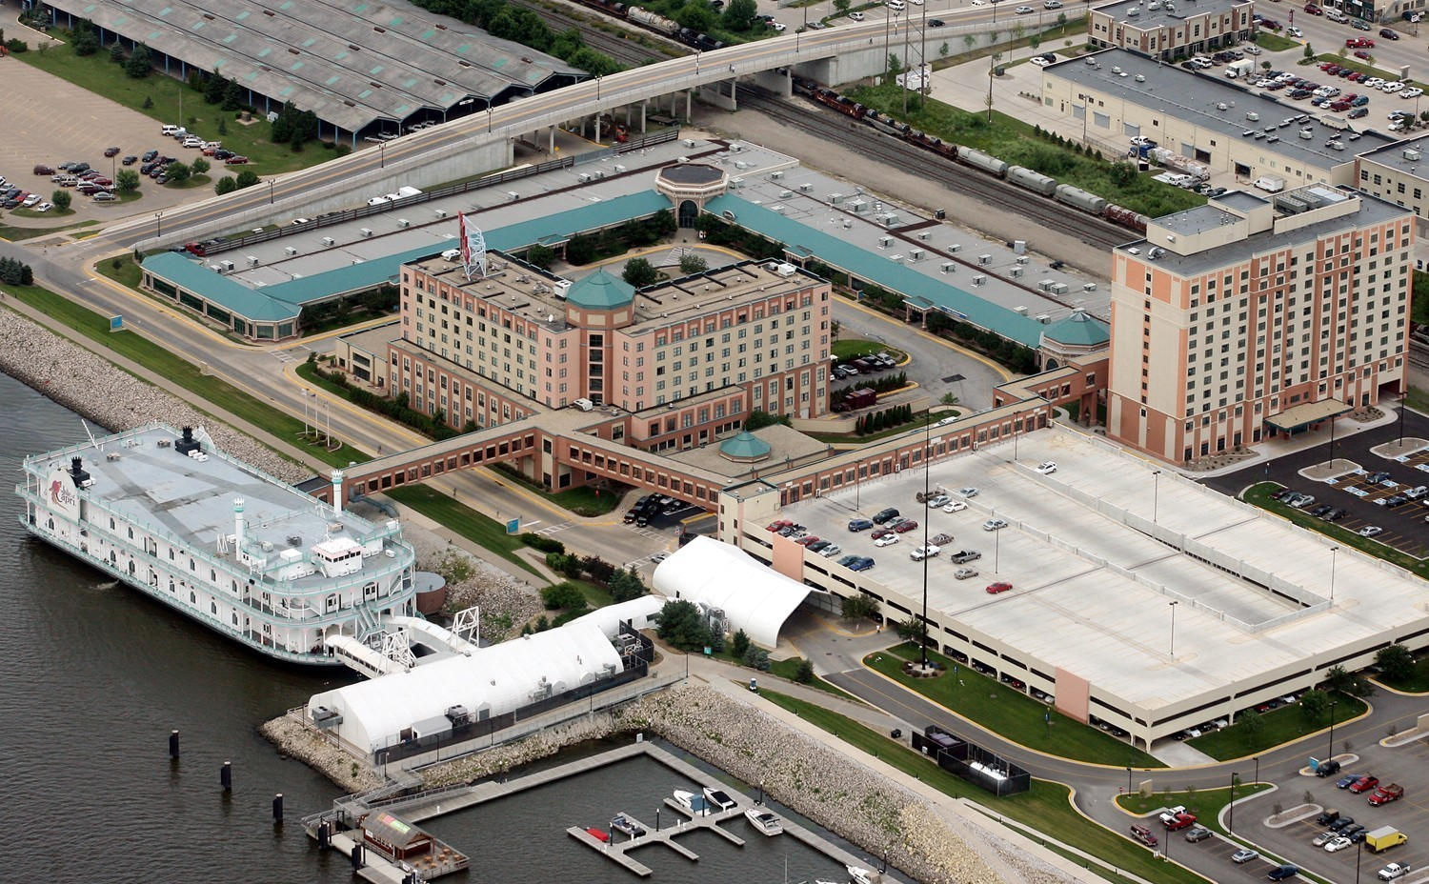
Bettendorf, IA
 | 2007 | 2008
Admissions | 1,438,258 | 1,371,411
Slot Drop | $583,126,473 | $624,214,746
Slot Coin In | $1,047,761,479 | $1,099,921,126
Slot Revenue | $83,586,870 | $87,968,236
Table Drop | $37,415,383 | $35,336,762
Table Revenue | $8,188,475 | $7,666,216
Adjusted Gross Revenue | $91,775,345 | $95,634,452
City Tax | $458,876 | $478,173
County Tax | $458,876 | $478,173
Gambler’s Treatment | $458,876 | $478,173
Endowment Fund | $597,485 | $765,076
State Miscellaneous Fund | $92,406 | $191,269
Gaming Tax | $17,714,054 | $18,238,718
Regulatory Fee | $851,798 | $869,267
TERRIBLE’S LAKESIDE CASINO
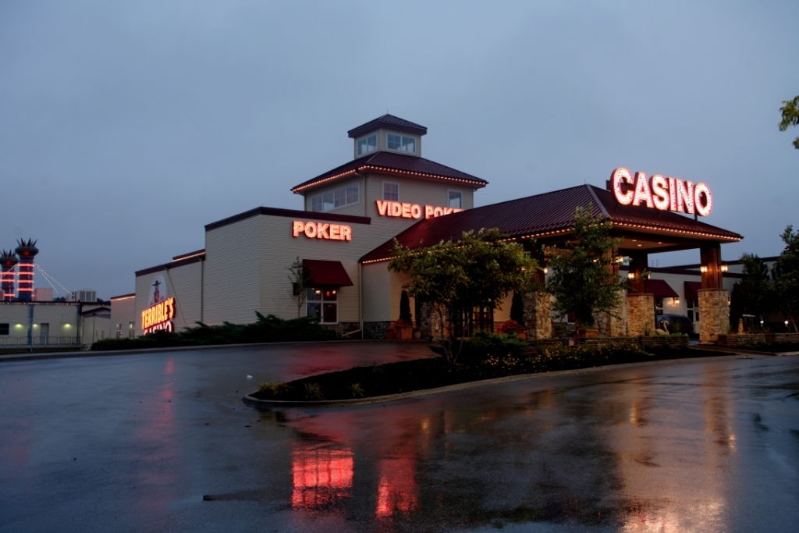
Osceola, IA
 | 2007 | 2008
Admissions | 1,086,241 | 867,014
Slot Drop | $357,463,995 | $321,788,376
Slot Coin In | $590,792,641 | $524,081,468
Slot Revenue | $52,790,776 | $47,800,194
Table Drop | $22,932,268 | $21,964,572
Table Revenue | $4,690,055 | $4,572,219
Adjusted Gross Revenue | $57,480,831 | $52,372,413
City Tax | $287,405 | $261,862
County Tax | $287,405 | $261,862
Gambler’s Treatment | $287,405 | $261,862
Endowment Fund | $372,246 | $418,979
State Miscellaneous Fund | $56,561 | $104,745
Gaming Tax | $10,944,764 | $9,802,621
Regulatory Fee | $706,566 | $724,900
RIVERSIDE CASINO AND GOLF RESORT LLC
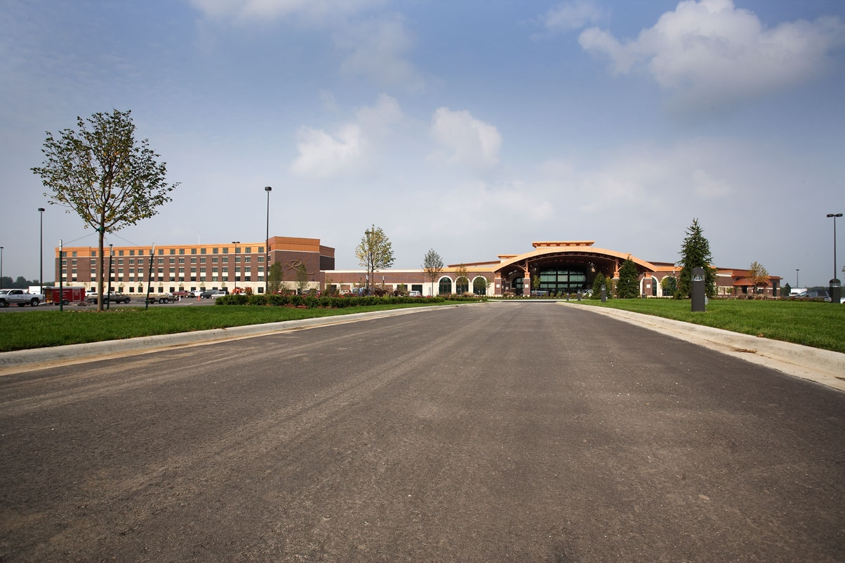
Riverside, IA

 | 2007 | 2008
Admissions | 1,759,500 | 1,996,691
Slot Drop | $557,229,801 | $543,717,930
Slot Coin In | $884,727,812 | $860,810,926
Slot Revenue | $74,354,794 | $75,577,730
Table Drop | $57,220,908 | $45,819,406
Table Revenue | $12,332,197 | $10,166,366
Adjusted Gross Revenue | $86,686,991 | $85,744,096
City Tax | $433,435 | $428,720
County Tax | $433,435 | $428,720
Gambler’s Treatment | $433,435 | $428,720
Endowment Fund | $562,442 | $685,953
State Miscellaneous Fund | $86,005 | $171,488
Gaming Tax | $16,712,379 | $16,310,099
Regulatory Fee | $816,930 | $795,465
DIAMOND JO – WORTH
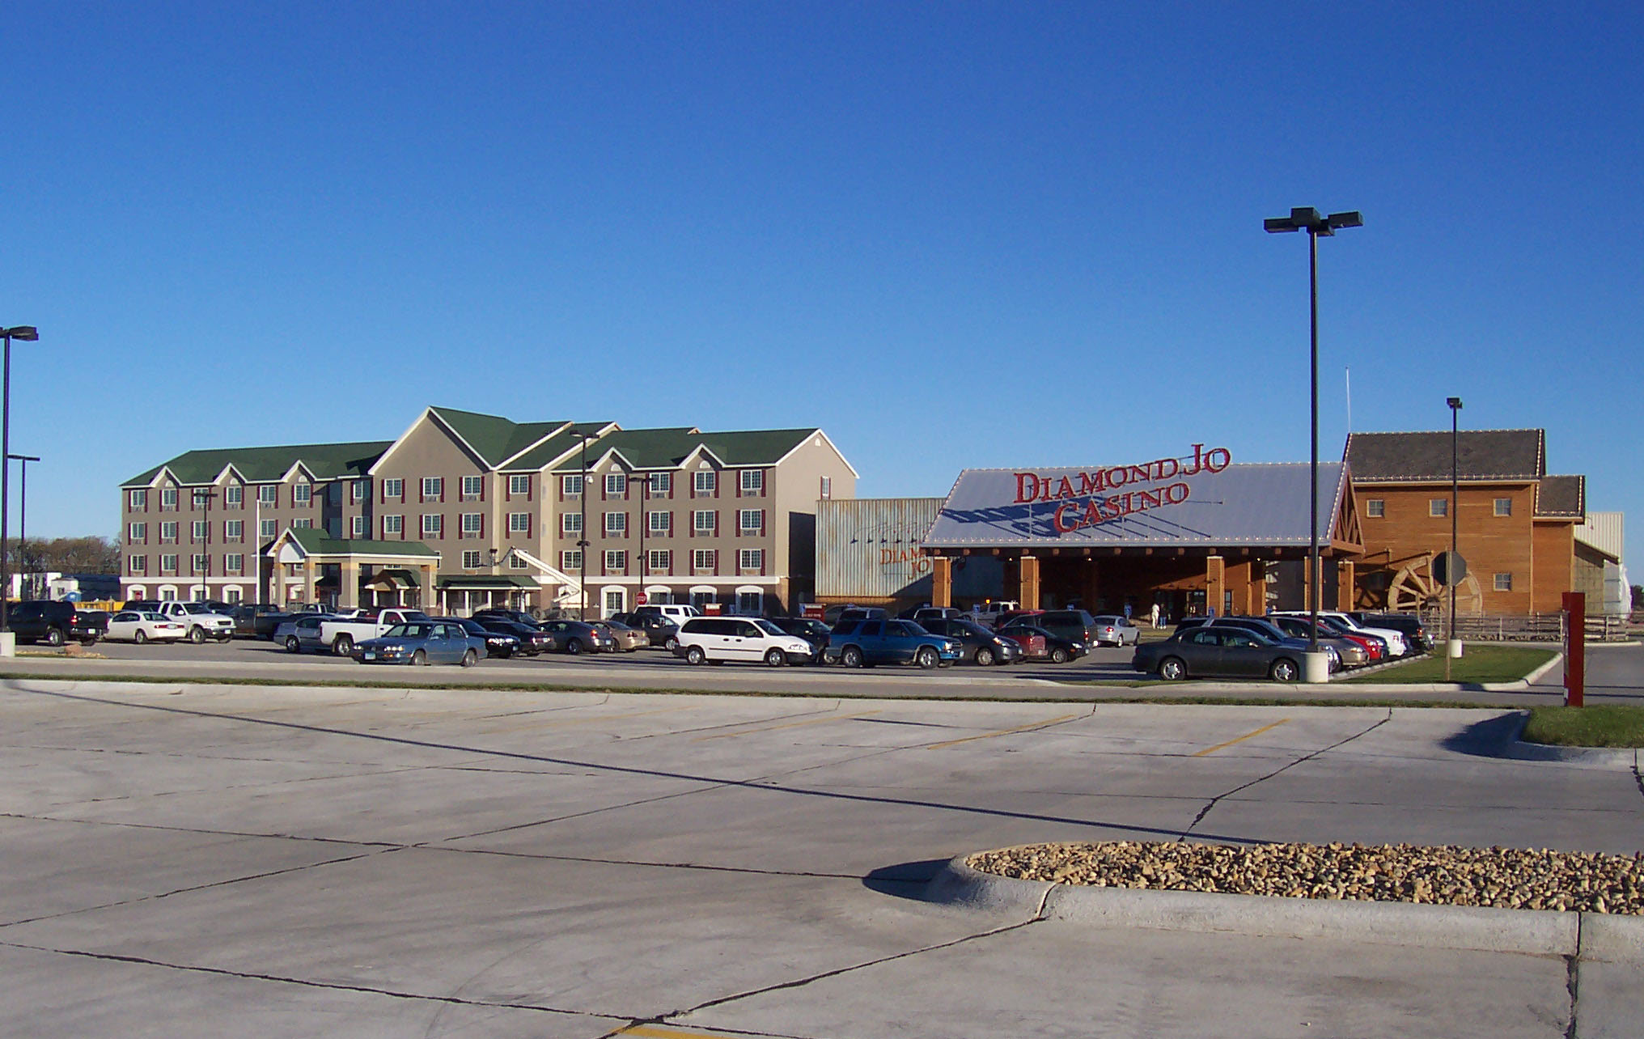
Northwood, IA

 | 2007 | 2008
Admissions | 1,256,092 | 1,260,085
Slot Drop | $385,303,447 | $439,083,402
Slot Coin In | $758,368,527 | $803,882,738
Slot Revenue | $67,853,301 | $72,170,176
Table Drop | $31,185,143 | $29,834,852
Table Revenue | $6,107,291 | $6,540,640
Adjusted Gross Revenue | $73,960,592 | $78,710,816
City Tax | $369,803 | $393,554
County Tax | $369,803 | $393,554
Gambler’s Treatment | $369,803 | $393,554
Endowment Fund | $486,714 | $629,686
State Miscellaneous Fund | $77,941 | $157,421
Gaming Tax | $14,187,266 | $14,938,610
Regulatory Fee | $706,566 | $724,900
WILD ROSE – EMMESTBURG
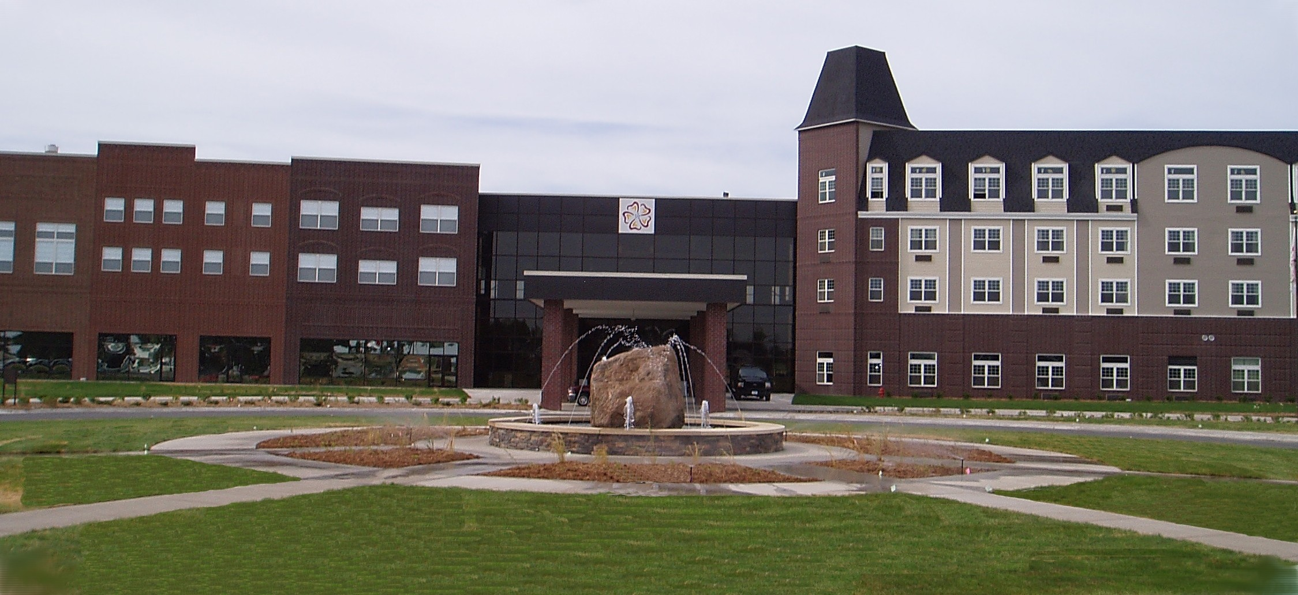
Emmetsburg, IA

 | 2007 | 2008
Admissions | 587,908 | 561,211
Slot Drop | $149,758,959 | $161,835,715
Slot Coin In | $279,171,091 | $290,293,951
Slot Revenue | $23,293,605 | $24,684,377
Table Drop | $13,777,884 | $13,321,404
Table Revenue | $2,726,701 | $3,037,326
Adjusted Gross Revenue | $26,020,306 | $27,721,703
City Tax | $130,101 | $138,609
County Tax | $130,101 | $138,609
Gambler’s Treatment | $130,101 | $138,609
Endowment Fund | $169,530 | $221,774
State Miscellaneous Fund | $26,286 | $55,443
Gaming Tax | $4,728,347 | $4,995,732
Regulatory Fee | $706,566 | $724,900

THE ISLE CASINO & HOTEL AT WATERLOO

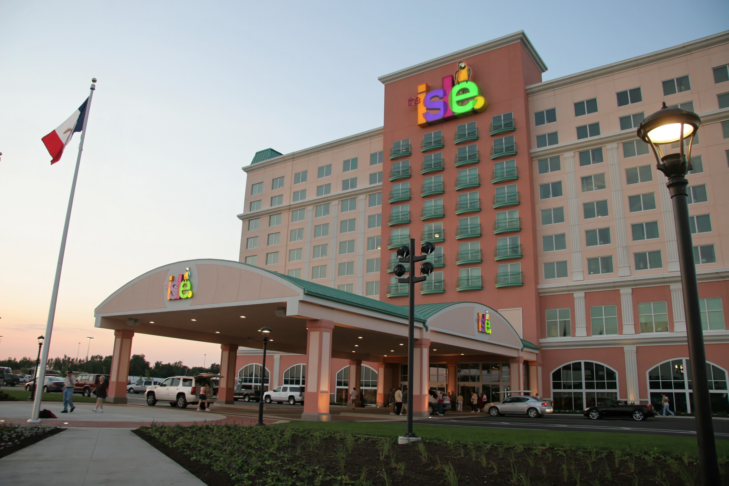
Waterloo, IA
The Isle at Waterloo opened on June 30, 2007
 | 2007 | 2008
Admissions | 993,448 | 1,565,178
Slot Drop | $270,537,997 | $516,652,448
Slot Coin In | $441,115,899 | $821,471,184
Slot Revenue | $35,375,750 | $70,348,409
Table Drop | $19,556,196 | $37,269,776
Table Revenue | $3,602,418 | $7,066,065
Adjusted Gross Revenue | $38,978,168 | $77,414,474
City Tax | $194,891 | $387,073
County Tax | $194,891 | $387,073
Gambler’s Treatment | $194,891 | $387,073
Endowment Fund | $310,938 | $619,316
State Miscellaneous Fund | $77,364 | $154,829
Gaming Tax | $7,141,886 | $14,685,823
Regulatory Fee | $756,320 | $793,088
EXCURSION BOAT REVENUE AND EXPENDITURES
2008
EXPENDITURES FOR REGULATION
Salary and Benefits | $2,527,192.87
Travel | $25,906.44
State Vehicle | $2,881.21
Office Supplies/Printing/Postage | $24,694.52
Equipment Maintenance | $20,981.42
Communications | $126,322.58
Rentals | $43,461.99
Professional, Scientific & Outside Services | $43,832.55
Intra-State Transfers | $43,378.11
Advertising/Publicity | $580.80
ITD/IT Outside Services | $28,222.75
Reimbursements to Other Agencies | $22,960.36
Equipment | $184,449.39
TOTAL | $3,094,864.99
REVENUES TO STATE
Annual Licensing Fees | $83,875
Regulatory Fees | $9,443,406
Initial Application Fees | $0
Occupational License Fees | $78,640
Manufacturers/Distributors License Fees | $27,250
Fines | $114,700
Gaming Tax | $180,019,605
Gambler's Treatment | $4,763,070
State Miscellaneous Fund | $1,905,224
TOTAL | $196,409,520
REVENUES TO LOCAL GOVERNMENT
Gaming Taxes (City/County) | $9,526,140
Endowment Fund | $7,620,909
Many local governments charge an admission fee not to exceed $.50/person as authorized under 99F.10 which is not included above.

