**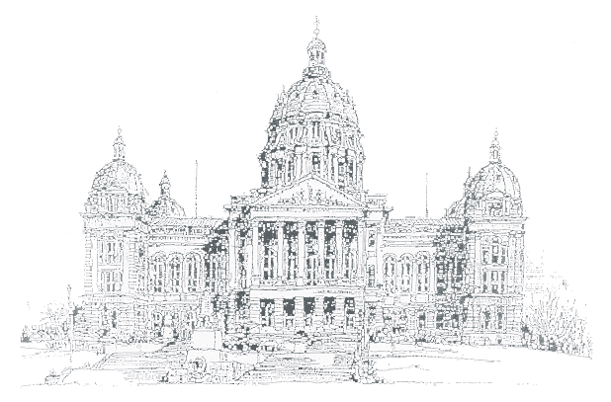**

##### Issue I

**January 2004**

Capitol

Connections

|  |  |  |
| --- | --- | --- |
| **Kevin Techau** | A newsletter for State Employees on the Capitol Complex | **Robert Garrison** |
| **Commissioner** | From Iowa State Patrol District 16 | **Colonel** |

We would like to start this issue by wishing everyone a happy New Year. With the New Year, comes…you guessed it… a new issue of the Capitol Connections newsletter. With the start of the legislative session right around the corner, please be mindful that good parking will become increasingly more difficult to find. We encourage all employees and visitors to allow for adequate time to find a parking spot. Illegal parking will result in a ticket from District 16 troopers. If you have a topic or event that you would like to have covered in the Capitol Connections newsletter, please submit your information to Tina Jensen of the Iowa State Patrol District 16 at [jensen@dps.state.ia.us](mailto:jensen@dps.state.ia.us).

**Martin Luther King Jr. Holiday**

The 15th Annual Dr. Martin Luther King Jr. Commemoration Ceremony will be held in the New Historical Building on Monday, January 19, 2004 from 10:45 a.m. until 12:00 noon. The ceremony will include a traditional bell ringing and presentation of the Dr. Martin Luther King, Jr. Lifetime Achievement & Service Project Awards. These awards recognize individuals who have demonstrated commitment to the vision of Dr. King by promoting the racial equality of all people of Iowa. In order to be considered to receive this award, one must have demonstrated a lifetime commitment to diversity and inclusion in his or her community and in the State of Iowa. Greg Alan Williams will be the Keynote speaker. This event is open to the public.

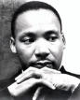

* January 5th – SEHARC Weigh-In, State Capitol
* January 12th – Legislative Session begins
* January 19th – 2004 Iowa Caucus
* January 19th – MLK ceremony, New Historical Building
* February 10th – Job Shadow Day
* February 11th – Taste of Iowa, State Capitol

**2003 End of Year Totals**

C:\WINDOWS\Application Data\Microsoft\Media Catalog\Downloaded Clips\cl84\j0331727.wmf1449 Complex Tickets

135 Motorist Assists

237 Escorts

18 Medical Assists

C:\WINDOWS\Application Data\Microsoft\Media Catalog\Downloaded Clips\cl64\j0250853.wmf

C:\WINDOWS\Application Data\Microsoft\Media Catalog\Downloaded Clips\cl0\FD00362_.wmfWe would like to thank the folks at the Department of Administrative Services and the Department for the Blind for providing Christmas care baskets for all of the Post 16 Troopers working on Christmas Day. Each basket was filled to the brim with snacks and other holiday goodies. These care baskets certainly made working Christmas Day more enjoyable for each of the troopers. Thank you very much for your kindness and generosity during the holiday season.

**Reminder to:**

**"MOVE OVER, SLOW DOWN"**

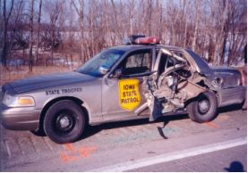**The law has been in effect since July 1, 2002 and is as follows**:

1. The operator of a motor vehicle approaching a stationary authorized vehicle that is displaying flashing yellow, amber, white, red, or red and blue lights shall proceed in one of the following manners, absent any other direction by a peace officer.

|  |
| --- |
| This State Patrol Vehicle was struck while parked along the Interstate with lights flashing. |

a. Make a lane change into a lane not adjacent to the authorized emergency vehicle, if possible in the existing safety and traffic conditions.

b. If a lane change under paragraph "a" would be impossible, prohibited by law, or unsafe; reduce the speed of the motor vehicle to a reasonable and proper speed for the existing road and traffic conditions, which speed shall be less than the posted speed limit, and be prepared to stop.

2. The law also applies to operators of a motor vehicle approaching a stationary towing or recovery vehicle, or a stationary highway maintenance vehicle, that is displaying flashing yellow, amber or red lights.

C:\WINDOWS\Application Data\Microsoft\Media Catalog\Downloaded Clips\cl5c\j0230340.wmf**FINE -** For a violation under section 321.323A or 321.324, the scheduled fine is fifty dollars ($50)

**"Better to remain silent and be thought a fool than to speak out and remove all doubt." - Abraham Lincoln**