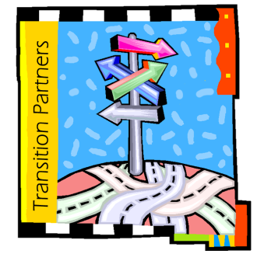
Henry County Transition Partners

Discovery of Key Barriers to Effective Transition
for Henry County Youth with Disabilities

Education  - Lack of vocational courses  - Lack of vocational/career exploration  - Lack of 1-1 time with teachers  - Lack of coordinated services within school district  - Resource room mostly tutoring and test taking assistance  - Turnover of paraprofessionals  - Purpose: graduation, adult life prep, post-secondary education  - Need longitudinal, sequential curriculum  - Youth leave school without a plan  - Impact of No Child Left Behind and high stakes testing  - Need Activities of Daily Living skill training in the summer  Families and adult service providers not involved in IEP process  - Stigma; lack of acceptance by peers  Employment  - Fear loss of benefits with employment  Family history of not working  - Lack of summer opportunities  - Youth do not understand work  Information  - Lack of information about services  - i.e. What can they do?  - Incorrect information about services  - Need information about benefits  - Families/Youth don’t know where to look for help when they need it |  | Preparation  - Lack of a team approach  Late diagnosis of disability  - Lack connection with post-secondary disability services  - Lack of testing for use by post-secondary disability services  Systemic  - Successful transition appears to be individual by individual; need a system for all students  - Complexity of the adult service system; teachers don’t understand it  - Complexity of the school systems; adult service providers don’t understand it  - Lack of easy access to services  - No follow-up to see how youth are doing  Youth  - Lack of support for the “total youth”  - Youth in school unrealistic about “adult life”  - No one in the school/community to “talk to”  - Lack connections to the community  - Youth not in school seem to be on their own; need structure, accommodations  - Students need self-confidence  - Youth don’t ask for assistance because they don’t understand their disability  - Unfair treatment; judged by clothes, money, etc.  - Parental support sometimes lacking  - Health, depression, substance abuse, etc.

Complied from: Focus Groups and Interviews with Youth, Parents, Educators, AEA staff, and Service Providers

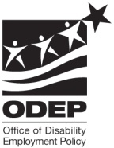
This document was developed by Henry County Transition Partners with Improving Transition Outcomes of Iowa Vocational Rehabilitation Services, funded by a grant/contract/cooperative agreement from the U.S. Department of Labor, Office of Disability Employment Policy #E-9-4-3-0093. The opinions expressed herein do not necessarily reflect the position or policy of the U.S. Department of Labor. Nor does mention of trade names, commercial products, or organizations imply the endorsement by the U.S. Department of Labor.

