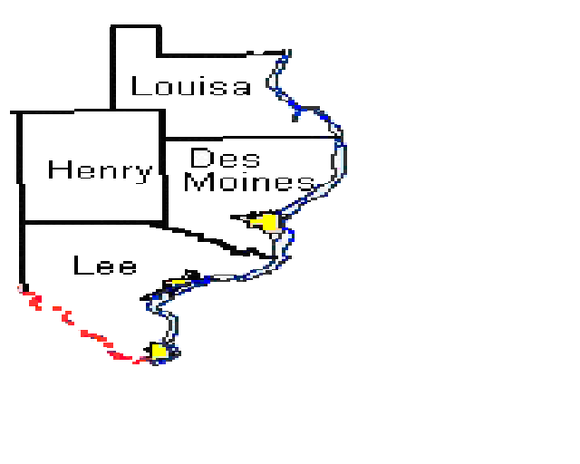

Iowa
Wesleyan
COLLEGE

Compiled by:
Collaboration and Transition Special Education Classes
Iowa Wesleyan College
Dr. Shawna Hudson, Professor

Printed by:
Great Prairie Area Education Agency
Special thanks go to the following students, who compiled the information required for this resource guide:

Edition 1:
Melissa Anderson
Debbie Arndt
Brian Benson
Darlene Broadhurst
Teresa Buck
Debbi Castle
Melissa Coleman
Steve Douthart
Lloyd Duncan
Dena Ellington
Mary Jo Hall
Jennifer Hirt
Kim Hobbs
Lorna Hood
Erica Knipe
Vida Long
Sara Maher
Natalie McDowell
Luann Murphy
Lisa Nichols
Barbara Oetken
Todd Prunty
Mindy Rees
Dawn Shipman
Rea Springsteen
Jennifer Stafford
Amanda Stiefel
Laurie Storm
Kristin Stuekerjuergen
Paul Thompson
Jo Beth Vincent
Kate Ward
Amber Wetzel
Jan Woodruffe

Edition 2:
Mark Begey
Nancy Benner
Megan Dralle
Rae Fedler
Melinda Freiburger
Kathleen Griggs
Denise Harris
Bridget Jones
Amanda Kruger
Jeanne Mulford
Kathy Newberry
Barbara Peters
Annmarie Sabel
Heather Sanders
Michael Sheerin
Nicole Smith
Peggy Wenzel
Wendy Wiley
Beth Brooks
Deborah Scott
Tammy Swenka

