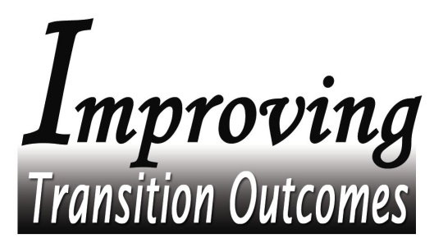

Resource Map Trainings

9:00 – 3:00 with lunch provided
Featuring: Lois Smidt,
Director of Beyond Welfare Training Center in Ames, Iowa

Friday, December 12, 2003
Southwestern Community College in Creston

Thursday, December 18, 2003
Mississippi Bend AEA in Bettendorf

Wednesday, January 7, 2004
Western Iowa Tech Community College in Sioux City

Thursday, January 15, 2004
Hawkeye Community College in Waterloo

Tuesday, February 3, 2004
Des Moines Area Community College in Ankeny

Attendance limited to 50. Additional trainings will be scheduled if interest is sufficient.

Consider inviting representatives from: Business organizations, Civic groups, Faith-based organizations, Recreational groups and Youth organizations

Registration required
Register on-line at http://soe.drake.edu/iapaths/
or print and fax registration to 515-281-4150

- Transition Alliance Programs are asked to bring 2 students
- Division of Vocational Rehabilitation Services Supervisors & Counselors:
- Attendance required for DVSR Counselors assigned to TAPs
- Attendance optional for DVRS Supervisors and other Counselors
          - DVRS employees must attend the closest location
  - Att

Sponsored by: U.S. Department of Labor, Office of Disability Employment Policy State Alignment Grant for Improving Transition Outcomes for Youth with Disabilities through the Use of Intermediaries Administered by the State of Iowa Department of Education Division of Vocational Rehabilitation Services Grant # E-9-4-3-0093.

