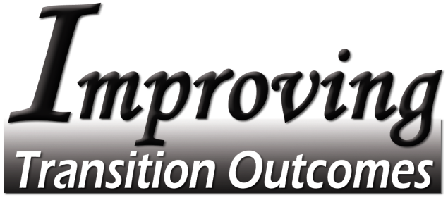

Resource List

ABCD: The Asset-Based Community Development Institute: Books, Workbooks and Videos including Building Communities from the Inside Out: A Path Toward Finding and Mobilizing a Community’s Assets, John P. Kretzmann and John L. McKnight, ACTA Publications, 4848 North Clark Street, Chicago, IL 60640, www.northwestern.edu/ipr/abcd.html

Beyond Welfare, Lois Smidt, Executive Director, 130 S. Sheldon. Suite 302, Ames, IA 50010, 515-2923-5992 Web site: http://www.beyondwelfare.org/

City Scan (Des Moines) http://www.city-scan.com/

Coming Together Building Community Collaboration and Consensus http://www.communitycollaboration.net/

Community Audit http://www.doleta.gov/usworkforce/communityaudits/eta_default.cfm

Community Youth Mapping (Des Moines) http://www.communityyouthmapping.org/Youth/

Environmental Scanning http://www.cce.cornell.edu/admin/program/documents/scanintr.htm

National Center on Secondary Education and Transition: Creating Opportunities for Youth with Disabilities to Achieve Successful Futures http://www.ncset.org/

National Collaborative on Workforce and Disability http://www.ncwd-youth.info/index.html

Pathways Mapping Initiative http://www.pathwaystooutcomes.org/index.cfm

Person-Centered Planning http://www.ncset.org/publications/viewdesc.asp?id=1431

Training and Technical Assistance for Providers funded by the Office of Disability Employment Policy, US Department of Labor http://www.t-tap.org/

What’s Really Worth Doing and How to Do It: A Book for People Who Love Someone Labeled Disabled (Possibly Yourself) by Judith A. Snow, M.A., Philosopher, Centre for Integrated Education and Community, Toronto, Canada, January 1994, Inclusion Press

State Alignment Grant for Improving Transition Outcomes for Youth with Disabilities through the Use of Intermediaries,
administered by the State of Iowa Department of Education, Iowa Vocational Rehabilitation Services
Funded under a grant/contract supported by the Office of Disability Employment Policy of the U. S. Department of Labor, grant/contract #E-9-4-3-0093. The opinions contained in this publication are those of the grantee/contractor,
and do not necessarily reflect those of the U. S. Department of Labor.

