*State of Iowa*

*Consolidated Plan for Housing and Community Development*

2006 Annual Performance Report

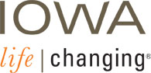

*March 2007*

**CONSOLIDATED PLAN FOR HOUSING AND COMMUNITY DEVELOPMENT**

**Annual Performance Report — Program Year 2006**

TABLE OF CONTENTS

Introduction 1

PART A: Summary of Resources and Programmatic Accomplishments 2

1. Resources Made Available to the State 2

2. Investment of Available Resources 4

3. Geographic Distribution and Location of Investments 7

4. Families and Persons Assisted 12

5. Actions Taken to Affirmatively Further Fair Housing 12

6. Assessment of Other Actions 17

7. Proposed Accomplishment Measures 22

PART B: AFFORDABLE HOUSING 23

1. State’s Progress in Meeting Objectives 23

2. Narrative Discussion of Performance 24

PART C: COMMUNITY DEVELOPMENT BLOCK GRANT 25

1. Assessment of the Relationship Between Use of Funds and State Priorities 25

2. Changes in Program Objectives 25

3. Benefit to Low- and Moderate-income Persons 25

4. Compliance with Civil Rights Laws 25

PART D: HOME 27

1. Results of On-site Inspections 27

2. Private Sector Participation 27

3. CHDOs 27

4. Tenant Assistance/Relocation 27

HOME Match Report 29

Annual Performance Report 32

**Appendices**

Emergency Shelter Grants Program (Year 2006) As an Attachment

Emergency Shelter Grants Program (Year 2005) As an Attachment

PER Forms for Years 1996-2006 As an Attachment

2006 Emergency Shelter Grants Program Matching Funds……..As an Attachment

ESG Program Assessment of Five-Year Objectives…………….As an Attachment

Program Self-Evaluation for ESGP……………………………..As an Attachment

Continuum of Care- 2006 Application Summary……………….As an Attachment

**State of Iowa Consolidated Plan for Housing and Community Development**

**Annual Performance Report—Program Year 2006**

# Introduction

This document is the State of Iowa's Annual Performance Report (APR) for the period beginning January 1, 2006 and ending December 31, 2006 (Program Year 2006). This report is intended to fulfill the U.S. Department of Housing and Urban Development (HUD) requirements that require the state to annually review and report the progress made in carrying out its Consolidated Plan for Housing and Community Development.

This report, and the supplemental documentation included with it, replaces several year end reports submitted individually in the past. These separate reports were:

* The Community Development Block Grant (CDBG) Performance and Evaluation Report (PER);
* The HOME Investment Partnership Annual Performance Report (APR); and
* The Comprehensive Housing Affordability Strategy (CHAS) Annual Performance Report (APR)

The State of Iowa, in this document, has chosen to report under the Consolidated Plan format while incorporating all required elements of the PER and APRs.

The Iowa Department of Economic Development (IDED) is responsible for developing and carrying out the State of Iowa's Consolidated Plan, and therefore serves as the lead agency for this Annual Performance Report. This report was prepared in accordance with 24 CFR Part 91.520.

IDED made a draft of this report available for public review and comment. A notice of availability was published in the Des Moines Register on February 25, 2007. The report was also placed on the IDED website, with a related announcement, on February 28, 2007. To date, IDED has not received any comments on the report.

# PART A: Summary of Resources and Programmatic Accomplishments

## 1. Resources Made Available to the State

In 2006, the following federal resources were made available to the State for housing activities:

**Iowa Community Development Block Grant (CDBG) Program**

IDED administers the state CDBG program, which is funded by HUD. The State sets aside 25 percent of CDBG funds for housing, which are combined with state HOME funds in the IDED Housing Fund. CDBG funds are available on a competitive application basis to all counties and to cities with populations less than 50,000. In 2006, $6.603.508 was available for housing through the CDBG program.

**HOME Investment Partnerships Program**

First funded in 1992, HOME is a federal program dedicated to affordable housing for low-income persons. IDED administers the state HOME program in Iowa, which is available statewide. Local governments, Community Housing Development Organizations (CHDOs), for-profit entities and nonprofit organizations are eligible for HOME funds. In 2006, $10,146,294 was available through the state HOME program. In conjunction with the HOME Program, $207,746 was available to the Iowa statewide program through the ADDI (American Dream Downpayment Initiative) for homeownership assistance.

**Emergency Shelter Grant (ESG) Program**

HUD provided $1,494,852 to the State of Iowa for the ESG program in 2006. This program funds a variety of facilities and services for homeless persons and for prevention of homelessness. It is available through annual competition among local governments and eligible not-for-profit service providers within their jurisdictions.

**Low Income Housing Tax Credits**

The Iowa Finance Authority (IFA) administers the Low Income Housing Tax Credit program in Iowa. It is available to investors for affordable rental housing projects. In 2006, $6,262,738 in tax credits was available through IFA, creating 803 affordable units.

**State-funded Housing Programs**

IFA administers the Iowa Housing Assistance Program. In 2006, $9,189 was expended through this program to provide assistance to 7 low and moderate income homebuyers. IFA also provided $475,000 for Homeless and Transitional Housing projects through the state Housing Shelter Operations Grant (HSOG) Program

**State Housing Trust Fund**.

The Iowa Finance Authority operates the Local Housing Trust Fund Program and the Project-Based Housing Program, both components of the State Housing Trust Fund. During 2006 IFA awarded $1,440,000 to thirteen (13) local or regional trust funds and $490,000 to six (6) project-based local housing programs.

**Federal Weatherization Funds**

The Iowa Department of Human Rights (DHR) receives funds from federal sources (chiefly the U.S. Department of Energy) for housing weatherization for low-income persons. These funds are distributed to Community Action Agencies, which administer the local weatherization programs. In calendar year 2006, DHR spent $16,582,857 to help in the weatherization of 2,342 homes.

**Federal Mortgage Revenue Bond and Tax Exempt Multi-Family Bond Programs**

Federal Housing Programs administered by the Iowa Finance Authority included the FIRSTHOME Program, providing $255,502,715 from mortgage revenue bonds to fund home purchases for 3,005 Iowa families.

In 2006, the following federal resources were available to the State for non-housing community development activities:

**Iowa CDBG Program**

Seventy-five percent of the State CDBG program is available for non-housing community development activities that principally benefit low- and moderate-income persons. CDBG funds are available on a competitive application basis to all counties and to cities with populations less than 50,000. In 2006, $19,810,525 was available through the CDBG program for all non-housing community development. Of this, $5,282,807was set aside for economic development and job training programs. A special set-aside to meet emergency or special opportunities has a reserve amount of $1,320,702. The remaining funds were available for the annual competition for public works, public facilities and public services.

**Clean Water State Revolving Fund**

The U.S. Environmental Protection Agency annually funds the Clean Water State Revolving Fund (CWSRF), a revolving fund for sewage treatment system improvements, as part of the Clean Water Act. The Iowa Department of Natural Resources (DNR) administers the program in Iowa. In 2006, $53,800,000 was awarded through this revolving loan program.

**Drinking Water State Revolving Fund**

The U.S. Environmental Protection Agency annually funds the Drinking Water State Revolving Fund (DWSRF), a revolving fund for drinking water system improvements. The Iowa Department of Natural Resources (DNR) administers the program in Iowa. In 2006, $56,589,000 was awarded through this revolving loan program.

## 2. Investment of Available Resources

Following is a discussion of actual investments in affordable housing for low- and moderate-income (LMI) persons and community development during 2006. Investments generally refer to funds the State awarded to a recipient, and some of the figures are based on estimates. This discussion is organized by the general priorities for housing and community development identified in the Consolidated Plan. The tables for each category show the breakdown of the investment and number of units by activity. References to the HOME Program refer both to federal HOME funds and state-appropriated match committed to HOME-funded projects.

**Elderly Renter Households**

The State invested $2,316,623 to produce 199 affordable rental units for the elderly.

|  |  |  |
| --- | --- | --- |
| HOME rehabilitation | $ 280,000 | 133 units |
| HOME Program (new construction) | $ 798,250 | 18 units |
| Low Income  Housing Tax Credits (new construction) | $ 889,869 | 86 units |
| LIHTC (Rehabilitation) | $ 348,504 | 62 units |

**Small Related LMI Renter Households**

The State invested $ 6,693,734 to provide 560 affordable rental units for small families.

|  |  |  |
| --- | --- | --- |
| HOME (Transitional) | $ 3,108,410 | 100 units |
| HOME TBRA | $ 0 | 0 units |
| HOME Program (new construction) | $ 400,000 | 8 units |
| HOME Program (rehabilitation) | $ 1,056,000 | 66 units |
| Low Income Housing Tax Credits (IFA) | $ 2,129,324 | 386 units |

**Large Related LMI Renter Households**

The State invested $ 544,000 to provide 34 affordable rental units for large families.

|  |  |  |
| --- | --- | --- |
| HOME Program (new construction) | $ 544,000 | 34 units |

**All Other LMI Renters (non-related)**

The State invested $ 5,304,157 to provide 324 affordable rental units for other renters.

|  |  |  |
| --- | --- | --- |
| HOME Program (Special Needs New Construction) | $ 2,061,116 | 48 units |
| HOME Program (Special Needs Rehabilitation) | $ 350,000 | 7 units |
| LIHTC (IFA) Assisted Living | $ 1,779,943 | 154 units |
| LIHTC (IFA) Transitional | $ 781,341 | 84 units |
| LIHTC (IFA) Persons w/Disabilities | $ 331,757 | 31 units |

**Existing LMI Homeowners**

The State invested $9,335,241 to assist 284 existing low-income homeowners.

|  |  |  |
| --- | --- | --- |
| CDBG Program (rehabilitation) | $ 9,335,241 | 284 units |

**LMI Homebuyers (with and without children)**

The State invested $259,904,000 to help 4,264 low-income families purchase/rehabilitate homes.

|  |  |  |
| --- | --- | --- |
| HOME Program (acquisition) | $ 1,846,250 | 74 units |
| Iowa Finance Authority (Homebuyer Loans) | $255,502,715 | 3005 units |
| Iowa Finance Authority (Down Payment Assistance) | $ 2,555,115 | 1185 units |

**Homeless Individuals and Families**

The State invested $ 2,490,000 to help homeless individuals and families through homeless shelter rehabilitation, operations and services assistance, transitional housing and homelessness prevention activities. The sources of funds were as follows:

|  |  |
| --- | --- |
| Emergency Shelter Grant Program | $ 1,490,000 |
| Homeless Shelter Operations Grant Program | $ 1,000,000 |

**Non-housing Community Development**

The PER data sheets found in the appendix to this document detail the investment of state resources (i.e., CDBG funds) in non-housing community development activities. The table below summarizes that data for FY06.

|  |  |  |
| --- | --- | --- |
| Centers/Facilities | $3,726,000 | 9 projects |
| Water Projects | $6,057,647 | 25 projects |
| Sewer Projects | $5,827,440 | 20 projects |
| Flood and Drainage Projects | $681,000 | 2 projects |
| Administration (non-housing) | $1,045,846 | 69 projects |
| Business Assistance/Employment Training | $6,281,915 | 21 projects |
| Acq., Demo. And Reloc. | $261,253 | 1 project |

## 

## 3. Geographic Distribution and Location of Investments

The maps on the following pages show the geographic distribution of the State’s investment of available resources. The first map shows the distribution of FY 06 housing awards made through the HOME and CDBG programs. The second map shows the distribution of FY 06 homeless shelter awards made through the ESG program. CDBG and HOME awards are further differentiated by type of assistance. The third map shows the distribution of CDBG awards for non-housing community development projects during FY 06. The fourth map shows the distribution of resources in areas of minority concentration. The awards are further differentiated by type.

The maps show the State making investments in a number of metropolitan and non-metropolitan counties. While several major urban areas appear to have a concentration of projects, many rural areas also received awards. These areas often are smaller communities experiencing economic growth, with a shortage of affordable housing for low-income residents.

Local interest and initiative in developing and carrying out programs and projects controls the geographic distribution of the State’s investments in affordable housing and non-housing community development. In an effort to distribute awards statewide, the State conducted outreach activities, including ongoing contacts and meetings with regional groups, such as Councils of Governments and Community Action Agencies.

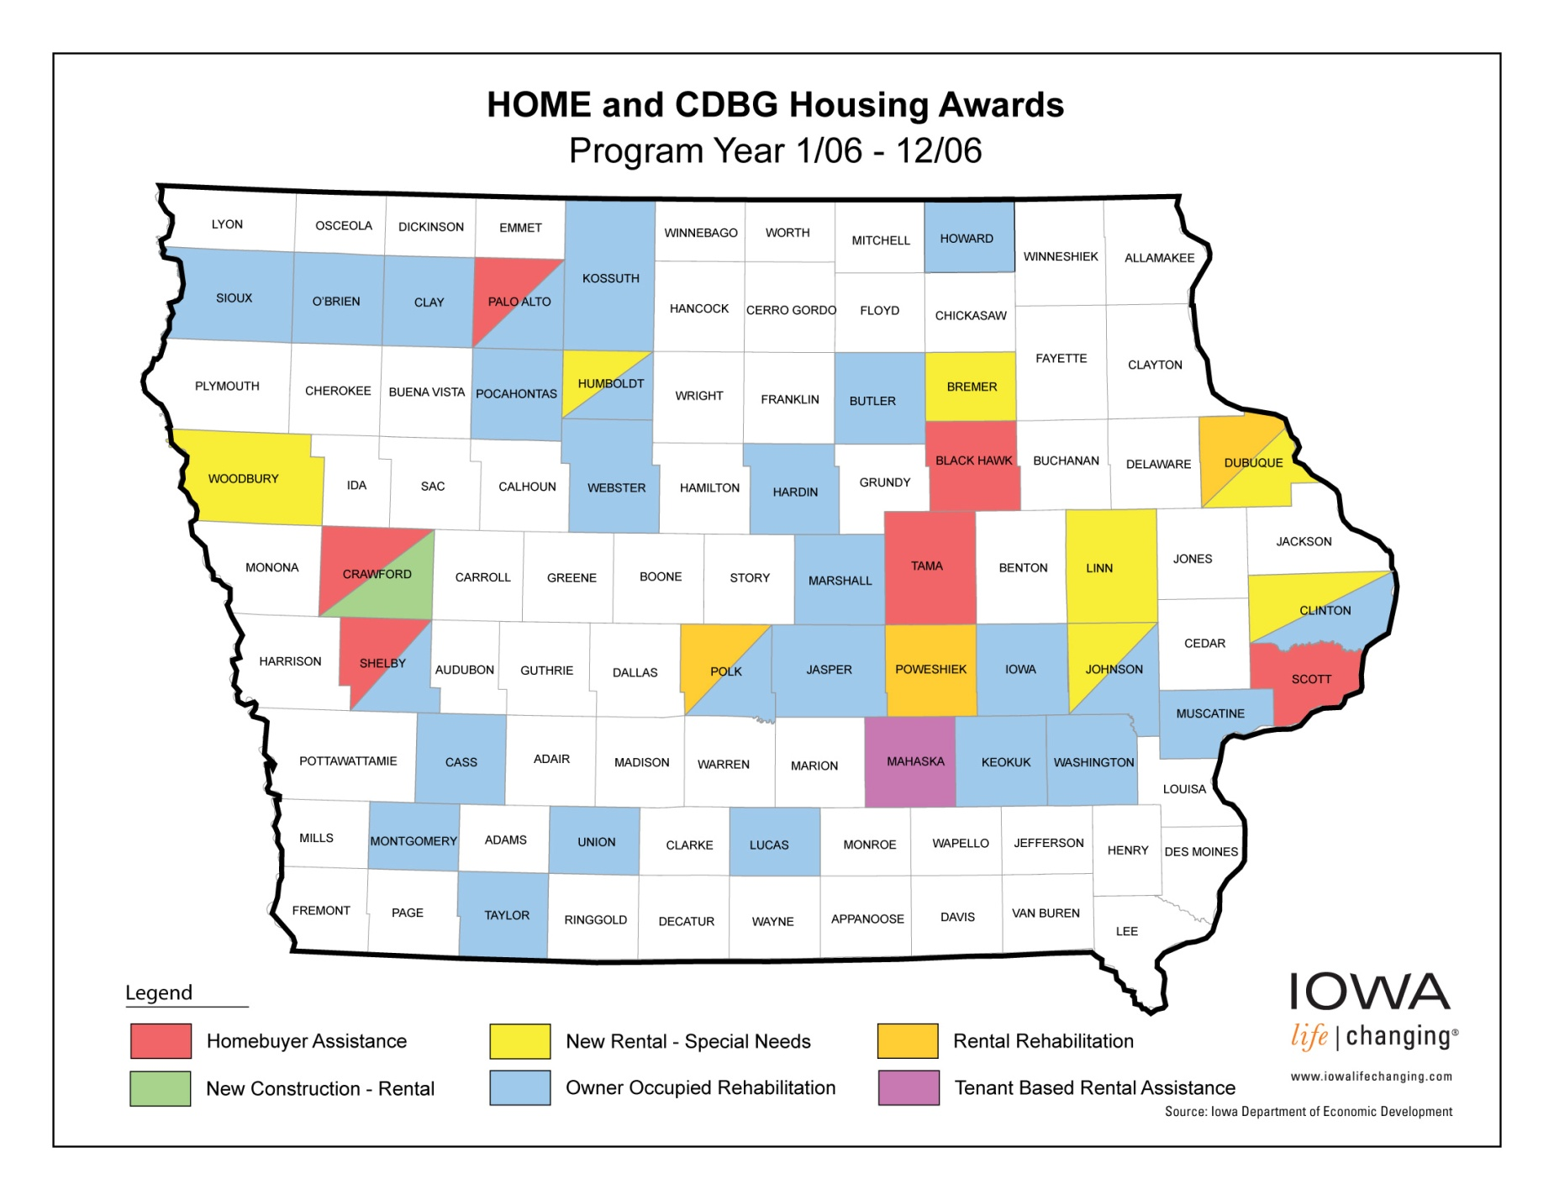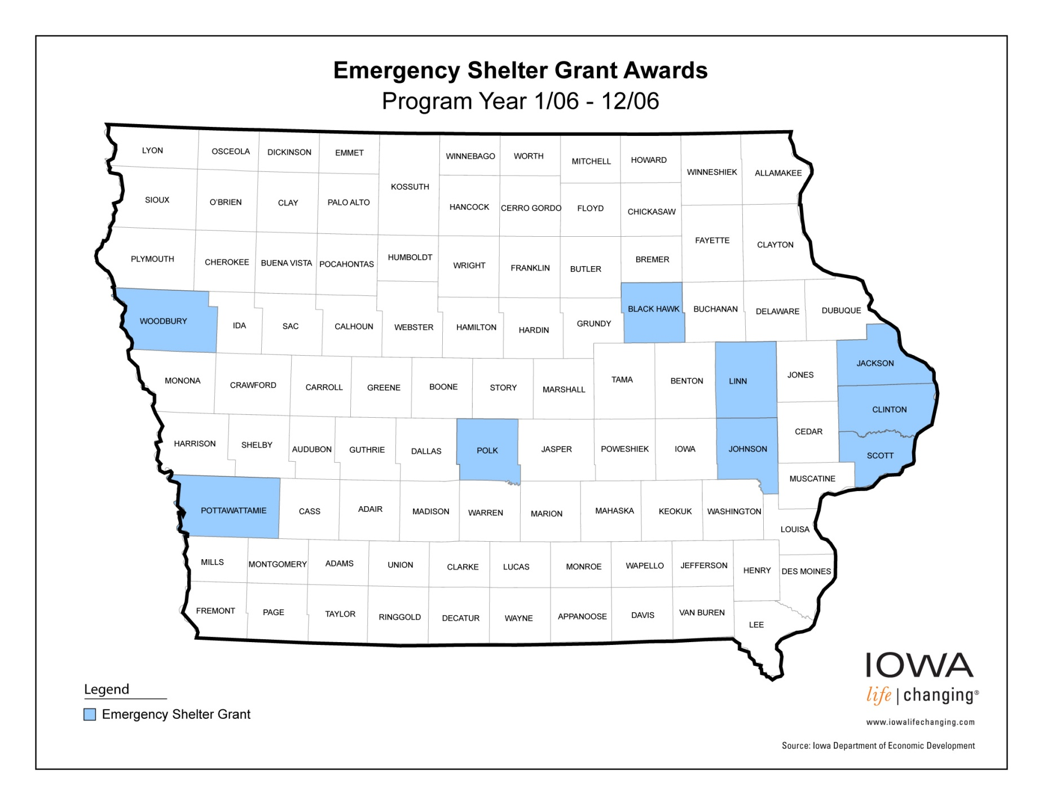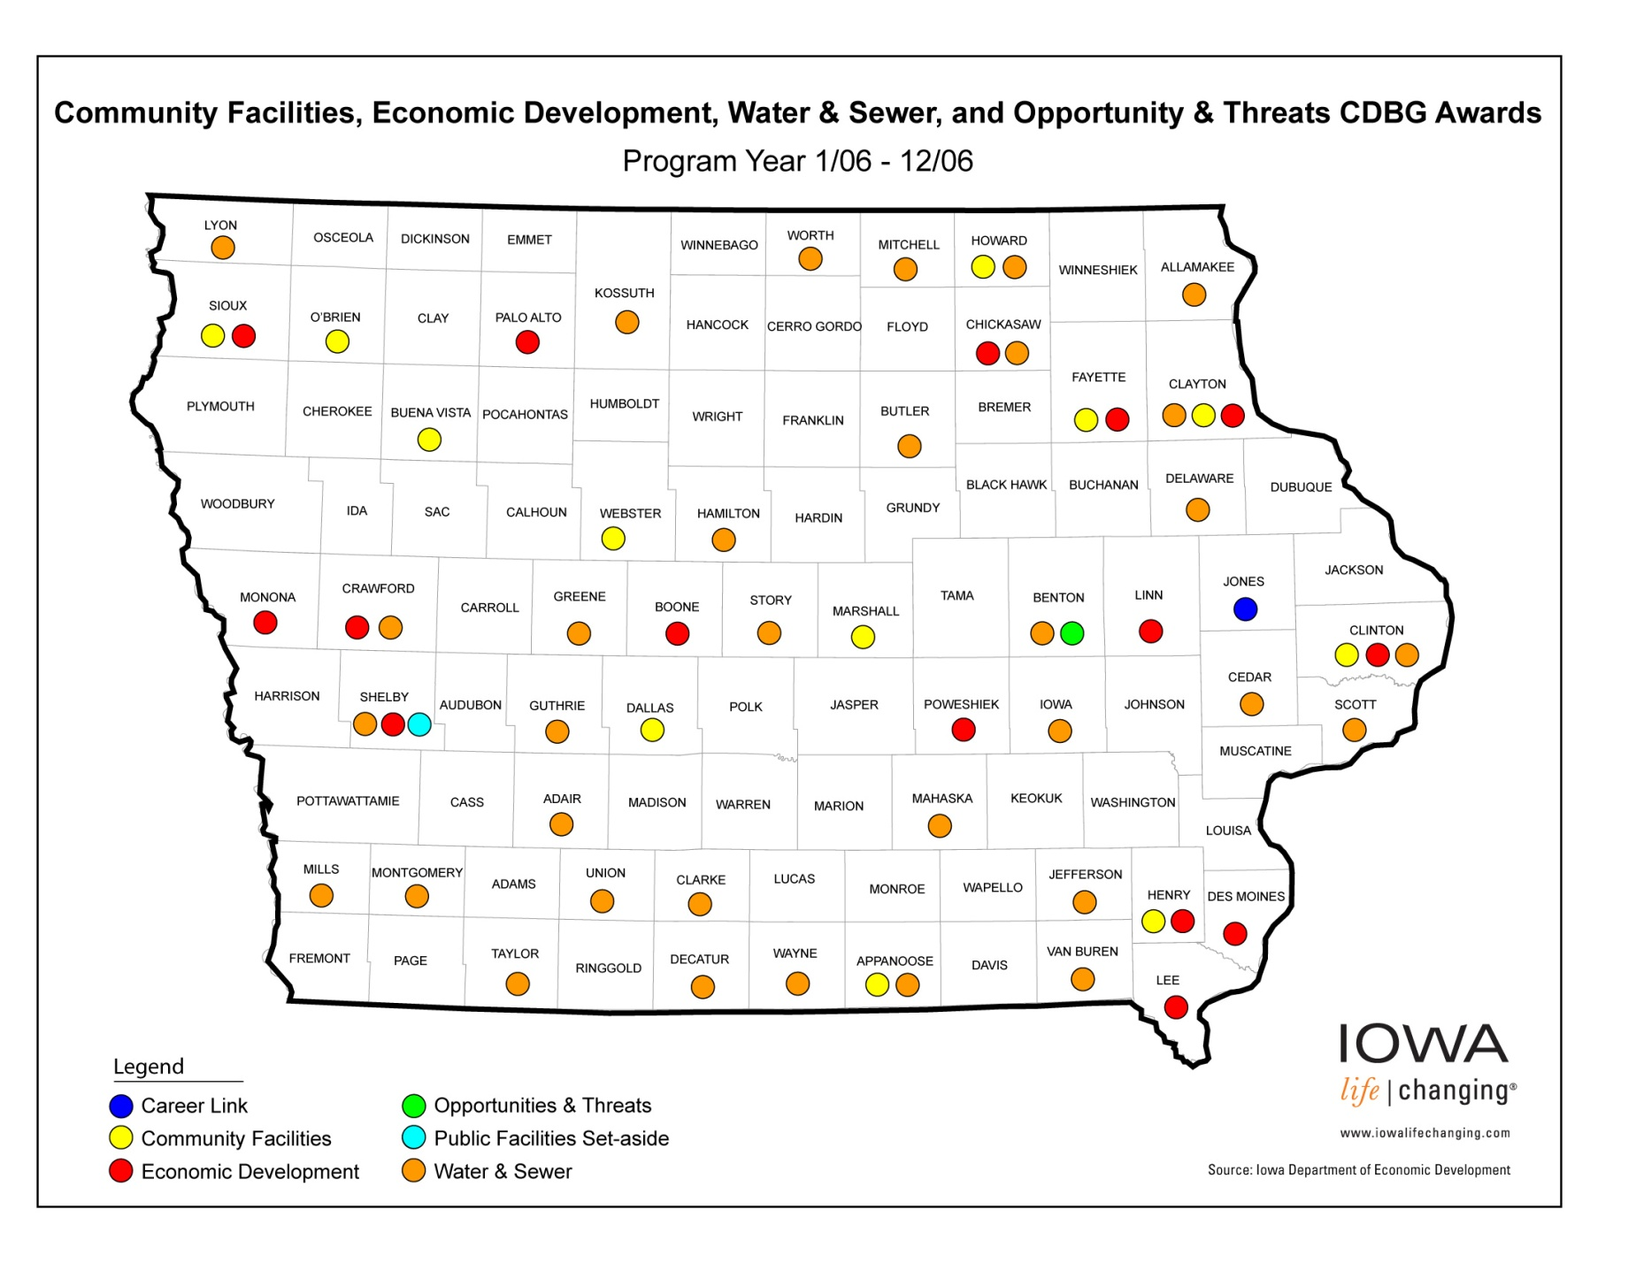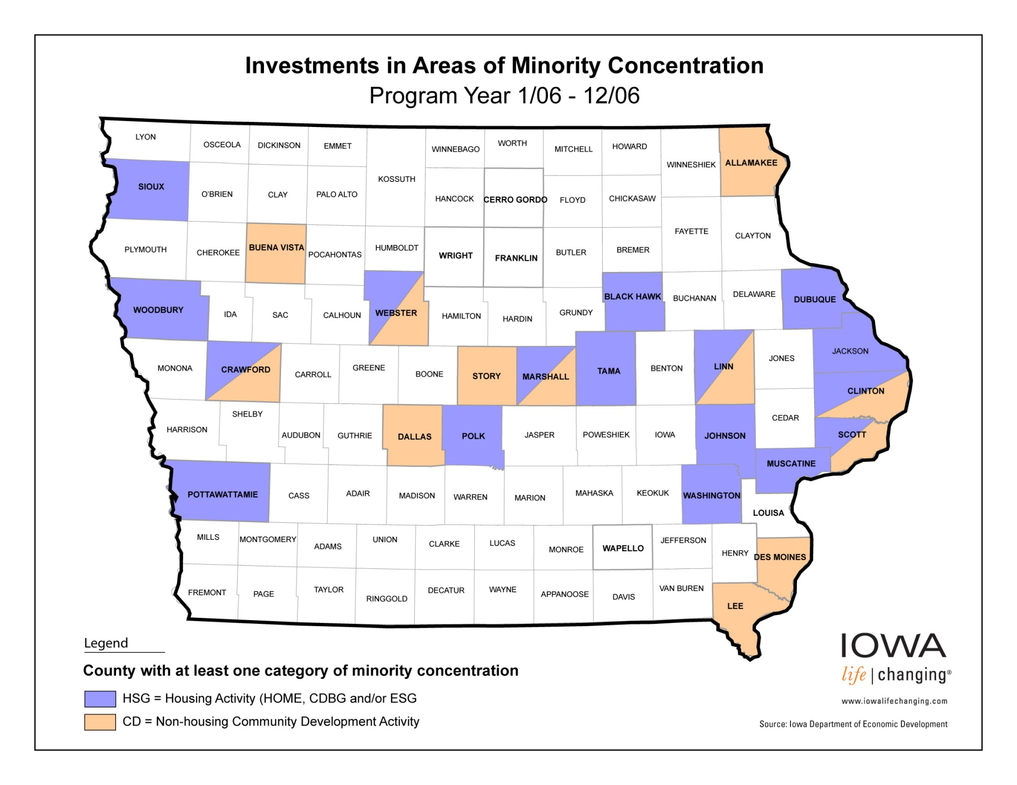

## 4. Families and Persons Assisted

CHAS Annual Performance Report Table 1 on page ____ shows the specific data on the State’s housing accomplishments in 2006 in providing assistance to low- and very low-income households, renters, owners, homeless persons and persons with special needs. These data are based on HOME and CDBG-funded projects completed within the reporting period. Specific data on persons assisted through non-housing community development projects (i.e., CDBG-funded projects) can be found in the PER data sheets in the appendix to this document.

**Documentation of Assistance Provided**

The State collects data concerning assistance provided to each household (or person) from funded entities. Recipients of federal funds through the State are responsible for maintaining documentation of assistance necessary to support the data.

## 5. Actions Taken to Affirmatively Further Fair Housing

The State is committed to fair housing. IDED demonstrates the State’s commitment to fair housing through its policies, procedures and practices. These are conveyed through workshops, contractual language, management guide instructions and technical assistance. IDED’s *CDBG Management Guide* and *Housing Fund Management Guide*, which are distributed to program recipients, both contain sections on fair housing and affirmative marketing. They clearly articulate the goals and criteria pertinent to fair housing and provide guidance for achieving the goals. Recipients pattern their fair housing efforts from the guides, which include these recommendations:

* Publicize that the local government will assist persons experiencing discrimination in housing. Such assistance can be in the form of facilitating the filing of a complaint with HUD or the Iowa Civil Rights Commission.
* Develop and adopt a fair housing ordinance and identify the methods of enforcement.
* Provide housing counseling services which assist minorities and women seeking housing outside areas of concentration.
* Work with local real estate brokers to form a Voluntary Area-wide Marketing Agreement.
* Work with local banks to end “redlining” practices and to post “equal lending opportunity” advertisements.
* Use “equal housing opportunity” slogan and logo on city/county letterhead.
* Sponsor fair housing seminars and campaigns.
* Work with minority and women leaders in the area to promote housing development and increase minority and female participation.
* Help local housing developers develop outreach programs to attract minorities and females.
* Review zoning ordinance and comprehensive plans to insure they promote spatial deconcentration of assisted housing units.
* Make city-owned property located outside areas of concentration available to developers at no or nominal costs for construction of assisted units particularly for large family units.
* Develop an Area-wide Housing Opportunity Plan.
* Support fair share housing allocation plans.
* Create a local housing authority.
* Conduct studies to ensure minority and female housing needs are adequately defined.
* Adopt a code enforcement ordinance that will compel landlords to keep their units in safe and sanitary condition.
* Publicly advertise that the city is a “fair housing city” (See the sample “Public Notice”).
* Work with local real estate brokers and mortgage lenders in reviewing mortgage credit analysis and underwriting criteria.
* Provide fair housing counseling programs that include information on fair housing rights and the availability of housing in a variety of locations, emphasizing housing choice.
* Modify local ordinances and land use measures in pursuit of housing opportunity.
* Support a training and education program for real estate agents, housing managers, city officials and others to increase knowledge of techniques for promoting economically and racially integrated housing. They may also carry out promotional activities to initiate housing proposals in areas outside those with a high proportion of lower-income persons.

In addition, HOME recipients with more than five units of rental housing must submit an Affirmative Marketing Plan that addresses the following:

* methods to inform the public, owners and potential tenants about their fair housing rights;
* a description of how the recipient/owner will affirmatively market HOME-assisted housing;
* a description of how the recipient/owner will provide special outreach to persons not likely to apply for assistance;
* maintenance of records documenting actions to affirmatively market housing;
* a description of how affirmative marketing efforts will be assessed and corrective actions taken when needed.

Affirmative marketing activities must be part of the ongoing administration of rental projects throughout the term of affordability.

Some examples of affirmative marketing by award recipients in the past year are the contacting of the following types of entities:

media schools churches day care centers

businesses employees newspapers community centers

government realtors social/civic groups chambers of commerce

shoppers shelters human service agencies

and producing the following types of publications:

brochures

mailing lists

site signs

letters

posters

handouts

phone calls

publications that target minority audiences

IDED project managers provide technical assistance to recipients in the area of fair housing. Additionally, through project monitoring, IDED reviews each recipient’s fair housing performance. If noncompliance with fair housing policies and procedures is indicated, further action is taken. IDED did not identify any cases of noncompliance in 2006. One IDED project manager is assigned fair housing as a specialty area. That individual is listed with the HUD Fair Housing Information Clearinghouse and serves as a resource person on fair housing issues.

IDED’s monitoring of HOME recipients in 2006 found the following examples of special affirmative marketing efforts:

-A recipient of HOME funds from IDED acquired and rehabilitated a building to be used for permanent housing with supportive community living services for persons with serious mental illness. The recipient provided an in-service training by an attorney from the local legal aid office on individual’s rights and responsibilities under the Fair Housing Act.

-Another recipient non-profit has made an extra effort to reach MBE/WBEs. They send individual written solicitations to 15 or more organizations including trade groups, plan rooms, associations and media outlets.

-Some entitlement cities have local set-asides for MBEs which impact our state recipients when projects are jointly funded.

-One of our state recipients has employed a part-time bi-lingual fair housing coordinator. This coordinator conducts Fair Housing public service announcements in Spanish and English, and produces Fair Housing handbooks and brochures in English and Spanish. They also celebrate a Fair Housing Month Campaign. Another interesting aspect is called the “Dear Amy” column published in the local newspaper on Fair Housing issues.

In addition, IDED coordinated efforts, again this past year, with the Iowa Civil Rights Commission in fair housing and affirmative marketing initiatives that included fair housing presentations throughout the year for advocacy groups, individuals, builders, contractors, realtors and many other housing providers. Below is a list of accomplishments:

* 12 Fair Housing training/presentations were provided for housing providers.
* Staff conducted interviews on housing cases in Council Bluffs and Davenport and answered questions regarding fair housing from the public; and fair housing materials were sent to individuals requesting them.
* 84 fair housing investigations were completed and transmitted to HUD
* A contract with the Fair Housing Center of Nebraska was executed to do testing. 24 total tests were completed – 12 phone tests and 12 site visits. This included Race tests and Disability tests.
* One fair housing presentation was conducted in Council Bluffs by the Iowa Civil Rights Commission Executive Director
* The Iowa Civil Rights Commission maintained a booth at the Iowa State Fair and over 5000 people received materials.
* The 2006 “Iowa’s Mosaic Diversity Conference” was held on October 16 and 17, 2006 in Ames, Iowa. This conference was to help Iowans appreciate and welcome diversity. It brought together over 500 interested individuals and professionals committed to diversity. This year’s conference theme was “Creating an Inclusive Environment.”

The State’s Analysis of Impediments to Fair Housing Choice was submitted as part of the Consolidated Planning process. The Iowa Civil Rights Commission maintains record s concerning complaints related to fair housing and the IDED maintains records pertaining to actions taken to overcome impediments to fair housing choice. We coordinate our efforts together. Actions taken in 2006 included training on affirmatively furthering fair housing at IDED’s Housing and Community Development Recipient Workshop, revision of IDED’s *Housing Fund Management Guide* and *CDBG Management Guide* and monitoring of recipient fair housing compliance.

The IDED is also involved with implementing the Olmstead Decision and serves as an on-going task force member for the implementation of the Governor’s Executive Order 27, which deals with better living choices for persons with disabilities, including housing options.

The IDED worked in cooperation with the Iowa Finance Authority and the Iowa Lt. Governor to reach a goal of creating and or preserving 1,000 units of housing for people with disabilities. That goal was reached August 1, 2006. “All Iowans deserve safe and decent housing that provides independence and a sense of personal fulfillment,” Lt. Governor Pederson said. “The Governor and I are committed to bettering our state for the sake of all Iowans, regardless of their gender, race, income or disability. The creation and preservation of these 1,000 units reinforces that commitment.”

The housing project manager sat on a committee this past year to help coordinate the “Iowa Housing Conference” held September 19-20, 2006 at the Hotel Ft. Des Moines in Des Moines, Iowa. Specifically, staff helped with the Special Needs Track – “Fair Housing: How to Legally House Specific Populations.” This track followed how to comply with Fair Housing laws while meeting the needs of their community. Over 350 people attended the Iowa Housing Conference.

The IDED is involved with implementing the Olmstead Decision and serves as an on-going task force member for the implementation of the Governor’s Executive Order 27, which deals with better living choices for persons with disabilities, including housing options.



## 6. Assessment of Other Actions

**Minority- and Women-owned Business Outreach**

The State requires recipients to solicit participation of minority- and women-owned business enterprises (MBE/WBEs) in contracting under the CDBG and HOME programs. Recipients are to include qualified MBE/WBEs on solicitation lists and to solicit their participation whenever they are potential sources. The State has an ongoing program of identifying and targeting MBE/WBEs. A component of this effort is the targeted small business certification program operated by the Iowa Department of Inspections and Appeals (DIA). The listing of certified Targeted Small Businesses is available on DIA’s website, www.state.ia.us/government/dia IDED’s records of contracting in HOME and CDBG programs shows recipients contracted with 10 MBE/WBEs in 2006 for contracts in excess of $10,000 per contract. IDED records also show 21 contracts or subcontracts with MBE’s, and 36 contracts or subcontracts with WBE’s, in the HOME Program for calendar year 2006 (see HUD form 40094 which is part of this Annual Performance Report).

**Public Policies**

The Consolidated Plan did not commit the State to any specific actions to remove or reduce negative effects of public policy. However, to be proactive, the State continuously monitors public policy, watchful for issues that may relate to affordable housing and community development. Generally, policies that negatively affect development in more urban areas are not prevalent in Iowa. The State is fortunate that growth controls, excessive regulations, inordinate developer fees, rent control and other potentially negative public policies are not critical problems.

**Institutional Structure**

The Consolidated Plan did not commit the State to any specific actions in the year 2006 to improve its institutional structure for carrying out the housing strategy.

IDED does have an ongoing relationship with other housing providers to coordinate funding decisions and service delivery. HART (the Housing Assistance Review Team), initiated in FY94, is made up of representatives of several agencies that fund housing projects, including IDED, USDA Rural Development, IFA, the Iowa office of HUD, the Federal Home Loan Bank, and Fannie Mae’s Iowa Partnership Office. The team meets on an as-needed basis to review a “pre-application” form and narrative, discuss each proposal and respond to the applicant. This joint letter of response identifies the funding sources potentially available for the activity or project, the appropriate applications required and their deadlines, specific concerns or questions about the activity or project and an estimated time of funding availability. This process is designed to provide technical assistance to applicants and foster better communication among the funding agencies.

These ongoing discussions have resulted in changes in the way each of the participating agencies operates its programs. IDED, for example, has instituted revised review sheets and review processes for Housing Fund applications. IFA and IDED have coordinated the review cycles of the Housing Fund (IDED) and LIHTC (IFA) programs. The coordination has resulted in a reduction of paperwork required from applicants, better targeting of funding resources by the funding agencies, and increased access to the funding sources for the applicant. HART members are considering other ways to coordinate their activities, such as through joint monitoring of housing projects.

**Intergovernmental Cooperation**

IDED is committed to intergovernmental cooperation and continuously seeks ways to improve its effectiveness.

The State of Iowa has completed an update to the study of statewide housing conditions and policies impacting housing development. This second housing analysis was a joint effort among the University of Iowa, IDED, and IFA. The collection and analysis of data from the 2000 census is instrumental in the follow-up study of changes in housing condition in Iowa. The Study had been the basis for a number of policy initiatives in 2003. The public participation process and open discussion of these proposed policy changes led to significant program realignment in 2004. Based on feedback from various client focus groups, the Housing Fund administrative rules were amended to include provisions to lessen the documentation required to establish need for certain housing activities, and raised the maximum dollar amounts for housing rehabilitation projects.

Another update to those Housing Studies has been recently completed. The report is entitled Housing and Community Development in Iowa in 2005: Meeting New Challenges, and was released in December of 2006.

Examples of intergovernmental cooperation in 2006 included the following:

* the HART joint review process described under Institutional Structure above;
* joint application submission and review of projects requesting Low Income Housing Tax Credit and HOME funding;
* joint review of CDBG applications with other agencies, including the Department of Natural Resources, Department of Human Services, the State Empowerment Council, and the USDA Rural and Community Development Service;
* use of a joint application process with IFA for LIHTC and HOME applications;
* the growth of the Interagency Homeless Council created by Executive Order in November, 2003 to include a formal working Committee structure and policy development function;
* ongoing implementation of an interagency agreement between the Iowa Finance Authority and the IDED to jointly address State housing policy issues;
* ongoing implementation of a common environmental review worksheet by IDED and USDA staff;
* IDED and Department of Natural Resources – State Revolving Loan Fund (DNR/SRF) and IDED developed a methodology to determine the appropriate lead agency for 106 review on jointly funded projects – this process has now been submitted to the Advisory Council on Historic Preservation for their approval;
* Developed and implemented a Programmatic Memorandum of Understanding with the State Historic Preservation Office (SHPO) that allows fewer projects to require SHPO review, thereby increasing the timeliness of project environmental reviews;
* IDED, Dept. of Natural Resources (DNR), IFA and private consultants participated in a “Kaizen” event to improve the internal environmental review process of DNR;
* IDED and DNR have undertaken a new review process whereby DNR reviews water/sewer projects for engineering/technical completeness prior to the decision-making on requests for CDBG assistance. This should improve the CDBG project’s readiness-to-proceed after the decision to fund a project has been made;
* The Iowa Finance Authority will now provide 0 percent, 3 year loans for the planning and design of water/sewer projects. This will help cities undertaking water and sewer projects to be readier to proceed when they apply for CDBG funding of these projects;
* CDBG project engineers and CDBG administrators participated in a focus group with CDBG staff to discuss rule changes to help in the goal of funding water/sewer projects that are readier to proceed, without limiting accessibility to the program to the smaller communities;

**Low Income Housing Tax Credit**

IFA administers the Low Income Housing Tax Credit program. The HART process and joint IFA-IDED review of Housing Fund applications helps coordinate the tax credit program with other federal housing programs. This coordination ensures that the tax credits are used to maximum advantage.

**Public Housing Initiatives**

The State does not operate any public housing units, therefore the Consolidated Plan did not commit to any specific actions related to public housing initiatives. However, the State does work with local public housing agencies, and is interested in efforts to increase residents’ involvement in public housing management and provide them with expanded

homeownership opportunities.

**Iowa Housing Education Project**

Another effort that is a collaboration of a variety of individuals and organizations is the Iowa Homeownership Education Project (IHOEP). This group develops, improves and supports qualify homeownership education, services and resources across Iowa. In order to better meet this goal IHOEP has also developed a Certification Program. The objectives of this program are to set minimum standards for homebuyer counseling agencies and act as a clearinghouse and resource to homebuyer agencies, lenders, realtors, state and local officials, and others who want information on homebuyer counseling efforts in Iowa. IHOEP also provides grants to organizations for homeownership and anti-predatory lending projects.

**Environmental Review**

In order to improve the Section 106 review process IDED staff has completed the following:

* IDED staff meets with Iowa SHPO staff every six weeks to discuss issues and project specifics.
* IDED staff and SHPO staff have developed and executed programmatic memorandums of understanding for undertakings involving ground disturbance and involving architectural/historic resources.

**Long-Term Monitoring of HOME-assisted Projects**

Since many of our Multi-Family rental projects have utilized several sources of funding, IDED is working with the USDA and the Iowa Finance Authority on combining physical site inspections and annual compliance reports to reduce paperwork and prevent unnecessary duplication.

**Lead-based Paint Hazard Reduction**

Through the Iowa Department of Public Health (IDPH), the State received **$1,704,092** in state and federal funding during FY 06 for various lead poisoning prevention programs.  The IDPH Bureau of Lead Poisoning Prevention administers several programs with those funds, including a Childhood Lead Poisoning Prevention Program, Lead-Based Paint Activities Training and Certification Program, Pre-Renovation Notification Program, and Adult Blood Lead Epidemiology and Surveillance Program. IDPH also awards funds on a formula basis to local boards of health for childhood lead poisoning prevention services. The activities of these programs included the following:

* + Assuring that children are tested for lead poisoning.
  + Creating, maintaining and analyzing central databases of the results from blood lead testing of children and adults.
  + Educating and training health care providers, parents, and housing and environmental officials.
  + Devising methods to make housing lead-safe before children are poisoned.
  + Providing medical and environmental management services for lead-poisoned children.
  + Lead professional training oversight and certification. Many lead professionals have been trained and/or certified since the program’s inception. This now includes statewide registration of lead-safe work practices trained contractors.
  + Implementing an EPA-authorized programs requiring notification regarding lead-based paint prior to renovation, remodeling, and repainting;
  + Working with IDED, entitlement communities, public housing authorities, and weatherization programs for the implementation of the new HUD regulations requiring control of lead-based paint hazards in HUD-assisted housing.

IDED has revised its housing programs to ensure compliance with HUD’s “Lead Safe Housing” regulations for all pre-1978 housing receiving assistance.  This has entailed revisions to our Housing Fund Administrative Rules, our Housing Fund Management Guide, contracts, forms (including the creation of forms) and an Owner-Occupied Rehabilitation Model Program Implementation Guide (updated annually).

The IDED has encouraged our recipients and their administrators (housing practitioners) to become certified lead professionals (e.g., Lead Based Paint Inspectors/Risk Assessors or Visual Risk Assessors/Sampling Technicians, etc.) to work with the Lead-Safe Housing legislation.  We have also encouraged local training of contractors in “safe work practices”.  The IDED has held numerous training sessions regarding this new legislation for those potentially affected by it and intends to hold additional training sessions in the future.

**Four (4) Iowa jurisdictions applied for HUD lead hazard control funding in 2006, and none of them were funded.  One city reapplied for the lead hazard control demonstration grant, and that city was also not funded.**

## 7. Proposed Accomplishment Measures - 2005

**HOME Program – Data from Annual Performance Report Table 1 unless otherwise noted**

1. Number of units assisted to meet applicable housing Codes or standards = 548 (262 renters + 286 Existing Homeowners);
2. Number of units assisted that resulted in lead-hazard reduction = 353 (246 owner-occupied + 107 rental – data from IDED internal database);
3. Number of affordable rental units developed for low-income households = 262;
4. Number of families assisted in purchasing a home = 140;
5. Number of Fair Housing complaints received by the Iowa Civil Rights Commission = 91 (data obtained from the ICRC).

**CDBG Program – Data from state database report “Completions by Activity Type”**

1. (a) Number of water systems built or improved = 31;  
   (b) Number of LMI benefiting from water projects = 17,712;
2. (a) Number of sanitary sewer systems built or improved = 27;  
   (b) Number of LMI benefiting from sanitary sewer projects = 15,296;
3. (a) Number of community facilities built or improved = 25;  
   (b) Number of LMI benefiting from assisted community facility projects = 16,899;
4. Jobs created or retained with required wages and benefits = 1,247.

**ESGP Program**

Number of Homeless individuals sheltered through assisted projects = _____ individuals and ____ families.

# PART B: AFFORDABLE HOUSING

This section addresses the State’s progress in meeting its specific objective of providing affordable housing.

## 1. State’s Progress in Meeting Objectives

The Consolidated Plan established numerical 1-year goals for activities related to each of the housing priority needs identified. Following is a summary of the State’s performance in carrying out these goals in 2006.

**Elderly Renters**

Goal: 107 households

Performance (from Table 1): 30 households

Percentage of goal achieved: 28 percent

Performance (includes IFA programs): 229 households

**Other Renters**

Goal: 388 households

Performance (from Table 1): 139 households

Percentage of goal achieved: 36 percent

Performance (includes IFA programs): 733 households

**Existing Homeowners**

Goal: 250 households

Performance (from Table 1): 286 households

Percentage of goal achieved: 114 percent

Performance (includes IFA programs): 570 households

**Homebuyers**

Goal: 426 households

Performance (from Table 1): 140 households

Percentage of goal achieved: 33 percent

Performance (includes IFA programs): 4,404 households

**Homeless**

Goal: 90 households

Performance: ____ individuals and ____ families

(includes ESGP and Continuum of Care funding)

**Non-homeless Persons with Special Needs**

Goal: 316 households

Performance (from Table 1): 114 households

Percentage of goal achieved: 36 percent

Performance (Includes IFA programs): 438 households

## 2. Narrative Discussion of Performance

The State of Iowa and its communities made significant progress in FY 06 in carrying out the affordable housing strategies and priorities identified in the Consolidated Plan. It should be noted that the achievements referenced above tend to be in the highest of the lower-income categories (51 to 80 percent of median family income). Consolidated Plan goals were not established according to income category, so it is impossible to make direct comparisons between goals and accomplishments by income category.

The greatest frustration IDED continues to face is the overall shortage of funds in relation to the existing needs. Citing figures from the Consolidated Plan, persons involved with affordable housing in Iowa point out the State is able to serve only a small percentage of the probable total number of households in need. This suggests that in addition to attempts to increase the availability of public funds for affordable housing from any and all sources, the State must work harder to leverage private funding resources, and to better target types of assistance and recipients. As noted earlier, some changes in program rules and procedures were made in 2003 and 2004 in attempts to better target available funding. The State’s financial underwriting efforts generally have reduced the public subsidy amount from funds requested, substituting greater private participation in projects than initially proposed by the applicant.

The State does not expect the basic priorities and objectives established in its 5-year strategy to change significantly in the future. However, IDED anticipates having to make changes in the way it carries out its strategy and is preparing for those potential changes.

# PART C: COMMUNITY DEVELOPMENT BLOCK GRANT

*This section addresses the State’s use of CDBG and assesses how the use of funds relates to the priorities and objectives identified in the Consolidated Plan.*

## 1. Assessment of the Relationship Between Use of Funds and State Priorities

The Consolidated Plan established the following non-housing community development needs as “high” priorities: public works, public facilities and services, and economic development. Historically, local interest and initiative have driven Iowa's CDBG program. Specifically, IDED has tried to be responsive to the priorities and needs expressed by applicants, rather than imposing state-established priorities on local governments. Therefore, IDED did not specify numerical objectives for non-housing community development activities. The PER data sheets in the appendix to this document contain detailed information about the use of CDBG funds.

## 2. Changes in Program Objectives

Beginning with FY98 funding, the State separated the annual competition for CDBG funds into two separate programs: the Community Facilities and Services Fund, and the Water-Sewer Fund. The purpose of the split is to increase the variety of assisted projects. Although day care facilities, senior centers and other community services have always been eligible for funding under the annual competition, they generally did not compete well against traditional infrastructure projects, such as sewer and water systems.

Beginning with FY ’02 funding, the State provided funding for projects that meet the objectives of the CDBG program as well as the goals of Iowa 2010 – the State Strategic Plan. To date these funds have been used to fund renewable energy projects.

## 3. Benefit to Low- and Moderate-income Persons

Of the project activities awarded utilizing 2006 CDBG funds, all were primarily of benefit to LMI persons. The specific breakdown of allocations is as follows:

* Benefit to LMI Persons: $22,343,136
* Prevent or Eliminate Slum and Blight $ 261,253
* Meet Urgent Community Development Needs $ 335,000
* Local Administration $ 1,005,646

## 4. Compliance with Civil Rights Laws

**Summary of the State’s Reviews of Recipient Civil Rights Performance**

The State demonstrates its commitment to civil rights through its policies, procedures and practices. These are conveyed to each recipient city, county and business through workshop participation, contractual language, management guide instructions and technical assistance. Through project monitoring, IDED reviews each recipient’s civil rights performance.

IDED designates a staff member to oversee the civil rights compliance program. When a grant is awarded, the recipient is informed it must comply with IDED civil rights requirements. Normal monitoring procedures include the review of civil rights compliance of each grant recipient. If noncompliance is indicated, further actions are taken. No instances of noncompliance were noted in 2006.

**Equal Employment Opportunity Commission EEO-4**

The Iowa Department of Personnel maintains EEOC EEO-4 form data for IDED.

# PART D: HOME

*This section addresses several compliance issues related to the HOME program.*

## 1. Results of On-site Inspections

IDED performed on-site inspections (or contracted with USDA for on-site inspections) of 48 HOME-funded projects during 2006. These inspections revealed only minor instances of non-compliance with housing codes or other regulations. The field staff members responsible for monitoring these projects report that there have been no significant instances of non-compliance.

## 2. Private Sector Participation

The State has made every effort to maximize the private sector participation of nonprofit and for-profit organizations in the financing, development, rehabilitation and management of affordable housing. IDED markets its programs directly to potential private investors, including developers and investors. In reviewing project applications, IDED attempts to ensure the maximization of private financing resources before committing HOME gap financing. The State expects multi-family projects to meet departmental standards both limiting the owner's rate of return and regarding the maintenance of a proper debt coverage ratio throughout the required period of affordability. Projects are, when possible, renegotiated to contain a greater share of local private sector funds.

In FY 06, over sixty-nine percent (69.4 %) of HOME funds were awarded to for-profit organizations or individuals.

## 3. CHDOs

In FY 06, over seven percent (7.3 %) of the State’s HOME funds were awarded to CHDOs. There are 30 certified CHDOs in the State (some certified by IDED, others certified by entitlement cities).

## 4. Tenant Assistance/Relocation

Any governmental agency that receives HOME funds from the state must comply with Section 104(d) of the Housing and Community Development Act, as amended (the associated Rules are at 24 CFR Parts 42, 91, 92, and 570.) Compliance with these requirements would include the preparation and adoption of a Residential Anti-Displacement and Relocation (RARA) Plan that identifies the steps the recipient will take to minimize displacement.

The following are sample actions recommended by IDED that could be part of the RARA Plan:

* Coordinate code enforcement with rehabilitation and housing assistance programs.
* Evaluate housing codes and rehabilitation standards in reinvestment areas to prevent undue financial burden on established owners and tenants.
* Rehabilitate rental units in such a way as to allow tenants to remain in the building/complex during and after the rehabilitation, working with empty units first.
* Arrange for facilities to house persons who must be relocated temporarily.
* Adopt policies to identify and mitigate displacement resulting from intensive public investment in the neighborhood.
* Adopt policies that provide reasonable protection for tenants faced with conversion to a condominium or cooperative.
* Adopt tax assessment policies, such as deferred tax payment plans, to reduce the impact of increasing property tax assessments on lower income owner-occupants or tenants in revitalizing areas.

Separate from the above requirements on governmental agencies, any HOME (or CDBG) project that involves displacement of tenants must comply with the policies and procedures set forth in 49 CFR Part 24 (which implement the Uniform Relocation Act.)

One HOME-assisted project, 04-HM-428-21, included tenant assistance/relocation.

The Historic Hotel Iowa, L.L.L.P. was acquired for rehabilitation to create 53 rental units of permanent affordable housing for elderly persons.  Twenty-eight of the project’s units received HOME assistance.

Thirty-five of the hotel building’s rooms were occupied at the time of acquisition.  The project owner followed URA and 104(d) requirements.  Twenty-five persons were displaced and ten persons returned to live in the rehabilitated building.  The total cost for moving tenants, providing rental assistance and security deposits was $20,350.  The administrative costs incurred for counseling and coordinating the relocation are not included in that total.

**HOME Match Report** **U.S. Department of Housing and Urban Development** Match Contribution for:

Office of Community Planning and Development

**Annual Performance Report** **U.S. Department of Housing** **and Urban Development**

**HOME Program** Office of Community