Investigative Report

State of Iowa
Citizens’ Aide/Ombudsman

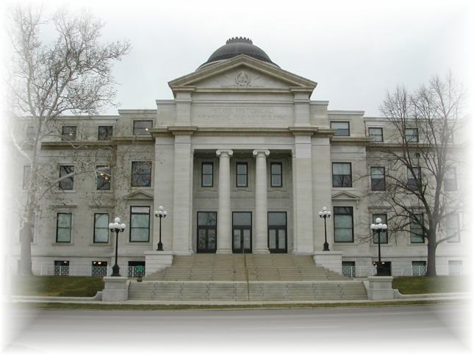

investigation into Randolph Public Library’s Closed Session Violations

TO: Kathe Fichter
Randolph Public Library Director

and

Daisy Malcolm
Randolph Library Board President

FROM: William P. Angrick II
Citizens’ Aide/Ombudsman

RE: Case File 0600432

Issued: October 12, 2006

Published: December 11, 2006

Role of the Ombudsman

The Office of Citizens’ Aide/Ombudsman (Ombudsman) is an independent, nonpartisan, investigative agency of the Iowa General Assembly. Its powers and duties are defined in Iowa Code chapter 2C.

The Ombudsman investigates complaints against most Iowa state and local governmental agencies. The Ombudsman can investigate to determine whether agency action is unlawful, contrary to policy, unreasonable, unfair, oppressive, or otherwise objectionable. After an investigation, the Ombudsman may issue an investigative report, stating its findings and conclusions, as well as any recommendations for improving agency law, policy, or practice. Before publishing the report, the Ombudsman provides the agency the opportunity to reply, and appends the unedited reply to the report.

Complaint and Investigation

The Ombudsman received a complaint alleging the Randolph Library Board (Board) did not have a quorum at its December 2005 meeting when it terminated a library employee. During the investigation, the Ombudsman became aware of additional violations of closed session and meeting notices. In addition, there appeared to be contradictory rules regarding the Board’s proxy voting and required number of members on the Board.

The investigation was assigned to Assistant Citizens’ Aide/Ombudsman Andy Teas. Actions taken by Mr. Teas will be attributed to the Ombudsman in this report.

The Ombudsman interviewed Library Director Kathe Fichter, Board President Daisy Malcolm, and reviewed materials provided by them, including the December 2005 meeting minutes and January 2006 meeting agenda. The Ombudsman also analyzed relevant Iowa statutes on open meetings law, treatises on conducting public meetings, Iowa Library Trustee’s Handbook, and Attorney General’s “Sunshine Advisory” bulletins, and consulted Robert’s Rules of Order Newly Revised.

In addition, the Ombudsman presented the Board the initial findings, conclusions, and recommendations in a letter dated June 5, 2006. (Appendix A.) A Reply was drafted by Kathe Fichter and delivered in person by Randolph Mayor Vance Trively on July 13, 2006. (Appendix B.)

Findings and Analysis

- Closed Session.

At the December 27, 2005 meeting, the Randolph City Library Board discussed business matters regarding Nobah, a company with which the Board was in legal negotiations. Shantelle Nagunst, an assistant librarian, was asked to leave at this time due to a conflict of interest since she was a partner in the company. (Appendix C.) The Board was following the city attorney’s direction who recommended the Board have Ms. Nagunst leave.

The Ombudsman informed the Board in the letter dated June 5, 2006, that he found the Board effectively held a closed session under § 21.5(1)(c) to discuss matters that are presently in litigation. The Ombudsman concluded the Board could legally discuss litigation matters in closed session, but it failed to follow the necessary procedure for going into a closed session when it did not hold a public vote for a closed session. The Ombudsman also found the Board discussed Ms. Nagunst’s termination while in closed session, a matter unrelated to the litigation. The Ombudsman concluded this violated the open meetings law because Ms. Nagunst did not request a closed session to discuss her employment status.

In the Reply, the Board defended its actions, claiming it had not held a closed session, did not vote to go into a closed session, and did not declare a closed session. The Board asserted it asked Ms. Nagunst to leave so it could discuss the litigation:

We did not have a closed session at any time. It was not voted to go into a closed session, we just asked her to leave at this particular time regarding the newspaper project. She left the building and did not return for the remainder of the meeting.

This explanation does not absolve the Board. If the Board asked Ms. Nagunst to leave the open session, the Board violated Iowa Code § 21.3, regulating open meetings. This section reads:

Meetings of governmental bodies . . . shall be held in open session unless closed sessions are expressly permitted by law. Except as provided in section 21.5, all action and discussions at meetings of governmental bodies, whether formal or informal, shall be conducted and executed in open session.

Iowa Code defines “open session” as “a meeting to which all members of the public have access.” Iowa Code 21.2(3) (2005). Ms. Nagunst, as a member of the public, had the right to be present during the open session.

Conclusion: Whether or not the Board entered into a closed session or remained in an open session, its actions violated Iowa's Open Meetings law. The Ombudsman finds sufficient indicia that the Board effectively went into a closed session and in doing so, failed to follow the procedures required under section 21.5 and improperly discussed Ms. Nagunst's termination in addition to discussing legal strategy. If the Board wanted to discuss pending litigation privately, it should have followed the procedures to hold a closed session under section 21.5(1)(c). Even if the Board remained in open session, as it claims, the Board violated section 21.3 by requesting Ms. Nagunst to leave the meeting. A governmental body cannot conduct an open meeting and exclude certain members of the public of its choosing.

- Agenda.

The Ombudsman investigated an alleged violation of Iowa Code § 21.4 relating to an agenda for the Board’s January 24, 2006 meeting. This meeting was cancelled just prior to the date it was to be held, but an agenda was drawn up and distributed before the cancellation. A copy of the agenda Ms. Nagunst received had the bottom portion cut off. The Ombudsman reviewed the complete January agenda provided by Kathe Fichter, the library director. The complete agenda had a hand-written notation stating “Shantelle was not given this information due to conflict. KLF,” and had an arrow pointing to an underlined section titled “Will ask Shantelle to leave to discuss.” (Appendix D.) Ms. Fichter later stated she did not know why Ms. Nagunst did not receive the complete agenda.
Iowa Code § 21.4(1) states reasonable notice of a public meeting shall include “posting the notice on a bulletin board or other prominent place which is easily accessible to the public and clearly designated for that purpose at the principle office of the body holding the meeting.” The Attorney General Sunshine Advisory, March 2002, states the following regarding an agenda’s content:
- Agendas must provide notice sufficient to inform the public of the specific actions to be taken and matters to be discussed at the meeting. (An agenda that merely states "Approve minutes, old business, new business" does not provide reasonable notice to the public.) Notice also must include the time, date and place of meetings.
- The precise detail needed to communicate effectively will depend on the situation, including whether the public is familiar with an issue. The less the public knows about an issue, the more detail is needed in the tentative agenda.
http://www.state.ia.us/government/ag/Sunshine_adv/advisory_Mar02_agendas.htm. (Accessed May 25, 2006).
In his June 5 letter, the Ombudsman concluded the Board acted contrary to law by providing only a partial agenda to Ms. Nagunst. The January agenda contained adequate information to inform the public of the issues that were going to be discussed at the meeting. However, the complete agenda must be available to everyone who requests it or to whom it is provided. The Ombudsman found when Ms. Nagunst was given only a portion of the agenda, she was not provided with sufficient notice of the specific actions to be taken and the matters to be discussed.
The Board, in a response drafted by Kathe Fichter, did not offer a rationale for providing only a partial agenda to a member of the public. Instead, the Board defended itself in its Reply, stating, “[the] January meeting was cancelled and such agenda would be null and void.”
Conclusion: Even if cancellation of the meeting may have rendered the contents of the agenda null and void for purposes of the meeting, it did not negate the action associated with making an agenda available. The Ombudsman finds the Board acted contrary to law when it provided Ms. Nagunst with a partial agenda before the meeting was cancelled.
- Proxy Voting and Voting Outside of Meeting.
The Ombudsman also inquired about proxy voting by the Board. The December minutes revealed the Board took action to terminate Ms. Nagunst’s employment. Sherry Perkins moved for her termination, and it was seconded. The minutes state, “Daisy reported that she had vote by proxy from board members Carol Scott and Cindy Heywood. The motion carried.”
Neither Library Board President Daisy Malcolm nor Library Director Kathe Fichter could reference a Board policy governing proxy voting. There appeared to have been an assumption that proxy voting was allowed, with no formal written policy being relied on. The Ombudsman was informed the Board follows the Robert’s Rules of Order Newly Revised, which does address proxy voting. The relevant section provides:
A proxy is a power of attorney given by one person to another to vote in his stead; the term also designates that person who holds the power of attorney. Proxy voting is not permitted in ordinary deliberative assemblies unless the law of the state in which the society is incorporated require it, or the charter or bylaws of the organization provide for it. Ordinarily it should neither be allowed nor required, because proxy voting is incompatible with the essential characteristics of a deliberative assembly in which membership is individual, personal, and nontransferable. (RONR, 10th Edition, p. 414, l. 15-25) [emphasis added].
The Ombudsman, in his June 5, 2006 letter, said if the Board adhered to the Robert’s Rules of Order Newly Revised, 10th Edition (2000), it should not have allowed proxy voting. Even if the Board did not use Robert’s Rules of Order, the Ombudsman still had concerns about the legality of proxy voting, and advised the Board to consult with legal counsel if it chose to incorporate this policy.
In its Reply, the Board stated the reference to “proxy voting” in the minutes was a clerical mistake by the secretary. The Board explained:
[A]ll members were called by the President about the monthly meeting. Those who couldn’t be there then had their vote declared to the President through the phone conversation.
Even if the Ombudsman accepts this explanation no proxy voting occurred, despite the Board defining this action as proxy voting in the minutes, and no previous explanation by Library officials the action was anything but proxy voting, the Ombudsman believes another violation of the open meetings law occurred.
Conclusion: Iowa Code 21.3 states “all actions and discussions at meetings of governmental bodies, whether formal or informal, shall be conducted and executed in open session,” unless closed session is permitted by law. That section also requires the minutes “indicate the vote of each member present” and “[t]he vote of each member present shall be made public at the open session.” [emphasis added]. There is no provision allowing a member to vote on a matter prior to and outside of the meeting at which the matter is decided. It is the Ombudsman’s opinion the open meetings law implicitly prohibits such action, and what occurred in this instance as contrary to the spirit and intent of the law.
In the event the Board considered the telephone call(s) to be an electronic meeting, how it was handled did not comply with § 21.8 of the Iowa Code. The Iowa Attorney General Sunshine Advisory, July 2006, states a governmental body may meet electronically, but only if meeting in person is impossible or impracticable, and the minutes must state why a meeting in person was impossible or impracticable. (http://www.state.ia.us/ government/ag/Sunshine_adv/ 2006July_electronically.html, Accessed July 14, 2006). Also, the electronic meeting can only be conducted if the public has access to hear the meeting.
The advisory provides the following points when an individual is going to participate in a meeting electronically:
- Parliamentary procedure: The parliamentary rules of the governmental body should be consulted to determine if they permit individual members to participate electronically.
- Discussion: Any member participating electronically should be connected by speaker phone or other device, so that the public can hear any discussion by that member. If the session is closed under Iowa Code section 21.5, the tape recording of the closed session must pick up the discussion by any member who is participating electronically. Iowa Code sec. 21.5(4).
- Voting and minutes: The vote of any member participating electronically must be made public at the open session, and the minutes must include information sufficient to indicate the vote of each member participating electronically. Iowa Code sec. 21.3. (The vote of the member should be audible to the public through a speaker connection.)
- Number of Members on the Board.
The Ombudsman learned the Board had six board members, though it is not known by the Board how long it has been operating with six members. The Randolph City Ordinance, which the Board had been operating under for much of this time, stated the Board was to have “three resident members.” According to Ms. Fichter, the original intent was to have six members on the Board, and at some point, whether through clerical error or otherwise, the number of members was listed at three.
It is unknown how the Board came to have six members. According to a State of Iowa Library representative, an even-numbered board is very rare. The Ombudsman received conflicting statements from Board members on what action the Board takes in cases of tie votes. One version held the president’s vote was thrown out in a tie, while another held the president had no vote at all. The Board had no written policy to rely on if confronted with a tie vote.
The Ombudsman recommended the Board consult with the city attorney and the city council about making changes in the number of Board members and necessary procedures for making the change. The Board stated in its Reply it had approached the city and will file with the State that it has voted to have five members.
V. Quorum.
The Board’s policy regarding quorums was as unique as its choice in board size. The Board required only three of its six Board members to be present at a meeting to call a quorum. The Board did not have a written policy on quorum requirements.
Iowa Code Section 372.13(1), which regulates city officers, states “[a] majority of all council members is a quorum.” The Ombudsman recommended the Board change its quorum policy from three members to four, a majority, before it calls a quorum, as required under Iowa Code § 372.13(1). The Board replied it will require three members be present at a meeting before it calls a quorum, and will add this to their policy. Because the Board has changed the number of members on the Board to five instead of six, three members make a majority of the Board, and is in accordance with Iowa law.
VI. Relying on Advice from Legal Representative and Liability.
The Board justified some of its actions pertaining to Ms. Nagunst by saying it relied on the advice of the city attorney, who no longer represents the city. It must be noted that relying on an attorney’s advice is a partial defense, but a government body may still be liable for damages. (Attorney General Sunshine Advisory, August 2004, http:// www.state.ia.us/government/ag/Sunshine_adv/04August_advisory_legal_advice.html. Accessed May 25, 2006). The government body has an obligation to be knowledgeable of the applicable laws that govern its actions.
“When a violation of Open Meetings Law and Open Records Law is found by a court, each member of the governmental body who is found to have participated in the violation will be assessed damages ranging from $100 to $500.” (Attorney General Sunshine Advisory, December 2003, http://www.state.ia.us/government/ag/Sunshine_adv/03Dec _Non compliance.html. Accessed May 25, 2006). In addition, “citizens who bring successful enforcement actions in court will be awarded the costs of the litigation and reasonable attorney’s fees for the trial and appeal.” If no one is assessed damages, costs and attorney fees are paid from the governmental body’s budget.
Under Iowa law, public officials who relied on legal advice for proven violations are shielded from liability for monetary damages (Iowa Code § 31.6(3)(a)(3)). According to the Attorney General Sunshine Advisory, “if no public officials remain on whom liability can be imposed, attorney’s fees and costs are paid from the offending government body’s budget, or its parent’s budget.” (Attorney General Sunshine Advisory, August 2004) [emphasis added]. “Reliance on legal advice is a narrow defense to assessment of monetary damages against individual public officials, or payment of attorney fees and costs by them. But, if a violation is proven, governmental bodies remain accountable.” Id. It is important for the Board to become familiar with the Iowa open meetings law that governs it in order to avoid liability in the future.
Recommendations

In summary, the Ombudsman makes the following recommendations:

  - The Board should not exclude any members of the public from its open meetings. If the Board wants to discuss a matter privately, it should determine if it can go into a closed session under Iowa Code section 21.5 and follow that procedure.

  - If the Board wants to go into a closed session, it should do so only under one or more of the eleven enumerated reasons stated in Iowa Code section 21.5, and only after it has followed the required procedures. In addition, the Board should limit the discussion to those matters for which it went into the closed session.

  - The Board should provide the complete agenda to all members of the public. Agendas must be posted in a prominent place that is easily accessible to the public. Agendas should contain sufficient information to inform the public the actions to be taken and matter to be discussed at the meeting.

  - Robert’s Rules of Order Newly Revised, states proxy voting “is not permitted in ordinary deliberative bodies” and generally discourages its use. The Ombudsman believes it also contravenes the intent of Iowa’s open meetings law for governmental decisions, and the basis and rationale for those decisions, be easily accessible to the people. Because it is highly questionable whether proxy voting is legally permissible to be used by Iowa governmental bodies, the Ombudsman recommends against its usage.

  - The Board should cease the practice of allowing a member to declare his or her own vote to the President prior to and outside the meeting at which the matter will be decided. The Ombudsman believes such action violates the intent and the implicit requirement of the open meetings law for members to deliberate and vote at the appointed meeting.

  - If the Board conducts an electronic meeting, it should ensure the public can hear the absent member through a speaker phone or other means. The minutes must state why a meeting in person is impossible or impracticable. The Ombudsman recommends the Board incorporate written rules on how and when electronic meetings will be conducted, and ensure they are in compliance with Iowa Code section 21.8.

  - The Board should ensure all its members are knowledgeable about the Iowa Open Meetings Law and Iowa Open Records Law, Chapters 21 and 22 of the Iowa Code, respectively. Relying solely on the legal council’s advice will not shield the government body from liability if the body fails to follow these laws.
Ombudsman’s Comment

The Ombudsman sent Randolph Public Library Board President, Daisy Malcolm, and Librarian, Kathe Fichter, a “Notice of Intent to Reply” form together with the Report on October 10, 2006. The Ombudsman offered the opportunity to reply within 30 days from the date they received the Report. Ms. Fichter returned the form and indicated a reply would follow an October 25 Board of Trustees meeting. Assistant Ombudsman Andy Teas contacted Ms. Malcolm and Ms. Fichter on November 20, 2006. Ms. Malcolm stated Ms. Fichter would reply on behalf of the Board. Ms. Fichter stated the Board had accepted the recommendations and no reply would be submitted.

Appendix A

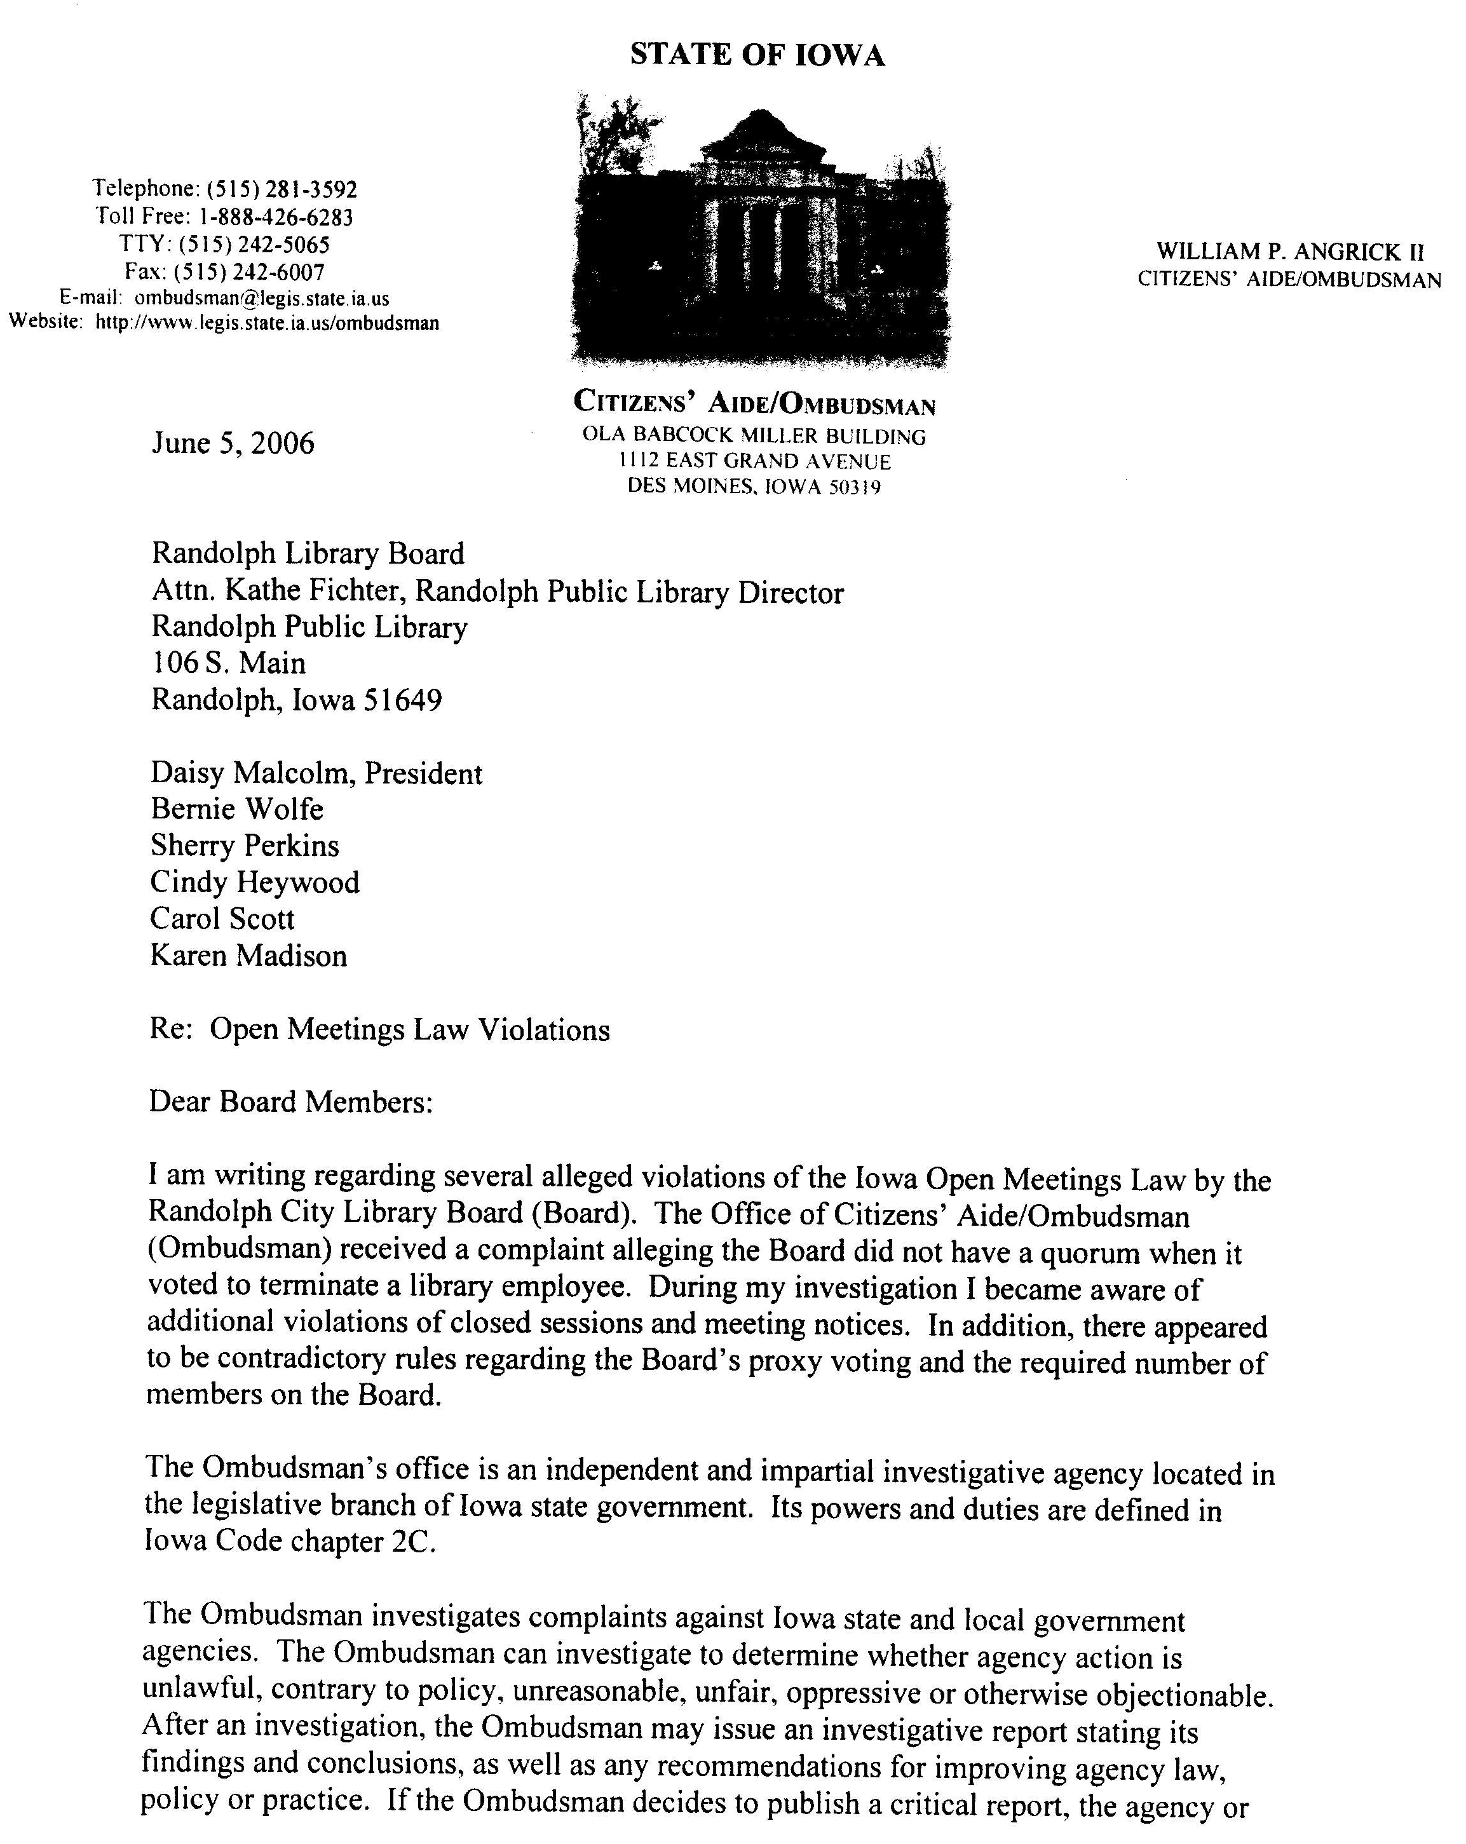
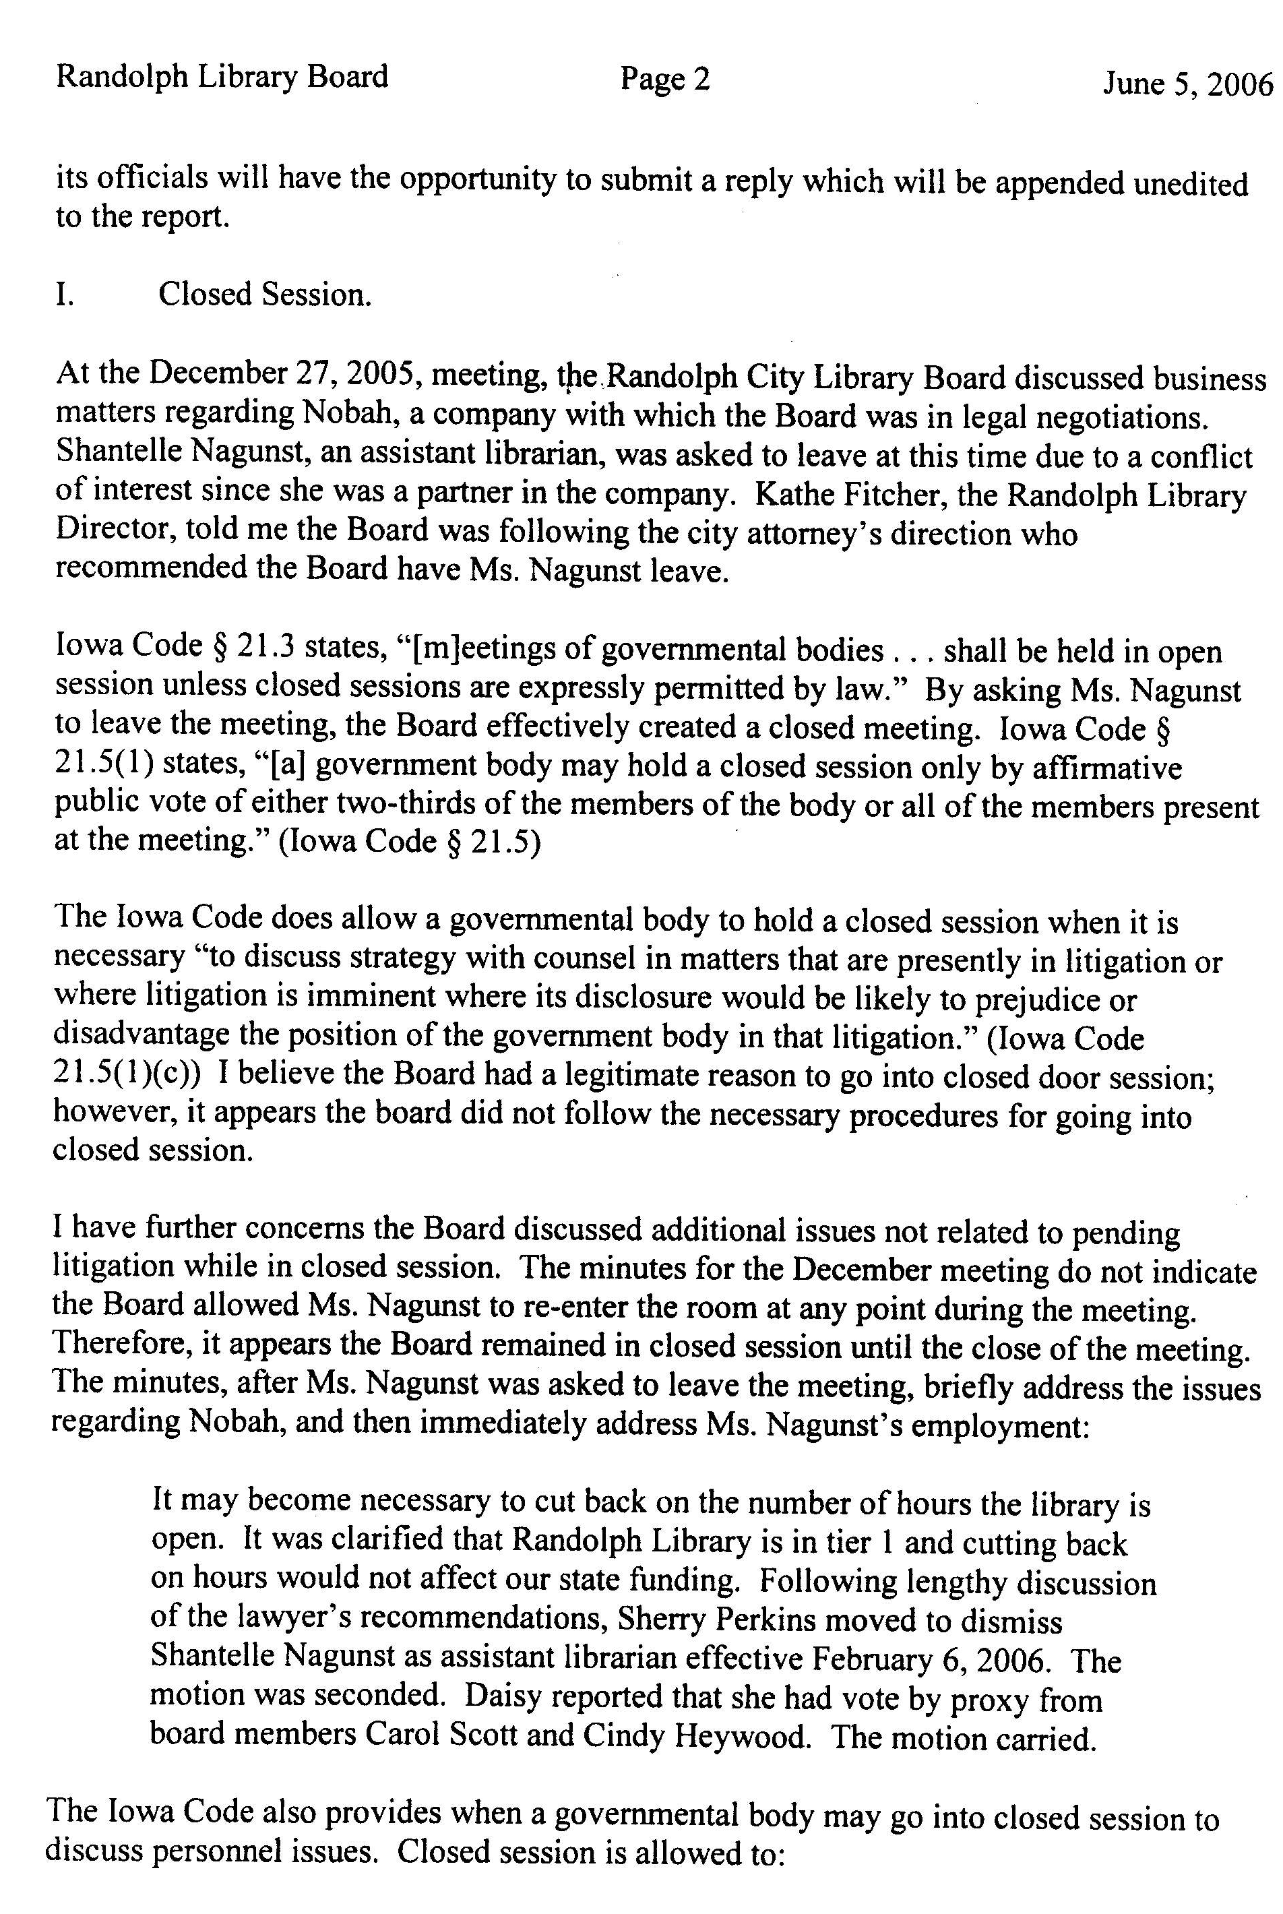
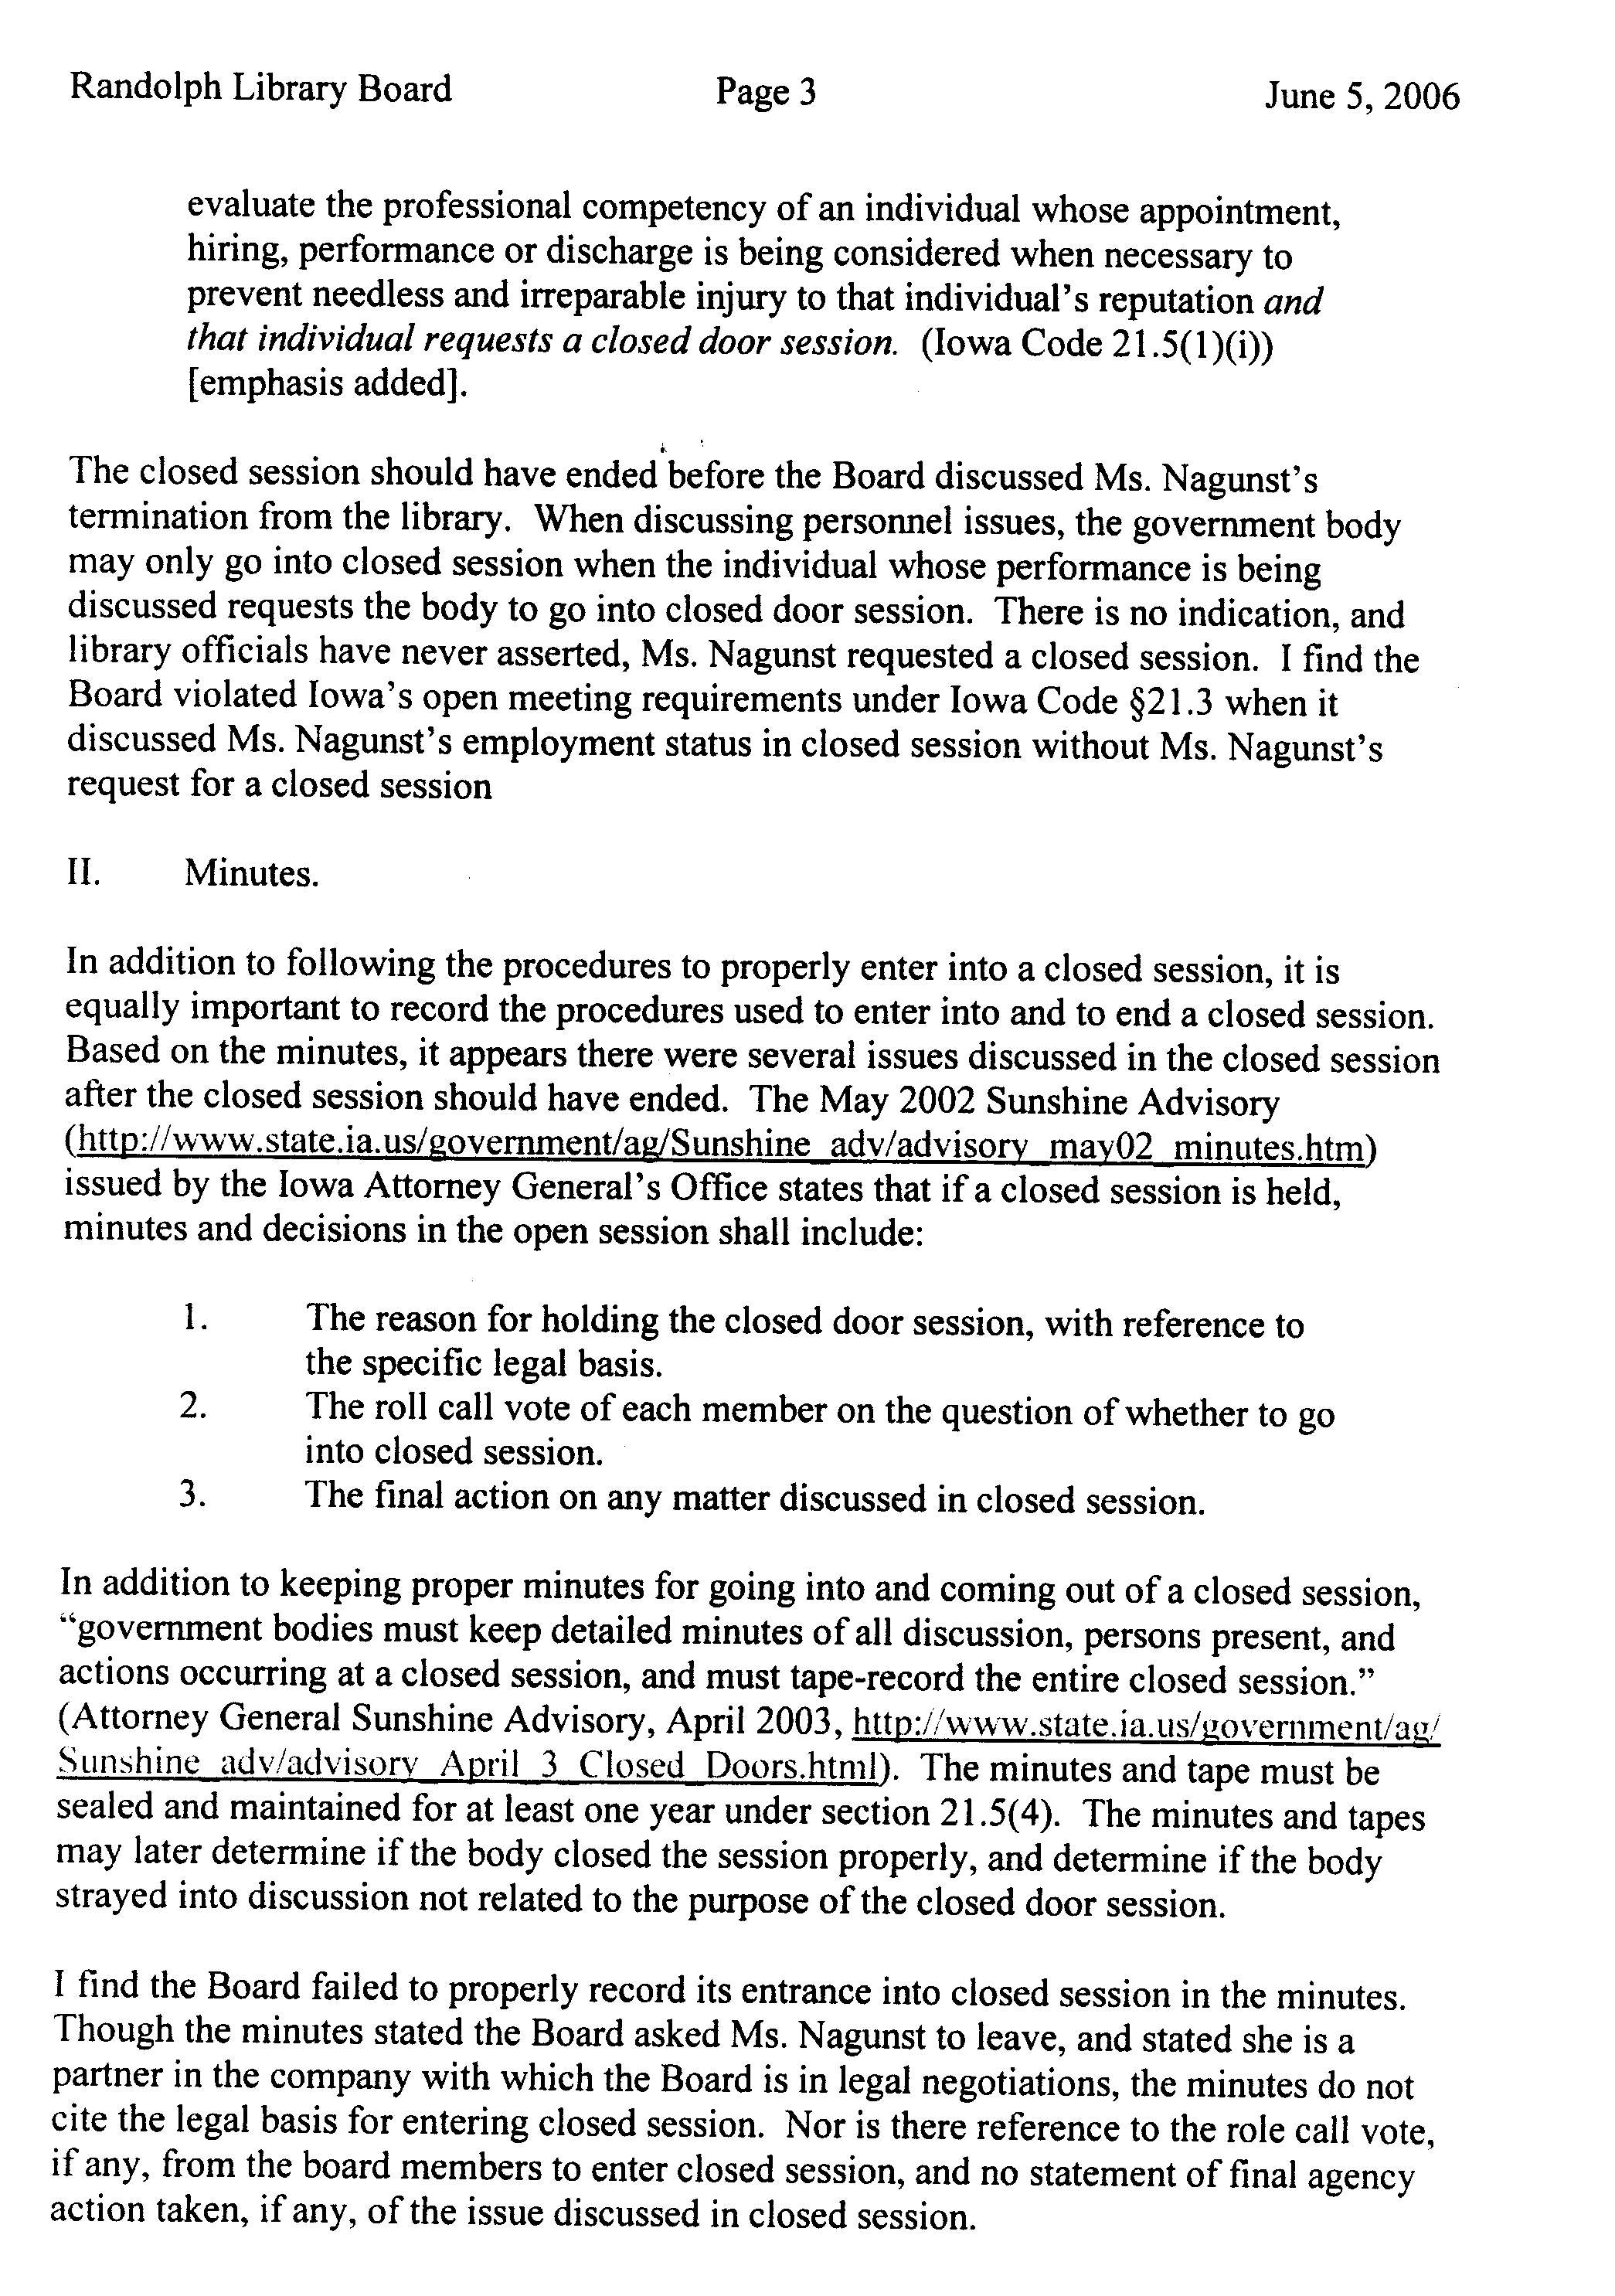
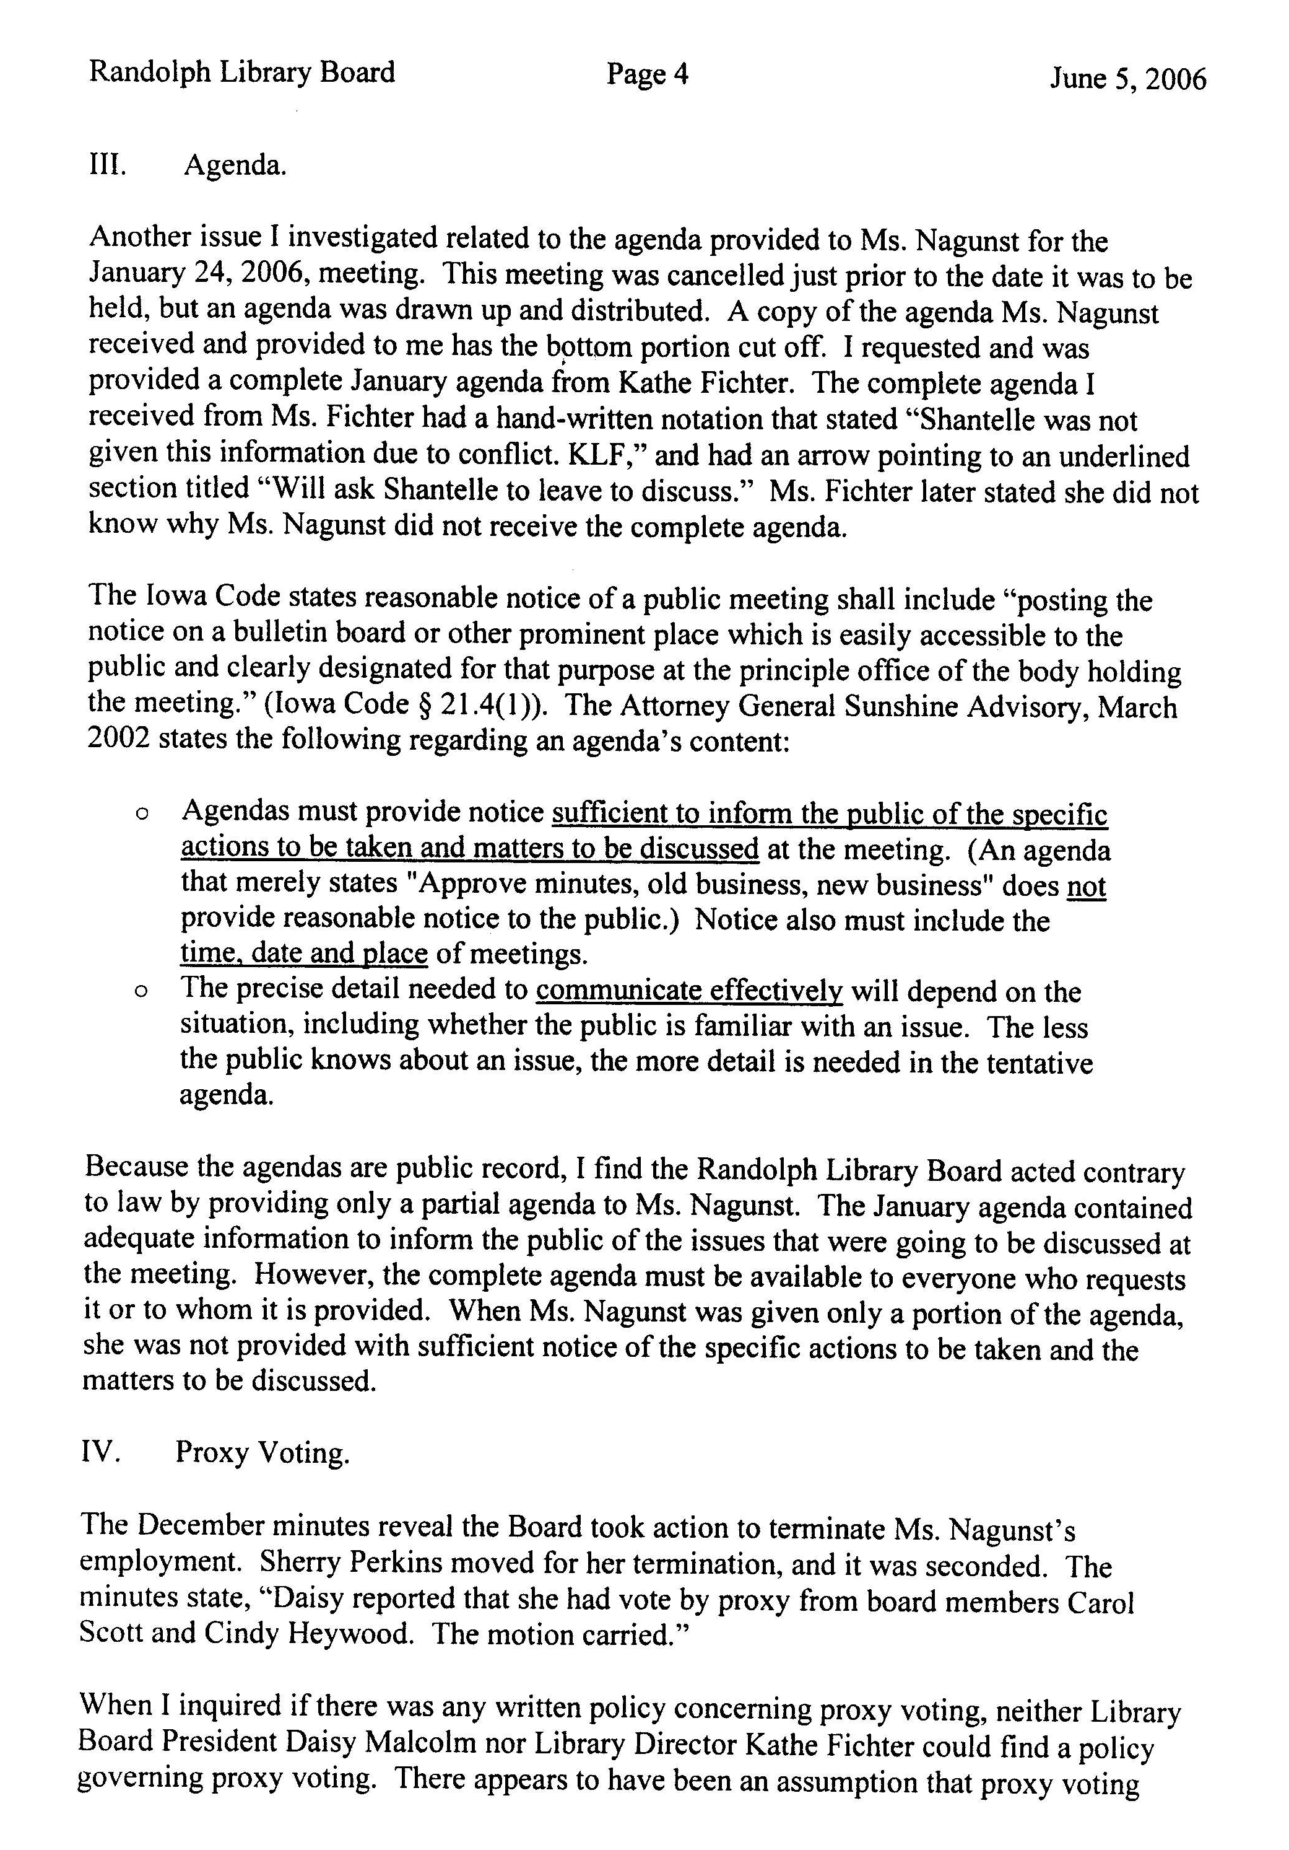
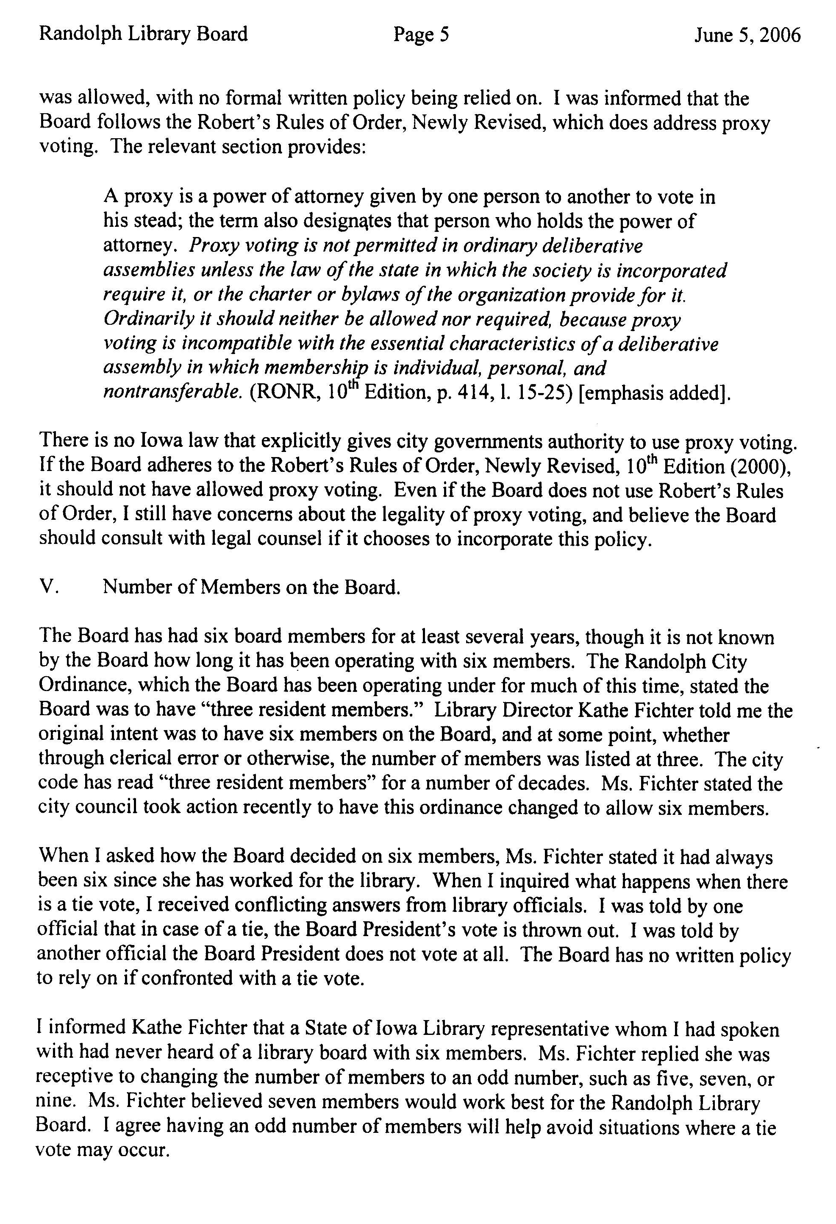
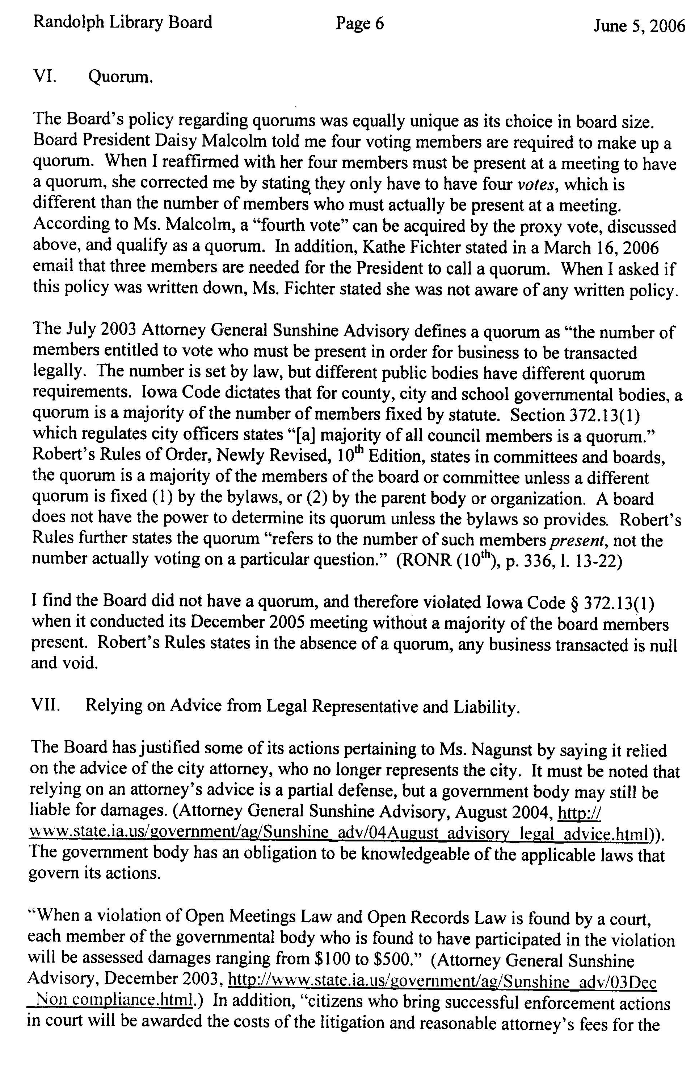
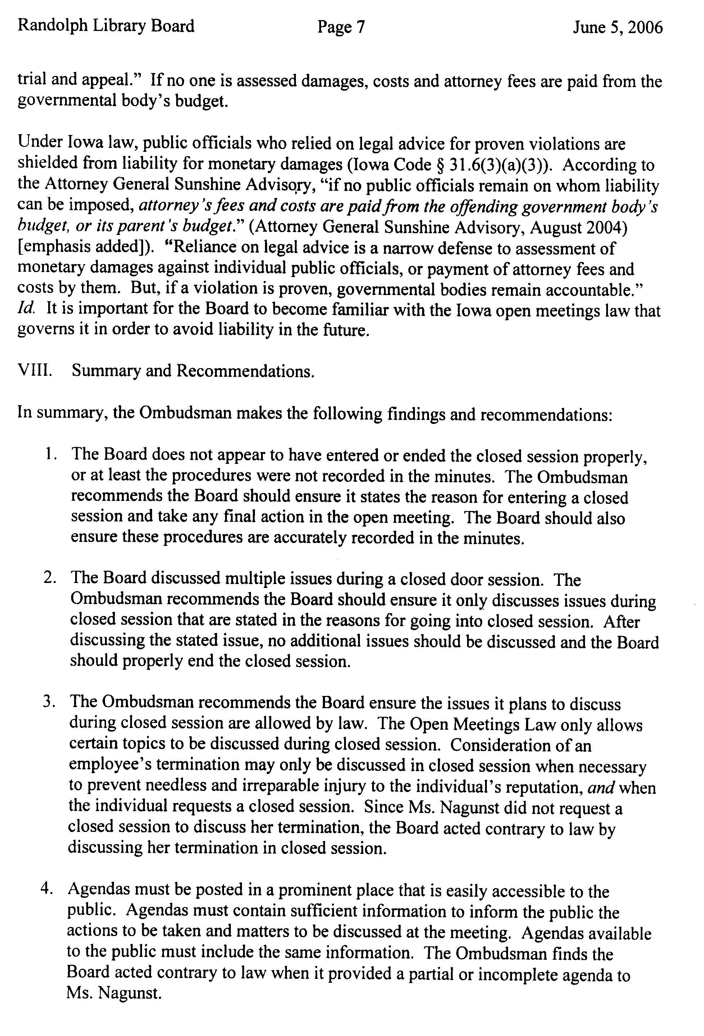
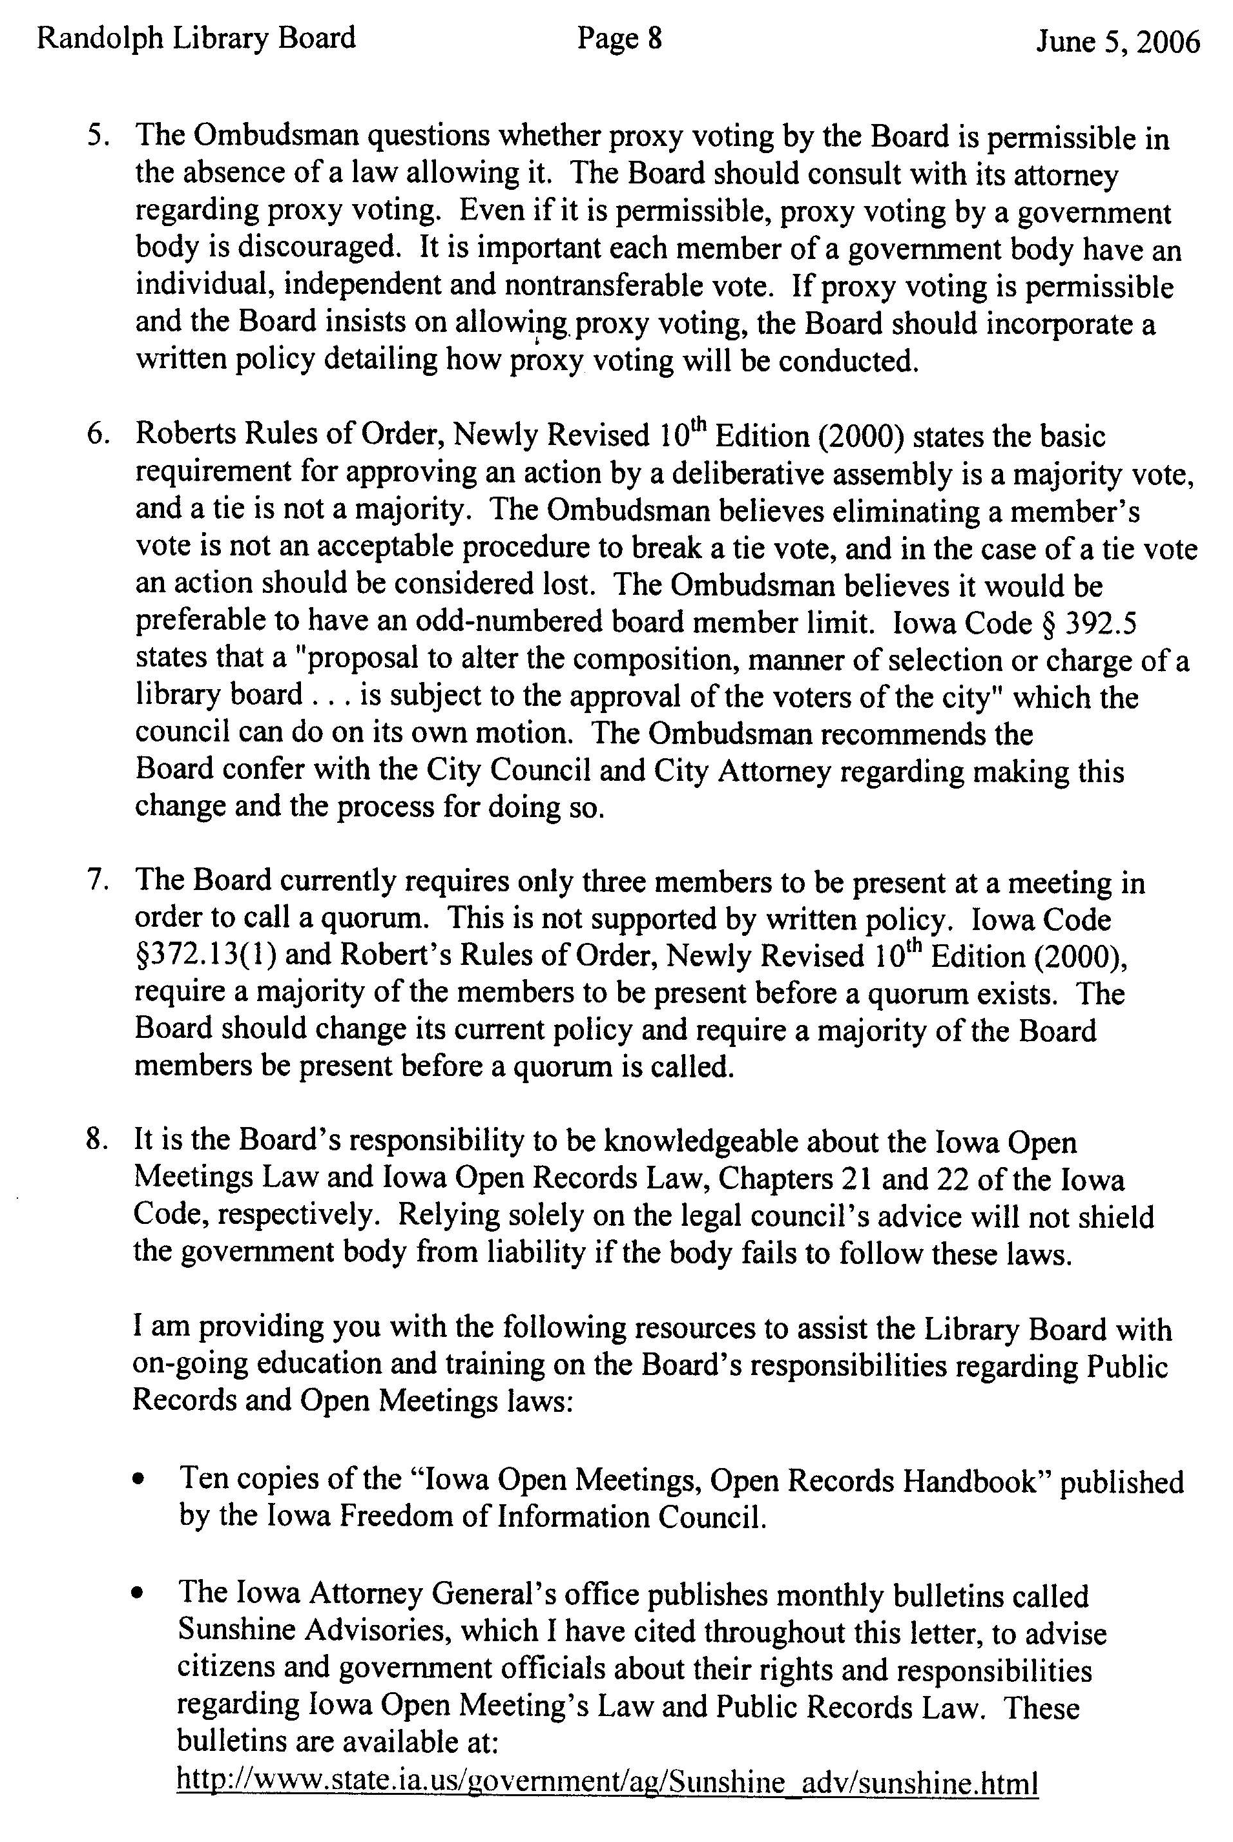
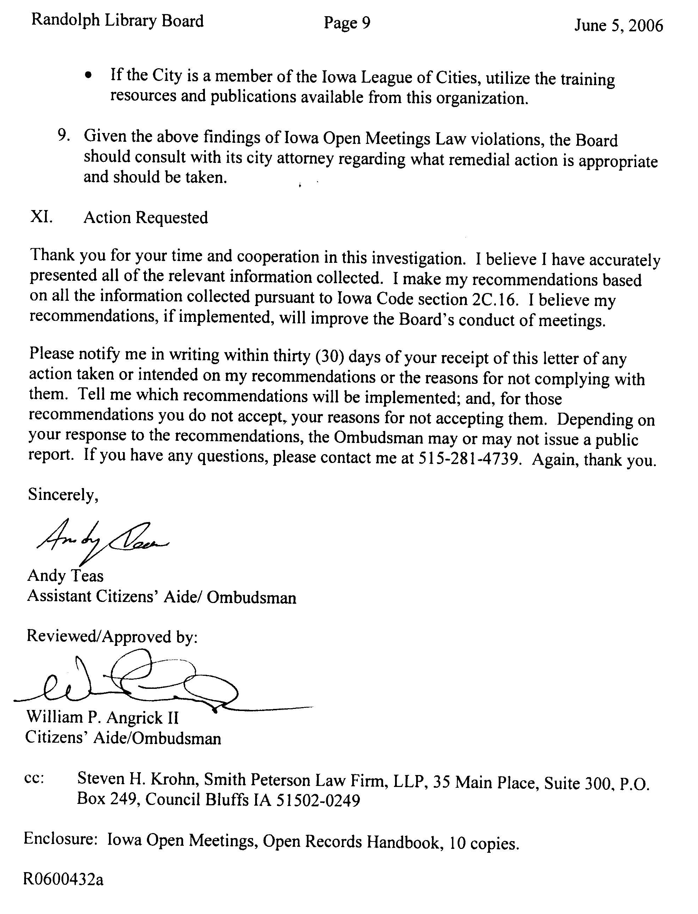
Appendix B

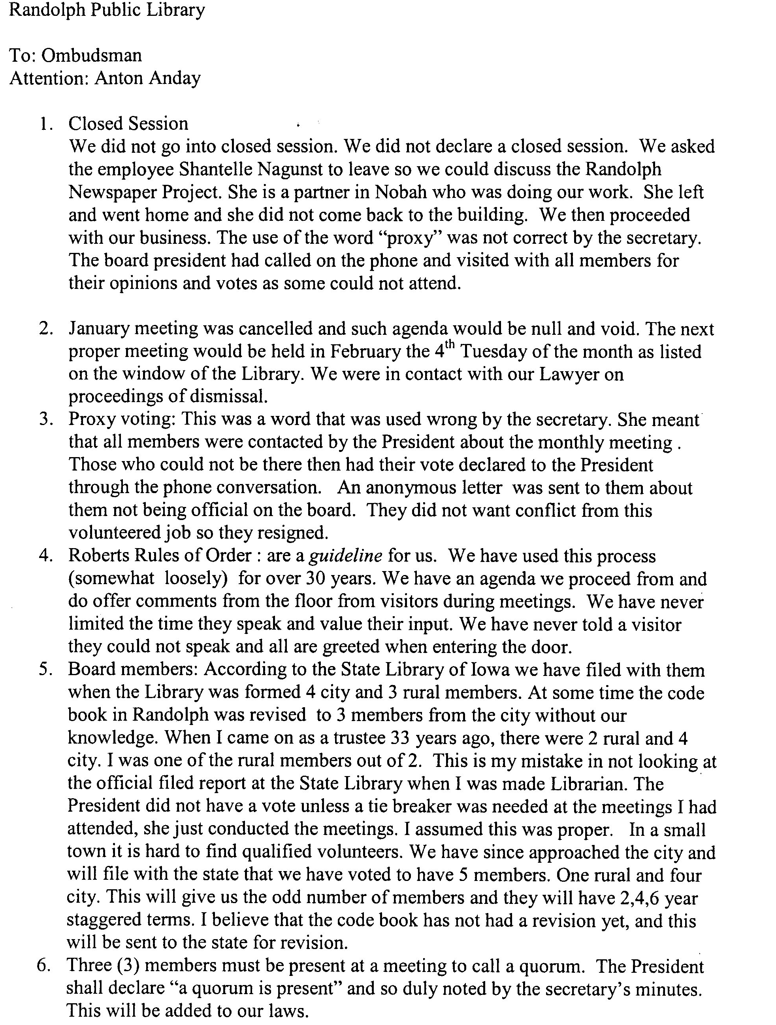
Appendix C

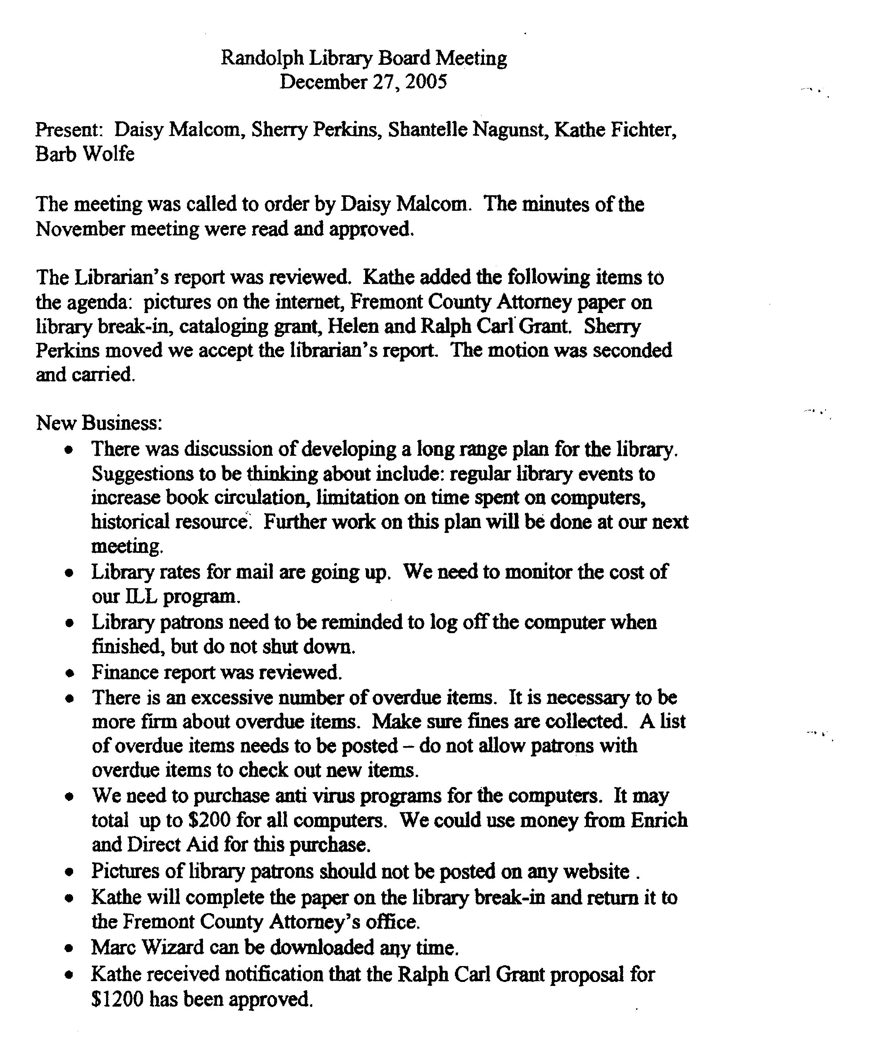

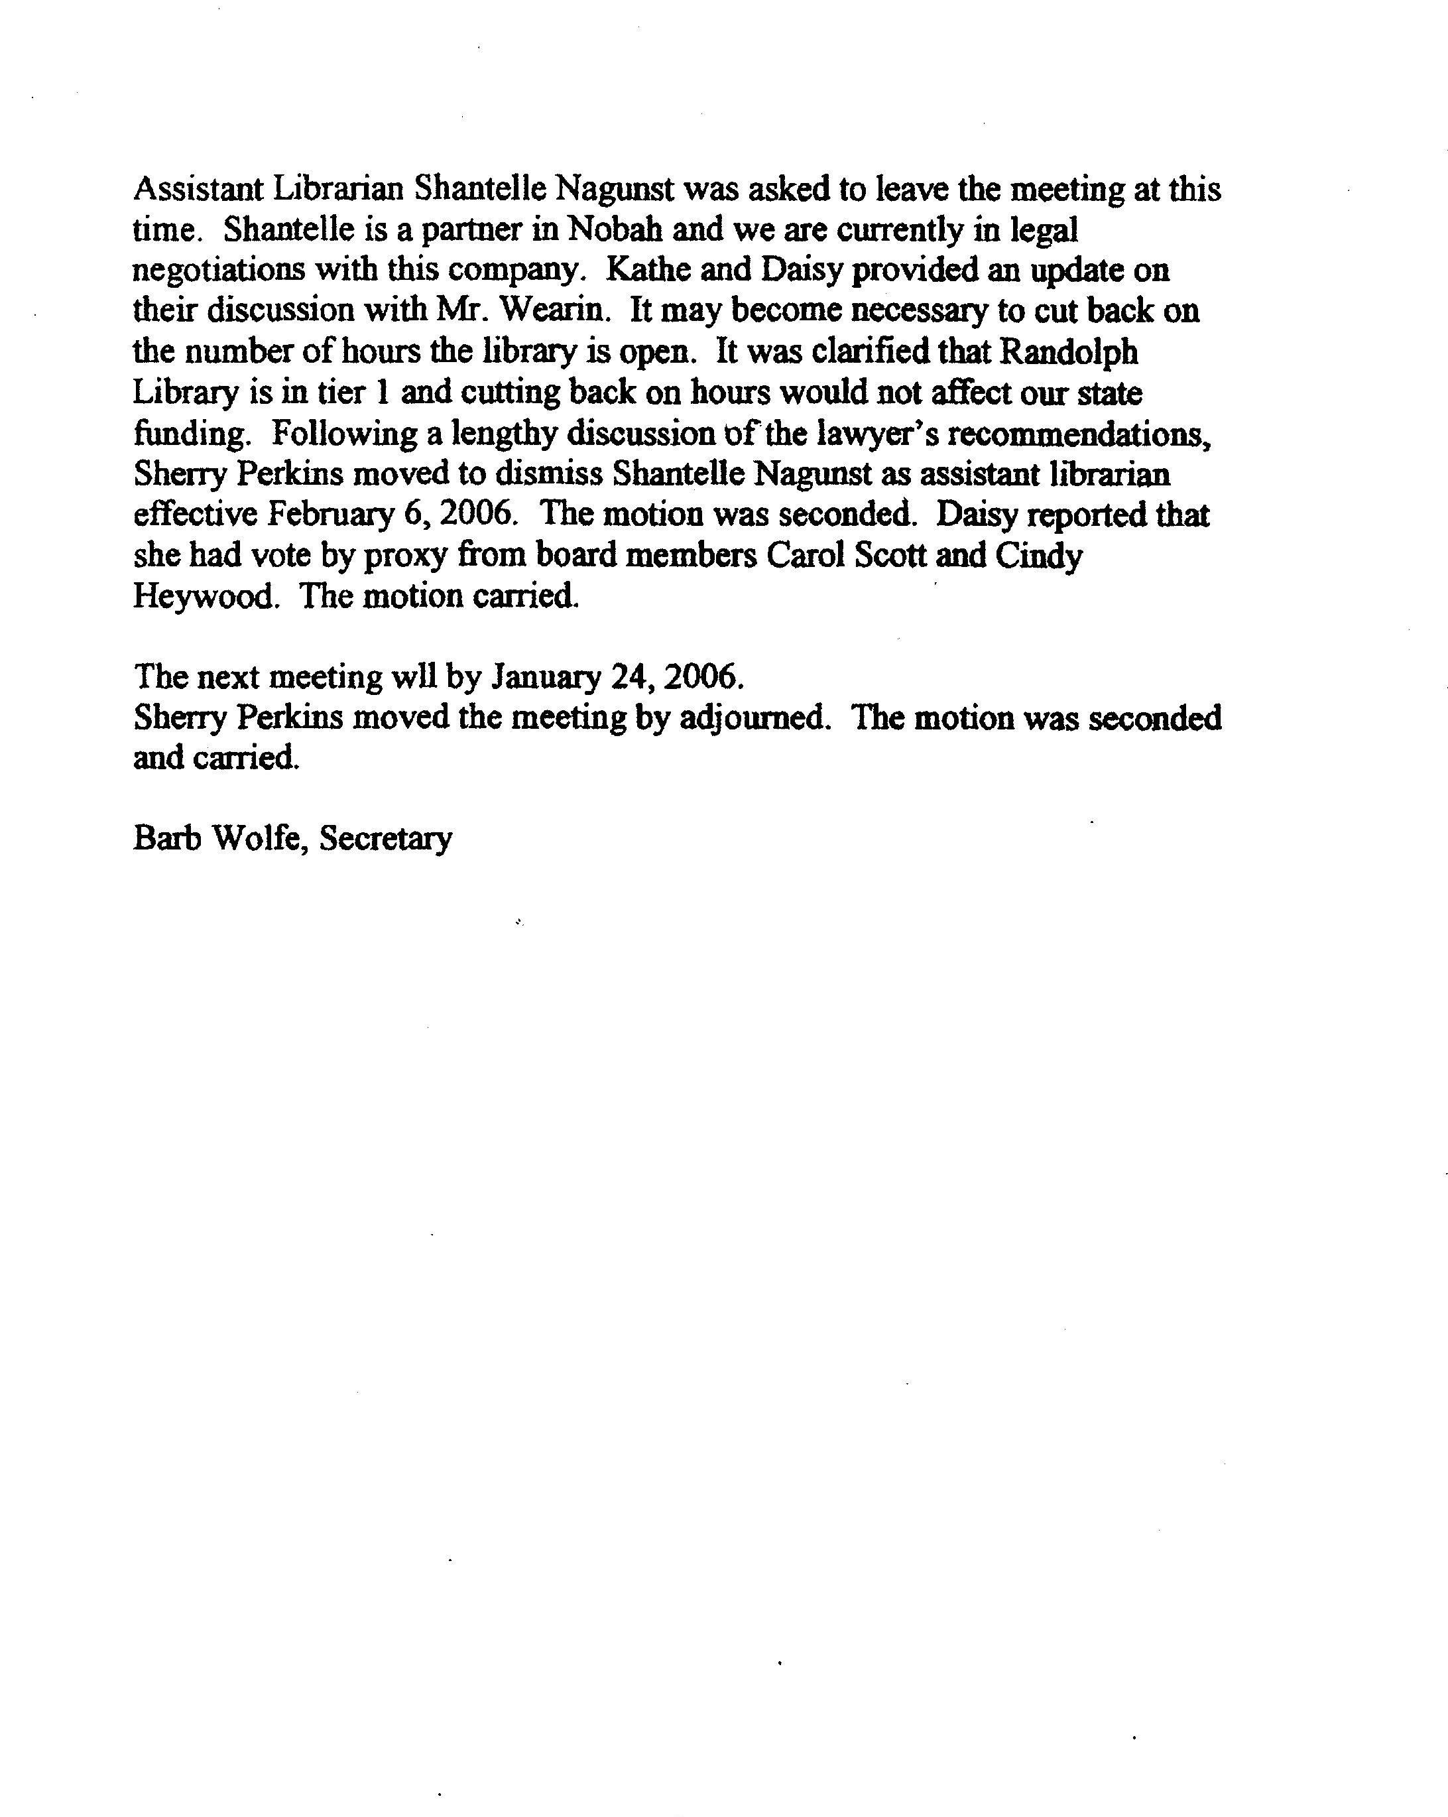
Appendix D
