Introduction and Summary

Iowa Code Section 8D.10 requires that certain state agencies prepare an annual report to the
General Assembly certifying the identified savings associated with that state agency’s use of the Iowa Communications Network (ICN). The report is due on or before January 15 of each year.

This report covers estimated cost savings related to video conferencing via ICN for the Iowa Department of Transportation (DOT).

In FY 2005, the DOT conducted one training session utilizing the ICN video conferencing system which resulted in $726 in estimated savings to the DOT.

The DOT also scheduled four training sessions for the Iowa Motor Truck Association (IMTA). IMTA has partnered with the Transportation Security Administration in launching the new Highway Watch program. The Highway Watch program trains participants to recognize potential safety and security threats to help protect Iowa’s interstate and state highway system from potential terrorist attacks. IMTA, which manages the federally funded Highway Watch program for Iowa, reimbursed the DOT for the cost of using the ICN video conferencing system. There was no cost savings realized by the DOT for the above sessions. (See Appendix B)

DOT Video Conferences

The DOT has seven small video conference sites: at five of the six District Offices, the Administration Building in Ames, and the Motor Vehicle Division in Des Moines. DOT staff each year also utilizes the ICN classroom video sites or the ICN network for video conferences requiring more space, or for conferences at locations where the DOT does not have video facilities.

In FY 2005, the DOT established one video conference training session with the ICN. The estimated cost savings from use of the ICN results from applying estimates to savings in staff time and travel expenses (meals and mileage). Following are other benefits of video conferencing not included in the cost estimates:

- broader participation by more people allowing for enhanced input and discussion;
- more timely information-sharing;
- fuller, more productive participation through visual sharing not offered by telephone conferences;
- closer, more productive relationship between central office and geographically dispersed customers; and
- ability to videotape meetings to share with others or keep as historical record.

Video Conferencing Costs

The DOT reimburses the ICN for a video conference session when the DOT is the scheduling agency, or if there are special requirements such as the use of an ICN classroom. DOT is not billed for ICN video conference sessions if the session was scheduled by another agency.
DOT Cost Savings in FY 2005

The following chart details the cost savings estimated for DOT use of ICN video conferencing in FY 2005:

Number of videoconferences held 1
Number of non-DOT participants 19
Number of DOT participants 1 (trainer conducted 1 session
via ICN to 5 locations)
Travel miles avoided 589
(estimated using map mileage)

(Savings rounded to nearest dollar)
Vehicle cost savings $ 341.00
(@ 29 cents per mile)
Meal cost savings $ .00
Travel time savings $ 555.00
(@ $26 per hour)
Total estimated savings $ 896.00

Less direct cost of using ICN $ 170.00

Net savings for FY 2005 $ 726.00

This savings applies only to the DOT staff who conducted the training sessions. Conferences included non-DOT staff. Cost savings accrued to non-DOT staff is not included in these estimates.

Assumptions used for cost savings computation

Estimate amounts are based on the following assumptions:

- meetings would be held at the DOT host site, or in the case of training sessions, the DOT trainer would travel to multiple sites to provide the training;
- at least one participant from each site would have traveled to the meeting site;
- DOT cost savings for mileage are based on travel miles avoided, times the state car rate of 29 cents per mile;
- distances are calculated using Iowa Transportation Map distances between cities; and
- productivity gain is calculated on travel time avoided (miles driven divided by 55 miles per hour) multiplied by an hourly rate, excluding fringe cost of $25.94 which is an average amount for a motor vehicle captain at a pay grade 31 in FY 2005.

Appendix A
Iowa Department of Transportation
(Cost in whole dollars)

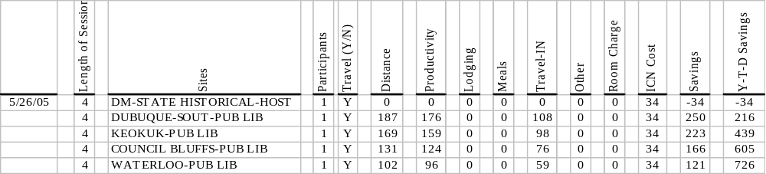

Appendix B
Iowa Motor Truck Association/Transportation Security Administration
(Cost in whole dollars)
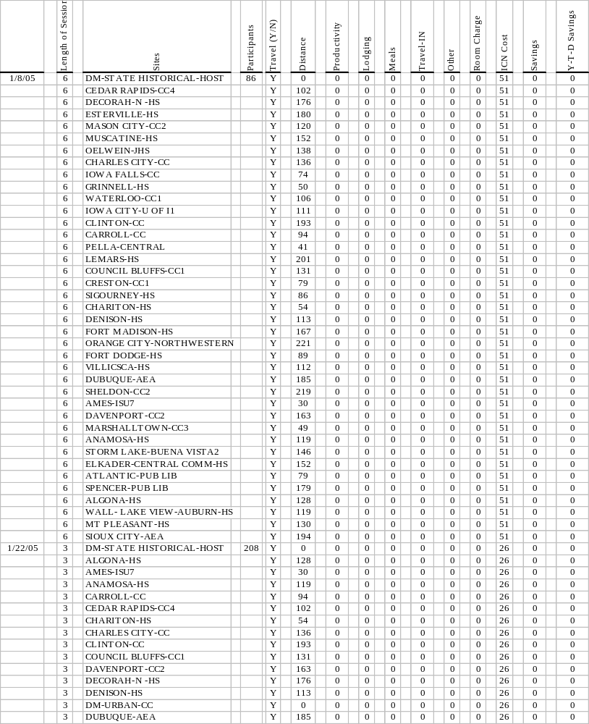

Appendix B
Transportation Security Administration/Iowa Motor Truck Association
(Cost in whole dollars)


