IOWA DEPARTMENT OF TRANSPORTATION

PERFORMANCE REPORT

Performance Results Achieved for Fiscal Year 2004

TABLE OF CONTENTS

SECTION | PAGE
INTRODUCTION |  | 1
AGENCY OVERVIEW |  | 4
STRATEGIC PLAN RESULTS |  | 7
Goal 1 - Accessibility…………………………………………………………... … |  | 8
Goal 2 - Responsiveness…………………………………………………………. |  | 21
Goal 3 - Accountability……………………………………………………………. |  | 23
PERFORMANCE PLAN RESULTS |  | 25
Core Function - Enforcement and Investigation ………………………………… |  | 25
SPA - Motor Vehicle Enforcement ………………………………………………. |  | 27
Core Function - Physical Asset Management ………………………………….. |  | 32
SPA - Vertical/Fixed Asset Management ………………………………………. |  | 34
Core Function - Regulation and Compliance |  | 37
SPA - Driver Services |  | 39
Core Function - Research, Analysis & Information Management |  | 45
SPA - Information Technology |  | 46
Core Function - Resource Management |  | 48
SPA - Information Management |  | 52
SPA - Information Technology |  | 54
SPA - Financial/Human Resource Management |  | 56
Core Function - Transportation Systems |  | 59
SPA - Highway Management |  | 61
SPA - Modal/Planning Functions Management |  | 67
RESOURCE REALLOCATIONS |  | 71
AGENCY CONTACTS |  | 71

INTRODUCTION

Purpose: I am pleased to present the Iowa Department of Transportation’s (DOT) performance report for fiscal year 2004. This report summarizes the performance of the DOT in carrying out its responsibility of providing and preserving an adequate, safe, efficient multi-modal transportation system.

Scope: This report presents an overview of the department, a summary of progress on the strategic plan, and reports on performance plan results.

SUMMARY - Achievement of Strategic Goals

The DOT’s Strategic Plan consists of three goals. Performance on established measures indicates successful implementation of several strategies. Recent Enterprise emphasis on measurement has allowed the DOT to review existing measures and develop news ones designed to provide more useful information for decision making.

GOAL 1 - Accessibility

Approximately 20 percent of DOT’s forms are currently available on line. Review of the process revealed that work to date has focused on forms most often requested by users and that it actually takes very little time to get a form on line once a request is made.

A review of the original measures associated with Goal 1 led to the decision to focus on utilization measures in place of public satisfaction with access. Measures covering utilization of six modes of transportation will be used in the upcoming strategic plan review.
GOAL 2 - Responsiveness

A review of the original measure tracking response to citizens and businesses revealed the need to clarify who was involved and how things should be done. A process was developed and is now in place to track correspondence for the Director or Governor’s signature and the length of time taken to respond. This data should be available for the next strategic plan review.

Similar discussion is underway for tracking customer satisfaction with the DOT’s communication process.

GOAL 3 – Accountability

The DOT has been able to keep the percent of the Road Use Tax Fund monies transferred to the Primary Road Fund that are spent for DOT operations well below its target of 50 percent. This demonstrates the DOT’s success in curtailing operational costs while maximizing the amount of money available for projects.

The DOT continued its outstanding performance in regard to completion of employee evaluations, with nearly all evaluations completed on time.

One of the key strategic challenges faced by the DOT during the past fiscal year was the uncertainty surrounding federal transportation funding. This led the DOT to focus on a one-year transportation plan rather than developing a five-year plan. Economic factors within the state contributed to uncertainty regarding resources available to the DOT to accomplish its work. Notable challenges facing the DOT include:
- balancing competing public/user demands/desires;
- competing for and maintaining a highly skilled workforce;
- balancing internal (agency) resource needs with external (program) resource needs;
- nurturing win-win relationships with partners (such as contractors, consultants, counties, commercial carriers and suppliers);
- appropriately assimilating technology into business procedures;
- maximizing available funding; and
- securing stable, predictable, growing revenue streams.

SUMMARY - Key Agency Services, Products and Activities

The DOT monitors performance of six core functions, under which are nine services, products and activities (SPAs). In all, 42 measures are used to monitor the core functions and SPAs in the DOT’s performance plan.

Overall, DOT’s performance was good in fiscal year 2004. Of the 42 measures in the DOT’s performance plan, 25 measures (60%) met or exceeded their targets and five measures (12%) showed improved performance, but fell short of their target.

Broken down by level, 85 percent of core function measures and 48 percent of SPA measures met or exceeded their targets. The five measures showing improvement mentioned earlier were all SPA measures, which translates into 66 percent of SPA measures met/exceeded their targets or showed improvement.
DOT Performance Plan – Targets Met

Core Function  SPA | # of Measures | Targets Met
Enforcement & Investigation | 2 | 2
Motor Vehicle Enforcement | 5 | 0
Physical Asset Management | 2 | 2
Vertical/Fixed Asset Management | 3 | 2
Regulation and Compliance | 2 | 1
Driver Services | 6 | 2
Research Analysis and Information Mgt | 1 | 1
Information Technology | 2 | 0
Resource Management | 4 | 4
Information Management | 1 | 1
Information Technology | 1 | 0
Financial/Human Resource Mgt | 3 | 3
Transportation Systems | 2 | 1
Highway Management | 5 | 4
Modal/Planning Functions Management | 3 | 2

Performance measures monitoring the fiscal core functions of Physical Asset Management and Resource Management show the DOT has done well in managing resources. A total of 12 of the 14 (86%) core function and SPA measures met or exceeded their predetermined targets.

Core function and SPA measures within the Transportation Systems core function indicate good performance overall. Taking into account that information tracking adequate rail access is used at the core function and SPA level, 78 percent of core function and SPA measures met or exceeded their target.

Review of performance shows that Motor Vehicle Enforcement and Driver Services are likely the SPAs impacted most by the number of assigned personnel. Adjustments to schedules and personnel early in fiscal year 2005 have resulted in some improvements, such as reductions in those eligible for Money-Back Guarantee. The DOT is working to maintain these improvements during the current fiscal year.

A review of the actual measures used in the FY 2004 Performance Plan revealed that measures used to monitor the Motor Vehicle Enforcement and Driver Services SPAs were tracking changes in percentages and had targets developed that were impractical given current resources. This information is driving discussions to improve measures for these and other SPAs in the DOT’s FY 2005 Performance Plan.
The DOT is a custodian of one of the state’s largest assets, Iowa’s multi-modal transportation system. This system provides the means to deliver goods, provide services, supply health care, support and grow the economy, and connect with family and friends. Though often challenging, working to maintain the state’s transportation infrastructure is rewarding and we invite all those impacted by it to help us make Iowa a better place to live.

Sincerely,

Mark Wandro, Director
Iowa Department of Transportation

AGENCY OVERVIEW

The DOT’s purpose is “to deliver transportation services to Iowans.” We achieve this by effectively implementing our vision, mission and values, as well as through the use of well-designed strategic and performance plans.

Vision: DOT’s vision is “The Department of Transportation will strive to provide safe and efficient multi-modal transportation systems and services for Iowa.”

Mission: DOT’s mission statement reflects these responsibilities: “The Department of Transportation advocates and delivers transportation services that support the economic, environmental and social vitality of Iowa.”

Values: The DOT embraces four fundamental values:
- to maintain a statewide focus;
- to be customer driven;
- to encourage innovation; and
- to be ethical in all we do.

DOT believes these values put us in a position of credibility with employees, customers, stakeholders, partners, suppliers and contractors.

Core Functions: In FY 2004 the DOT’s Performance Plan consisted of the following core functions
- Transportation Systems;
- Enforcement and Investigation;
- Regulation and Compliance;
- Physical Asset Management;
- Research, Analysis and Information Management; and
- Resource Management.

Key services, products and activities:
The department has eight key services, products and activities aligned under two categories: line of business and support.

Line of business key services, products and activities include:

Motor Vehicle Enforcement: Enforce commercial vehicle laws and investigate motor vehicle law violations.

Driver Services: License, register and permit all users of the highway system.

Highway Management: Develop, design, construct and maintain state roadways and bridges.

Modal/Planning Functions Management: Administer modal (air, rail, transit and water) transportation programs.

Support key services, products and activities include:

Vertical/Fixed Asset Management: Provides management of department facilities.

Information Technology: Provide automation support, application development, and radio/data/telephone infrastructures in support of transportation activities.

Information Management: To manage media relations, policy programs, and agency records.

Financial/Human Resource Management: Provide financial and human resource services.

Customers and stakeholders: The DOT’s key customer groups and stakeholders are the residents of Iowa, business owners, local governments, other jurisdictions, commercial carriers and the traveling public. All customer groups desire a safe, reliable, accessible and economical transportation system, and easy and speedy transportation service delivery.

The DOT is responsible for providing and preserving an adequate, safe and efficient multi-modal transportation system.
The DOT’s main services include:
- oversight of highway, aviation, rail, water and public transit services and programs;
- motor vehicle driver licensing;
- enforcement of commercial vehicle laws and rules;
- interstate credentialing for commercial carriers; and
- providing transportation expertise to other jurisdictions.
The DOT’s main product is the state’s transportation system consisting of state and interstate roadways, bridges and interchanges.
The main product and the services are primarily developed, designed and managed by in-house resources. However, contracting of services and multi-jurisdictional partnering play an important role in the actual provision of DOT products and services to Iowans and the traveling public. Delivery mechanisms used by the DOT include: direct staff interaction; contractors and consultants; and partnerships with others, including trade organizations, local jurisdictions, and other state and federal agencies.

Customer and stakeholder delivery mechanisms: The department uses several avenues to deliver services and products to customers and stakeholders. The department has employees across the state, organized into six districts. Each district office is staffed to communicate with and provide direct services and products to local customers and stakeholders. Each district office is assigned a Field Services Coordinator whose responsibility is to function as a liaison with citizens and local governments.
Public relations and responding to citizen and stakeholder questions and concerns is an important service provided by the DOT to the citizens of Iowa. Department staff are fully engaged in meeting and working with the public. This is accomplished by:
- participating in metropolitan planning organizations, regional planning affiliations, and city and county government associations;
- participating in numerous advisory councils; and
- Transportation Commission’s tours/public input meetings that are held throughout the state each year.
The department continues to automate its services by including more on-line access to forms and applications. Customers and stakeholders can access these forms and applications via the department Web site www.dot.state.ia.us. The department has added electronic access to 13 additional forms and applications during fiscal year 2004.

Organizational Structure: The DOT is organized into seven divisions.
- Director’s Staff Division
- Highway Division
- Information and Technology Division
- Modal Division
- Motor Vehicle Division
- Operations and Finance Division
- Planning and Programming Division

Also included in the organizational structure, with a non-supervisory reporting relationship to the DOT director, is the General Counsel who is an employee of the State Attorney General’s Office. A seven-member Transportation Commission, appointed by the Governor, approves the Iowa Transportation Improvement Program and makes general transportation investment decisions for the DOT, but has no oversight or authority on day-to-day operations. The DOT Director reports directly to the Governor. The DOT lines of authority and reporting flow from the Governor to the DOT Director to DOT division directors to managers/supervisors to DOT employees.
Under both centralized and district management, DOT functions associated with highway planning, development, construction and maintenance are organized into districts across the state. This structure allows for more immediate and tailored response to operational issues and customer needs at a regional level while maintaining a departmental focus.

Number of staff: There are 3,350 funded, permanent positions at the DOT. Of that number, 280 are supervisory positions; 261 are non-supervisory and non-contract covered; and 2,809 are contract-covered positions. DOT has been experiencing about a five percent vacancy factor in these permanent positions.

Locations: Department employees report to work in about 175 locations in all 99 Iowa counties.

Budget: The department’s budget dollars are provided by two funding streams: the Road Use Tax Fund at 14 percent and the Primary Road Fund at 86 percent.

STRATEGIC PLAN RESULTS

Key Strategic Challenges and Opportunities:

Analysis of the department’s external assessment resulted in senior leaders identifying six primary challenges (threats) facing the department. These challenges include:

- Challenge 1 - citizens expect to have easy access to transportation staff;
- Challenge 2 - the traveling public continually increase their expectations of the access to and the modernization of the transportation systems;
- Challenge 3 - with the advancement in technology, citizens expect faster and faster responses to their ideas, suggestions and concerns;
- Challenge 4 - citizens, businesses and elected officials expect an increasing level of quality, efficiency and responsiveness from their public agencies;
- Challenge 5 - in these times of decreasing revenues, the public demands
government agencies to be better stewards of tax dollars, while providing the same or higher levels of service; and
- Challenge 6 - recruiting and retaining skilled employees.

The department is actively addressing each of these challenges. Challenges 1 and 2 are addressed in Goal 1 of the Strategic Plan; challenges 3 and 4 are addressed in Goal 2 of the Strategic Plan; and Challenges 4 and 5 are addressed in Goal 3 of the Strategic Plan.

Analysis of the external assessment also identified three primary opportunities. These opportunities include:

- implementation of the Accountable Government Act;
- availability of new technology; and
- opportunities to partner with businesses and local jurisdictions to obtain the best return on investments in providing transportation systems.

The department has taken full advantage of these opportunities. We have developed and integrated performance measures within our strategic and performance planning, as well as the I/3 budgeting process. In addition, the department has fully embraced the Iowa Excellence Initiative which helped us focus on customers, stakeholders and other state agencies to accomplish the opportunities listed above.

Goal #1: Accessibility - Enhance the public’s access to the DOT and Iowa’s transportation systems.

Strategies:
- Make doing business with the department easy.

- Make it easy for the traveling public to use the airways, highways, railways, trails, transit and waterways.

Measures/Results
Performance Measure:  Percent of forms available on-line.  Data Sources:  Forms are designed and deployed from our FileNet Forms manager software. | 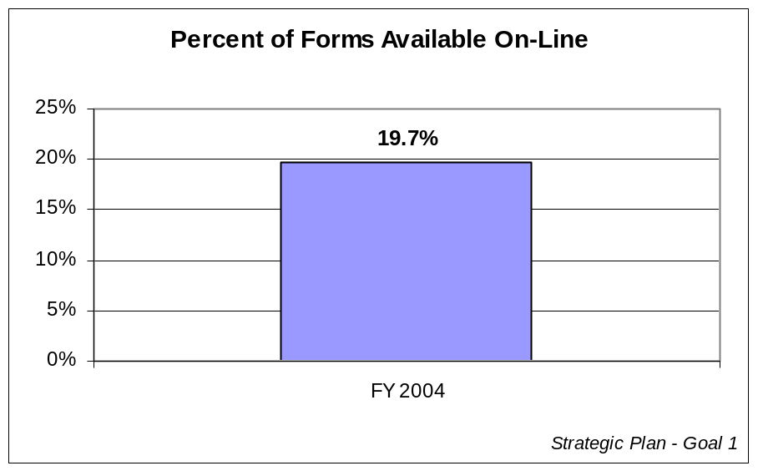

Data Reliability: Reporting and tracking of these forms are maintained through the IDMS mainframe application.

What was achieved: One hundred (100) percent of all forms that were requested to be put on-line are available on-line.

Analysis of results: One hundred (100) percent of all forms that were requested to be put on-line are available on-line.

Link(s) to Enterprise Plan: Forms Management is participating in establishing an Enterprise-wide forms standard.

Measures/Results
Performance Measure:  Percent of customers satisfied with accessibility to DOT.  Data Sources: | This measure has been replaced with utilization measures focused on the various modes of transportation.
Data Reliability:

What was achieved:

Analysis of results:
Link(s) to Enterprise Plan:

As part of the last strategic plan review, staff decided that ‘accessibility’ would be represented through a series of utilization-oriented measures for the various modes of transportation. The following measures for aviation, highway, rail, trails, transit and water were put in place toward the end of the FY 2004 cycle. Information presented in this report for these measures is the background data that will be used in the next review cycle.

Measures/Results
Performance Measure:  Percent of customers satisfied with accessibility to the state’s transportation system.  Data Sources: | This measure has been replaced with utilization measures focused on the various modes of transportation.

Data Reliability:

What was achieved:

Analysis of results:
Link(s) to Enterprise Plan:

As part of the last strategic plan review, staff decided that ‘accessibility’ would be represented through a series of utilization-oriented measures for the various modes of transportation. The following measures for aviation, highway, rail, trails, transit and water were put in place toward the end of the FY 2004 cycle. Information presented in this report for these measures is the background data that will be used in the next review cycle.

Measures/Results
Performance Measure:  Aviation – Passenger: Number of annual enplanements.  Data Sources:  Office of Aviation | 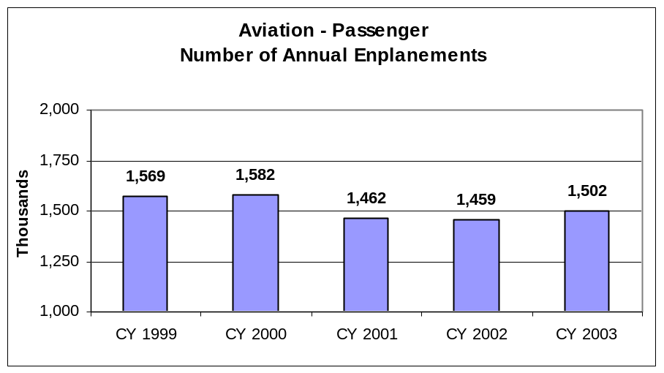

Data Reliability: Enplanement data is from FAA based on their revenue passenger boarding data. This data is collected uniformly across the nation.

What was achieved: A total of 1,501,546 passengers boarded airlines at Iowa’s commercial service airports in CY 2003.

Analysis of results: After a significant drop in passenger enplanements in CY 2001, the number of enplanements is steadily increasing in Iowa. This is consistent with steady increases in enplanements prior to CY 2001.

Link(s) to Enterprise Plan: This measure, along with others, is being used to monitor the utilization of Iowa’s various modes of transportation. This transportation system is one of Iowa’s key transportation infrastructures which supports and facilitates the work being done to accomplish the initiatives within the Enterprise Strategic Plan.

Measures/Results
Performance Measure:  Aviation – Freight: Number of cargo tons.  Data Sources:  Office of Aviation | 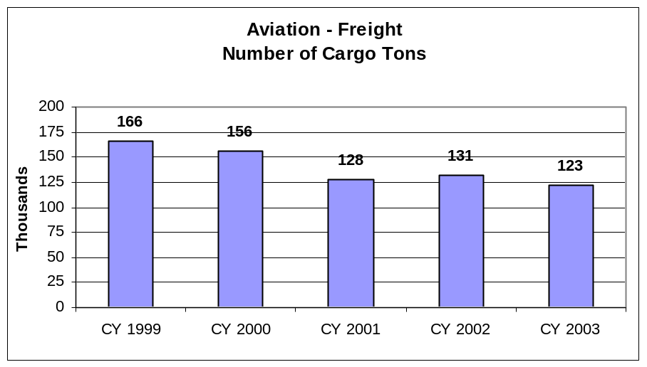

Data Reliability: Cargo tonnages are reported monthly by Iowa’s airports to the Office of Aviation and represents the tons of cargo handled at those airports.

What was achieved: A total of 122,559 tons of freight was handled at Iowa’s airports in CY 2003.
Analysis of results: After an increase in cargo tonnage in CY 2002, values for CY 2003 dropped back to just under CY 2001 levels.
Link(s) to Enterprise Plan: This measure, along with others, is being used to monitor the utilization of Iowa’s various modes of transportation. This transportation system is one of Iowa’s key transportation infrastructures which supports and facilitates the work being done to accomplish the initiatives within the Enterprise Strategic Plan.

Measures/Results
Performance Measure:  Highway – Passenger: Passenger vehicle miles of travel.  Data Sources: Office of Transportation Data | 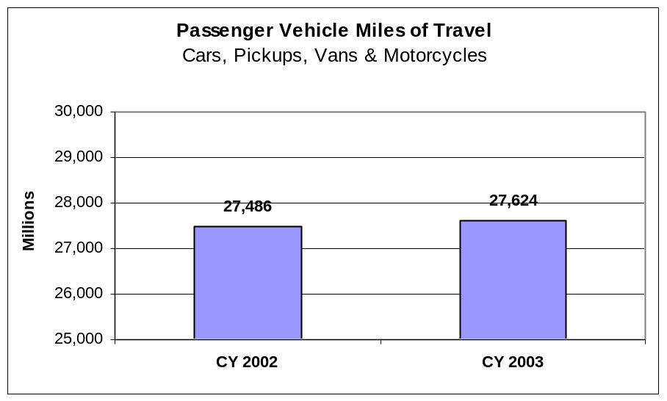

Data Reliability: Passenger vehicle miles of travel are based on traffic count data collected by the Iowa Department of Transportation on all public roads. Data is collected based on sample counts and permanent recorders and is factored in a statistically sound manner to reflect total traffic on all public roads.

What was achieved: A total of 27.6 billion vehicle miles of travel occurred on public roads in CY 2003 by cars, pickups, vans and motorcycles. These types of vehicles represent the predominant form of highway transportation for the movement of people.
Analysis of results: Passenger vehicle miles of travel have grown steadily over time. Since 1980, passenger vehicle miles of travel have grown 173 percent while the miles of roads have shown very little growth.
Link(s) to Enterprise Plan: This measure, along with others, is being used to monitor the utilization of Iowa’s various modes of transportation. This transportation system is one of Iowa’s key transportation infrastructures which supports and facilitates the work being done to accomplish the initiatives within the Enterprise Strategic Plan.

Measures/Results
Performance Measure:  Highway – Freight: Large truck vehicle miles of travel.  Data Sources: Office of Transportation Data | 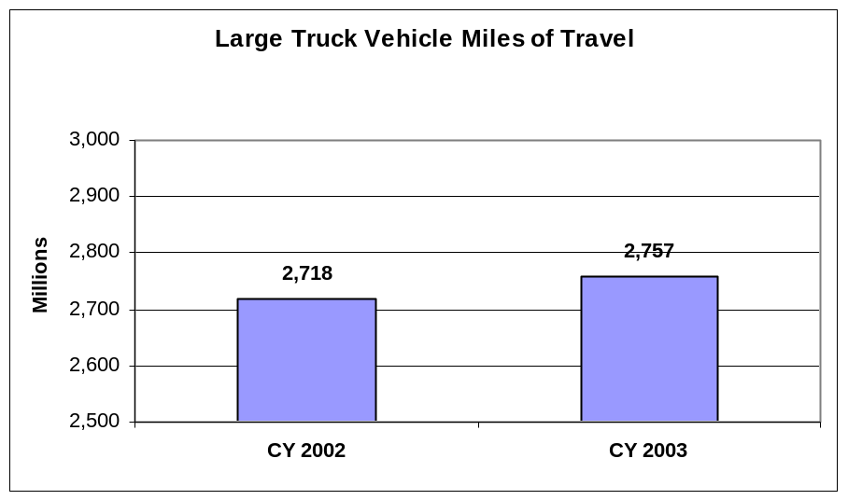

Data Reliability: Large truck vehicle miles of travel are based on traffic count data collected by the Iowa Department of Transportation on all public roads. Data is collected based on sample counts and permanent recorders and is factored in a statistically sound manner to reflect total large truck traffic on all public roads.

What was achieved: A total of 2.76 billion vehicle miles of large truck travel occurred on public roads in CY 2003. Large trucks are the predominant form of highway transportation for the movement of freight.
Analysis of results: Large truck vehicle miles of travel have grown steadily over time. Since 1980, large truck vehicle miles of travel have grown 231 percent while the miles of roads have shown very little growth.
Link(s) to Enterprise Plan: This measure, along with others, is being used to monitor the utilization of Iowa’s various modes of transportation. This transportation system is one of Iowa’s key transportation infrastructures which supports and facilitates the work being done to accomplish the initiatives within the Enterprise Strategic Plan.

Measures/Results
Performance Measure:  Rail – Passenger: Number of annual AMTRAK passengers.  Data Sources:  Office of Systems Planning | 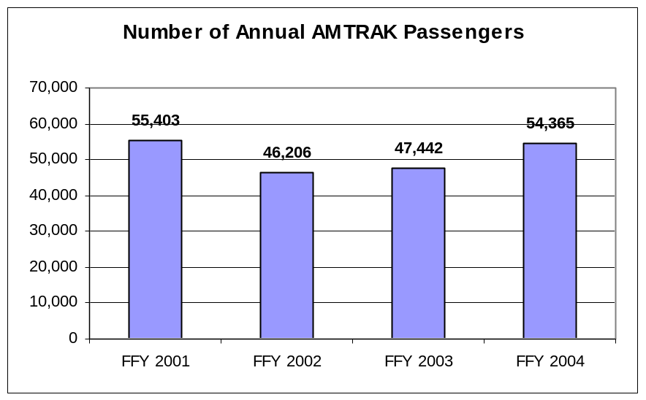

Data Reliability: This data is reported by AMTRAK and represents the actual number of passengers that boarded AMTRAK trains in Iowa.

What was achieved: In FFY 2004, 54,365 passengers boarded AMTRAK trains in Iowa and this represents a 15 percent increase over FFY 2003 ridership.
Analysis of results: FFY 2004 ridership continues a three year trend of increasing passenger usage of AMTRAK.
Link(s) to Enterprise Plan: This measure, along with others, is being used to monitor the utilization of Iowa’s various modes of transportation. This transportation system is one of Iowa’s key transportation infrastructures which supports and facilitates the work being done to accomplish the initiatives within the Enterprise Strategic Plan.

Measures/Results
Performance Measure:  Rail – Freight: Number of tons (originated and terminated).  Data Sources:  Office of Systems Planning | 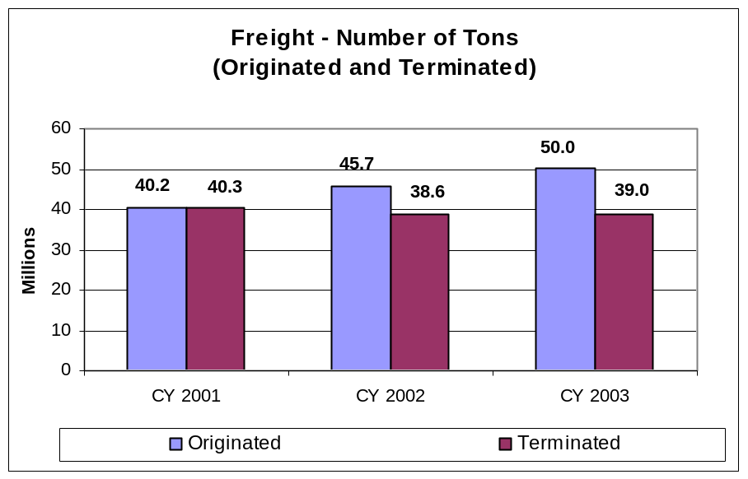

Data Reliability: Data is reported annually by railroads to the Iowa Department of Transportation and is based on actual traffic volumes. This data does not include the tons of freight that pass through Iowa.

What was achieved: Over 50 million tons of rail freight originated in Iowa and another 39 million tons of rail freight terminated in Iowa.
Analysis of results: Rail freight originating in Iowa has continued to grow at a significant rate the past three years while terminating freight movements have remained relatively stable.
Link(s) to Enterprise Plan: This measure, along with others, is being used to monitor the utilization of Iowa’s various modes of transportation. This transportation system is one of Iowa’s key transportation infrastructures which supports and facilitates the work being done to accomplish the initiatives within the Enterprise Strategic Plan.

Measures/Results
Performance Measure:  Trails: Number of miles for public use.  Data Sources:  Office of Systems Planning | 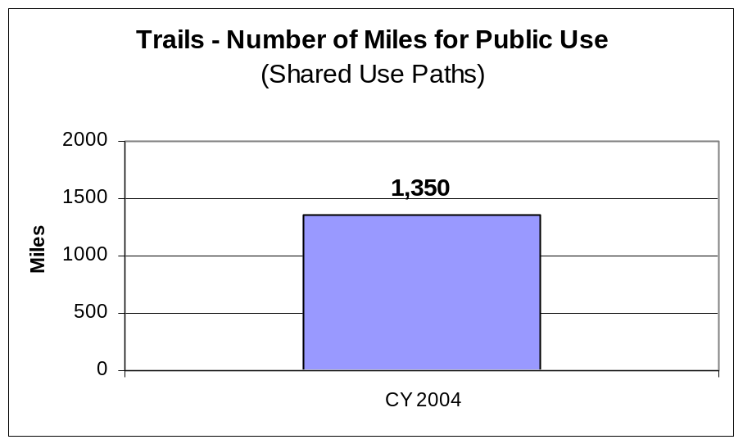

Data Reliability: This is based on reports of shared use path mileages from Iowa’s Regional Planning Affiliations and Metropolitan Planning Organizations. It does not include the mileage of shared use paths in Iowa’s state parks.

What was achieved: The mileage of shared use paths has not been regularly reported in past years. The reporting for CY 2004 will be a benchmark for future reporting that is expected to occur on a regular cycle.
Analysis of results: See above. While mileage has not been regularly tracked in the past, funding has been utilized each year to build new trails in Iowa.
Link(s) to Enterprise Plan: This measure, along with others, is being used to monitor the utilization of Iowa’s various modes of transportation. This transportation system is one of Iowa’s key transportation infrastructures which supports and facilitates the work being done to accomplish the initiatives within the Enterprise Strategic Plan.

Measures/Results
Performance Measure:  Transit – Ridership: Number of annual passengers.  Data Sources:  Office of Public Transit | 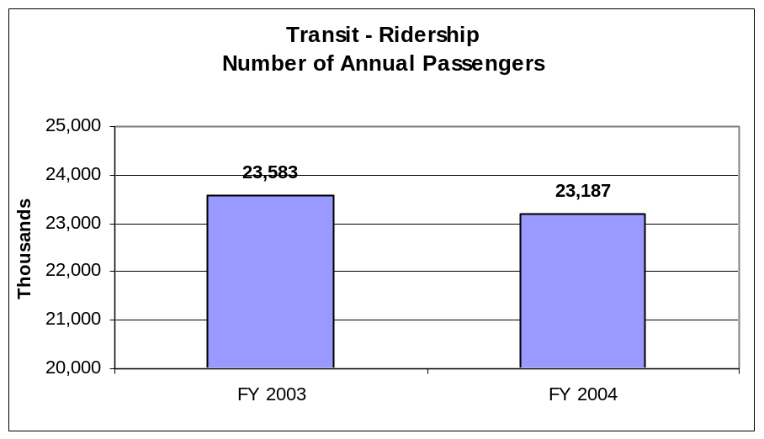

Data Reliability: Iowa’s public transit agencies report actual number of passengers to the Office of Public Transit.

What was achieved: Over 23 million passengers utilized public transit services in FY 2004.
Analysis of results: While this is slightly down from FY 2003 there is still a general upward trend in ridership in recent years.
Link(s) to Enterprise Plan: This measure, along with others, is being used to monitor the utilization of Iowa’s various modes of transportation. This transportation system is one of Iowa’s key transportation infrastructures which supports and facilitates the work being done to accomplish the initiatives within the Enterprise Strategic Plan.

Measures/Results
Performance Measure:  Transit: Total route mileage.  Data Sources:  Office of Public Transit | This measure will be changed due to lack of data.

Data Reliability:

What was achieved:

Analysis of results

Link(s) to Enterprise Plan:

Measures/Results
Performance Measure:  Water: Number of tons shipped into and out of Iowa by barge.  Data Sources:  U.S. Army Corp of Engineers | 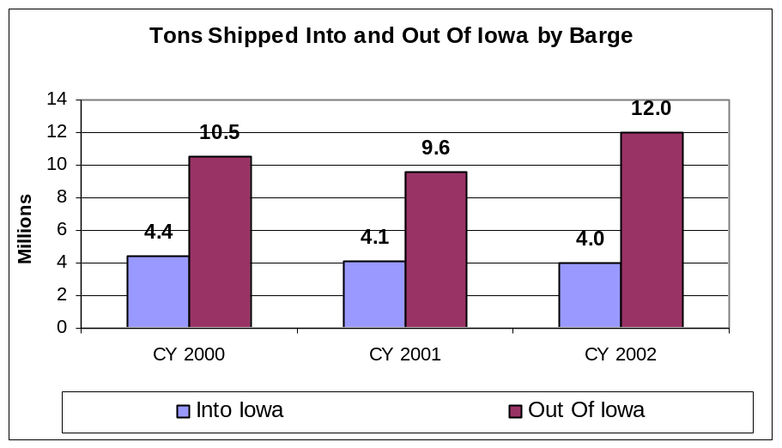

Data Reliability: Data represents the tons of cargo loaded and unloaded at Iowa terminals from barges using the Mississippi and Missouri Rivers. This is based on actual tonnages as reported to the U.S. Army Corps of Engineers.

What was achieved: Over 12 million tons of freight was loaded onto barges in Iowa in
CY 2002.
Analysis of results: CY 2002 freight loaded onto barges was the highest level in recent history, while the freight unloaded from barges at Iowa terminals has remained relatively stable. The freight loaded onto barges in Iowa is mostly grain being shipped for export markets. This value is approximately triple the tonnage of freight that is unloaded in Iowa.
Link(s) to Enterprise Plan: This measure, along with others, is being used to monitor the utilization of Iowa’s various modes of transportation. This transportation system is one of Iowa’s key transportation infrastructures which supports and facilitates the work being done to accomplish the initiatives within the Enterprise Strategic Plan.

Goal #2: Responsiveness - Be responsive to the citizens and businesses of Iowa in addressing their needs and ideas.

Strategies:
- Collect and act on the concerns and suggestions of the public.

Measures/Results
Performance Measure:  Average number of days taken to respond to citizen/business concerns, projects and/or suggestions.  Data Sources: Director’s Staff Division | Data from this measure will be available in FY 2005.

Data Reliability:

What was achieved:

Analysis of results:
Link(s) to Enterprise Plan:

Measures/Results
Performance Measure:  Percent of customers satisfied with the DOT/customer communication process.  Data Sources: | A review of the original measure revealed the need for more clarity. A discussion is underway to review the tracking of customer satisfaction with the DOT’s communication process.

Data Reliability:

What was achieved:

Analysis of results:
Link(s) to Enterprise Plan:
Goal #3: Accountability - Enhance the DOT’s management of financial and human resources.

Strategies:
- Manage and use resources wisely.

Measures/Results
Performance Measure:  Percent of Road Use Tax Fund revenue to the Primary Road Fund that is spent by Iowa DOT for DOT operations.  Data Sources: Operations and Finance Division records | 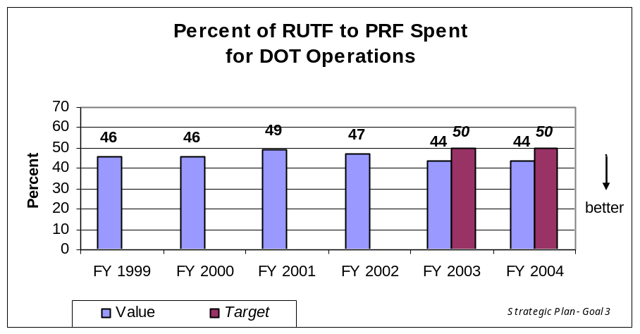

Data Reliability: Data is collected from the department’s financial records and is valid and accurate.

What was achieved: Forty-four (44) percent of the Road Use Tax Fund revenue that was deposited in the Primary Road Fund was spent by the department for DOT operations. The balance was invested in the highway improvement program.
Analysis of results: The department was well below the target of not more than fifty (50) percent being spent on DOT operations. This result shows that the operations budget is not consuming an increasing share of available resources and that an appropriate level of investment in the highway improvement program is being maintained.
Link(s) to Enterprise Plan: None

Measures/Results
Performance Measure:  Percent of employee performance evaluations completed on time.  Data Sources: Operations and Finance Division records | 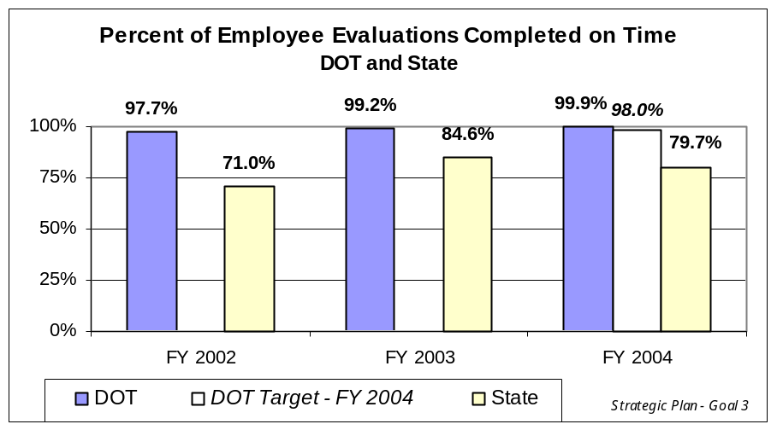

Data Reliability: Data was collected by the DOT and reviewed by the Iowa Department of Administrative Services-Human Resources Enterprise which verified results.

What was achieved: A total of 99.9 percent of employees received an employee evaluation on time. This exceeded the department’s FY 2004 target by 1.9 percent.
Analysis of results: Analysis indicates that the employee evaluations are being completed in a timely fashion and that no significant process flaws exist. Managers and supervisors are monitoring employee performance as required.
Link(s) to Enterprise Plan: This measure is one of the indicators used in the Governor’s and Lt. Governor’s operational scan as listed on the ResultsIowa.org Web site.

PERFORMANCE PLAN RESULTS

CORE FUNCTION

Name: Enforcement and Investigation

Description: Enhance the safety and well being of the public through the enforcement of state and federal laws and investigate those incidences where laws have been violated. Activities may include: patrolling highways; investigating major crimes, alleged fraud, or other incidents of law violations; enforcing gaming laws and laws involving wildlife harvest; and motor carrier enforcement.

Why we are doing this: To enforce state and federal laws to reduce the number and severity of crashes.
What we're doing to achieve results: Enforcement is concentrating on vehicle safety defects and driver deficiencies to remove unsafe vehicles and unqualified or impaired drivers from operating on our roadways.

Results
Performance Measure:  Number of motor carrier contacts.  Performance Target: The current performance target is 52,000.  Data Sources: Motor Vehicle Division records | 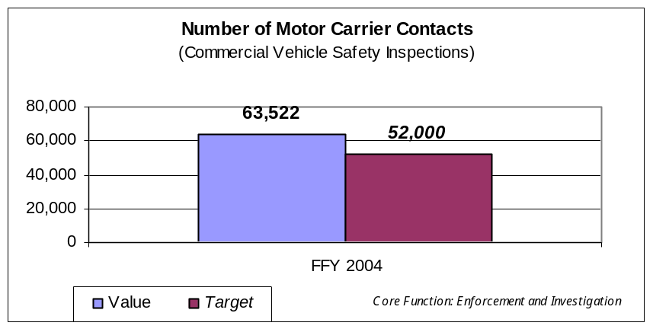

Data reliability: Validation edits are checked in all fields throughout SAFETYNET (Motor Vehicle Enforcement’s inspection report files).
Why we are using this measure: To monitor the outcome of providing a safe driving environment. Results are loaded to a national database and carrier snap shots and profiles are available to roadside enforcement nationwide.
What was achieved: A total of 5,612 drivers and 11,451 vehicles were not allowed to continue on until serious driver/vehicle deficiencies were corrected.
Analysis of results: This is a major function in Motor Vehicle Enforcement and results exceeded performance target measures.
Factors affecting results: Staffing levels
Resources used: Normal function of a Motor Vehicle Enforcement Officer. Motor Vehicle Enforcement currently has 84 uniformed officers making these contacts.

Results
Performance Measure:  Number of fraudulent documents detected.  Performance Target: The current performance target is 500.  Data Sources: Motor Vehicle Division records | 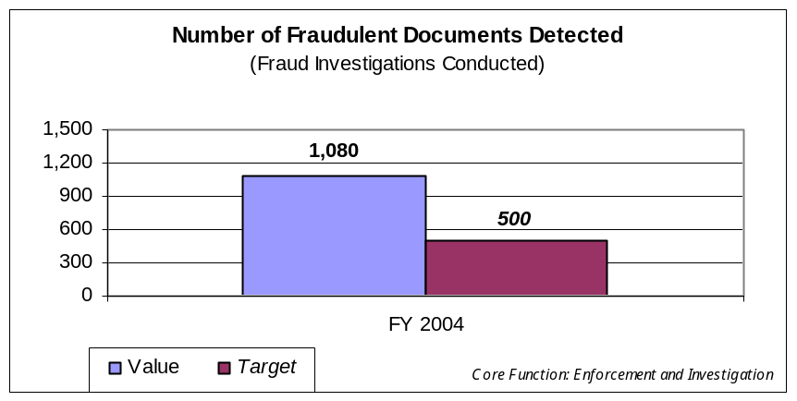

Data reliability: Information taken directly from weekly report, and Captain reviews all case reports prior to submission to the Commander.
Why we are using this measure: To monitor the outcome of providing increased awareness for the detection of fraudulent documents.
What was achieved: We achieved our current performance target. Over 1,000 fraud cases resulted from active detection of fraudulent documents.
Analysis of results: Fraud is prevalent in the specific areas of odometer tampering, use tax evasion and driver licensing. In addition, incidents of fraud are pervasive throughout all socioeconomic groups and are not based on gender or ethnicity.
Factors affecting results: Investigations are not solicited and are generated by citizens initiating complaints. Staffing levels affected the overall results.
Resources used: Five Investigators specialized in fraud conducted the inspections. However, 16 other Investigators may work fraud depending on the complexity of the case.

SERVICES/PRODUCTS/ACTIVITIES

Name: Motor Vehicle Enforcement

Description: Enforce commercial vehicle laws and investigate motor vehicle law violations.

Why we are doing this: To educate the motor carrier industry, their drivers, haulers of hazardous materials and officers enforcing the Federal Motor Carrier Safety and Hazardous Materials Regulations about commercial motor vehicle transportation regulations.
What we're doing to achieve results: Conducting motor carrier safety and hazardous materials educational outreaches at various locations across the state.

Results
Performance Measure:  Annual percent increase in Motor Vehicle Carrier Safety and Hazardous Materials Regulation training.  Performance Target: The current performance target is 10 percent.  Data Sources: Motor Vehicle Division records | 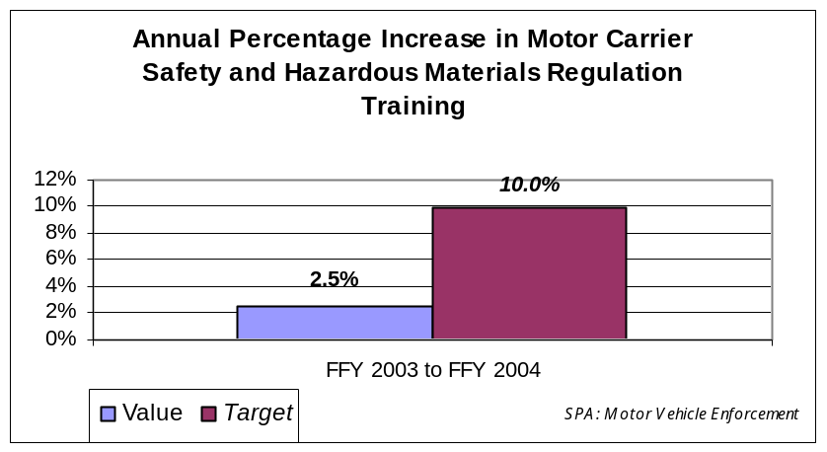

Data reliability: Information is retrieved from training forms submitted by Motor Vehicle Enforcement Officers upon completion of the sessions.
Why we are using this measure: To ensure the industry and their drivers are aware of current regulatory requirements.
What was achieved: Attendees were provided with current inspection procedures and regulatory changes to enable them to operate safely on Iowa’s roadways.
Analysis of results: Expectations exceeded even with changes in staffing. With current staffing levels, a 10 percent increase is unattainable. Adjustments will be made to eliminate any percentage increase in future performance measures.
Factors affecting results: Reduced our training program for external customers to further enhance internal training.
Resources used: Four Hazardous Material Officers handle HM training; one Training Specialist handles all motor carrier safety training.

Results
Performance Measure:  Annual percentage increase in new entrant carrier reviews.  Performance Target: The current performance target is 20 percent.  Data Sources: Motor Vehicle Division records | 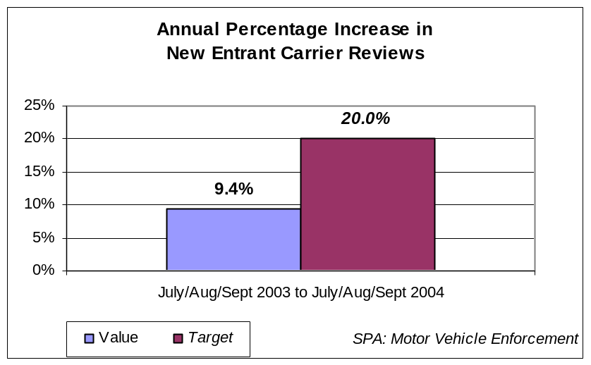
Data reliability: New entrant audits are electronically submitted. New Entrant Investigators submit weekly activity reports that are reviewed by a Captain and compiled into a database for reporting purposes.
Why we are using this measure: To ensure new carriers are contacted to implement applicable regulatory requirements in their operation.
What was achieved: Regulatory compliance
Analysis of results: An analysis of the results showed that we could only compare a three-month period because of the newness of the program. Therefore based on the 9.4 percent increase for 3 months, we believe that by the end of the fiscal year we will reach our 20 percent target.
Factors affecting results: Number of new motor carriers entering the program
Resources used: Four Motor Carrier Investigators handle the entire state.

Results
Performance Measure:  Annual percentage increase in surveillance on out-of-service drivers and vehicles.  Performance Target: The current performance target is 10 percent.  Data Sources: Motor Vehicle Division records | 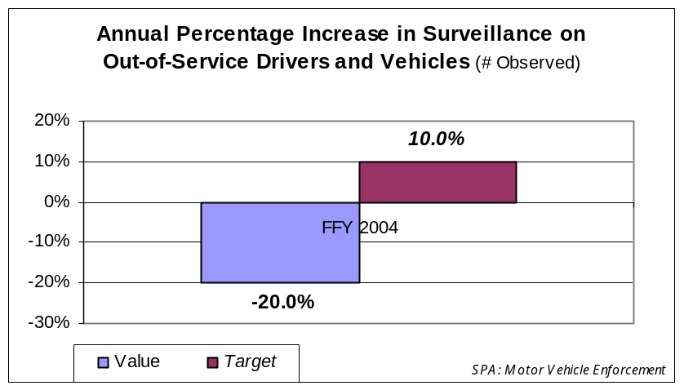

Data reliability: Surveillance counts are generated from the actual inspection report database.
Why we are using this measure: To ensure drivers/vehicles make required corrections before continuing on.
What was achieved: Deterred drivers/vehicles from leaving before making required repairs.
Analysis of results: We did not meet our target level. The results will be discussed with command staff to ensure we are striving towards our performance target.
Factors affecting results: Staffing levels, weather and location all impact results.
Resources used: Normal function of a Motor Vehicle Enforcement Officer at scale facilities and on patrol. Actual covert activity is based on an officer’s intuition that the driver will leave the location before making corrections. This activity could be performed by any of the 84 officers across the state.

Results
Performance Measure:  Annual percentage increase in commercial motor vehicles and hazardous materials carriers inspected.  Performance Target: The current performance target is 7 percent.  Data Sources: Motor Vehicle Division records | 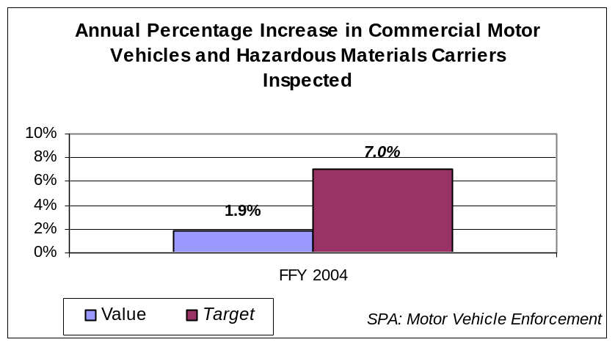

Data reliability: Inspection counts are generated from actual inspection records.
Why we are using this measure: Results from these inspections provide us with knowledge of compliance as well as driver and vehicle defect trends.
What was achieved: A total of 749 unsafe vehicles and 161 drivers were ordered out of service for serious violations.
Analysis of results: Our actual performance indicates that the current 7 percent target is unattainable. We will eliminate a percentage increase and replace it with a comparison of actual inspections conducted from federal fiscal year to federal fiscal year.
Factors affecting results: Because there are only five Hazardous Materials Officers, the inspection levels will remain fairly consistent.
Resources used: Normal function of a Motor Vehicle Enforcement Officer. Five Hazardous Materials Specialists conduct 52 percent of the inspections with the remaining inspections being done by the Motor Vehicle Enforcement Officers.

Results
Performance Measure:  Annual percent increase in fraudulent document detection training.  Performance Target: The current performance target is 15 percent.  Data Sources: Motor Vehicle Division records | 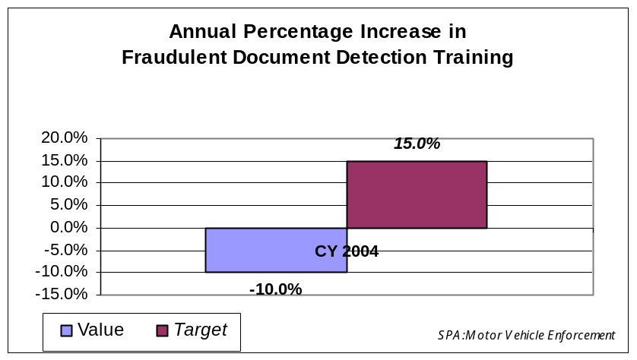

Data reliability: Information is kept on a computer-generated spreadsheet which is updated each time a training session is held.
Why we are using this measure: To assist law enforcement, Vehicle Services personnel, county treasurers and industry on identifying fraudulent motor vehicle documents.
What was achieved: For the calendar year 2004, less training was given than in 2003.
Analysis of results: A percentage target increase is unattainable. Training is conducted on demand. You can only train so many people in a calendar year. Though the number of training sessions dropped 10 percent, the number of people attending those sessions increased 24 percent.
Factors affecting results: Motor Vehicle Enforcement has one Fraud Investigator conducting all fraud training and he conducted several out-of-state training sessions in addition to his normal work activities.
Resources used: One Fraud Investigator

CORE FUNCTION

Name: Physical Assets Management

Description: Manages state government assets including, but not limited to state government buildings, monuments and vehicles. Activities may include property surplus; parking and grounds maintenance; design, construction and maintenance of facilities; space utilization; and the upkeep of state vehicles.

Why we are doing this: To assure that the department builds, buys and maintains the physical assets necessary to carry out its mission.
What we're doing to achieve results: The department actively plans, monitors and inventories the acquisition, construction and maintenance of all physical assets.

Results
Performance Measure:  Percent of life standard reviewed annually.  Performance Target: The current performance target is 50 percent.  Data Sources: Operations and Finance Division records | 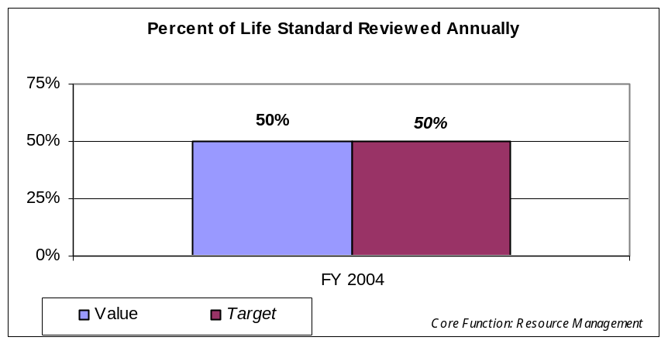

Data reliability: Data is collected from staff responsible for reviews. Employee reviews are checked annually by management and proposed changes are discussed at annual equipment reviews.
Why we are using this measure: To assure that DOT gets optimum value from its equipment by retaining it for the appropriate length of time.
What was achieved: A target of 50 percent was met.
Analysis of results: A target of 50 percent was met.
Factors affecting results: Staffing
Resources used: .04 FTE (from Equipment Revolving Fund)

Results
Performance Measure:  Percent completion of automated inventory.  Performance Target: The current performance target is 20 percent.  Data Sources: Operations and Finance Division records | 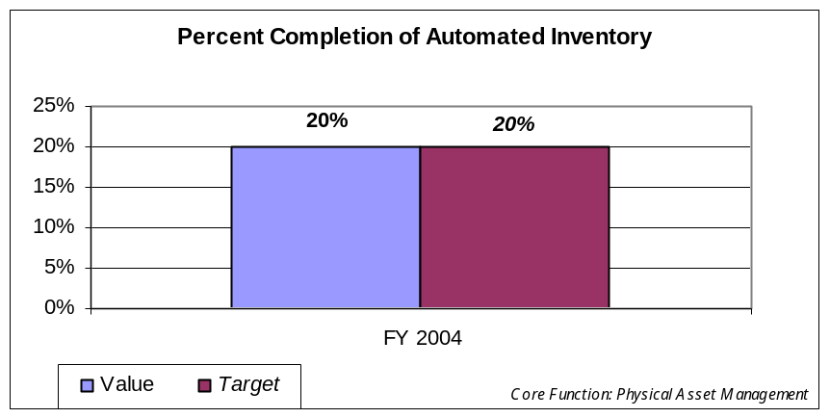

Data reliability: Data is collected from department’s ERMS records and is accurate and reliable.
Why we are using this measure: To get a system in place that provides inventory data to help manage DOT’s vertical infrastructure.
What was achieved: A target of 20 percent completion was met.
Analysis of results: A target of 20 percent completion was met.
Factors affecting results: None noted
Resources used: Mainframe space requirements of 2.1 megabytes and .05 FTE.

SERVICES/PRODUCTS/ACTIVITIES

Name: Vertical/Fixed Asset Management

Description: Provides management of department facilities.

Why we are doing this: To access the overall performance of our vertical/fixed management initiative to ensure all facilities and rolling stock are maintained at desired levels.
What we're doing to achieve results: Data is gathered and evaluated monthly. Annual meetings are conducted with divisions and district offices to review the overall performance for the year and to discuss potential projects for the next year.

Results
Performance Measure:  Percent completion of annual maintenance plan.  Performance Target: The current performance target is 90 percent.  Data Sources: Operations and Finance Division records | 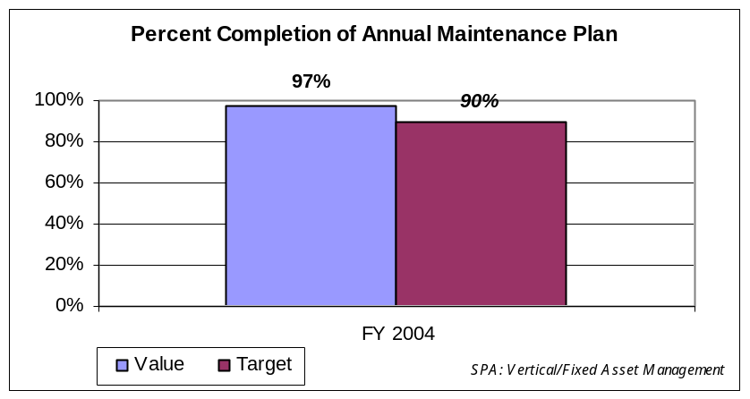

Data reliability: Data is very reliable because projects and payments are closely tracked by staff.
Why we are using this measure: Plans are monitored to assure planned projects are completed and the buildings are maintained in good repair.
What was achieved: Completed 94 percent (107/114) of Ames Complex Facilities Improvement projects and 100 percent (150 of 150) of Field Facilities Improvement projects resulting in an overall completion rate of 97 percent of the 264 projects in the annual maintenance plan.
Analysis of results: Results are well above target.
Factors affecting results: Availability of staff hours and availability of funds
Resources used:
$275,000 - Cost Center 1210 (Ames Complex) Funding Source: PRF
$2,000,000 - Cost Center 5509 (Field) Funding Source: PRF

Results
Performance Measure:  Percent completion of capital and special projects.  Performance Target: The current performance target is 95 percent.  Data Sources: Operations and Finance Division records | 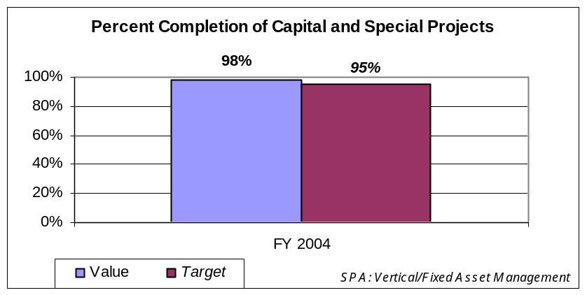

Data reliability: Data is very reliable because all projects and payments are closely tracked by staff. In addition, a monthly capital expenditure report is issued by the Office of Finance and reviewed by Facilities staff.
Why we are using this measure: This measure is used to assure projects for which we have capital appropriations are completed in a timely manner.
What was achieved: Ninety-eight (98) percent of the capital projects that had appropriations expiring on 6/3/04 were completed.
Analysis of results: Results are 3 percent above target.
Factors affecting results: Availability of design staff hours
Resources used: $2,800,000 Cost Centers: 7075, 7076, 7077, 7078, 7079

Results
Performance Measure:  Percent of light fleet into service within time standard.  Performance Target: The current performance target is 85 percent.  Data Sources: Operations and Finance Division records | 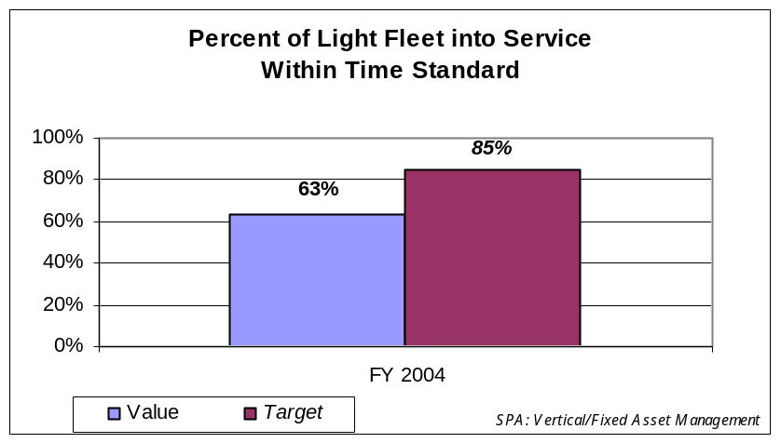

Data reliability: Data is from Equipment Management System. Data used to determine when a vehicle was placed in service may vary by up to a week based on equipment delivery and approval of equipment transfers.
Why we are using this measure: To assure that DOT gets maximum value from new vehicles purchased by seeing that equipment is used for its intended purpose as soon as possible after purchase.
What was achieved: Sixty-three (63) percent of light vehicles were in service within the time standard.
Analysis of results: Target was not met as new light bars needed to be designed and manufactured to fit 64 of the pickup trucks. This delayed getting these trucks into service.
Factors affecting results: Availability of custom manufactured parts from DOT shop and other sources. Need to redesign item such as light bars to fit new makes or models purchased.
Resources used: .5 FTE (from Motor Pool Revolving Fund)

CORE FUNCTION

Name: Regulation and Compliance

Description: Enhance the safety, health and economic well being of the public through consultation and enforcement of state regulations. Activities may include: examining; accreditation; inspections and compliance; and various licensing, permit and registration activities.

Why we are doing this: To enhance the safety of the public by ensuring only those individuals who are qualified are licensed to operate motor vehicles on the public roadways. Perform related functions in the most effective, efficient and courteous manner possible.
What we're doing to achieve results: Constant evaluation of program effectiveness, staff development, resource allocation, customer service delivery and contribution to our highway safety mission.

Results
Performance Measure:  Number of driver improvement interviews conducted.  Performance Target: The current performance target is 7,000.  Data Sources: Motor Vehicle Division records (indexing record) | 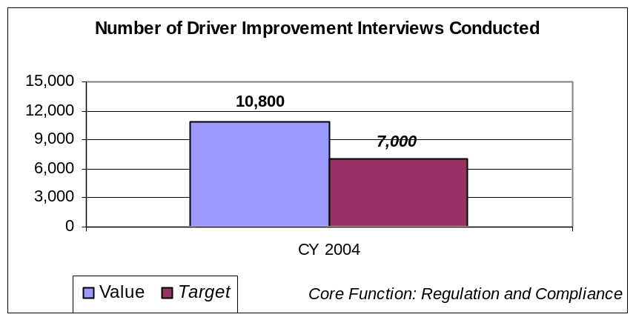

Data reliability: Information is retrieved from workflow processing files of MVD document imaging system.
Why we are using this measure: To monitor the outcome of providing a safe driving environment.
What was achieved: Over 10,000 driver improvement actions were reviewed for appropriateness and consistency with the agency’s highway safety objectives.
Analysis of results: Effective use of technology and flexibility in work task assignments allowed us to exceed the performance target and stay timely with the work.
Factors affecting results: Cross trained staff and distributed records processing system
Resources used: Driver Services central office and field staff

Results
Performance Measure:  Number of drivers receiving Money-Back Guarantee.  Performance Target: The current performance target is 550.  Data Sources: Motor Vehicle Division records | 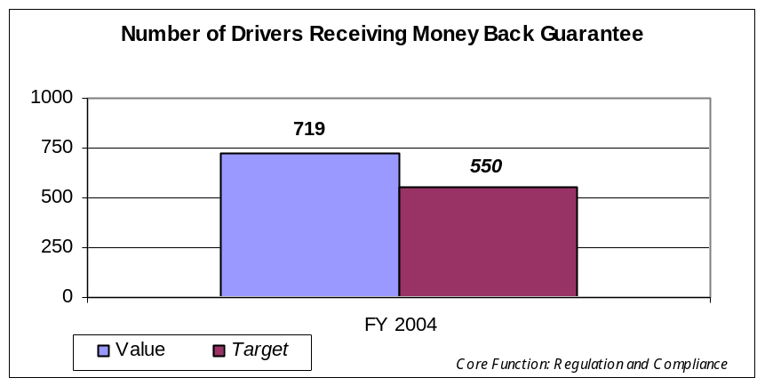

Data reliability: Information is reported from the driver license audit program and direct reporting by driver licensing staff.
Why we are using this measure: To monitor the outcome of providing enhanced service to drivers.
What was achieved: The performance target was not met. A total of 719 persons received a Money-Back Guarantee in FY 2004.
Analysis of results: Eight of the DOT’s 18 driver license facilities were open to the public six days a week. Staffing levels were insufficient to provide quality customer service over the six day schedule. This resulted in delays in customer service, increased stress for the employees and increased absenteeism which further exacerbated the staffing issues. When the customer service schedules for these eight stations were reduced to five days a week, we were able to maintain better staffing levels over the entire schedule, allowing us to provide a higher level of service in every service category and improve the work environment for staff, reducing stress and absenteeism. The new schedule has allowed us to serve more customers better and with less wait time than before. The new schedule changes were implemented in August 2004. The weekly average of Money-Back Guarantees during the August - November period was 2.7. The weekly average for FY 2004 was 13.8.
Factors affecting results: Staffing and customer service schedules
Resources used: Driver Services staff

SERVICES/PRODUCTS/ACTIVITIES

Name: Driver Services

Description: License, register and permit all users of the highway system.

Why we are doing this: To enhance the safety of the public by ensuring only qualified individuals are licensed to operate motor vehicles on the public roadways. Perform related functions in the most effective, efficient and courteous manner possible.

What we're doing to achieve results: Constant evaluation of program effectiveness, staff development, resource allocation, customer service delivery and contribution to our highway safety mission.

Results
Performance Measure:  Annual percentage increase in TraCS users.  Performance Target: The current performance target is 35 percent.  Data Sources: Motor Vehicle Division records | 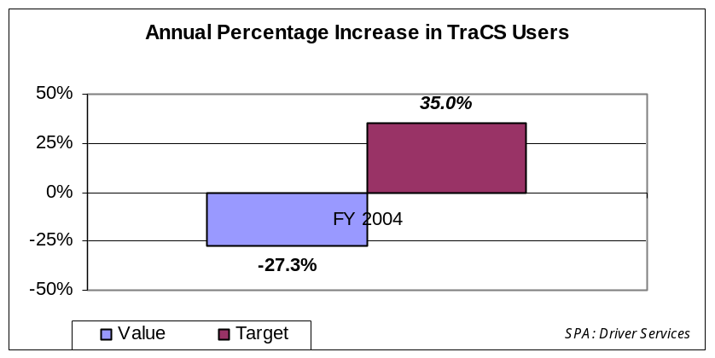

Data reliability: Information is retrieved from the accident processing system and direct reporting of TraCS team members.
Why we are using this measure: Number of TraCS users is an indicator of the level of satisfaction of TraCS use across the state; however, a preferred measure is the percentage of crash reports received electronically through the use of TraCS. The percent of electronic crash reports is a more direct measure of results.
What was achieved: The number of agencies issuing TraCS was intentionally reduced to ensure adequate support of those agencies submitting large numbers of reports. Even with fewer agencies using TraCS, the percentage of officers’ crash reports being submitted electronically increased to 61 percent in September 2004 from 50 percent in September 2003.
Analysis of results: Several low volume TraCS user agencies were consistently requiring unacceptably high levels of support resources from the TraCS team. With available staff resources it was impossible to maintain support of these agencies and provide the appropriate level for the other, more productive user agencies. A decision was made to discontinue support for these low volume, high maintenance agencies in order to ensure adequate support for the more active agencies. This strategic change appears to be validated by the 22 percent increase in electronic reporting in the last 12 month period.
Factors affecting results: Staff resources and user agency support needs
Resources used: 3.9 FTE

Results
Performance Measure:  Annual percentage increase in GDL/older driver classes.  Performance Target: The current performance target is 15 percent.  Data Sources: Motor Vehicle Division records | 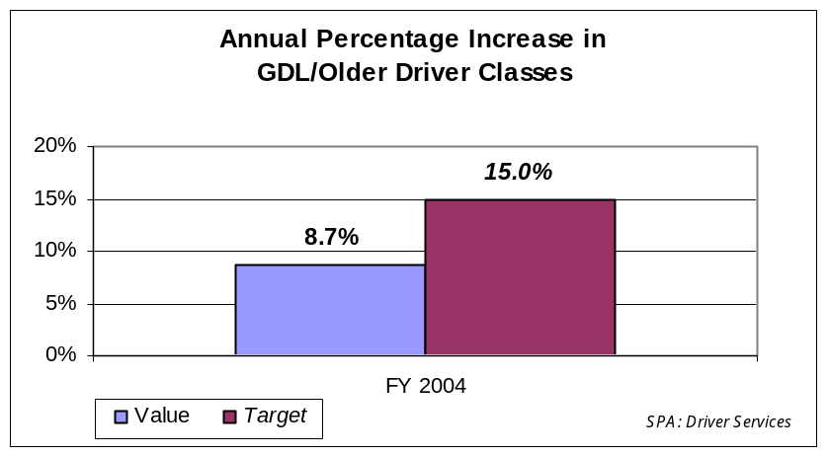

Data reliability: Direct reporting by Driver Services field staff
Why we are using this measure: These classes represent a significant public outreach program to the two highest risk groups of drivers in the state.
What was achieved: Driver Services sustained its commitment to cordial and informal presentations of driver licensing and safe driving information to these two high-risk driver groups “on their own turf”, outside the sometimes intimidating environment of the driver license station.
Analysis of results: In spite of near static driver populations and driver education programs, we realized a modest gain in GDL classes. We’ve been active in this area for several years and may be close to reaching the saturation point. The older driver program is relatively new and still building momentum as reflected in the 60.5 percent increase in these classes. It appears activity in this area will increase steadily for several years as the older driver population continues to grow. Our examining staff also benefit from these casual interactions, developing increased understanding and empathy for stress and fear that can be associated with the driver licensing process by these groups.
Factors affecting results: Driver populations, staffing, scheduling, and communication
Resources used: Driver license examiners and supervisors - 84 in FY 2004.

Results
Performance Measure:  Annual percentage decrease in those eligible for Money-Back- Guarantee.  Performance Target: The current performance target is 15 percent.  Data Sources: Motor Vehicle Division records | 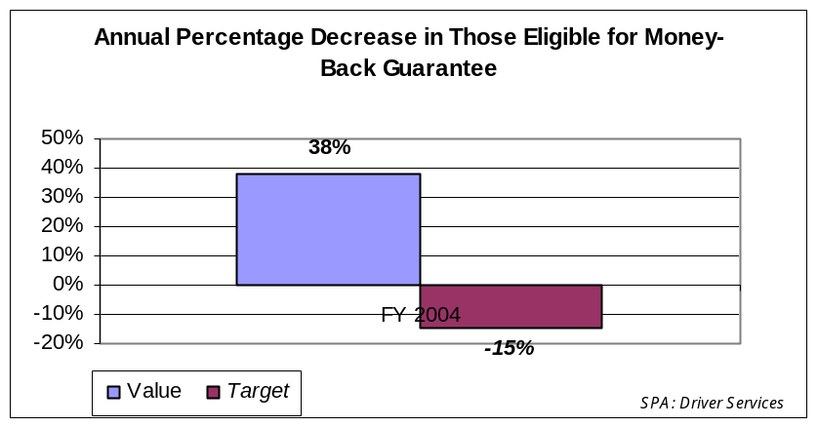

Data reliability: Information is reported from the driver license audit program and direct reporting by driver licensing staff.
Why we are using this measure: To monitor the outcome of providing enhanced service to drivers.
What was achieved: There was a 38 percent increase in persons eligible for Money-Back Guarantee.
Analysis of results: Eight of the DOT’s 18 driver license facilities were open to the public six days a week. Staffing levels were insufficient to provide quality customer service over the six day schedule. This resulted in delays in customer service, increased stress for the employees and increased absenteeism which further exacerbated the staffing issues. When the customer service schedules for these eight stations were reduced to five days a week, we were able to maintain better staffing levels over the entire schedule, allowing us to provide a higher level of service in every service category and improve the work environment for staff, reducing stress and absenteeism. The new schedule has allowed us to serve more customers better and with less wait time than before. The new schedule changes were implemented in August 2004. The weekly average of Money-Back Guarantees during the August - November period was 2.7. The weekly average for FY 2004 was 13.8. This is a decrease of 80 percent.
Factors affecting results: Staffing and customer service schedules
Resources used: Driver Services staff

Results
Performance Measure:  Annual percentage decrease in time to hold line drive re-examinations.  Performance Target: The current performance target is 15 percent.  Data Sources: Motor Vehicle Division records | 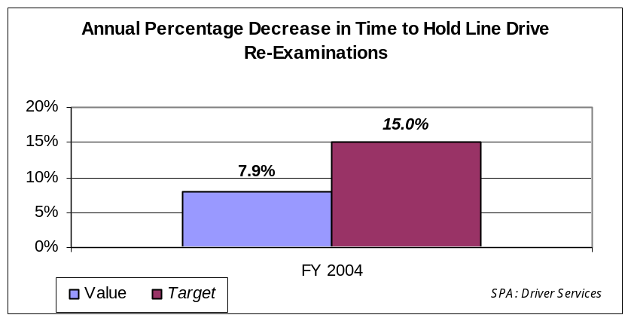

Data reliability: Information is taken from case reports and driver history records.
Why we are using this measure: It is a direct measure of time to deliver service to these customers and to resolve driver safety issues. This is important to the individual drivers affected and those who may share the public roadways with them.
What was achieved: A new service delivery strategy was implemented, staff were trained and a modest decrease in time to deliver the service was realized.
Analysis of results: Responsibility for the activity was shifted from central office staff to field supervisors. Initially scheduling was made more difficult because during training the schedules of the Des Moines based trainer, the field supervisor and the driver had to be coordinated. However, once training was completed the reexaminations could be scheduled more quickly because the Driver License supervisors were much more accessible to the drivers in their regions. Supervisors can also use the re-examination as an opportunity to assess the quality of previous tests administered by examining staff under their supervision.
Factors affecting results: Staffing and workload
Resources used: Driver services staff. Due to gradual implementation of a new process, staffing was not static for the reporting period.

Results
Performance Measure:  Annual percentage increase in carriers using “e-filing.”  Performance Target: The current performance target is 15 percent.  Data Sources: Motor Vehicle Processing System | 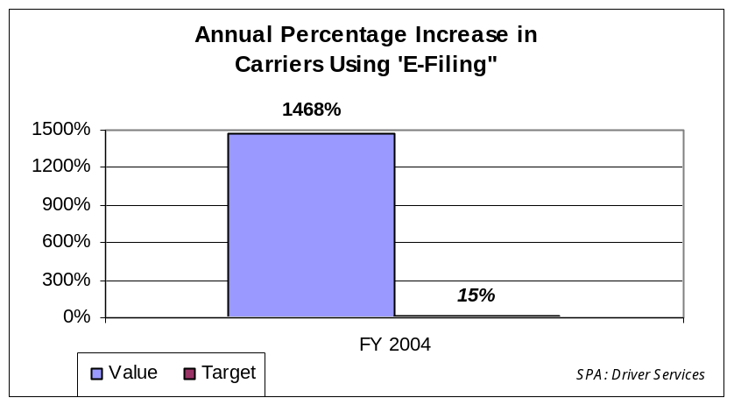

Data reliability: Actual counts of carrier and transactions from the processing system.
Why we are using this measure: The measure best reflects the carriers being provided e-filing services.
What was achieved: We now offer three different types of e-filing services to our carriers - - oversize/overweight permit requests, quarterly fuel tax reporting, and international registration plan requests.
Quarterly fuel tax reporting and IRP through the Web are new programs this year. We went from none to 27 percent of the carriers being able to process through the WEB in IRP and 8 percent of the carriers are now submitting their quarterly fuel tax reports through the Web.
The oversized and overweight permits remained the same. The program has been around for a period of time and we do not see any large changes occurring in the participation. Sixty-eight percent of the business being done through the Web is exceptional for both us and the carriers. We would like to maintain that number.
Analysis of results: Though the newest of the programs and the wording of the measure contributed to an exaggerated value, overall results are better then expected. The well established oversize and overweight permitting program is running well. The IRP e-filing is doing better then expected, and it reflects good results from promotional efforts to get carriers signed up. We will be adding some features to our quarterly fuel tax reporting that will allow companies to send files. Currently most of the permitting services that file on behalf of a lot of companies have automated systems already and they do not want to re-key the data when they can just hit print and send. Therefore, we are working with our data processing support to allow file transfers, in addition to entering the data, directly though the Web. However, for the smaller carriers what we currently have has been a good option and we have gotten very positive feedback.
Factors affecting results: We have done a lot of promotion to let carriers know about their new filing options. As more people become aware, there should be even better results.
Resources used: Internal resources (staff time and internal processing systems) were used to develop, monitor, analyze and act on the analysis findings. Work was assigned to staff as a normal daily assignment requiring no additional funds to the division.

Results
Performance Measure:  Annual percentage decrease in time to complete customer-centric processes.  Performance Target: The current performance target is 15 percent.  Data Sources: Motor Vehicle Division records | 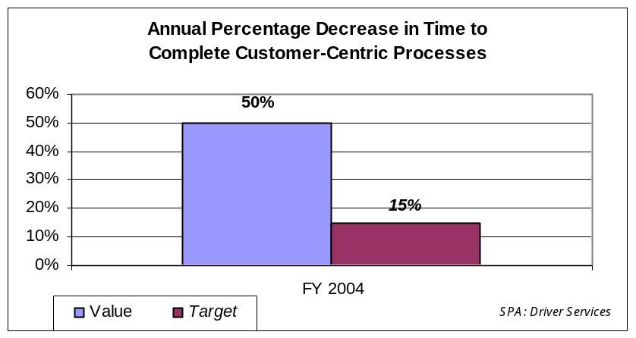

Data reliability: All forms are now completed on-line and follow specific formats.
Why we are using this measure: To improve the quality of customer service, reduce staff processing time and provide accountability for fees that are returned, refunded or deposited.
What was achieved: Reduction in staff time, easy access to information when customers call in or come into the office for assistance, accountability and a more professional approach and look to forms and certificates created.
Analysis of results: The new automated processes are successful in providing information that is easy to understand for customers, reducing their time to complete applications and reducing questions and calls to this office. A side benefit is a gift certificate that has a professional appearance for gift givers.
Factors affecting results: The automation has improved internal and external customer services by reducing the time it takes to process documents, certificates and information.
Resources used: Internal staff time was used to develop and program information. This was assigned as a project for daily operations requiring no additional funding for the department.

CORE FUNCTION

Name: Research, Analysis and Information Management

Description: Provides relevant information and technical services in a timely manner to customers, stakeholders and policy makers to help make informed decisions. Activities may include: collection, analysis, management, interpretation and dissemination of information.

Why we are doing this: To effectively manage department resources so that our customers have the resources needed to achieve their assigned duties.
What we're doing to achieve results: The department is constantly looking for ways to improve performance through automation.

Results
Performance Measure:  Percent of time the user is able to access information technology (IT) resources during their business hours.  Performance Target: The current performance target is 98 percent.  Data Sources: Information Technology Division records | 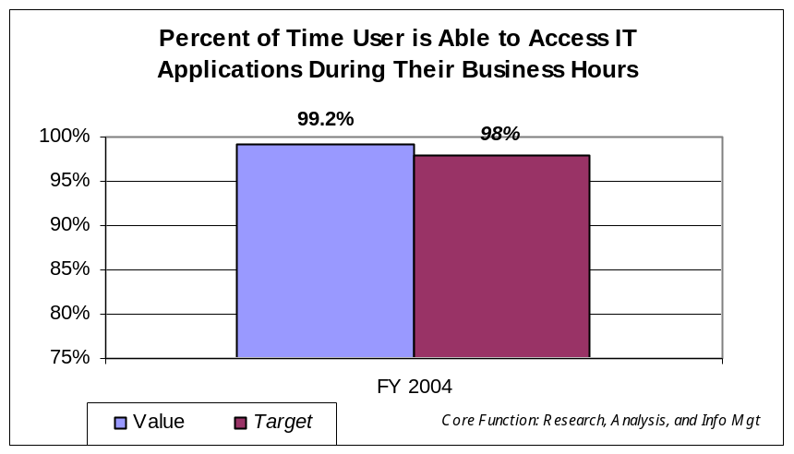

Data reliability: Data was collected from our Clarify (call tracking) system.
Why we are using this measure: To monitor the outcome of providing IT capabilities to users.
What was achieved: IT applications were available 99.2 percent of the time during DOT business hours.
Analysis of results: We are currently meeting our goals. Rather than relying on trouble ticket information in the future, application monitoring software will be used to track individual applications.
Factors affecting results: Lack of start and end times on some tickets caused us to assume applications were down longer than actual outages.
Resources used: Internal resources (staff time and materials) were used to develop, monitor, analyze and act on the analysis findings. Work was assigned to staff as a normal daily assignment requiring no additional funds to division.

SERVICES/PRODUCTS/ACTIVITIES

Name: Information Technology

Description: Provides access to technical services in a timely manner to customers, stakeholders and policy makers to help make informed decisions. Activities may include: collection, analysis, management, interpretation and dissemination of information.

Why we are doing this: To effectively manage department resources so that our customers have the resources needed to achieve their assigned duties.
What we're doing to achieve results: The department is constantly looking for ways to improve performance through automation.

Results
Performance Measure:  Percent of approved mainframe and network System Access (SA) documents completed within three work days from entry approval.  Performance Target: The current performance target is 95 percent.  Data Sources: Information Technology Division records | 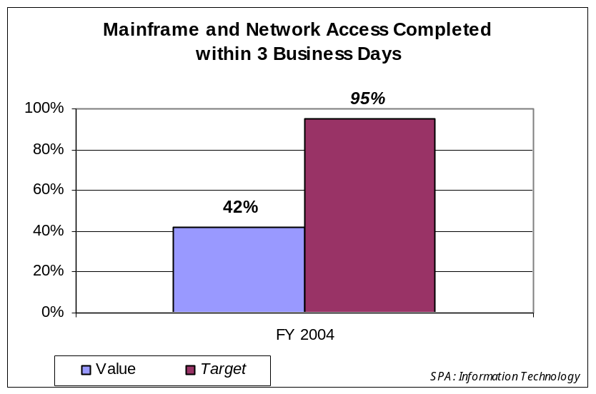

Data reliability: The information was obtained from our System Access application.
Why we are using this measure: To ensure that our customers have the access needed to perform their assigned tasks in a timely manner.
What was achieved: Three (3) percent of the Mainframe Access requests were completed in three business days. Fifty (50) percent of the requests for LAN Access was completed in three business days.
Analysis of results: The performance was lower than expected. As a result, we have adjusted work flow timing and also cross trained additional employees. This will ensure we have staff available to process these requests.
Factors affecting results: The system used to capture this data was changed late in the year. Therefore, the number of documents that we were able to use in our calculations is less than a whole year’s work.
Resources used: Internal resources (staff time and materials) were used to develop, monitor, analyze and act on the analysis findings. Work was assigned to staff as a normal daily assignment requiring no additional funds to division.

Results
Performance Measure:  Percent of time the network is available.  Performance Target: The current performance target is 99.9 percent.  Data Sources: Information Technology Division records | 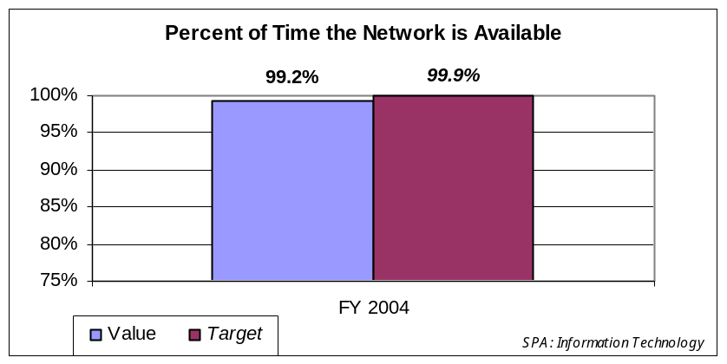
Data reliability: To calculate this measure we took the number of DOT sites and multiplied it by the number of days in the year. We then used our Clarify (call tracking) System to count the number of outages for the year. If an Outage occurred we assumed that the resource was down for the entire day. Therefore, the numbers represent a worst case calculation.
Why we are using this measure: To ensure that the resources that our customers need to perform their assigned task are available when needed.
What was achieved: Network resources were available 99.2 percent of the time.
Analysis of results: We have determined that we are close to meeting our goals but there is still room for improvement. Rather than relying on trouble ticket information in the future, network monitoring software will be used to track individual applications.
Factors affecting results: Our assumption that any reported outage resulted in an outage for the whole day causes an extreme over count of down time. Actual outages should have been four hours or less.
Resources used: Internal resources (staff time and materials) were used to develop, monitor, analyze and act on the analysis findings. Work was assigned to staff as a normal daily assignment requiring no additional funds to division.

CORE FUNCTION

Name: Resource Management

Description: Provides all vital infrastructure needs necessary to administer and support agency operations. Key activities may include financial and personnel services such as payroll, accounting and budget; purchasing of goods and services; media management; information technology enhancement, management and support; staff development; leadership; planning; policy development; maintenance of physical infrastructure and governance system development to achieve results for Iowans.

Why we are doing this: To effectively manage department resources so that the workforce has the resources needed to achieve their assigned duties.
What we're doing to achieve results: The department is constantly looking for ways to improve performance through customer and stakeholder feedback, analyzing performance, improving work processes and applying technology where applicable.

Results
Performance Measure:  Percent of customers that perceive the Director’s Staff Division as a valued information source.  Performance Target: The current performance target is 80 percent.  Data Sources: Director’s Staff Division records and survey results | 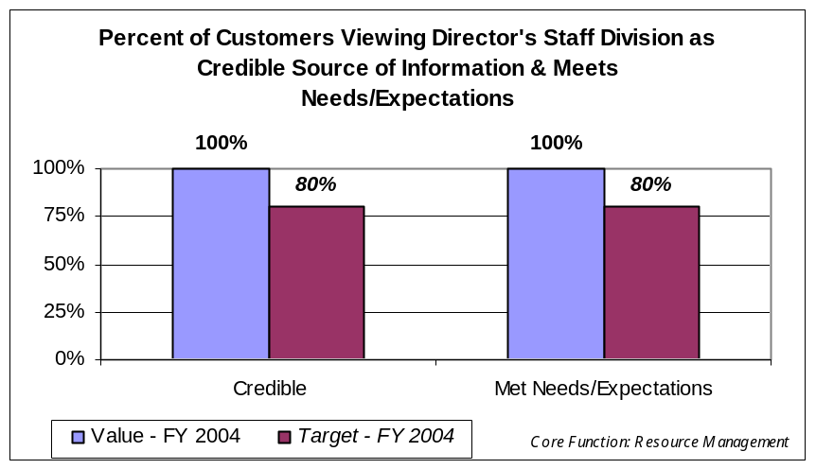
Data reliability: Data was collected from a survey of news media outlets conducted by the Office of Media and Marketing. Response rate was 56 percent. Respondents answered questions using a four-point level of agreement scale and provided comments. Results reported are for those indicating some level of agreement. Written comments supported the numerical results, providing evidence of numerical data quality. It’s important to note that this is the first time the measure has been used.
Why we are using this measure: To gather customer feedback on the degree to which the Director’s Staff Division is considered a valued information resource.
What was achieved: One hundred (100) percent of respondents agreed that the Director’s Staff Division is a credible source of information and met their needs/expectations. Feedback on meeting needs and being a credible source of information were used as indicators for being a valued information source.
Analysis of results: Sufficient customer feedback was received to determine that the Director’s Staff Division is perceived as valued information resource and that no major process or strategy changes are required.
Factors affecting results: None noted
Resources used: Internal resources (staff time and materials) were used to develop, monitor, analyze and act on the analysis findings. Work was assigned to staff as a normal daily assignment requiring no additional funds to division.

Results
Performance Measure:  Percent of customers satisfied with IT acquired equipment.  Performance Target: The current performance target is 90 percent.  Data Sources: Information Technology Division records | 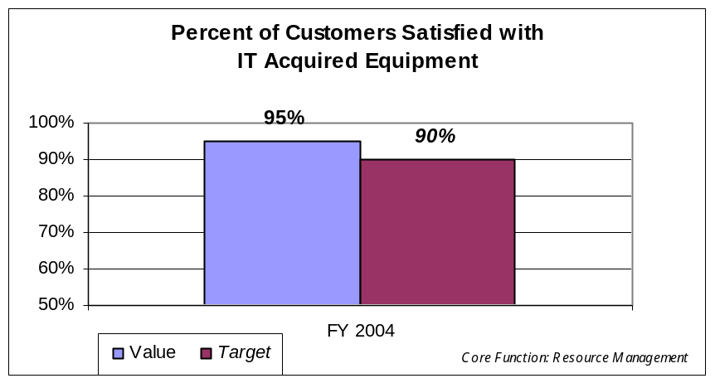
Data reliability: Data was collected from a survey sent to our customers that received new equipment during the past year. Sixty-nine (69) percent of the total number of people surveyed provided responses.
Why we are using this measure: To ensure that the automation equipment is meeting the needs of our customers.
What was achieved: Ninety-five (95) percent of the respondents agreed that the equipment being purchased is meeting their needs.
Analysis of results: Sufficient customer feedback was received to determine that the equipment that is being purchased meets the needs of our customers.
Factors affecting results: None noted
Resources used: Internal resources (staff time and materials) were used to develop, monitor, analyze and act on the analysis findings. Work was assigned to staff as a normal daily assignment requiring no additional funds to division.

Results
Performance Measure:  Percent of Road Use Tax Fund (RUTF) revenue to the Primary Road Fund (PRF) that is spent for DOT operations.  Performance Target: The current performance target is under 50 percent.  Data Sources: Operations and Finance Division records | 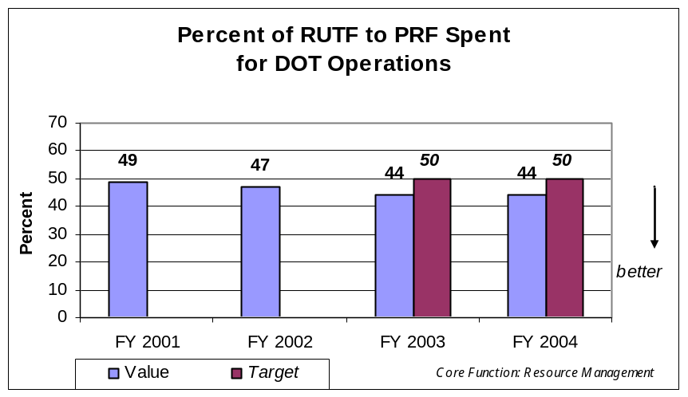
Data reliability: Data is collected from the department’s financial records and is valid and accurate.
Why we are using this measure: To monitor and control the portion of available funds that is being spent for DOT operations.
What was achieved: Forty-four (44) percent of the Road Use Tax Fund revenue that was deposited in the Primary Road Fund was spent by the department for DOT operations. The balance was invested in the highway improvement program.
Analysis of results: The department was well below the target of not more than fifty (50) percent being spent for DOT operations. This result shows that the operations budget is not consuming an increasing share of available resources and that an appropriate level of investment in the highway improvement program is being maintained.
Factors affecting results: None noted
Resources used: Internal resources (primarily staff time) were used to develop, monitor, analyze and act on the analysis findings.

Results
Performance Measure:  Percent of Employee Development and Performance Dialogues (EDPDs) current as of June 30, 2004.  Performance Target: The current performance target is 98 percent.  Data Sources: Operations and Finance Division records | 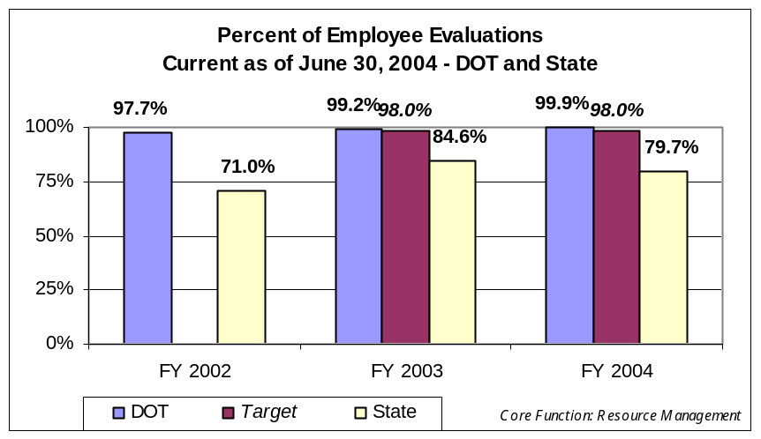

Data reliability: Data was collected by DOT and verified by DAS-HRE.
Why we are using this measure: To measure whether department management staff are effectively managing their human resources.
What was achieved: DOT has consistently exceeded its goals.
Analysis of results: The data demonstrates that managers and supervisors are consistently reviewing employee performance and providing feedback to employees.
Factors affecting results: Some performance reviews cannot be completed when the employee is on long-term leave such as sick leave, military leave, long-term disability or injury leave.
Resources used:
- Time of all employees and supervisors to perform evaluations.
- Operations and Finance Division staff time to train, monitor, record, file and report
results.

SERVICES/PRODUCTS/ACTIVITIES

Name: Information Management

Description: To manage media relations, policy programs, and Director’s Staff Division records.

Why we are doing this: The primary purpose for this SPA is to provide the citizens of Iowa and the traveling public with reliable and accurate information concerning Iowa’s transportation system.
What we're doing to achieve results: The Director’s Staff Division reviews established practices, processes and philosophies, as well as solicits feedback from customers and stakeholders to evaluate overall performance of division staff. Information learned and feedback received is used to determine what the staff should continue to do and those things that require improvement.

Results
Performance Measure:  Percent of customers that view information being disseminated as valuable, accurate and understandable.  Performance Target: The current performance target is 80 percent.  Data Sources: Director’s Staff Division records and survey results | 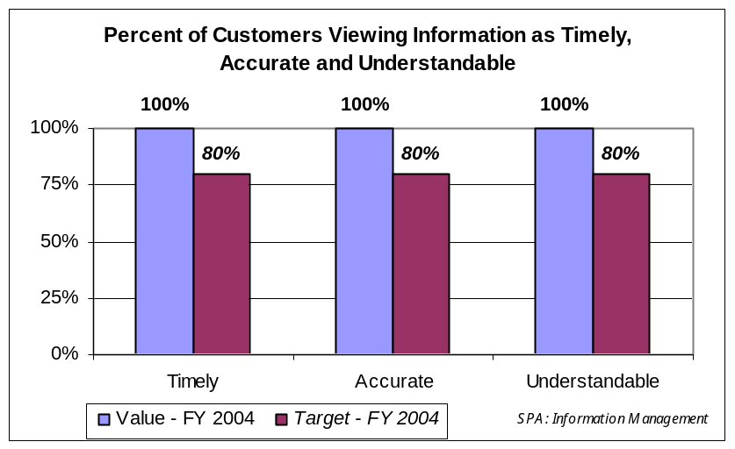
Data reliability: Data was collected from a survey of news media outlets conducted by the Office of Media and Marketing. Response rate was 56 percent. Respondents answered questions using a four-point level of agreement scale and provided comments. Results reported are for those indicating some level of agreement. Written comments supported the numerical results, providing evidence of numerical data quality. It’s important to note that this is the first time the measure has been used.
Why we are using this measure: Director’s Staff Division staff wanted to know the degree to which customers are satisfied with the dissemination of information
What was achieved: One hundred (100) percent agreed that the Director’s Staff Division disseminated information that was timely, accurate and understandable.
Analysis of results: Analysis shows the approaches and processes being used are successful in providing timely, accurate and understandable information. Timeliness was used as a substitute for value.
Factors affecting results: None noted
Resources used: Internal resources (staff time and materials) were used to develop, monitor, analyze and act on the analysis findings. Work was assigned to staff as a normal daily assignment requiring no additional funds to division.

SERVICES/PRODUCTS/ACTIVITIES

Name: Information Technology

Description: Provide automation support, application development, and radio/data/telephone infrastructures in support of transportation activities.

Why we are doing this: To effectively manage department resources so that the workforce has the resources needed to achieve their assigned duties.
What we're doing to achieve results: The department is constantly looking for ways to improve performance through customer and stakeholder feedback, analyzing performance, improving work processes and applying technology where applicable.

Results
Performance Measure:  Percent of purchases deployed within 45 days of receipt.  Performance Target: The current performance target is 85 percent.  Data Sources: Information Technology Division records | 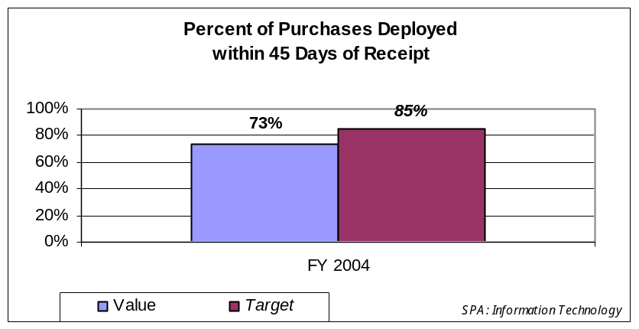
Data reliability: Data was collected from our Equipment Management System and our Purchasing System.
Why we are using this measure: To ensure that equipment is being prepared and delivered in a timely manner to our customers.
What was achieved: Seventy-three (73) percent of the equipment purchased was prepped and installed within the 45 day range.
Analysis of results: We did not achieve our goals. The DOT orders equipment for “on time” delivery. However, external emergencies cause delays in delivery of equipment to the customers. No change in process is anticipated.
Factors affecting results: The time to deploy equipment was affected by the number of critical security patches that needed to be installed and in the fall of 2003 unanticipated desktop support was required in the implementation of a new e-mail system.
Resources used: Internal resources (staff time and materials) were used to develop, monitor, analyze and act on the analysis findings. Work was assigned to staff as a normal daily assignment requiring no additional funds to division.

SERVICES/PRODUCTS/ACTIVITIES

Name: Financial/Human Resource Management

Description: Provide financial and human resource services.

Why we are doing this: To effectively manage the department’s financial resources in order to maximize the use of available highway program funds.
What we're doing to achieve results: The department reviews program resource needs on a monthly basis so that needed adjustments can be made.

Results
Performance Measure:  Percent of cash flow resources borrowed from internal funds.  Performance Target: The current performance target is under 10 percent.  Data Sources: Operations and Finance Division records | 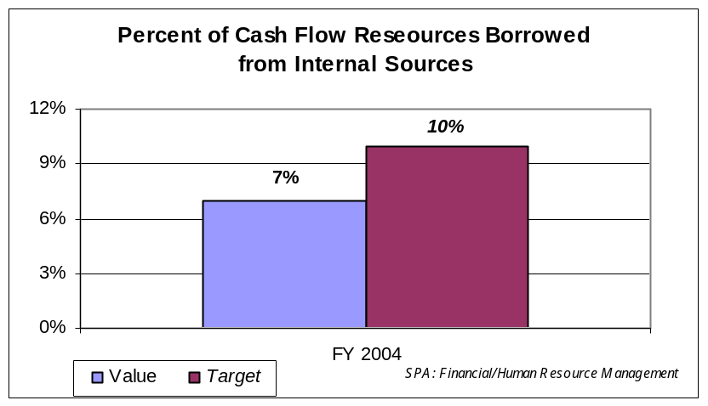
Data reliability: Data is collected from the department’s financial records and is valid and accurate.
Why we are using this measure: To monitor resource availability so that highway program cash flow needs are met.
What was achieved: Seven (7) percent of the cash flow resources were borrowed from internal funds.
Analysis of results: The department met the performance target of borrowing under 10 percent of the total cash flow resources from internal funds.
Factors affecting results: None noted
Resources used: Internal resources (primarily staff time) were used to develop, monitor, analyze and act on the analysis findings.

Results
Performance Measure:  Percent of classification requests (single position requests that do not require class studies or class description changes) analyzed and a report of the classification analysis and recommendation sent to appropriate division director within 30 calendar days of receipt of a complete (all request requirements satisfactorily met) request.  Performance Target: The current performance target is 90 percent.  Data Sources: Operations and Finance Division record. | 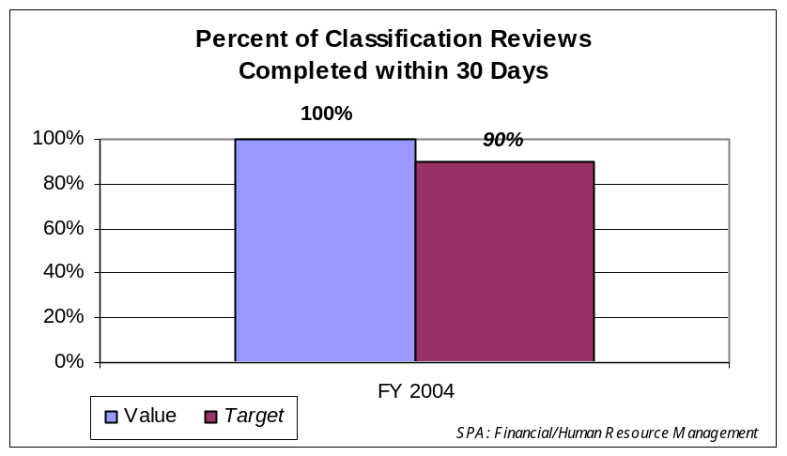
Data reliability: Data provided by the Operations and Finance Division. Data was reported to and reviewed by the DOT Management Team.
Why we are using this measure: This data measures whether requests for position classification reviews are being completed in a timely manner.
What was achieved: One hundred (100) percent of the reviews completed in FY 2004 met the 30-day standard.
Analysis of results: The current process is providing the desired results. Operations and Finance Division staff exceeded the 90 percent targeted rate.
Factors affecting results: No process or qualitative deficiencies are indicated.
Resources used: Operations and Finance staff

Results
Performance Measure:  Percent of diversity action plan developed in detail and ready for implementation by December 31, 2004.  Performance Target: The current performance target is 95 percent.  Data Sources: Operations and Finance Division records | 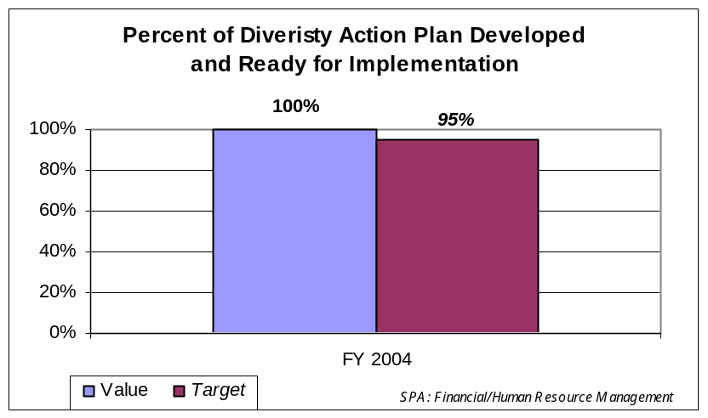
Data reliability: Data is provided by the Operations and Finance Division and reviewed by the DOT Management Team.
Why we are using this measure: To monitor progress of development of a plan to enhance awareness and value of a diverse work force.
What was achieved: One hundred (100) percent of the plan was developed by the target date.
Analysis of results: The Operations and Finance Division exceeded the targeted goal.
Factors affecting results: No significant process flaws were apparent in the planning process.
Resources used: Operations and Finance Division staff

CORE FUNCTION

Name: Transportation Systems

Description: Build and maintain Iowa’s transportation systems to ensure public safety and to meet the various needs of Iowans. Transportation systems include the following key activities: highway maintenance, construction, planning, design and research; rail; water; transit; and air transportation systems.

Why we are doing this: Transportation systems are the key element of the department’s mission to “advocate and deliver transportation services that support the economic, environmental and social vitality of Iowa.”
What we're doing to achieve results: The department continually monitors multiple performance measures to assure that Iowans are provided a safe and efficient multi-modal transportation system. By monitoring these measures the department can shift emphasis as needed to meet goals and objectives.

Results
Performance Measure:  Percent of highway miles that meet or exceed a sufficiency rating of tolerable or above.  Performance Target: The current performance target is 75 percent.  Data Sources: Department records | 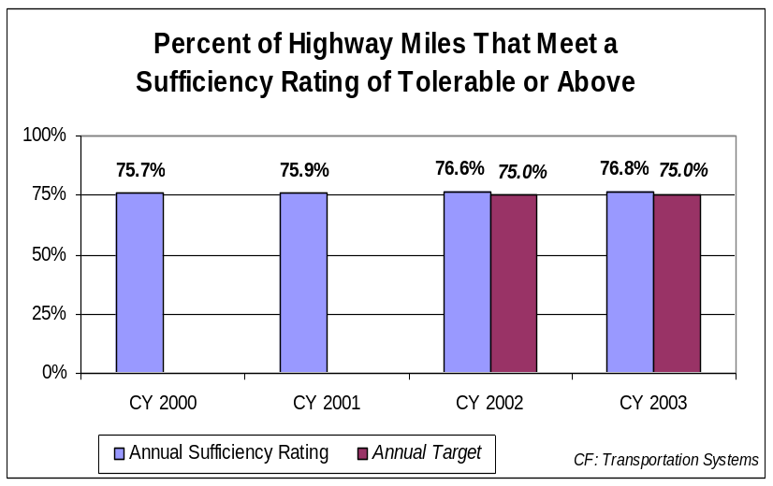
Data reliability: The calculation of sufficiency ratings is an objective process and is based on an analysis of many variables including pavement condition, traffic, crash history and pavement geometrics. All data is collected in a uniform and objective manner.
Why we are using this measure: The sufficiency rating is a measure that quantifies the ability of a highway segment to safely carry the volume of traffic on that highway. The rating takes into account the condition of the highway, highway geometrics, crash history, volume of traffic, and other factors that effect the operation of the highway. Because this rating evaluates the overall operation of the highway it is an important tool for the department to monitor the conditions of the entire highway network over time. It is also used as a tool to identify segments of highway that may be in need of improvement.
What was achieved: A total of 76.8 percent of highways meet or exceed a sufficiency rating of tolerable or above. This exceeds the target of 75 percent.
Analysis of results: Iowa’s highways continue to exceed the target for highway condition. Continuing the trend of recent years, the percent of highway miles that meet a sufficiency rating of tolerable or above has increased.
Factors affecting results: Changes in traffic from year to year along with crash history can have an impact on the sufficiency ratings.
Resources used: Department records of traffic, crashes, pavement condition, and pavement geometrics

Results
Performance Measure:  Percent of counties that have adequate access to rail, aviation and transit transportation options.  Performance Target: The current performance target is 100 percent.  Data Sources: Department records | 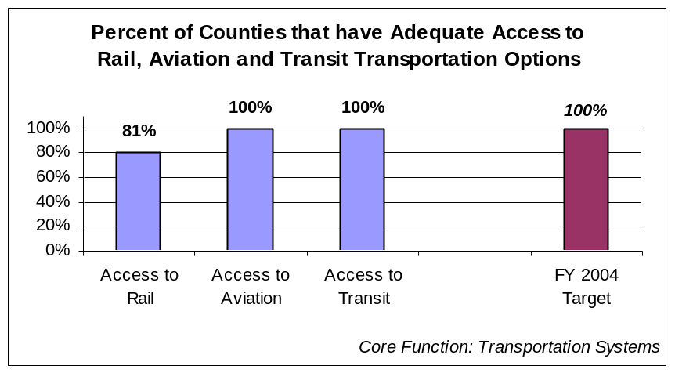
Data reliability: The data reliability is described for each mode under the SPA performance measures for Modal/Planning Functions Management.
Why we are using this measure: Access to the State’s multi-modal transportation system is a key component of the department’s mission to “support the economic, environmental and social vitality of Iowa.”
What was achieved: Eighty (80) of Iowa’s 99 counties of have adequate access to rail, aviation, and transit transportation options as defined by the department.
Analysis of results: All Iowa counties have adequate access to aviation and transit transportation options, but not all have adequate access to rail services.
Factors affecting results: None noted
Resources used: Department records and maps

SERVICES/PRODUCTS/ACTIVITIES

Name: Highway Management

Description: Develop, design, construct, and maintain state roadways and bridges.

Why we are doing this: These measures assure the department and all Iowans of the care and effective response we give to the highway system.
What we're doing to achieve results: In addition to establishing effective schedules and maintaining a very qualified staff, the Highway Division uses several reporting mechanisms to measure our performance.

Results
Performance Measure:  The overall annual percent of all districts’ A and B highway miles returned to a reasonable, near-normal surface condition within 24 hours from the end of a winter storm.  Performance Target: The current performance target is 95 percent.  Data Sources: Highway Division records | 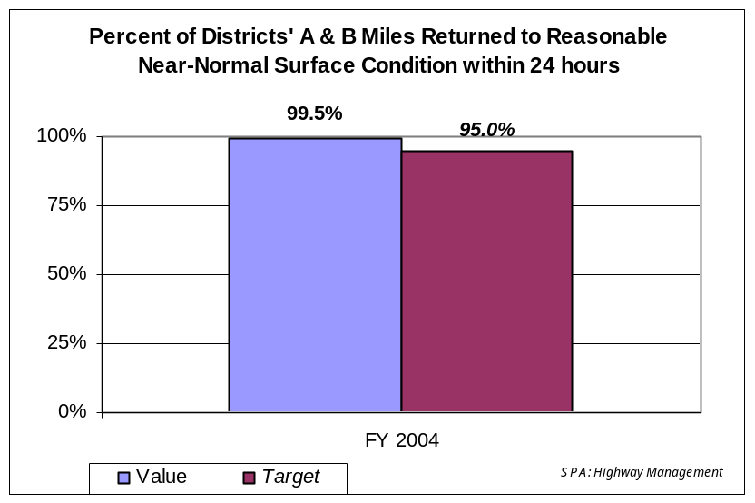
Data reliability: Data is collected from each state maintenance garage through an online daily report and analyzed centrally for compilation of statewide status. The data gathered is compared to an accepted set of standards for reporting winter maintenance activities.
Why we are using this measure: This measure indicates the effectiveness of winter maintenance operations in restoring near-normal roadway travel conditions after the conclusion of a winter storm. Maintaining roadway surface conditions during and immediately after severe winter weather promotes safe driving conditions and minimizes disruptions in commerce.
What was achieved: The department exceeded its goal by returning approximately 15,000 lane miles of A-B level roadways to a reasonable, near-normal condition within 24 hours of the end of the storm for all storms during the winter reporting period.
Analysis of results: There are many variables associated with winter storms that make measurement of maintenance effectiveness a challenge. After each winter season, the data reporting system is reviewed to determine if changes are needed to improve reporting accuracy. Based on results reported, resources and procedures were appropriate to achieve standards for the 2003-2004 winter period.
Factors affecting results: The end of a winter storm is defined as, "when precipitation no longer accumulates on the roadway surface.” This definition provides for situations where snow has stopped, but strong winds cause drifting or refreezing as snow continues to accumulate on the roadway surface. Situations such as freezing rain or ice and extremely cold temperatures can impede restoring roads to reasonable near-normal conditions.
Resources used: This measurement is part of the reporting system developed by the Highway Division and the maintenance staff statewide. No additional staff hours are needed to compile and report the data.

Results
Performance Measure:  The overall annual percent of all districts’ C and D highway miles returned to a reasonable, near-normal surface condition within three working days from the end of a winter storm.  Performance Target: The current performance target is 85 percent.  Data Sources: Highway Division records | 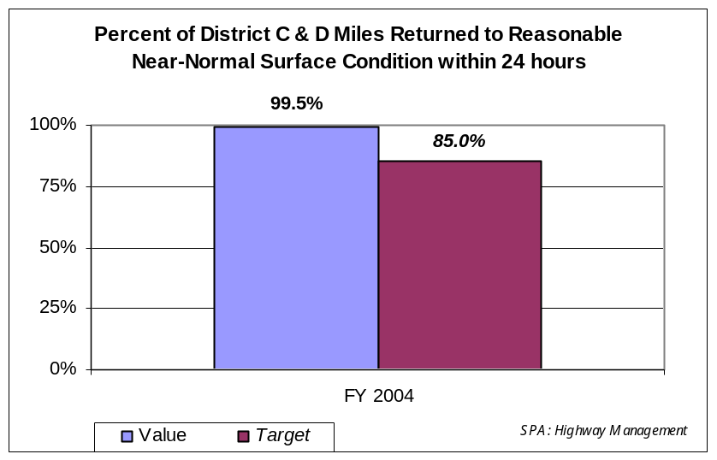
Data reliability: Data is collected from each state maintenance garage through an online daily report and analyzed centrally for compilation of statewide status. The data gathered is compared to an accepted set of standards for reporting winter maintenance activities.
Why we are using this measure: This measure indicates the effectiveness of winter maintenance operations in restoring near-normal roadway travel conditions after the conclusion of a winter storm. Maintaining roadway surface conditions during and immediately after severe winter weather promotes safe driving conditions and minimizes disruptions in commerce.
What was achieved: The department exceeded its goal by returning approximately 9,400 lane miles of C-D level roadways to a reasonable, near-normal condition within three working days of the end of the storm for all storms during the winter reporting period.
Analysis of results: There are many variables associated with winter storms that make measurement of maintenance effectiveness a challenge. After each winter season, the data reporting system is reviewed to determine if changes are needed to improve reporting accuracy. Based on results reported, resources and procedures were appropriate to achieve standards for the 2003-2004 winter period.
Factors affecting results: The end of a winter storm is defined as, "when precipitation no longer accumulates on the roadway surface.” This definition provides for situations where snow has stopped, but strong winds cause drifting or refreezing as snow continues to accumulate on the roadway surface. Situations such as freezing rain or ice and extremely cold temperatures can impede restoring roads to reasonable near-normal conditions.
Resources used: This measurement is part of the reporting system developed by the Highway Division and the maintenance staff statewide. No additional staff hours are needed to compile and report the data.

Results
Performance Measure:  Percent of projects where the project cost is less than or equal to the program estimate.  Performance Target: The current performance target is 85 percent.  Data Sources: Highway Division records | 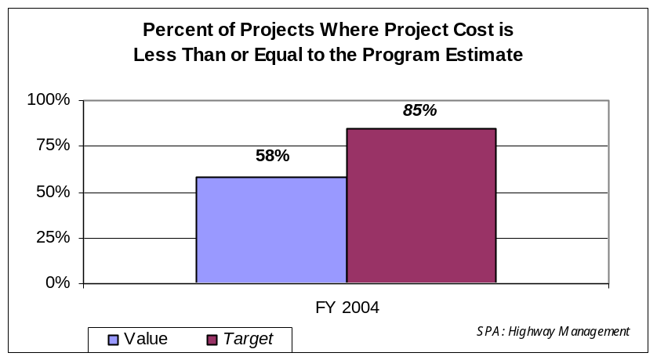
Data reliability: The data for this measure comes from project planning estimates developed by the department against project costs for all projects within the annual highway program. Since this measure compares the number of projects without regard to an acceptable range of deviation, the measure is difficult to meet. (A project off $15,000 on a $3,000,000 total program is counted the same as one that’s off $200,000 on a $10,000,000 project. A project can be “off” either high or low and count toward not meeting this goal.)
Why we are using this measure: This measure allows for the monitoring of how often and over what types of projects the project planning estimate differs with bids received.
What was achieved: Fifty-eight (58) percent of the projects let out for bid in FY 2004 had project costs less than or equal to the project planning cost estimate.
Analysis of results: All projects cannot be assessed equally as there is too much variation in scope, size and complexity among them. As a result this measure will need to be examined in more detail so it can be retooled to be more representative of the broader issues. It should be noted that this was our first year in formally reporting this measure.
Factors affecting results: This measure compares the number of individual projects without regard to an acceptable range of deviation. (A project off $15,000 on a $3,000,000 total program -- .5 percent -- is counted the same as one that’s off $200,000 on a $10,000,000 project – 4 percent. A project can be “off” either high or low and count toward not meeting this goal.) Thus, several projects that are “off” by tenths of a percent receive the same weight as projects that may be “off” by whole percents.
Resources used: Existing data and existing staff are used to compile and report this data. No extra time or resources are used.

Results
Performance Measure:  Ratio of annual program cost versus annual program cost estimate.  Performance Target: The current performance target is 95 percent to 105 percent.  Data Sources: Highway Division records | 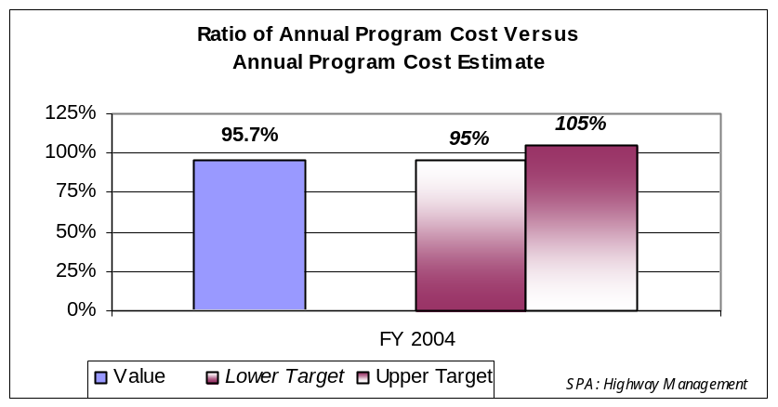

Data reliability: Data for this measure compares project planning estimates developed by the department against project costs for all projects within the annual highway program. Since this measure compares the total dollar costs for all projects, the measure is a tool that helps the department manage the total annual highway program.
Why we are using this measure: This measure provides a method to analyze performance in establishing sound planning estimates for projects contained within the annual highway program.
What was achieved: The total project cost for the year was 95.7 percent of the total program estimate.
Analysis of results: Good competition among contractors bidding on state highway construction work has resulted in favorable prices for the type and level of work engaged in for this annual period.
Factors affecting results: The economy, level of bidding competition, project scope, and size of individual projects are items that can influence how sound planning estimates are for the annual highway program.
Resources used: Existing data and existing staff are used to compile and report this data. No extra time or resources are used.

Results
Performance Measure:  Percent of reduction for “single vehicle run off the road crashes” on roads with newly paved shoulders per HMVMT.  Performance Target: The current performance target is 10 percent.  Data Sources: Highway Division records | 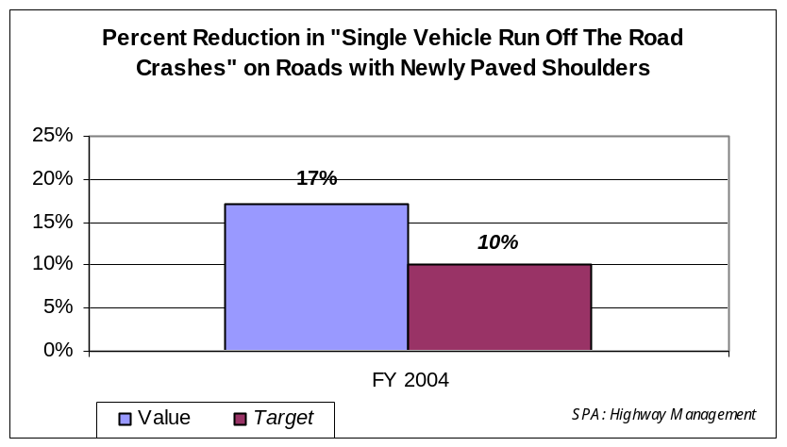
Data reliability: The data for this measure comes from the FY 2002 and FY 2003 crash data for the specific segments of road having the new shoulders.
Why we are using this measure: The measure will help demonstrate the safety benefits of providing additional miles of paved shoulders on state highways.
What was achieved: The target was a 10 percent reduction in “run off the road” (ROR) crashes per hundred million vehicle miles traveled (HMVMT) on routes with newly paved shoulders. The performance was a 17 percent reduction in crashes per HMVMT.
Analysis of results: The results were consistent with experiences in other states. The department will continue to increase the road miles that have paved shoulders.
Factors affecting results: Many factors influence ROR crashes (i.e., weather, visibility, driver condition, driver error). Paved shoulders give drivers extra time to recover regardless of the cause.
Resources used: New reporting mechanisms were used to generate the data and report. However, the new information was designed and obtained using regular work modes and resources.

SERVICES/PRODUCTS/ACTIVITIES

Name: Modal/Planning Functions Management

Description: Manage transportation grant programs and develop long-range plans and five-year transportation improvement programs.

Why we are doing this: The purpose of this SPA is to assure the citizens of Iowa have adequate access to a high-quality multi-modal transportation system.
What we're doing to achieve results: The Planning & Programming Division and the Modal Division continually monitor the performance of the multi-modal transportation system and the level of access the citizens of Iowa have to these systems. As part of that monitoring system is a feedback process to identify areas that require additional emphasis.

Results
Performance Measure:  Percent of counties that have adequate access to rail services.  Performance Target: The current performance target is 100 percent  Data Sources: Department records | 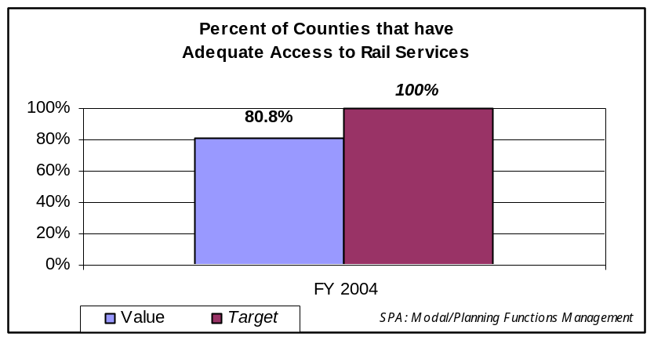
Data reliability: The Department maintains maps showing all intermodal yards in the Midwest. Using Geographic Information Systems (GIS), the department is able to identify which counties have adequate physical access to intermodal yards. As defined by the department this measure is easily measurable and objective.
Why we are using this measure: Access to the State’s multi-modal transportation system is a key component of the department’s mission to “support the economic, environmental and social vitality of Iowa.”
What was achieved: Eighty-one (81) percent of Iowa’s counties have adequate physical access to intermodal yards as defined by the department.
Analysis of results: While the majority of counties have adequate physical access to rail services this is short of the performance target of 100 percent. Additional efforts to encourage expanded rail services will be required.
Factors affecting results: None noted
Resources used: Department records and maps

Results
Performance Measure:  Percent of counties that have adequate access to aviation services.  Performance Target: The current performance target is 100 percent.  Data Sources: Department records | 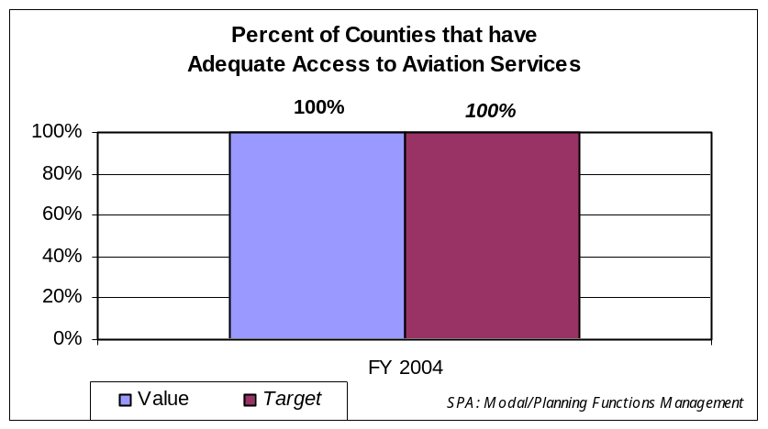
Data reliability: The department maintains maps showing all commercial and general aviation airports in the State. Using Geographic Information Systems, the drive time to each airport can be calculated to determine area coverage. As defined by the department this measure is easily measurable and objective.
Why we are using this measure: Access to the State’s multi-modal transportation system is a key component of the department’s mission to “support the economic, environmental and social vitality of Iowa.”
What was achieved: All 99 counties of Iowa have adequate access to aviation services as defined by the department.
Analysis of results: Iowa has adequate access to aviation services.
Factors affecting results: None noted
Resources used: Department records and maps

Results
Performance Measure:  Percent of counties that have adequate access to transit services.  Performance Target: The current performance target is 100 percent.  Data Sources: Department records | 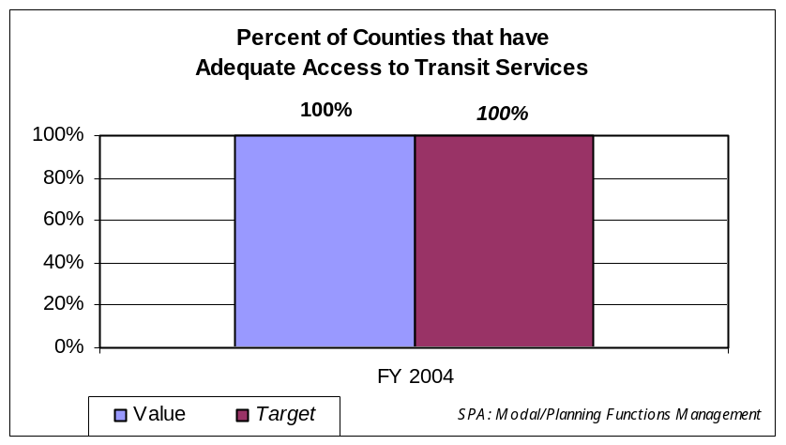
Data reliability: The department works with all transit agencies in Iowa and understands and monitors the services they provide.
Why we are using this measure: Access to the State’s multi-modal transportation system is a key component of the department’s mission to “support the economic, environmental and social vitality of Iowa.”
What was achieved: All 99 counties of Iowa have adequate access to transit services as defined by the department.
Analysis of results: Iowa has adequate access to transit services.
Factors affecting results: None noted
Resources used: Department records

RESOURCE REALLOCATIONS

Outside of reallocations of staff and funding mentioned in summaries of individual measures, there were no major reallocations with the DOT during the 2004 state fiscal year.

AGENCY CONTACTS

Copies of Iowa Department of Transportation’s Performance Report are available on the DOM Web site at www.dom.state.ia.us/planning_peformance/plans.html. Copies of the report can also be obtained by contacting Mary Christy at 515-239-1731.

Iowa Department of Transportation
Director’s Staff Division
Attn: Mary Christy
800 Lincoln Way
Ames, IA 50100

