

AGENCY
PERFORMANCE

REPORT

Fiscal Year 2004

TABLE OF CONTENTS

SECTION | PAGE
INTRODUCTION |  | 4
AGENCY OVERVIEW ………………………………………………………………. |  | 5
STRATEGIC PLAN RESULTS |  | 8
Goal 1…………………………………………………………………. |  | 8
Goal 2…………………………………………………………………. |  | 9
Goal 3…………………………………………………………………. |  | 10
Goal 4…………………………………………………………………. |  | 10
Goal 5…………………………………………………………………. |  | 11
Goal 6…………………………………………………………………. |  | 12
Further Results………………………………………………………. |  | 12
PERFORMANCE PLAN RESULTS |  | 16
Core Function – Adjudication/Dispute Resolution |  | 16
SPA – Administrative Hearings |  | 20
SPA – Unemployment Insurance Appeals |  | 23
SPA – OSHA/Contractor Registration Appeals |  | 24
Core Function – Advocacy |  | 26
SPA – Court-Appointed Special Advocate |  | 28
SPA – Local Citizen Foster Care Review Board |  | 30
Core Function – Legal Representation |  | 33
SPA – Public Defender Services |  | 39
SPA – Indigent Defense Claims |  | 39
Core Function – Regulation & Compliance |  | 40
SPA – Compliance & Licensing |  | 49
SPA – Social & Charitable Gambling Enforcement |  | 50
SPA – Targeted Small Business Certification |  | 52
SPA – Food and Consumer Safety |  | 53
SPA – Long-term care and Habilitation facilities and programs  licensing/certification |  | 55
SPA – Elder Group Homes, Assisted Living Program, and Adult Day Services  Program Certification |  | 59
SPA – Investigation Services |  | 62
SPA – Collections Services |  | 64
SPA – Audit Services |  | 64
Core Function – Resource Management |  | 65

RESOURCES REALLOCATIONS | 66

AGENCY CONTACTS | 67

INTRODUCTION

I am pleased to present the FY04 (July 1, 2003 – June 30, 2004) performance report for the Iowa Department of Inspections and Appeals (DIA). This report is published to provide department employees, the Governor, the legislature, and citizens with information about the challenges and accomplishments of the department during FY04.

The biggest key strategic challenge facing the agency is continuing to deliver timely and accurate services that are critical to our mission with reduced human and financial resources.

Another key strategic challenge is to identify ways to improve collaboration and communication with internal and external customers and stakeholders to accomplish our mission and vision.

Major accomplishments during FY04 include:

• 73.9% of the permanency planning case-specific or systems findings and recommendations made by the Child Advocacy Board were implemented.

• 100% of DHS appeal decisions were issued by the Administrative Hearings Division within the required timeframes.

• 99% of unemployment decisions by the Employment Appeal Board (EAB) were issued within 75 days.

• 95% of decisions by the EAB related to OSHA cases were not appealed to district court.

• 99.99% of the cases handled by the State Public Defender system had no final findings of ineffective counsel.

• 99.7% of challenged indigent defense claims were upheld upon final judicial review.

• 93% of the racing animals were inspected for health and fitness prior to a race under the jurisdiction of the Racing and Gaming Commission.

• $2.1 million in pubic assistance overpayments was collected by the Investigations Division.

• 127% of all health care facilities were timely audited by the Investigations Division.

We invite all citizens and our customers and stakeholders to join with us to protect the public interests and integrity of executive branch programs.

Respectfully submitted,

Steven K. Young
Director

AGENCY OVERVIEW

The Department of Inspections and Appeals (DIA) is a diverse regulatory agency established to protect the public through the enforcement of state and federal laws.

The services, products and activities of DIA relate to five core functions: Adjudication/Dispute Resolution; Advocacy; Legal Representation; Regulation and Compliance; and Resource Management.

Our Vision is to be “a diverse agency of dedicated employees who are respectful, accountable and responsive to the citizens of Iowa.”

Our Mission is to “administer and enforce state and federal laws to provide for the protection of the public interests and ensure program integrity to programs and services administered by the executive branch.”

Eight principles guide us in upholding the law through:

• Service Focus
• Proactivity in All We Do
• Employee Involvement
• Collaborative Leadership
• Decisions Based on Data
• Continuous Improvement
• Ensuring Program Integrity
• Protecting Those We Serve

DIA consists of four operating divisions and five attached units.

• The Administrative Division provides essential, centralized fiscal and administrative services, such as budget preparation, accounts payable and receivable, personnel, public information, purchasing, lease and vehicle management, legislative affairs, strategic and performance planning, and legal counsel.

The Division regulates social and charitable gambling activities to protect the public from incidence of fraudulent or illegal activities and certifies targeted small businesses for eligibility of state loans and procurement opportunities.

The Division provides for the conduct, either through state inspectors or contracts with local boards of health, food safety inspections at restaurants, grocery stores, food processing plants, egg handlers, and vending machines, and sanitation inspections of barber and cosmetology shops and hotels and motels to ensure Iowans receive safe and wholesome foods and clean service.

The Director enters into and implements agreements or compacts between the State of Iowa and Indian tribes to operate Indian gaming establishments in accordance with federal law.

• The Administrative Hearings Division affords citizens with due process for adverse actions taken by state agencies. The Division conducts quasi-judicial contested case hearings involving Iowans who disagree with an administrative ruling issued by a state government agency. The division issues a proposed decision subject to final review by the director of the agency involved in the contested case proceeding. During FY04, nearly 11,000 hearings were held. Nearly two-thirds of all administrative hearings conducted by the Division involve Iowans who have had their driver’s license revoked or suspended by the Iowa Department of Transportation.

• The Health Facilities Division enhances the safety, security and general welfare of the persons served in over 1,800 licensed/certified facilities and programs. The Division inspects/monitors, licenses and/or certifies under the Medicare and Medicaid Programs health care providers and suppliers, which includes long-term care facilities, hospitals, hospices, end-stage renal disease units, rural health clinics, elder group homes, assisted living programs, adult day services programs and child-placing agencies.

The Division also provides staff for the Hospital Licensing Board, which consults with and advises the Division in matters of policy affecting hospital administration, including reviewing and approving rules and standards prior to adoption.

• The Investigations Division works to ensure misspent public assistance moneys obtained through fraud, inadvertent error, or agency error are identified and collected so that only eligible applicants receive public assistance moneys in the appropriate amounts. The Division also provides necessary and timely information so the Department of Public Health may appropriately address professional licensing complaints. In addition, the Division ensures compliance with applicable federal and state financial requirements by DHS offices and health care facilities. The Division conducts front-end, fraud, dependent adult abuse and divestiture investigations related to welfare programs, financial audits in local DHS offices and health care facilities, and professional licensing complaint investigations, and initiates recovery actions to recoup public assistance and audit overpayments.

• The Child Advocacy Board works to ensure effective permanency planning for all children in out of home placement through advocacy. The Board accomplishes this purpose through local citizen foster care review boards, foster care registry and the Court Appointed Special Advocate volunteer program. In addition, the Board makes recommendations to the Governor, Legislature, Supreme Court, and chief judge of each judicial district, Department of Human Services, and child-placing agencies on ways to improve the delivery of foster care services and how to remove barriers that prevent the delivery of top-quality foster care.

• The Employment Appeal Board timely adjudicates the rights and duties of workers and employers under unemployment insurance laws and final resolution of contested OSHA and contractor registration violations and personnel-related cases. The Board serves as the final administrative law forum for unemployment benefit appeals. The Board also hears appeals of rulings of the Occupational Safety and Health Administration (OSHA), ruling of the Department of Administrative Services on state employee job classifications, rulings of the Iowa Public Employees Retirement System (IPERS), appeals involving peace officer issues, elevator rule violations, and contractor registration requirements.

• The Racing and Gaming Commission works to protect the public from incidence of fraudulent or illegal activities at pari-mutuel racetracks and excursion boat gambling and to protect the health and welfare of the racing animals. The Commission licenses eligible applicants and sets and enforces standards for the licensing of industry occupations and for the operation of all racetracks and excursion gambling boats.

• The State Public Defender provides high-quality and cost-efficient legal representation to indigent clients in state criminal court, juvenile court, and other proceedings as required by law in those areas of the state where local public defenders exist. The provision of legal services to indigent clients is constitutionally mandated. In Iowa, these services are provided through a combined system of local public defenders and private attorneys. The State Public Defender also has jurisdiction over the Indigent Defense Fund, which provide funds to pay for indigent defense and ancillary services provided by private and contract attorneys and miscellaneous vendors, such as expert witnesses and court reporters. Indigent defense services are constitutionally mandated, which requires these services to be paid by the state. The Indigent Defense Fund pays for those indigent services not covered by local public defenders.

DIA customers and stakeholders include state agencies; municipal corporations; citizens (adults and children); federal government agencies, consumer of elder group homes, assisted living programs, adult day services programs, health care facilities, and health care providers; licensees; industry and advocacy associations; targeted small businesses; businesses; unemployed persons; indigent persons; attorneys; law enforcement, legislature; and court system.

STRATEGIC PLAN RESULTS

STRATEGIC PLAN

Key Strategic Challenges and Opportunities:
The protection of the public interests and executive branch program integrity is the key result of the mission of the Department of Inspections and Appeals (DIA). Accomplishing that result is challenged by the ability to continue to deliver timely and accurate services with reduced human and financial resources and to overcome the negative perception of our regulatory and oversight role.

To address these strategic challenges, DIA established six long-term goals and associated key strategies:

Goal #1: Achieve the highest possible voluntary compliance of statutes, rules and regulations.

Strategies:
1.1 Partner with communities, other state agencies, and the court system to
ensure children in foster care have comprehensive permanency plans.

1.2 Conduct all required financial audits at nursing facilities, residential care
facilities and local Department of Human Services offices within
applicable timeframes.

1.3 Establish a comprehensive training and education program to enhance
the ability of licensed health care facilities comply with all applicable
statutes, rules and regulations.

1.4 Ensure all health care facilities and providers are adequately, accurately,
and timely inspected and investigated for compliance with federal and
state regulations.

1.5 Strengthen the food and consumer safety bureau’s compliance and
enforcement program.

1.6 Partner with the Division of Criminal Investigation and the Alcoholic
Beverages Division to inspect social gambling locations and non-
licensed beer or liquor establishments for illegal gambling.

1.7 Increase public awareness of Targeted Small Business Certification
program eligibility standards.

1.8 Collaborate with other entities in the conduct of investigations and audits
to expedite the resolution of cases, initiate the recovery of program
dollars, and encourage compliance.

1.9 Develop processes to improve exchange of information between the
Racing and Gaming Commission and licensees.

Goal # 2: Enhance the provision of education, information and assistance to our customers, the public, law enforcement and other state agencies.

Strategies:
2.1 Expand the utilization of the best practices program to areas of licensing
beyond long-term care

2.2 Educate current licensee and potential applicants regarding permissible
and impermissible gambling activities.

2.3 Promote increased participation in the Iowa Food Safety Task Force by
industry, state agencies, academia and consumers.

2.4 Educate and update customers and potential applicants quarterly
regarding Targeted Small Business programs and eligibility standards in
collaboration with the Departments of Economic Development and
Personnel.

2.5 Provide training to Nursing Facilities and Residential Care Facilities in
creating, updating or changing bookkeeping systems that will meet
standards for generally accepted accounting procedures.

2.6 Providing training and information to the general public, service
organizations, educational institutions, state agencies and law
enforcement agencies on ways to detect fraud and abuse or the intent of
the investigative programs.

  - Expedite and improve the processing time required for the claim establishment and collection process.

2.8 Enhance the training curriculum for the claims establishment and
collections process in collaboration with the Department of Human
Services.

Goal # 3: Increase customer satisfaction and enhance the public image of the department.

Strategies:
3.1 Disseminate the results of the Health Facilities Division “Survey
Satisfaction Questionnaire” on a quarterly basis.

3.2 Establish caseload performance and quality representation expectations
for the SPD System and public defender field offices.

3.3 Maintain a process for the review and adjudication of indigent defense
claims that produces correct results within a reasonable time.

3.4 Allow social and charitable gambling license applicants to pay for license
application fees using credit cards.

3.5 Process and manage indigent defense claims more efficiently in
accordance with statute and State Public Defender rules.

3.6 Enhance public awareness relative to the accomplishments of the
department.

3.7 Conduct special investigative operations with planned media coverage.

3.8 Assess customer needs to further develop information distributed
through the Racing and Gaming Commission website.

Goal # 4: Create a work environment that enhances job satisfaction, customer service, process improvement, and public accountability.

Strategies:
4.1 Establish detailed performance measures that go beyond the reporting
expectations of the Centers for Medicare and Medicaid Services (CMS).

4.2 Maintain economic efficiency of indigent defense programs by
maximizing use of public defender resources while maintain quality
representation.

4.3 Ensure accuracy of collections entered on the overpayment recovery
system to generate collections statistics.

4.4 Operate within FDA’s established limits for the workload ratios for
inspector/inspections.

4.5 Establish recruitment, training, and mentoring programs to enhance
visibly the quality and effectiveness of State Public Defender personnel.

4.6 Develop processes to improve exchange of information and resources
throughout the State Public Defender system, thereby enhancing
performance and customer satisfaction.

  - Increase cooperation with other state, local and federal law enforcement
agencies to maximize program results.

4.8 Expand quality of the investigative process beyond state and federal
minimum requirements for division operations.

4.9 Increase the time for identification of claims that need to be purged as
not collectable.

4.10 Ensure Racing and Gaming Commission employees have the
knowledge to carry out job duties.

4.11 Develop a process for Racing and Gaming Commission employees to
make suggestion for improvement of current procedures.

Goal # 5: Maximize the use of information technology resources to increase the efficiency and effectiveness of the department.

Strategies:
5.1 Establish an electronic license request and renewal capability for all
licenses issued and monitored by the Health Facilities Division.

5.2 Provide electronic access to case file information by ALJs and support
staff.

5.3 Improve electronic access to records, such as licensee applications,
reports, and correspondence in order to provide an immediate response
to inquiries from licensees, general public, and stakeholders.

5.4 Implement an electronic food safety inspection process for state
inspectors.

5.5 Enhance technology support within the overpayment recovery system so
that internal processes are streamlined and the necessary data is
available for reports for internal use, the legislature, news media and
others as requested.

5.6 Implement an electronic web-based certification system for Targeted
Small Business.

5.7 Refine the intranet Information Resource Guide for Racing and Gaming
Commission staff.

5.8 Develop on-line licensing for Racing and Gaming Commission licensees.

5.9 Design Racing and Gaming Commission technology systems to improve
licensee compliance tracking and exchange of information with other
jurisdictions.

Goal #6: Enhance the provision of adjudication/dispute resolution services through timely issuance of decisions.

Strategies:
6.1 Develop procedures to ensure contested case hearings are scheduled
within seven days of receipt and ALJ decisions are issued within 30 days
of closing the record.

6.2 Enforce mandatory compliance by ALJs with Code of Administrative
Judicial Conduct.

6.3 Address workload issues through technology and temporary staffing.

6.4 Communicate importance of timeliness standards with staff.

Results: The results for the performance measures identified for all the goals are reported in the performance plan results sections of this report.

Additional special-identified results related to implementation of strategies follows:

1.9 Develop processes to improve exchange of information between the
Racing and Gaming Commission and licensees – The Commission
administrator meets annually with each licensed facility general manager.
Commission staff meets periodically with the Iowa Gaming Association on
specific issues of interest to the licensees.

3.1 Disseminate the results of the Health Facilities Division “Survey Satisfaction
Questionnaire” on a quarterly basis – The Iowa Foundation for Medical Care
tabulates all responses to the “Questionnaire” and reports the results to the
Health Facilities Division on a monthly basis. The information is used to
report ratings for the agency’s performance plan and provided to
consumers and stakeholders upon request. The information is also used in
evaluating the performance of employees and developing strategies to
improve customer service.

3.2 Establish caseload performance and quality representation expectations
for the SPD System and public defender field offices – The caseload
expectation of 70,000 cases was exceeded by 2% for a total of 71,118
cases handled. High quality representation was evident as a result of less
than .01% of the cases having a finding of ineffective assistance of counsel
(6 of 71,118 cases).

3.3 Maintain a process for the review and adjudication of indigent defense
claims that produces correct results within a reasonable time – Judges
upheld disputed SPD actions reducing claims 99.7% of the time.

3.9 Assess customer needs to further develop information distributed
through the Racing and Gaming Commission website – The Commission
conducted an assessment of customer needs, resulting in referendum
history information, pertinent studies and riverboat license application forms
being added to their website.

4.2 Maintain economic efficiency of indigent defense programs by
maximizing use of public defender resources while maintain quality
representation – The reallocation of resources to Muscatine to have public
defenders take high cost cases in the 7th Judicial District, many trial victories
and less than .01% of the cases with a finding of ineffective counsel, resulted
in 1,118 more cases being taken by public defenders than expected and the
cost per case being reduced.

4.5 Establish recruitment, training, and mentoring programs to enhance visibly
the quality and effectiveness of State Public Defender (SPD) personnel –
SPD either supported or sponsored various Continuing Legal Education
(CLE) programs. The CLE credit cost for all attending attorneys at the Public
Defender Association criminal law seminar was paid by SPD. The SPD
sponsored the statewide ICN forensic science seminar for PDs, plus anyone
else who wanted to attend. SPD and First Assistant SPD gave
presentations to local CLE programs. SPD obtained National Institute for
Trial Advocacy scholarship for Iowa PDs.

4.6 Develop processes to improve exchange of information and resources
throughout the State Public Defender system, thereby enhancing
performance and customer satisfaction – Crossfeed of information on expert
witnesses, winning motions, trial strategies. Set up “Orders and Pleadings”
link at SPD website for posting of informative documents. SPD website
carries up to date information on all indigent defense issues, including
“Recent News” postings of course offerings, national developments, and
information of interest to the profession and the public.

4.10 Ensure Racing and Gaming Commission employees have the knowledge to
carry out job duties – Annual staff meetings are held, employees are
allowed to attend all industry training held in their area, and employees are
allowed attend conferences and industry meetings.

4.11 Develop a process for Racing and Gaming Commission employees to make
suggestions for improvement of current procedures – Supervisors, during
evaluations, ask the employee if they have any suggestions for
improvement of current regulatory procedures. Staff also holds pre- and
post-race meetings with the vets, stewards, and licensing assistants to get
information on what works well or what needs to be changed.

5.8 Refine the intranet Information Resource Guide for Racing and Gaming
Commission staff – The Resource Guide was reviewed and updated based
on legislative changes made in 2004.

5.9 Develop on-line licensing for Racing and Gaming Commission licensees –
Preliminary research was conducted by visiting another regulatory
jurisdiction where on-line licensing was currently being utilized.

5.10 Design Racing and Gaming Commission technology systems to improve
licensee compliance tracking and exchange of information with other
jurisdictions – A database was implemented in order to track the
compliance of the licensee on issues mandated by law. The Commission
continues to download licensing and ruling information to the two racing
organizations.

6.3 Address workload issues through technology and temporary staffing – With
input from Employment Appeal Board staff, technology changes (CD
transcription vs tape transcription) are being investigated, as part of a
modification of work processes.

6.4 Communicate importance of timeliness standards with staff – The
Employment Appeal Board case processing work processes, with input from
staff, were modified to ensure timeliness standards are met.

Link(s) to Enterprise Plan:
DIA’s six goals and associated key strategies link to the following Enterprise Goals:

• Increase by 50,000 the number of employed workers with college experience.
• Create 50,000 high-paid, high-skill jobs that require two years post secondary education within four years.
• All Iowans have access to quality health care, including access to mental health and substance abuse treatment services.
• Seniors, adult with disabilities and those at risk of abuse have safe quality living options in their communities.

PERFORMANCE PLAN RESULTS

CORE FUNCTION

Name: Adjudication/Dispute Resolution - 01

Description: This core function relates to administrative hearings of adverse actions by state agencies and adjudication of the rights and duties of workers and employers under unemployment insurance (UI) laws.

Why we are doing this: To afford citizens due process.

What we're doing to achieve results: The Administrative Hearings Division conducts quasi-judicial contested case hearings involving Iowans who disagree with an administrative ruling issued by a state government agency. Administrative law judges (ALJs) listen to evidence provided by the departments and the affected individuals regarding actions taken by the agency. After a thorough review of the information, the ALJ issues a proposed decision to both parties. The decision is then subject to final review by the director of the agency involved in the contested case proceeding.

A three-member Employment Appeal Board serves as the final administrative law forum for state and federal unemployment benefit appeals. The Board also hears appeals of rulings of the Occupational Safety and Health Administration (OSHA), rulings of the Iowa Department of Administrative Services (DAS/HRE) on state employee job classifications, and rulings of the Iowa Public Employees Retirement System (IPERS). The Board hears appeals involving peace officer issues and contractor registration requirements.

Results
Performance Measure:  Percentage of DHS Food Stamp appeals proposed decisions issued within 38 days of receipt form DHS.  Performance Target:  95%  Data Sources:  Administrative Hearings Division | 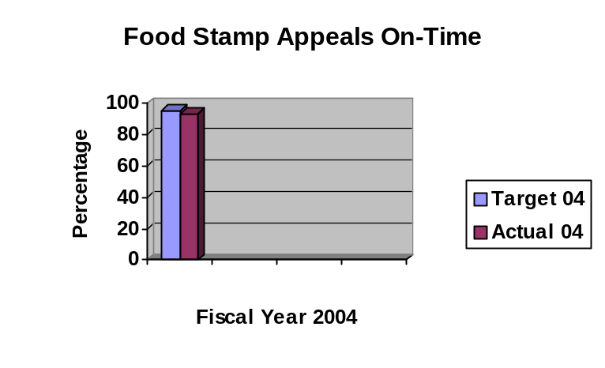

Data reliability: The data is collected and calculated by the Administrative Hearings staff based on the number of cases meeting the timeline compared to the total number of cases heard.
Why we are using this measure: Timely issuance of decisions is a critical component of food stamp contested cases. This measure will show how well we are doing in meeting this component.
What was achieved: 93% of the decisions were issued within the required timeframes.
Analysis of results: The percentage was short of the target, due to staffing limitations. The administrator will review the workload of all types of contested cases to determine how to ensure food stamp decisions are issued timely.
Factors affecting results: Due to budget constraints, the division’s staffing level was down compared to prior years.
Resources used: Expenditures for the Administrative Hearings Division, as a whole, for FY04 were 22.84 FTE and $2,271,273.
Results
Performance Measure:  Percentage of DHS all other appeals proposed decision issued within 65 days of receipt from DHS.  Performance Target:  95%  Data Sources:  Administrative Hearings Division | 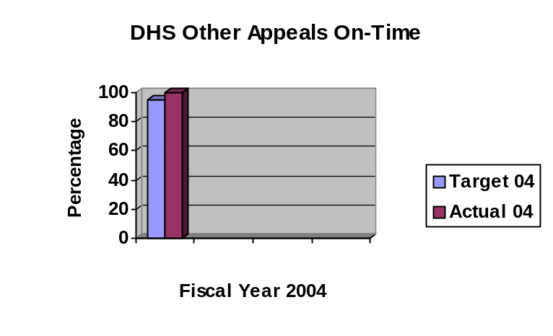
Data reliability: The data is collected and calculated by the Administrative Hearings staff based on the number of cases meeting the timeline compared to the total number of cases heard.
Why we are using this measure: Timely issuance of decisions is a critical component of contested cases. This measure will show how well we are doing in meeting this component.
What was achieved: 100% of the decisions were issued within the required timeframes.
Analysis of results: The percentage exceeded the target. The administrator will review the workload of all types of contested cases to determine how to ensure DHS cases continue to be issued timely.
Factors affecting results: In some cases, appeals may have been withdrawn before a hearing was necessary or the appellant defaulted by not showing up for the hearing. These factors would have affected the number of days to issue a decision.
Resources used: Expenditures for the Administrative Hearings Division, as a whole, for FY04 were 22.84 FTE and $2,271,273.

Results
Performance Measure:  Percentage of DOT OWI appeals heard within 45 days of receipt of request for hearing.  Performance Target:  100%  Data Sources:  Administrative Hearings Division | 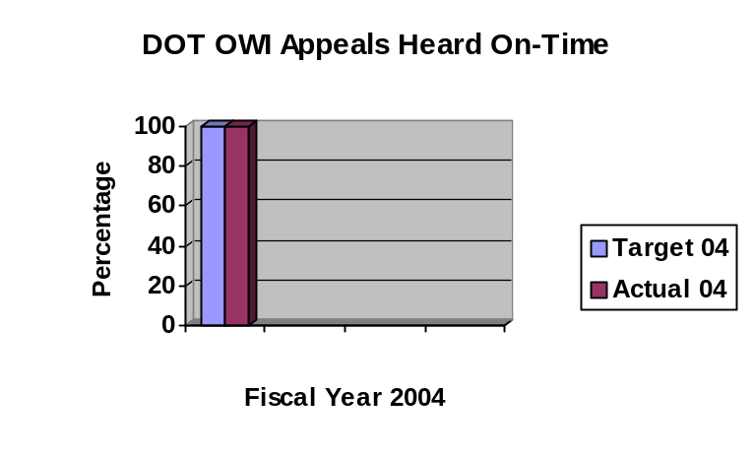
Data reliability: The data is collected and calculated by the Administrative Hearings staff based on the number of cases meeting the timeline compared to the total number of cases heard.
Why we are using this measure: Timely issuance of decisions is a critical component of DOT OWI appeals. This measure will show how well we are doing in meeting this component.
What was achieved: 100% of the decisions were issued within the required timeframes.
Analysis of results: The percentage met the target. The administrator will review the workload of all types of contested cases to determine how to ensure DOT cases continue to be heard timely.
Factors affecting results: A major factor is how quickly DOT certifies the appeal to us to get them scheduled within the 45-day limit. Also, in some cases, appeals may have been withdrawn before a hearing was necessary or the appellant defaulted by not showing up for the hearing. These factors would have affected the number of days to hear a case.
Resources used: Expenditures for the Administrative Hearings Division, as a whole, for FY04 were 22.84 FTE and $2,271,273.

Results
Performance Measure:  Percentage of UI decisions issued within federal Department of Labor guidelines.  Performance Target:  50% within 45 days  90% within 75 days  Data Sources:  Employment Appeal Board | 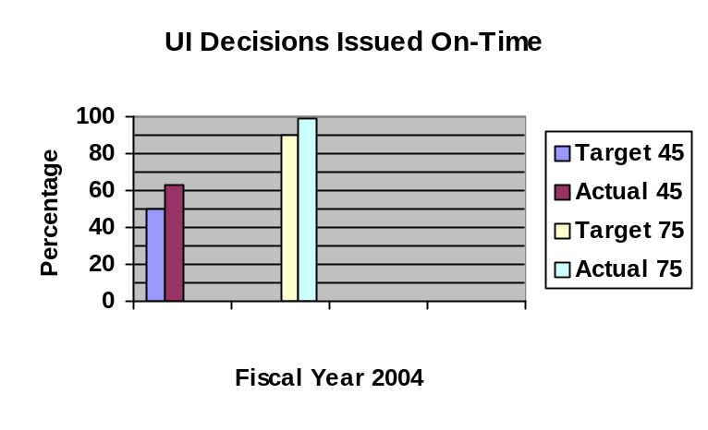
Data reliability: The data is collected and calculated by the Employment Appeal Board staff based on the number of decisions issued meeting each of the timelines compared to the total number of decisions issued.
Why we are using this measure: Timely issuance of decisions is a critical component of unemployment insurance claims. Federal timeliness guidelines are required and may impact federal funding if guidelines are not met. This measure will show how well we are doing in meeting this component.
What was achieved: 63% of the appeal decisions were issued within 45 days; 99% were issued within 75 days.
Analysis of results: The Employment Appeal Board (EAB) was timelier in issuing unemployment insurance appeal decisions than the guidelines require. EAB will continue to monitor the timeliness to ensure the guidelines are, at a minimum, met.
Factors affecting results: Timeliness can be impacted by the number and/or complexity of the appeals, staff workload and simplicity/difficulty of decisions being issued.
Resources used: Expenditures for the Employment Appeal Board, as a whole, for FY04 were 12.97 FTE and $913,544.

Results
Performance Measure:  Percentage of OSHA decisions not appealed to district court.  Performance Target:  85%  Data Sources:  Employment Appeal Board | 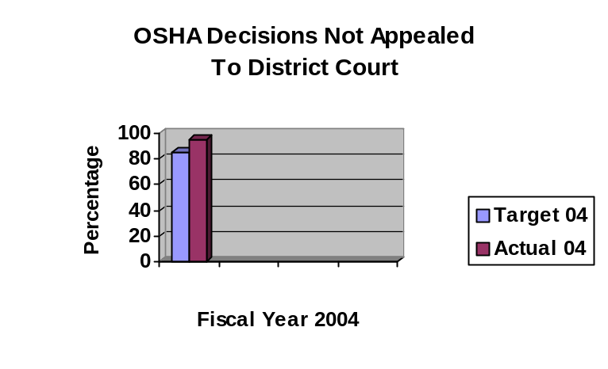
Data reliability: The data is collected and calculated by the Employment Appeal Board staff based on the number of decisions not appealed to district court compared to the total number of decisions.
Why we are using this measure: Decisions not appealed is an indicator of the quality of decisions issued. If a decision is not appealed, the perception is the parties involved felt they were given a fair and equitable opportunity to be heard and the decision was based on fact.
What was achieved: 95% of the decisions were not appealed to district court.
Analysis of results: More of the decisions of the Employment Appeal Board related to OSHA cases became the final decision without further judicial review. This shows that the parties involved are either in agreement with the EAB decision or do not see a basis for judicial review. EAB will continue to monitor the quality of decisions through this measure.
Factors affecting results: The complexity of a case may impact the quality of the decision. The financial standing of a company or individual may also impact whether judicial review is requested for a decision.
Resources used: Expenditures for the Employment Appeal Board, as a whole, for FY04 were 12.97 FTE and $913,544.

SERVICE/ PRODUCT/ ACTIVITY

Name: Administrative Hearings

Description: The conduct of quasi-judicial contested case hearings involving Iowans who disagree with an administrative ruling issued by a state government agency.

Why we are doing this: To afford citizens with due process for adverse actions taken by state agencies.

What we're doing to achieve results: Conducting hearings in a timely and equitable manner. Issuing a proposed decision subject to final review by the director of the agency involved in the contested case proceeding.

Results
Performance Measure:  Average turnaround time for issuing food stamp decisions compared to the required timeframe of within 38 days of receipt from DHS.  Performance Target:  Baseline to be established in FY04  Data Sources:  Administrative Hearings Division | 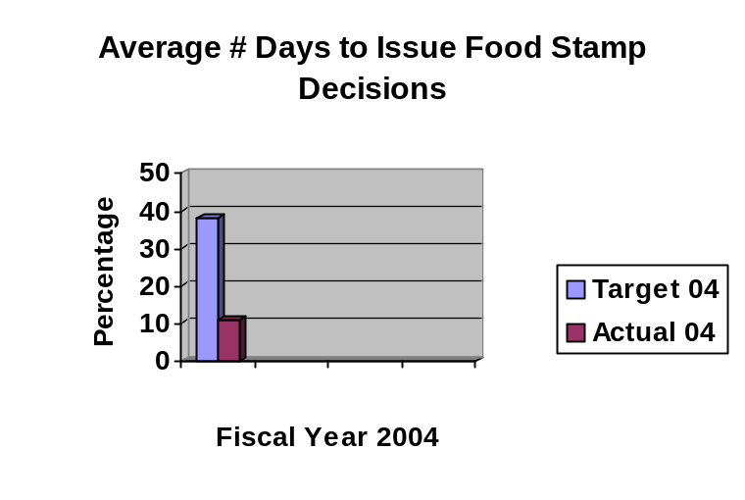
Data reliability: The data is collected and calculated by the Administrative Hearings staff based on the actual total number of days from receipt to issuing decisions for all cases divided by the actual total number of decisions issued.
Why we are using this measure: Timely issuance of decisions is a critical component of food stamp contested cases, as well as a federal requirement. This measure shows how well we are doing in meeting this component.
What was achieved: The average number of days between the date of receipt of an appeal and the issuance of a food stamp decision was 11 days compared to the required maximum timeframe of 38 days.
Analysis of results: The issuance of food stamp decisions was timelier than the requirement. The administrator will review the workload of all types of contested cases to determine how to ensure food stamp decisions continue to be issued within timeliness standards.
Factors affecting results: In some cases, appeals may be withdrawn before a hearing was necessary or the appellant defaulted by not showing up for the hearing. These factors would have affected the number of days to issue a decision.
Resources used: Expenditures for the Administrative Hearings Division, as a whole, for FY04 were 22.84 FTE and $2,271,273.

Results
Performance Measure:  Average turnaround time for issuing DHS all other appeals proposed decisions compared to the required timeframe of within 65 days of receipt from DHS.  Performance Target:  Baseline to be established in FY04  Data Sources:  Administrative Hearings Division | 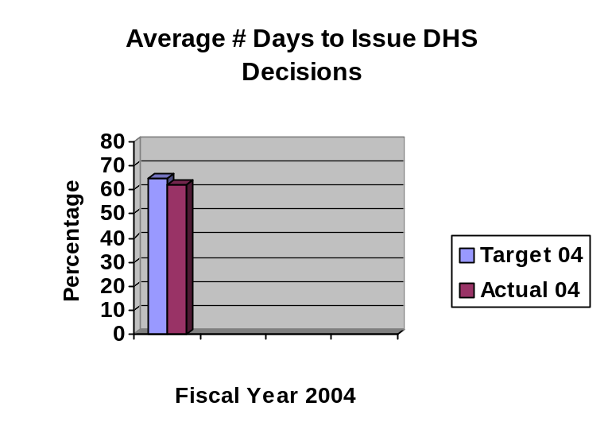
Data reliability: The data is collected and calculated by the Administrative Hearings staff based on the actual total number of days from receipt to issuing decisions for all cases divided by the actual total number of decisions issued.
Why we are using this measure: Timely issuance of decisions is a critical component of DHS contested cases, as well as a federal requirement. This measure shows how well we are doing in meeting this component.
What was achieved: The average number of days between the date of receipt of an appeal and the issuance of a DHS all other appeals proposed decision was 62 days compared to the required maximum timeframe of 65 days.
Analysis of results: The issuance of DHS all other appeals decisions was timelier than the requirement. The administrator will review the workload of all types of contested cases to determine how to ensure these decisions continue to be issued within timeliness standards.
Factors affecting results: In some cases, appeals may be withdrawn before a hearing was necessary or the appellant defaulted by not showing up for the hearing. These factors would have affected the number of days to issue a decision.
Resources used: Expenditures for the Administrative Hearings Division, as a whole, for FY04 were 22.84 FTE and $2,271,273.

Results
Performance Measure:  Average turnaround time for hearing DOT OWI appeals compared to the required timeframe of within 45 days of receipt of request for hearing.  Performance Target:  Baseline to be established in FY04  Data Sources:  Administrative Hearings Division | 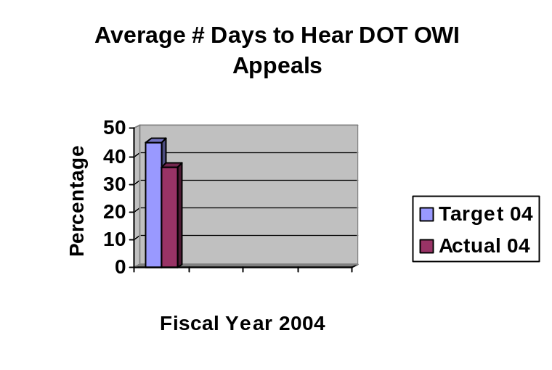
Data reliability: The data is collected and calculated by the Administrative Hearings staff based on the actual total number of days from receipt to hearing all cases divided by the actual total number of appeals heard.
Why we are using this measure: Timely hearing of appeals is a critical component of DOT OWI contested cases. This measure shows how well we are doing in meeting this component.
What was achieved: The average number of days between the date of receipt of a request for a hearing and the date the request is heard was 36 days compared to the required maximum timeframe of 45 days.
Analysis of results: Hearing DOT OWI cases was timelier than the requirement. The administrator will review the workload of all types of contested cases to determine how to ensure these cases continue to be heard within timeliness standards.
Factors affecting results: In some cases, appeals may be withdrawn before a hearing is held. This factor would have affected the number of days to hear a case..
Resources used: Expenditures for the Administrative Hearings Division, as a whole, for FY04 were 22.84 FTE and $2,271,273.

SERVICE/ PRODUCT/ ACTIVITY

Name: Unemployment Insurance (UI) Appeals

Description: Timely adjudication of the rights and duties of workers and employers under unemployment insurance (UI) laws.

Why we are doing this: To afford citizens with an administrative due process.

What we're doing to achieve results: A three-member Employment Appeal Board, representing labor, management and the public, serves as the final administrative law forum for state and federal unemployment benefit appeals.

Results: It was intended to begin collecting data to measure the average turnaround time for UI appeals at the 45-day and 75-day marks. This information is not yet available. The percentage of cases meeting the 45-day and 75-day federal guidelines is shown under the Adjudication Core Function.

SERVICE/ PRODUCT/ ACTIVITY

Name: OSHA and Contractor Registration Appeals

Description: Appeals of rulings of the Occupational Safety and Health Administration (OSHA) and Division of Labor contractor registration requirements are heard by the Employment Appeal Board.

Why we are doing this: To afford citizens with an administrative due process.

What we're doing to achieve results: A three-member Employment Appeal Board timely hears and rules on OSHA and contractor registration appeals based on statutory requirements.

Results
Performance Measure:
Percentage of OSHA decisions not appealed to district court.

Performance Target:
85%

Data Sources:
Employment Appeal Board
Data reliability: The data is collected and calculated by the Employment Appeal Board staff based on the number of decisions not appealed to district court compared to the total number of decisions.
Why we are using this measure: Decisions not appealed is an indicator of the quality of decisions issued. If a decision is not appealed, the perception is the parties involved felt they were given a fair and equitable opportunity to be heard and the decision was based on fact.
What was achieved: 95% of the decisions were not appealed to district court.
Analysis of results: More of the decisions of the Employment Appeal Board related to OSHA cases became the final decision without further judicial review. This shows that the parties involved are either in agreement with the EAB decision or do not see a basis for judicial review. EAB will continue to monitor the quality of decisions through this measure.
Factors affecting results: The complexity of a case may impact the quality of the decision. The financial standing of a company or individual may also impact whether judicial review is requested for a decision.
Resources used: Expenditures for the Employment Appeal Board, as a whole, for FY04 were 12.97 FTE and $913,544.

PERFORMANCE PLAN RESULTS

CORE FUNCTION

Name: Advocacy - 04

Description: This core function describes the two volunteer child advocacy programs of the Child Advocacy Board (CAB). CAB operates the Court Appointed Special Advocate (CASA) and the Iowa Citizen Foster Care Review Board (ICFCRB) programs.

Why we are doing this: To ensure effective permanency planning exists for all children in out-of-home placement.

What we're doing to achieve results: Under the CASA program, volunteers are appointed by the Court to advocate for a specific abused or neglected child. The CASA volunteer serves many roles in a child’s court case, including investigation, assessment, facilitation, advocacy, and monitoring. Under the ICFCRB program, volunteers are appointed by the Court to serve on a local, community board that conducts a review of the case of each child in out-of-home placement in their community once every six months. The ICFCRB volunteers make specific findings and recommendations as to the individual case as well as systemic findings and recommendations for Iowa’s child welfare system.

Results
Performance Measure:  Percentage of all children in out-of-home placement with current permanency plans.  Performance Target:  Baseline was to be established in FY04  Data Sources:  Child Advocacy Board | 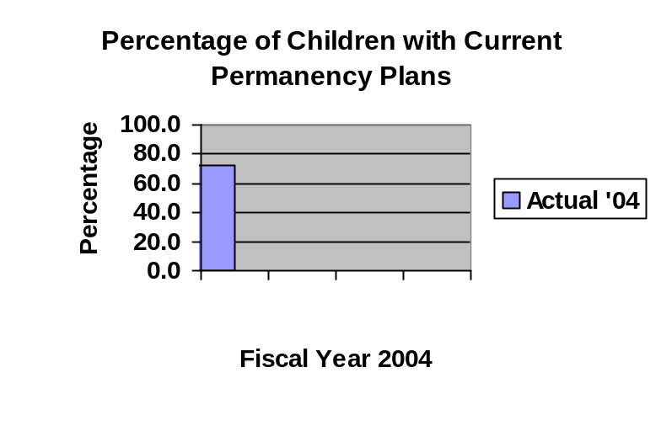
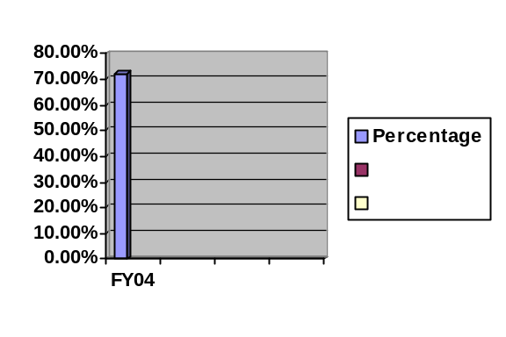

Data reliability: The information is based on records kept by the staff of CAB of children assisted or reviewed by the volunteers.

Why we are using this measure: To establish a trend of the impact of advocacy in ensuring permanency for children.
What was achieved: 72.3% of the children in out-of-home placement in the areas covered by the Iowa Citizen Foster Care Review Board had current permanency plans.
Analysis of results: As FY04 was a baseline year, an analysis will be done with FY05 data to determine initial trends and establish strategies to address those trends.
Factors affecting results: Insufficient staffing levels at the Department of Human Services, which puts a burden on the workload and ability to complete permanency plans timely and completely. Lack of cooperation or available services for the family to provide a long-term permanency plan.
Resources used: Expenditures for the Child Advocacy Board, as a whole, for FY04 were 36.89 FTE and $2,507,388.
Results
Performance Measure:  Percentage of permanency planning case-specific or systems findings and recommendations implemented.  Performance Target:  Baseline was to be established in FY04  Data Sources:  Child Advocacy Board | 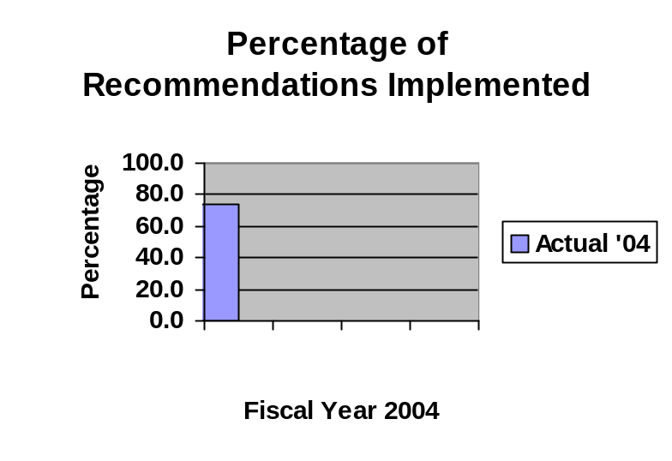

Data reliability: The information is based on records kept by the staff of CAB based on information provided by the volunteers. This information is also included in CAB’s annual report to the Legislature, Iowa Supreme Court, and Department of Human Services.
Why we are using this measure: To establish a trend of the impact of advocacy in ensuring specific children have current permanency plans and in making improvements to the child welfare system.
What was achieved: 73.9% of the permanency planning case-specific or systems findings and recommendations were implemented.
Analysis of results: As FY04 was a baseline year, an analysis will be done with FY05 data to determine initial trends and strategies to address the trends.

Factors affecting results: Lack of resources, human and financial, to implement recommendations. Opposing positions by stakeholders to the recommendations.
Resources used: Expenditures for the Child Advocacy Board, as a whole, for FY04 were 36.89 FTE and $2,507,388.

SERVICES/PRODUCTS/ACTIVITIES

Name: Court Appointed Special Advocate

Description: The Iowa Court Appointed Special Advocate (CASA) Program commissions community volunteers to serve as an effective voice in court for abused and neglected children, strengthening efforts to ensure that each child is living in a safe, permanent and nurturing home.

Why we are doing this: To ensure effective permanency planning exists for all children in out of home placement.

What we're doing to achieve results: Use volunteers to investigate and gather information related to specific cases in the juvenile court system and prepare reports on those cases with specific recommendations to the court for that case. The CASA volunteer serves many roles in a child’s court case, including investigation, assessment, facilitation, advocacy, and monitoring.

Results
Performance Measure:  Percentage of written reports submitted to the court within specified timeframes.  Performance Target:  95%  Data Sources:  Child Advocacy Board | 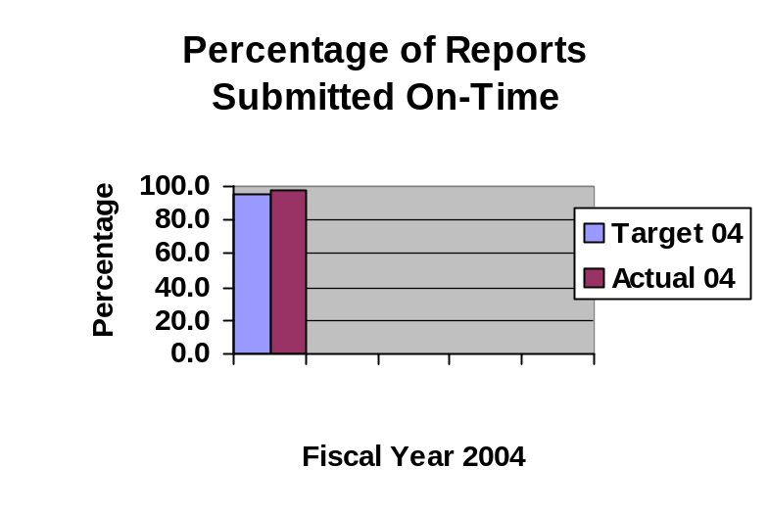
Data reliability: The information is based on records kept by the staff of CAB based on information provided by the volunteers.
Why we are using this measure: To ensure abused and neglected children are receiving timely services from their CASA and the Court has the necessary information in a timely manner in order to assist the children in obtaining permanency.
What was achieved: 97.6% of the reports were submitted to the Court within specified timeframes.
Analysis of results: The CASA program exceeded their target of 95%. The analysis of this information shows that CASA volunteers are committed to ensuring permanency for abused and neglected children. Analysis will continue as more trend information becomes available in future years.
Factors affecting results: Lack of cooperation by the parties involved or services available to the parties can impact the ability of the CASA volunteer to timely accomplish their tasks and submit a complete report to the Court.
Resources used: Expenditures for the Child Advocacy Board, as a whole, for FY04 were 36.89 FTE and $2,507,388.

Results
Performance Measure:  Percentage of children having a CASA available when needed.  Performance Target:  90%  Data Sources:  Child Advocacy Board | 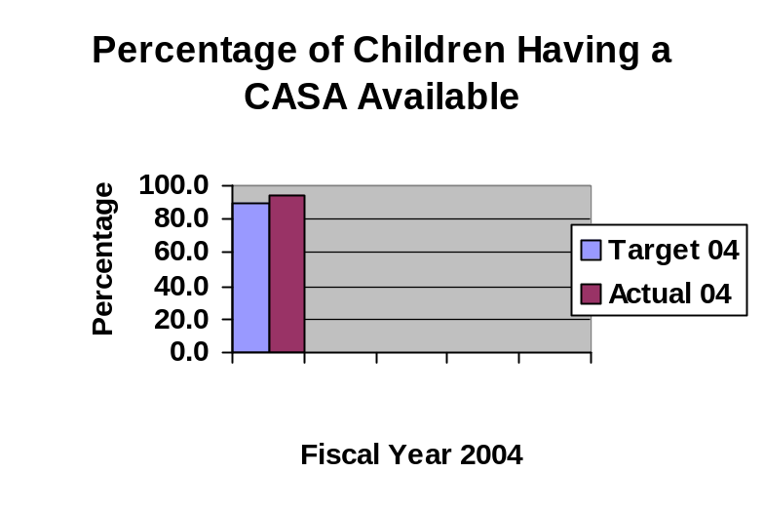
Data reliability: The information is based on records kept by the staff of CAB based on requests from the Court and actual volunteer assignments.
Why we are using this measure: To identify the ongoing need for CASA volunteers for use in determining necessary staffing levels.
What was achieved: 94.3% of the court requests for CASA volunteers for abused and neglected children were met.
Analysis of results: The CASA program exceeded their target of 90%. The analysis of this information shows that the CASA program is recruiting and training additional volunteers to meet the needs of abused and neglected children. Recruiting and training efforts, within available resources, will continue to move toward meeting the needs for additional volunteers. Analysis will continue as more trend information becomes available in future years.
Factors affecting results: Limited resources available to recruit and train additional volunteers.
Resources used: Expenditures for the Child Advocacy Board, as a whole, for FY04 were 36.89 FTE and $2,507,388.

Name: Local Foster Care Review Board

Description: The Iowa Citizen Foster Care Review Board (ICFCRB) program empowers the citizens of Iowa to review cases, collect data, and recommend changes to promote the safety and permanency of children who have been removed from the homes of their families.

Why we are doing this: To ensure effective permanency planning exists for all children in out of home placement.

What we're doing to achieve results: Under the ICFCRB program, volunteers are appointed by the Court to serve on a local, community board that conducts a review of the case of each child in out-of-home placement in their community once every six months. The ICFCRB volunteers make specific findings and recommendations as to the individual case as well as systemic findings and recommendations for Iowa’s child welfare system.

Results
Performance Measure:  Percentage of required reviews conducted within specified timeframes  Performance Target:  98%  Data Sources:  Child Advocacy Board | 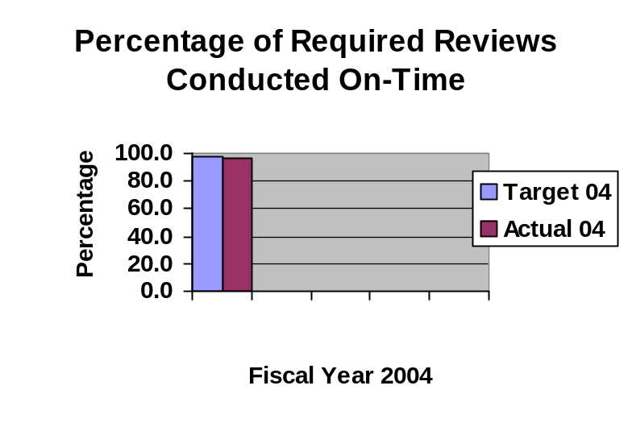
Data reliability: The information is based on records kept by the staff of CAB based on the review schedule versus the timeframe.

Why we are using this measure: To ensure children in out-of-home placement are reviewed within required timeframes to move toward permanency and, for those eligible for federal funds, the funding is not jeopardized by not timely meeting review timeframes.
What was achieved: 96.6% of the required reviews were conducted within specified timeframes.
Analysis of results: The ICFCRB program fell short of their target of 98%. The analysis of this information shows that ICFCRB meets the standard for compliance with the federal time mandates, but fails slightly to meet the timelines concerning matching reviews to court hearings. Efforts will be made during FY05 to address any barriers to meeting the target. Analysis will continue as more trend information becomes available in future years.
Factors affecting results: Lack of consistent and timely scheduling of hearings by Courts in some parts of the state.
Resources used: Expenditures for the Child Advocacy Board, as a whole, for FY04 were 36.89 FTE and $2,507,388.
Results
Performance Measure:  Percentage of all children in out-of-home placement being reviewed by a local foster care review board.  Performance Target:  50%  Data Sources:  Child Advocacy Board | 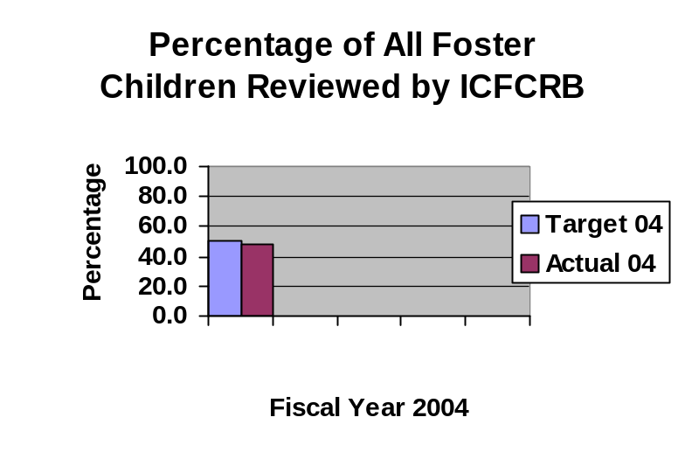
Data reliability: The information is based on records kept by the staff of CAB based on number of children reviewed by ICFCRB and total number of children identified by DHS in out-of-home placement.
Why we are using this measure: To identify the ongoing need for CASA volunteers for use in determining necessary staffing levels.
What was achieved: 48% of all children in out-of-home placement are reviewed by the ICFCRB program.
Analysis of results: The ICFCRB program fell short of their target of 50%. The analysis of this information shows that the number of children in judicial districts not covered by the ICFCRB program increased in FY04 compared to the prior year. Analysis will continue as more trend information becomes available in future years.

Factors affecting results: Total number of affected children in the state compared to the number of affected children in areas served by the ICFCRB program. This is not under the control of CAB.
Resources used: Expenditures for the Child Advocacy Board, as a whole, for FY04 were 36.89 FTE and $2,507,388.

PERFORMANCE PLAN RESULTS

CORE FUNCTION

Name: Legal Representation - 37

Description: This core function relates to the provision of legal services to indigent clients through either public defenders or court-appointed private attorneys.

Why we are doing this: To provide high-quality and cost-efficient representation by public defenders to indigent clients in State criminal court, juvenile court, and other proceedings as required by law. To ensure the prompt and fair review and adjudication of claims for payment of indigent defense fees and costs from indigent defense providers.

What we're doing to achieve results: The results for public defenders is being achieved through the recruitment and hiring the best attorneys, investigators, and administrators available, providing or coordinating the tools (resources/ training/ professional development) for the staff to do their best, establishing and monitoring individual performance expectations, and reviewing caseloads on a regular basis. Claims results are being accomplished by publishing and properly applying administrative rules and internal procedures that govern the indigent defense claims process, acquiring and administering appropriate data automation systems to manage the process, and reviewing data on an ongoing basis to ensure propriety and timeliness of claims actions.

Results
Performance Measure:  Percentage of public defender cases where there have been no final findings of ineffective assistance of counsel either on direct appeal of convictions, after post-conviction relief actions, or (for civil commitments) habeas corpus actions.  Performance Target:  99%  Data Sources:  State Public Defender | 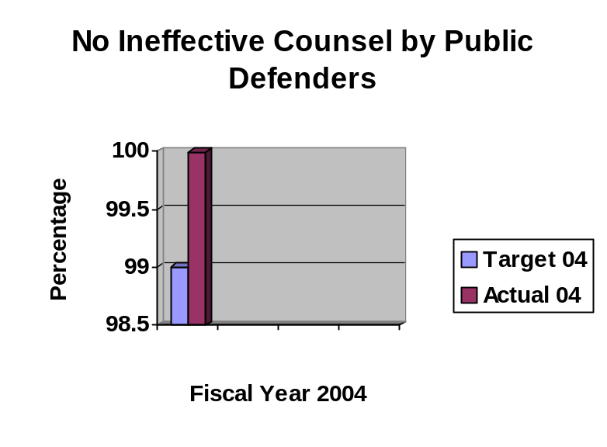
Data reliability: The data comes from calculations by the State Public Defender staff, based on the total number of cases handled and the number of those cases with final findings of ineffective assistance of counsel. Final findings would be determined by the Court system.
Why we are using this measure: This measure is being used as one indicator of the quality and cost-effectiveness of counsel. If a public defender is found ineffective, the cost to assign new counsel and go through a potential new trial would dramatically increase the cost of a case.
What was achieved: 99.99% of the cases (71,112 of 71,118 cases) had no final findings of ineffective counsel.
Analysis of results: Based on the results, the State Public Defender will continue to use the strategies of ensuring high-quality and cost-efficient public defender services and address individual situations involving ineffective counsel.
Factors affecting results: Public defenders are rarely found ineffective, even though that is often alleged by defendants on the losing end of court cases. The lack of a “plain error” rule in Iowa (unlike a majority of states, which apply a plain error doctrine) was a factor in many of the findings of ineffectiveness, i.e., the judge, prosecutor, and defense counsel all contributed to the error but the only way to grant relief was to find the defense counsel “ineffective.”
Resources used: Expenditures for the State Public Defender and Indigent Defense, as a whole, for FY04 were 202 FTE and $39,427,116.

Results
Performance Measure:  Percentage of caseload performance expectations achieved by the State Public Defender (SPD) System.  Performance Target:  95%  Data Sources:  State Public Defender | 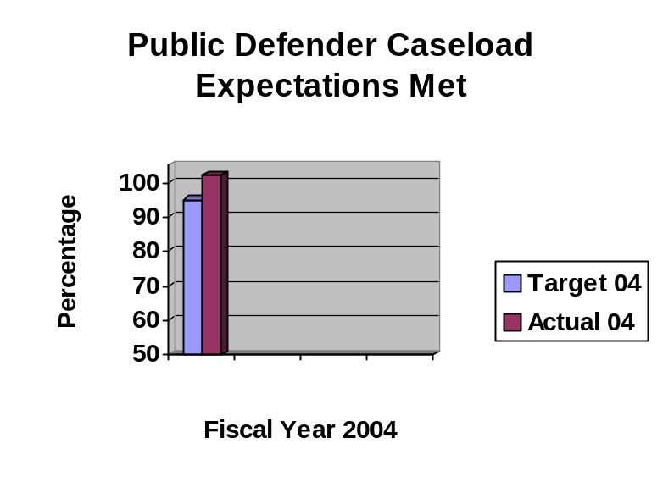
Data reliability: The data comes from calculations by the State Public Defender staff, based on the actual number of cases handled compared to the caseload performance expectations set by the State Public Defender.
Why we are using this measure: This measure is being used as one indicator of the cost-effectiveness of counsel. If the public defender system is not achieving the caseload performance expectations, the cost to the indigent defense system increases.
What was achieved: 102% of the caseload performance expectations were met.
Analysis of results: Based on the results, the State Public Defender will review the caseload performance expectations to determine if the expectations need to be adjusted and will monitor on an ongoing basis to ensure expectations are met. The State Public Defender will address individual situations involving lack of meeting expectations.
Factors affecting results: The type and complexity of cases may impact the number of cases local public defenders are able to handle in the course of the fiscal year. Also, available resources may also impact the number of cases handled by the system.
Resources used: Expenditures for the State Public Defender and Indigent Defense, as a whole, for FY04 were 202 FTE and $39,427,116.

Results
Performance Measure:  Percentage of challenged Notices of Action on indigent defense claims that are upheld upon final judicial review.  Performance Target:  90%  Data Sources:  State Public Defender | 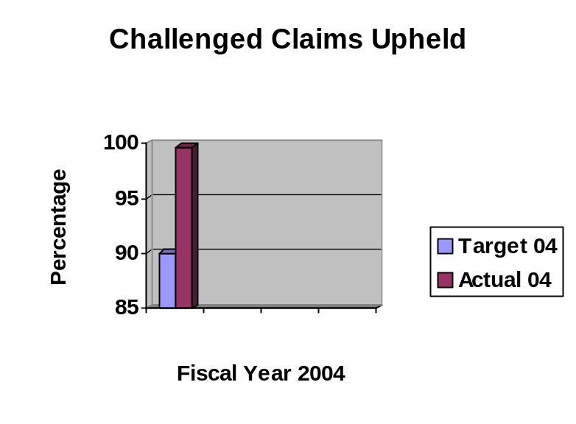
Data reliability: The data comes from calculations by the State Public Defender staff, based on the total number of challenged indigent defense claims Notices of Action compared to the number upheld upon final judicial review.
Why we are using this measure: This measure is being used as one indicator of the fair review and adjudication of indigent defense claims.
What was achieved: 99.7% of the challenged claims are being upheld upon final judicial review.
Analysis of results: Based on the results, the State Public Defender will review the claims not upheld to determine how to address similar claims and to clarify any rules or procedures for staff and vendors.
Factors affecting results: The Code of Iowa and the State Public Defender’s administrative rules expressly address the vast majority of reasons Notices of Action reducing claims are issued. Consistent application of these rules results in a high percentage of favorable rulings.
Resources used: Expenditures for the State Public Defender and Indigent Defense, as a whole, for FY04 were 202 FTE and $39,427,116.

Results
Performance Measure:  Percentage of indigent defense claims review and acted upon with an the established time period of 35 days of receipt.  Performance Target:  90%  Data Sources:  State Public Defender | 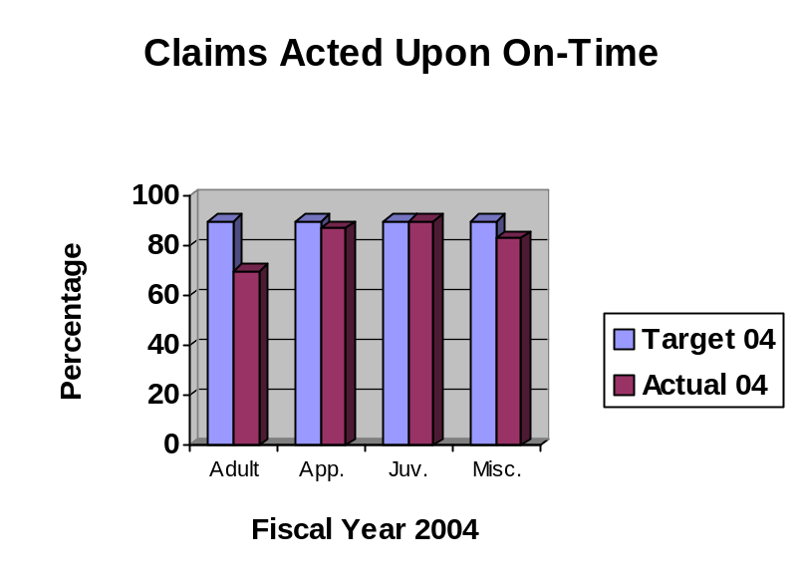
Data reliability: The data comes from calculations by the State Public Defender staff, based on the total number of claims reviewed and acted upon compared to the number reviewed and acted upon within 30 days using receipt and payment dates.
Why we are using this measure: This measure is being used as one indicator of the promptness of getting claims through the review and payment process.
What was achieved: 70% of adult claims, 87% of appellate claims, 90% of juvenile claims, and 83% of miscellaneous claims were reviewed and acted upon within 30 days.
Analysis of results: Based on the results, the State Public Defender has reengineered the claims review process to allocate personnel resources more efficiently. In addition, claims payments have been given appropriate priority by fiscal staff.
Factors affecting results: Volume of claims and staff absences may impact the number of days it takes to review and act upon all claims.
Resources used: Expenditures for the State Public Defender and Indigent Defense, as a whole, for FY04 were 202 FTE and $39,427,116.

Results
Performance Measure:  Average processing time for an indigent defense claim within an established standard.  Performance Target:  30 days  Data Sources:  State Public Defender | 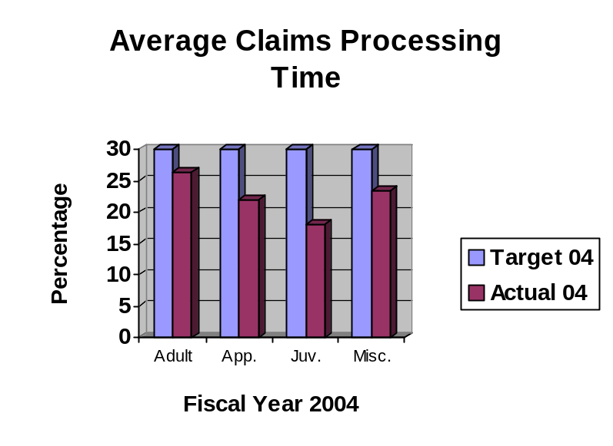
Data reliability: The data comes from calculations by the State Public Defender staff, based on the total number of days to review and act upon the various types of claims divided by the total number of claims by type using receipt and payment dates.
Why we are using this measure: This measure is being used as one indicator of the promptness of getting claims through the review and payment process.
What was achieved: Adult claims – 26.29 days average; Appellate claims – 21.87 days average; Juvenile claims – 18.09 days average; and Miscellaneous claims – 23.52 days average compared to the standard of 30 days average.
Analysis of results: Although the average days for the various types of claims were better than the standard, the State Public Defender has reengineered the claims review process to allocate personnel resources more efficiently to further improve the average. In addition, claims payments have been given appropriate priority by fiscal staff.
Factors affecting results: Volume of claims and staff absences may impact the number of days it takes to review and act upon all claims.
Resources used: Expenditures for the State Public Defender and Indigent Defense, as a whole, for FY04 were 202 FTE and $39,427,116.

SERVICE/ PRODUCT/ ACTIVITY

Name: Public Defender Services

Description: Provision of constitutionally mandated legal services to indigent clients through a local public defender system.

Why we are doing this: To provide high-quality and cost-efficient representation by public defenders to indigent clients in State criminal court, juvenile court, and other proceedings as required by law.

What we're doing to achieve results: The results for public defenders is being achieved through the recruitment and hiring the best attorneys, investigators, and administrators available, providing or coordinating the tools (resources/training/ professional development) for the staff to do their best, establishing and monitoring individual performance expectations, and reviewing caseloads on a regular basis.

Results: The results data for all performance measures for public defender services are reported under the Legal Representation core function.

SERVICE/ PRODUCT/ ACTIVITY

Name: Indigent Defense Claims

Description: Review and payment of indigent defense and ancillary services provided by private and contract attorneys and miscellaneous vendors, such as expert witnesses and court reporters.

Why we are doing this: To ensure a prompt and fair review and adjudication of claims for payment of indigent defense fees and costs from indigent defense providers.

What we're doing to achieve results: Claims results are being accomplished by publishing and properly applying administrative rules and internal procedures that govern the indigent defense claims process, acquiring and administering appropriate data automation systems to manage the process, and reviewing data on an ongoing basis to ensure propriety and timeliness of claims actions.

Results: The results data for all performance measures for indigent defense claims are reported under the Legal Representation core function.

PERFORMANCE PLAN RESULTS

CORE FUNCTION

Name: Regulation and Compliance - 61

Description: This core function covers the multitude of regulatory and compliance activities within the Department of Inspections and Appeals.

Why we are doing this: To protect the public from incidence of fraudulent or illegal activities and protect the public health, safety and welfare. The individual services/products/activities will provide more detail on the results expected.

What we're doing to achieve results: The department through licensing, certification, investigation, and auditing activities ensure applicants, participants, organizations, providers, and service recipients meet the requirements set out in state and federal law and rules and regulations. The individual services/ products/activities will provide more detail on how results are being achieved.

Results
Performance Measure:  Percentage of animals inspected for health and fitness prior to a race.  Performance Target:  Baseline to be established in FY04  Data Sources:  Iowa Racing and Gaming Commission | 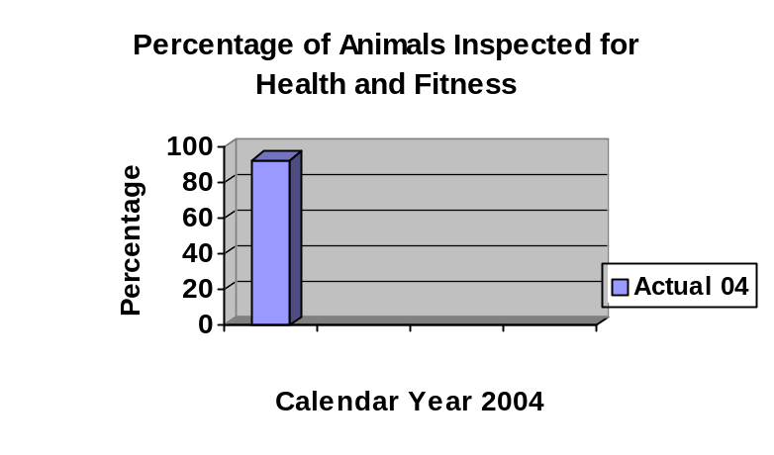
Data reliability: The data was calculated by Commission staff based on the total number of animals scheduled for all races in the calendar year compared to the actual number inspected prior to the race.
Why we are using this measure: To determine the level of compliance with ensuring only healthy and fit animals are allowed to race.
What was achieved: 93% of the racing animals were inspected for health and fitness prior to a race.
Analysis of results: As this is the first year this data has been formally collected, the Commission will continue to monitor and address any downward trends.
Factors affecting results: Available funding impacts the number of racing animals the state veterinarian has the time to inspect prior to the race, including hiring assistant veterinarians.
Resources used: Expenditures for the Racing and Gaming Commission, as a whole, for FY04 was 47.90 FTEs and $4,255,566.
Results
Performance Measure:  Percentage of required animals sampled for illegal substances.  Performance Target:  Baseline to be established in FY04  Data Sources:  Iowa Racing and Gaming Commission | 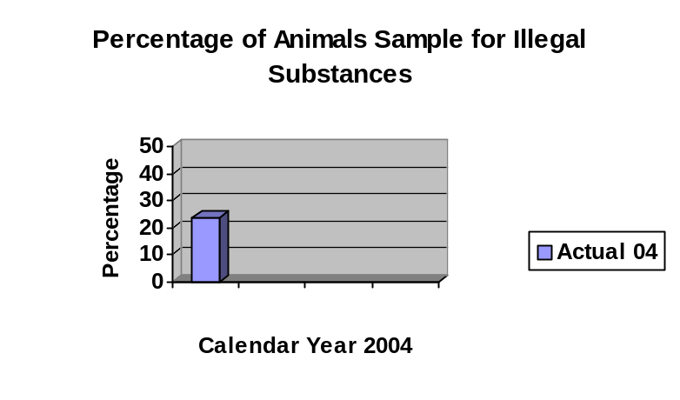
Data reliability: The data was calculated by Commission staff based on the total number of animals required to be sampled compared to the actual number sampled.
Why we are using this measure: This measure is one indicator of the integrity of racing through ensuring specified animals, such as winners, animals racing out of their normal pattern, and randomly, are tested to ensure purses are awarded to compliant owners and to show the public the fairness of the races.
What was achieved: 24% of the required racing animals were tested.
Analysis of results: As this is the first year this data has been formally collected, the Commission will continue to monitor and address any downward trends.
Factors affecting results: Available funding impacts the number of racing animals the state veterinarian and assistants have the time to sample.
Resources used: Expenditures for the Racing and Gaming Commission, as a whole, for FY04 was 47.90 FTEs and $4,255,566.

Results
Performance Measure:  Percentage of referrals to DCI resulting in prosecution, confiscation, or other disciplinary action.  Performance Target:  Baseline to be established in FY04  Data Sources:  Department of Inspections and Appeals - Social and Charitable Gambling Unit | 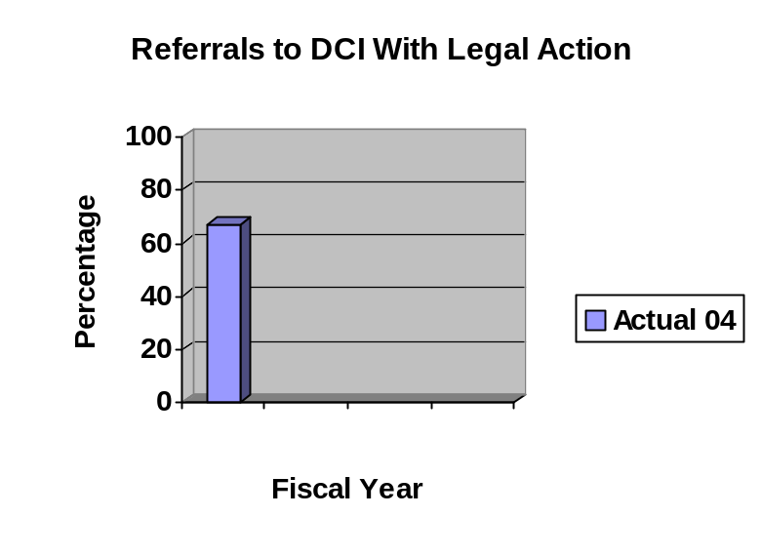

Data reliability: The data was calculated by department staff based on the total number of referrals sent to the DCI compared to those completed and resulting in some legal action.
Why we are using this measure: This measure is one indicator of showing how regulatory actions ensure integrity in the social and charitable gambling industry.
What was achieved: Of the three referrals to DCI, one resulted in revocation of the license and criminal prosecution, one resulted in revocation of the license and is still under investigation for possible further action, and one was unfounded. There were four other referrals that were pending at the end of the fiscal year and will be included in the FY05 report.
Analysis of results: The referrals were thoroughly investigated and immediate action was taken to ensure the violations did not continue and put the public at risk of illegal gaming. The department will continue to work with the DCI to ensure referrals are timely investigated and appropriate action is taken to protect the public.
Factors affecting results: The number of referrals is based on complaints received. The action on the referrals is dependent on the timeliness of the DCI investigation and evidence available.
Resources used: Expenditures for the Social and Charitable Gambling/TSB Unit, as a whole, for FY04 was 2.00 FTEs and $208,605.

Results
Performance Measure:  Percentage of applications administratively closed due to not meeting requirements.  Performance Target:  Baseline to be established in FY04  Data Sources:  Department of Inspections and Appeals – Targeted Small Business Certification Unit | 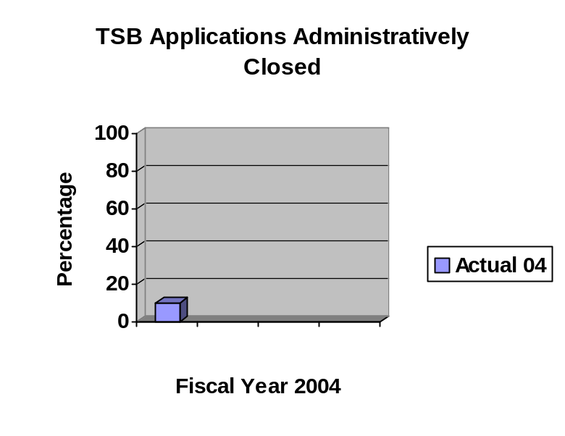
Data reliability: The data was calculated by department staff based on the actual total number of applications received compared to the actual number closed due to not meeting requirements.
Why we are using this measure: This measure is one indicator to show that only eligible applicants receive certification to access state loans and procurement opportunities.
What was achieved: 58 cases or 10% of the total number of applications received were closed due to not meeting requirements.
Analysis of results: As a result of the data, greater education, in cooperation with other state agencies (Economic Development and Administrative Services), banks, small business centers, etc., is being done at seminars and conferences to better explain the requirements. The department will continue to monitor this measure to determine the benefits of the additional education, including whether the number of ineligible applicants is reduced.
Factors affecting results: Applicants not following the instructions and rules provided with the application prior to submission or submitting the application trying to defraud the system and when challenged do not respond. Available loan money may also be a factor.
Resources used: Expenditures for the Social and Charitable Gambling/TSB Unit, as a whole, for FY04 was 2.98 FTEs and $285,074.

Results
Performance Measure:  Rate of individuals affected by a substantiated foodborne illness per 100,000 population.  Performance Target:  Baseline to be established in FY04  Data Sources:  Department of Inspections and Appeals – Food and Consumer Safety Bureau | 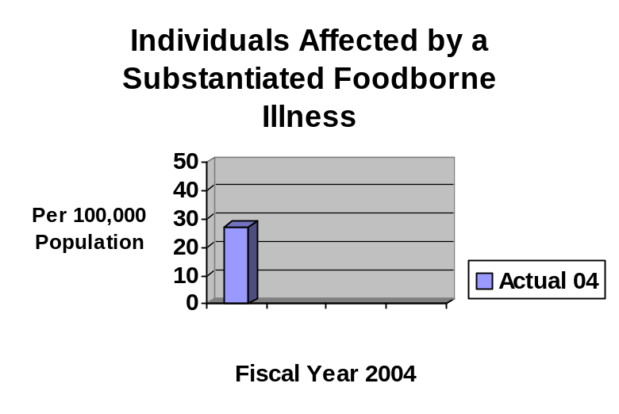
Data reliability: The data is compiled by department staff, in cooperation with the state epidemiologist, based on the actual number of people identified as being affected as a result of a substantiated food establishment foodborne illness investigation in relation to every 100,000 Iowans.
Why we are using this measure: This measure is used as an indicator to show the impact of inspections and licensing on protecting the public from incidence of serious disease in food establishments. This measure is modified from the original measure to better show impact.
What was achieved: FY04 was a baseline year for the revised measure. 27.5 persons per 100,000 population were affected by a substantiated foodborne illness.
Analysis of results: As FY04 was the baseline year, trend lines are not yet available. The department will continue to monitor this data to determine appropriate courses of action.
Factors affecting results: Ability of the state and contracts to comply with the Food Code regarding inspection frequency due to unfunded fee structure. Emerging pathogens with a prevention course not yet identified by the Centers for Disease Control.
Resources used: Expenditures for the Food and Consumer Safety Bureau, as a whole, for FY04 was 12.11 FTEs and $847,959.

Results
Performance Measure:  Percentage of licensed/certified healthcare facilities requiring a second revisit.  Performance Target:  Baseline to be established in FY04  Data Sources:  Department of Inspections and Appeals – Health Facilities Division | 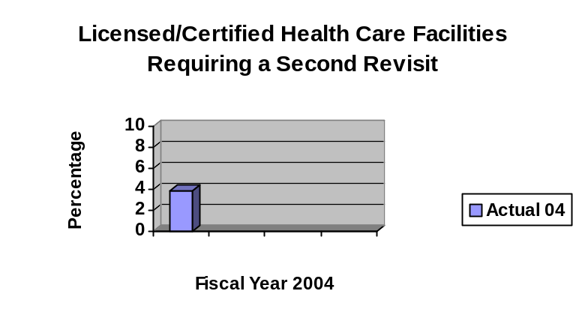
Data reliability: The data was compiled by department staff based on the actual number of health care facilities being surveyed compared to the number of facilities requiring a second revisit because of violation corrections not being made within specified timeframes or additional violations found at the first revisit.
Why we are using this measure: This measure serves as one indicator to show the level of compliance with health, safety, and security standards by health care facilities.
What was achieved: FY04 serves as the baseline year. 3.9% of the facilities surveyed required a second revisit.
Analysis of results: As FY04 is the baseline year, the department will monitor the trends to determine the best course of action to reduce the percentage. The department will make presentations and participate in training opportunities to assist provider and advocacy organizations in improving and enhancing compliance efforts. The department’s website will be continually updated with information to assist consumers and facilities in improving the level of facility compliance.
Factors affecting results: Changes in ownership, management, or staffing may negatively impact the compliance level at the time of a survey, which could result in the need for a second revisit. Ability or willingness of the facility to make violation corrections may also impact the result.
Resources used: Expenditures for the Health Facilities Division, as a whole, for FY04 was 101.65 FTEs and $9,663,656.

Results
Performance Measure:  Percentage of Habilitation facilities that are deficiency-free.  Performance Target:  20%  Data Sources:  Department of Inspections and Appeals – Health Facilities Division | 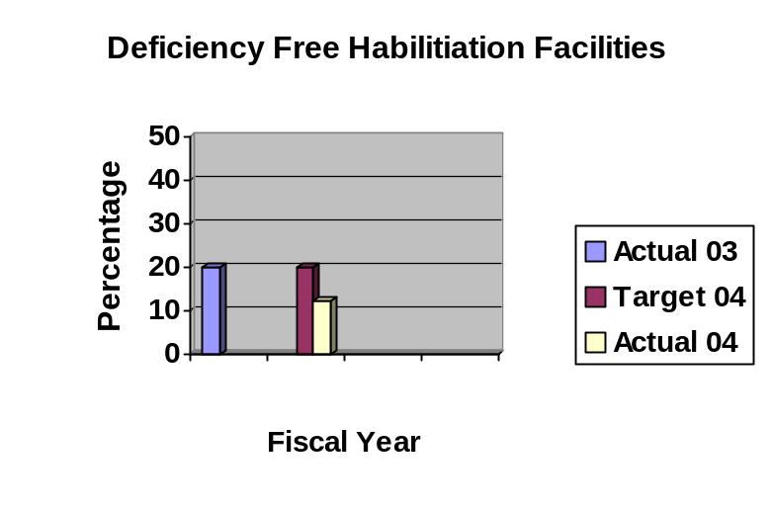
Data reliability: The data is compiled by department staff based on the actual total number of habilitation facilities inspected during the fiscal year compared to the number of facilities receiving no violations/deficiencies.
Why we are using this measure: This measure is one picture to show the level of compliance with health, safety, and security standards by habilitation facilities, such as residential care facilities for persons with mental illness and residential care facilities for persons with mental retardation.
What was achieved: 15 of 123 facilities or 12.2% of the facilities were deficiency-free.
Analysis of results: The department reviewed the data to determine why the actual percentage for deficiency-free facilities was below the target of 20%. As a result of this review, the department will make presentations and participate in training opportunities to assist provider and advocacy organizations in improving and enhancing compliance efforts. The department’s website will be continually updated with information to assist consumers and facilities in improving the level of facility compliance.
Factors affecting results: The FY04 decrease could be due to new providers added to the program and/or changing interpretations of the regulations by the federal government and providers not yet fully adjusted to the new interpretation.
Resources used: Expenditures for the Health Facilities Division, as a whole, for FY04 was 101.65 FTEs and $9,662,656.

Results
Performance Measure:  New dollars collected for public assistance programs compared to the previous year.  Performance Target:  Baseline to be established in FY04  Data Sources:  Department of Inspections and Appeals – Investigations Division | 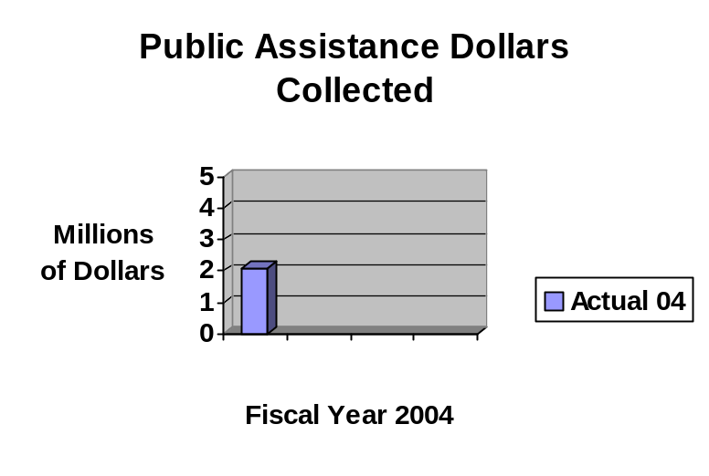
Data reliability: The data is compiled by department staff from database records showing the actual amount of dollars collected during the fiscal year.
Why we are using this measure: This measure is one indicator to show the efforts to collect public assistance dollars owed to the state. Eventually the trend will show efforts compared to the previous fiscal year. This is a revised measure from what was submitted in the performance plan – it is more realistic in terms of data collection.
What was achieved: In the baseline year for data collection, $2.1 million was collected during the fiscal year.
Analysis of results: Following a review of the data and collection efforts, the department and the Department of Human Services (DHS) began working together to identify and implement ways to improve the claims management processes.
Factors affecting results: If claim establishment by DHS is down, collections will be down. Also, as collection authorization requirements change, collections may be impact either positively or negatively.
Resources used: Expenditures for the Investigations Division, as a whole, for FY04 was 38.91 FTEs and $3,067,821.

Results
Performance Measure:  Percentage of local DHS offices audited in compliance with required timeframes.  Performance Target:  95%  Data Sources:  Department of Inspections and Appeals – Investigations Division | 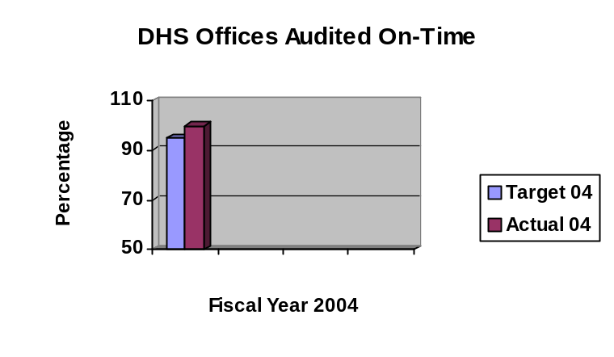
Data reliability: The data is compiled by department staff based on the actual numbers of offices required to be audited within the year compared to the actual number audited.
Why we are using this measure: This measure is one indicator to show that offices are timely held to compliance with applicable federal and state financial requirements.
What was achieved: 100% of all DHS local offices were audited in compliance with required timeframes, which exceeded the target.
Analysis of results: The data was reviewed to determine future projections of timeliness and if the process used to meet this performance measure could be applied to other types of audits. The department will continue to monitor the trends to ensure on-time audits and determine staffing needs.
Factors affecting results: The complexity of the audit and number of audit exceptions can impact the ability to complete audits on-time. Available staffing resources will also impact the results.
Resources used: Expenditures for the Investigations Division, as a whole, for FY04 was 38.91 FTEs and $3,067,821.

Results
Performance Measure:  Percentage of care facilities audited in compliance within required timeframes.  Performance Target:  Baseline to be established in FY04  Data Sources:  Department of Inspections and Appeals – Investigations Division | 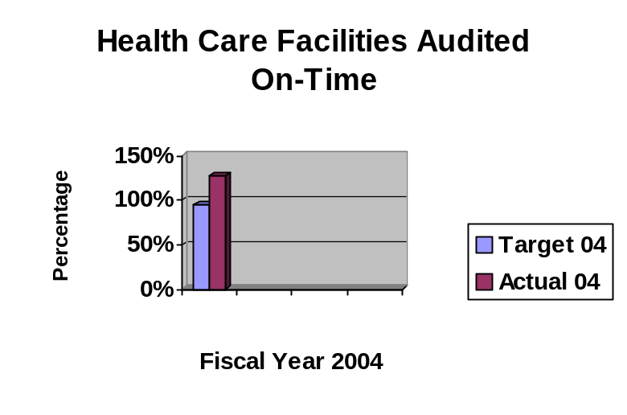
Data reliability: The data is compiled by department staff based on the actual numbers of facilities required to be audited within the year compared to the actual number audited.
Why we are using this measure: This measure is one indicator to show that facilities are timely held to compliance with applicable federal and state financial requirements.
What was achieved: 127% of all facilities were audited in compliance with required timeframes, which exceeded the target.
Analysis of results: The data was reviewed to determine future projections of timeliness and if the process used to meet this performance measure could be applied to other types of audits. The department will continue to monitor the trends to ensure on-time audits and determine staffing needs.
Factors affecting results: The complexity of the audit and number of audit exceptions can impact the ability to complete audits on-time. Available staffing resources will also impact the results.
Resources used: Expenditures for the Investigations Division, as a whole, for FY04 was 38.91 FTEs and $3,067,821.

SERVICE/ PRODUCT/ ACTIVITY

Name: Compliance and Licensing

Description: Statewide regulatory oversight of pari-mutuel and excursion boat gambling operations.

Why we are doing this: To ensure racing and gaming activities comply with state statute and administrative rules in order to maintain integrity for the public and the racing animals.

What we're doing to achieve results: Licensing, drug testing, compliance, and revenue collection are the main activities used to achieve integrity of racing and gaming operations.

Results: Some preliminary information was collected related to the two performance measures identified in the FY04 agency performance plan. This information is insufficient to provide definitive data. In addition the performance measures were modified for the FY05 agency performance plan to better reflect available and accurate data.

SERVICE/ PRODUCT/ ACTIVITY

Name: Social and Charitable Gambling Enforcement

Description: Statewide regulatory oversight of bingo, raffles, games of skill, games of chance, electrical and mechanical amusement devices, and other social and charitable gambling operations.

Why we are doing this: To protect the public from fraudulent and illegal activities ensuring that only legitimate applications are process and licenses issued.

What we're doing to achieve results: Application processing, licensing/registration, complaint investigations, audits, and enforcement activities are used to protect the integrity of social and charitable gambling activities in the state.

Results
Performance Measure:  Percentage of applications acted upon within five working days.  Performance Target:  98%  Data Sources:  Department of Inspections and Appeals – Social and Charitable Gambling Unit | 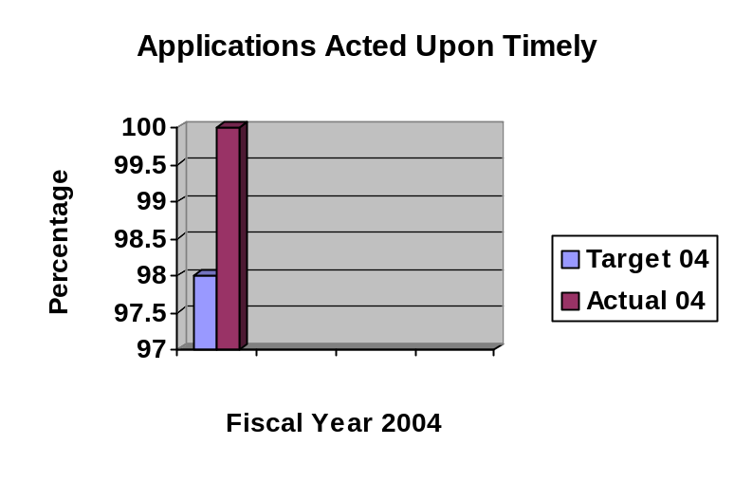
Data reliability: The data is compiled by department staff based on the total number of applications processed compared to the actual number of applications processed within five working days after receipt of all required information.
Why we are using this measure: This measure is one indicator to show that applications are timely processed to allow organizations to begin activities, which results in resources being provided for various charitable purposes.
What was achieved: 100% of the applications were processed within five working days after receipt of all required information. Processing an application will result in either licensure or denial.
Analysis of results: While the data shows the applications are processed timely, the department continues to look for ways to further improve the processing time. One improvement being considered is to develop and implement an electronic web-based licensing system with ability to accept credit card payments and with an integrated database.
Factors affecting results: Limited staffing and staff absences are two major factors impacting the ability to process applications timely. Another factor is the volume of applications at the same point in time.
Resources used: Expenditures for the Social and Charitable Gambling/TSB Unit, as a whole, for FY04 was 2.00 FTEs and $208,605.

Results
Performance Measure:  Ratio of applications processed compared to licenses/registration issued.  Performance Target:  Baseline to be established in FY04  Data Sources:  Department of Inspections and Appeals – Social and Charitable Gambling Unit | 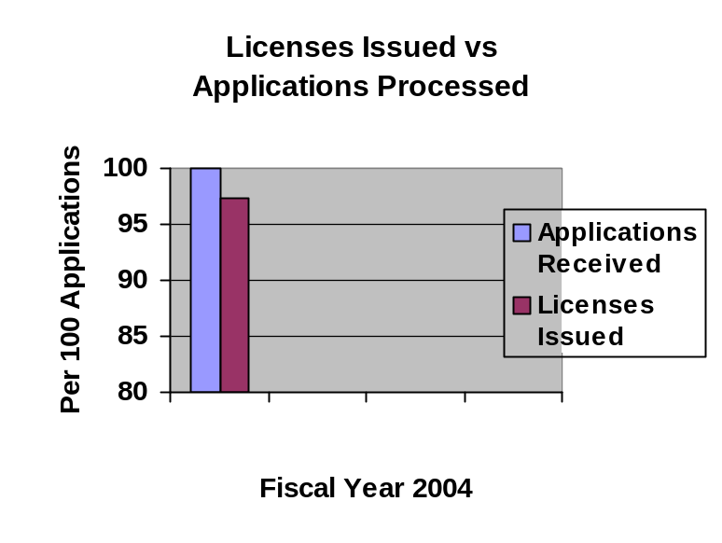
Data reliability: The data is compiled by department staff based on the total number of applications processed compared to the actual number of licenses/registration issued and using a factor of per 100 applications.
Why we are using this measure: This measure is one indicator to show that only eligible applicants are issued licenses/registration.
What was achieved: 97.4 per 100 applications were issued a license/registration. Of the 3,363 applications received, only 89 were denied.
Analysis of results: The data shows that as a result of a thorough review most applicants meet the requirements for licensure/registration. This data can also be used to compare with other data, such as complaints received, to verify applicants are eligible.
Factors affecting results: Sophistication of applicants to “use the system” to illegally obtain a license to defraud the public may be a factor affecting the results. Staff turnover without proper training would also be a factor.
Resources used: Expenditures for the Social and Charitable Gambling/TSB Unit, as a whole, for FY04 was 2.00 FTEs and $208,605.

SERVICE/ PRODUCT/ ACTIVITY

Name: Targeted Small Business Certification

Description: Statewide regulatory oversight of certification for targeted small businesses.

Why we are doing this: To protect the public from fraudulent and illegal activities by ensuring that only legitimate TSB applicants receive certification.

What we're doing to achieve results: Applications and supporting documentation are reviewed for compliance with statutory and administrative requirements in determining eligible applicants.

Results
Performance Measure:  Percentage of TSB certification application determinations made within 30 days of receipt of all required documentation.  Performance Target:  90%  Data Sources:  Department of Inspections and Appeals – Targeted Small Business Certification Unit | 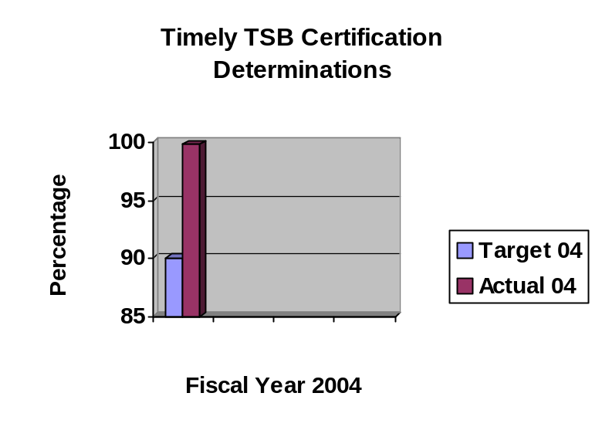
Data reliability: The data is compiled by department staff based on the total number of applications processed compared to the actual number of applications processed within 30 working days after receipt of all required information.
Why we are using this measure: This measure is one indicator to show that applications are timely processed to allow targeted small businesses to begin operation, thus providing job opportunities to Iowans, providing services within a community, and improving local and statewide economics.
What was achieved: 99.8% of the application certification determinations were made within 30 days of receipt. Only one case out of the 565 applications was not processed within the target timeframe.
Analysis of results: While the data shows the applications are processed timely, the department continues to look for ways to further improve the processing time. Through outreach efforts, in cooperation with Economic Development and Administrative Services, education and training is done to ensure applicants better understand the requirements and information required.
Factors affecting results: Limited staffing and staff absences are two major factors impacting the ability to process applications timely. Another factor is the volume of applications at the same point in time.
Resources used: Expenditures for the Social and Charitable Gambling/TSB Unit, as a whole, for FY04 was 2.00 FTEs and $208,605.

SERVICE/ PRODUCT/ ACTIVITY

Name: Food and Consumer Safety

Description: Statewide regulatory oversight of food establishments, hotels/motels, food processing plants, and egg handlers.

Why we are doing this: To protect the public from incidence of serious disease and injury in the regulated environments.

What we're doing to achieve results: The department, or through contract, conducts inspections, complaint investigations, and foodborne illness investigations, issues licenses to eligible applicants, and takes appropriate disciplinary action to ensure compliance with state and federal requirements. Contracts are monitored to ensure they meet contract compliance.

Results
Performance Measure:  Percentage of inspections conducted in compliance with the risk-based schedule.  Performance Target:  Baseline to be determined FY04  Data Sources:  Department of Inspections and Appeals – Food and Consumer Safety Bureau | 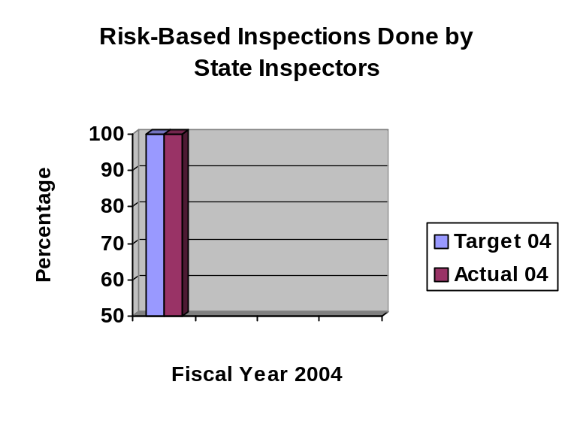
Data reliability: The data was compiled by department staff based on the total number of inspections done compared to the actual number done under the risk-based frequency criteria outline in the Food Code.
Why we are using this measure: This measure is one indicator of how the department ensures licensees are in compliance with state and federal requirements, which are based on scientific factors to reduce the incidence of foodborne illnesses. Establishments at a higher risk for foodborne illness are inspected more frequently to ensure compliance.
What was achieved: 100% of all licensed establishments were inspected through risk-based criteria.
Analysis of results: Having only reliable data available for the state inspectors, the target and measure for FY04 have been modified. After review of available data and with a new database system in place, the FY06 performance measure may be changed to show the average number of inspections per licensed establishment on a statewide basis, including the contracts. Under a risk-based approach, an average of two inspections per licensed facility would be the target.
Factors affecting results: Available staffing resources may well impact the ability to meet the risk-based inspection frequency. A dramatic increase in the number of establishments without corresponding resources would also be a factor.
Resources used: Expenditures for the Food and Consumer Safety Bureau, as a whole, for FY04 was 12.11 FTEs and $847,959.

SERVICE/ PRODUCT/ ACTIVITY

Name: Long-term care and Habilitation facilities and programs licensing/
certification

Description: Statewide regulatory oversight of health care facilities, hospitals, Medicare-certified health care providers and programs, and children’s facilities/programs.

Why we are doing this: To enhance the safety, security and general welfare of persons served in licensed/certified health-related facilities and programs.

What we're doing to achieve results: The department conducts application processing, regular surveys/inspections and complaint investigations to ensure facilities and programs are in compliance with state and federal regulatory requirements prior to making licensing/certification decisions.

Results
Performance Measure:  Ratio of the average number of months between nursing facility surveys in comparison with the federal timeframe guidelines.  Performance Target:  12:12.9  Data Sources:  Department of Inspections and Appeals – Health Facilities Division | 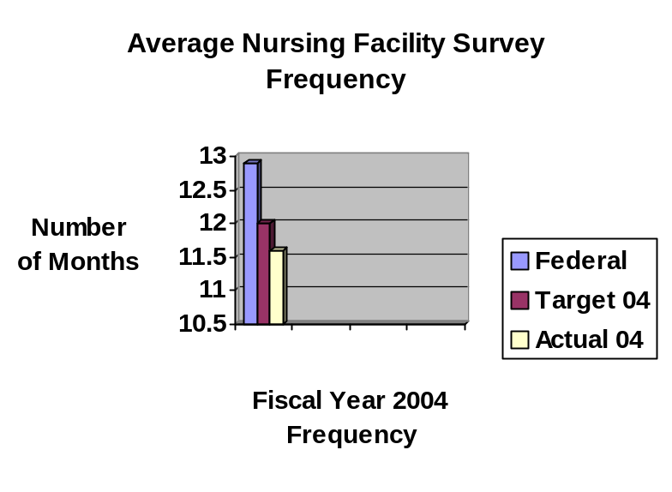
Data reliability: The data is compiled by department staff using information from specific databases and based on the actual number of months from the last survey for all facilities surveyed during the year divided by the number of facilities compared to the federal guideline of 12.9 months.
Why we are using this measure: This measure is one indicator of how the department ensures licensees are in compliance with state and federal requirements, which are based on factors to protect the health, safety and welfare of consumers of services. Federal frequency guidelines are based on how often a facility/program should be surveyed. Facilities/programs at a higher risk may be inspected more frequently or multiple times to ensure compliance.
What was achieved: A frequency rate of 11.6:12.9 was achieved, which was better than the target of 12:12.9.

Analysis of results: There have been concerted efforts by all staff to keep the survey frequency down. One of the efforts has been the implementation of a database system for monitoring surveys, which has enabled the program coordinators to make better choices in canceling a survey to provide surveyors to cover complaints. The department will continue to monitor this measure on at least a quarterly basis and take appropriate action to maintain a low frequency rate.
Factors affecting results: The biggest factor impacting the results is the number and severity of complaints received. Complaints requiring investigation initiation within 2 or 10 working days may cause an already scheduled survey to be rescheduled for a later date – this adds to the months between surveys and raises the frequency rate.
Resources used: Expenditures for the Health Facilities Division, as a whole, for FY04 was 101.65 FTEs and $9,662,656.

Results
Performance Measure:  Percentage of complaint investigations initiated within state required timeframes  Performance Target:  Baseline to be established in FY04  Data Sources:  Department of Inspections and Appeals – Health Facilities Division | 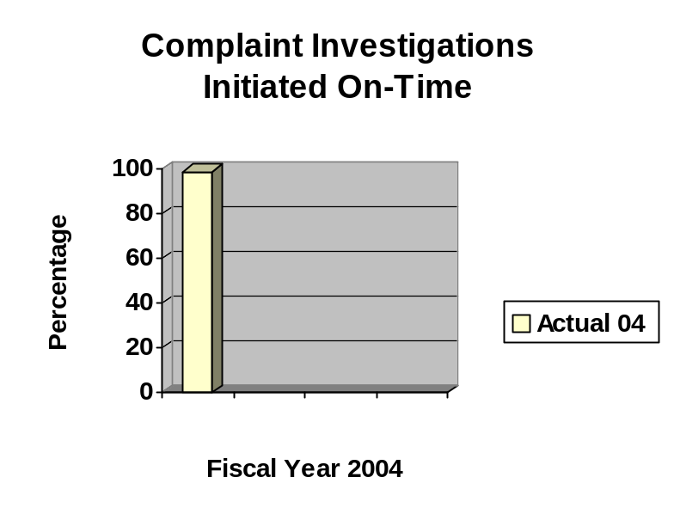
Data reliability: The data is compiled by department staff using information from specific databases and based on the actual number of days from receipt to initiation of the complaint investigation compared to the state guidelines.
Why we are using this measure: This measure is one indicator of how the department ensures licensees are in compliance with state and federal requirements, which are based on factors to protect the health, safety and welfare of consumers of services. State guidelines are based on how quickly a complaint investigation should be initiated to achieve the results.
What was achieved: 98.9% of all complaints investigations were initiated within the state guidelines.

Analysis of results: There have been concerted efforts by all staff to initiate complaint investigations timely. One of the efforts has been the implementation of a database system for monitoring surveys, which has enabled the program coordinators to make better choices in canceling a survey to provide surveyors to cover complaints. The department will continue to monitor this measure on at least a quarterly basis and take appropriate action to ensure guidelines are being met.
Factors affecting results: The biggest factor impacting the results is the number and severity of complaints received at a point in time and regular surveys already scheduled.
Resources used: Expenditures for the Health Facilities Division, as a whole, for FY04 was 101.65 FTEs and $9,662,656.
Results
Performance Measure:  Average rating of complainants rating the responsiveness of DIA staff to a complaint.  Performance Target:  4.00  Data Sources:  Department of Inspections and Appeals – Health Facilities Division | 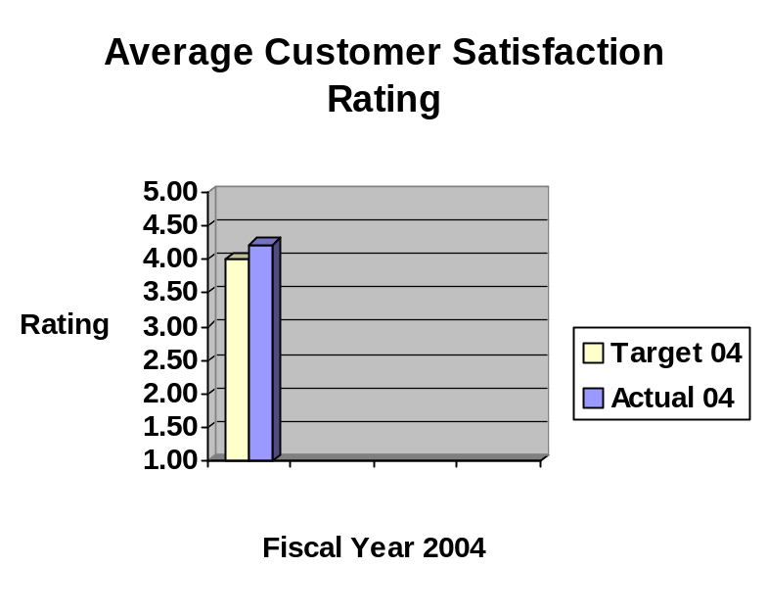
Data reliability: The data is compiled for and reported to the department by the Iowa Foundation for Medical Care using actual responses from complainants from a customer satisfaction questionnaire on a 5-point Likert scale, with 1 being Strongly Disagree and 5 being Strongly Agree.
Why we are using this measure: This measure is one indicator to show the responsiveness of the department to complaints received from the general public, staff, family, resident advocates, etc.
What was achieved: The average rating for FY04 was 4.22 compared to the target of 4.00.

Analysis of results: Satisfaction by complainants is important to the integrity of investigations. If complainants are satisfied with the responsiveness of the department in addressing their complaints, whether the complaint is substantiated or not, gives credibility to the decisions made by the department. The department will monitor the ratings on a regular basis and appropriately address any downward trends. The department will also review the detail of the responses to determine how the rating level can be improved.
Factors affecting results: One factor impacting the results is the number and severity of complaints received, which may impact the department’s ability to quickly respond. Another factor is those cases where a person(s) files ongoing unsubstantiated complaints.
Resources used: Expenditures for the Health Facilities Division, as a whole, for FY04 was 101.65 FTEs and $9,662,656.

SERVICE/ PRODUCT/ ACTIVITY

Name: Elder Group Homes, Assisted Living Program, and Adult Day Services Program Certification

Description: Statewide regulatory oversight of elder group homes, assisted living programs, and adult day services programs.

Why we are doing this: To enhance the safety, security and general welfare of persons served in certified home and community-based service environments.

What we're doing to achieve results: The department conducts application processing, regular monitoring evaluations and complaint investigations to ensure homes and programs are in compliance with state regulatory requirements prior to making certification decisions.

Results
Performance Measure:  Percentage of assisted living programs completed at least 10 days prior to certification expiration date.  Performance Target:  Baseline to be established in FY04  Data Sources:  Department of Inspections and Appeals – Adult Services Bureau | 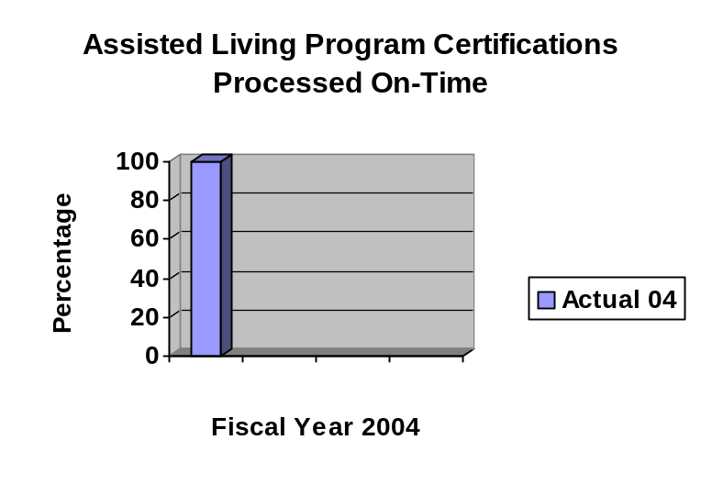
Data reliability: The data was compiled by department staff based on the actual total number of assisted living programs due for re-certification compared to the number completed prior to the certification expiration date.
Why we are using this measure: This measure is one indicator for how well the department is ensuring the health, safety and welfare of consumers of services in these homes and programs through timely certification, which includes a monitoring evaluation.
What was achieved: 100% of the programs were re-certified prior to their expiration date.
Analysis of results: The department will continue to pursue completed re-certifications prior to expiration.
Factors affecting results: Some of the factors are the availability of staff to conduct the monitoring evaluations; delay in receipt of required documentation; delay in receipt and approval of plans of correction; communications delays; and multiple re-certifications being due at the same point in time delaying processing.
Resources used: Expenditures for the Adult Services Bureau of the Health Facilities Division, as a whole, for FY04 was 5.74 FTEs and $569,990.

Results
Performance Measure:  Percentage of complaint investigations initiated within state required timeframes  Performance Target:  Baseline to be established in FY04  Data Sources:  Department of Inspections and Appeals – Adult Services Bureau | 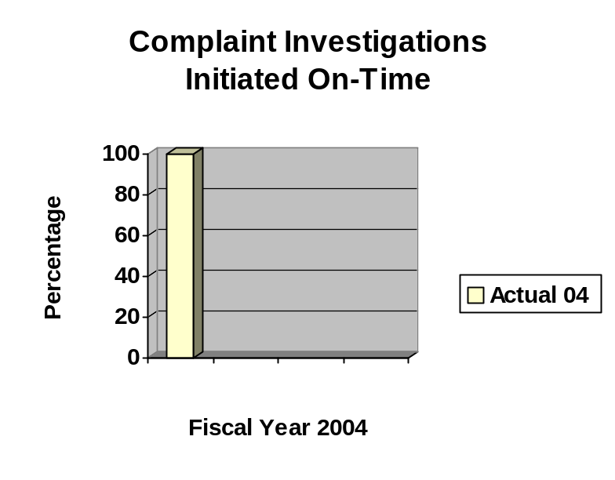
Data reliability: The data is compiled by department staff using information from specific databases and based on the actual number of days from receipt to initiation of the complaint investigation compared to the state guidelines.
Why we are using this measure: This measure is one indicator of how the department ensures certificate holders are in compliance with state requirements, which are based on factors to protect the health, safety and welfare of consumers of services. State guidelines are based on how quickly a complaint investigation should be initiated to achieve the results.
What was achieved: 100% of all complaints investigations were initiated within the state guidelines.
Analysis of results: There have been concerted efforts by all staff to initiate complaint investigations timely. The department will continue to monitor this measure on at least a quarterly basis and take appropriate action to ensure guidelines are being met.
Factors affecting results: The biggest factor impacting the results is the number and severity of complaints received at a point in time and regular monitoring evaluations already scheduled.
Resources used: Expenditures for the Adult Services Bureau of the Health Facilities Division, as a whole, for FY04 was 5.74 FTEs and $569,990.

SERVICE/ PRODUCT/ ACTIVITY

Name: Investigations Services

Description: Investigation services to the Department of Human Services (DHS) regarding various public assistance programs and the Department of Public Health (DPH) regarding professional standards.

Why we are doing this: To assure that any overpayments made in the public assistance programs administered by DHS are identified and earmarked for repayment. To provide information to professional licensing board in DPH so that the licensing board can take appropriation action in response to professional standards complaints.

What we're doing to achieve results: Through research, audits, and interviews, the department conducts economic fraud investigations, front-end investigations, and Medicaid fraud investigations to determine if a person or provider obtained public assistance benefits through fraudulent action, agency error, or non-fraudulent action. The department also conducts investigations for professional licensing boards to obtain information about complaints directed at professions governed by those boards.

Results
Performance Measure:  Percentage of economic fraud investigation cases closed within statutory timeframes.  Performance Target:  Baseline to be established in FY04  Data Sources:  Department of Inspections and Appeals – Investigations Division | 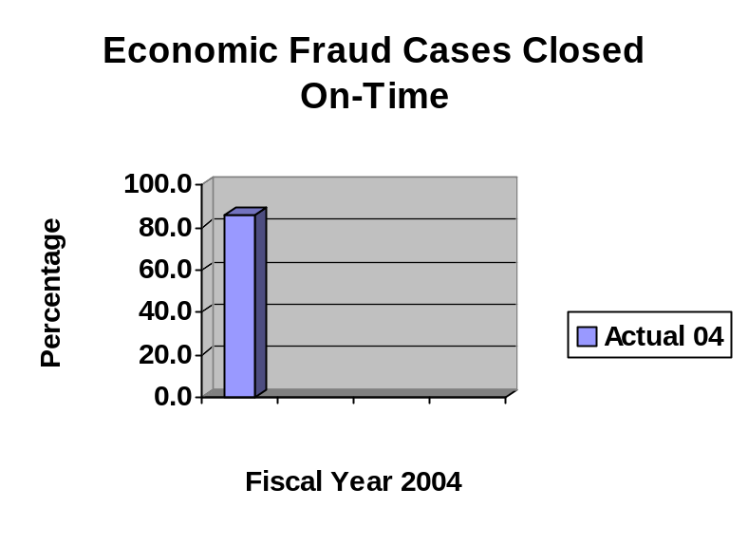
Data reliability: The data was compiled by department staff based on the number of cases investigated during the year compared to the number initiated within statutory timeframes.

Why we are using this measure: This measure is one indicator to show how well the department is doing in completing investigations timely and ensuring that state and federal dollars owed are identified.
What was achieved: 85.6% of the cases were completed in the fiscal year.
Analysis of results: During the last fiscal year, emphasis has been placed on identifying and completing fraud cases that are out of and approaching criminal statute of limitations. The creation of a new investigative database has been established to assist in tracking and identifying statutory timeframes. This action will assist management efforts to ensure cases are done timely.
Factors affecting results: One factor impacting the results is the number of referrals being determined by DHS, along with limited staffing levels to address increases in referrals. Another factor is the complexity of the case and cooperation of the involved parties.
Resources used: Expenditures for the Investigations Division, as a whole, for FY04 was 38.91 FTEs and $3,067,821.

Results
Performance Measure:  Rate of completion of professional standards investigations.  Performance Target:  Baseline to be established in FY04  Data Sources:  Department of Inspections and Appeals – Investigations Division | 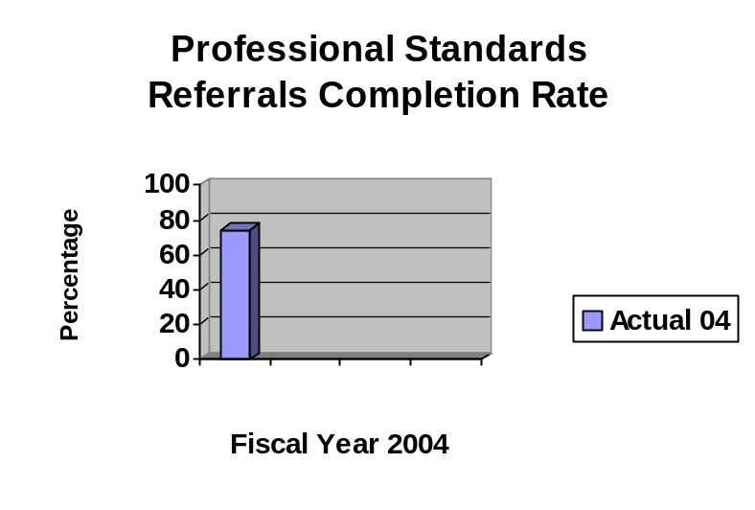
Data reliability: The data was compiled by department staff based on the number of cases referred in the year compared to the number actually completed.
Why we are using this measure: This measure is one indicator to show how well the department is doing in completing investigations timely and ensuring that professional licensing boards have timely information from which to make licensing and disciplinary decisions.
What was achieved: 51% (105 out of 206) of the cases pending from the prior year and referred during FY04 were completed within in the fiscal year.
Analysis of results: A temporary reduction in staffing levels and training of new staff impacted the results. In addition, 39 of the cases were referred as priority or a request for additional information, which creates delays in the investigation of other cases already in process or new referrals.

Factors affecting results: One factor impacting the results is the number of cases referred by DPH, along with limited staffing levels to address increases in referrals. Another factor is the complexity of the case and cooperation of the involved parties.
Resources used: Expenditures for the Investigations Division, as a whole, for FY04 was 38.91 FTEs and $3,067,821.

SERVICE/ PRODUCT/ ACTIVITY

Name: Collections Services

Description: Collection of overpayments in various public assistance programs.

Why we are doing this: To assure repayment of any overpayments made in the public assistance programs administered by DHS.

What we're doing to achieve results: The Investigations Division uses various collections methods, including but not limited to: voluntary repayment agreements, state tax offset, small claims, and court-ordered repayment.

Results: The original performance measure was revised from what was submitted in the performance plan to a more realistic measure in terms of data collection. The results are reported under the Core Function section.

SERVICE/ PRODUCT/ ACTIVITY

Name: Audit Services

Description: Local DHS offices and health care facility financial audits.

Why we are doing this: To assure that local DHS offices and health care facilities comply with state and federal law related to financial resources.

What we're doing to achieve results: The Investigations Division conducts financial audits to identify any audit exceptions and follows up to ensure that reimbursement for audit exceptions are timely made to the state or federal government or to residents/families.

Results: The results are reported under the Core Function section.

PERFORMANCE PLAN RESULTS

CORE FUNCTION and SERVICE/ PRODUCT/ ACTIVITY

Name: Resource Management - 67

SPAs: Fiscal Services and Administrative Services

Description: Fiscal and administrative services provided to all agency personnel.

Why we are doing this: To provide consistently accurate and timely administrative and fiscal services to agency personnel so they can better provide their services to department constituencies.

What we're doing to achieve results: The department has a central staff to provide coordinated, efficient and cost-effective fiscal and administrative services, such as budgeting, financial management, inventory, claims processing, human resources, public information, information technology, vehicle coordination, purchasing, enterprise management, etc., to all divisions and attached units.

Results: Capturing reliable data with the current Resource Management performance measures has proven challenging for the department. We are able to report that there have been no significant reportable audit exceptions noted in the department’s audit reports, non-general fund sources for the department exceed the target of 67%, and the majority of media and public information inquiries are responded to within 48 hours and generally within 24 hours.

As a result of our data challenge, we will be revising the performance measures for Resource Management for FY05 and FY06.

RESOURCES REALLOCATIONS

During FY04, the Department continued to address the challenge of limited human and financial resources, resulting from prior years’ budget reductions and early out programs. This challenge was addressed by vacant positions being left open for longer periods of time, negotiating with the federal government to reduce state match rates for federal funds, applying for and receiving federal and private grants, and using temporary staff.

Some additional resource reallocations included:

Work processes in the Employment Appeal Board (EAB) were modified to improve timely case processing to ensure federal timeliness guidelines for issuing decisions are met. With staff input, it was determined that accomplishing initial appeal intake through transcript production a minimum of 28 days prior to the 45 days benchmark provided enough time to get transcripts copied, sent to the parties for a 10-day review period, and on a Board list with ample time for adjudication while meeting the federal timeliness standards. Work assignments were realigned to accomplish and monitor timely case processing. In addition, EAB is also investigating technology changes that can improve production (currently testing CD transcription vs tape transcription). Iowans benefit from these improvements by receiving timely adjudication of the rights and duties or employers and employees under unemployment compensation laws.

The State Public Defender (SPD) reallocated $1 million from the Indigent Defense Fund to allow the SPD to fill attorney vacancies that had been held open for budget reasons, resulting in public defenders handling more cases and reducing overall indigent defense costs. One vacant supervisor position was transferred from Burlington to Muscatine and one vacant staff attorney position was transferred from Sioux City Adult to Muscatine. This action allowed Muscatine to realign from a branch office to an independent trial division field office, with further allowed the SPD to designate Muscatine to receive appointments in Class A and B felonies throughout the 7th Judicial District, further reducing overall indigent defense costs.

AGENCY CONTACTS

Copies of the Iowa Department of Inspections and Appeals’ Agency Performance Report are available on the Results Iowa web site (www.resultsiowa.org) and the DIA web site (www.state.ia.us/government/dia/index.html). Copies of the report can also be obtained by contacting Beverly Zylstra at 515-281-6442 or via e-mail at beverly.zylstra@dia.state.ia.us.

General Contact Information:
Iowa Department of Inspections and Appeals
Lucas State Office Building
321 East 12th Street
Des Moines, IA 50319
(515) 281-7102
Telephone Number of the Hearing Impaired: 515-242-6515

