Iowa Department of Corrections

Annual
Performance Report

Fiscal Year 2005


Table of Contents

Section Page

- Introduction 3

- Agency Overview 5

- Key Results 9

- Agency Performance Plan Results 14

- Resource Reallocations 19

- Agency Contacts 19

Introduction

The Department of Corrections is pleased to provide its Annual Performance Report for fiscal year 2005 in compliance with requirements of the Iowa’s Accountable Government Act. The following pages outline the Department’s overall mission and purpose, key products and activities, Strategic Plan initiatives, Performance Plan results and highlights of services to Iowans during the last fiscal year.

Over the past year the Department has formalized our approach to performance measurement and has developed processes for the regular review of performance results by Department leadership. The Department has expanded its use of data in daily management and decision making at all levels of the organization, improved the accuracy of that data, and continues to fine-tune its ability to focus on indicators of those factors that enhance our ability to impact offender outcomes.

The Department is committed to the goals and principles of accountable government, embracing the concept that accountability and responsiveness to the people of Iowa are central to achieving our mission. The responsibility for the safety and well being of our ultimate customers, the citizens of Iowa, is of foremost consideration.

The Departments’ key services include: the assessment and identification of the risk offenders pose to the community; the effective management of individual offender risk and offender accountability; the reduction of future risk from supervised offenders through the use of intervention and treatment programs that have been shown to impact criminal behavior; and management of the facilities and resources that provide for healthy, safe and humane environment for staff and offenders.

The Departments’ key strategic initiatives focused on the areas of: enhancing public and staff safety; controlling prison population growth through offender case planning and reentry initiatives; utilizing “best practices” in operations and programming to achieve the departments mission; and reinventing the way the Department does business to manage resources in the most cost effective manner.

The Department's key accomplishments include the progress made in its ability to collect and analyze performance data on an outcome, rather than output, level. The continued development and expansion of the ICON offender data system enhances the ability to use data to better manage local and statewide operations on a daily basis. ICON’s linkage with the Criminal Justice Data Warehouse has provided an opportunity to link corrections data with data from the Iowa Courts. This capability will provide key outcome data relative to offender recidivism, offender compliance with court directives, and offender reparation to victims and society.

The Department met or exceeded 48% of its 2005 performance targets, and did not meet 36%. 14 % of the performance measure areas produced baseline data, which will provide the foundation for future performance analysis.

Key strategic initiative results include:

Enhancing public & staff safety: The Department has maintained a safe and constitutional system as evidenced by the limited number of critical incidents, escapes, injuries to staff, and adverse court findings. While the number of inmate suicides was higher than anticipated, the Department has responded with major initiatives to better manage and treat mentally ill offenders.

Controlling prison population growth: While the Department continued to experience prison populations that exceeded capacity, efforts to stabilize that population were successful. The delayed development of the offender Re- Entry Case Plan impeded the ability to meet initial targets. The Department initiated a Kaizen improvement process that expanded the scope of the initiative but has resulted in reengineering of the offender release and reentry process that begins at the point an offender enters the corrections system. These changes are anticipated to not only reduce length of stay, and therefore prison populations, but should also enhance the Department's ability to manage its housing and treatment program resources.

Utilizing Best Practices: Analysis of the use of validated risk assessment tools, a best practice, has indicated that the tools of custody classification, LSI-R, and Iowa Risk Assessment are being applied within acceptable parameters and indicate the corrections system finds them credible in identifying offender risk and need. Our ability to examine our success at linking correctional interventions with offenders’ criminogenic needs was limited by the delayed development of the offender Re-Entry Case Plan. When finalized, this plan will reside on the ICON automated offender record and not only be utilized by all components of the corrections system but will link the plan with the LSI- R, another best practice tool, that will identify and prioritize offender need. This will for the first time, enable the department to analyze our effectiveness in correctly linking our intervention efforts with criminogenic needs (those that contribute to criminal behavior) in a comprehensive way.

Reinventing Government: The Department volunteered to become a Charter Agency. Through utilization of Charter Agency flexibilities, DOC met its goal of reducing operating cost by $500,000. It also achieved the goal of increasing the amount of non-general funds into the DOC operating budget by 2% or $175,000. The Department was not able to reduce the amount of salary dollars redirected to support expenditures due to fixed costs such as food, and fuel. The Department was, however, successful in generating significant savings in the cost of pharmaceuticals. A Charter Agency pilot program in which four institutions participated in a pharmaceutical purchasing contract resulted in those institutions not experiencing cost increases and instead spending only 74% of the total amount spent the prior year.

Agency Overview

Mission Statement

The mission of the Iowa Department of Corrections is to: Protect the Public, the Employees, and the Offenders.

Public
- Prevent escapes and maintain accountability of offenders in the community
- Increase community safety in support of a vital economy
- Reduce recidivism and increase the self-responsibility of offenders
- Keep citizens informed about corrections issues and activities
- Make responsible decisions about the use of taxpayer dollars
- Attend to the needs and concerns of victims
- Treat members of the public with respect

Employees
- Provide current equipment and staffing to insure employee safety
- Provide for a safe working environment
-  Attend to emotional and physical well being of employees
- Maintain high levels and standards for training
- Insure policies are sound, current, and consistently and fairly enforced
- Treat employees with respect

Offenders
- Provide a physically and mentally safe and healthy environment for offenders
- Manage offenders in a firm, fair and consistent manner
- Provide programming, training and education to encourage good work habits and pro-social interaction
- Promote pro-social thinking with contemporary programming
-  Keep offenders informed about current corrections policies and procedures
- Develop community support and partnerships that foster reintegration
- Treat offenders with respect

Vision Statement

The Iowa Department of Corrections will be recognized as a national leader in providing a fully integrated corrections system. As the nation’s leader, we will provide the most sophisticated and strongly supported continuum of community and institution programs and services.

- We will be seen as an organization that delivers research-driven correctional programs of the highest quality while utilizing the most effective communication and technology resources to provide “best practices” management.

- We will be known as an organization that is driven by a strong value system that recognizes the intrinsic worth of all human beings, respects and recognizes the needs of victims, and holds the belief that offenders can change their lives.

- We will be known for our staff development and training programs that engender the strong ethics, diversity, and professional nature of this Department.

- We will be known for keeping operational costs low, while providing high-quality programs in a safe environment.

- We will be seen as a highly credible Corrections Department that focuses on its mission, and takes care of its people.

Overview

The Department of Corrections is a public safety agency within the Safe Communities enterprise of the executive branch of state government. The Department is charged with the supervision, custody, and correctional programming of convicted adult offenders who are sentenced by the state Courts for a period of incarceration in State prisons.
The Department has funding and oversight responsibilities for the state’s eight Judicial District Departments of Correctional Services, which provide the community supervision and correctional services component of Iowa’s adult correctional system across the state. The legislatively appropriated budget is administered and allocated by the Department of Corrections, and the Department oversees the Districts’ compliance with requirements of the Iowa Administrative Code through an annual purchase of service agreement with the Department of Corrections which sets forth programming, administrative, financial, and operational requirements

Under the leadership of Gary D. Maynard, the Department is structured into five main divisions: Administration, Western Region, Eastern Region, Offender Services and Iowa State Industries. Support process operations include Policy and Legal, Training and Professional Development, Information Technology, and Human Resources. The Department oversees a General Fund budget of over $292,000,000.

The Department operates nine major institutions that operate 24 hours a day throughout the year. The Department is responsible for providing “control, treatment, and rehabilitation of offenders committed under law” to its institutions.
This is accomplished by the classification of offenders to identify their security risk and their individual offender needs that contribute to their criminality, and assignment to supervision levels and correctional interventions that will address those needs. Recognition of the ultimate release of most offenders makes release planning and transitioning a key component of institutional operations.

Iowa State Industries operates offender training and employment opportunities at Iowa’s institutions. Work programs include furniture, farming, printing, and private sector employment projects. Work programs enhance an offender’s ability to maintain employment upon release as well as in meeting their financial obligations to their families and victims of their crimes.

Iowa’s eight Judicial District Departments of Correctional services provide supervision and services to offenders in the community who are on pre trial release, probation, parole, or work release. Each district has a number of satellite offices in communities around the state and operates 23 residential facilities. The charge to the Districts is to “provide pretrial release, pre sentence investigations, probation services, parole services, work release services, programs for offenders convicted under Iowa Code 321J (OWI), and residential treatment centers throughout the district, as necessary”. Community programs complete the seamless system of risk and need assessment, correctional supervision and interventions while also utilizing resources of partners (such as mental health, substance abuse, education) that exist in those communities.

Offender case planning creates the road map that guides the corrections system as the offender makes his / her way though the various components of the correctional continuum. This Re-Entry Case Plan not only insures that each offender is managed and transitioned in a manner that is most effective for that offender but also insures that correctional resources are aligned where and when offenders most require them.

Currently the system employs approximately 4,100 staff, houses approximately 8,700 offenders in prison, and supervises over 30,000 offenders in the community.

DOC activities and operations are administered by a Director, appointed by the Governor and advised by the Corrections Board, and a DOC executive staff. A Director appointed by the District Board administers each of the District Departments.

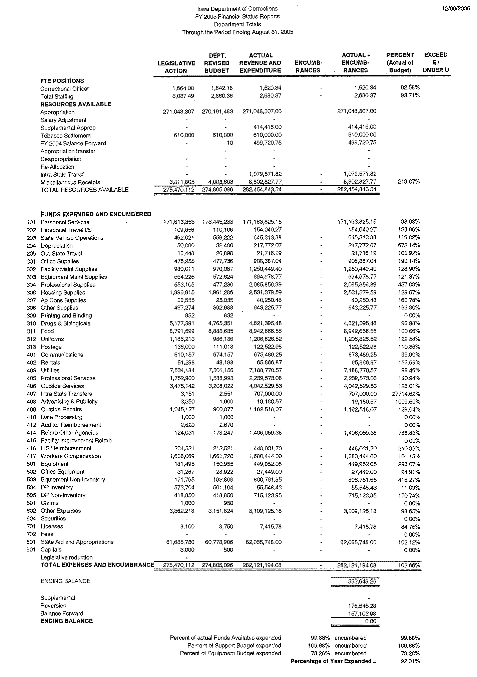
FY 2005 Financial Report
KEY RESULTS

CORE FUNCTION

Name: Offender Supervision Custody, & Treatment Core Function: Critical Incidents

Description: The Department of Corrections manages offenders in correctional institutions in a manner that minimizes the risk of offender harm within the institution and to the community

Why we are doing this: The citizens of Iowa must be protected from harm from offenders sentenced to the care and custody of the Iowa Department of Corrections.

What we're doing to achieve results: In order to safely and effectively manage offenders, the Department must assess and classify offenders in order to house them in facilities that provide the necessary security and programming to control their risk to themselves, staff, and the general public. Offenders must be supervised by trained staff, utilizing “ best’ correctional practices.

Results
Performance Measure:  Number of critical incidents: assaults on staff and offenders, escapes, suicides, homicides, and disturbances  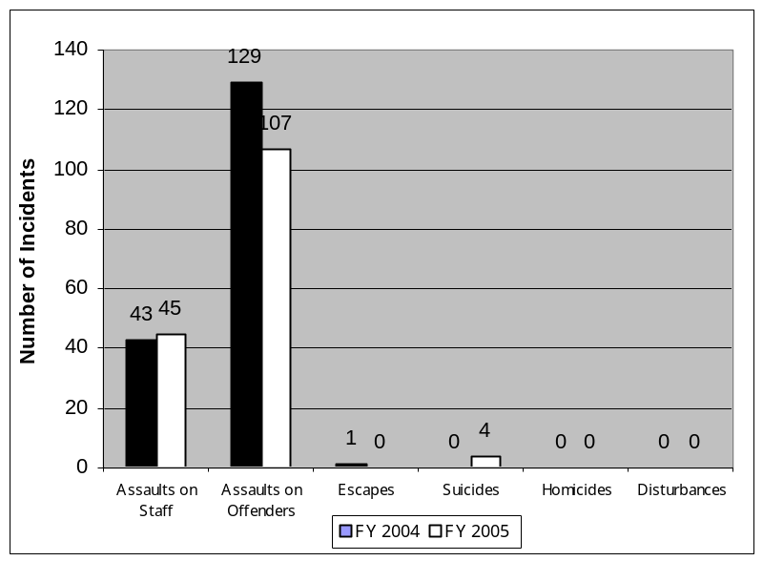  Performance Target:  (Reflects goal of no increase over prior year)  43 assaults on staff  129 assaults on offenders  1 Escape  0 Suicides  0 Homicides  0 Disturbances | Critical Incidents

What was achieved: The number of staff injuries increased only slightly, the number of offender assaults with injury decreased, the number of escapes was reduced to zero, and the number of homicides and disturbances remained at zero.
Data Sources: Institutions report critical incidents via statistical workbooks maintained on the Outlook system.

Resources: These activities are funded through General Fund appropriation and Iowa Prison Industry revolving fund. Thos activities, conducted at Iowa's correctional institutions and prison industry/farm operations, were delivered at a cost of $218,384,830.40. FTE totals are not available.

KEY RESULT

Service, Product, and Activity

Name: Basic Life Care SPA: Constitutional System

Description: Court findings that the Department is in violation of constitutional requirements of deliberate indifference, cruel and unusual punishment, or lack of due process.

Why we are doing this: The citizens of Iowa expect Iowa’s’ correctional system to manage and treat offenders in fair and humane ways that comply with basic human rights provided by the constitutions. Failure to comply may results in additional costs both in terms of litigation costs or actual damages. It may also result in regular oversight by the courts or all or part of the corrections system. Ultimately a non-compliant system decreases public trust.

What we're doing to achieve results: The Department trains staff in legal rights and responsibilities. Policy and procedure are promulgated to insure that these rights are protected on a daily basis. Facilities and basic life care services address inmates daily needs. Offenders my address their grievances via a court sanctioned grievance process which provides opportunities to correct problems before they rise to the level that would lead to litigations.

Results
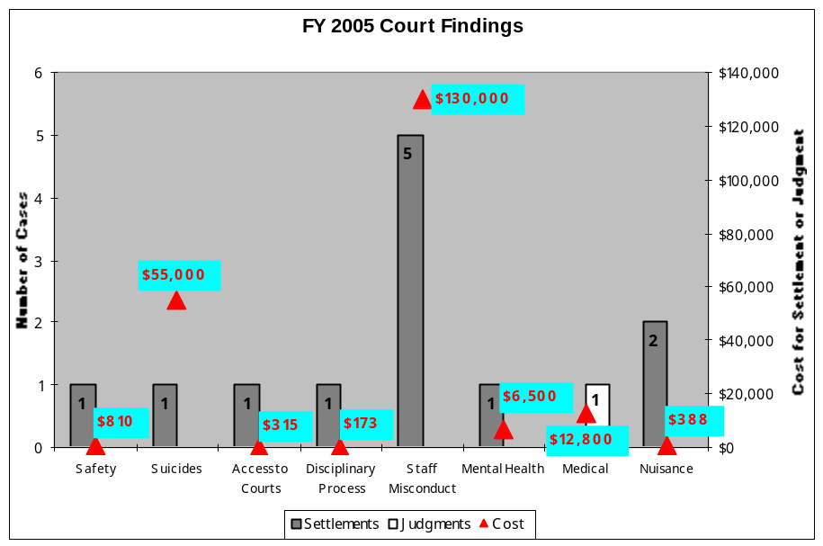
Performance Measure:  Findings by Courts of instances of deliberate indifference, cruel and unusual punishment, or lack of due process.  Performance Target:  Zero findings | Target = 0

What was achieved: There was one adverse judgment during the fiscal year. There were twelve settlements generating costs and fees totaling $205,986..
Data Sources: Department General Counsel & Attorney General of Iowa

Resources: These activities are funded through General Fund appropriation to Iowa's nine correctional institutions at a cost of $77,256,052.51. FTE totals are not available.

KEY RESULT

STRATEGIC GOAL

Name: Controlling prison population

Description: The Department has instituted a number of initiatives to both control the number of offenders coming into the prison system as well as to expedite the safe release of offenders back into their community

Why we are doing this: Correctional institutions are best safely and humanely managed when they do not house more offenders than their physical plant and program resources are designed to accommodate. Due to the high cost of building prisons and housing offenders in a prison setting, it is fiscally sound to manage offenders at the lowest possible level that corresponds to their risk.

What we're doing to achieve results: The Department has continued to improve its utilization of validated assessment tools to identify risk and program need. Classification systems make sure offenders are supervised at the lowest appropriate level consistent with risk. The department continues to devote resources to insure that there are adequate community corrections resources to manage offenders most economically in the community. The Department continues their effort to evaluate the effectiveness of correctional programs at reducing risk of future offenses and redirecting resources from programs that are not found to be effective. The Re-Entry Case Plan deployment will provide a seamless system for offenders to flow through the corrections system in the most efficient and effective manner. The provision of adequate institution program resources will insure offenders are not held in prison while awaiting program participation.
Results
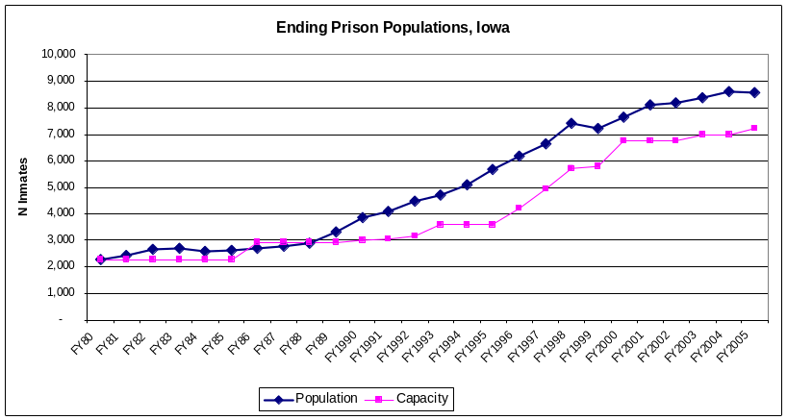
Performance Measure:  Offender prison population as percent of capacity.  Performance Target:  100% | Insert chart or graph

What was achieved: Iowa’s prison population has remained stable at 119 % of capacity throughout the fiscal year. While the population was not reduced to design capacity, the continued rise that had previously been experienced has successfully been controlled.
Data Sources: ICON

Resources: These activities are provided by General Fund appropriation and locally generated funds. Activities are carried out in the Department of Corrections Central Office, nine correctional institutions, and eight judicial districts. Cost for these activities totaled $323,844,249.51. FTE totals are not available.
KEY RESULT

STRATEGIC GOAL, CORE FUNCTION, & SERVICE/PRODUCT/ACTIVITY

Name: Offender Supervision, Custody, and Treatment Core Function: Best Practices
Risk Identification & Risk Management SPA

Description: Appropriate, research-based intervention strategies and programs, offenders referred to interventions consistent with identified criminogenic needs, and offender release planning.

Why we are doing this: By utilizing nationally recognized correctional offender management “best practices” the Department will ensure that limited resources are directed where they will have the most impact in changing offender behavior for the long term thereby impacting levels of recidivism and assisting offenders to become contributing members of their safer communities.

What we're doing to achieve results: The Iowa Department of Corrections is redesigning offender case management processes in line with nationally recognized correctional practices shown to impact behavior change and recidivism. These include assessing offenders needs, creating an individualized re-entry case plan that outlines the course of supervision and program interventions for an offender, and places the offender in programs and interventions that are linked to the needs that contribute to their criminality. These programs must also be evaluated to determine if they comply with nationally recognized standards.

Results
Performance Measures:  - Percent of offenders who receive appropriate, research-based intervention strategies.  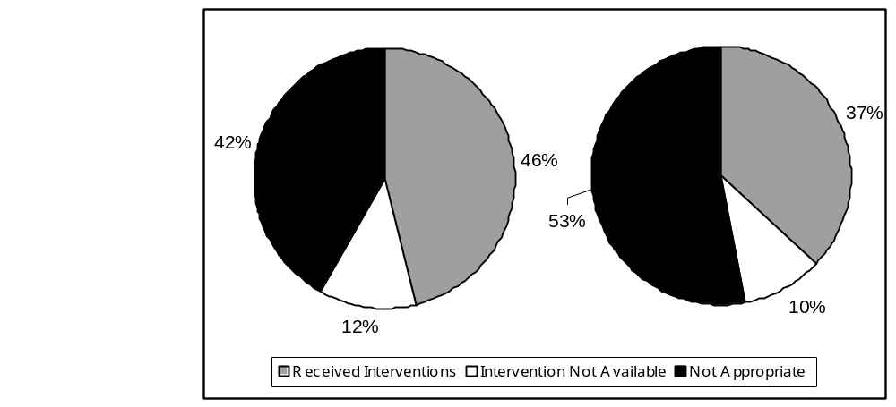  - Percent of offenders referred to interventions consistent with identified criminogenic needs and appropriate level of service on the LSI-R assessment.  - Percent of offenders with documented release plans.  Performance Target:  Research based interventions - 75%  Interventions linked with need - 90%  Release plans - 90% | FY 2005 Interventions  Community Institutions

What was achieved: The offender Re-Entry Case Plan was designed and the reentry process was redesigned. The process was not completed in time to deploy and ultimately generate meaningful data. During the next fiscal year the Department will be better able to gather relevant measurement data and will begin the long-term process of evaluating correctional programs.
Data Sources: ICON

Resources: These activities are funded through General Fund appropriation and locally generated funds. Programs and services are delivered at Iowa's eight judicial districts and nine correctional institutions at a total cost of $44,5630,709.51. FTE totals are not available.

KEY RESULT

STRATEGIC GOAL& SERVICE/ PRODUCT/ ACTIVITY

Name: Fiscal efficiencies produced by change in “doing business" processes. Fiscal Management SPA

Description: The Department implemented a Charter Agency pilot program to control ever increasing costs of institution pharmaceuticals.

Why we are doing this: The cost of institution pharmaceuticals has been spiraling higher year after year. Since the provision of medical care at a level that complies with recognized standards of care requires the provision of medications to inmates who are presenting with increasingly complex medical conditions, the cost of pharmaceuticals was growing out of control. To meet these costs, funds were often diverted from personnel thereby reducing the number of staff that was available to perform critical functions.

What we're doing to achieve results: Through a pilot project a purchasing contract was developed for four institutions.

Results
Performance Measure:  Pharmaceutical cost increase compared to FY 04 costs.  Performance Target:  $377,481 | Pharmaceutical Costs – Charter Agency Pilot  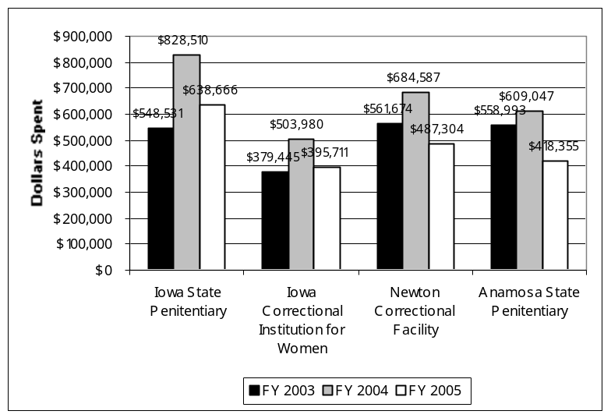

What was achieved: Participating institutions experience no pharmaceutical cost increase and reduced the cost of their pharmaceuticals spending only 74% of what had been spent the year before.

Data Sources: Institution financial reports.

Resources: These activities are funded by General Fund appropriation. Services are delivered in the Department of Corrections Central Office, eight judicial districts, and nine correctional institutions at a total cost of $8,679,329.10. FTE totals are not available.

Name of Agency: Iowa Department of Corrections
Agency Mission: Protect the Public, the Employees, and the Offenders
Core Function: Offender Supervision, Custody, and Treatment
Performance Measure (Outcome) | Performance Target | Performance Actual | Performance Comments & Analysis
1. Percent of offenders supervised at level commensurate with risk assessment. | 90%  No Override | 86%  No Override | What Occurred: Performance standards were not met however levels of overrides of validated risk assessment instruments were within acceptable standards than as compared to national standards. The performance target was set higher than national standards and will be adjusted.  Data Source: ICON
2. Number of critical incidents.  Assaults  Escapes  Suicides  Offender violence | 43  0  0  0 | 45  0  4  0 | What Occurred: Performance was at or near targets in all areas except offender suicide. Several mental health initiatives have been implemented to address causal factors.  Data Source: DOC Statistical Workbook
3. Offenders meet court ordered obligations. | 75% | 56% & 18% | What Occurred: The target was not achieved. 56% of community offenders met restitution obligations. 18% of institution offenders met their restitution obligations.  Data Source: Criminal Justice Data Warehouse
4. Percent of offenders who receive appropriate research- based, intervention strategies. | 0 | Not available | What Occurred: Evaluations of intervention programs have not been completed. Offender Re entry Case Plans deployment was delayed to FY ’06. Data comparisons linking needs to research-based interventions will be possible in FY ’06.  Data Source: ICON
5. Findings by Courts of constitutional requirement violation. | 0 | 1 | What Occurred: The performance target was not achieved.  Data Source: DOC General Counsel

Service, Product or Activity: Risk Identification
Performance Measure | Performance Target | Performance Actual | Performance Comments & Analysis
1. Percent of offender case files audited for LSI Quality Assurance. | 5% | 3% & 5% | What Occurred: The performance target was not achieved in institutions but was achieved in the community.  Data Source: ICON
2. Percent of offenders referred to interventions consistent with identified criminogenic needs and appropriate level of service on  LSI-R assessment. | 90% | 88% & 90% | What Occurred: The performance target was partially attained. Institutions placed 88% of offenders and Judicial Districts place 90% of offenders.  Data Source: ICON
Service, Product or Activity: Risk Management
Performance Measure | Performance Target | Performance Actual | Performance Comments & Analysis
1. Percent of offenders with documented release plans. | 90% | 0 | What Occurred: The target was not achieved. The implementation of this initiative was delayed until completion of a process improvement project and will be completed in FY 06.  Data Source: DOC
2. Number of recommendations for release to Parole Board. | 4, 948 | 5034 | What Occurred: The performance target was exceeded. Parole recommendations increased by 7% rather than the targeted 5%  Data Source: DOC
3. Reduction in rate of probation technical violations that result in institutionalization. | 2% | Not available | What Occurred: Data analysis program is currently being rewritten and validated.  Data Source: Criminal Justice Data Warehouse
4. Ratio of successful to unsuccessful probation and parole status closures. | 4:1 | 3.4 / 1 | What Occurred: The performance target was not achieved.  Data Source: ICON

Service, Product or Activity: Risk Reduction
Performance Measure | Performance Measure | Performance Actual | Performance Comments & Analysis
1. Percent of successful to unsuccessful intervention closures. | 75% | 15% to 86% | What Occurred: Fourteen community interventions were measured. Success rates ranged from 45% to 86%. Five institution interventions were measured. Success rates ranged from 15% to 77%. Further evaluation is underway.  Data Source: ICON
2. Hours of Offender Public Service Work. | 637,656 Hours | 645,063 | What Occurred: The target of a 10% increase was exceeded by an increase of 11%.  Data Source: DOC Statistical Workbook
Service, Product of Activity: Basic Life Care
Performance Measure | Performance Measure | Performance Actual | Performance Comments & Analysis
Facilities’ compliance with standards of care, safety, constitutional requirements and standards, and state and local mandates. | 90 days | 90 days | What Occurred: The performance standard was achieved. Concerns were corrected within 90 days.  Data Source: DOC Offender Grievance system.

Name of Agency: Iowa Department of Corrections
Agency Mission: Protect the Public, the Employees, and the Offenders
Core Function: Resource Management
Performance Measure (Outcome) | Performance Target | Performance Actual | Performance Comments & Analysis
1. Percent of support dollars expended per dollar budgeted. | 100% | 102.5% | What Occurred: The target was not achieved. Fixed support costs (food, fuel, pharmacy, etc.) exceeded budget.  Data Source: DOC Financial Reports
2. Percent of new hire staff turnover. | 9.9% | 10.71% | What Occurred: The target was not achieved.  Data Source: DOC Statistical workbook.
3. Number of stakeholder meetings. | 10 | 36 | What Occurred: The targeted number of stakeholder meetings was exceeded.  Data Source: Director Log
4. Percent of ICON available for institutions use. | 80% | 100% | What Occurred: All eight new modules were brought on line thereby exceeding the target.  Data Source: ICON
Service, Product or Activity: Leadership and Oversight
Performance Measure | Performance Target | Performance Actual | Performance Comments & Analysis
1. Percent of institution policies consistent with DOC policies. | 100% | Not available. | What Occurred: Compliance levels were not measured due to system wide revision of DOC policy.  Data Source: DOC
2. Reporting compliance with Prison Rape Elimination Act. | 100% | 100% / not available | What Occurred: Institution data was reported at 100% level. District data is incomplete. Reporting mechanism is being established at Judicial District Department level.  Data Source: DOC Statistical Workbooks
3. Number of Districts with Evidence Based Practice Advisory Committees. | 100% | 100% | What Occurred: Performance target was achieved.  Data Source: DOC

Service, Product or Activity: Fiscal Resources & Management
Performance Measure | Performance Target | Performance Actual | Performance Comments & Analysis
1. Increase in cost of institutional pharmaceuticals. | $377,481 | 0 | What Occurred: Target exceeded. Costs at institutions participating in pilot purchase project experienced no cost increase and spent only 74% of what had been spent in  FY 04 was expended.  Data Source: DOC Financial reports.
2. Percent of offenders diverted to Diversion programs. | 100% | Not available | What Occurred: Data could not be captured from offender management data system. A system wide definition of Diversion Program is not available.  Data Source: NA
Service, Product or Activity: Employee Focus
Performance Measure | Performance Target | Performance Actual | Performance Comments & Analysis
1. Correctional Officer Overtime as percent of payroll | 1. 5 % | 2. 29 % | What Occurred: The target was not achieved. Leadership continues to analyze the source of overtime costs.  Data Source: DOC Statistical Workbooks
Service, Product or Activity: Information Systems and Records
1. Number of operational informational modules added to ICON. | 8 | 8 | What Occurred: Planned additions were completed.  Data Source: ICON

Resource Reallocations

The Department of Corrections utilized its status as a Charter Agency to change the way it conducted business in several areas. Resources that were conserved as a result of these efforts were utilized to meet the ever-rising fixed costs driven by operating facilities, “twenty- four by seven”, with ever increasing offender caseloads. Historically fixed costs such as food, fuel, and pharmaceuticals exceed budgeted expenditures thereby diverting funds from personnel to support. However, efficiencies were produced in FY 2005 which resulted in the Department being able to fill critical positions in order to not only provide the necessary level of offender supervision, but to operate facilities and programs in a constitutionally compliant manner.

Agency Contact Information

Copies of the Iowa Department of Corrections Performance Report are available on the DOC Web site at www.doc.state.ia.us. Questions can be directed to Barbara Olk Long at 515-242-5756

Iowa Department of Corrections
420 Watson Powell Jr. Way
Des Moines, Iowa 50309
515-242-5702

