Department of Commerce
Iowa Utilities Board

PERFORMANCE
REPORT

Performance Results Achieved
for Fiscal Year 2004

SECTION PAGE

INTRODUCTION 1
AGENCY OVERVIEW 2
Guiding Principles/Core Values 2
STRATEGIC PLAN RESULTS 4
Goal # 1 4
Goal # 2 5
Goal # 3 6
PERFORMANCE PLAN RESULTS 7
Core Function - Regulation and Compliance 7
Services, Products, and Activities in the Regulation and Compliance Core Function 14
Core Function – Resource Management 32
Services, Products and Activities in the Resource Management Core Function 33
RESOURCE REALLOCATIONS 36
AGENCY CONTACTS 37

INTRODUCTION

The Iowa Utilities Board (IUB) is pleased to present its performance report for fiscal year 2004 (July 1, 2003 - June 30, 2004). The report highlights the services the IUB provided to Iowans, along with results achieved to ensure reliability, and to improve and expand utility service infrastructure in Iowa. This information is provided in accordance with the State of Iowa Accountable Government Act, Iowa Code chapter 8E.

The two basic business functions of the IUB are utility regulation and compliance, and resource management. This report covers performance information for both of these areas.

As fiscal year 2004 is the first year some of our performance measures have been tracked, we are gathering baseline data and do not have historical comparisons. Two important measures of service to the citizens of Iowa deal with complaint resolution. The percentage of customer complaints against utilities resolved within 90 days has increased from 83 percent in fiscal year 2000, to over 96 percent in fiscal years 2003 and 2004. The IUB has also shortened the average number of days from receipt of a written complaint to referral to the utility for a response. From January 2001 through June 2001, the average was 3.33 days. In fiscal year 2004, the average was 2.17 days.

The agency is addressing a number of key strategic challenges. New telecommunications technologies are beginning to compete with traditional landline phones, thereby changing the traditional regulatory model for telecommunications service. The electric industry is debating whether a competitive retail market is preferable to rate regulation and whether the industry would benefit by separating utilities into separate generation and distribution companies. And the electric wholesale power market is becoming increasingly competitive. By carefully maintaining and managing our personnel assets, the IUB is able to adapt to the changing regulatory environment, while promoting regulatory practice in the best interests of Iowans. In order to meet these challenges, the IUB is involved in national and regional regulatory activities, and maintains a skilled technical and legal staff.

The mission and vision of the IUB is integrally tied to the State’s goal to "develop or improve an infrastructure to support the new economy." The IUB’s role of ensuring that reasonably priced, reliable, and safe utility services are available to Iowans supports economic growth and opportunity in the state.

Diane Munns
Chairman

Mark O. Lambert
Board member

Elliott G. Smith
Board member

AGENCY OVERVIEW

The Iowa Utilities Board (IUB), an independent division of the Iowa Department of Commerce, regulates the rates and services of electric, natural gas, telephone, and water utilities in the state.

The agency culture is focused on public service, as reflected in the
agency's mission statement:

The IUB regulates utilities to ensure that reasonably priced, reliable, and safe utility services are available to all Iowans, supporting economic growth and opportunity.

The agency's vision statement defines the agency’s direction:

The IUB will continue to be a nationally recognized leader in utilities regulation to assure:

- Consumers receive the best value in utility services.
- Utilities receive an opportunity to earn a fair return on their investment in regulated services.
- Services are provided in a safe, reliable, and environmentally conscious manner.
- Economic growth is supported by ensuring utility services adequate to meet new customer demand.
- Consumers have access to the information they need to make informed choices about their utility services.
- Competitive markets develop where effective.
- All market participants receive fair treatment.

Guiding Principles/Core Values
The IUB has four core organizational values in the fulfillment of agency duties:

Responsibility
Integrity
Fairness
Responsiveness to Customers

Key Services and Products of the IUB include:

- Review of utility rates and service quality.
- Issuance of:
  - Pipeline permits.
  - Electric line franchises.
  - Electric Generation Certificates.
  - Certificates authorizing construction of new utility infrastructure.
  - Telecommunication Certificates.
- Inspection of utility facilities for compliance with safety and service quality objectives.
- Acts as agent for the federal Department of Transportation in pipeline safety matters.
- Intervention in federal regulatory cases affecting Iowans.
- Representing Iowa’s interests in national and regional activities in the utility industry.
- Approval and monitoring of utility energy efficiency plans.
- Administration of two programs that provide telephone accessibility to people who are deaf, hard of hearing, or speech impaired.
- Responding to thousands of utility customer calls and letters each year.
- Creating and distributing informational brochures.

- Conducting public comment hearings.
- Working with members of the media.
- Keeping and managing official agency records.
- Billing utilities for services provided.
- Accounting.

The IUB's two primary customer groups are utility consumers and utility companies. The agency also considers utility associations, federal agencies, regulatory agencies in other states, other State of Iowa agencies, and all Iowans to be its customers and stakeholders.

The decisions, reports, and resolutions issued by the IUB are distributed via numerous methods, including public meetings, U.S. mail, e-mail, news releases, and the IUB Web site.

The agency's key supplier/customer partnering relationships include utility companies, customer groups, and various regulatory organizations nationwide. The IUB communicates with these stakeholders through various mechanisms, including informal meetings, formal hearings and filings, conferences, phone calls, mail and e-mail, news releases, and the IUB Web site. Through their participation in IUB processes, the stakeholders provide information that helps the Board members to make balanced decisions.

The Iowa Utilities Board is an independent, quasi-judicial agency. The three Board members are appointed by the Governor and confirmed by the Senate. The IUB is one of six autonomous divisions under the umbrella of the Department of Commerce. The chairman of the IUB serves as the division administrator and chief executive officer.

The agency is organized into eight sections: Customer Service; Energy (electricity, natural gas, and water); Telecommunications; Safety and Engineering; Policy Development; General Counsel; Records and Information; and Accounting and Assessments. In FY 2004, the IUB had 70 employees, including the three Board members. Seventy percent of the staff is covered by the American Federation of State, County and Municipal Employees (AFSCME) contract.

The IUB offices are located at 350 Maple Street, east of the Des Moines River, and several blocks from the Capitol.

The IUB is entirely funded by the industries it regulates. In FY 2004, the agency’s expenditures were $6.48 million.

STRATEGIC PLAN RESULTS

Key Strategic Challenges and Opportunities:

Goal # 1
The Iowa Utilities Board will prepare its staff for leadership roles within the agency and in the state, regional, and national regulatory communities.

Strategy: Continue to identify and pursue leadership opportunities available to staff members. Maintain a list of staff leadership activities and recognition of staff participating in those roles.

Results
Performance Measure:  Percentage of staff participating in agency, state, regional, and national leadership roles.  Data Sources:  IUB statistics | 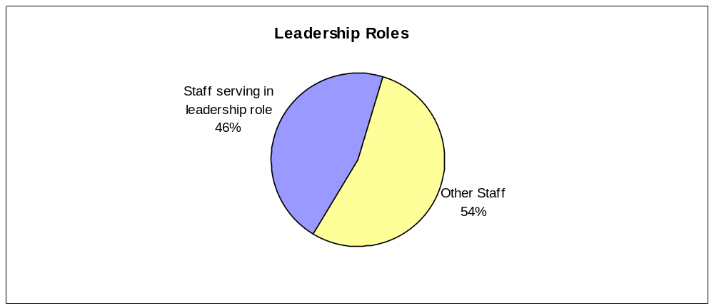

Data reliability: Each section manager records his or her staff’s leadership participation and the results are compiled for the agency.
What was achieved: The results displayed are baseline data. Nearly one-half of IUB staff members participated in a leadership role.
Analysis of results: By holding positions of leadership in agency, state, regional and national regulatory groups, IUB staff members directly represent Iowan’s best interests in discussions of regulatory policy. Despite being a medium to smaller sized regulatory agency in the USA, Iowa is looked upon as a leader.
Link(s) to Enterprise Plan: None.

Goal # 2
The Iowa Utilities Board will prepare for staff succession in a manner that will maintain competency, accountability, and the professionalism of the agency when tenured staff depart.

Strategy: Prepare for changes in staffing by implementing cross training, position aids, and process and procedure manuals.

Results
Performance Measure:  Percentage of agency positions with more than one staff member trained to perform essential tasks.  Data Sources:  IUB statistics | 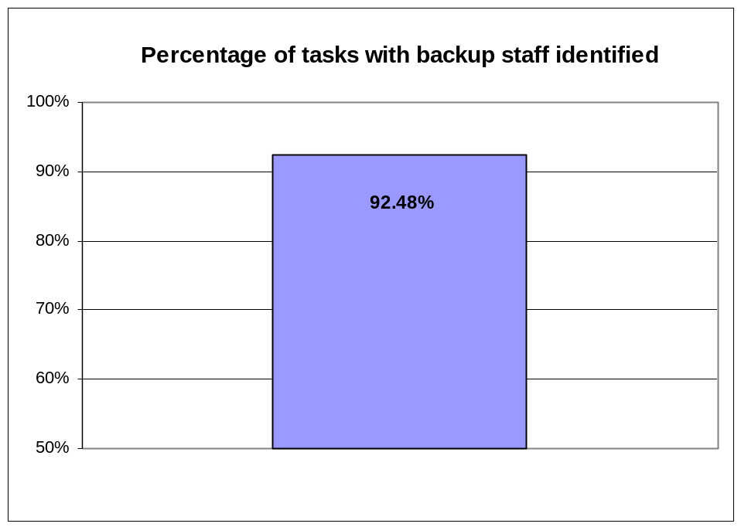

Data reliability: The IUB leadership team is responsible for compiling the data.
What was achieved: The results displayed are baseline data.
Analysis of results: Job sharing and tag team working relationships have been established by the Board’s leadership team to ensure coverage on a daily and long-term basis. Challenges include depth of staff in highly technical and specialized areas of analysis.
Link(s) to Enterprise Plan: None.

Goal # 3
Increase Iowans’ awareness of Iowa Utilities Board services, informational resources, and responsibilities.

Strategy: Increased awareness and visibility among the citizens of Iowa and the Midwest.

Results
Performance Measure:  Number of public comment/educational forums held and the public participation in those forums. Benchmark polling of public awareness as resources permit.  Data Sources:  IUB statistics
  Public  Forums | Number Held | Total Attendance
  Consumer Comment Hearings | 10 | 1728
  Fall Customer Service Meetings | 6 | 289

Data reliability: The IUB Customer Service team is responsible for compiling the data.
What was achieved: The results displayed are baseline data.
Analysis of results: Iowans were given an opportunity to be heard by the IUB. Benchmark polling of public awareness has been discussed but not commenced.
Link(s) to Enterprise Plan: None.

PERFORMANCE PLAN RESULTS

Core Function

Name: Regulation and Compliance

Description: Utility Regulation as directed by Iowa Code chapter 476, 476A, 478, 479, 479A, 479B, and 477C.

Why we are doing this: Traditionally, public utility services have been considered natural monopolies, primarily because of economies of scale and safety considerations. Where monopoly utility markets exist, the Iowa Utilities Board fulfills its statutory duties by balancing utility consumer’s needs for reliable, safe, and adequate services with the utilities’ need to have an opportunity to earn a reasonable return on investment in infrastructure. In the telecommunications area, the IUB has a statutory duty to investigate and determine when a regulated communications service is subject to effective competition and can be deregulated. As competitive markets have emerged, the IUB has been a leader in change. The IUB has identified the following desired outcomes of regulation:

- Minimizing the number of accidents or incidents caused by improper operation or maintenance of utility facilities.

- Regulated utility services are offered at a fair price.

- Reliable utility service is available for Iowans to run their businesses and households.

What we’re doing to achieve results: Where traditional regulation is necessary, the IUB continues to regulate. Where regulation is no longer necessary, the IUB has deregulated. In fiscal year 2004, the IUB opened Docket No. INU-04-1 to investigate the status of competition in the telecommunications industry and determine whether continued regulation is appropriate. The IUB is involved in regional and national groups to ensure Iowan’s best interests are protected in an evolving utility market structure.

Results
Performance Measure:  Percent of scheduled inspections of Iowa utility facilities completed within a year.  Performance Target:  Establish baseline and maximize. Goal 100%.  Data Sources:  IUB Safety & Engineering Section. | 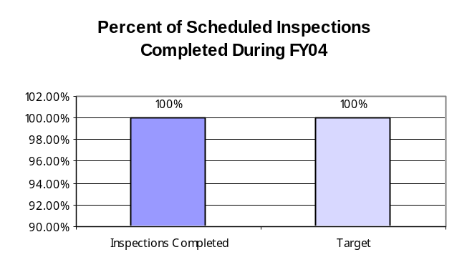

Data reliability: The IUB Safety and Engineering Section schedules the inspections in advance and tracks the progress.
Why we are using this measure: Physical inspection of utility facilities ensures that safety codes and standards have been followed and implemented. It’s important for reliability of service and to the overall safety of the system and thus the State.
What was achieved: During fiscal year 2004, a vacant inspector position was filled. With the inspection team fully staffed, the necessary and scheduled inspections were completed.
Analysis of results: By filling the inspector vacancy with an experienced 20-year veteran in the field of electric power distribution, the inspection schedule was maintained.
Factors affecting results: Having a full inspection staff is critical to completing the necessary inspections within a year.
Resources used: The IUB has five inspectors on its team. Funding for this function is provided in part by the federal Office of Pipeline Safety.

Results
Performance Measure:  Number of accidents per year reported by electric and gas utilities.  Performance Target:  Establish baseline and monitor.  Data Sources:  Utility reports to IUB.
  Accidents Reported by Utility Companies
  in FY04
  Natural Gas | 9
  Electricity | 7

Data reliability: The Safety and Engineering Section compiles the information from reports submitted by the electric and gas utilities in Iowa.
Why we are using this measure: Following safety standards and codes and maintaining utility facilities will help to minimize accidents and keep Iowa citizens safe.
What was achieved: See above chart for initial baseline results.
Analysis of results: These are baseline results that will be analyzed as future data is compiled.
Factors affecting results: Relies on accurate and complete reporting by the utilities.
Resources used: IUB Safety and Engineering staff.

Results
Performance Measure:  All Sectors average price of electricity for Iowa versus national average as determined by Energy Information Administration (EIA).  Performance Target:  Track. Set Benchmarks, study variances.  Data Sources:  EIA | 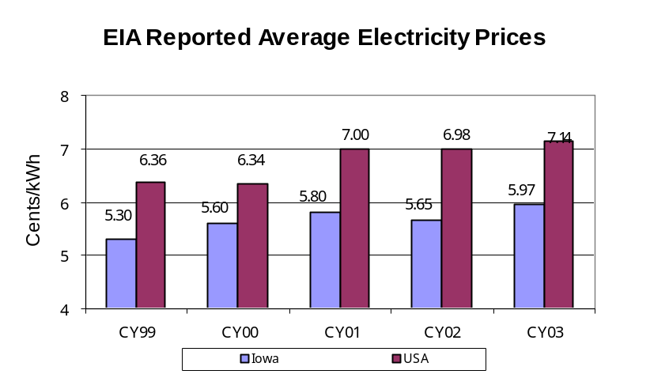

Data reliability: EIA is the independent statistical and analytical agency within the U.S. Department of Energy.
Why we are using this measure: The IUB is tracking the information and studying variances as one indicator of whether Iowa’s rates fairly balance customer expectations of quality and reliable service with utility company opportunities to earn a reasonable return on investment. The Board makes utility rate decisions based on a wealth of detailed information. This is one of many statistics available to gauge Iowa’s electric rate environment.
What was achieved: The results show that Iowa averages have been below the national averages for the five-year period shown.
Analysis of results: While the results shown are averages and will not necessarily equal the actual rate per kilowatt hour charged by the numerous utility companies serving various customer classes in Iowa, they do show an overall healthy relationship to national averages.
Factors affecting results: Each utility’s rate structures vary by type of service, so it is difficult to obtain a true kilowatt hour to kilowatt hour comparison.
Resources used: IUB staff members gather data from EIA’s website.

Results
Performance Measure:  Average price of Natural Gas delivered to Iowan’s, by class of service, compared to national averages as determined by EIA.  Performance Target:  Track. Set Benchmarks, study variances.  Data Sources:  EIA | 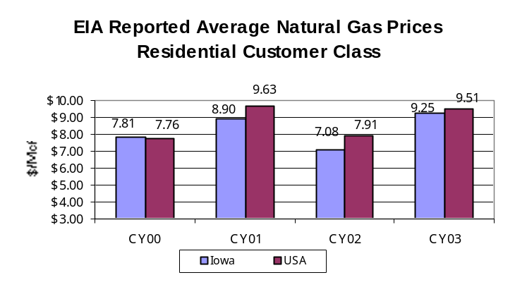
 | 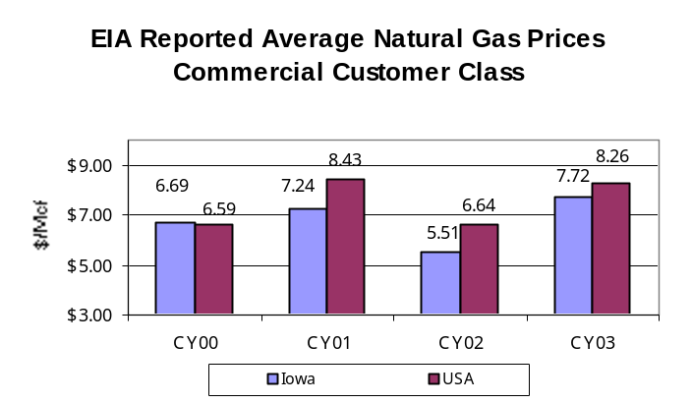
 | 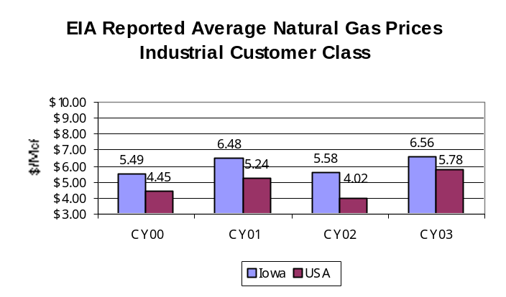

Data reliability: EIA is the independent statistical and analytical agency within the U.S. Department of Energy.
Why we are using this measure: Natural gas commodity prices have been high and volatile over the last several years and the IUB has encouraged regulated companies to develop business practices that help moderate the effects of these conditions on consumer bills. The IUB is tracking the information and studying variances as one indicator of whether Iowa’s rates fairly balance customer expectations of quality and reliable service with utility company opportunities to earn a reasonable return on investment. The Board makes utility rate decisions based on a wealth of detailed information; this is one of many statistics available to gauge Iowa’s natural gas rate environment.
What was achieved: The results show that for residential and commercial customers, Iowa averages have been below or very close to the national averages for the five-year period shown. Iowa’s industrial gas rates have been higher than the national average.
Analysis of results: While the results shown are averages and will not necessarily equal the actual rate per ccf charged by the numerous gas utility companies serving various customer classes in Iowa, they do generally show a healthy relationship to national averages. Iowa has allowed industrial and large commercial natural gas customers to choose their natural gas commodity suppliers for many years. While the IUB has relatively little input into those processes and their financial results for those customers, the IUB does evaluate such information to remain able to advise state leadership of the relative competitive status of such companies, vis-à-vis their energy costs.
Factors affecting results: Each utility’s rate structures vary by type of service, so it is difficult to obtain a true ccf to ccf comparison. (Note: Natural gas is measured by volume. A ccf is 100 cubic feet of natural gas. An Mcf is 1,000 cubic feet.)
Resources used: IUB staff members gather data from EIA’s website.

Results
Performance Measure:  Percent of peak alert days where load is met by mechanisms in place.  Performance Target:  Establish baseline for gas & electric and maximize.  Goal of 100%.  Data Sources:  Iowan’s gas & electric  utility companies. | 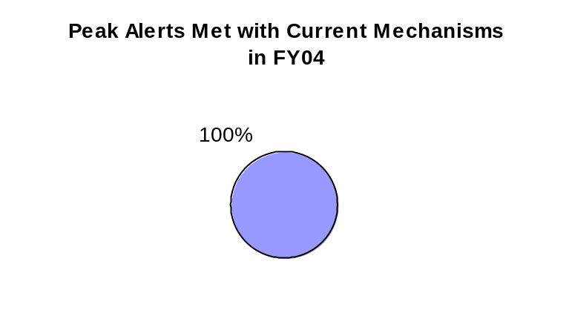

Data reliability: The data is reported by the utilities and compiled by the Energy Section of the IUB.
Why we are using this measure: The public expects and economic development demands reliable energy sources. This is a measure of service availability under high demand load conditions.
What was achieved: Consumer load was met with mechanisms in place.
Analysis of results: Utility companies issue notice to their customers when they project the system will be at or over capacity and brownouts or gas supply shortages could result. Consumers are encouraged to limit usage during highest peak demand times. Mechanisms in place to remedy electric peak load include voluntary customer shifting of use to later evening, early morning; interruption of service to customers whose rates are based on their agreement to be interrupted; purchase of additional capacity; and starting up additional generation service units whose cost to run is higher than the units used to serve normal loads. Mechanisms in place to remedy gas peak load include interruption of service to customers whose rates are based on their agreement to be interrupted; use of natural gas placed in storage; and additional purchases of natural gas on the spot market.
Factors affecting results: Weather, unplanned base load plant outages.
Resources used: Data is compiled by the IUB’s Energy Section.

Services, Products, and Activities in the Regulation and Compliance Core Function

Name: Prepare, sign and issue Board decision orders in a timely manner.

Description: Board decision orders are the mechanism by which the Board renders its official decisions.

Why we are doing this: To ensure the Board’s decisions are issued on a timely and accurate basis.

What we're doing to achieve results: Diligently tracking due dates and order status to insure that timelines are met. Multiple staff members review the orders to help insure accuracy and clarity.

Results
Performance Measure:  Percentage of orders issued on or before statutory deadline.  Percentage of errata orders issued.  Performance Target:  Goal of 100%.  Establish baseline and minimize.  Data Sources:  IUB statistics | 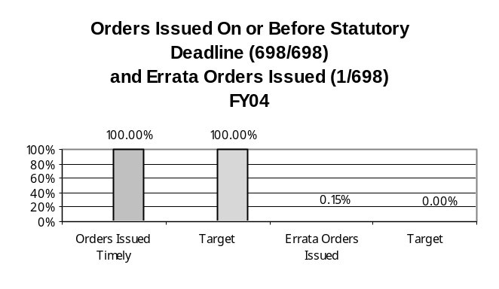

Data reliability: The IUB administrative support staff compiles this data.
Why we are using this measure: To ensure the Board’s decisions are issued on a timely and accurate basis.
What was achieved: The goal of all decisions being issued on a timely basis was accomplished. One order, out of 698 issued, was an errata order issued to correct an error in an earlier order.
Analysis of results: The Board is meeting its timeliness and accuracy goals for rendering decisions.
Factors affecting results: Some cases before the IUB have statutory timelines. The workflow must be controlled within the timelines set by statute.
Resources used: Numerous members of the IUB staff work to ensure that the Board members’ decision orders are issued.

Name: Represent Iowan’s best interests on regulatory issues at the regional and national level.

Description: Board Members serve on committees at the regional and national level.

Why we are doing this: To ensure the best interests of Iowan’s are represented in the evolving utility industry.

What we're doing to achieve results: Using our personnel and monetary resources as efficiently as possible.

Results
Performance Measure:  Percentage of Board members holding positions in national regulatory organizations.  Performance Target:  Goal of 100%.  Data Sources:  IUB statistics | Examples of Board member appointments:  Diane Munns, Chairman  Second Vice President, National Association of Regulatory Utility Commissioners (NARUC)  Chair, NARUC Committee on Finance and Technology  NARUC Committee on Electricity  NARUC Executive Committee  NARUC Board of Directors  Advisory Council, Board of Directors of the Electric Power Research Institute (EPRI)  Board of Directors, National Regulatory Research Institute (NRRI)  NARUC Representative, Federal Communications Commission’s Federal-State Joint Board on Separations  NARUC Representative, Federal-State Joint Conference on Accounting Issues  Mark O. Lambert, Board member  NARUC Energy Resources and the Environment (ERE) Committee  Vice-chair, ERE Environment Subcommittee  National Wind Coordinating Committee (NWCC)  NWCC Economic Development Working Group NWCC Transmission Working Group  Advisory Board, Center for Global and Regional Environmental Research at the University of Iowa  Advisory Board, Iowa Energy Center at Iowa State University  Elliott G. Smith, Board member  NARUC Telecommunications Committee  NARUC Washington Action Committee  NARUC Ad Hoc Committee on Critical Infrastructure  NARUC Representative, North American Numbering Council  North American Billing and Collection, Inc. Board of Directors  Vice Chair, 14-state Qwest Regional Oversight Committee

Data reliability: The data is compiled by the IUB’s administrative staff.
Why we are using this measure: Representation on national and regional organizations ensures Iowans a voice in a constantly changing industry and regulatory environment.
What was achieved: All three Board members are involved in numerous national regulatory organizations.
Analysis of results: Broad coverage of the electric, gas, and telecommunications issues.
Factors affecting results: Openings, recommendations, and invitations to serve on committees and organizations and availability of the Board members.
Resources used: Board member expenses related to meetings are sometimes covered completely or in part by the organization.

Name: Organize and conduct consumer comment hearings, educational meetings, and resources for increasing the public’s knowledge of IUB duties and responsibilities.
Description: Consumer comment hearings allow the public to ask questions about a pending rate proceeding. Educational meetings focus on topics of interest to consumers, and agencies that serve consumers. The IUB has numerous informational brochures, such as: Natural Gas Pricing and Bill Comparison; Avoid Telephone Billing and Marketing Deception; Getting the Most for your Energy Dollar; and Land Restoration After Pipeline Construction - Your Rights as an Iowa Landowner.
Why we are doing this: The public must have reasonable access to the Board to voice their concerns and receive answers to questions on pending rate cases.
Educational meetings and informational brochures help the public understand what we do and how we can assist them.

What we're doing to achieve results: Board staff reviews all consumer comments filed in rate proceedings. An analysis of the geographic origin of the comments is done to determine where and how many comment meetings should be held. Meeting locations are selected based on accessibility and comfort for the participants.

Results
Performance Measure:  Number of comment meetings held in major service areas where there is significant consumer concern over a pending proceeding filed with the Board.  Performance Target:  Comment meetings will be conducted in 100% of cases where significant consumer concern is filed with the Board.  90/60 – Hold comment meetings in locations so that at least 90 percent of the people who have expressed concern have to travel less than 60 miles.  Data Sources:  IUB Customer Service Staff.
  Cases with Significant Customer Concern | Customer Comment Meetings held
  Interstate Power and Light Company | 10
 | 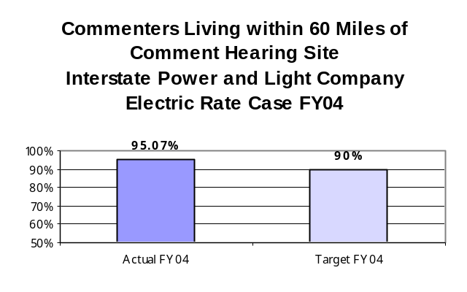

Data reliability: The data is compiled by the IUB’s Customer Service staff.
Why we are using this measure: This measure is a gauge of our accessibility to the public.
What was achieved: In FY 2004, ten consumer comment hearings were held in the Interstate Power and Light Company rate proceeding. Six Fall Customer Service meetings were held to provide utility customer service staff and staff from help organizations that assist customers with information about and updates on new and existing Board rules, the winter moratorium, and other customer issues. Over 2,000 people attended these hearings and meetings.
Analysis of results: Iowans have the opportunity to be heard by the IUB.
Factors affecting results: Number of cases filed with the Board, number of objections filed, time considerations.
Resources used: The Customer Service staff organizes all of these meetings, and conducts Fall Customer Service meetings. Board members, along with technical, legal, and Customer Service staff members, conduct consumer comment hearings.

Name: Assist low-income Iowans in obtaining financial assistance with basic telephone service via existing programs.

Description: Lifeline is a plan that assists qualified low-income Iowans by providing a monthly credit on their telephone bill.

Why we are doing this: So eligible Iowans will be aware of and take advantage of this plan.

What we're doing to achieve results: Working with the Iowa Telephone Association, the Rural Iowa Independent Telephone Association, and assistance organizations to promote program awareness.

Results
Performance Measure:  Percentage of eligible  Iowans registered for the Lifeline program.  Performance Target:  Establish a baseline using a three-year rolling average of Lifeline registrations using USAC reported numbers; target growth.  Data Sources:  IUB Telecommunications Section/Lifeline program. | 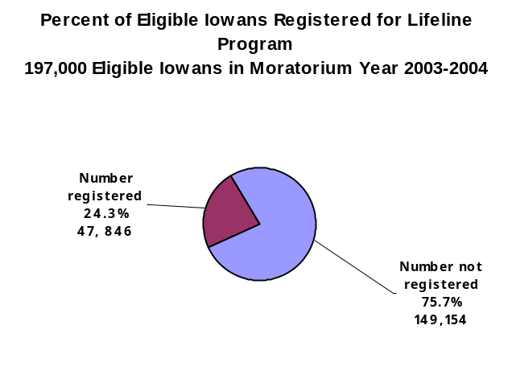

Data reliability: The data is gathered by the IUB Telecommunications staff from the Universal Service Administration Company (USAC).
Why we are using this measure: This measure is an indication of Iowan’s awareness and use of the Lifeline program.
What was achieved: Nearly 25% of eligible Iowans registered for the year.
Analysis of results: There is educational work to be done to ensure the public is aware of this program and that eligible Iowans register.
Factors affecting results: Effectiveness of public awareness programs.
Resources used: IUB staff.

Name: Prompt resolution of customer complaints about utility service.

Description: Assisting utility customers in dispute resolution with the utility companies.

Why we are doing this: This service assists Iowans in maintaining their utility service by resolving complaints and ensuring that established utility service rules are being interpreted correctly and carried out.

What we're doing to achieve results: The IUB is reviewing and updating its processes and procedures, providing staff training, and using data tracking to assure that acknowledgement letters and complaint resolution letters are rendered within the goals established.

Results
Performance Measure:  Number of days from receipt of complaint to the referral to a utility for response.  Average resolution time for written complaint files.  Performance Target:  Acknowledgement and utility referral letters will be sent within four business days of receipt of customer complaint.  Data Sources:  IUB Customer Service Staff. | 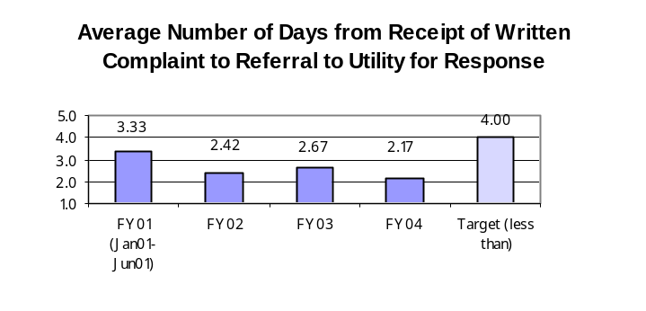
 | 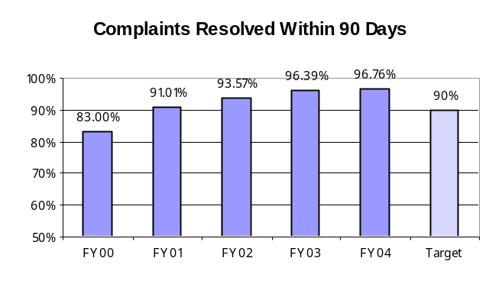

Data reliability: The data is compiled by the IUB Customer Service staff.
Why we are using this measure: Utility consumers look to the IUB for assistance with complaint resolution. Complaints deal with issues such as service disconnections, payment agreements, and credits for unsolicited service billings. Prompt action and resolution of these issues is in everyone’s best interest. Timely resolution of informal investigations requires that the utility be notified of the consumer’s complaint as soon as possible.

What was achieved: The percentage of customer complaints against utilities resolved within 90 days has increased from 83 percent in fiscal year 2000, to over 96 percent in fiscal years 2003 and 2004. The IUB has shortened the average number of days from receipt of a written complaint to referral to the utility for response from an average of 3.33 days in 2001 to 2.17 days in fiscal year 2004.
Analysis of results: Progress has been positive.
Factors affecting results: Number of complaints filed, difficulty of issues needing resolution, and volume of customer calls incoming to IUB, as the same analysts that staff the phones also handle written correspondence.
Resources used: IUB Customer Service representatives.

Name: Recognize, discuss, and exchange information on regulatory issues affecting the natural gas, electric, and telecommunications industry, as appropriate.

Description: Face to face meetings between the IUB staff and industry personnel.

Why we are doing this: To encourage dialog between industry and staff that will result in timely and appropriate regulatory changes.

What we're doing to achieve results: Communicating.

Results
Performance Measure:  Number of meetings held to discuss issues between staff and industry in a year.  Performance Target:  Establish baseline and hold meetings as appropriate.  Data Sources:  IUB Section Managers.
  Number of Meetings Held to Discuss Issues between Staff and Industry
  in FY04
  Policy Development | 103
  Telecommunications | 118
  Energy | 123
  Customer Service | 17
  IUB Total | 361

Data reliability: Each IUB section manager tracks his section’s meetings with industry.
Why we are using this measure: This measure is one gauge of how the IUB is keeping in touch with the industry on relevant issues.
What was achieved: Some of the meetings listed were attended by multiple IUB staff sections, enabling a wider array of issues to be addressed.
Analysis of results: The lines of communication are open.
Factors affecting results: Industry trends and issues, IUB staff workload.
Resources used: IUB staff.

Name: Assist the Board’s decision-making role by providing timely and competent analysis of technical issues in: (1) Utility general rate changes, ratemaking principles cases and rulemakings; (2) Federal Energy Regulatory Commission (FERC) and Federal Communications Commission (FCC) filings.

Description: Multi-disciplinary teams research and analyze issues to assist the Board members in their decision making process.

Why we are doing this: To provide the Board members with the information they need to decide cases or to participate in Federal proceedings.

What we're doing to achieve results: Through continuous review and discussion, ensuring that teams understand their role in the Board members’ decision making process.

Results
Performance Measure:  Percentage of cases where General Counsel, Energy, Policy and Telecommunications:  Provides participants and/or team leaders in cases as expertise is needed.  Timely (in accordance with docketing schedule)  - Each team member writes his/her own portions of Pre-hearing, Post-hearing, and Decision memos.  - Team leaders and managers review draft orders to assure that technical issue coverage aligns with Board decisions.  - Team members attend hearings, providing coverage of individual team member issues.  Performance Target:  Goal of 100%.  Data Sources:  IUB Team Leaders. | 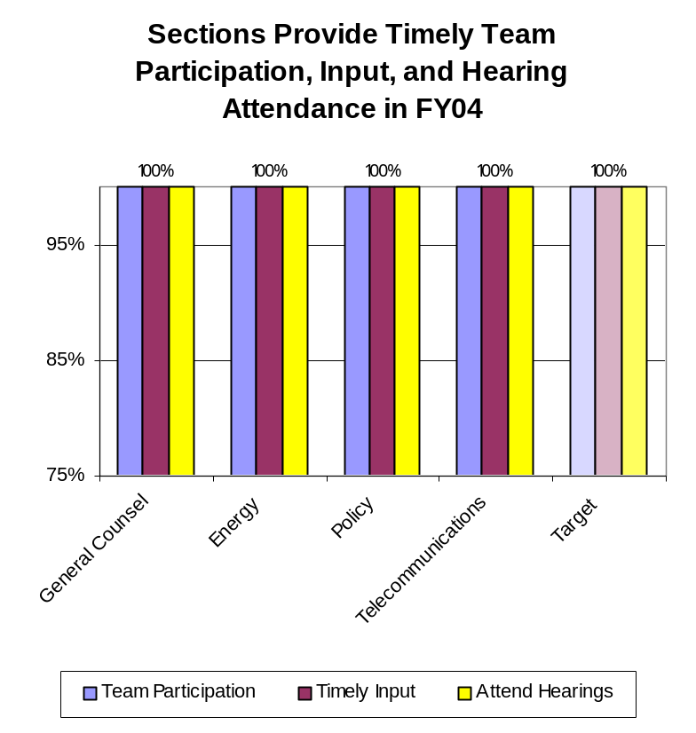

Data reliability: The data is gathered by IUB team leaders and compiled by staff.
Why we are using this measure: This is one measure of the assistance provided by staff to the Board.
What was achieved: The Board was provided timely technical analysis and assistance in 100% of the cases before them.
Analysis of results: The IUB team review process is working.
Factors affecting results: Case load and staff availability.
Resources used: IUB staff.

Results
Performance Measure:  Number of FERC and FCC cases the IUB files comments in or intervenes in.  Performance Target:  Establish baseline, monitor, and file as appropriate.  Target growth.  Data Sources:  IUB Management Team.
  Number of FERC and FCC Cases Where the IUB Filed Comments or Intervened
  in FY04
  FERC | 2
  FCC | 8
  IUB Total | 10

Data reliability: The data is tracked and gathered by the IUB management team.
Why we are using this measure: To track our efforts and involvement at the national regulatory level.
What was achieved: The Board filed comments or intervened in 10 cases at the national level.
Analysis of results: Participating in federal regulatory cases allows the IUB to directly put forth Iowans’ best interests.
Factors affecting results: Number of cases at the IUB, number of federal cases, importance and potential impact of federal issues on Iowans, staff availability.
Resources used: IUB staff.

Name: Collaborate with regional and national organizations to develop and implement efficient regulatory processes.

Description: Working with others in the utility regulatory field to promote best practices.

Why we are doing this: To learn from other regulators and work with them to achieve results.

What we're doing to achieve results: Working with numerous regional and national groups.

Results
Performance Measure:  Percent of technical staff participating in collaborative efforts.  Performance Target:  Establish baseline and maximize.  Data Sources:  IUB Management Team. | 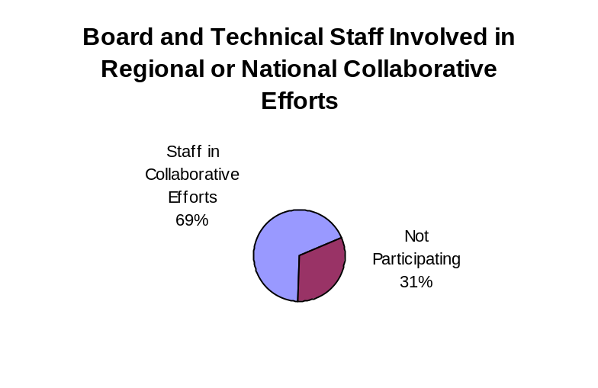

Data reliability: The data is compiled by IUB section managers.
Why we are using this measure: This measure is one way of reviewing technical staff’s involvement in utility issues outside of the IUB office.
What was achieved: Nearly 70% of the technical staff were involved in a collaborate effort.
Analysis of results: IUB staff are active and make an impact outside the agency. The IUB is looked upon with respect from fellow state regulators.
Factors affecting results: Number of collaborative efforts and staff availability.
Resources used: IUB staff.

Name: Conduct surveys and issue reports on the status of the energy and telecommunications markets in Iowa.

Description: The Policy Development Section of the IUB provides valuable information for the Board and various stakeholders through the surveys conducted and reports issued.

Why we are doing this: By gathering and compiling statistics and industry information, the IUB is able to assist stakeholders, as well as enhance the Board members’ decision making process.

What we're doing to achieve results: Developing schedules and plans to conduct surveys and issue reports each year.

Results
Performance Measure:  Number of surveys conducted and reports issued.  Performance Target:  Minimum: A report or survey for the telecommunication or energy sector each year. More as caseload allows and need requires.  Data Sources:  IUB Policy Development Section.
  Surveys and Reports Issued in FY04
  Facts Concerning the Consumption and Production of Electric Power in Iowa | December 2003
  Update - Natural Gas Price Volatility White Paper | September 2, 2003
  NOI-03-2 Review of Utility Ratemaking Procedures | January 5, 2004
  Telecommunications Competition Survey for Retail Local Voice Services in Iowa | January 26, 2004
  IUB Target =2 | IUB FY04 Total = 4

Data reliability: The data is compiled by the IUB Policy Development Section.
Why we are using this measure: This is a concrete measure of IUB research.
What was achieved: Four surveys/reports were issued in fiscal year 2004.
Analysis of results: The IUB exceeded its target goal in fiscal year 2004.
Factors affecting results: Caseload before the Board and number of pertinent issues worthy of research.
Resources used: IUB Policy Development staff.

Name: Conduct a pipeline safety program under certificate from the federal Office of Pipeline Safety (OPS).

Description: IUB regulatory inspectors review natural gas pipeline construction projects to ensure that safety standards are met.

Why we are doing this: To ensure safe transportation of natural gas to Iowans.

What we're doing to achieve results: Promptly responding to any areas noted for improvement in the OPS annual evaluation of the IUB inspection program.

Results
Performance Measure:  Iowa’s score in the annual evaluation of its pipeline safety program by the U.S. OPS.  Performance Target:  Score of 90 or higher. Maximize federal grant eligibility.  Data Sources:  OPS | 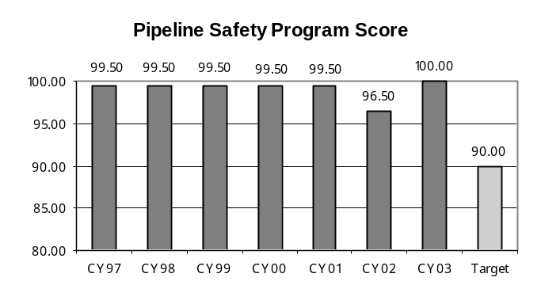

Data reliability: The Office of Pipeline Safety, which is part of the Federal Department of Transportation, scores Iowa’s program.
Why we are using this measure: This is an independent measure of the efficiency and effectiveness of the IUB’s pipeline inspection program.
What was achieved: The IUB has consistently maintained a score in the high 90’s.
Analysis of results: The inspection program is maximizing the IUB’s eligibility for federal funding grants.
Factors affecting results: Number of inspectors on staff, miles of pipeline, and number of construction projects. There is a time lapse between the program evaluation date and the announcement of scores; the score for calendar year 2003 is the last reported score.
Resources used: IUB Safety and Engineering staff. Part of the program cost is funded by federal grants.

Name: Process petitions for electric franchises and pipeline permits.

Description: This is the approval process electric and gas utilities must go through to build new electric transmission lines and intrastate gas pipelines.

Why we are doing this: To ensure that Iowa has adequate infrastructure to supply the necessary utility services and to boost economic development opportunities for Iowa.

What we're doing to achieve results: Monitoring progress on petition reviews and reassigning staff resources as needed to complete approval processes in a timely manner.

Results
Performance Measure:  Percentage of petitions for approval of new construction processed in a timely manner.  Performance Target:  For projects proposing new construction a hearing notice or deficiency letter is issued within 90 days of petition filing.  Data Sources:  IUB Safety & Engineering Section. | 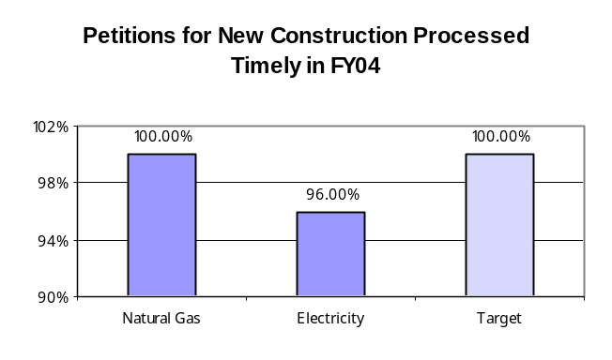

Data reliability: The data is compiled by the IUB Safety and Engineering Section.
Why we are using this measure: This is an efficiency measure that relates to the IUB’s mission and vision, as well as Iowa’s growth goals.
What was achieved: Over 95% of petitions seeking approval of new pipelines or electrical transmission facilities were set up for hearing or had a deficiency letter sent to the requesting utility within 90 days.
Analysis of results: There is some room for growth, but overall initial response time to new petitions is acceptable.
Factors affecting results: Number of petitions filed, staff workload.
Resources used: IUB Safety and Engineering staff, along with members of the General Counsel.

Name: Efficient administration of equipment distribution program (EDP) and Relay Iowa.

Description: The Iowa Equipment Distribution Program helps the deaf/hard-of- hearing/speech-impaired community to pay for specialized telephone equipment. Qualified individuals can receive a voucher for approximately 95 percent of the average cost of specialized telephone equipment.

Why we are doing this: This program is required by the Iowa Code, chapter 477C. The general assembly finds that the provision of a statewide dual party relay service will further the public interest and protect the health, safety, and welfare of the people of Iowa through an increase in the usefulness and availability of the telephone system. Many persons who are deaf, hard-of-hearing, or have speech impairments are not able to utilize the telephone system without this type of service.

What we're doing to achieve results: The IUB works with contracted parties on a regular basis to ensure contract compliance and that the program operates efficiently.

Results
Performance Measure:  Percent of EDP vouchers processed timely.  Performance Target:  Establish baseline and maximize.  Data Sources:  IUB Accounting & Assessments and Telecommunications Sections. | 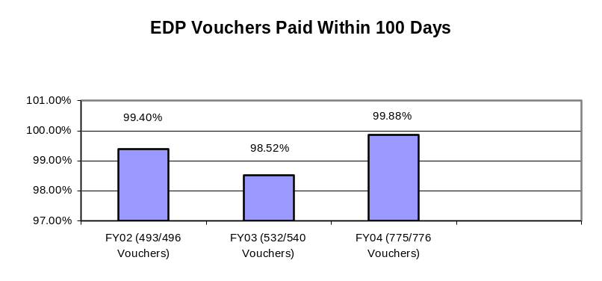

Data reliability: The data is compiled by the IUB Accounting and Assessments and Telecommunications Sections.
Why we are using this measure: This is a way to measure the efficiency of the EDP program reimbursement process.
What was achieved: Over 98% of the EPD vouchers have been paid within the 100-day deadline.
Analysis of results: There is room for improvement, but overall results are satisfactory.
Factors affecting results: Number of vouchers submitted for payment, workload of staff.
Resources used: IUB Accounting and Assessments staff.

Core Function

Name: Resource Management

Description: Resource management provides the infrastructure necessary to administer and support agency operations. Key activities include accounting, financial and personnel services, purchasing, and maintenance of official agency records.

Why we are doing this: Resource management is the backbone necessary to support and operate the agency.

What we're doing to achieve results: Reviewing processes for efficiency improvement opportunities.

Results
Performance Measure:  Rate of compliance with Revenue & Finance standards as reported in their audit sample.  Performance Target:  Establish baseline and maximize.  Data Sources:  Iowa Department of Administrative Services - State Accounting Enterprise. | 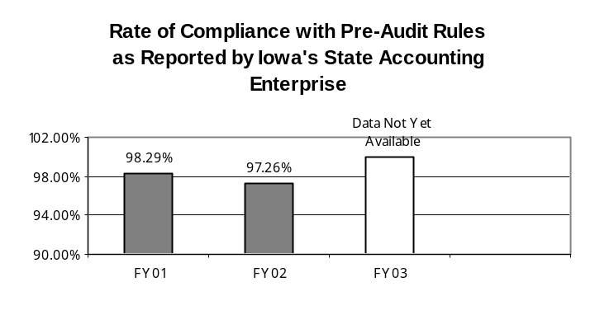

Data reliability: The data is a direct product of audits conducted by the Auditor of State, which reviews our transactions for compliance with State Accounting Enterprise (SAE) rules.
Why we are using this measure: This is an independent measure of how well we process our claims according to the established standards.
What was achieved: The IUB has consistently maintained a compliance rate in excess of 95%.
Analysis of results: Our accounting and internal audit staff know the rules and pay attention to detail.
Factors affecting results: Data is not available for FY 2003 as SAE time has been devoted to implementing a new state accounting system; audit compliance rate letters have not been distributed. Since the IUB has maintained a high compliance rate, our audit sample size has been reduced. With a smaller audit sample, maintaining the high compliance rate leaves very little room for error.
Resources used: IUB Accounting and Assessments staff.

Services, Products and Activities in the Resource Management Core Function

Name: Issue timely agency direct and remainder assessment billings.

Description: Billing the utility companies and other parties that participate in cases before the IUB.

Why we are doing this: This is how the IUB is funded.

What we're doing to achieve results: Streamlining the time recording process to speed up the rendering of bills.

Results
Performance Measure:  Average days between end of billing cycle and issuance of bills.  Performance Target:  Establish baseline and minimize.  Data Sources:  IUB Accounting & Assessment Sections. | 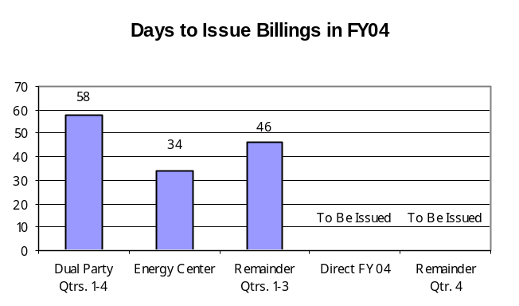

Data reliability: The IUB Accounting and Assessment Section prepares all the bills and tracks the timing of their issuance.
Why we are using this measure: To track the efficiency of our billing process.
What was achieved: Our goals were not met in fiscal year 2004.
Analysis of results: This is an area for growth.
Factors affecting results: Number of companies/parties needing to be billed, availability of staff to compile billing information and prepare invoices.
Resources used: The IUB has three staff members on the Accounting and Assessment Team. These three also work for the Office of Consumer Advocate and the Iowa Insurance Division, who pay for a portion of the costs of running the section.

Name: Acknowledge receipt of official filings.

Description: When a company makes a filing with the IUB, they receive a letter acknowledging that the IUB has received the filing.

Why we are doing this: Acknowledgement letters confirm for filing parties that the information has been received.

What we're doing to achieve results: Receiving and acknowledging new filings as expeditiously as possible.

Results
Performance Measure:  Average number of days between filing made and acknowledgement letter sent.  Performance Target:  Establish baseline and minimize.  Target 2 days or less.  Data Sources:  IUB Records & Information Center. | 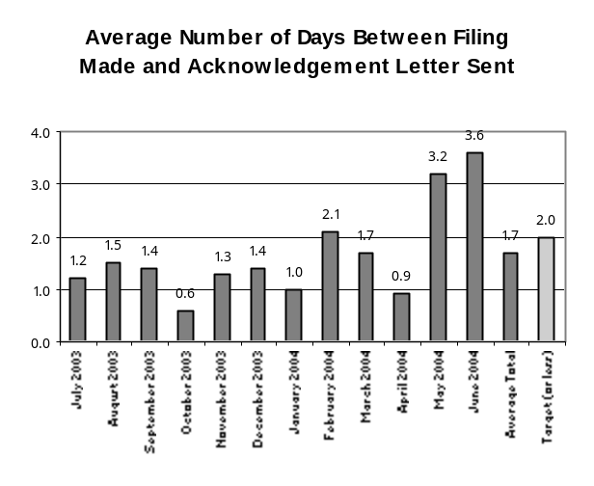

Data reliability: The IUB Records and Information Center staff, who receive all filings and issue acknowledgement letters to the filing parties, track the results.
Why we are using this measure: This is another measure to track the efficiency of our processes.
What was achieved: Since July of 2003, the average number of days is 1.7.
Analysis of results: The average achieved meets our target of 2 days or less.
Factors affecting results: Number of filings made in a given day, other work priorities on a given day, and the number of staff members available on a given day.
Resources used: The IUB Records and Information Center staff.

Name: Distribute new filings to staff.

Description: Processing filings made by utilities and distributing them to the Board members and staff for technical analysis and review.

Why we are doing this: This is an integral part of the regulatory process.

What we're doing to achieve results: Receiving and distributing new filings as expeditiously as possible.

Results
Performance Measure:  Percentage of new filings set up and distributed to staff by the end of the following work day.  Performance Target:  Establish baseline and maximize.  Target: 100% of new filings will be distributed to staff by the end of the following workday.  Data Sources:  IUB Records & Information Center. | 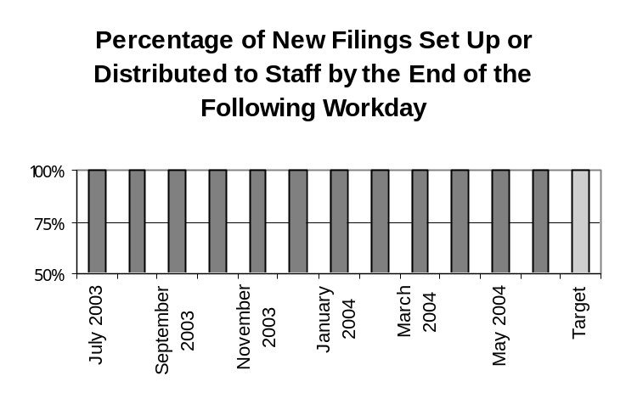

Data reliability: The IUB Records and Information Center staff, who receive all filings and distribute copies to the Board members and staff, track the results.
Why we are using this measure: This is another measure to track the efficiency of our processes.
What was achieved: For each month of fiscal year 2004, 100% of filings were distributed by the end of the following workday.
Analysis of results: Our target goal was met.
Factors affecting results: Number of filings made in a given day, other work priorities on a given day, and the number of staff members available on a given day.
Resources used: The IUB Records and Information Center staff.

RESOURCE REALLOCATIONS

Because the IUB is a relatively small agency within the Department of Commerce, in fiscal year 2004, the IUB did not utilize resource reallocation to a measurable degree. Our human resources are sometimes shifted from one section of the agency to another, depending on workload. The staff of the IUB is often organized into multi-disciplinary teams, whose goals are to provide Board members the best possible information on which to base their decisions.

AGENCY CONTACTS

Copies of the Iowa Utilities Board’s Performance Report are available on our Web site at www.state.ia.us/iub.

Iowa Utilities Board
350 Maple Street
Des Moines, IA 50319-0069
(515) 281-5979

