NEWS RELEASE | For Statewide Distribution

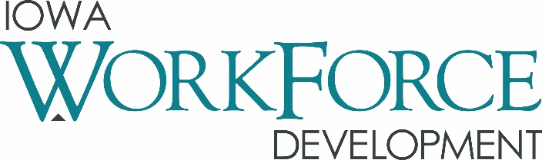
For Release: 9:00 a.m.  Date: September 20, 2019 | Contact: Molly Elder (515) 725-4116  molly.elder@iwd.iowa.gov
Iowa’s Unemployment Rate Remains at 2.5 Percent

DES MOINES, IOWA – Iowa’s seasonally adjusted unemployment rate remained at 2.5 percent in August. The state’s jobless rate was 2.4 percent one year ago. The U.S. unemployment rate remained at 3.7 percent in August.

"In August, we saw another increase in the number of working Iowans in the labor force, up 5,800 from last month,” said Director Beth Townsend, Iowa Workforce Development. “Even with the increase in the number of Iowans working, employers are still in search of skilled workers to fill tens of thousands of open jobs across the state. At the Future Ready Iowa Fall Summits, employers are sharing successful strategies with each other including working with the disabled, returning citizens, as well as how easy registered apprenticeship programs are to create and maintain and the overwhelmingly positive benefit employers get from these programs. There's still plenty of time to attend a summit and you can register at FutureReadyIowa.gov/registration."

The number of unemployed Iowans increased to 43,800 in August from 42,800 in July. The current estimate is 3,600 higher than the year ago level of 40,200.

The total number of working Iowans increased to 1,686,200 in August. This figure was 5,800 higher than July and 39,300 higher than one year ago.

Seasonally Adjusted Nonfarm Employment

In August, Iowa’s business establishments gained a slight 300 jobs over July’s total and now rest at 1,595,200 jobs. Firms involved in goods production showed the most promise (+800), while private services were sluggish since July and trended down (-700). Government was fueled by hiring at the state level and advanced by 200 jobs. This sector is now up 1,300 jobs annually.

Construction gained the most jobs in August (+1,000) and was bolstered by hiring in the construction of new residential and commercial buildings. This gain marks the fifth consecutive advancement for this sector following a weak start to the year. Financial activities added jobs in August (+800). This was the first monthly gain since May and helps trim some of the losses stretching back to last year. Professional and business services again added jobs (+600) with growth being concentrated within administrative support and waste management services. Losses this month were deepest in the education and health care super sector (-1,600). Virtually all the decline was due to reductions in staffing in the health care and social assistance sector. This drop would almost certainly be a temporary correction in payroll and not indicative of any long term trend for this sector. Trade, transportation, and utilities pared 400 jobs due to continued sluggishness in the retail sector.

Over the past twelve months, Iowa has trended up and is 12,600 jobs higher than last August. Despite two small declines over the past two months, manufacturing continues to be the catalyst of job growth (+6,500). Durable goods factories have provided more new jobs than non-durable goods shops. The other services sector advanced by 2,500 jobs and construction is now up 2,300 jobs annually. Those sectors paring jobs since last year are information services (-1,300), financial activities (-700), and trade, transportation, and utilities (-600).

Visit www.iowalmi.gov for more information about current and historical data, labor force data, nonfarm employment, hours and earnings, and jobless benefits by county.
###

An Equal Opportunity Employer/Program
Auxiliary aids and services are available upon request for individuals with disabilities.
www.iowaworkforcedevelopment.gov• www.iowaworks.gov

MEDIA ALERT: Local data for August will be posted to the IWD website on Tuesday, September 24, 2019. Statewide data for September 2019 will be released on Friday, October 18, 2019.

