NEWS RELEASE | For Statewide Distribution

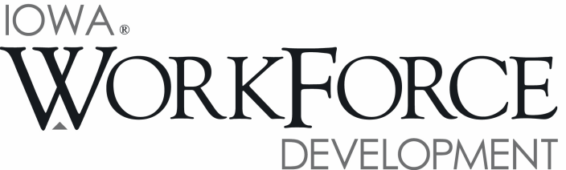
For Release: 9:00 a.m.  Date: August 17, 2018 | Contact: Cory Kelly (515) 330-5646
Iowa's Unemployment Rate Drops to 18-Year Low

DES MOINES, IOWA – Iowa’s seasonally adjusted unemployment rate dropped to 2.6 percent in July. The state’s jobless rate was 3.1 percent one year ago. The U.S. unemployment rate decreased to 3.9 percent in July.

"Iowa hasn't seen an unemployment rate this low in 18 years and the amount of help available to employers to find workforce is substantial as evidenced by the more than 13,000 additional Iowans employed now compared to the same time last year” said Beth Townsend, director of Iowa Workforce Development. “At our IowaWORKS Centers across the state, we are helping employers find employees even in this tough environment by using resources like the Work Opportunity Tax Credit and the Federal Bond Program that bring individuals with barriers into the workplace. We are bringing veterans to Iowa through Home Base Iowa, which helps businesses find highly motivated and skilled workers every day. So far over 600 Iowans have signed up to attend Future Ready Iowa summits across the state this fall to help their communities develop plans to meet their own talent pipeline needs. As usual, Iowans are working collaboratively to build the workforce we need now and in the future."

The number of unemployed Iowans decreased to 44,000 in July from 44,900 in June. The current estimate is 8,100 lower than the year ago level of 52,100.

The total number of working Iowans increased to 1,640,300 in July. This figure was 5,200 higher than June and 13,200 higher than one year ago.

Seasonally Adjusted Nonfarm Employment

Iowa total nonfarm employment decreased by 700 in July, lowering the total down to 1,591,500 jobs. This small loss is the third of 2018, but follows a surge in hiring over the last two months. Goods producing sectors combined to add jobs for the six-consecutive month stretching back to January. Service industries shed 2,300 jobs following large gains over the past two months. Private industries as a whole experienced no change since June, while government shed 700 jobs and is up a slight 400 jobs annually.

Retail trade shed the most jobs in July (-3,000) and was responsible for all of the loss in the trade and transportation super sector (-2,100). Much of the decline was expected given the recent announcements of stores closing around the state. For the most part, retail has trended down since the beginning of 2017. This trend may continue through 2018 as online sales continue to gain in popularity around the nation. The educational services and healthcare sector posted the only other major loss this month due to small losses in both segments. This sector is expected to trend back up during the second half of the year. Alternatively, job gains were largest in manufacturing this month (+1,300) and follow another moderate gain of 900 jobs in June. The financial activities sector added 600 jobs in July and continues to expand its footprint in the Iowa economy. Leisure and hospitality rebounded from a loss last month and gained 600 jobs. This sector has been ramping up staffing levels since the fourth quarter of last year and gains have been heaviest within accommodations and food services. Construction had a small gain this month (+300), marking the sixth consecutive month for growth.

Since last July, the state has gained 19,000 jobs. Over half of those gains occurred within Iowa’s factories (+11,300). Durable goods shops have outpaced their non-durable goods counterparts in terms of growth—7,900 jobs added versus 3,400 jobs, respectively. Construction industries are up 3,500 jobs annually following job gains stretching back to January. The finance sector continues to fare well in Iowa and has added 2,900 jobs. Private sector losses have been limited to other services (-2,600) and trade and transportation (-2,200).

Visit www.iowalmi.gov for more information about current and historical data, labor force data, nonfarm employment, hours and earnings, and jobless benefits by county.

###

An Equal Opportunity Employer/Program
Auxiliary aids and services are available upon request for individuals with disabilities.
www.iowaworkforcedevelopment.gov• www.iowajobs.org

MEDIA ALERT: Click here to access an audio cut of comments about Iowa's labor market situation. Local data for July will be posted to the IWD website on Tuesday, August 21, 2018. Statewide data for August 2018 will be released on Friday, September 21, 2018.

