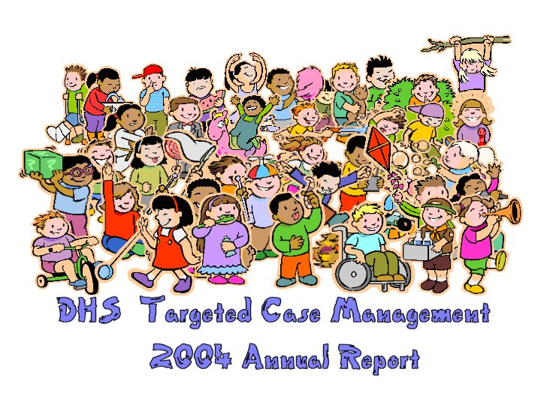
Ninety-four percent of children served by DHS Case Management live in their parents or a relative’s home.

2004 The Year of Big Change
In the year 2004, we received a three-year accreditation, which allows us to continue to practice case management in the state of Iowa. All of our staff had worked so very hard but we did receive several suggestions for improvement and a strong suggestion to evaluate our current caseload structure. We took a long hard look at our expectations and decided to adopt a weighted caseload of 1 to 35. Due to additional work required to serve chronically mentally ill consumers they are counted as 1.4 while MR, DD and BI consumers are counted as 1. A case manager would then have a combination of CMI, MR, DD and BI consumers that totaled 35. This change resulted in two rates for our populations served.

We divided the state into two equal parts and called them the East Region and the West Region. This allowed a sharing of resources to a greater area. There is a principal of “economy of scale” and using the two regions allows the services of training, accounting, clerical support and IT to be stretched further than if we retained our four region structure.

These ideas seemed simple at the time of conception but the reality of implementation hit hard. We needed to add staff to meet the caseload expectations, which meant office expansion and new equipment. We added offices on the campuses of Glenwood, Independence and Cherokee. Our Dubuque office was relocated in the same building to a larger space and our Central office in Des Moines also moved within the same building to accommodate growth. Almost all offices added new space and people. Our training was endless but in the end all the hard work paid off as today we have achieved the caseload of 1-35 and we have seen an immediate benefit to our consumers and staff.

Our financial team felt the pressure of additional work as well. With preauthorizations we added one more account tech to assist with financial duties. The management of two separate rates of service resulted in a lot more accounting work but accounting staff never complained for they felt the populations served demanded this distinction.

I had not foreseen the addition of 382 new consumers in the middle of all of this. I find the following statistics fascinating:
Year | Cases Opened | Cases Closed | Net Gain
2003 | 470 | 363 | 107
2004 | 948 | 566 | 382

Our supervisors had their work cut out for them with hiring and establishing new offices. This was more work than anyone bargained for but we are now seeing the fruits of our labor with decreases in psychiatric hospitalization, more time spent with all consumers and better documentation.

We are excited about our new partnerships with the resource centers and counties. It is our goal this year to bring 10 citizens back to their home communities from the resource centers. These partner ships are lessons in learning and devotion to our core principals of community life.

We look forward to the year 2005 as one of promise as well as challenge. We believe the quality of service we provide will be evident to all of our customers in the next year. We appreciate the opportunity to work in our 25 contracted counties.

Diane C Diamond,
Social Work Administrator, DHS Case Management

TCM Table of Organization
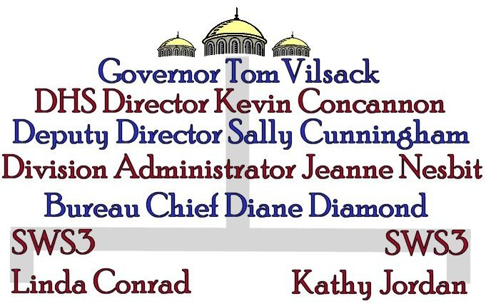
Furthermore the DHS Case Management Unit has 9 Social Work Supervisors who supervise 120 Case Managers. An additional 27 workers cover the areas of Accounting, Clerical Support, IT, and Quality Assurance.

Advisory Board
The advisory board of the DHS Case Management Unit helps to identify areas of concern within the Unit, and assists in finding solutions and ways of better serving our consumers. Advisory Board members for 2004 included:
Kristi Dierking, Warren County CPC

Mary Dubert, Scott County CPC

Jill Eaton, Marshall County CPC

Jan Heikes, Winneshiek County CPC

Joann Hagen, Parent, Winneshiek County
Lori Nosekabel, Clark County CPC
Chris Sparks, Exceptional Persons Inc., Waterloo
Mary Williams, Benton County CPC

Linda Conrad, Social Work Supervisor 3
Diane Diamond, Social Work Administrator

Kathy Jordan, Social Work Supervisor 3



Membership for our advisory board is renewed annually. Officials in counties we contract with, provider agency staff, consumers and guardians can be considered for membership.

County & Office Locations 2004
In 2004 our unit reorganized into a two region structure. Shown below are the counties in our East and West regions as well as additional offices maintained by the DHS Case Management Unit.
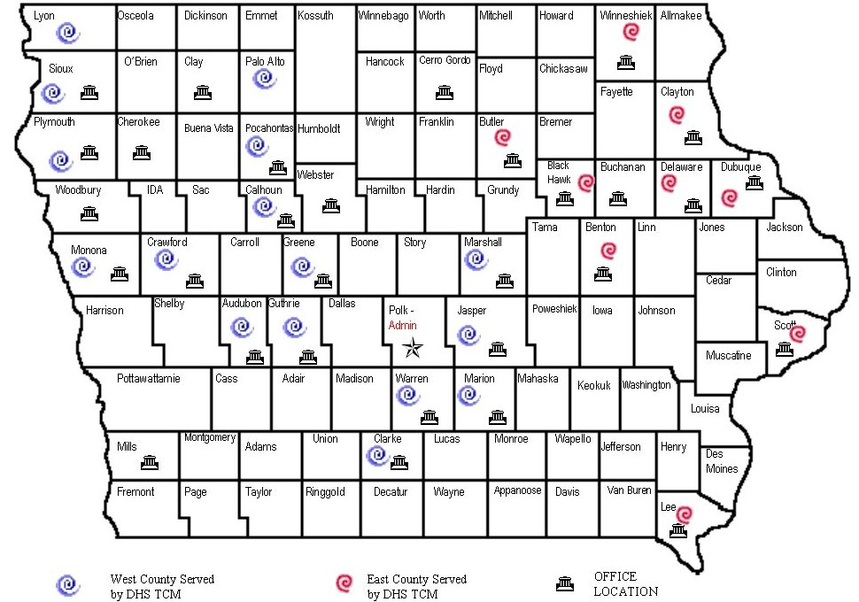
This year offices were added in Buchanan, Cherokee, and Mills County in an effort to house case managers at the mental health institutions in these communities.

County Survey Results
Supervisors conduct annual satisfaction surveys with the CPCs in counties we serve. Our Advisory Board designed the survey, which rates Case Management on a scale from 1-10 in several areas. Below are the results of the 2004 CPC surveys.
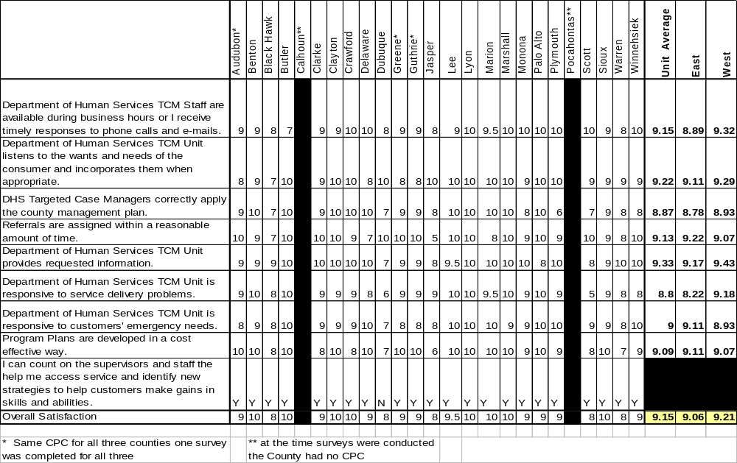Lead supervisors address scores of 7 or less, and a corrective action plan is submitted to the county CPC.

Our Consumers

Total Number of Consumers | 3530

Age | 0-17 | 18-34 | 35-64 | 65+
Number of consumers | 608 | 1129 | 1708 | 85

Male | 1933
Female | 1597

Diagnosis | MR (MR + MR Child) | CMI | DD | BI
Number of consumers | 2490 | 719 | 156 | 165

Guardian | 1803
No Guardian | 1727

Years With TCM | 0-5 | 5-10 | 10+
Number of Consumers | 2056 | 937 | 534

Opened in 2004 | 948
Closed in 2004 | 566

Data is current as of 12-31-2004

Consumer Survey Results
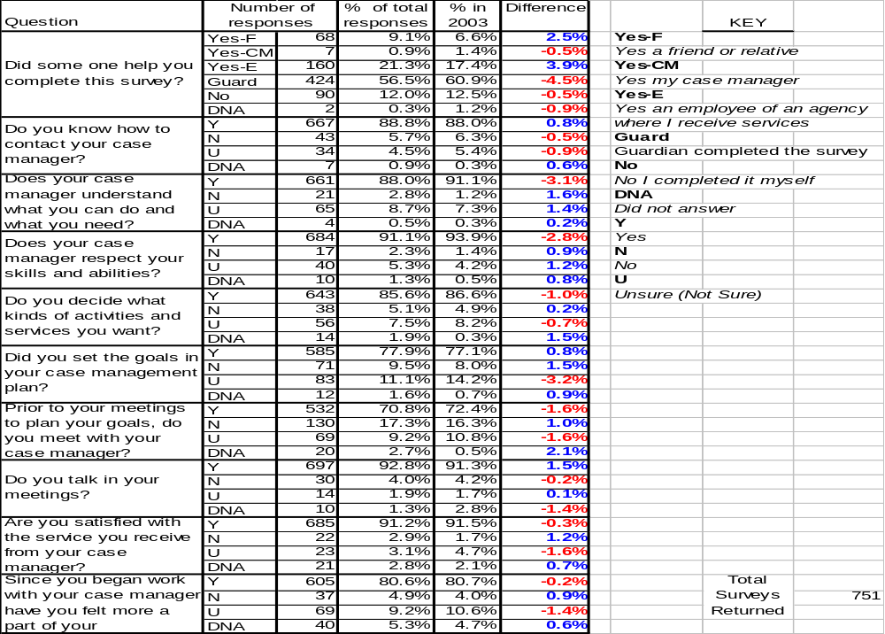
Surveys are sent to a random 50% of the consumers (or their legal guardians where appropriate) in each county we serve. Surveys are only sent to consumers who have been with TCM for at lest one year. At the request of the CPC 100% of a county’s consumers may be surveyed.

Consumer Satisfaction
Satisfaction is shown by county as the number of those who reported satisfaction vs. the number of surveys returned.
Audubon  13 / 14 |  | 92.9% | Delaware  28 / 30 |  | 93.3%
Benton  21 / 24 |  | 87.5% | Dubuque  59 / 72 |  | 81.9%
Black Hawk  93 / 102 |  | 91.2% | Greene  8 / 9 |  | 88.9%
Butler  21 / 21 |  | 100% | Guthrie  6 / 6 |  | 100%
Calhoun  19 / 23 |  | 82.6% | Jasper  34 / 34 |  | 100%
Clarke  16 / 17 |  | 94.1% | Lee  37 / 39 |  | 94.9%
Clayton  18 / 18 |  | 100% | Lyon  5/5 |  | 100%
Crawford  21 / 23 |  | 91.3% | Marion  23/24 |  | 95.8%

Consumer Satisfaction
Marshall  22 / 23 |  | 95.7% | Sioux  32/36 |  | 88.9%
Monona  2 / 2 |  | 100% | Scott  44 / 54 |  | 81.5%
Palo Alto  14 / 15 |  | 93.3% | Warren  16 / 18 |  | 88.9%
Plymouth  14 / 19 |  | 73.7% | Winneshiek  18 / 20 |  | 90%
Pocahontas  16 / 16 |  | 100% | State Cases  77 / 87 |  | 88.5%

A total of 751 surveys were returned this year with an overall satisfaction rating of 91.2%.

Consumer Survey Comments
At the end of each survey is a space for consumers and or their legal guardians to leave comments for their case manager. Surveys are coded to indicate diagnosis, the region and county in which the case manager is located, and the consumer’s case manager. Answers are not identified in any other way. In other words, opinions are totally confidential and cannot be linked to a consumer or guardian by name. Listed below are some highlights of the feedback received in 2004.

 Case Manager brightens my day and always makes me feel at ease as a good guide in my life. She is A-ok and always helpful in anyway she can.
 Case Manager does an excellent job. She is always on top of things and offers us services that we wouldn’t even know about if not for her.
 Case Manager does a great job. She has helped us through difficult times. Case Manager is easy to talk to, kind and very competent.
 Case Manager has been wonderful to all of us. Her concern and compassion makes her stand out.
 We could never find a better case manager. She is knowledgeable about every aspect of my son’s care. She has the exact amount of firmness and kindness and the ability to know when to use each.
 Case Manager is an excellent professional. Her attendance at staffing and reviews helps everyone set and keep realistic goals while always working towards more community involvement.
 Case Manager does an awesome job. We appreciate her willingness to do anything to answer our questions and concerns.
 We are pleased with Case Manager. She is the most on the ball worker we have encountered in our many years working with DHS.
 My caseworker is always proactive in trying to improve my situation and contacts me and my guardian regularly.
 Case Manager and I meet to talk about my goals. She does a real good job with me and we discuss my feelings. I don’t want to lose her at any time.
 My case manager does a great job with me. I highly recommend her.

Every case manger is sent detailed results of the surveys returned with their code on it. This includes all feedback, positive or negative, left in the comments section.

Assessment Data
Consumers are assessed annually in areas related to safety, health, stability and self-sufficiency. Additionally adult consumers are scored on a scale from 1-11 in 16 areas related to their safety, health, stability and self-sufficiency. For the annual report we look at assessment data pertaining to adult MR, CMI, DD and BI consumers. Below is a breakdown of the assessment population.
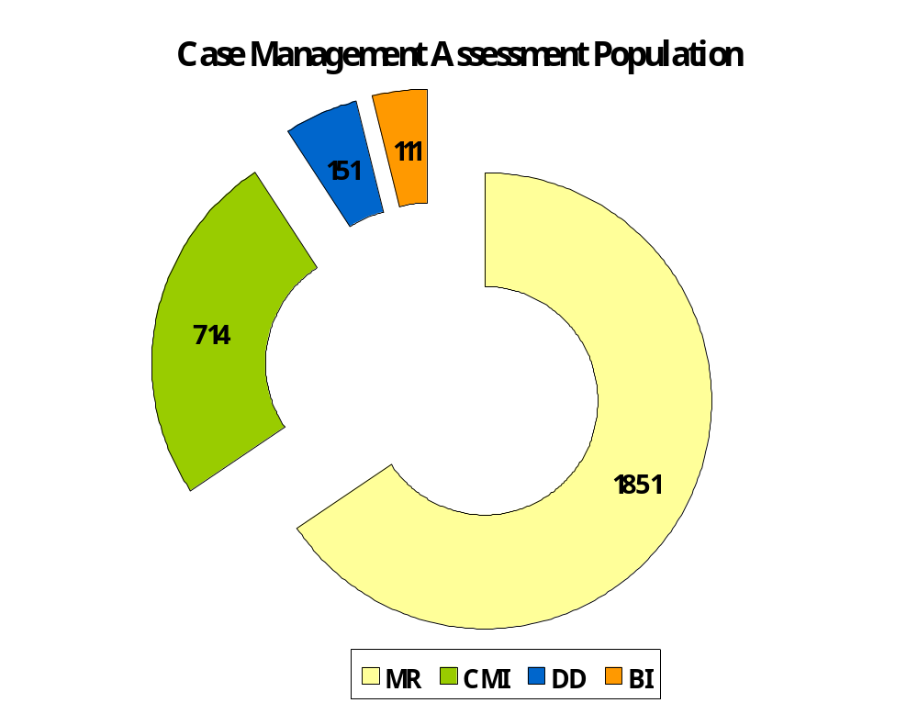

The assessment process was first introduced in 1997 and resulted from collaboration with Iowa State University through our contract with the ISU Child Welfare Project.

Assessment Data - Safe
Abuse Reports and Criminal Convictions

Abuse reports are counted when the consumer is a victim of founded abuse. Founded abuse is shown below by diagnosis and as a percent of the total population.
 | MR | CMI | DD* | BI* | Total
2000 | 0.5% | 1.1% | 0.6% |  | 0.7%
2001 | 0.2% | 1.2% | 0.5% |  | 0.5%
2002 | 0.4% | 0.7% | 0.0% |  | 0.4%
2003 | 0.4% | 1.0% | 0.0% |  | 0.7%
2004 | 0.4% | 0.3% | 0.0% | 0.9% | 0.4%
Total abuse in 2004 is tied with 2002 for the lowest percent on record.

Criminal convictions are shown for those consumers with a legal judgment. Consumers are counted during the year that the judgment occurred.
 | MR | CMI | DD* | BI* | Total
2000 | 0.8% | 2.7% | 3.0% |  | 1.6%
2001 | 1.7% | 1.9% | 1.7% |  | 1.8%
2002 | 0.8% | 2.0% | 2.2% |  | 1.2%
2003 | 0.8% | 5.5% | 3.0% |  | 2.3%
2004 | 0.6% | 2.1% | 0.7% | 0.0% | 1.0%
Total criminal convictions are the lowest they have been since we started tracking this data in 1998.

*In previous years DD and BI stats were tracked together as DD for the annual report.

Assessment Data - Healthy
The Percentage of consumers who had one or more medical hospitalizations during the year is shown.
 | MR | CMI | DD* | BI* | Total
2000 | 5.5% | 11.1% | 15.7% |  | 8.0%
2001 | 6.0% | 10.3% | 11.5% |  | 7.8%
2002 | 7.8% | 11.45% | 8.0% |  | 8.6%
2003 | 6.2% | 7.6% | 9.7% |  | 6.9%
2004 | 6.5% | 7.1% | 9.9% | 13.5% | 7.0%
The 2004 percentage of CMI consumers with one or more medical hospitalizations is the lowest on record.

The percentage of consumers who had at least one 23-hour observation during the year is shown.
 | MR | CMI | DD* | BI* | Total
2000 | 1.0% | 4.9% | 0.6% |  | 2.0%
2001 | 1.2% | 2.2% | 0.0% |  | 1.4%
2002 | 0.7% | 2.1% | 0.7% |  | 1.3%
2003 | 0.7% | 2.5% | 0.8% |  | 1.2%
2004 | 0.5% | 1.3% | 0.6% | 0.0% | 0.7%
23-hour observations are at their lowest total percentage on record.

Percentage of consumers who had at least one psychiatric hospitalization during the year is shown.
 | MR | CMI | DD* | BI* | Total
2000 | 4.0% | 26.6% | 3.0% |  | 7.2%
2001 | 4.0% | 27.0% | 4.6% |  | 11.2%
2002 | 4.0% | 26.7% | 2.9% |  | 10.9%
2003 | 3.5% | 20.6% | 2.7% |  | 8.3%
2004 | 3.5% | 19.4% | 4.0% | 0.9% | 7.5%
The percentage of CMI consumers with one or more psychiatric hospitalizations had declined every year since 2001.

*In previous years DD and BI stats were tracked together as DD for the annual report.

Assessment Data – Self Sufficient
The number of consumers in each work setting is shown by diagnosis for 2004*
Work Setting | MR | CMI | DD | BI
Competitive | 209 | 120 | 28 | 12
Supported | 217 | 70 | 25 | 11
Sheltered Work | 955 | 221 | 58 | 20
Supported and sheltered work settings have increased over 2003 numbers while competitive has seen a small decline.

The total number of working consumers is shown by type of work setting and year.
Work Setting | 2000 | 2001 | 2002 | 2003 | 2004
Competitive | 151 | 185 | 275 | 380 | 369
Supported | 317 | 302 | 202 | 270 | 323
Sheltered Work | 966 | 672 | 508 | 971 | 1254

The total percentage of working consumers is shown by diagnosis for 2004.
MR | CMI | DD | BI | Total
65.6% | 52.7% | 63.6% | 34.2% | 63.2%
Over half of all of our consumers are employed in some form of work setting and earn an income.

The average income for all working consumers in 2004 was $321.37 monthly.

*Some consumers have multiple work settings.

Assessment Data - Stable
Consumers who live in a stable environment such as their own home or a relative’s home score higher on the assessment. This demonstrates the positive impact the home setting has on result areas. As you can see a majority of the consumers in our assessment population live in their own home or with a relative.

2004 | MR | CMI | DD | BI
Own Home | 1008 | 430 | 82 | 68
Relative's Home | 447 | 42 | 38 | 28
RCF | 89 | 122 | 12 | 3
RCF - MR | 196 | 2 | 8 | 1
RCF - MI | 4 | 42 | 1 | 0
ICF | 4 | 3 | 0 | 1
ICF/MR | 3 | 0 | 0 | 0
Family Life Home | 4 | 2 | 0 | 1
Skilled Nursing Facility | 0 | 1 | 0 | 0
Jail | 0 | 0 | 0 | 0
Other | 78 | 42 | 1 | 4

In both 2003 and 2004 we had no consumers in Jail at the time of their assessment. In 2002 we had one.

Assessment Score Summary
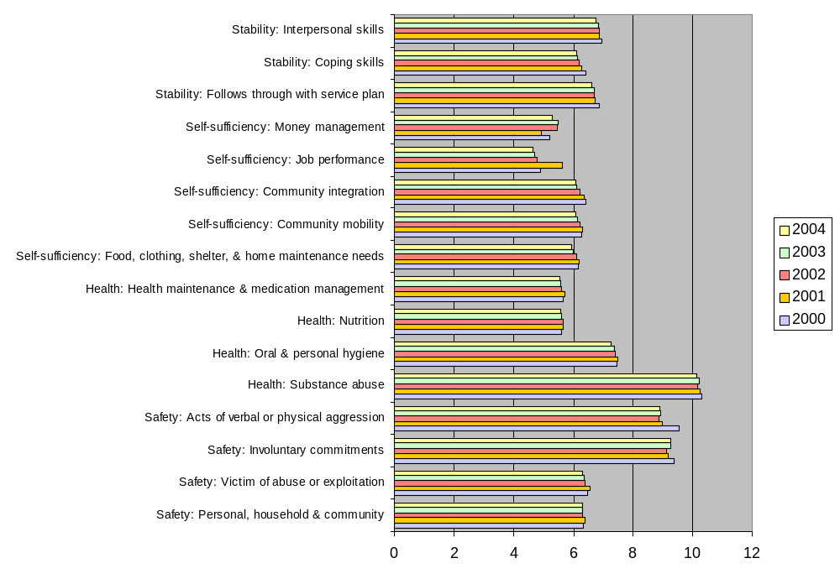

Safety
Calendar year 2003 was the first twelve-month period in which incidents, of a serious nature, were reported to the Iowa Department of Human Services Targeted Case Management Unit. With a year of baseline data we are now able to report on the second twelve-month period, calendar year 2004. The data on this page and the next page represents a comparison of the number and type of incidents by category, diagnosis, outcome, and age for 2003 and 2004.
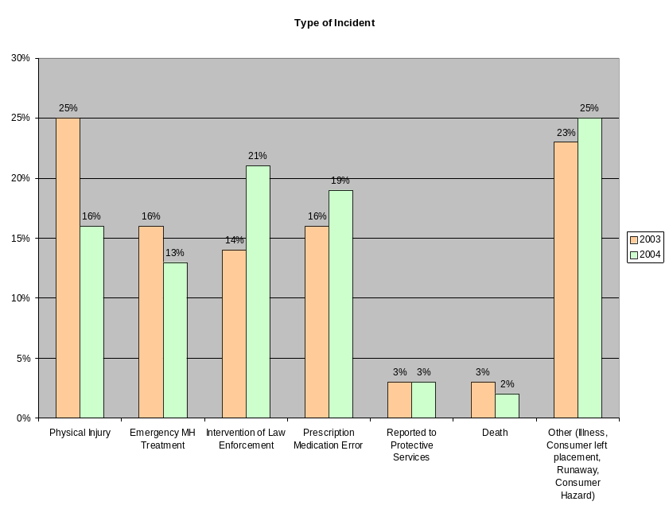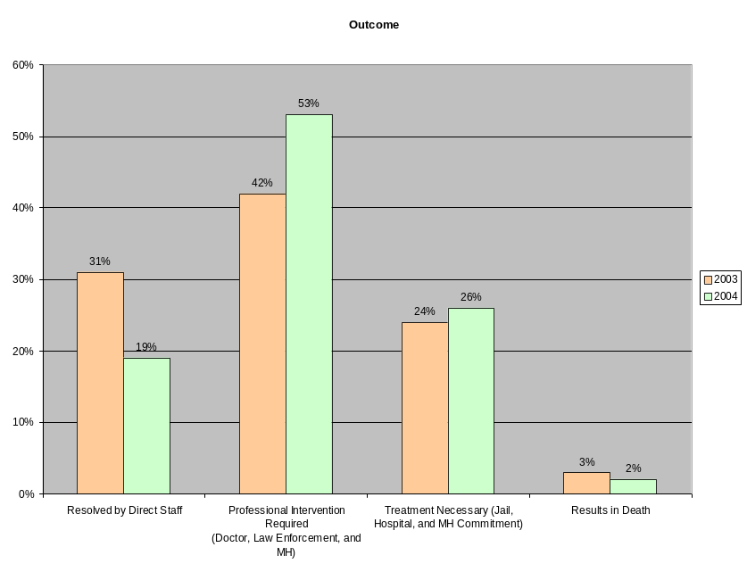
Incidents by Type
In 2004 the most frequently reported incident, by type, were incidents categorized as “other.” These incidents include: illness, runaways and consumer safety hazards. This year 25% (n = 325) fell into this category. This represents a two-percentage increase over last year’s report. The intervention of law enforcement accounted for 21% (n = 274) of the total number of incidents reported. This is a seven percent increase over last year’s report.

Medication errors remained fairly constant at 19% (n = 248) a three percent increase over last year’s figure. There were three percent fewer emergency mental health related concerns this year. In 2004, 13% (n = 165) sought mental health treatment. Concerns related to protective issues remained the same at 3% (n = 44). Always sad to report are the individuals, we serve, that die during the year. In 2004, 2% (n = 25) individuals died.

Incidents by Outcome
In 2004 professional intervention was required in 53% (n=684) of the reportable incidents. This represents an 11% increase over 2003. As such direct staff was able to resolve fewer incidents this year. In 2004 19% (n=247) or 12% fewer cases than the previous year. Treatment was necessary in 26% (n = 335) or 2% more cases this year.

Safety
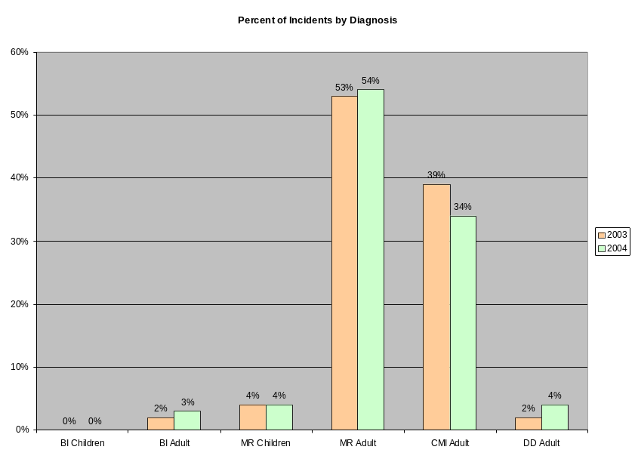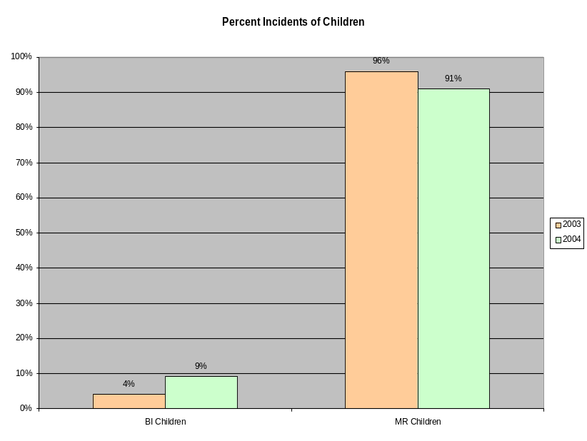

Total Incidents by Diagnosis
The vast majority of our incidents continue to be comprised between our MR and CMI adult population. Last year 92% of our caseload was comprised of the MR and CMI adult population. This year this number slipped four percent to 88%.

Individuals with a chronic mental illness or those who are mentally retarded, often represent a challenge to direct providers, in ensuring their safety. As we notify them of incidents by consumer, they will be able to see trends in their consumer behavior, which will allow them to intervene more appropriately.

Incidents by Children
In 2004 we saw a small increase in the total number of incidents reported, that involved children. In 2003 twenty-five of the total incidents submitted involved children. In 2004 there were thirty-two incidents that involved children. The data for this year indicates that half of these incidents were related to child protective concerns. This year targeted case management initiated a “safety review” process for incidents that involved child protective concerns. While it is our goal to ensure the safety of all our consumers we are especially concerned about children. With this review process we are able to bring the most serious concerns for review and action by our safety team.

Quality Improvement

The DHS Targeted Case Management Unit is the IAC Chapter 24 provider of choice to 25 counties. To maintain this relationship, the Unit places utmost importance on building high quality standards in order to provide the best possible services to its consumers and to maintain its case management accreditation. This is accomplished through the coordinated work of management and the Quality Team to provide continuous quality training of case managers, case reviews of every case manager, revised training materials, and policy improvements.

Quality Team. The Quality Team provides leadership on Quality issues by identifying problems and solutions in policy and practice. It serves as a customer service and support to supervisors and case managers and provides feedback and technical support to case managers in their work. Services include program and policy improvements, case reviews, training documents, consultations, specialized studies, hands-on training with case managers, and data collection.

Accreditation Survey and Corrective Action Plan. The highlight of 2004 was the recertification of DHS-TCM in May to continue doing business for another 3 years. In response to the accreditation survey, the Unit developed a Corrective Action Plan to implement continuing improvements in case documentation in such areas as needs and functional limitations in the Assessment, and goals, incremental steps, baselines, and discharge plans in the OAP. A training implementation plan was developed and all case managers are participating. Progress on this training has been very good, and it will be completed in June 2005. The goal for meeting documentation standards will be 80% for 2005, 85% for 2006, and 90% for 2007.

Administrative Handbook and Best Practice Book. In 2004, the policies and procedures in the DHS-TCM Administrative Handbook were updated to incorporate changes from the Corrective Action Plan. Also revised was the Best Practice Book, a training and working tool for all case managers that puts the Administrative Handbook and IAC Chapter 24 into a user-friendly daily guide.

Quality Case Reviews. Written quality case reviews, or readings, of randomly selected cases are done by members of the Quality Team. The case review provides feedback to the case manager and supervisor on the quality of case documentation as required by the Administrative Handbook and IAC Chapter 24 and identifies areas for improvement and training. In 2004, 276 cases were reviewed. The diagnosis breakout of these cases matches the overall breakout of cases. Selected data from these cases are indicated in the charts on the following page.

Quality Improvement
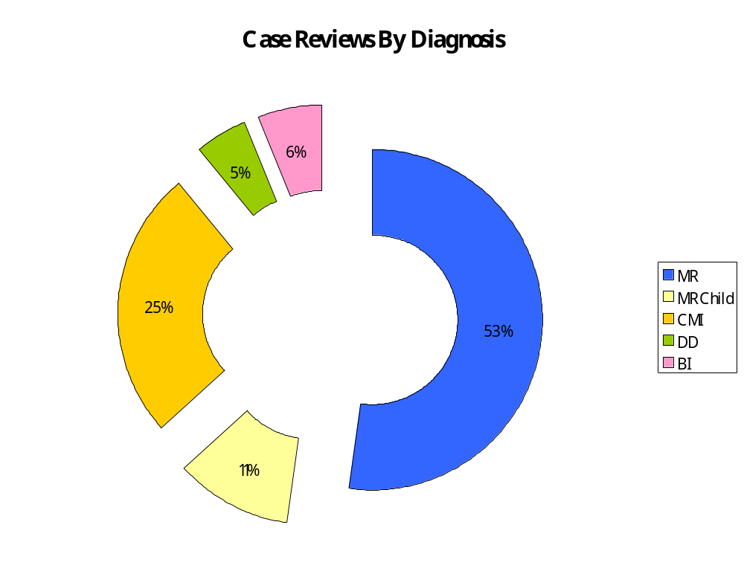
Case Documentation Meeting Standards
Total Cases | Need for TCM |  |  | Individual F/F Narrative |  |  | Crisis Plan |  |  | Quarterly  Review |  |  | Measurable Goals/S.A.s |  |  | Incremental Steps |  |  | Discharge Plan
 | Yes | No | N/A | Yes | No | N/A | Yes | No | N/A | Yes | No | N/A | Yes | No | N/A | Yes | No | N/A | Yes | No | N/A
276 | 190 | 80 | 6 | 258 | 14 | 4 | 198 | 73 | 5 | 190 | 42 | 44 | 239 | 35 | 2 | 209 | 50 | 17 | 163 | 111 | 2
100% | 69% | 29% | 2% | 94% | 5% | 1% | 72% | 26% | 2% | 69% | 15% | 16% | 87% | 13% | 0% | 76% | 18% | 6% | 59% | 40% | 1%

2004 Financial Information
The DHS Targeted Case Management Unit operates as a Medicaid provider. The Bureau operates on a projected rate for reimbursement of services and then retrospectively settles with various funders on actual costs incurred.

The federal share in SFY 2004 was 66.77%. The State of Iowa and the counties with which we contract split the remainder of costs, or 16.615% each. The Bureau does not receive an appropriation and operates solely upon revenues generated for services provided. The basis for allowable reimbursable costs is only those costs directly associated with providing TCM.

The Bureau's salary costs represent 82.69% of total expenses and are limited to staff who directly serve the consumers and staff who support those who serve the consumer. Support costs include items such as rent, travel, training, technology, office equipment, and telephones.
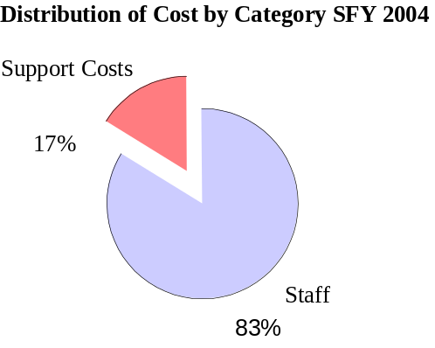
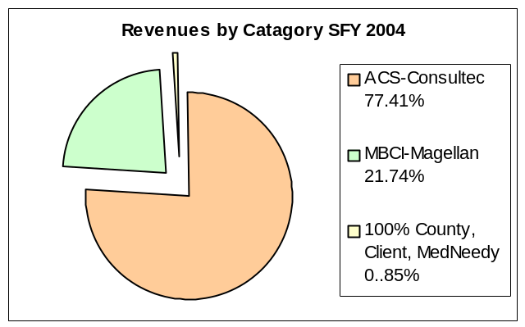

- Number of units of service provided were 41,992 compared to 39,429 the previous year. This was a 6.5% increase over the prior year.
- Proving problematic for the financial team this year were issues arising from the preauthorization of consumers for TCM services rendered under T-19. Preauthorizing eligibility and receiving timely payment for services rendered continues to be the paramount issue.
The DHS TCM financial team consists of two financial professionals performing the functions of Accountant and Budget Analyst. Five full time field account technicians complement them. The Financial Audit Division of the Auditor of State is scheduled to perform a full financial audit for SFY 2004 in March 2005.

