NEWS RELEASE | For Statewide Distribution

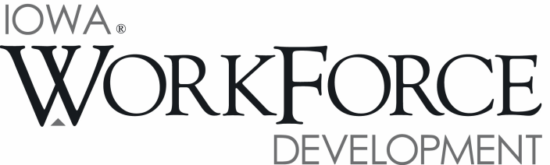
For Release: 9:00 a.m.  Date: January 23, 2018 | Contact: Cory Kelly (515) 330-5646
Iowa’s Job Market Tightens as Unemployment Rate Drops to 2.8 Percent in December

DES MOINES, IOWA – Iowa’s seasonally adjusted unemployment rate decreased to 2.8 percent for December.
The state’s jobless rate was 3.5 percent one year ago. The U.S. unemployment rate remained at 4.1 percent in December for the third straight month.

"Iowa businesses finished 2017 strong, bolstering payrolls by 7,100 jobs in December. Iowa factories have added 11,700 jobs in 2017," said Beth Townsend, Iowa Workforce Development Director. "With an unemployment rate at 2.8%, Iowa must address the shortage in skilled workers. It will take all hands on deck to sustain this economic growth including support from our partners in K-12, community colleges, universities, business and industry, economic developers and non-profits - all of whom participated in writing the Future Ready Iowa strategic plan. The plan will put Iowa in a position to create and sustain the skilled workforce we need now and in the future."

The number of unemployed Iowans decreased to 47,000 in December. The current estimate is 12,000 lower than the year ago level of 59,000.

The total number of working Iowans increased to 1,637,800 in December. This figure was 200 higher than November and 3,200 higher than one year ago.

Seasonally Adjusted Nonfarm Employment

In December, Iowa establishments added 7,100 jobs and lifted the total number of jobs to 1,600,100. This month’s increase marks the eighth monthly increase in 2017 versus just four months of losses. Growth was fueled by several sectors of the economy, particularly manufacturing, healthcare, and transportation. Additionally, the December gain follows another sizable increase in November. In total, private sectors advanced by 5,800 jobs this month. On the other hand, government added 1,300 jobs this month due to gains in local government and now stands 1,000 jobs higher than last year.

Manufacturing added the most jobs in December (+3,300) with the largest gains being in durable goods factories (+2,400). Non-durable goods factories added 900 jobs due in part to hiring in food production. This gain marks the fourth-consecutive for manufacturing to end the year. Healthcare and social assistance added 1,600 jobs to fuel all of the growth in the education and healthcare super sector. Healthcare and social assistance also had a sizable gain in November (+1,200). Trade and transportation fared well due to larger-than-expected gains in transportation and warehousing this month and was up 1,400 jobs. Much of this spike was due to a surge in parcel delivery related to holiday shopping. Like years past, retail was somewhat sluggish to end the year and was down 300 jobs in December. This trend in decreasing retail employment may be partially attributable to a shift toward online shopping and decreased reliance on brick-and-mortar stores during the holidays. Smaller sector gains this month included leisure and hospitality (+1,000) and financial activities (+700). Private sector losses were limited to construction (-1,300), professional and business services (-500), and other services (-400).

Annually, the state of Iowa has gained 28,300 jobs. Manufacturing leads the way in jobs added with 11,700 over the last twelve months. Growth for this sector began in May with 12,400 jobs being added over the past eight months. Education and healthcare has gained 6,900 jobs annually, followed by leisure and hospitality, up 6,600 jobs. Sector losses have been strongest in construction (-7,500) in the wake of a booming 2016. Smaller losses occurred in other services (-1,600) and information (-700).

Visit www.iowalmi.gov for more information about current and historical data, labor force data, nonfarm employment, hours and earnings, and jobless benefits by county.

###

An Equal Opportunity Employer/Program
Auxiliary aids and services are available upon request for individuals with disabilities.
www.iowaworkforcedevelopment.gov• www.iowajobs.org
MEDIA ALERT: An audio cut of comments about Iowa’s labor market situation is available by calling
(515) 281-6057. Statewide and local data for January 2018 will be released on Monday, March 12, 2018.

