NEWS RELEASE | For Statewide Distribution

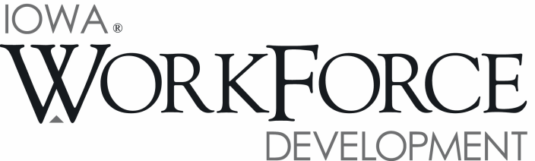
For Release: 9:00 a.m.  Date: December 22, 2017 | Contact: Cory Kelly (515) 330-5646
Iowa’s Unemployment Rate Drops Below 3.0 Percent for 1st Time in 17 Years

DES MOINES, IOWA – Iowa’s seasonally adjusted unemployment rate decreased to 2.9 percent for November. The last time the rate was this low was in December 2000. The state’s jobless rate was 3.5 percent one year ago. The U.S. unemployment rate remained at 4.1 percent in November.

"Following two months of losses, Iowa businesses displayed growing confidence in the economy in November and added 6,300 jobs to their payrolls," said Beth Townsend, Iowa Workforce Development Director. "Manufacturing is vital to our state’s economic security, and job creation has been especially strong within Iowa’s factories. Compared to last year, no sector has added more jobs to the Iowa economy than manufacturing. This growth has no doubt contributed to the state’s falling unemployment rate which now rests at 2.9 percent."

The number of unemployed Iowans decreased to 49,100 in November. The current estimate is 10,700 lower than the year ago level of 59,800.

The total number of working Iowans increased to 1,637,600 in November. This figure was 2,000 higher than October and 2,100 higher than one year ago.

Seasonally Adjusted Nonfarm Employment

Iowa businesses added 6,300 jobs in November, rebounding from losses accrued during the prior two months. Private sectors were responsible for all of the job growth with the largest growth being in service industries. This is welcomed news as over the past two months private services were responsible for much of the job loss. Goods producing industries have now trended up for three consecutive months with hiring within Iowa’s factories offsetting construction sector losses. Government trended down slightly (-400) and is nearly unchanged versus this time last year.

Professional and business services added the most jobs in November following losses in September and October (+2,500). Within this super sector, administrative and support services gained 2,000 jobs to fuel most of the monthly growth. Manufacturing gained 1,700 jobs and was fueled by hiring in durable goods factories (+1,600). This is now the third consecutive month of growth for manufacturing which has unmistakably trended up throughout the year. Financial activities rebounded from a slight decline last month and gained 1,500 jobs in November. Finance and insurance was responsible for most of the growth although real estate and rental industries contributed 300 jobs. In total, seven of ten private super sectors added jobs in November. Overall, losses were slight and limited to other services (-700), construction (-400), and information (-100).

Over the past twelve months, Iowa establishments have gained 22,700 jobs (+1.4 percent). During that time, no sector has added more jobs than manufacturing (+9,200). Nondurable goods factories are up 5,000 jobs and durable goods are up 4,200 jobs. Healthcare and social assistance has advanced by 5,700 jobs and has fueled all of the growth in the education and healthcare super sector. The financial activities sector experienced two months of declines in August and September, but has since rebounded and is now up 4,400 jobs versus last year thanks to this month’s gain. Losses have been dominated by construction (-6,100) which has trailed last year’s mark for much of the year and has been steadily trending down following record levels last year. Other services are down 1,400 jobs over the past twelve months and information has pared 1,000 jobs.

Visit www.iowalmi.gov for more information about current and historical data, labor force data, nonfarm employment, hours and earnings, and jobless benefits by county.

###

An Equal Opportunity Employer/Program
Auxiliary aids and services are available upon request for individuals with disabilities.
www.iowaworkforcedevelopment.gov• www.iowajobs.org
MEDIA ALERT: An audio cut of comments about Iowa’s labor market situation is available by calling
(515) 281-6057. Statewide and local data for December 2017 will be released on Tuesday, January 23, 2018.

