NEWS RELEASE | For Statewide Distribution

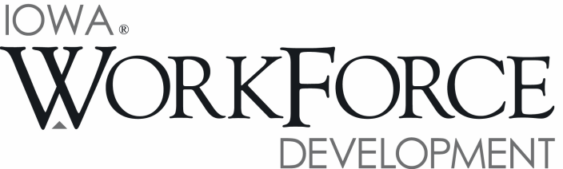
For Release: 9:00 a.m.  Date: August 18, 2017 | Contact: Cory Kelly (515) 330-5646
Manufacturing Posts Job Gain for Third Straight Month;
Iowa’s Unemployment Rate Remains at 3.2 Percent in July

DES MOINES, IOWA – Iowa’s seasonally adjusted unemployment rate remained at 3.2 percent for July. The state’s jobless rate was 3.7 percent one year ago. The U.S. unemployment rate decreased slightly to 4.3 percent in July.

“Iowa’s unemployment rate held steady at 3.2 percent while Iowa businesses continued to expand payrolls in July,” said Beth Townsend, Iowa Workforce Development Director. “This month’s gain is the third consecutive increase for nonfarm employment and was fueled by hiring in manufacturing industries. Factory jobs have been the backbone of this state’s economy for many years and recent hiring has provided evidence that demand may be increasing for our state’s goods.”

The number of unemployed Iowans increased to 54,400 in July. The current estimate is 9,300 lower than the year ago level of 63,700.

The total number of working Iowans decreased to 1,628,100 in July. This figure was 4,300 lower than June and 8,500 lower than one year ago.

Seasonally Adjusted Nonfarm Employment

Total nonfarm employment increased for the third consecutive month in July, gaining 1,600 jobs. Since April, 10,700 jobs have been added with most of the job gains being in private services. Government shed jobs this month (-500) following a larger than expected increase in June. Altogether, government trails last year’s mark by 2,400 jobs, while total nonfarm employment is up 15,900 jobs.

Manufacturing added the most jobs this month (+1,800) and has gained jobs in each of the last three months, adding 5,000 jobs during that span. The majority of those gains have been in durable goods factories, although nondurable goods factories have also experienced strong job growth since April. Among durable goods firms, jobs have been added in fabricated metal products and agricultural and construction machinery shops. Within nondurable goods factories, animal slaughtering and processing along with food manufacturing have fared the best. Other gains this month included trade and transportation (+1,600), leisure and hospitality (+1,200), and education and health services (+600). Losses this month were concentrated in construction (-2,300) due to staff reductions with projects completing early this year. Smaller losses included other services (-600) and professional and business services
(-400).

Annually, healthcare remains a driving force in job growth in Iowa and has added 6,900 jobs over the past twelve months even after this month’s slight decline. Finance and insurance was flat this month but still remains up 4,300 jobs since last July. In fact, most sectors have shown signs of growth versus last year including manufacturing (+1,800) following the recent hiring boon since April. Those few sectors that are down annually were construction
(-4,400), regressing from last year’s record pace as large-scale industrial projects ended, and information services
(-1,200) due to structural changes within the industry.

Visit www.iowalmi.gov for more information about current and historical data, labor force data, nonfarm employment, hours and earnings, and jobless benefits by county.

###

An Equal Opportunity Employer/Program
Auxiliary aids and services are available upon request for individuals with disabilities.
www.iowaworkforcedevelopment.gov• www.iowajobs.org
MEDIA ALERT: An audio cut of comments about Iowa’s labor market situation is available by calling
(515) 281-6057. Statewide data for August 2017 will be released on Friday, September 15, 2017. Local data for August will be posted to the IWD website on Tuesday, September 19, 2017.

