NEWS RELEASE | For Statewide Distribution

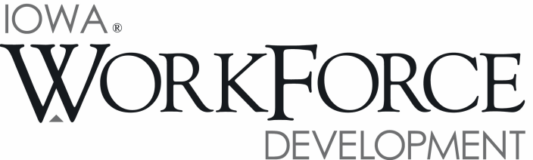
For Release: 9:00 a.m.  Date: May 19, 2017 | Contact: Cory Kelly (515) 330-5646
Iowa’s Unemployment Rate Remains at 3.1 Percent

DES MOINES, IOWA – Iowa’s seasonally adjusted unemployment rate remained at 3.1 percent in April. The state’s jobless rate was 3.8 percent one year ago. The U.S. unemployment rate dropped to 4.4 percent in April.

“The Iowa economy provided little clue in terms of long-term trend in April, with slight change in most economic measures,” said Beth Townsend, Iowa Workforce Development Director. “There was another small decrease in total nonfarm employment for the state, a possible sign that businesses are a little more apprehensive about hiring to begin the summer season compared to previous years. This was particularly true in construction which is down slightly compared to last year’s record highs.”

The number of unemployed Iowans remained at 52,100 in April. The current estimate is 11,900 lower than the year ago level of 64,000.

The total number of working Iowans decreased to 1,640,000 in April. This figure was 200 lower than March and 3,300 higher than one year ago.

Seasonally Adjusted Nonfarm Employment

Following a hiring surge to begin the year, total nonfarm employment has been sluggish over the past two months, shedding 1,400 jobs since February, and now rests at 1,579,700 jobs in April. While job growth was particularly anemic in goods-producing sectors, half of all private sectors shed jobs this month. Among public entities, government shed jobs for the fourth consecutive month and pared 500 jobs in April. Government trails last year’s mark by 1,300 jobs due primarily to reductions at the local level.

Construction was down 1,500 jobs in April to lead all sectors. This sector continues to trail last year’s historic highs slightly, but may exceed those marks as the summer projects hit their peak. Manufacturing also lost jobs this month (-700) stemming from reductions in durable goods factories which have now decreased in three of the last four months. Smaller drops this month included other services (-500), information (-300), and trade and transportation (-300). Alternatively, job gains this month were largest in education and health care (+1,800) and were fueled by larger than expected hiring in health services and social assistance. Financial activities expanded again this month and added 800 jobs. This month’s increase marks the eighth-consecutive gain dating back to August 2016. Smaller gains in April included professional and business services (+400) and leisure and hospitality (+300).

Annually, Iowa has added 8,000 jobs over the past twelve months. Health care industries have boosted the education and health services super sector to a gain of 5,300 jobs. Professional and business services remains up 3,900 jobs due primarily to hiring in professional, scientific, and technical services. The financial activities sector has steadily trended up over the past several months and is now up 3,500 jobs annually. On the other hand, annual losses are now evident in four private super sectors in Iowa and continue to be led by manufacturing (-4,100). Durable goods factories continue to struggle with weak demand and retooling factories are down markedly versus one year ago (-3,700). Information continues to adjust to the changing economy and trails last year’s level by 1,500 jobs. Construction is also down annually (-1,300), although this loss is compared to historic highs reached last year and this sector may be recovering from a weak start to the summer building surge.

Visit www.iowalmi.gov for more information about current and historical data, labor force data, nonfarm employment, hours and earnings, and jobless benefits by county.

###

An Equal Opportunity Employer/Program
Auxiliary aids and services are available upon request for individuals with disabilities.
www.iowaworkforcedevelopment.gov• www.iowajobs.org
MEDIA ALERT: An audio cut of comments about Iowa’s labor market situation is available by calling
(515) 281-6057. Statewide data for May 2017 will be released on Friday, June 16, 2017. Local data for May will be posted to the IWD website on Tuesday, June 20, 2017.

