NEWS RELEASE | For Statewide Distribution

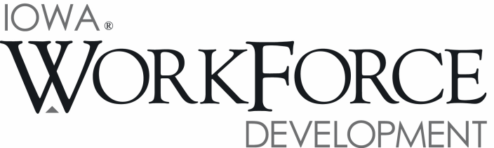
For Release: 9:00 a.m.  Date: December 16, 2016 | Contact: Courtney Maxwell Greene (515) 281-9646
Iowa’s Unemployment Rate Falls to 3.8 Percent in November

DES MOINES, IOWA – Iowa’s seasonally adjusted unemployment rate fell to 3.8 percent in November. The state’s jobless rate was 3.5 percent one year ago. The U.S. unemployment rate dropped to 4.6 percent in November.

"The unemployment rate in Iowa is the lowest since March, which in part is due to holiday hiring and the great fall weather we have had this year,” said Beth Townsend, Director of Iowa Workforce Development. “The economy remains soft as we transition to seasonal unemployment during the winter months."

The number of unemployed Iowans decreased to 65,000 in November from 70,400 in October. The current estimate is 5,300 higher than the year ago level of 59,700.

The total number of working Iowans decreased to 1,655,000 in November. This figure was 200 lower than October and 10,600 higher than one year ago.

Seasonally Adjusted Nonfarm Employment

Iowa establishments shed 4,700 jobs in November and lowered employment down to 1,580,100 jobs. This
drop marked the third straight month for job losses for the state. Private sector losses totaled 3,900 jobs and government pared 800 jobs. Public sector drops were primarily within local government (-600), although the federal sector shed jobs also (-200). Government trails last year’s level by 1,300 jobs. Private sectors remain
up (+11,300), but the magnitude of the annual increase has been waning as the year comes to an end.

In November, the largest movement occurred in trade, transportation, and utilities which experienced a decline of 2,300 jobs. The majority of the loss was incurred in retail (-1,400), although transportation, utilities, and wholesale shed jobs this month as well. Iowa’s retail sector has not fared well through 2016 and is down compared to last November (-1,400). Iowa’s manufacturers lost 1,400 jobs with losses distributed evenly between durable and nondurable goods factories. This marks the second straight decline following a brief upsurge in the summer. Other notable losses included other services (-1,200), leisure and hospitality (-500), and information (-200). On the other hand, job gains were realized in three private industries and led by professional and business services (+1,400) and heavily fueled by hiring in administrative support and waste management services. All other gains this month were small and included education and health care (+300) and financial activities (+100).

Annually, total nonfarm employment is up just 10,000 jobs. Monthly declines over the past few months have reduced the annual growth rate considerably. Construction continues to sustain employment and leads all sectors with 8,300 jobs added. Education and health care is second in terms of growth (+4,200) followed by financial activities (+3,900). Manufacturing continues to trend down and lags behind last year’s mark by 7,300 jobs. The only other sectors down annually are professional and business services (-2,200) and information (-1,300).

Visit www.iowalmi.gov for more information about current and historical data, labor force data, nonfarm employment, hours and earnings, and jobless benefits by county.

###

An Equal Opportunity Employer/Program
Auxiliary aids and services are available upon request for individuals with disabilities.
www.iowaworkforcedevelopment.gov• www.iowajobs.org
MEDIA ALERT: An audio cut of comments about Iowa’s labor market situation is available by calling
(515) 281-6057. Statewide and local data for December 2016 will be released on Tuesday, January 24, 2017.

