NEWS RELEASE | For Statewide Distribution

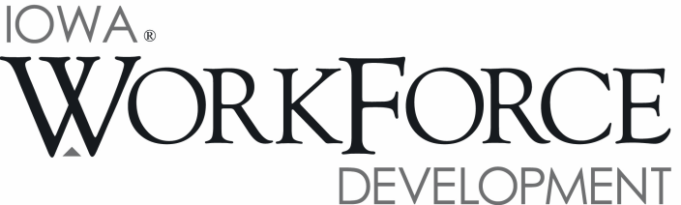
For Release: 9:00 a.m.  Date: June 17, 2016 | Contact: Courtney Maxwell Greene (515) 281-9646
May Unemployment Rate Remains Stable at 3.9 Percent

DES MOINES, IOWA – Iowa’s seasonally adjusted unemployment rate remained at 3.9 percent in May. The state’s jobless rate was 3.6 percent one year ago. The U.S. unemployment rate dropped to 4.7 percent in May compared to 5.0 percent in April.

"Consistent with the anemic job report posted nationally, Iowa did not see a decrease in the unemployment rate in May,” said Iowa Workforce Development Director Beth Townsend. “Although Iowa's unemployment rate remained at 3.9 percent, Iowa saw a decline in its labor force. The drop may be attributed to a number of factors. On the positive side, construction, health services and education continue to lead all job sectors in growth for the year."

The number of unemployed Iowans rose to 66,500 in May from 66,200 in April. The current estimate is 4,500 higher than the year ago level of 62,000.

The total number of working Iowans decreased to 1,644,800 in May. This figure was 2,600 lower than April and 8,200 higher than one year ago.

Seasonally Adjusted Nonfarm Employment

Total nonfarm employment shed 4,200 jobs in May and now rests at 1,577,900. The decrease is the second for 2016 and is primarily due to cut backs in goods producing sectors. Service industries were nearly unchanged versus April. Private industry shed a combined 3,700 jobs and government was reduced by 500. The loss in government was due to drops in local and state government and was partially offset by a gain of 200 at the federal level. Compared to last year, government remains up 2,100 jobs.

Manufacturing experienced a sharp decline this month in durable goods factories with 2,700 jobs pared overall. This sector has been steadily trending down and dealing with reduced demand forecasts for machinery and transportation products. Construction also experienced a reduction in May (-1,400); however, this drop follows very large gains in March and April which saw a combined 6,900 jobs added, so this month’s decline may represent a seasonal shift. Other sectors losing jobs this month included professional and business services (-600) and financial activities (-500). Alternatively, gains were sporadic in May and were led by education and health services (+700). Private education fueled the growth this month as health care shed 200 jobs. Trade and transportation was buoyed by hiring in wholesale and retail trade this month and added 300 jobs. Information, other services, and leisure and hospitality also trended up slightly.

Annually, nonfarm employment remains up 18,000 jobs or 1.2 percent. Despite a drop this month, construction leads all sectors in both jobs gained (+10,400) and by percentage increase (+13.4). Education and health services has also fared well annually (+5,700) due mostly to hiring in private health care. Losses are still being fueled by durable goods manufacturing (-7,300) which has added jobs just once since January of 2015. Other sectors paring jobs annually were professional and business services and information, each down 1,700 jobs.

MEDIA ALERT: An audio cut of comments about Iowa’s labor market situation is available by calling
(515) 281-6057. Statewide data for June will be released on Friday, July 22, 2016. Local data for
June will be posted to the IWD website on Tuesday, July 26, 2016.

Visit www.iowaworkforcedevelopment.gov/labor-market-information-division for more information about current and historical data, labor force data, nonfarm employment, hours and earnings, and jobless benefits by county.

An Equal Opportunity Employer/Program
Auxiliary aids and services are available upon request for individuals with disabilities.
www.iowaworkforcedevelopment.gov• www.iowaworks.org • www.iowajobs.org

