NEWS RELEASE | For Statewide Distribution

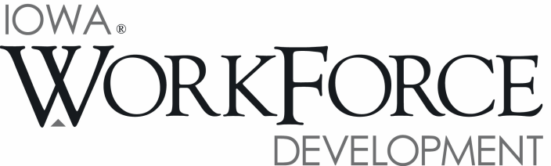
For Release: 9:00 a.m.  Date: May 20, 2016 | Contact: Courtney Maxwell Greene (515) 281-9646
Iowa’s Unemployment Rate Increases to 3.9 Percent in April

DES MOINES, IOWA – Iowa’s seasonally adjusted unemployment rate increased slightly to 3.9 percent in April from 3.8 percent in March. The state’s jobless rate was 3.7 percent one year ago. The U.S. unemployment rate remained at 5.0 percent in April.

“Although Iowa’s unemployment rate ticked up for the third straight month, the good news is that there are over 56,000 jobs posted at iowajobs.org, indicating Iowa’s employers are still in significant need of skilled workers,” said Iowa Workforce Development Director Beth Townsend. “While we never like to see the unemployment rate increase, Iowa still maintains a friendly environment for job seekers.”

The number of unemployed Iowans rose to 66,100 in April from 65,500 in March. The current estimate is 3,800 higher than the year ago level of 62,300.

The total number of working Iowans decreased to 1,647,200 in April. This figure was 2,300 lower than March and 10,200 higher than one year ago.

Seasonally Adjusted Nonfarm Employment

In April, Iowa’s nonfarm employment advanced by 4,300, lifting employment to 1,580,800 jobs. The monthly gain is the second consecutive for the state following an unusually large paring in February. Despite increasing concern over an economic downturn, Iowa businesses continue to hire and the state has added jobs in six of the last seven months leading to an increase of 20,000 jobs versus one year ago. Private sector firms increased marginally this month (+2,400). Government added jobs primarily at the local government level (+2,100) and is up 2,000 jobs annually.

Construction added the most jobs this month (+3,300). This increase follows another large increase in March and is not unexpected given the large quantity of institutional and infrastructure projects taking place around the state. The financial sector rebounded from a slight loss last month and added 1,600 jobs. This sector has steadily advanced throughout 2015 and carrying over into 2016. Other sectors adding jobs this month include manufacturing (+1,000), education and health care (+900), and professional and business services (+500). Alternatively, losses were concentrated in trade and transportation (-3,500). Declines were nearly split between both wholesale and retail trade payrolls in April. All other losses were minor this month and included leisure and hospitality (-600) and other services (-600).

Annually, construction continues to hire and has accounted for slightly over half of all job gains in Iowa (+10,600). The state’s continued expansion in construction provides at least some indication of continued optimism firms hold regarding the economic future. Education and health care is second in terms of growth (+5,100) followed by financial activities (+3,800). Losses have been sparse with the exception of manufacturing (-4,200), information (-1,800), and professional and business services (-900).

MEDIA ALERT: An audio cut of comments about Iowa’s labor market situation is available by calling
(515) 281-6057. Statewide data for May will be released on Friday, June 17, 2016. Local data for May will be posted to the IWD website on Tuesday, June 21, 2016.

Visit www.iowaworkforcedevelopment.gov/labor-market-information-division for more information about current and historical data, labor force data, nonfarm employment, hours and earnings, and jobless benefits by county.

An Equal Opportunity Employer/Program
Auxiliary aids and services are available upon request for individuals with disabilities.
www.iowaworkforcedevelopment.gov• www.iowaworks.org • www.iowajobs.org

