State Rehabilitation Council

Division of Vocational Rehabilitation

510 East 12th Street

Des Moines, Iowa 50319

Iowa

State

Rehabilitation Council

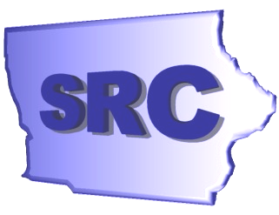

**2003—2004**

# **Annual Report**

## **From the Chair**

#### ***Kathryn Baumann-Reese***

December 31, 2004

To the Honorable Thomas J. Vilsack, Governor, State of Iowa:

The Iowa State Rehabilitation Council (SRC) is pleased to present to you the 2004 Annual Report.

The SRC continues to work closely with the Division of Vocational Rehabilitation Services (DVRS), Department of Education, to improve and expand employment services for Iowans with disabilities. During the past year, the SRC has taken a more active role in providing guidance to DVRS. The Council continues to increase its awareness and seeks new approaches to service delivery. One focus has been to broaden the representation of individuals serving on the Council. This would not have been possible without your staff being responsive to our needs when seeking qualified individuals to serve. We believe this partnership has strengthened our ability to serve Iowans with disabilities.

During the past year the SRC has adopted new by-laws and restructured committees to improve our ability to provide meaningful input to both DVRS and the State of Iowa. The agency has continued to seek ways to maximize the use of resources while enhancing services to clients. These initiatives demonstrate our accountability to Iowa and the consumers we serve.

As always, the SRC continues to focus on consumer satisfaction, opportunities for collaboration, and ways to improve the quality of life and economic outcomes of Iowans with disabilities. We look forward to another successful year in 2005.

Sincerely,

Kathryn Baumann-Reese

Chair

## **From the Division Administrator**

#### ***Stephen A. Wooderson***

December 31, 2004

To the Honorable Thomas J. Vilsack, Governor, State of Iowa:

Federal Fiscal Year 2004 has been a year of significance for the Iowa Division of Vocational Rehabilitation Services (DVRS). Due to increases in referrals and costs in providing rehabilitation services, waiting lists were implemented in May of 2002. This meant that large numbers of clients were placed on waiting lists. Beginning in November of 2002, the process of removing clients from the waiting lists and providing services began. By February of 2003, all clients who were classified as most significantly disabled were being served; however, all other new referrals still were placed on a waiting list. Waiting lists historically impact referrals, staff morale and outcomes. I am pleased to say, however, that in the midst of these challenges, the staff of DVRS continued to provide high quality services and meet the needs of those we served during a very difficult year.

Fiscal Year 2004 ended with a surprising development; we exceeded the number of successful placements into competitive employment from the previous year. Typically we would have expected a decrease from the previous year due to the continuing existence of our waiting lists. Two thousand one hundred thirteen persons with disabilities were placed into competitive employment as a direct result of the work of DVRS staff. Additionally, DVRS had increases in the number and percentage of successful placements, as well as the percentage of persons with significant disabilities being served.

In 2004, DVRS planned and implemented new programs and initiatives, expanded its collaborative efforts with employers, consumers and community-based organizations, and strengthened its partnerships with the State Rehabilitation Council, public and private service providers, and with state and other government agencies.

The DVRS staff is dedicated to providing quality service leading toward quality outcomes. We continue to challenge old beliefs, meet higher standards and expectations, work closely with our partners, improve communications, utilize our resources wisely, and celebrate our achievements.

Sincerely,

DIVISION OF VOCATIONAL

REHABILITATION SERVICES

Stephen A. Wooderson, Administrator

## **State Rehabilitation Council**

#### ***2003 - 2004***

#### Mission

“Iowans in partnership with DVRS to assure that people with disabilities meet their employment, independence, and economic goals.”

#### Introduction

The Iowa State Rehabilitation Council (SRC) is a body of citizens, in partnership with the Division of Vocational Rehabilitation Services (DVRS), appointed by Governor Thomas Vilsack, under the authority of the Rehabilitation Services Act of 1973, as amended, to provide guidance and advice on issues impacting rehabilitation in the State of Iowa. The Council reviews, analyzes, and advises the Iowa DVRS regarding the state’s vocational rehabilitation programs.

#### Establishment of the SRC

The Iowa State Rehabilitation Council (SRC) was established in 1993 as mandated by the 1992 amendments to the Rehabilitation Act. The SRC was originally established as an advisory council, and later the name was changed with the 1998 amendments to the Rehabilitation Act of 1973.

#### Council Duties

**Review, analyze, and advise** the Iowa Division of Vocational Rehabilitation Services (DVRS) regarding the performance of the responsibilities of DVRS under Title I, particularly responsibilities relating to:

* + - Eligibility;
    - The extent, scope and effectiveness of services provided; and functions performed by DVRS that affect, or that potentially affect, the ability of individuals with disabilities to achieve employment outcomes under Title I.

**In partnership with DVRS:**

* + - * Develop, agree to, and review State goals and priorities in the State Plan.
      * Evaluate the effectiveness of the vocational rehabilitation program and submit reports of progress to the Commissioner in accordance with the State Plan.

**Advise DVRS** regarding the activities authorized to be carried out and assist in the preparation of the State Plan and amendments to the plan, applications, reports, needs assessments, and evaluations required by Title I.

**Conduct a review** and analysis (to the extent possible) of the effectiveness of, and consumer satisfaction with:

* + - * The functions performed by DVRS;
      * Vocational rehabilitation services provided by State VR agencies and other public and private entities responsible for providing vocational rehabilitation services to individuals with disabilities under the Vocational Rehabilitation Act; and
      * Employment outcomes achieved by eligible individuals receiving services under Title I, including the availability of health and other employment benefits in connection with such employment outcomes.

**Prepare and submit** an annual report to the Governor and the Commissioner on the status of vocational rehabilitation programs operated within the State, and make the report available to the public.

**To avoid duplication of efforts and enhance the number of individuals served,** coordinate activities with the activities of other councils within the State, including:

* + - * The Statewide Independent Living Council;
      * The advisory panel of the Individuals with Disabilities Education Act;
      * The State Developmental Disabilities Council of the Developmental Disabilities Assistance and Bill of Rights Act;
      * The State Mental Health Planning Council; and
      * The State Workforce Investment Board.

**Provide for** coordination and the establishment of working relationships between DVRS and the Statewide Independent Living Council and centers for independent living within the State.

**Perform such other functions**, consistent with the purpose of the Vocational Rehabilitation Act, Title I, as the State Rehabilitation Council determines to be appropriate, that are comparable to the other functions performed by the Council.

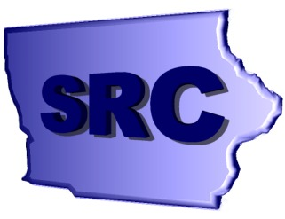

Membership of the SRC

The Council must be composed of at least 15 members who are appointed by Governor Thomas Vilsack. Membership includes representatives from:

* + Statewide Independent Living Council;
  + The Parent Training and Information Center;
  + Client Assistance Program;
  + Qualified vocational rehabilitation counselor;
  + Community rehabilitation program service providers;
  + Four representatives of business, industry, and labor;
  + Disability groups that include: individuals with physical, cognitive, sensory, and mental disabilities; and representatives of individuals with disabilities who have difficulty representing themselves;
  + Current or former applicants for, or recipients of, vocational rehabilitation services;
  + State educational agency responsible for the public education of students with disabilities;
  + State Workforce Investment Board;
  + Administrator of the Division of Vocational Rehabilitation Services as an ex- officio, nonvoting member.

#### Activities of the SRC

(October 1, 2003 – September 30, 2004)

**Bylaws**

This year the SRC developed a new and complete set of bylaws. These bylaws incorporate the requirements for membership and appointment that are spelled out in the Rehabilitation Act. They also define the officers, executive committee, and standing committees.

###### Committees

The bylaws call for three standing committees: Outreach; Planning and Evaluation; and Finance. With these committees clearly defined in the bylaws, the Council has developed new energy to carry out their responsibilities.

###### Legislative Reception

The SRC membership hosted a legislative reception to educate members of the Iowa Legislature and others about DVRS, its services, and those whom we serve. For the first time in many years, the SRC did the reception on its own, after several years of doing it in conjunction with the Statewide Independent Living Council (SILC). Sixty-four legislators attended the reception.

**State Plan Goals and Priorities Review**

The SRC is active in reviewing and approving the Agency’s “Goals and Priorities” report which is required by the Rehabilitation Services Administration (RSA) as a part of the State Plan. During the last fiscal year the following activities took place in an effort to accomplish the goals outlined in the Agency’s State Plan.

**Goal 1. Utilizing awareness and outreach strategies recommended by the DVRS Cultural Diversity Committee DVRS will:**

1. **continue to monitor referrals to ensure that minorities represent at least 5% of the active caseload;**
2. **aim to achieve a rehabilitation rate for minorities at least equal to that of**

**non-minorities.**

**Report:** Minorities make up 7.5% of the DVRS caseload. The 2000 U.S. Census reports that only 3.7% of Iowa’s residents are minorities. This past year the rehabilitation rate for whites was 46.2%, but for minorities it was only 30.2%, or a ratio of .654. All of these are down from last year. We believe this is due to efforts to clean inactive cases out of caseloads, which led to a large number of unsuccessful closures. We are working on a plan to better partner with the Department of Human Rights in helping our staff develop better abilities in cultural competency. Surveys of minorities closed as unsuccessful have been conducted in Waterloo and Davenport. None of the individuals interviewed expressed a feeling that race had played any part in their lack of success.

The Cultural Diversity Committee continues to study the problem, hoping to identify ways of improving the retention and successful closure of minorities with disabilities. The Committee has begun having one of its members present a “diversity moment” at the beginning of each meeting. These are video taped and provided to each area office to be used at a staff meeting.

**Goal 2. DVRS will actively participate in the implementation of the Workforce Investment Act in Iowa.**

**Report:** This year we have been actively watching the WIA re-authorization process to see how our involvement may need to be modified to meet the potential changing mandates of the Workforce Investment Act. Our staff continue to work with the local boards and other partners, many of which are currently revising their Memorandum of Understanding (MOUs). Although we know of no staff who are voting members of a regional board, there are several that are non-voting members and a number who attend most meetings of the boards.

**Goal 3. DVRS will maintain at least one counselor in each area office who will serve on the Rehabilitation Counselors for the Deaf and Hard of Hearing group (RCDHH). This group will advise the agency on the purchase and training of communication devices for the deaf (TTYs) and on other issues related to the provision of services to the Deaf and Hard of Hearing.**

**Report:** The RCDHH group continues to meet on a quarterly basis. This year they have developed a very positive relationship with the head of Deaf Services of Iowa. She has been a regular participant in their meetings. They have also discussed several questions that arise when working with persons with hearing disabilities. In particular they are looking at: 1) multiple purchases of hearing aids over time; 2) eligibility of clients with hearing loss (at what level do individuals have serious vocational limitations); 3) should we consider paying for cochlear implants; and 4) should we recommend to the SRC that they modify their client satisfaction survey (we have evidence that the current one may be difficult for some deaf individuals to understand). The RCDHH has provided training to staff on the use of the TTY.

**Goal 4. DVRS will develop, disseminate, and monitor methods and procedures to keep clients involved with the rehabilitation program until they become successfully employed. The goal will be that DVRS meets the requirements established in the RSA Standards and Indicators.**

**Report:** As we began to see the effect of restricting services by placing individuals on waiting lists, we recognized that successful closures were going to fall, but that we would have a difficult time predicting the volume of clients we could handle if their were large numbers of inactive cases in the caseloads. Therefore, we directed staff to spend time during the year closing those cases of clients that they could no longer find or who were no longer interested in services. This resulted in fewer rehabilitation closures and more unsuccessful closures. Our rehabilitation rate suffered, and we did not meet the standard in that area. However, the ratio of minorities to non-minorities was finally above the standard. We have developed and implemented a full-blown quality assurance effort, which we believe will result in an increase in quality casework over the next few years. In addition, a work group dealing with placement has been actively working to improve efforts at moving clients into quality and permanent jobs.

**Goal 5. Through increased collaboration and cooperation with the network of mental health providers, DVRS will increase the successful rehabilitation outcomes of persons with mental illness by 3% and maintain that increase.**

**Report:** Implementing new efforts that will have a significant affect on outcomes is difficult during a time when individuals are being placed on waiting lists. Last fall DVRS sponsored a day long review of mental health efforts. A wide variety of groups were invited, including NAMI, county case managers, Community Rehabilitation Programs (CRPs), mental health center workers, and school personnel. A group of about 50 people spent the day identifying areas in which they felt that VR should review and possibly revise their practices. Following the meeting we asked for volunteers who were interested in helping DVRS work further on this effort. Two groups were established, one to work on outreach, application and eligibility, the other to work on plan development, follow-up, and placement. Both groups have met regularly and are close to proposing a pilot study of some of the material they have developed. The percent of our rehabilitation closures that have a mental health diagnosis continues to be just over 22%.

**Goal 6. Provide technical assistance to at least 10 CRPs to assist them in improving the quality of supported employment services they provide to clients of DVRS.**

**Report:** In the belief that CRPs can only provide quality services if they are adequately compensated, we completed work on and introduced the Menu of Services this year. The service fees in the Menu are based on actual CRP cost data. Because it allows the client and counselor to select just those services that are needed (instead of pre-set packages), it also allows the Agency to be fiscally responsible and potentially serve more clients. Many CRPs received assistance in understanding and beginning to use the Menu during the past year.

**Goal 7. Track data on the Transition Alliance Projects (TAPs) students and assess the effectiveness compared to other transition students.**

**Report:** Previously this goal had been to increase the number of TAPs by 4 each year. In FFY ’04, we suspended that goal because of a concern over our staff’s capacity to manage additional projects. As we have looked at the data the current TAPs have provided, we have realized that in some instances they did not correctly understand what we were requesting. Because of this and a lack of initial planning for data collection, we are trying to develop usable data that will allow us to make some determinations on whether these are worthwhile. This is important for the schools to know, too, since they are working with very tight budgets. Not all TAPs do exactly the same things. This data collection and analysis should allow us to determine if some models work better than others.

**Waiting List**

Through the effective management of resources, DVRS has been able to continue to place persons who qualify as Most Significantly Disabled (MSD) into the active caseload as soon as they are determined to be eligible. A number of individuals who qualify as Significantly Disabled (SD) are taken off the waiting list and moved to services each month. The number depends on staff and financial resources.

**Customer Satisfaction Survey**

In Fiscal Year 2004, the State Rehabilitation Council continued conducting a Client Satisfaction Survey. The survey was developed in FY ’01 and distributed at the end of the year. In FY ’02, the process was changed so that the survey was mailed out at the end of the month in which the client’s file was closed. This change was implemented in the hope that it would increase the response rate. The overall response rate in FY ‘04 was 26.6%, up from 23.3% the previous year. Thirty-two point nine (32.9%) of the employed (successfully rehabilitated) clients returned a completed survey, and seventeen (17%) of the unsuccessfully rehabilitated client surveys were completed and returned.

Clients’ average scores were significantly higher for those cases closed as successfully rehabilitated as compared to those closed as not successfully rehabilitated. Compared to last year, the average scores on the individual items were little changed.

.





**IRSS**

IRSS stands for the Iowa Rehabilitation Services System. Our target is to implement the first phase of IRSS in August 2005. We are still at a point in development where that target date could easily change. The purpose of the first phase is to modernize systems used to help serve our clients and to improve those client services by making DVRS more efficient.

We have developed technical business requirements, diagrams for web pages, and a framework of the system. These materials are now being used as a foundation for building the rest of IRSS.

For IRSS to be completely successful, it must do an excellent job of meeting the needs of the business. No one knows those needs better than the DVRS staff. All agency staff involved in rehabilitation services, financial services, planning and development have been encouraged to influence the design of IRSS. Key members of the staff have participated in numerous planning and design sessions. Most additional staff members had face-to-face opportunities to influence the IRSS design when key project leads visited each area office and each support organization in Des Moines.

Two DVRS employees are working full-time on the development team. Frank de Lathouder, of Quality Consulting, Inc. (QCI), was hired under a staff augmentation contract and serves as project manager. The rest of the development team is staffed by Quilogy who was awarded a contract after their proposal was competitively selected in 2003.

## **DVRS Leadership in the Nation**

*Fiscal year 2004 was a year for national leadership for the Iowa Division of Vocational Rehabilitation Services*

**Ticket to Work**

The Past Chair (Sherry Becker) and Dr. Ralph L. Childers, one of the DVRS staff supports for the SRC, continue to participate in national programs, teleconferences, and listservs. DVRS continues to assign Tickets and has one of the highest per capita rates in the country. Also on a per capita basis Iowa has one of the highest rates of Employment Networks (ENs). This is do largely to the work of DVRS staff. Staff continue to recruit ENs by providing information and assisting in the application process. The SRC has been very supportive of Iowa DVRS’ leadership role in the Ticket to Work program.

**Iowa Paths**

Iowa Paths was a systems change project awarded to Iowa Division of Rehabilitation Services (DVRS) by the Department of Education, Rehabilitation Services Administration (RSA) from 1998-2004 that worked to expand employment opportunities for individuals with disabilities receiving public assistance. The project was a cooperative effort between seven state agencies that collaborated to develop multi-agency working groups at the state level to observe and respond to activities, feedback and lessons learned from community projects funded to identify and address barriers to competitive employment for the target population. Beginning in 1998, this initiative began: (1) collecting qualitative data on local barriers and assets through focus groups and interviews; (2) providing funds to local communities to develop and implement strategic plans to remove these barriers; (3) bringing expert assistance and “toolkits” to local communities to develop the capacity to enhance local collaboration through training on systems building, community-based leadership and community asset development.

Locally funded projects from this grant demonstrated that skilled local leaders who can facilitate and bring the right partners to the table to address barriers, establish trust and encourage open communication are critical to statewide problem solving efforts. The internal analysis of the local project outcomes provided evidence of the critical role community partners play in confronting systemic barriers. In a responsive effort to sustain and enhance these local systems change efforts, seven State agency partners created and signed an “Interagency Memorandum of Agreement” that will continue to support multi-level collaboration across agencies to strengthen employment services for Iowans with disabilities. Partners to this agreement include:

* Iowa Department for the Blind
* Iowa Department of Education
* Iowa Department of Human Rights, Division of Persons with Disabilities
* Iowa Department of Human Services
* Iowa Division of Vocational Rehabilitation Services
* Iowa Governor’s Developmental Disabilities Council
* Iowa Workforce Development

## **DVRS Leadership in Iowa**

*In 2003 – 2004, DVRS undertook new ventures to provide innovative services to persons with disabilities*

**Iowa Excellence**

Iowa DVRS was one of the first agencies to participate in Iowa Excellence and completed a two-year reassessment in 2003. The Iowa Excellence process covers issues involving the approach and deployment of: (1) collaborative leadership; (2) long-range thinking; (3) customer focus; (4) data-based decision-making; (5) employee participation; and (6) continuous improvement. Examiner’s feedback led to the development of an Improvement Plan focused on Strategic Development. Components of the Improvement Plan included a comprehensive revision of the strategic planning process and measuring employee satisfaction with internal support processes. The Chair of the SRC and a representative of the CRP Advisory Group provided key input to the strategic planning process.

**Accountable Government Act**

The Accountable Government Act (AGA) is a new approach to governing that transcends politics and reflects Iowa’s values. The AGA establishes a comprehensive and consistent framework of best management practices that have been proven in the private sector and includes: Strategic Planning, Performance Measurement, Results-Oriented Budgeting, Performance Reporting, Performance Audits, Performance Contracting, and Return on Investment. As a result of the AGA, Iowa DVRS volunteered as a lead agency in implementing the responsive accountable government principles.

**Menu of Services**

The Menu of Services was a collaborative effort with the Community Rehabilitation Programs to establish a process for purchasing services for DVRS clients that would allow the client to be a more active participant in the process. Over 2,200 clients have begun receiving services through this process. We will be tracking the provision of services to see which services appear to be most supportive of assisting the client in achieving their employment outcome. We will also be looking at whether or not we are able to decrease the rate of recidivism for those clients placed into employment.

As with any new process, there are some challenges in the implementation of the Menu of Services, but the majority of the feedback to date is positive. During the next year another study will be done to evaluate the cost of the provision of the services to the Community Rehabilitation Programs, and this information will be used to establish new rates.

**Iowa Youth Leadership Forum**

In partnership with the Iowa Division of Persons with Disabilities and the Iowa Department for the Blind, DVRS sponsors the Iowa Youth Leadership Forum (YLF). YLF is an innovative leadership training program for high school juniors and seniors with disabilities. Twenty-nine individuals participated from across the State of Iowa in this intense five-day training program.

Information is shared on occupational and career choices, the history of disability legislation and advocacy, and assistive technology for independence. Barriers to personal and professional success are identified and individual plans are developed to deal with those barriers. Individual participants develop a personal leadership plan that will be implemented to assist with their successful transition into the world of work or into a post-secondary environment.

Goals for the Forum are to increase employment and self-sufficiency for young people with disabilities, improve each participant’s knowledge of the resources available to assist them in becoming successful adults, and expose the participants to professionals with disabilities who are recognized leaders and role models.

New programming was also initiated this year involving college juniors and seniors and vocational/technical undergraduates focusing on a college leadership forum (CLF). Fourteen participants were involved in a four-day training program located at Iowa State University. Participants were students with disabilities, and the training was targeted at empowering them to reach their employment goals. Forum topics included setting goals toward transition and independence, ADA and self-advocacy, principles of leadership, the experience of disability, technology and resources, reasonable accommodations, resume writing and job search skills.

Long-term data collection was also initiated to assist with tracking students as they transition from school to work to life for both YLF and CLF. This data will assist with further tracking and analysis of the program data.

**Entrepreneurs with Disabilities**

The Entrepreneurs with Disabilities Program (EWD) is designed for the DVRS or Iowa Department for the Blind client whose goal is to achieve self-sufficiency through the operation of a business. The EWD Program is a collaborative effort between the Iowa Department of Education, DVRS, Iowa Department for the Blind, and the Iowa Department of Economic Development.

The purpose of the EWD program is to provide technical and financial assistance to qualified individuals with disabilities who are seeking self-sufficiency by establishing or expanding a small business. Through the EWD Program DVRS provides clients with:

* feasibility studies and market research;
* technical assistance;
* business and marketing consultants (who work directly with the entrepreneur);
* assistance in leveraging money to establish a business;
* post-business support and follow-up;
* equipment purchase for starting or expanding a business.

Technical assistance is provided to each applicant as he/she works to start, expand, or acquire a business. The applicant works cooperatively with the consultant(s) to ensure active participation in the business planning/development process.   
   
Financial assistance may be provided for the purpose of purchasing business equipment, rent, or other start-up, expansion, or acquisition costs identified in an approved business plan. Total financial assistance provided to an individual shall not exceed 50% (up to $10,000) of the financial package.

## **DVRS Partnerships in Education**

*As a division of the Department of Education, Iowa DVRS continues to serve students with disabilities at all levels of secondary and postsecondary education. Partnering with education professionals is an important activity of the division to effectively provide rehabilitation services.*

**Iowa High School Districts**

Recognizing the need to assist youth with disabilities transition into the world of work, Iowa DVRS assigns a rehabilitation counselor to every high school in Iowa. High schools refer students with disabilities for vocational rehabilitation services in their junior or senior year.

**Iowa Regents, Private and Community Colleges**

Iowa DVRS maintains a staffed office on the campus of thirteen of the fifteen community colleges in Iowa and maintains intensive service arrangements with the three   
Regents institutions. DVRS college counselors work closely with college personnel to ensure that DVRS students with disabilities receive necessary accommodations.

**State Alignment Grant-Improving Transition Outcome**

The Iowa Division of Vocational Rehabilitation partners with the Department for the Blind, Department of Education, Department of Human Services, Governor’s Developmental Disabilities Council and Iowa Workforce Development to administer this project. Building upon ongoing collaboration, these governance group partners support community efforts to systematically identify, recruit, involve and utilize the wide array of available assets.

Three local communities have been awarded grant funding. The community project strategies and activities include case studies from the perspective of the youth to identify significant barriers and effective supports, protocols for youth to identify available services and opportunities, creating a transition curriculum based on the Intensive Psychiatric Rehabilitation key principles, youth working with community members to develop a business plan to open and operate a coffee shop, and e-mentoring with local business employees.

The Improving Transition Outcomes team is partnering with statewide agencies and organizations to develop Resource Mapping tools specific to youth with disabilities and their families. An advisory board of youth with disabilities and families will guide development and evaluate sample Resource Mapping products. The governance group will facilitate replication throughout the state of successful strategies that support transition of youth with disabilities from public school to higher education or employment.

**Transition Alliance Programs (TAP)**

The Transition Alliance Program (TAP) was established as a result of recommendations from the Iowa Transition Project and is designed to address identified gaps in services to youth with disabilities. The TAP is a joint venture between the Iowa Division of Vocational Rehabilitation Services and local school districts, Area Education Agencies, the Department of Human Services, community colleges, and the business community. Together these partners develop the structure of the program, monitor its implementation in participating schools, and evaluate each program’s procedures and outcomes, consistent with the requirements of the Rehabilitation Act of 1973, as amended, and the Individuals with Disabilities Education Act.

The program focuses on assisting individuals with disabilities to transition from school to employment by providing career exploration, paid and unpaid work experience, post secondary planning, vocational skills training, job skills preparation, life skills training, job coaching supports, job development and job placement. The goal of the TAP is that through the development and implementation of a new pattern of services for youth with disabilities, individual participants will increase their opportunities for successful employment in the competitive labor market.

Special features of the program include:

* year round (12 month) services;
* services provided in community based settings;
* provision of necessary and individualized job supports to achieve competitive employment;
* follow-along for a minimum of one year after employment;
* follow-up per individual need through age 25;
* community based independent living skills training;
* community based workplace social skills training;
* connection of work and school to promote a course of study that is meaningful and motivating.

In Fiscal Year ’03, DVRS successfully rehabilitation 62 students through the TAP programs (FY’04 data not yet available). The average hourly wage was $8.15/hour with an average of 34.5 hours of work per week. This generated an average weekly income of $281.18. Approximately 800 students continue to participate in TAPs in fourteen different locations.

Due to staff capacity issues and restrictions in funding, no additional TAPs were added this fiscal year. There have been requests from other districts to enter into an agreement with DVRS to provide TAP services. The staff capacity issue remains a limiting factor in being able to expand.

**Iowa Department of Education**

DVRS and the Bureau of Children, Family and Community Services (BCFCS) collaborate extensively on meeting the needs of students with disabilities. DVRS is a member of the Special Education Advisory Panel, which is composed of educators, parents, students, and interested community members. DVRS and the BCFCS developed an interdepartmental agreement to enhance collaboration and communication at the local level in serving students as they transition from school to post-school activities.

**Olmstead Real Choices Executive Order**

The Council is assisting DVRS in the identification of policies, actions, and processes that could be carried out in ways that will encourage services being provided in the least restrictive environment possible. Within the Department of Education, DVRS has taken the lead in developing the strategies to move Olmstead ideals forward throughout the whole of the Department of Education.

## **DVRS Partnerships with Iowa Communities**

*Iowa DVRS continues to strengthen and expand services to Iowans with disabilities by establishing solid partnerships with local community programs.*

**Community Rehabilitation Programs**

DVRS continues to work closely with the Community Rehabilitation Programs (CRPs) to maintain a close partnership to insure clients are provided quality services in a timely manner. DVRS also uses twice yearly meetings of the Community Rehabilitation Advisory Board to receive feedback on the effect actions of DVRS have on the CRPs and to identify emerging issues for the CRPs.

**Iowa County System**

At one time or another DVRS has established contractual partnerships with one-third of Iowa’s 99 counties to increase or improve services to clients with mental retardation and/or mental illness. Through these partnerships Iowa DVRS has explored new methods of service delivery, trial methods for transportation in local areas, increased collaboration in local school districts, coordination of community programs and a number of other service issues. DVRS continues to explore opportunities to improve services through the county system. DVRS administration regularly meets with the Iowa State Association of Counties and their partners to work toward the resolution of funding and programmatic issues. Several DVRS staff participated in work groups established to redesign the way services are provided to persons with disabilities through the county system.

**DVRS Continuous Quality Improvement**

*For the past three years, Iowa DVRS has seen steady and significant improvement in successful outcomes.*

DVRS continues to see an increase in services to individuals with most significant disabilities. Average Hourly Earnings for clients who enter competitive employment exceeded the federal standard for the last three years. After rehabilitation, a majority of DVRS clients consistently show their own earnings as their primary source of support.

**RSA Performance Standards and Indicators**

**VR Standard 1 = Employment Outcomes**

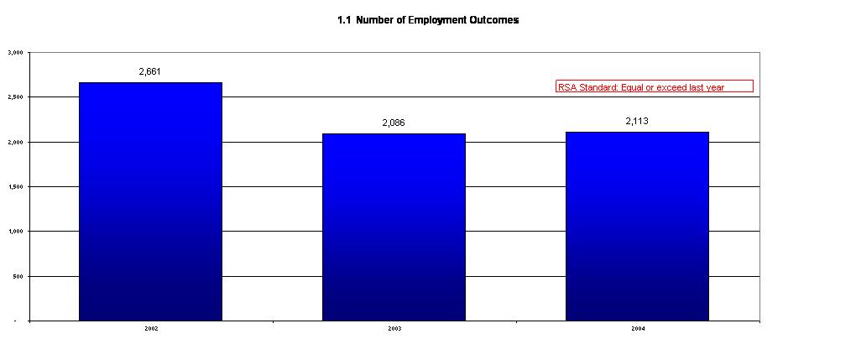

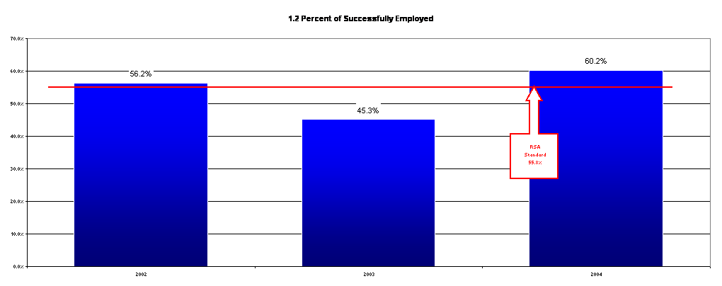









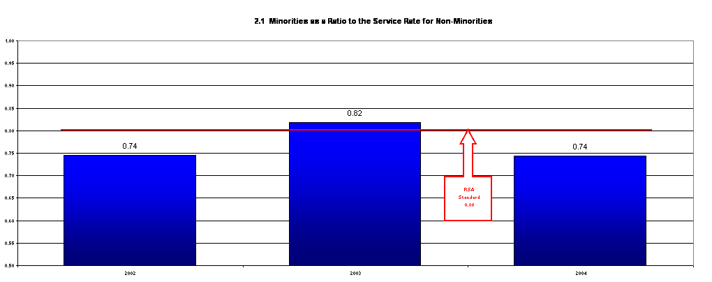

## **SRC Member Biographies**

#### ***2003 - 2004***

#### Kathryn Baumann-Reese

Ms. Baumann-Reese is serving her second full term on the SRC. She lives in Des Moines and serves as the Administrator of the Deaf Services Commission of Iowa, Department of Human Rights. She represents disability groups on the SRC.

#### Sherry O. Becker

Ms. Becker lives with her husband, Tim, and their family in Mason City. Sherry represents disability advocacy groups on the SRC. She completed her second term on the Council during this year. Ms. Becker’s interest in rehabilitation is not only personal, but also professional. As a rehabilitation counselor, Sherry works at NIVC, a community rehabilitation partner with DVRS.

#### David Bertling

Mr. Bertling resides in Mt. Pleasant and represents business and industry on the SRC. David is serving his second term on the SRC. He is an independent business person who has enjoyed hiring people with disabilities. Mr. Bertling also has a daughter with a disability.

#### Dennis Dykstra

Mr. Dykstra lives in Urbandale and serves as an Administrative Consultant in the Bureau of Children, Family, and Community Services, Iowa Department of Education.  His membership represents the state education agency that is responsible for the public education of students with disabilities.  Dennis will serve on the SRC through June of 2005.

#### Lisa Heddens

Ms. Heddens is the Family Support Coordinator for the Parent Training and Information Center of Iowa (PTI), which is a federally-funded grant of the U.S. Department of Education which advocates on behalf of children and their families under the provisions of the Individuals with Disabilities Education Act (IDEA). She represents PTI on the SRC. Lisa was recently elected to her second term in the Iowa House of Representatives. Her background experience is in elementary education and as an advocate with Iowa Protection and Advocacy, as the Project PRIDE and Partners in Policymaking Coordinator. Lisa resides in Ames, Iowa, with her husband, Jeff, and their two children, Makenzie, 15, and Paul,10, who has Down Syndrome.

#### Harlietta Helland

Ms. Helland is the Client Assistance Program (CAP) representative to the SRC.  As the CAP representative, she has no term limit.  Harlietta has served on the SRC since 1995.  As a client advocate, she represents applicants and clients of DVRS.  Ms. Helland’s office is in Des Moines; however, she serves the entire state of Iowa and travels frequently.  Ms. Helland resides in Marshalltown.

Terry L. Johnson

Mr. Johnson of Jefferson, Iowa, was appointed to the SRC in 2003. He is the CEO of Genesis Development, a rehabilitation organization. His 30 years in the disability field has led to many experiences and interests in the needs of people with disabilities. Mr. Johnson represents community rehabilitation programs on the SRC.

Thomas Jolas

Mr. Jolas started his second term on the SRC during this year. He is an attorney as well as a partner in RE/MAX Results Realty in Mason City. He is a former Deputy Director of the Iowa Department of Economic Development and a former Mayor of Mason City. He represents business, labor and industry on the SRC.

#### Karen Keninger

Ms. Keninger is a Program Administrator at the Iowa Library for the Blind.  Karen has been blind since birth.  Ms. Kenninger is in her second term on the SRC.  She has worked for the Iowa Department for the Blind for ten years.  Karen served as a Rehabilitation Consultant for five of those years.

Curtis Lindholm

Curtis Lindholm began his first term on the SRC in July 2004. Mr. Lindholm is a quadriplegic and lives in Ames. Mr. Lindholm represents disability advocacy groups.

#### Raynard (Ray) Manning

Mr. Manning completed his first term as an appointee to the SRC and asked not to be reappointed. He is a DVRS Counselor in the Iowa City Area Office. He represents VR counselors. Ray is one of three VR Regents’ University caseload counselors. He is responsible for the delivery and coordination of rehabilitation services for VR clients who are enrolled at the University of Iowa. Ray arrived in Iowa from Texas in 1967 as a freshman at the University of Iowa via a full football scholarship. He played tight end for the “Hawks” as a starter during his four-year undergraduate tenure. He received a BS degree in Science Education (Zoology) in 1971 and an MA in Rehabilitation Counseling in 1976 from the University of Iowa.

Joe Mara

Mr. Mara is a first-term member of the SRC. He is a person with a disability and represents a disability group on the Council. Mr. Mara is very actively involved with various disability issues.

Marsha Mott

Ms. Mott is in her first term as an appointee to the SRC.  She lives in Clear Lake with her husband, Russ, and family.  She is beginning her tenth year as a Vocational Rehabilitation Counselor in the Mason City Area Office.  She has a general caseload and is the office Transition Counselor.  Marsha will represent VR counselors.

#### Allan Oberlander

Mr. Oberlander began his tenure on the SRC in 2000. He resides in Des Moines and represents business and industry on the SRC. He served on the Board of VSA Iowa (providing arts opportunities to individuals with disabilities) for six years, including one year as chair. He has recently been elected to the Special Olympics of Iowa Board. Al is an architect with RDG Planning & Design of Des Moines.

Donald Rowen

Mr. Rowen is in his first term to the SRC.  He represents labor.  Mr. Rowen has worked in the labor movement for over 42 years.  He is the retired Executive Vice President of the Iowa Federation of Labor, AFL-CIO.  He is a Korean War Army veteran.  He has served two six-year terms on Polk County Health Services; and 12 years as a board member of Des Moines Area Community College.

Norma Schmoker

Mrs. Schmoker represents the Iowa Workforce Development Board on the SRC. She resides in Fort Dodge and is currently in her second term on the SRC. From a workforce standpoint, Norma is interested in the “untapped resources” that people with disabilities offer. Mrs. Schmoker is a former business owner who employed people with disabilities who she believes were some of her best employees. Norma also has a grandson with a disability. She feels her work on the SRC is a way to ensure that he has a place in the workforce when he is ready.

#### Ellen Sokolowski

Ms. Sokolowski resides in Atlantic and represents the Iowa Rehabilitation Association, an advocacy group, on the SRC.  Ellen is employed with DVRS in Council Bluffs as a Vocational Rehabilitation Counselor at IWCC.  She was appointed to the SRC in June of 2000.

LaVerne Tutson

Ms. Tutson is a graduate of the University of Iowa, with a Master’s Degree in Rehabilitation Counseling. She has served as an Intern for the Division of Vocational Rehabilitation on two occasions; once as an Intern in the Iowa City office as a Counselor in Training, and once as an Intern in the Diversity Outreach training program at the University of Missouri, Columbia. She is the mother of six children and is presently employed at the Illinois-Iowa Center for Independent Living. She is in her first term on the Council and represents the Statewide Independent Living Council (SILC).

Stephen A. Wooderson

Mr. Wooderson has worked in the vocational rehabilitation profession since 1981. He began his career as a counselor, and has served at all levels of supervision and management prior to his appointment as Administrator of the Iowa Division of Vocational Rehabilitation Services on December 6, 2002.