NEWS RELEASE | For Statewide Distribution

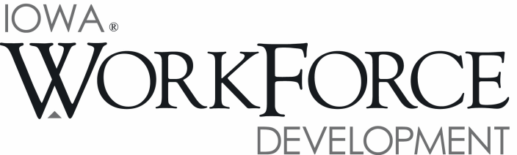
For Release: 9:00 a.m.  Date: August 21, 2015 | Contact: Ed Wallace (515) 281-5082
Iowa’s Unemployment Rate at 3.8 Percent in July

DES MOINES, IOWA – Iowa’s seasonally adjusted unemployment rate increased slightly to 3.8 percent in July from 3.7 percent in June. The state’s jobless rate was 4.3 percent one year ago. The U.S. unemployment rate remained at 5.3 percent in July.

“Iowa’s nonfarm employment surged ahead in July, gaining 8,100 jobs,” said Beth Townsend, director of Iowa Workforce Development. “Jobs were added in virtually all sectors this month and lifted nonfarm employment 30,900 jobs higher than one year ago.”

The number of unemployed Iowans remained at 63,900 in July. The current estimate is 10,300 lower than the year ago level of 74,200.

The total number of working Iowans decreased to 1,636,500 in July. This figure was 4,000 lower than June, and 4,100 higher than one year ago.

Seasonally Adjusted Nonfarm Employment

Total nonfarm employment advanced by 8,100 jobs in July, raising nonfarm employment to 1,577,400 jobs. The unexpectedly large gain this month was primarily the result of growth in private sectors (+6,100). Both goods-producing and service sectors advanced for the third consecutive month, while government added 2,000 jobs due primarily to hiring at the local level. Of the eleven super sectors, only two pared jobs this month: professional and business services (-2,700) and trade and transportation (-900).

Education and health services added the most jobs this month (+3,700), more than recovering from an early seasonal decline last month. Jobs were added in both education and health care services. Leisure and hospitality added jobs for the first time in three months. The majority of the gains were in seasonal recreation activities. Financial activities increased for the third straight month (+1,500). The job growth is a stark contrast from year’s end when hiring was sluggish for Iowa’s financial sector. A combined 3,300 jobs have been added over the past three months. Smaller gains this month included manufacturing (+1,300), which has also increased in three consecutive months. Construction added 900 jobs and now rests just below 80,000 total jobs in Iowa.

Annually, Iowa nonfarm employment is up 30,900 jobs (+2.0 percent). Despite the mediocre showing this month, trade and transportation continues to fare well versus last year and is up 6,700 jobs—the most of any super sector. The education and health services sector has also benefitted from unexpected gains this month and is up 5,200 jobs. Construction continues to maintain a strong presence and has added 4,800 jobs. Only information services trails last year’s level (-800). Public sectors are up 5,000 jobs due primarily to education hiring at the state and local levels.

MEDIA ALERT: An audio cut of comments about Iowa’s labor market situation is available by calling
(515) 281-6057. Statewide data for August will be released on Friday, September 18, 2015. Local data for August will be posted to the IWD website on Tuesday, September 22, 2015.

Visit www.iowaworkforcedevelopment.gov/labor-market-information-division for more information about current and historical data, labor force data, nonfarm employment, hours and earnings, and jobless benefits by county.

An Equal Opportunity Employer/Program
Auxiliary aids and services are available upon request for individuals with disabilities.
www.iowaworkforcedevelopment.gov• www.iowaworks.org/ • www.iowajobs.org

