NEWS RELEASE | For Statewide Distribution

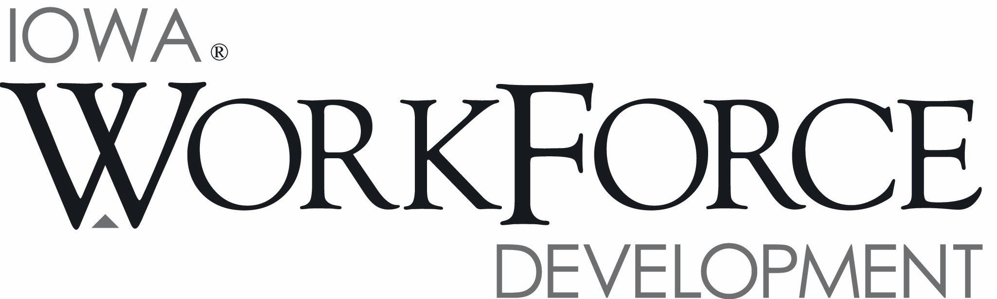
For Release: 9:00 a.m.  Date: August 18, 2014 | Contact: Kerry Koonce (515) 281-9646
Iowa’s Unemployment Rate Increases Slightly to 4.5 Percent

DES MOINES, IOWA – Iowa’s seasonally adjusted unemployment rate increased slightly to 4.5 percent in July from 4.4 percent in June. The state’s jobless rate stood at 4.8 percent one year ago. The U.S. unemployment rate was little changed at 6.2 percent in July compared to 6.1 percent in June.

“The state’s labor force continued to expand in July, causing a slight increase in the monthly unemployment rate,” said Teresa Wahlert, director of Iowa Workforce Development. “Iowa’s labor force has grown steadily this year, and surpassed 1.7 million in July.”

The number of unemployed Iowans increased to 76,900 in July from 74,300 in June. The current estimate is 3,700 lower than the year ago level of 80,600.

The total number of working Iowans decreased to 1,623,800 in July from 1,624,700 in June. This figure was 900 lower than June, and 30,300 higher than one year ago.

Seasonally Adjusted Nonfarm Employment

Iowa nonfarm employment totaled 1,550,200 jobs in July and remained unchanged since June. Job gains in the private sector were exactly offset by declines in government. This month’s stagnation halts three consecutive months of gains in nonfarm employment, and leaves the state up 16,500 jobs versus one year ago (+1.1 percent).

Education and health services added the most jobs this month (+2,800) due to gains in both private education services and health care services. In the case of educational services, job gains were partially due to a shift in seasonality; health care industries continue to steadily advance upward due to increasing demand. Professional and business services was buoyed by growth in professional, scientific, and technical services this month and gained 1,000 jobs. Construction also fared well this month (+1,000), marking the fourth consecutive month for job gains. Smaller increases this month included financial activities (+800), other services (+500), and information (+200). Alternatively, leisure and hospitality experienced an unexpectedly large drop this month
(-2,300) with losses being nearly even in accommodations and food services and arts and entertainment. Trade and transportation also shed 2,300 jobs due mostly to losses in transportation and retail. The only other loss this month occurred in manufacturing (-300) which has now pared jobs in six of the last seven months, yet remains up 1,200 jobs since last July.

With this month’s unexpected gain, education and health services has now added the most jobs annually (+4,000). Health care jobs have advanced steadily (+2,900) and are responsible for the majority of the growth in this super sector. Construction has also shown considerable promise since last year (+3,900) due to renewed demand for commercial and residence projects. Professional and business rebounded this month, and now rests up 2,300 jobs since last July. The majority of these gains are found in administrative and support services.

MEDIA ALERT: An audio cut of comments about Iowa’s labor market situation is available by calling
(515) 281-6057. Statewide data for August 2014 will be released on September 19, and local data will be posted to the Web on September 23, 2014.

- More -

Visit www.iowaworkforce.org/lmi/laborforce/locallaborforce.html for county unemployment rates,
www.iowaworkforce.org/lmi/laborforce/index.html for current and historical labor force data and
www.iowawokforce.org/lmi/empstat/msanonag.htm for detailed information on nonfarm employment.

Visit www.iowaworkforce.org/trends/wages.html for information on hours and earnings and www.iowaworkforce.org/trends/uiclaimscomo.html to obtain a breakout of jobless benefits by county.

An Equal Opportunity Employer/Program
Auxiliary aids and services are available upon request for individuals with disabilities.
www.iowaworkforce.org • www.iowaworks.org • www.iowajobs.org

